Children and Families
Training and Continuous Professional Development Portfolio

Calendar 2020 -2021

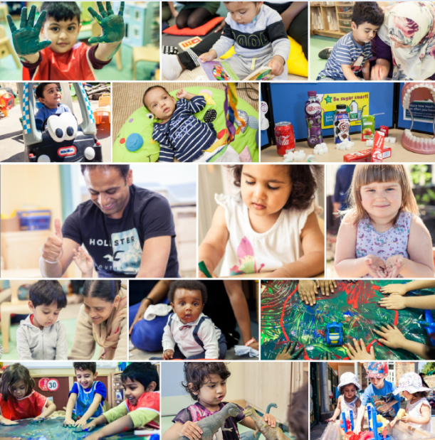

Training and CPD

The Early Years Service in partnership with sector organisations have produced this training calendar to support you and your staff during the Covid-19 pandemic and beyond.

Slough Early Years Service is committed to supporting the sector with training and continuous professional development opportunities. We are constantly reviewing our offer and have recently made some changes to the next annual calendar to take into considerations the impact of COVID-19. We have planned a years worth of networks and training programmes and will continue monitor the offer and consider what changes may be required should the situation change.

You will see that for the spring term we have now scheduled all of our training and network opportunities online (apart from Paediatric First Aid) and we hope to resume face to face meetings from the summer term, COVID dependant.

All of the training that has been scheduled has been based on feedback from the sector but if you are looking for something specific that we haven’t organised please contact us and we will be happy to discuss your requirements, please contact earlyyears@slough.gov.uk or call 01753 476581

Slough Early Years Service is committed to supporting affordable professional development across the sector by keeping charges low.

Providers from other local authorities are welcome to access some of our training in Slough.
If you would like to organise whole setting training please contact us to discuss this.
Please note that venue hire will add to the cost of the training course but if you are considering using your own setting as the training venue we ask that you consider carefully whether you can provide suitable adult facilities for all attendees (adult height chairs/tables, toilets etc.)

We need a minimum of eight practitioners in order to deliver a training session or workshop. If you are a sole provider or a group provider requesting fewer than eight training places we will endeavour to find practitioners from other settings to join you in the training before confirming your booking.

All training courses scheduled throughout the year and can be booked via ‘The Link Website’:www.thelink.slough.gov.uk

Email Invitations
Please note that the invites for private training course and meetings will come as an email from “Eventbrite”. Before requesting an invite please review the target audience and check your emails to ensure you haven’t already received an invite.

Bookings will close 5 days prior to the training, please ensure you book your place(s) on time as once the bookings have closed you will not be able to book a place

Waiting List
Please note that all of our training courses have a waiting list, please use this function as this helps us to measure demand and determine if an additional course is required, also if a booking becomes available you will be notified via email.

Cancellations
- Any cancellations must be made 7 days prior to the event.
- Any bookings including free courses and network meetings, cancelled within these 7 days will be subject to a £15.00 cancellation fee
- Non attendance will also be subject to a £15.00 charge for free sessions and full charges for costed courses
- If the Slough Early Years and Prevention Service cancel a course all booked and paying participants will receive a full refund

Polite reminder and protocol for accessing online training and networks
- Join the meeting early to ensure everything is working OK, and so any technical issues can be resolved. The meeting will be open to you 10mins before the scheduled start time.
- Please ensure you arrive on time for training, if you are more than 10 minutes late unfortunately you will not be able to join the training.
- Turn your camera on and have it at eye level
- If you have a poor internet connection, you can turn your camera off to improve the quality
- Please ensure there is only one person per screen, this is to ensure that you are able to interact with the training as per the design of the course. Most of our training deliver will include the use of ‘break out’ rooms and this function does not work if a screen is shared with other delegates.
- If there is more than one person from the same setting attending the training then you will need to position your self in a different room on a different screen.
- If you would like to run a whole group session where you project the training onto a big screen please contact earlyyears@slough.gov.uk so we can organise and plan a session specifically for this purpose. In this situation we would design the course differently and ‘break out rooms’ would not be a feature.
- No unauthorised person should join the training and if the trainer suspects that this is the case they have the right to end the online session.
- Please maintain the level of respect that you typically would for a face-to-face environment

Ask questions
The chat box is a function of online training for a reason and just because you’re in a virtual classroom setting does not mean that you cannot or shouldn’t ask questions. It’s been scientifically proven that we learn by asking questions and according to Success magazine, questioning allows us to explore different perspectives and become less biased in our decision-making.

Mute your microphone
When you’re not talking or contributing to the session, it’s useful to mute your microphone to ensure that any background noise doesn’t disrupt the session. You can always unmute yourself when you want to ask a question, but make sure you are mindful of the appropriate times to do so.

Be respectful
This applies to your trainer and fellow delegates too. Remember, your trainers have put a lot of time and effort into delivering high-level course content (especially during a notably unusual situation), so maintain the level of respect that you typically would for a face-to-face environment. And when it comes to your fellow delegates, remember that for some, this may be the first time that they’ll be undertaking an online course. Lastly, as with face-to-face sessions, please be on time and be respectful of other people’s time.

Be mindful of your language
As well as the obvious curse words or rude tone (this falls into the respectful category too), this means avoiding using caps lock, sarcasm or humour that may be misconstrued. It’s easy for written text to be misread. According to Psychology Today, without facial expressions, tone of voice or gestures, it can be difficult to interpret how a message was intended, and our minds will fill in the blanks based on previous experiences. So, make sure you read it out loud first before you hit the send button.

Try not to get distracted
Similar to a face-to-face classroom environment, distractions can hinder your learning experience, and this is something that you should look to avoid if you wish to fully take advantage of this time. 70% of workers state that they feel distracted within their working day, which is hugely problematic for motivation when you’re trying to add development time into this schedule. So, switch off your phone, minimise your background noise and find an area where you’ll be able to set up and fully concentrate on the course at hand. Don’t forget to switch off emails, messaging apps and other pop-ups that can come up on your screen prior to the session.

Do not share inappropriate material
Sounds pretty obvious we know but nothing that you share online is ever private, even in the breakout rooms with other delegates. Be mindful of what you share and remember that we’re living in a world of screenshot culture.

Maintain confidentiality
While you’re learning, you may be encouraged to share workplace examples that relate to the topic of discussion. However, be mindful of client confidentiality, especially when sharing examples via the written chatbot where information can be screenshotted. Plus, remember that Live Online sessions could be recorded so can be accessed later on. So, if your fellow delegates missed the hypersensitive information you shared the first time around, it’s unlikely that they will by the second or third occasion.

Handouts
When attending training run by Slough Early Years Service it is encouraged that key messages and learning from the training is shared, however it is not expected that attendees would attempt to deliver or duplicate the training in anyway. If you do share any of the key messages please acknowledge the original source of this intellectual property to be copyright compliant.

Feedback
Participants who attend training will be sent an email with a link to an evaluation survey. You will then have 28 days to complete the feedback online and will receive your certificate once this has been done. If you have not completed the survey within 28 days your certificate will also no longer be available.

MULTI-AGENCY TRAINING OFFER 2020-21 is under review (Level 2 Safeguarding)
Covid 19 has presented many challenges for our workforce and has taught us a lot about Virtual working together!

We are currently revising all our training and developing virtual modules. We have committed to virtual training September through to March 2021 unless it is safe to have face to face training.

https://www.sloughsafeguardingpartnership.org.uk/scsp/scsp/training/multi-agency-training-offer-2020-21-refreshed-in-light-of-covid-19

Safeguarding basics and COVID-19
Below is a link to a video which has been developed to cover the basics of safeguarding during COVID-19. It covers safeguarding for both children and adults at home and also includes domestic abuse and exploitation.

It takes less than 10 minutes to view and may be particularly useful as a resource for:-
- redeployed staff
- staff or volunteers working in different ways within the safeguarding arena during this period
- volunteers who do not read English very well as there is no requirement to read the slides.

The messages are simple - “There is no excuse for abuse during Lockdown” and “Help is available -It is business as usual for safeguarding services”

Link to Slough Safeguarding basics https://youtu.be/RDc4mBGbRmA

Safeguarding Level 3
It is always recommended that Designated Safeguarding Leads complete a localised Safeguarding course to ensure they have up to date information about local policy’s and procedures. Due to COVID 19 the Slough Safeguarding Partnership are currently unable to offer face to face training but will endeavour to review other options such as online training in the future. In the meantime there are a number of other organisations who offer Level 3 Safeguarding training online which you could access, however we strongly recommend that you ensure you are aware and up to date with Slough’s Safeguarding procedures https://berks.proceduresonline.com/slough/index.html

Please note these courses are not recommendations and we are not endorsing the training. This list is not exhaustive

Level 3 Safeguarding Children: Paediatric First Aid Training Online
This online safeguarding training level 3 course programme is aimed at all childminders, nursery staff, but also school teachers & support staff working with children & infants who could potentially assess and evaluating the needs of a child, infant or young person, who may be potentially at risk of harm.
https://www.onlinepaediatricfirstaid.co.uk/product/level-3-online-safeguarding-children-course-childminders-nursery-staff/

Designated Safeguarding Lead (Level 3): The National Nursery Training
As part of the National Nursery Training Designated Safeguarding Lead course you will learn:
- Understand the safeguarding structure and have an understanding of the law, policy and recommended guidance to uphold the highest safeguarding standards
- Understand the roles and responsibilities of the Designated Safeguarding Lead
- Be able to identify signs of possible abuse
- Understand the process to follow when a safeguarding issue is identified
- Understand the correct procedure for dealing with disclosures.
- Understand the varying levels of need of individuals and processes to follow.
- Understand the correct procedure for recording information and following due process beyond referral to external agencies.
https://nationalnurserytraining.com/product/designated-safeguarding-lead-level-3/
Designated Safeguarding Lead online Course: EYFS Resources
The Designated Safeguarding Lead course covers the following:
◦the definition of safeguarding and child protection,
◦recap on signs and symptoms of abuse
◦how to report concerns
◦how to respond to allegations of abuse
◦recording information correctly
◦roles and responsibilities of people and agencies
◦creating a child protection policy
◦the role of a Designated Safeguarding Lead (DSL)
https://www.eyfsresources.co.uk/training/early-years-safeguarding-courses/designated-safeguarding-lead-online-course

NSPCC Safeguarding Training
https://learning.nspcc.org.uk/training

Prevent
Prevent should be seen as part of the existing safeguarding framework;
While it remains rare for children and young people to become involved in terrorist activity, young people from an early age can be exposed to terrorist & extremist influences or prejudiced views. As with other forms of safeguarding strategies, early intervention is always preferable.

Slough Borough Council working with other local partners, families and communities, play a key role in ensuring young people and their communities are safe from the threat of terrorism.
Prevent training, aims of session.
• Understand Prevents aims
• Think about who may be vulnerable to Extremism and Radicalisation – all forms
• See why some people are able to influence and manipulate others to commit crimes
• Recognise when a vulnerable individual may be in need of help
• And be clear on what help and support looks like in this area, and who you should turn to if you have concerns
• Look at the threats, risks and vulnerabilities

9th December 2020 @ 10am – 12pm
12th January 2021 @ 10am – 12pm
9th February 2021 @ 10am – 12pm
9th March 2021 @ 10am – 12pm

To book a free space please email Philip.Dobson@slough.gov.uk

Alternative evening session will run on 23rd February 2021 @ 6.30pm – 8pm bookings via the Link

Food hygiene training
Level 2 award - food safety in catering

Training is an essential part of good food hygiene practice and is a legal requirement for all food handlers. Slough Borough Council run the Chartered Institute of Environmental Health (CIEH) Level 2 award in food safety in catering course every two months, or as necessary at the Council's offices. The course is designed for ALL food handlers, managers and food business owners, or individuals who want to learn about good food hygiene.

The CIEH qualifications are widely recognised within the industry and by food safety professionals. The CIEH is recognised for their high standards, they are a professional body who set standards, accredited courses and qualifications.

The cost of this course is £67.00 per person and includes training materials, a course handbook and the cost of the exam paper. If you have several people who require training, we can provide bespoke courses for you at your convenience. Please contact the food and safety team for further information. http://www.slough.gov.uk/business/environmental-health/food-hygiene-training.aspx

Whole setting ASD training
This training has been designed for whole staff teams and providers can join with other settings if applicable, it will support settings working with children with autism. Creating opportunities for joint attention, communication and interaction in Early Years.

• Practical strategies for early intervention
• Breaking down barriers to learning through positive shared play experiences

Settings can request this training package on a day that is suitable for them and a venue can be organised if required.

This training is delivered by two early years SEND professionals.

6 hours face to face delivery

Cost: starting from £32.50 per person

September 2020
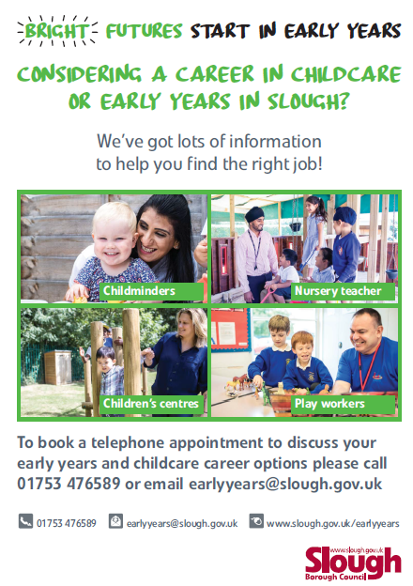
Careers in Childcare or Early Years
FREE Online Information sessions
Explore the different types of roles in childcare and early years, find out more about qualifications and training that could support you to get a job in the sector and discover what support is available in Slough for job seekers.

Wednesday 9th September 2020: General session all welcome
6.30pm – 7.30pm
To book: https://thelink.slough.gov.uk/events/careers-information-session-1

Friday 18th September 2020: Starting a career as a childminder
10am – 11am
To book: https://thelink.slough.gov.uk/events/starting-career-childminder-information-session

First Aid Training
Face to face
12 hours Paediatric First Aid Training
All early years and childcare practitioners welcome
Saturday 19th & 26th September 2020
9.30am – 4pm
Cost £115 per participant
Please note: that the group size has been capped to allow social distancing. PPE will also be provided by the trainer where required

To book: This is course is fully booked, to add your name to the waiting list please visit https://thelink.slough.gov.uk/events/paediatric-first-aid-training-5 or for alternative dates please see October and December
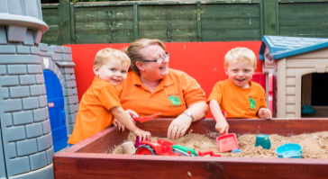
SEBDOS: Behaviour Management Training
FREE Online training
Session1
•Understanding behaviour as a form of communication
•Positive behaviour strategies
•Sharing consistent high expectations of behaviour with staff, children and parents/carers

Session 2
•Consistently challenging and complex behaviour
•How to develop problem solving around specific behaviours (biting?)
•Develop knowledge of how to adapt the environment

All early years and childcare practitioners welcome
Tuesday 22nd & Tuesday 29th September 2020
10am – 11.30am
Please note: Participants must attend both sessions
To book: https://thelink.slough.gov.uk/events/early-years-behaviour-management-training-sebdos

Childminder Cluster Meeting
FREE Online network session
This meeting is designed to support childminders. They are held termly and provide an opportunity for national and local updates, networking and sharing good practice.

All registered childminders
Wednesday 30th September 2020
7pm -8pm
To book:
https://thelink.slough.gov.uk/events/early-years-childminder-cluster-meeting-0

October 2020
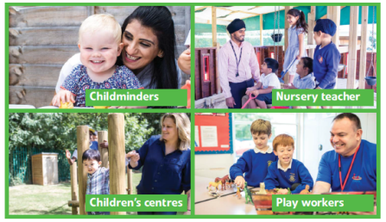
Careers in Childcare or Early Years
FREE Online Information sessions
Explore the different types of roles in childcare and early years, find out more about qualifications and training that could support you to get a job in the sector and discover what support is available in Slough for job seekers.

Tuesday 6th October 2020: Starting a career as a childminder (6.30pm – 7.30pm)
To book: https://thelink.slough.gov.uk/events/starting-career-childminder-information-session-0
Wednesday 14th October 2020: General session all welcome (10am – 11am)
To book: https://thelink.slough.gov.uk/events/careers-information-session-1
Attachment and Trauma Informed Approaches: FREE Online training
Dr Anna Bryant, Senior Educational Psychologist

We will consider early childhood relationships and their impact within early years settings. We will take a compassionate approach to early adverse childhood experiences and consider practical strategies that can be implemented in your settings in order to support children to thrive.
Wednesday 21st October @ 6.30pm – 8.30pm
Nursery practitioners / teachers, deputies, childminders and childminder assistants
https://thelink.slough.gov.uk/events/early-years-attachment-and-trauma-informed-approaches-training

ITALK Network
FREE Online training
This meeting is designed to support Early Language Lead Professionals (ELLPs) with the development of the I Talk programme within their own setting and to have the skills to support and mentor staff with the knowledge around children's speech, language and communication skills.

The content is repeated at the two different sessions to provide a range of suitable times

Monday 12th October 2020
1pm – 2pm or 6.30pm – 7.30pm
To book 1pm: https://thelink.slough.gov.uk/events/early-years-i-talk-network-meeting-7
To book 6.30pm: https://thelink.slough.gov.uk/events/early-years-i-talk-network-meeting-6

First Aid Training: Face to face
12 hours Paediatric First Aid Training
All early years and childcare practitioners

Saturday 10th & 17th October 2020 @ 9.30am – 4pm
Cost £115 per participant
Please note: that the group size has been capped to allow social distancing. PPE will also be provided by the trainer where required
To book: https://thelink.slough.gov.uk/events/paediatric-first-aid-training-6 or for alternative dates please see December

Early Years PVI Managers Meeting
FREE Online network session
The PVI manager meetings are designed to support managers in the private, voluntary and independent sector and provide a networking opportunity. During the meeting the early years service will provide the sector with national and local update information.

PVI managers
Monday 19th October 2020
6.30pm – 7.30pm
To Book: https://thelink.slough.gov.uk/events/early-years-pvi-managers-meeting-0

Early Years Cluster Meeting
FREE Online network session
This meeting is designed to support lead practitioners working in early years settings. They are held termly and provide an opportunity for national and local updates, networking and sharing good practice.

Lead practitioners working in nursery schools, nursery classes, day nurseries and preschools
Monday 19th October 2020 @ 4pm -5.15pm
To book: https://thelink.slough.gov.uk/events/early-years-cluster-meeting-3

October 2020 continued…
Introduction to Safeguarding Children
Online training session
This training is an introduction to Safeguarding children and has been designed for people who are new into early years and childcare. This training will enable staff to identify signs of possible abuse and neglect at the earliest opportunity, and to respond in a timely and appropriate way..

Unqualified / new practitioners, lunch time cover staff, apprentices, new Childminders, and volunteers
Friday 16th October 2020 @ 10am - 12.30pm
Cost: Full price for this training is £24.50 however we are offering an AUTUMN SPECIAL of 20% off book your space now for only £19.60

To book: https://thelink.slough.gov.uk/events/introduction-safeguarding-children-1

November 2020
Why Is Being Outdoors & Outdoor Learning So Important For Children?
Part 1: Online Training
This course will focus on the health and well-being aspects of being outside and how these support children’s growth, development and learning.
Tuesday 3rd November 2020
4pm – 5.30pm
Target audience: EY teachers, practitioners, childminders and senior staff - If you enjoy being outside and believe that outdoor learning is vital to young children this course is for you!

Cost: Full price for this training is £24.50 however we are offering an AUTUMN SPECIAL of 20% off book your space now for only £19.60
To Book: https://thelink.slough.gov.uk/events/why-being-outdoors-outdoor-learning-so-important-children-part-1

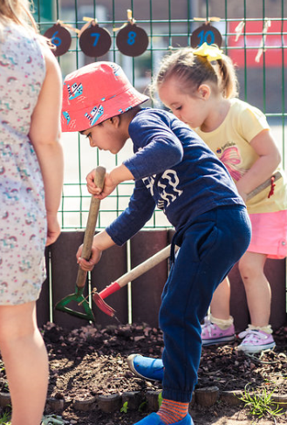

Promoting good oral health in children post COVID 19
Free Online Training
This training session will be delivered by Karen Gonzalez and Katy Rowlands, Oral Health Improvement Practitioners, Oxfordshire Community Dental Service. 70% of families with children under five report more snacking in their households during the lockdown (Dentistry Magazine August 2020). That’s more than double the figures of households without young children.

Learning outcomes
Participants will:
• Understand the criteria for Slough healthy smiles accreditation and how to join
• Increase their understanding and awareness of the importance of good oral hygiene for children
• Receive up to date information regarding good oral health practices and how to share the key messages with parents / carers

Wednesday 11th November 2020
6.30pm – 8pm
Target audience: Childminders, childminding assistance, early years practitioners, deputies / managers, family services officers

To Book: https://thelink.slough.gov.uk/events/early-years-promoting-good-oral-health-children-post-covid-19

Observation, Assessment & Planning (OAP)
Online Training
The observation, assessment and planning cycle is crucial to children’s progress in the EYFS, and takes into account children’s current learning interests and styles, developmental stage and level of achievement, and individual needs, to inform how practitioners develop the environment, shape experiences and provide opportunities for play and learning.

Monday 16th November 2020
1pm – 2.30pm or 6.30pm – 8pm

Target audience: All practitioners responsible for and contributing to observation assessment and planning in the EYFS including childminders, practitioners, and EYFS school staff.

Cost: Full price for this training is £24.50 however we are offering an AUTUMN SPECIAL of 20% off book your space now for only £19.60

To Book (1pm): https://thelink.slough.gov.uk/events/early-years-observation-assessment-and-planning-training
To Book (6.30pm): https://thelink.slough.gov.uk/events/early-years-observation-assessment-and-planning-training-0

Early Years PVI SEND Network
FREE Online Network
The SEND PVI network meeting is designed for managers and SENCo’s from the private, voluntary and independent sector. The network provides participants with the opportunity to network, receive national and local update information and share good practice.

Thursday 19th November 2020
6.30pm – 7.30pm
Target audience: Early years SENDCo's.

To Book: https://thelink.slough.gov.uk/events/early-years-send-pvi-network-meeting-1

SEBDOS: Behaviour Management Training
FREE Online training
Session1
•Understanding behaviour as a form of communication
•Positive behaviour strategies
•Sharing consistent high expectations of behaviour with staff, children and parents/carers

Session 2
•Consistently challenging and complex behaviour
•How to develop problem solving around specific behaviours (biting?)
•Develop knowledge of how to adapt the environment

All early years and childcare practitioners welcome
Tuesday 24th November & Tuesday 1st December 2020
6.30pm – 8pm
Please note: Participants must attend both sessions
To book: https://thelink.slough.gov.uk/events/early-years-behaviour-management-training-sebdos-0

December 2020

First Aid Training
Face to face
12 hours Paediatric First Aid Training
All early years and childcare practitioners

Saturday 5th & 12th December 2020
9.30am – 4pm
Cost £115 per participant
Please note: that the group size has been capped to allow social distancing. PPE will also be provided by the trainer where required

To book: https://thelink.slough.gov.uk/events/paediatric-first-aid-training-7

Schema
Online Training
This training will develop practitioners’ understanding of schematic play behaviour and explore how they can use these to effectively respond to children’s schemas to develop their dispositions for future learning in a positive behaviour environment

Thursday 10th December 2020
1pm – 2.30pm or 6.30pm – 8pm
Appropriate for practitioners working in the EYFS; PVIs, childminders and Teaching Assistants in nursery and reception classes

Cost: Full price for this training is £24.50 however we are offering an AUTUMN SPECIAL of 20% off book your space now for only £19.60

To Book (1pm): https://thelink.slough.gov.uk/events/early-years-schema-training
To Book (6.30pm): https://thelink.slough.gov.uk/events/early-years-schema-training-0

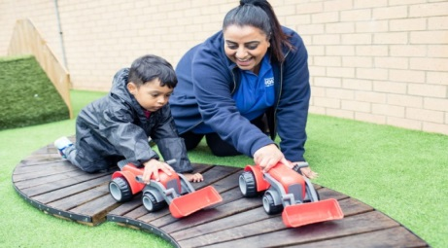

January 2021
Careers in Childcare or Early Years
FREE Online Information sessions
Explore the different types of roles in childcare and early years, find out more about qualifications and training that could support you to get a job in the sector and discover what support is available in Slough for job seekers.

Thursday 14th January 2021
10am – 11am
To book: https://thelink.slough.gov.uk/events/careers-information-session-3

Thursday 28th January 2021
12:30pm – 1:30pm
To book: https://thelink.slough.gov.uk/events/starting-career-childminder-information-session-1

First Aid Training
Face to face
12 hours Paediatric First Aid Training
All early years and childcare practitioners

Saturday 16th & 23rd January 2021
9.30am – 4pm
Cost £115 per person
Please note: The cost of this session will vary according to the group size that may need to be capped to allow social distancing.

To book: https://thelink.slough.gov.uk/events/paediatric-first-aid-training-8

Childminder Information Session
FREE Online session
Starting a career as a childminder

Wednesday 20th January 2021
6:30pm – 8:30pm

To book: https://thelink.slough.gov.uk/events/starting-career-childminder-information-session-1

Attention Autism
Online Training
Gina Davies Autism Centre Training
This 2 day course equips attendees with the skills to set up and run the 4 Stage Attention Autism programme.

The training focuses on the practical aspects of intervention, working in a team and offering an irresistible invitation to learn. The Attention Autism programme targets the teaching of attention, communication and social interaction skills. Training is run applying the principles of the attention autism programme throughout each day. There are demonstrations of the techniques in action, films of the work with children, practical hands-on experience for participants and ideas for activities. The intention is to share the practical skills needed for participants to feel confident in setting up and running the intervention immediately.

Appropriate for Early Years Practitioners level 2 & 3, Early years assistants and practitioners supporting children on a 1:1 basis
Friday 15th, 22nd January and 5th February 2021
11:30am – 2:30pm (half an hour break)

Cost: The full cost for this training is £210.00 per place, but as this training is being highly subsidised by the inclusion grant your contribution will cost £32.00 per place

To book: https://thelink.slough.gov.uk/events/early-years-attention-autism-training

The effects of domestic abuse on children
FREE online Training
Living in a home where domestic abuse happens can have a serious impact on a child or young person's mental and physical wellbeing, as well as their behaviour. And this can last into adulthood.

Target audience: All early years practitioners who have previously attended domestic abuse training

Monday 20th January 2021
6.30pm – 8.30pm

To book: https://thelink.slough.gov.uk/events/early-years-effects-domestic-abuse-children-training

January 2021 continued…..
Intent, Implement, Impact
Online Training
Understanding the elements of intent, implementation and impact to support the development of children's learning; considering observation assessment and planning techniques, adult interactions and the learning environment.

Appropriate for practitioners working in the EYFS; PVIs, childminders and Teaching Assistants in nursery and reception classes

Tuesday 26th January 2021
1pm - 2:30pm or 6:30pm – 8pm
Cost: Full price for this training is £26.30 however we are offering an SPRING SPECIAL of 20% off book your space now for only £21.04
Please note: you are only required to attend one session

To book: (1pm) https://thelink.slough.gov.uk/events/early-years-intent-implement-impact-training
To book: (6.30pm) https://thelink.slough.gov.uk/events/early-years-intent-implement-impact-training-0

Childminder Cluster Meeting
FREE Online network session
This meeting is designed to support childminders. They are held termly and provide an opportunity for national and local updates, networking and sharing good practice.

All registered childminders
Wednesday 27th January 2021
7pm – 8:30pm

To book: https://thelink.slough.gov.uk/events/early-years-childminder-cluster-meeting-1

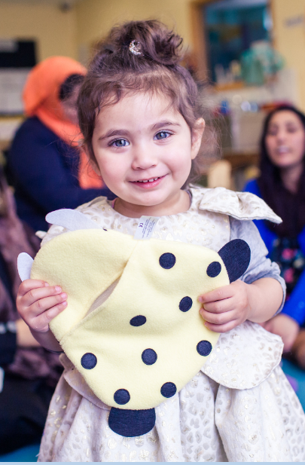
February 2021
Makaton Training
Online Training
All Makaton training provides you with information about what Makaton is and how it can be used in different settings. You also learn signs and symbols from the Core Vocabulary to an appropriate level.

Wednesday 3rd February 2021 – Part 1
Wednesday 10th February 2021 – Part 2
Wednesday 24th February 2021 – Part 3
Wednesday 3rd March 2021 – Part 4

6:30pm – 9pm

Cost: £32.00 per person (subsidised by the EY Inclusion Grant) original price per person £197.91

To book: https://thelink.slough.gov.uk/events/early-years-makaton-training-level-1-level-2

Supporting babies’ brain development
Face to face
This session will look at the rapid brain development that takes place in the first two years of life and how the experiences babies have play a fundamental part in laying down the pathways and foundations of brain development and learning for the future.

Appropriate for early years practioners working with under twos including child minders
Tuesday 2nd February 2021
1pm – 3pm or 6:30pm – 8:30pm
Cost: Full price for this training is £26.30 however we are offering an SPRING SPECIAL of 20% off book your space now for only £21.04
To book:
https://thelink.slough.gov.uk/events/early-years-supporting-babies-brain-and-language-development
https://thelink.slough.gov.uk/events/early-years-supporting-babies-brain-and-language-development-0

Early Years PVI Managers Meeting
FREE network session
The PVI manager meetings are designed to support managers in the private, voluntary and independent sector and provide a networking opportunity. During the meeting the early years service will provide the sector with national and local update information.

PVI managers
Monday 8th February 2021
6:30pm – 8:30pm

To book: https://thelink.slough.gov.uk/events/early-years-pvi-managers-meeting-1

Early Years Cluster Meeting
FREE network session
This meeting is designed to support lead practitioners working in early years settings. They are held termly and provide an opportunity for national and local updates, networking and sharing good practice.

Lead practitioners working in nursery schools, nursery classes, day nurseries and preschools
Monday 8th February 2021
4pm – 5:15pm
To book: https://thelink.slough.gov.uk/events/early-years-cluster-meeting-4

Moderation & Assessment Network
FREE Training / Network
These meetings will take place termly and support greater understanding, confidence and expertise in good early years practice and provision, with a focus on attainment, assessment and moderation.
Target audience: Reception teachers, Early Years Leads and coordinators responsible for completing the EYFS Profile.

Tuesday 9th and Thursday 11th February 2021
4pm – 5:15pm
To book 9th February: https://thelink.slough.gov.uk/events/early-years-la-moderation-and-assessment-network-5
To book 11th February:
https://thelink.slough.gov.uk/events/early-years-la-moderation-and-assessment-network-6
FGM
FREE Online Training
FGM training session is aimed to raise awareness of the practice of FGM and to inform Early Years practitioners of the facts and issues and how and where to make a referral.
Target audience: All early years practitioners new to the sector and all practitioners requiring a refresher course

Thursday 11th February 2021
10am – 12pm and 6:30pm – 8:30pm

To book: https://thelink.slough.gov.uk/events/early-years-fgm-training

February 2021 continued…
ITALK Network
FREE
This meeting is designed to support Early Language Lead Professionals (ELLPs) with the development of the I Talk programme within their own setting and to have the skills to support and mentor staff with the knowledge around children's speech, language and communication skills.

The content is repeated at the two different sessions to provide a range of suitable times

Monday 22nd February 2021
1pm – 3pm or 6:30pm – 8:30pm

To book 1pm:
https://thelink.slough.gov.uk/events/early-years-italk-network-meeting
To book 6.30pm:
https://thelink.slough.gov.uk/events/early-years-italk-network-meeting-0

Prevent training
FREE
Prevent should be seen as part of the existing safeguarding framework;
While it remains rare for children and young people to become involved in terrorist activity, young people from an early age can be exposed to terrorist & extremist influences or prejudiced views. As with other forms of safeguarding strategies, early intervention is always preferable.

Target audience: All early years practitioners new to the sector and all practitioners requiring a refresher course

Tuesday 23rd February 2021
6:30pm – 8:30pm

To book: https://thelink.slough.gov.uk/events/early-years-prevent-training-1

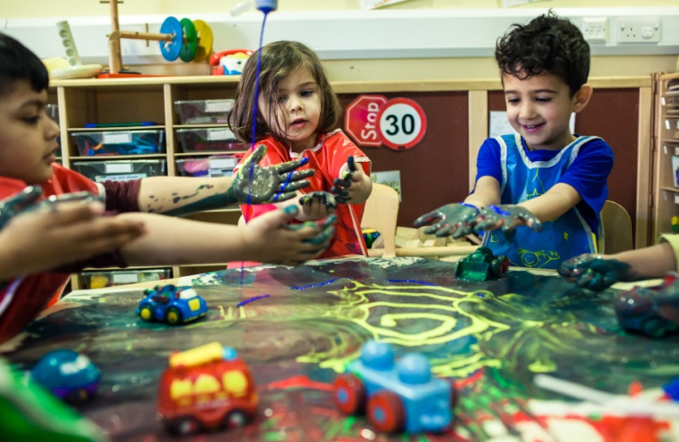
Introduction to Safeguarding Children
Online Training
To provide a basic Introduction to Safeguarding children where participants will learn to identify the four types of abuse and indicators of abuse.
Unqualified practitioners, lunch time cover staff, apprentices, new childminders, and volunteers
Thursday 25th February 2021
10am – 12:30pm
Cost: Full price for this training is £23.53 however we are offering an SPRING SPECIAL of 20% off book your space now for only £18.82
To book: https://thelink.slough.gov.uk/events/introduction-safeguarding-children-level-1

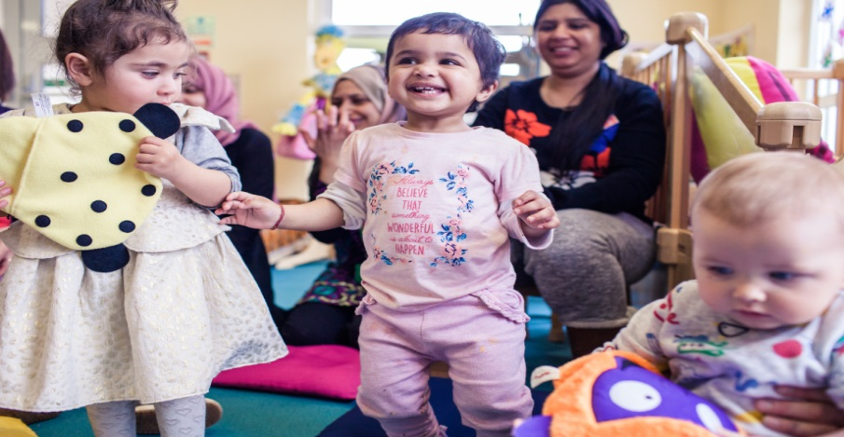

March 2021
Foundation Stage Profile Training
FREE Training / Network
The training will provide teachers with an understanding of the process of completing the profile and the relevant documentation, and will includes agreement trialling to ensure that EYFS profile assessments are in line with the requirements set out in the EYFS statutory framework.
Target audience: Reception teachers, Year 1 teachers, Early Years Leads and coordinators responsible for completing the EYFS Profile.
Tuesday 9th and Thursday 11th March 2021
9am – 12pm or 1pm – 4pm

To book (early adopter schools only): https://thelink.slough.gov.uk/events/early-years-foundation-stage-profile-training-early-adopter-schools
https://thelink.slough.gov.uk/events/early-years-foundation-stage-profile-training-early-adopter-schools-0
To book (all other settings):
https://thelink.slough.gov.uk/events/early-years-foundation-stage-profile-training-3
https://thelink.slough.gov.uk/events/early-years-foundation-stage-profile-training-4

Characteristics of effective learning
Online Training
This course looks at the three Characteristics of Effective Learning; ‘playing and exploring, active learning and creating and thinking critically’. Research has shown that it is these skills that make a difference to children’s long term outcomes and to their ability to become happy, resourceful and resilient adults.

Appropriate for practitioners working in the EYFS; PVIs, childminders and Teaching Assistants in nursery and reception classes
Monday 15th March 2021
1pm – 3pm or 6:30pm – 8:30pm
Cost: Full price for this training is £26.30 however we are offering an SPRING SPECIAL of 20% off book your space now for only £21.04
To book 1pm: https://thelink.slough.gov.uk/events/early-years-characteristics-effective-learning-training
To book 6.30pm: https://thelink.slough.gov.uk/events/early-years-characteristics-effective-learning-training-0
SEBDOS: Behaviour Management Training
FREE Online training
Session1
•Understanding behaviour as a form of communication
•Positive behaviour strategies
•Sharing consistent high expectations of behaviour with staff, children and parents/carers

Session 2
•Consistently challenging and complex behaviour
•How to develop problem solving around specific behaviours (biting?)
•Develop knowledge of how to adapt the environment

All early years and childcare practitioners welcome
Wednesday 10th & 17th March 2021
6.30pm – 8pm
Please note: Participants must attend both sessions

To book: https://www.eventbrite.co.uk/e/early-years-behaviour-management-training-sebdos-registration-130804380423
https://thelink.slough.gov.uk/events/early-years-behaviour-management-training-sebdos-1

Information Session
FREE Online session
This meeting is designed to support childminders. They are held termly and provide an opportunity for national and local updates, networking and sharing good practice.
Thursday 18th March 2021
10am – 12pm
To book: https://thelink.slough.gov.uk/events/careers-information-session-5
Or
Monday 29th March 2021
6:30pm – 8:30pm
To book: https://thelink.slough.gov.uk/events/careers-information-session-6

March 2021continued …….
Promoting good oral health in children post COVID 19
Free Online Training
This training session will be delivered by Karen Gonzalez and Katy Rowlands, Oral Health Improvement Practitioners, Oxfordshire Community Dental Service. 70% of families with children under five report more snacking in their households during the lockdown (Dentistry Magazine August 2020). That’s more than double the figures of households without young children.

Learning outcomes
Participants will:
• Understand the criteria for Slough healthy smiles accreditation and how to join
• Increase their understanding and awareness of the importance of good oral hygiene for children
• Receive up to date information regarding good oral health practices and how to share the key messages with parents / carers

Wednesday 22nd March 2021
6.30pm – 8pm
Target audience: Childminders, childminding assistance, early years practitioners, deputies / managers, family services officers

To Book: https://thelink.slough.gov.uk/events/early-years-promoting-good-oral-health-children-post-covid-19-0

First Aid Training
Face to face
12 hours Paediatric First Aid Training
All early years and childcare practitioners

Saturday 20th & 27th March 2021
9.30am – 4pm
Cost £115 per person
Please note: The cost of this session will vary according to the group size that may need to be capped to allow social distancing.

To book: https://thelink.slough.gov.uk/events/paediatric-first-aid-training-10

Makaton Training
Online Training
All Makaton training provides you with information about what Makaton is and how it can be used in different settings. You also learn signs and symbols from the Core Vocabulary to an appropriate level.

Wednesday 10th March 2021 – Level 1 Part 1
Wednesday 17th March 2021 –Level 1 Part 2
Wednesday 24th March 2021 – Level 2 Part 1
Wednesday 31st March 2021 – Part 2 Part 2

6:30pm – 9pm
Cost: £32.00 per person (subsidised by the EY Inclusion Grant) original price per person £197.91
To book: https://thelink.slough.gov.uk/events/early-years-makaton-training-level-1-level-2-0

2 year old provision
Online Training
This training will consider the physical and emotional learning and development needs of two year olds. Practitioners will gain insight into the importance of: the theory of mind, attachment and the active nature of learning at this stage. The session will include film clips and group discussion..

Target audience: EY practitioners in all settings working with 2 year olds, including childminders

Tuesday 30th March 2021
1pm – 3pm & 6:30pm – 8:30pm
Cost: Full price for this training is £26.30 however we are offering an SPRING SPECIAL of 20% off book your space now for only £21.04

To book (1pm): https://thelink.slough.gov.uk/events/early-years-two-year-old-provision-training
To book (6.30pm):
https://thelink.slough.gov.uk/events/early-years-two-year-old-provision-training-0

Early Years PVI SEND Network
FREE Online Network
The SEND PVI network meeting is designed for managers and SENCo’s from the private, voluntary and independent sector. The network providers participants with the opportunity to network, receive national and local update information and share good practice.

Target audience: Early years SENDCo's.

Wednesday 24th March 2021
6:30pm – 8:30pm

To book: https://thelink.slough.gov.uk/events/early-years-send-pvi-network-meeting-2

Summer term 2021: dates and times to be confirmed

April 2021
NDNA Leadership and Management
Face to face
This childcare course will cover the fundamentals of people management. Attendees will gain a professional awareness of their responsibilities and increase their confidence in their role.

Appropriate for deputies and managers

Curiosity Programme: Gina Davis
Face to face
This one day workshop is also for those working with or supporting very young children considered at risk in terms of autism spectrum disorders or showing some early difficulties with communication and social interaction. Many of the children in this group have a sibling on the autism spectrum and parents are understandably anxious about the younger sibling’s development.

Target audience: Early years leads, early years teachers, Early Years Practitioners, childminders, childminding assistants

SEBDOS: Emotional resilience training
FREE
Online Training
Understanding children’s emotional needs and behaviour, how they are linked, the impact of unmet emotional needs on attachment, what can impact attachment, parental availability, emotional regulation, the impact of trauma, how all this presents itself and how this might link to on-going issues.

Target audience: Early years leads, early years teachers, Early Years Practitioners, childminders, childminding assistants

Why Is Being Outdoors & Outdoor Learning So Important For Children?
Part 2: Loose Parts
Face to face
Practitioners will gain an understanding of the benefits and risks of play with 'loose parts', the typical resources that support this type of play and the extensive open-ended learning opportunities that come from playing with loose parts. This course will also have some 'hands-on' exploration so come dressed and prepared for fun learning outdoors.

EY practitioners in all settings with a passion for outdoor 'open ended' play

Supporting positive relationships with parents and the home learning environment
Face to face
For those new to childminding, this course is designed to support practitioners with developing supportive, positive relationships with parents and establish good information sharing to support children's learning at home.

Appropriate for new childminders

Supporting getting ready for Reading - early phonics (Part 1)
Face to face
The new Ofsted framework puts reading and vocabulary development at the heart of children's development. This session will support practitioners to have a good understanding of how and when to introduce 'pre-phonics' activities and learning with children. The session will include reference to Letters and Sounds phase 1 materials and how to use these practical activities and strategies for pre-phonics and early reading

Early years staff working in PVI nurseries and foundation stage in schools

Moderation & Assessment
FREE Training / Network
These meetings will take place termly and support greater understanding, confidence and expertise in good early years practice and provision, with a focus on attainment, assessment and moderation.

Target audience: Reception teachers, Early Years Leads and coordinators responsible for completing the EYFS Profile.

May 2021
Supporting getting ready for Reading – Mark Making (Part 2)
Face to face
Exploring techniques and strategies to develop children’s mark making skills, indoors and outdoors, understanding the physical and cognitive development of mark making

Early years staff working in PVI nurseries and foundation stage in schools

Foundation Stage Profile Training
FREE Training / Network
The training will provide teachers with an understanding of the process of completing the profile and the relevant documentation, and will includes agreement trialling to ensure that EYFS profile assessments are in line with the requirements set out in the EYFS statutory framework.

Target audience: Senior staff, assessment leads, EYFS leads and Year 1 teachers or early adopters TBC

Childminder Cluster Meeting
FREE face to face network session
This meeting is designed to support childminders. They are held termly and provide an opportunity for national and local updates, networking and sharing good practice.

All registered childminders

Safer Recruitment
FREE face to face network session
Participants gain the skills they need to ensure that safeguarding is at the heart of their recruitment decisions.

Appropriate for any early years staff involved in the recruitment process

Early Years PVI Managers Meeting
FREE network session
The PVI manager meetings are designed to support managers in the private, voluntary and independent sector and provide a networking opportunity. During the meeting the early years service will provide the sector with national and local update information.

PVI managers

Sensory Fun / Playful Experiences
Face to face
To have a basic understanding of multisensory learning, how sensory learning is critical for children with SEND. Practical ideas for resources

Appropriate for practitioners working in the EYFS; PVIs, childminders and Teaching Assistants in nursery and reception classes

Early Years Cluster Meeting
FREE network session
This meeting is designed to support lead practitioners working in early years settings. They are held termly and provide an opportunity for national and local updates, networking and sharing good practice.

Lead practitioners working in nursery schools, nursery classes, day nurseries and preschools

Team Teach
Face to face
Tailored training solutions teaching positive behaviour management strategies emphasising de-escalation and positive handling in conflict management.

Appropriate for practitioners working in the EYFS; PVIs, childminders and Teaching Assistants in nursery and reception classes

Cost: £61.34 per person (subsidised by the EY Inclusion Grant) original price per person £102.07

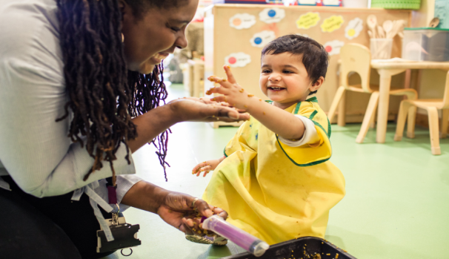

June 2021
Makaton Training
Face to face
All Makaton training provides you with information about what Makaton is and how it can be used in different settings. You also learn signs and symbols from the Core Vocabulary to an appropriate level.

SEBDOS: Behaviour Training
FREE Face to face
Consistently challenging and complex behaviour
How to develop problem solving around specific behaviours
Develop knowledge of how to adapt the environment

All early years and childcare practitioners welcome

First Aid Training
Face to face
12 hours Paediatric First Aid Training
All early years and childcare practitioners

Cost TBC
Please note: The cost of this session will vary according to the group size that may need to be capped to allow social distancing.

Supporting English as an additional language: effective interaction
Face to face
Practitioners will develop understanding how EAL children learn and consider how to support these children's learning across the EYFS and assessment of learning

Early years staff working in PVI nurseries and foundation stage in schools and child minders

Natural Learning /Forest Nursery
Face to face
This training session will explore how settings can embrace the principles of forest school and natural learning to enhance their own outdoor learning provision. Film clips will be used to show how 'teaching and learning' can take place in an outdoor environment with very few resources, a skilled practitioner and a willingness to embrace 'possible lines of development (PLODs)

Early years practitioners in all settings with a passion for outdoor learning

Early Years PVI SEND Network
FREE Online Network
The SEND PVI network meeting is designed for managers and SENCo’s from the private, voluntary and independent sector. The network providers participants with the opportunity to network, receive national and local update information and share good practice.

Target audience: Early years SENDCo's.

Introduction to Safeguarding Children
Face to face
To provide a basic Introduction to Safeguarding children where participants will learn to identify the four types of abuse and indicators of abuse. Participants will develop an understanding of how to respond effectively when a concern is raised, following the Slough Partnership reporting procedures

Unqualified practitioners, lunch time cover staff, apprentices, new childminders, and volunteers

