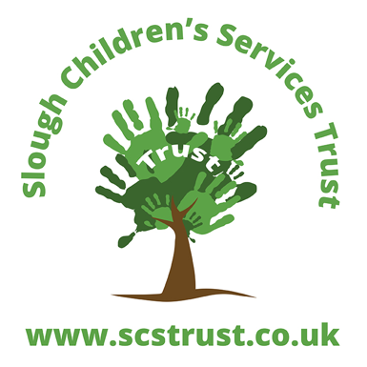

Slough Virtual School

Policy Summary
This policy is a guide for Children’s Social Care, Independent Fostering Agencies, Children’s Centres and other Early Years settings for children looked after by Slough Children’s Services Trust

Policy Owner: Anne Bunce, Virtual School Head

Version: 1.0

Date: February 2020

Review Date: February 2021

©Slough Children’s Services Trust
St Martins Place, 51 Bath Road Slough SL1 3UF
Registered Company: England and Wales: 9487106

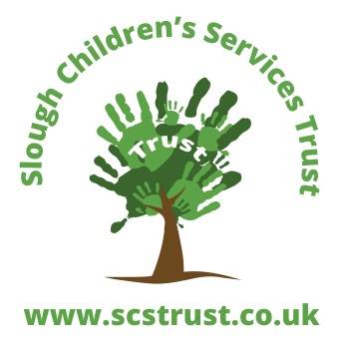
Contents
  - Promoting the education of CLA in the early years
Contents 1
Early education for children who become looked after 3
Registration with Children’s Centres 3
Early education 3
Accessing free early education 3
Children aged 2 years 4
Children aged 3 and 4 years 4
Reception Year 5
Personal Education Plans (PEPs) 5
Pupil Premium 5

Early education for children who become looked after
The positive impact of education in the early years of a child’s life on their long term educational achievement and life outcomes is now widely recognised and supported by a growing body of research, both in the UK and in other countries.
The importance of early education is recognised by government, and all children in England aged 3 and 4 years have an entitlement to free early education. For more vulnerable children, including those who are looked after, this entitlement is extended to those aged 2 years. Children aged 3 and 4 years who are looked after and participate in early education also attract Early Years Pupil Premium to support their educational achievement.
This practice guidance sets out the educational expectations for all children in the early years who are looked after by Slough Children’s Services Trust.

Registration with Children’s Centres
It is best practice for all children aged 0-5 years who become looked after by Slough Children’s Services Trust to be registered with their local Children’s Centre.
If the child is registered at a Children’s Centre it is the responsibility of the social workers to record the name, address and contact details of the Children’s Centre on ePEP, our electronic system for recording Personal Education Plans (PEPs). Social Workers and Supervising Social Workers should encourage Foster Carers to visit the Children’s Centre if the child is registered to engage in services that will support them and the child. Please contact the Virtual School for any help or advice.
Details of Children’s Centres in Slough can be found on the Slough Services Guide (https://www.sloughfamilyservices.org.uk) or by calling 01753 476589.
To identify the local Children’s Centre for children who are placed in another local authority area, look on that local authority’s website to find details of Children’s Centre services and contacts for further information.

Early education
All children aged 2, 3 and 4 years who become looked after by Slough Children’s Services Trust are eligible for up to 15hrs per week of free early education.
All children from the age of 3 months upwards will receive a personally chosen book from the Virtual School monthly.
For any other questions and queries please contact the Virtual School directly.
Children’s Foster Carers and Social Workers are responsible for ensuring that children are registered for free early education and the Virtual School will provide support.

Accessing free early education
Information about free early education in Slough for eligible 2 year olds, and an online application form, can be found by following the link below:
https://www.sloughfamilyservices.org.uk/kb5/sloughcst/directory/advice.page?id=ighIb1zDi8E
Information about free early education in Slough for 3 and 4 year olds can be found by following the link below:
https://www.sloughfamilyservices.org.uk/kb5/sloughcst/directory/advice.page?id=xHfB31nlvkQ
Free early education is available at the following early years settings:
- nursery schools;
- nurseries on school sites;
- nursery classes in schools and academies;
- children’s centres;
- day nurseries;
- some playgroups and pre-schools and
- childminders;
A list of approved places in Slough for Funded Early Learning can be found on the Slough Services Guide
http://slough.gov.uk/schools-and-learning/find-childcare-providers.aspx
For more information contact the Family Information Service by email FIS@slough.gov.uk or by calling 01753 476589.
Information about accessing free early education in other local authorities can be found via their websites. Slough Virtual School will provide support where no information can be found.

Children aged 2 years
It is best practice for all 2 year old children looked after by Slough Children’s Services Trust to be registered for free early education, but the child’s Social Worker and VSH will decide if it is appropriate for the child to take-up the free early education entitlement in full or part. Where it is not appropriate for the child to take-up the full entitlement the child’s Social Worker and VSH will agree the amount of free early education the child should take up. If the child does not take-up their full entitlement this decision should be reviewed at least every term as part of the PEP process, and communicated to the Independent Reviewing Officer by Virtual School.
No child should start a new provision without the approval of the Virtual School.

Children aged 3 and 4 years
It is best practice for all 3 and 4 year old children looked after by Slough Children’s Services Trust to take-up their full entitlement of early education, unless the child’s social worker and VSH agree that there are specific reasons why this is not appropriate and the entitlement should be only partially used.
If the child does not take-up their full entitlement this decision should be reviewed at least every term as part of the PEP process, and communicated to the Independent Reviewing Officer by Virtual School.
No child should start a new provision without the approval of the Virtual School.

Reception Year
By law children do not have to start school until they reach statutory school age, which is the term after their fifth birthday. However children are normally admitted to school in the September following their fourth birthday, which is at the start of Reception Year.
Applications for primary school places must be submitted to the local authority in which the child is placed by the middle of January in the same calendar year that the new school place is sought (e.g. applications for a place in September 2020 must have been received by 15 January 2020).
The child’s Social Worker is responsible for ensuring that an application for a primary school place (or first school or infant school place) is completed and submitted in accordance with the admission procedures of the local authority in which the child is placed. The child’s Social Worker must liaise with the VSH in arranging the school place and the school must be approved by the VSH as appropriate and suitable to meet the child’s needs. If the child has a special educational need or disability, the SEND Team may also be required to ensure that the school can meet the child’s needs.

Personal Education Plans (PEPs)
All children looked after by Slough Children’s Services Trust in Reception and under must have an Early Years PEP recorded on ePEP.
Where it has been agreed that a child does not take-up their full entitlement to free early education, the PEP must record the reasons for this and next date that this decision will be reviewed.

Pupil Premium
The Early Years Pupil Premium (EYPP) is additional funding for early years settings to improve the education they provide for disadvantaged 3 and 4 year olds. Children aged 3 and 4 years who are looked after by Slough Children’s Services Trust and who receive free early education will attract EYPP funding, even if they do not take-up the full free early education entitlement. This funding is paid directly to the setting the child is attending by the relevant local authority.
Children looked after by Slough Children’s Services Trust who attend school Reception Year will attract the Looked After Children Pupil Premium Plus paid to school age children. Looked After Children Pupil Premium is allocated to schools in accordance with Slough Children’s Services Trust Pupil Premium Policy (February 2020).

