Virtual School Offer 2021/22

Safer in a Slough School

Contents
Who we are 3
Introduction 4
The Offer for CLA and PLAC - EYFS and Primary age 5
The Offer for CLA and PLAC - Secondary age 7
The Offer for Post-16 9
Suport for Educational Outcomes for Children with a social worker, known locally as Safer in a Slough School (SiaSS) 12

Who we are

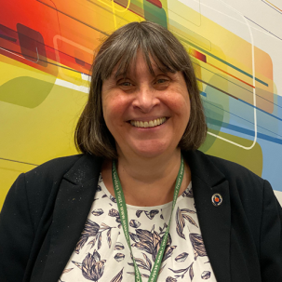  Anne Bunce  Head of  Virtual School | Sherry Landa  Learning Advocate  07590 432679 | Cherie Sears  DHT for SiaSS | Sameena Rizvi  Post 16Learning Advocate  07826 905264

Julia Elmes Rozario  Year 6 and Key Stage 3  07787 697867 | Faiza Waseem  PEP Champion | Ewen Godfrey  Key Stage 4  01753 690811 | Farrah Mughal  Virtual School Business Coordinator
Nathan Richardson  Post 16 EET lead | Reem Ali  ETE direct worker

Introduction

- The changes in funding, staffing and the New Responsibilities for all children with a social worker have created a time of change and opportunity within the Virtual School.
- We are taking the chance to work smarter and support more children. Allowing the support of the Virtual School to have impact for Child in Need and Child Protection cases
- Locally we are calling the new responsibilities, Safer in a Slough School (SiaSS)
- We are looking to work with Slough schools to design the offer, and share best practice. We are very lucky to have such buy-in locally.
- This offer sets out how we can continue to offer a quality service for CLA and PLA whilst developing the service for the new responsibilities.
- The idea it is a viable option to March 2022, when the national decisions will determine whether the new responsibilities continue.
- Designated Teachers will be supported throughout the process
- Designated Safeguarding Leads will be included in Virtual School support
- Training is organized on October 12th 2021 to go through the proposals in detail

Team roles are outlined in Powerpoint slide accompanying this offer.

The Offer for CLA and PLAC - EYFS and Primary age

 | What we will continue to do | What we will try to do | What we can no longer do
School / Setting | - Ensure that you are in a Good or Outstanding school or setting, work with your foster and birth family to make sure it is as local as possible and meets your needs.  - Ensure that you can visit before you start and that you are consulted about changes.  - Ensure that you have an identified key person who you can go to if you need any help or support.
PEPs | - Ensure that you have a PEP within 20 school days of starting at a new provider.  - Ensure that you have a PEP termly when you are in education.  - Attend your PEP if it is the first one after you have started at a new school/setting or your last one before a planned move (for example, in Year 6).  - Attend your PEP if there something important happening. If we cannot attend, we will quality assure them and liaise with your educational setting to be sure you are getting what you need. | Attend more PEPs if needed. | We cannot travel to attend PEPs in person, except in very special circumstances.
Resources | - Provide you with a book or book token monthly which will be posted to you 6x a year  - Fund tuition through the NTP programme for up to 15 hours per academic year (Years 1 to 6)  - Provide laptops in key year groups. | - Provide you with any special books you or your carer asks for.  - Work with your carer and school to ensure you have access to a laptop that meets your needs. | - Provide books between mail outs.  - Fund tuition outside of this programme except in exceptional circumstances.  - Automatically provide a laptop when you are out of school due to lockdown/self-isolation.
CLA Reviews | Attend where there is an urgent need – sending a report if we cannot attend. | Combine this with a PEP meeting | Attend all your meetings.
PPMs | Attend where there is an urgent need, if we are available | Liaise with your social worker if we cannot attend | Attend all your meetings.
EHCPs | - Support your school or setting to apply for statutory assessment if you need one.  - Attend your annual review where there is a change of provider needed.  - Liaise with SBC SEND to ensure you get the best possible service. | - Liaise with other SEND teams where you are living if this is not in Slough  - Attend an EHCP draft planning meeting.  - Attend your annual review where you are staying in the same school/setting if this can be combined with your PEP. | Attend lots of meetings for you, where other professionals can and should take a lead (your social worker or SEND officer).
Adoption | - Attend family finding meetings where your family finder is confident of a likely match.  - Support your prospective adopters to understand your educational needs.  - Provide information for your prospective adopters on Post Adoption support. | Attend other family finding meetings if they can be combined with PEPs. | Attend all your family finding meetings.
PLAC | - Co-host monthly drop-ins (term time only) for Slough adopters with the post adoption team.  - Provide advice and support/signpost parents, carers and guardians as needed.  - Provide advice and support/signpost Slough schools and settings as needed. | - Co-host training for other professionals around education in the adoption process.  - Liaise with your school or setting where there is a need. | Provide any direct work or hands-on support.

The Offer for CLA and PLAC - Secondary age

 | What we will continue to do | What we will try to do | What we can no longer do
School / Setting | - Ensure that you are in a Good or Outstanding school or setting, work with your foster and birth family to make sure it is as local as possible and can meet your needs.  - Ensure when possible you can visit before you start and that you are consulted about changes.  - Ensure that you have an identified key person who you can go to if you need any help or support.
PEPs | - Ensure that you have a PEP within 20 school days of becoming CLA or starting at a new provider.  - We will ENABLE you to: Encourage, Nurture, Aspire, Believe, Learn ,Enjoy  - Ensure that you have a PEP termly.  - Attend your PEP if it is the first one after you have started at a new school/setting or your last one before a planned move.  - Attend your PEP if there is something important happening. If we cannot attend, we will quality assure them and liaise with your educational setting to be sure you are getting what you need.  - We expect your Social Worker to attend your PEP and make an active contribution to your education pathway.  - We will ensure that a record is made of your PEP by the school and your targets are reviewed termly and made available to you.  - We will ensure your voice is heard and your views represented. | Attend more PEPs if needed. | We cannot travel to attend PEPs in person, except in very special circumstances.
Resources | We will ensure that your PPP is distributed appropriately in line with your targets. | Work with your carer and school to ensure you have access to a laptop that meets your needs | - Provide books between mail outs.  - Fund tuition outside of this programme except in exceptional circumstances.  - Automatically provide a laptop when you are out of school due to lockdown/self-isolation.
CLA Reviews | Attend where there is an urgent need, if we are available. | Combine this with a PEP meeting | Attend all your meetings.
PPMs | Attend where there is an urgent need, if we are available. | Liaise with your social worker if we cannot attend. | Attend all your meetings.
EHCPs | - Support your school or setting to apply for statutory assessment if you need one.  - Attend your annual review where there is a change of provider needed.  - Liaise with SBC SEND to ensure you get the best possible service. | - Liaise with other SEND teams where you are living if this is not in Slough.  - Attend an EHCP draft planning meeting.  - Attend your annual review where you are staying in the same school/setting if this can be combined with your PEP. | Attend lots of meetings for you, where other professionals can and should take a lead (your social worker or SEND officer).
PLAC | Provide education help and advice and signpost the team around the child. | Liaise with your school or setting where there is a need. | Provide any direct work or hands-on support.

The Offer for Post-16

 | What we will continue to do | What we will try to do | What we can no longer do
School / Setting | - Ensure that our young people are placed in education provisions that are rated highly,  - Ensuring that young person is on most appropriate course and understand what is required of them, what is progression etc. | If good or outstanding education provisions are not possible due to location and course, ensuring there is effective support for that young person so they sustain and progress.
PEPs | - PEPs to be done within 20 day window when a young person comes into care, these will be informal or formal depending on individual (UASC will not have education attached in that time frame).  - All those in further education (6th form and college) to have a formal PEP in the autumn term. If they are then transitioning from provision and course at end of academic year then additional PEP to occur in the summer term.  - KIT (keeping in touch) with all those in education termly, and for those where there is issues (placement, attendance etc) then additional PEPs to be arranged.  - KIT with those young people in university if there are issues then informal PEPs to occur to get them back on track. | - Aligning of PEPs with other multi professional meetings such as CLA reviews, Annual reviews.  - Those that are in apprenticeships if there is a need then informal PEPs to take place.  - Do majority of PEPs virtual, as cost and time effective. If there is a need then can be done in person. | - 2/3 PEPs a year for those engaging in education.  - No PEPs for those that are NEET, interventions to be recorded on ICS.
Resources | Yrs. 12+ accessing academic courses (up to age 18)  - ESOL/Pre-entry/Entry up to £50 towards books or a Kindle/tablet with English learning app  - ESOL Level 1 level 2 and above – tablets or contribute towards refurnished laptops up to £100  - Level 2 – laptops £200  - Level 3 – laptops up to £300  Yr 14+ up to age 22  - Level 4 and above £400  - HE courses such as Law/Medicine/Sciences up to £500  - HE courses – termly bursary of £666 for duration of course up to age 25yrs (dependent on progression and minimum 80% attendance)  - Cost of fees to join the body which represents the profession/vocation they are studying. Up to value £150.  New UASC not yet in education  - Offer of group tuition and provide laptops to placements so they can be shared with the young people that reside there, for their group tuition (UASC)  - Agreements made with young people and placements around use of laptop and not being funded to get any further tech.  - Fund 1:1 tuition where required whilst in education Level 2+ course and above up to age 18 or if Post 18 if in FE/HE course  - Fund group tuition for learners up to Level 1 courses from Yr 12+ or those on ESOL courses | - Work on agreement with supplier of laptops to see if a deal can be agreed, especially with refurbished laptops predominately used for tuition purposes at placement.  - Level 2 – laptop up to £300 if progression to Level 3 likely  - Those with SEN in specialist provision up to £100 to fund specialist software if requested  - Those in education -up to £100 towards wi-fi/internet access support  - Up to Level 1 & 2 -  - up to £50 for books, course related uniform/course specific equipment/membership  - Level 3 – Up to £100 for books, course related uniform/course specific equipment/membership  - Level 4+ - up to £75pa for books  - Travel for up to 2 weeks max until permanent arrangement is made for those on Level 2+ course or SEN  - Apprentices – up to £50 towards study materials/equipment/other one-off need | - Fund Laptops to those that are not accessing education.  - We will not pay for travel  - We will not pay for stationary and other standard equipment.  - o 1: 1 Tuition 19+ education support unless in Level 3 + course
CLA Reviews | Attending CLA reviews as long as possible and feasible, if not possible then update/report to be shared with IRO. | Continue to make efforts to combine PEPs and CLA reviews, to reduce the number of meetings. | Attend all meetings.
PPMs | Attending PPMs as long as possible and feasible, if not possible then update/report to be shared. | Ensuring allocated social worker is up to date and aware of work conducted. | Attend all meetings.
EHCPs | - Contribution at Annual Reviews  - Support education provision in the application of statutory assessment if needed.  - Liaise with SBC SEND to ensure you get the best possible service.  - Ensuring the VS opinion is shared when discussions around placement changes. | - Liaise with other SEND teams where you are living if this is not in Slough.  - Combining of PEPs and annual reviews/ | Attend all meetings.
NEETs | - Post 16 – 18 NEETs offered direct intervention to obtain education employment and training  - Provide IAG, consultation and signposting to Care Leavers 19+.  - Attendance and lead at Operational EET group and feed into Strategic group.  - Continued attendance at EET networks like DWP and VS post 16.  - Updating and sharing of opportunities with PAs. | Conduct small pieces of direct work for care leavers 19+ (this is where it would be quicker to do this then signpost to additional agency). | Provide in house direct support for all Care Leavers that are NEET.
EYJS | - Continued direct working of those that are referred to ETE worker, including those that are NEET.  - Consults to be undertaken by ETE worker for all young people that are referred into YOT, utilising created pro-forma that then can be uploaded onto Childview and potentially ICS. | Face to face consults with young people where ongoing support isn’t needed. In order to signpost and work out most effective support. | Case loading and direct working of all young people open to EYJS. Pushback to education and practioners.

Please add for Year 14+ Cost of fees to join the body which represents the profession/vocation they are studying. Up to value £150.

Suport for Educational Outcomes for Children with a social worker, known locally as Safer in a Slough School (SiaSS)
This is a fixed term project initially to end of March 2022. National funding may continue after that date. It is required to be strategic approach. Our aim to is to create a collaborative environment and high aspiration so children with a Social Worker will be further afforded the opportunity to access the best possible resources to support their education.

A graduated response overview of a Universal, Targeted and Tailored offer

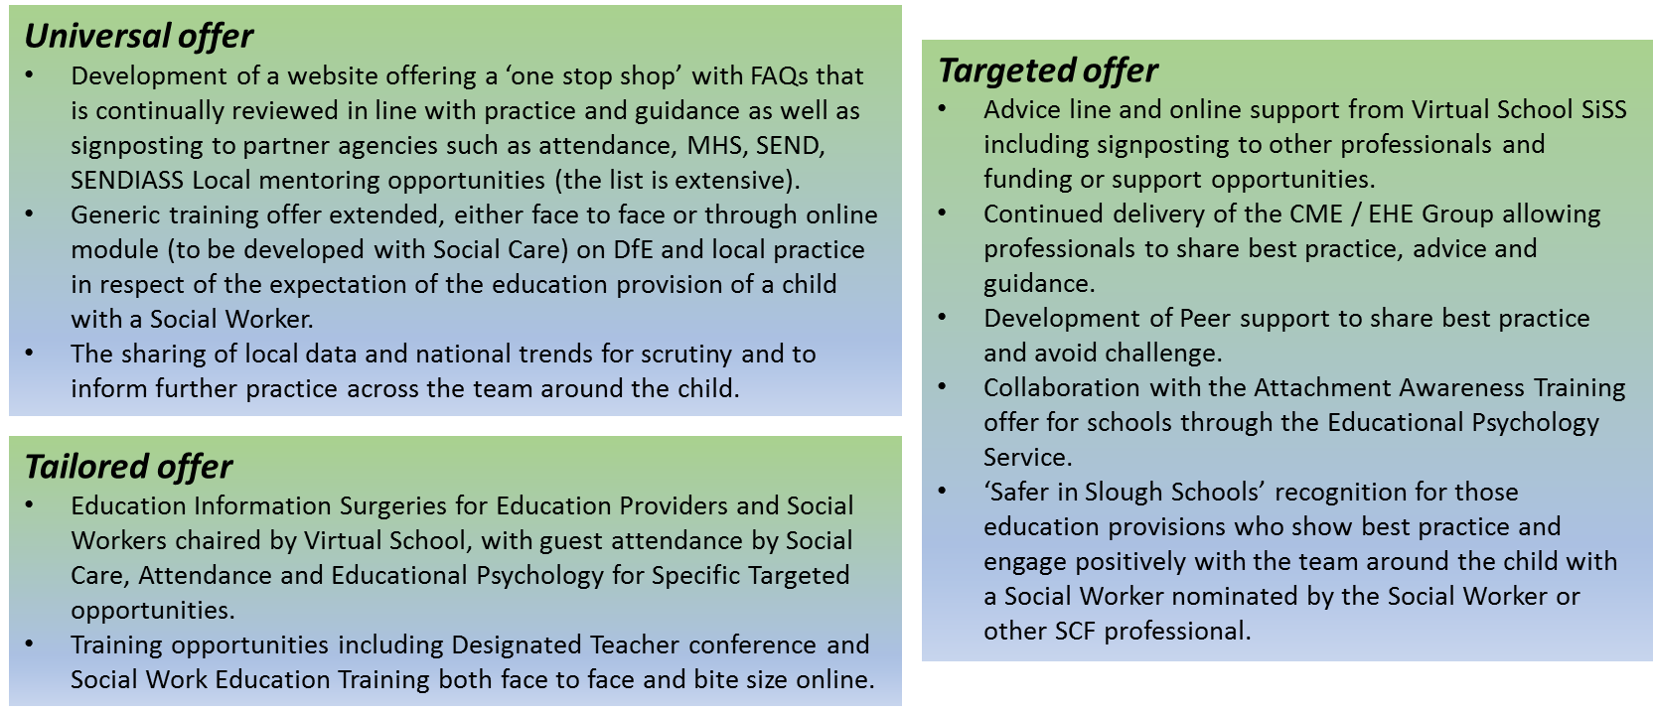

What we could provide:
- Provide support, advice and signposting through a manned telephone advice line, frequently scheduled specialist drop in surgeries and FAQs in an online portal accessible at any time with further signposting to other local offers and professionals.
- Develop a resource bank, with cost effective potential solutions
- Provide advice, support and training to education professionals and other’s involved in their education to ensure they understand the role of the Social Worker and how the team around the young person can work together, being clear about responsibilities, regulation and limitations.
- Supporting guidance for education provisions and Social Workers on working together to support improvements in attendance and punctuality and signposting further intervention where appropriate, including SBC Attendance Team
- Supporting education provisions to work towards Attachment and Trauma awareness through collaboration with our Educational Psychology Team.
- Advising education provisions on how to make the very best use of their Pupil Premium to promote attendance, punctuality, attainment and progress.
- Ensuring education professionals that report to Social Workers are clear about what information is required and how, between them, they can develop SMART Targets to support the individuals. This may include sharing best practice opportunities through our Designated Teacher Network and Peer Support for a school in particular challenge.
- Specific analysis of past cohort outcomes, being curious as to what external factors the individuals faced in order to highlight any themes of obscurities in both success or otherwise.
- Continue to bring together professionals through the CME / EHE Professionals Meetings, allowing further opportunities to share advice, guidance and best practice.

What cannot easily be provided:
- We cannot offer work with individual children or families. This includes direct or funded provision of academic or other interventions
- We cannot respond to requests from parents or carers to offer advice, intervention or support in relation to an individual with a Social Worker
- We are unable to take responsibility for children with Special Educational Needs & Disability (SEND) who do not have a Social Worker and those with one would require a collaborative approach alongside the SEND professionals. Those with an EHCP are subject to the direction of their SEND officer in the first instance.

This work is still at planning stage and we are open to suggestions from stakeholder about what would have most impact on the educational outcomes for the children in scope. Contact is Cherie.sears@sloughchildrenfirst.co.uk

