Spring 2020 – Assessment and moderation newsletter

Welcome back to a new decade in the 21st century.
There are changes afoot – and I don’t mean Brexit!

All potential moderators have taken the standardization exercises to become moderators this year. From what we have summised, we believe that we have twelve moderators for both Key stage 1 and 2.

A big thank you to all academies who have agreed to be moderated by Slough.

Important dates this term

Monday 17 February – pupil registration and access arrangements application forms (early opening, compensatory marks for spelling, additional time and timetable variations) open in the Primary Assessment Gateway
Friday 13 March – deadline for schools to complete pupil registration and to submit applications for early opening and compensatory marks for spelling
Monday 23 March – MTC ‘try it out’ area opens
Monday 27 April – deadline for schools to submit applications for additional time

NCA tools website has been replaced by Primary Assessment Gateway
The Primary Assessment Gateway opened in October. This is the new online portal for activities relating to 2019/20 national curriculum assessments. Please be aware that you should be considering your access arrangements.
In addition, schools can use the Primary Assessment Gateway to:
- place test orders
- submit holiday dates to help inform deliveries of test materials
- register pupils for the KS2 tests
- apply for KS2 access arrangements and special consideration
- download additional phonics and KS1 materials
- submit phonics, KS1 and KS2 headteacher’s declaration forms
- submit KS2 TA data
- view KS2 results and marked test scripts, and apply for reviews
- view TA standardisation materials

Key stage 1 and 2 moderation handbooks
The moderation handbooks have been update to reflect any changes this year. They will be available on ‘The Link’ website after half term

Exemplification materials this year Key stage 1 and 2

K1 and 2 exemplification materials were updated last year so there are no current revisions taking place at the moment. – Take a look at the pre key stage and science exemplification as reporting is required for both.

SATS 2020

There have been changes to SATs this year
Key stage 1 (KS1) and KS2 test packs will include 5 or 10 test papers. Please make sure you have enough packs to cover the number of pupils you have in your school. You may need extra because of new pupils attending the school, the need for extras should you need for readers, scribes and transcription.
KS2 stationery packs and attendance registers will not be with the papers and not in a separate pack.
At key stage 1 you can download extra papers from the Primary Assessment Gateway.
Some of you may be asked to take part in the science test which can be taken up until 19th June.

The STA are well aware that last year Parcelforce sometimes came a bit early to collect papers. You do not have to give the documents to them until the paper is finished and you have every right to tell them to return when you have completed and packed the tests. You do not send papers until timetable variation pupils have taken their tests , as a result you can ask Parcelforce to return the following week when they are completed.

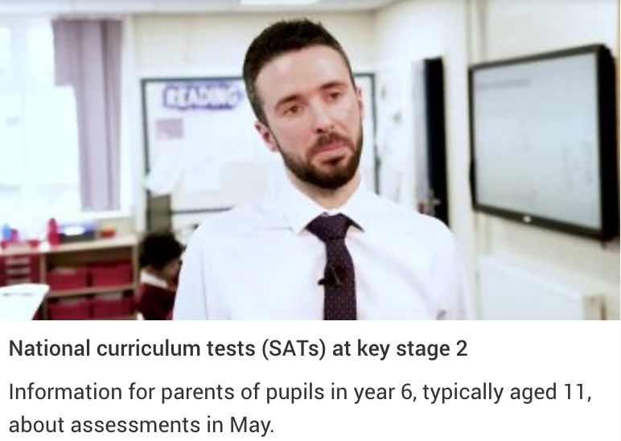

There are videos available to support schools with testing from the STA.
https://www.sta-videos.co.uk/
They include the multiplication tables check as well as the administration tests for KS1 and 2. Over time they will also be available on YouTube.
There will also be a video on how to pack the test papers to be sent to be marked. It is different this year as the attendance sheets go with each paper.

Multiplication tables check (MTC) update
The STA have considered allowing teachers a ‘try it out’ area but unfortunately this is not possible for 2020. Teachers should watch the guidance videos on GOV.UK and can observe their pupils using the ‘try it out’ area if they wish to see how it works. The STA do not encourage teachers to use a pupil’s PIN to access the check.
There have been improvements for 2020 as a result of the usability study and feedback from pupils and teachers on the 2019 MTC pilot:
- restructured home page with clearer section headings (in order of actions) and link to guidance
- pupil status page to display a summary of the school’s administration progress
- ability for schools to add ‘input assistant’ as an access arrangement after the check, as well as before
- broadcast messages with service updates,
Local authorities will not have access to MTC results for their schools until they are published on Analyse School Performance. A statistical publication detailing local authority and national MTC results will be available at www.gov.uk/government/statistics/announcements/multiplication-tables-check-2020.
The MTC will not be part of the LA’s monitoring procedures when both Key stage 1 and 2 tests and checks take place this year.
Cross moderation opportunities
Please book through Eventbrite on ‘TheLink’ website.
https://thelink.slough.gov.uk/overview/thelink-website
After half term, go to the title ‘Events and training’ on the front page. Go to the ‘Events and training’ page and use the filters to identify which events you wish to attend.
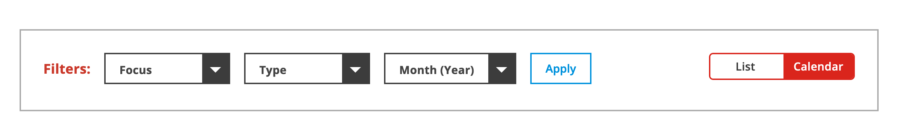
These opportunities are only available for schools that have informed the STA and LA they wish to be moderated by Slough.

Key stage 1

Focus | Date | Time | Venue
Writing | 03/03/2020 | 4 – 5.30 | Cippenham Infant School
Mathematics | 23/03/2020 | 4 – 5.30 | Cippenham Infant School
Reading | 28/04/2020 | 4 – 5.30 | Cippenham Infant School

Key Stage 2

Focus | Date | Time | Venue
The statement, ‘write effectively for a range of purposes and audiences, selecting language that shows good awareness of the reader.’ | 01/04/2020 | 4 – 5.30 | Khalsa Primary School
The statement, ‘write effectively for a range of purposes and audiences, selecting the appropriate form and drawing independently on what they have read as models for their own writing.’ | 23/03/2020 | 4 – 5.30 | Khalsa Primary School

