Return to School Primary PSHE Network Planning Grid
The Slough Primary PSHE Network anticipates that PSHE and health and wellbeing issues will be high on the agenda for preparing and supporting colleagues and children to return to school. In preparation for this, the Primary PSHE Network have identified the likely priority areas and collated the following list of resources that could be used (or adapted) to address the issues with pupils and support their return to school. Resources include classroom activities, preparation activities to do at home, guidance for staff, staff training opportunities and sources of support for children and families. It will be left to individual schools to decide how they use the resources but schools will be encouraged to start preparing pupils at home rather than leaving it until they arrive at school.
Thank you very much to everyone who contributed to this, especially those who have kindly shared their own resources.

Please get in touch if you would like further information or to discuss support for your school.
Susan

Susan Dyer
School Health & Wellbeing Project Officer
07753 316916
susan.dyer@slough.gov.uk

PSHE/Health & Wellbeing topics/issues
How do you feel about coming back to school? What are you looking forward to? Is anything worrying you?

Anxiety, what’s causing me to be anxious, emotional literacy, managing my anxiety, who can help?

Being back at school, how does it feel?

Re-establishing routines and getting used to new ones.

Resources & sources of support for children | Notes, comments, adaptations
CHILDLINE: Worries about Coronavirus  CHILDLINE: Calm Zone  CHILDLINE: Toolbox  YOUNG MINDS: Anxiety  YOUNG MINDS: What to do if you're anxious about Coronavirus  THE CHILDREN'S SOCIETY: Advice for children & young people on anxiety  ON MY MIND (Anna Freud Centre): Self care strategies for children and young people  EVERY MIND MATTERS: Top tips for coping with anxiety  SHEFFIELD CHILDREN'S HOSPTITAL: Self-care kit  CHARLIE WELLER MEMORIAL TRUST: Wellbeing action plan  EAST BERKSHIRE NHS: Covid-19 and your wellbeing #Coping guides for children, young people & families | - For children who require additional support, please consider liaising with your school’s Educational Psychologist, working with ELSA trained colleagues, contacting the Mental Health Support Team or Getting Help Service:  Slough Educational Psychology Team  http://www.slough.gov.uk/schools-and-learning/integrated-support-service.aspx  Mental Health Support Team and Getting Help Service  See page 4 for details of one to one online consultations for staff to discuss concerns about individual pupils  - Consider appointing a secure adult/key worker to each child for daily checking.  - Consider forming you own ‘specialist’ team in school which could include any or all of the following: PSHE Lead, Health & Wellbeing Lead, pastoral staff, ELSA trained staff, Mental Health First Aid trained staff, school counsellor (if you have one), your school’s Educational Psychologist, DSL, SENDCo.
Staff training | Notes, comments, adaptations
SLOUGH BOROUGH COUNCIL EDUCATIONAL PSYCHOLOGY TEAM: FREE webinars - The 3 Rs
RESILILENCE - READINESS - RECOVERY Slough Integrated Support Service has developed a number of webinars to support schools on ways to foster resiliency in children and young people. The first of these will be available from early June.
BERKSHIRE NHS TRUST, FREE WEBINAR: Talk with children under 5 years about Covid-19, 15th June, 15:00 – 16:00

BERKSHIRE NHS TRUST, FREE WEBINAR: Autism Awareness, 2nd June, 09:30-11:00

BERKSHIRE NHS TRUST, FREE WEBINAR: Supporting children and young people with their worries, anxiety, and low mood (PRIMARY), 19th June, 09:30-10:30

BERKSHIRE NHS TRUST, FREE WEBINAR: Autism and mental health, 19th June, 09:30-11:00

EMERGING MINDS FREE WEBINAR: Back to school after lockdown

NSPCC LEARNING: Supporting children with mental health

MIND ED: Free online learning about children and young people's mental health for professionals, parents and carers

SCHOOLS IN MIND (ANNA FREUD CENTRE): Recording of Schools in Mind Facebook Q&A 07.05.20 – Managing unexpected endings and transitions

Guidance for schools and staff | Ideas & resources from schools
SCHOOLS IN MIND (ANNA FREUD CENTRE): Managing unexpected endings and transitions  MENTALLY HEALTHY SCHOOLS (ANNA FREUD CENTRE): A guide to supporting the mental health and wellbeing of pupils during periods of disruption  MENTALLY HEALTHY SCHOOLS (ANNA FREUD CENTRE): Coronavirus anxiety toolkit  BARNARDO'S: Helping children cope with anxiety | - We will use DB primary to continue to communicate with our pupils and send info through our newsletter and website to parents.  - Have a daily theme which everything revolves around. Kindness, gratitude, love, stay alert, etc.
Teaching resources | Ideas & resources from schools
PUBLIC HEALTH ENGLAND: Year 6, Sleep lesson plan pack  PSHE ASSOCIATION: Sleep factor lesson plans  PARTNERSHIP FOR CHILDREN: FREE Wellbeing activity sheets for children  Aimed at KS1 children but easily adaptable for KS2. They can be used at home or at school and include activities on: coping with change, distraction, relaxation, worry, coping with loss, feelings and ways to feel better.  MENTALLY HEALTHY SCHOOLS (ANNA FREUD CENTRE): Emotion check-in  TWINKL: Anxiety and stress activity pack  PSHE ASSOCIATION: Mental health & emotional wellbeing power point and lesson plans  THE YEAR THEY CLOSED MY SCHOOL: Reflection on learning from home activity | - This resource could be adapted for KS1 with sentence starters and visual vocab list. It has been created for home learning, however there are some useful slides which discuss anxiety and managing these feelings:  - Discussion of what anxiety is and children’s experience of anxiety. Children then work in small mixed-ability groups to discuss scenario cards where they give advice to different fictional characters who are experiencing anxiety. Differentiate anxiety scenario cards for different age ranges.  - KS1 and Year 3: Worries Monster Activity sheet. Year 4,5,6 complete similar activity  This could be done after lots of class discussion and talk partner work about coping with worries and also focusing your mind on the good in the situation like the things you have to look forward to. Teachers should carefully read each worry monster activity sheet and use it as a potential screening tool to identify particularly anxious children who might benefit from further intervention.  - Consider the use of a feelings display board with an emoji for anxiety on it as well. This could be used to help identify children who are regularly feeling worried and may require extra support.  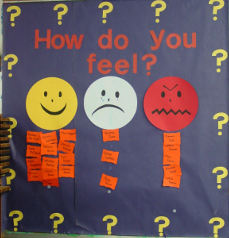  - Use a heart shape filled with different questions/feelings to describe how they are feeing. Discuss worries and possible ideas to dispel them.  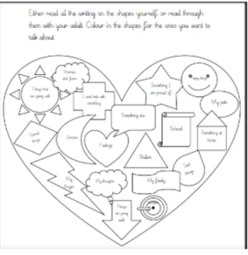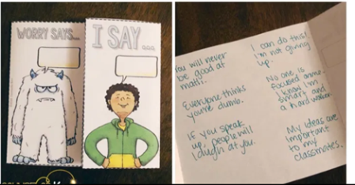  - Class/individual worry book(s)  - DK Wellbeing meditation sheets.  - R time lessons /SEBDOS transition resources.  - Circle Time  - Anonymous pupil surveys; SDQs or resilience surveys etc. for KS2.  - Describe different emotions.  - Make a rainbow of hope using different textures.  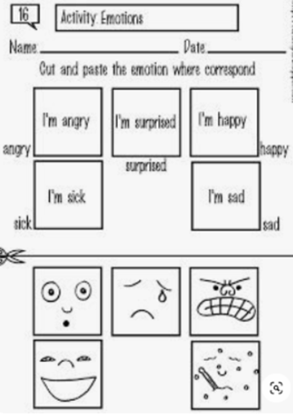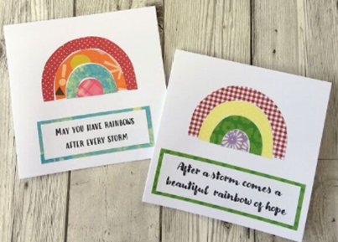  - What feelings can you see through binoculars (perhaps younger children):  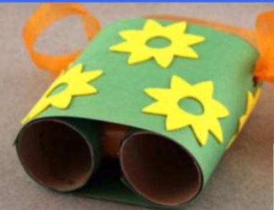  - Catching worries or fears:  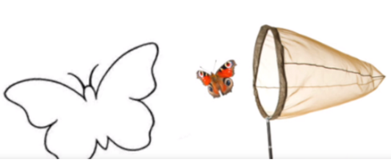  - Wheel of choice for managing emotions or emotions wheel naming feelings:  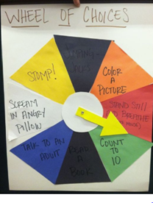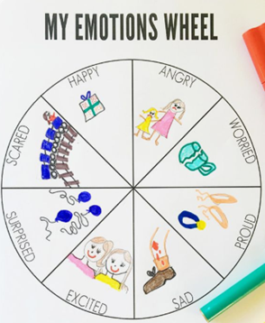  - My Feelings activity:  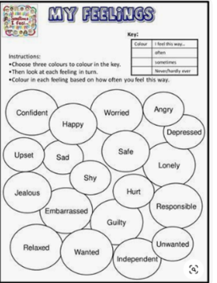

PSHE/Health & Wellbeing topics/issues
Hygiene and social distancing, how can we show we care?

What does it mean for our friendships, play and learning?

Re-establishing routines and getting used to new ones.

Guidance for schools and staff | Notes, comments, adaptations
GOV.UK: Implementing protective measures in education and childcare settings
GOV.UK: Safe working in education, childcare and children’s social care
GOV.UK: Preparing for the wider opening of schools from 1 June
Teaching resources and activities | Ideas & resources from schools
eBUG: Teaching resources about infection and hygiene  Includes posters to remind about hygiene and activities for use at home and at school.  HAND WASHING POSTERS  TWINKL: Personal hygiene ¹  ACTIVE MOVEMENT: Active recovery programme  ALTERNATIVES TO SHAKING HANDS | - There are numerous PPTs on Twinkl (for all ages) which talk about taking care of yourself and preventing the spread of germs – these could be adapted to include more facts about Covid-19 specifically.  - Children discuss and then play Traffic Lights with the added challenge of keeping 2 metres apart. Finally they design a poster to encourage others to follow the hygiene and social distancing guidelines.  - Class discussion with open ended questions: E.g. Why is it so important we follow the hygiene and social distancing guidelines?  - Design a 2M hat!  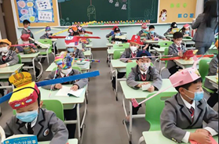  - Make up some simple signs that can be used from a distance, to show good manners and turn taking.  - Class/group come up with their own rules around keeping safe.

PSHE/Health & Wellbeing topic/issue
Friendships, re-making, being friends while social distancing, remembering how to be a good friend.

Behaving around other people, sharing, manners, taking turns.

Time to re-connect.

Teaching resources and activities | Ideas & resources from schools
BBC BITESIZE KS1: Friendships class clips  BBC BITESIZE KS2: Friendship struggles class clips  TWINKL: How to be a good friend cards (free)  PSHE ASSOCIATION: Teaching resources about special people who help us (members only)¹  Packs to teach about ‘special people’ focusing on the positive ways that people care for one another, especially in families and friendships. They encourage pupils to consider the most important aspects of maintaining positive relationships and reflect on how this can be challenging at times of change or uncertainty.  NSPCC: Making sense of relationships lesson plans (KS2)  Downloadable lesson plans including transition to secondary school and changing friendships. | - Create a display of drawings or flags to connect us all – like a puzzle.  - PSHE Jigsaw lessons cover friendships and being a good friend. Can be adapted to include social distancing.  - Children write a letter/email to a friend to tell them about what they have done during time off school, how they missed their friend and what they’ re looking forward to doing with their friend. (Less able children could do this activity pictorially.)  - Remind children of class charter and behaviour rules. Children play a simple game which allows for social distancing like hangman on mini-whiteboards, charades or ‘heads up’. Give children a choice of the game they would like to play. Ask some open-ended questions: How does good behaviour help boost your enjoyment of the game?  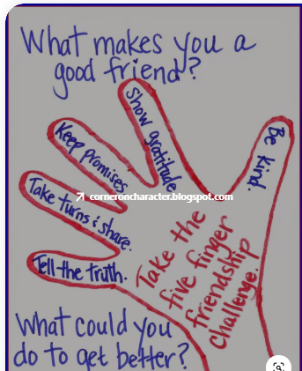  - Social Skills Groups

PSHE/Health & Wellbeing topic/issue
Reflection (themes – loss and gain): What was good? What was bad? Something you learned. Something you’re proud of.

Special people – people who looked after us, family, healthcare workers, frontline & essential workers

Being back at school, how does it feel?

Re-establishing routines and getting used to new ones.

My learning, learning in different ways.

Teaching resources and activities | Ideas & resources from schools
WILDERNESS FOUNDATION: Reflection activities  PARTNERSHIP FOR CHILDREN: Wellbeing activities for children during the Coronavirus outbreak  The packs are intended for home learning but can be adapted for use in the classroom.  CORONAVIRUS TIME-CAPSULE  ART THERAPY: Activities to do at home  CARE CARDS  NOTTINGHAMSHIRE COUNTY COUNCIL Educational psychology service  A story for KS1/KS2 to prompt discussion about feelings, resilience and hope.  GLOUCESTERSHIRE HEALTHY SCHOOLS: My journey and the Covid-19 pandemic  A journal for children to reflect on their emotions and experiences (including loss) and may continue to experience when back at school. There is also a KS1 version available.  TWINKL: Time capsule resource pack (free)  THE YEAR THEY CLOSED MY SCHOOL – Reflection activity  PSHE ASSOCIATION: Special people (members only) | - We intend to use the Choices ‘lite’ programme and adapt some JIGSAW lessons  - We also have PIXL wellbeing resources.  - Reflection should be considered a priority for day one.  - Children could also list their happy memories and the good things they experienced during the closure.  - A book about taking pleasure in everyday moments: AMAZON: All my treasures, a book of joy  - Write a letter/poem/song/diary/message in a bottle/worry jar/coping toolbox.  - PSHE lessons from the Jigsaw Scheme on the following topics: love and loss, managing feelings, mental health, identifying mental health worries and sources to support this, emotional and mental health, managing stress.  - Discussion: Invite children to share personal experience of loss if they feel comfortable to do so. Relate to the Covid-19 pandemic and invite children to share any worries about the future. Also ask children to share anything they learnt during their time of school and explain how we can make positives come out of an unfortunate situation.  - After discussion, children complete the reflection activity sheet.  - Discuss the learning powers and how children have used that home. Which learning powers do you think you used the most? Which learning powers could you have used more of?  - KS2 children write a thank you letter to Wexham Park Hospital on behalf of the community and KS1 make a thank you card. Also give children the option of writing a thank you card to someone who personally helped them.  - Symbols used e.g. rainbow, yellow hearts etc.  - Reflection on worry monster activity sheet. Do they still have the same worries? Are they more, less or the same worried now? What strategies have they got for dealing with the worries?  - Send cards to special people in the community.  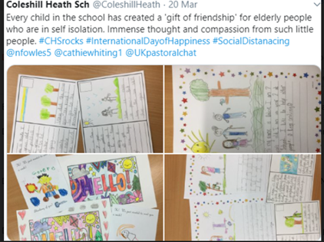  - Use sentence starters: I think it was good because, I am worried about…….because …etc  - If I made a time capsule to remind me of this time I would include…

PSHE/Health & Wellbeing topic/issue
Bereavement, saying goodbye, remembering.

Guidance for staff | Notes, comments, adaptations
IRIS CONNECT BLOG: School return - how do we talk about bereavement

EDUCATION SUPPORT PARTNERSHIP: Video - bereavement & its impact on education staff

THE KEY FOR SCHOOL LEADERS: Supporting pupils through bereavement

THE KEY FOR SCHOOL LEADERS: Supporting staff who are grieving

CHILD BEREAVEMENT UK: Supporting children bereaved during the Coronavirus outbreak

CHILDHOOD BEREAVEMENT NETWORK: Supporting children and young people bereaved during the Coronavirus outbreak

WINSTON'S WISH: Supporting children with SEND
Information about supporting children and young people who have special educational needs and disabilities after the death of a loved one.

WINSTON'S WISH: Alternative goodbyes
Suggestions of ways children can say goodbye to loved ones during the Coronavirus outbreak when attending a funeral isn’t possible.

Resources & sources of support for children | Ideas & resources from schools
DAISY'S DREAM  Daisy’s Dream is a Berkshire support service which responds to the needs of children and families affected by life threatening illness or bereavement of someone close to them. | - Daisy’s Dream talk therapy sessions.  - Children discuss the Dragonfly story (which is a metaphor for death and life after death). Help children to empathise with how the nymph felt when she lost her friend. Have they ever lost anything of value? How did they feel? How did they cope?  - Symbols used e.g. rainbow, yellow hearts etc.  - Books: Badger’s Parting Gifts/The Memory Tree/ Where Are You Now – A child’s Book of Loss (The Invisible String)
Teaching resources & activities | Ideas & resources from schools
CHILD BEREAVEMENT UK: Elephant's tea party  TWINKL: Power point on loss (adapt to your school)  TWINKL: Keepsake memory box bereavement activity | - Books that discuss loss and hope: AMAZON: The heart and the bottle  THE BOOK TRUST: The rabbit listened  - Write a letter to someone they miss/have lost.  - PSHE lessons from the Jigsaw Scheme on the following topics: love and loss, managing feelings, mental health, identifying mental health worries and sources to support this, emotional and mental health, managing stress.

PSHE/Health & Wellbeing topic/issue
Moving to a new school; moving to the next class.

Teaching resources and activities | Ideas & resources from schools
PUBLIC HEALTH ENGLAND (PHE): Transition to secondary school teaching materials  PUBLIC HEALTH ENGLAND: Dealing with change, lesson plan pack  This teaching pack is aimed at KS3 but could be adapted for year 6.  YOUNG MINDS: Activity pack for supporting year 6 transition to secondary school  THE CHOICES PROGRAMME  A version of the resource has been created for year 6 pupils which students will be able to access virtually, regardless of the technology they have available at home. The focus will be transition to Secondary school and to plan and prepare for it in a positive and structured way. It has enough flexibility built into it that, when year 6 pupils return to school, a teacher can take over the delivery at any point. It will effectively ’stand alone’ from Part 1 Kwan’s Story so will be available to all Slough Primary Schools regardless of whether they have engaged in The Choices Programme to date. For more information please contact Jo Broughton jo@engagelime.com  NSPCC: Making sense of relationships lesson plans (KS2)  Downloadable lesson plans including transition to secondary school and changing friendships.  COVID-19 TIME CAPSULE: Graduation class of 2020 pages  TWINKL: Transition activities | - You are awesome book study, Wayne Dixon workshop.  - We intend to use the Choices ‘lite’ programme and adapt some JIGSAW lessons.  - Transition lesson from PSHE Jigsaw.  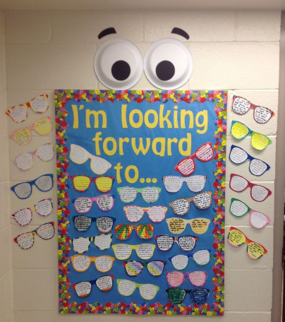

PSHE/Health & Wellbeing topic/issue
Physical activity and fitness.

Healthy eating.

Activities with no contact or sharing equipment.

Resources and activities | Ideas & resources from schools
ACTIVE MOVEMENT: Active recovery programme  SLOUGH SCHOOL SPORTS NETWORK  Also check the Berkshire SGO and Slough School Sports Network Twitter feeds for the latest information and ideas: @BerkshireSGO and @SloughSSN  NHS CHANGE 4 LIFE SCHOOL ZONE: Physical activity and healthy eating resources | - Continue to use Joe Wicks.  - Mindfulness and yoga sessions.  - E.g. Musical statues, runner bean game, Traffic Lights, Simon Says etc.  - Children could also work in groups to see if they could create their own exercise game which accommodates social distancing guidelines.

PSHE/Health & Wellbeing topic or issue
Resources from other areas

Resources and activities | Notes, comments, adaptations
MEDWAY COUNCIL: Return to school wellbeing support

QUARRY BANK PRIMARY SCHOOL: Returning to School Protocol and Procedures

