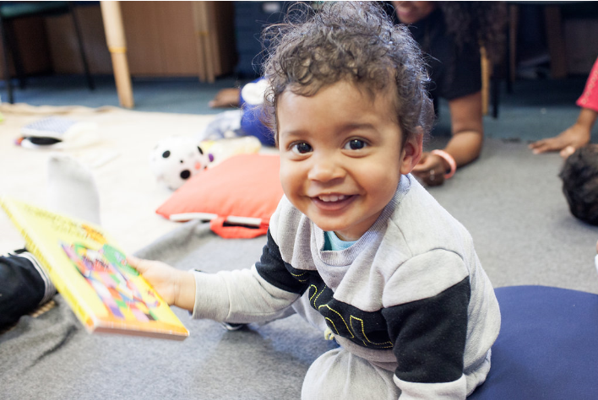
  Early Years and Prevention Service
    - COVID-19
    - 2nd June 2020
Recovery Planning for EArly Years and childcare providers |  | In This Issue: 2nd June 2020

One of the protective measures we can take to reduce transmission is to have smaller group and class sizes. We know that, unlike older children and adults, early years and primary age children cannot be expected to remain 2m apart from each other and staff.

You should therefore work through the hierarchy of measures set out in the protective measures guidance:
• ensure parents are advised to keep children with any symptoms at home
• ensure staff who are symptomatic do not attend work
• frequent hand cleaning and good respiratory hygiene practices
• regular cleaning of settings
• minimising contact and mixing

For pre-school children in early years settings, the staff to child ratios within Early Years Foundation Stage continue to apply, and we recommend using these to group children. More detail is provided in the protective measures guidance.

Keeping group sizes to a maximum of 8 children, while adhering to EYFS ratios, is preferable so groups are as small as possible. Providers are expected to ensure that there are no more than 16 children in a group in early years settings.

Depending on the size and the layout of individual settings, consider how floor space, rooms and outdoor space can be organised to ensure physical distancing between staff and between groups of children, considering the early years foundation stage (EYFS) age-based space requirements. Providers must meet the following indoor space requirements:
• children under 2 years need 3.5 metres squared per child
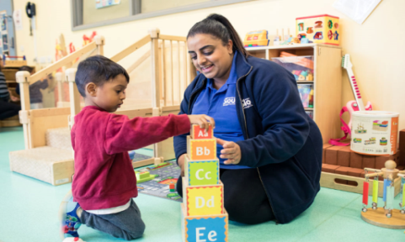
• 2 year olds need 2.5 metres squared per child
• children aged 3 to 5 years need 2.3 metres squared per child

Area dividers may help to keep children in different parts of the room, and floor markings could be helpful in assisting staff with keeping groups apart. The use of communal spaces in settings should be managed to limit the amount of mixing between groups as much as possible.

Smaller settings, including childminding settings, may have fewer children than larger settings, so the necessary adjustments may be different. It may be difficult for childminding settings, where family members are also present, to limit their use of shared spaces, however settings could consider whether a specific room could be designated for childcare during the day.

Recovery Planning

Class sizes and staff availability
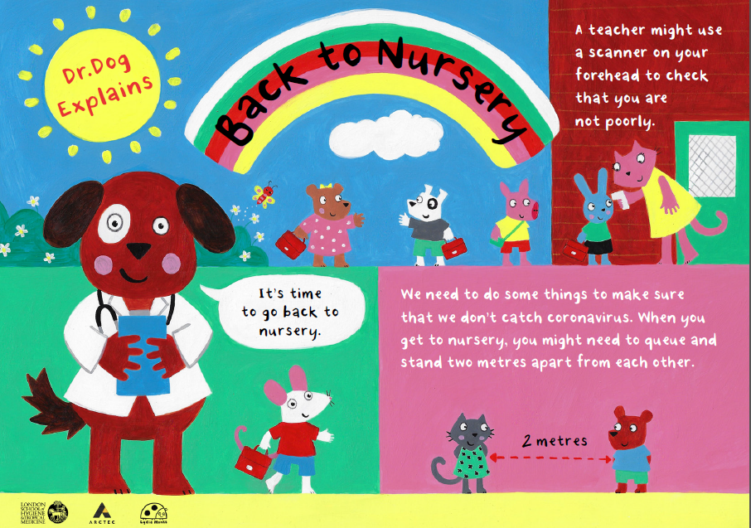
Resources
Resources to help children to learn about coronavirus and how to keep themselves and others safe

Supporting Children: SEND
What can early years and childcare providers do to support parental confidence to access early education following COVID-19 ?
Planning guide for early years and childcare settings
https://www.gov.uk/government/publications/preparing-for-the-wider-opening-of-early-years-and-childcare-settings-from-1-june/planning-guide-for-early-years-and-childcare-settings
As settings prepare for wider opening, there is guidance which provides information on provision for children and young people with Education, Health and Care (EHC) Plans and others with complex needs, such as children and young people with special educational needs and disability (SEND) who do not have an EHC Plan, but for whom the educational setting or local authority has exercised its discretion to do a risk assessment and offer a place at an educational setting.

Supporting Children: SEND

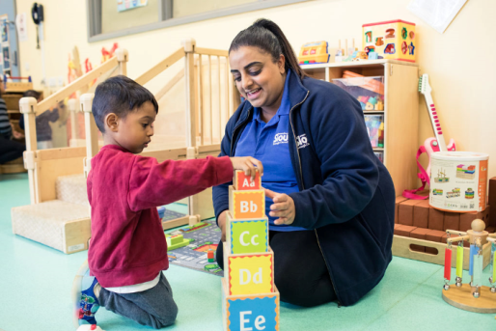
From 1 June, educational settings and local authorities should continue to offer places to all children and young people with EHC plans whose risk assessment determined that was the right course of action. Settings and local authorities should keep risk assessments up-to-date to reflect any changes in circumstances, including changes to coronavirus alert levels and the wider opening of education and care settings to more children and young people. Risk assessments should inform the way a school or college supports children and young people with EHC plans as they return. Local authorities and educational settings should make their own judgements as to whether risk assessments continue to be useful for each child or young person after they have returned to their setting.
Risk assessments may prove useful when planning how best to support the return of individual children and young people with EHC plans. Local authorities and educational settings should make their own judgements as to whether risk assessments continue to be useful for each child or young person after they have returned. For example, it may be useful to maintain these in cases where the return is initially only part-time.
Readjustment to the routines in a setting may prove more challenging for some children with SEND, particularly those who have been attending a different setting if their usual setting has been closed. Plan how to ensure your setting will have the staffing needed to support children with SEND at safe ratios, that there is a member of staff designated as a SENCO or interim SENCO and how this can best be accommodated in the planning of groups of children in your setting. Consider how you will involve parents and carers in planning and agreeing any changes to support, including reviewing EHC plans.
Preparing for children to return - SEND considerations:
- Agree what returning support is available for vulnerable and/or disadvantaged children and put in place provision for the return of pupils with special educational needs and disabilities (SEND) in conjunction with families and other agencies and engage with partners who will help to provide that support, for example, local authorities
- Some children with sensory needs will find being around people difficult, frightening and overwhelming. For some children this will be exacerbated by a fear of people in general. Having experienced weeks, or even months, of social distancing, children will have received an implicit message that other people are dangerous. This is a careful message to balance for children around danger versus retaining social distancing.
- Plan how to ensure your setting will have the staffing needed to support children with SEND at safe ratios, that there is a member of staff designated as a SENCO or interim SENCO and how this can best be accommodated in the planning of groups of children in your setting.
- Consider how to encourage attendance of vulnerable children and the best way to support them to transition into the setting according to their needs and their individual family circumstances.

Education, Health & Care Plans
Changes to the law on education, health and care needs assessments and plans due to coronavirus
Guidance on temporary changes to special educational needs and disability legislation during the coronavirus (COVID-19) outbreak. https://www.gov.uk/government/publications/changes-to-the-law-on-education-health-and-care-needs-assessments-and-plans-due-to-coronavirus

Education, Health & Care Plans
Supporting vulnerable children and young people during the coronavirus (COVID-19) outbreak
Guidance for education settings and local authorities about children supported through social care, with EHC plans or identified as vulnerable by their school, college, early years provider or local authority. https://www.gov.uk/government/publications/coronavirus-covid-19-guidance-on-vulnerable-children-and-young-people

Help children with SEND
Help children with SEND continue their education during coronavirus (COVID-19)
Advice for parents and carers looking after children with special educational needs and disabilities (SEND). https://www.gov.uk/guidance/help-children-with-send-continue-their-education-during-coronavirus-covid-19

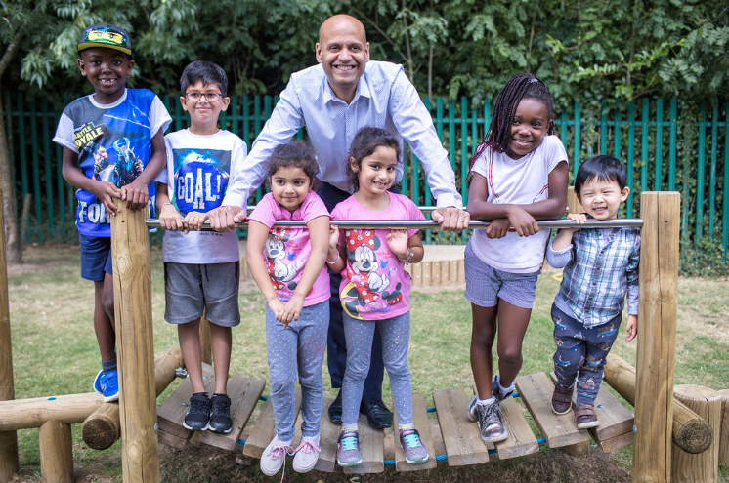

H

Answering your questions

Ask Michael
Service Lead Early Years and Prevention
If a parent cannot get their full entitlement at nursery/school can the funding be transferred to a childminder and what is the procedure to do this, i.e do the parents need to give the nursery an end date etc.,?

Many settings and schools are considering how best they can support children back into the provision in the safest ways possible. For some this will mean capping their numbers to reduce the potential spread of Coronavirus. This may mean that some children will not be able to access their funding entitlements but settings are being advised to prioritise 3 & 4 year old children.

If a parent chooses to end their funded entitlement placement with their child’s ‘usual’ setting they must give appropriate notice to the provider. The child will then be able to start recieveing their funded early education entitlement at a new setting. Parents will need to consider contnuity of care for their child, in these circumstances.

Parents should discuss their situation with their child’s funded early education provider before deciding to start at a new setting.

Slough Early Years and Prevention Service will consider each new application on a case by case basis and all providers must seek approval where a child is changing providers under these circumstances. The new provider must not agree any contractual arrangements with parents relating to funded early education without prior approval from the Service. Please email eyfunding@slough.gov.uk if you have a specific question relating to this.

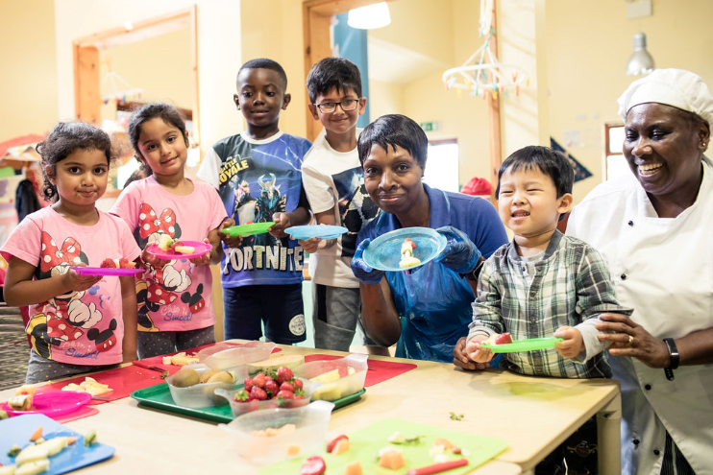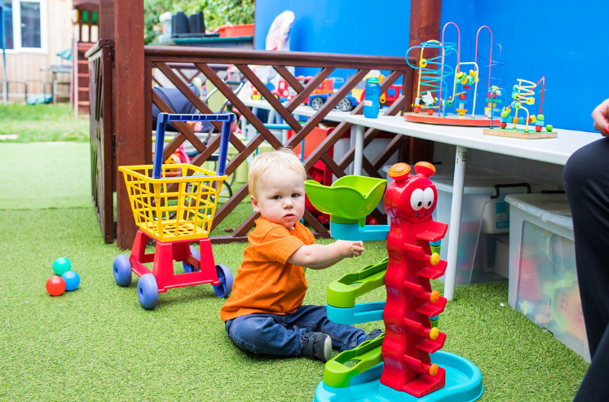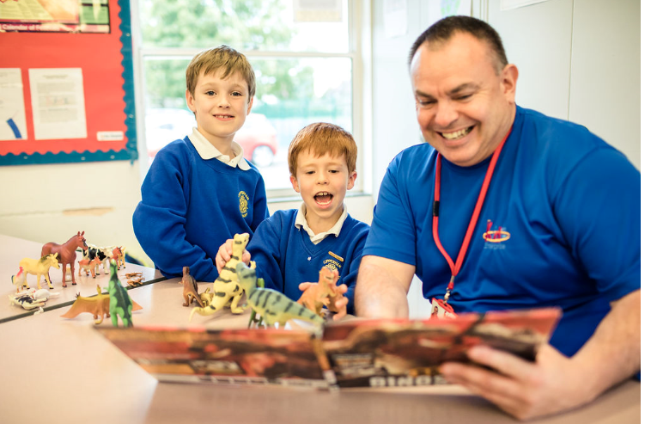

Ansering your questions

Resources to help children to learn about coronavirus and how to keep themselves and others safe

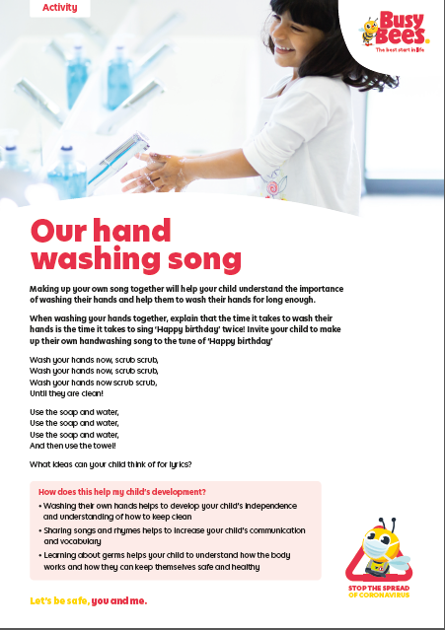
The priorities at this time are helping young children to adapt to their new routines and supporting children to settle back into the setting, especially where there have been staffing changes. Continuing to support their early language and communication skills is essential. Children who have had limited opportunities for exercise should be encouraged to exert themselves physically.
Settings should use reasonable endeavours to deliver the EYFS learning and development requirements as far as possible in the current circumstances, as set out in guidance on the temporary changes to the EYFS requirements in light of coronavirus. This means continuing to provide an environment that invites learning across all 7 areas as far as is practicable during this time. Consider how stories, singing and games can be used to help children to socialise and resettle into familiar everyday routines.
Plan how children can learn in age-appropriate ways about how they can keep themselves safe, including regular handwashing and using tissues. Consider how to encourage children to learn and practise these habits through games, songs and repetition.

Resources to help children to learn about coronavirus and how to keep themselves and others safe
- Professional association for children and early years (PACEY): supporting children in your setting
- Dr Dog explains coronavirus
- Busy Bees:
  - 2 metres apart activity (PDF, 2MB)
  - Our hand washing song (PDF, 958KB)
- Bright Horizons: Talking to Children about COVID-19 (novel coronavirus)



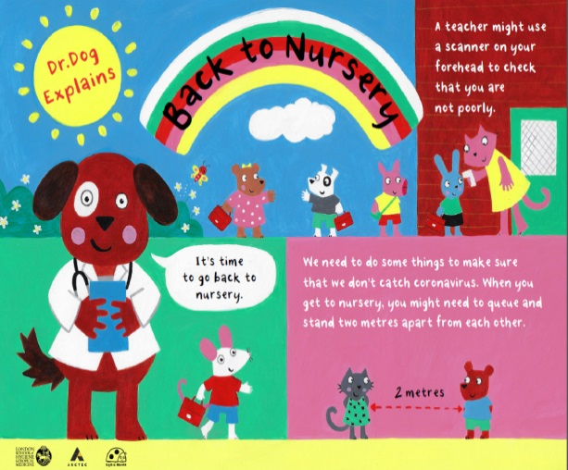

Sector Updates
Data collection
From Monday 1st June all providers that are open will be required to submit the following table with completed figures by 12pm on Monday’s and Thursday’s to earlyyears@slough.gov.uk. Please note we will NOT be requiring settings to submit Early Years registers every Friday from week beginning 1st June.

Attendance Totals – Children aged 0 – 4 years old only
1) Total number of children who are attending your educational setting today 0 -4 years old
2) Number of children with critical worker parents
3) Children in need (CIN)
4) Number of children with an Education , Health and Care Plan (EHC Plan)
5) Number of children who are both CIN and have an EHC Plan
6) Number of children assessed as vulnerable by providers or local authorities but not CIN and without an EHC Plan
7) How many 2 year old children attending your setting today are in receipt of their funding entitlement
8) How many 3 & 4 year old children attending your setting today are in receipt of their universal funding entitlement
9) How many 3 & 4 year old children attending your setting today are in receipt of their extended funding entitlement

Attendance Totals – Children aged 5 years and over only
1) Total number of children who are attending your educational setting today 5 years and over
2) Number of children with critical worker parents
3) Children in need (CIN)
4) Number of children with an Education , Health and Care Plan (EHC Plan)
5) Number of children who are both CIN and have an EHC Plan
6) Number of children assessed as vulnerable by providers or local authorities but not CIN and without an EHC Plan

Early years foundation stage statutory framework (EYFS)
The standards that school and childcare providers must meet for the learning, development and care of children from birth to 5. Updated to reflect wider opening of early years settings from 1 June 2020 and to provide a clarification on progress checks for children aged 2 https://www.gov.uk/government/publications/early-years-foundation-stage-framework--2?utm_source=b2eb43b4-5976-4210-836e-a5dd6e5dc6a8&utm_medium=email&utm_campaign=govuk-notifications&utm_content=immediate#history

Use of outdoor public spaces
Can early years providers take groups of children to outdoor public place, for example if there is not private outdoor space in the setting?
Settings should maximise use of outdoor space, while keeping small groups of children and staff away form others groups. Childminders and early years providers may take small groups of children to outdoor public spaces, for example parks, provided that a risk assesment demonstrates that they can stay 2m away from other people at all times. This should be restricted to small groups and should be done in line with wider government guidelines on the number of people who can meet in outdoor public places. Providers should not take larger groups of children to public outdoor spaces at one time.

Updated PPE guidance
Please note that guidance around PPE will shortly be updated with the following information:
Education and childcare settings and providers should use their local supply chains to obtain PPE.
If education or childcare settings cannot obtain the PPE they need they should approach their local authority (LA). Local authorities should support them to access local PPE markets and available stock locally, including through coordinating the redistribution of available supplies between settings according to priority needs.
If the local authority is not able to meet the PPE needs of education and childcare providers, the LA should approach their nearest local resilience forum (LRF) which will allocate stock if it is available once the needs of other vital services locally have been met. If neither the LA or LRF is able to respond to an education or childcare setting’s unmet urgent need for PPE, the setting will need to make their own judgement in line with their risk assessment as to whether it is safe to continue to operate.
Community centres and places of worship
For those of you who are still having problems with community venues and places of worship opening for childcare, please find attached updated regulations (the explanatory note on page 6 is clear that these venues can now be used).

Caring for your water dispenser upon schools re-opening
Date: 01.06.20 |  |  | Department: | School Effectiveness
 |  | Contact Name: |  | Health and Safety Team
Dear All,
Caring for your water dispenser upon schools re-opening
As schools are now preparing for opening we felt it was advisable to send this letter with guidance to ensure your water dispensers are ready for school re-opening. The guidance has been compiled from manufacturer’s recommendations (Eden Springs), but it is also relevant no matter what supplier you use so please do follow the instructions.
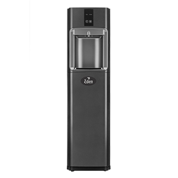
Mains-fed Dispensers, Tap Dispensers
- If your mains water has been unused during shutdown it is a good idea to freshen up the buildings mains if possible before flushing the water dispenser. Find the nearest mains tap to the dispenser and run off at least 10L of water
- Switch your appliance on at the wall and on at the machine
- Press both taps/buttons on the dispenser to run 5L of water into a large container.
- If you have been unable to flush the building mains first, release the taps/buttons briefly then repeat for another 5L (so that you have dispensed 10L in total).
- Empty and wash the drip tray in warm, soapy water. Clean the outside of the dispenser with a damp cloth and kitchen surface cleaner, avoiding the taps
- Disinfect the taps, dispensing area, and any finger-contact surfaces (tap handles, touch panel) with food-safe sanitiser spray and single-use paper towel, or disinfectant wipes
- Taste a cup of water from both taps. If you are not happy with the taste, try flushing another 5L of water through the taps.
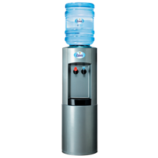
Bottle Water Dispenser
- Switch your appliance on at the wall and on at the machine
- Remove the bottle and drain the cooler through the taps into a large container
- Check the Best Before End date on the cap of your replacement bottle of water. Do not use any that are out-of-date or look yellow/ green/ cloudy.
(Unopened bottles inside their BBE will be safe to use)
- Fit a new bottle (remember to remove the protective cap sticker first!) and press both taps/buttons to dispense at least 2L water into a large container
- Empty and wash the drip tray in warm, soapy water. Clean the outside of the dispenser with a damp cloth and kitchen surface cleaner, avoiding the taps
- Disinfect the taps, dispensing area, and any area touched by fingers when dispensing water with food-safe sanitiser spray and single-use paper towel, or disinfectant wipes. Taste a cup of water from both taps. If you are not happy with the taste, remove the bottle of water, drain the cooler, and try a fresh bottle.
Water Fountains
- Please ensure these are not in use as the surfaces around the fountain including the spout, button/leaver and nozzles could pose a risk for the transmission of COVID-19.
- These still need to be maintained with weekly flushes, etc. Please refer to your maintenance plan.
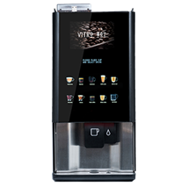
Hot Water Dispensers, Coffee Machines, Mains-Fed Boilers
- Where applicable remove any unused product from the machine.
- Switch the dispenser back on and allow it to reach temperature. Once up to temperature, drain the tank and allow it to re-fill.
- Empty and wash the drip tray in warm, soapy water. Clean the outside of the dispenser with a damp cloth and kitchen surface cleaner, avoiding the tap
- Disinfect the tap, dispensing area, and any finger-contact surfaces (tap handles, touch panel) with food-safe sanitiser spray and single-use paper towel, or disinfectant wipes
- Taste a cup of water from the dispenser. If you are not happy with the taste, try flushing, draining and re-filling the tank again. Contact us if there are still problems with taste, or if water is not flowing freely from the taps
Bean-to-Cup Coffee Machines:
- If the machine was not emptied and cleaned before shutdown:
- Use a vacuum cleaner to remove beans and other product from the machine (old beans will cause the grinder to jam)
- Clean the bean hopper/product containers/mixing bowls as advised by the manufacturer, with a cloth damped with sanitiser OR wash in a dishwasher. Dry with a single-use paper towel (liquid must not get into the grinder, and damp powder will cause blocking)
- Switch on the machine and run a complete cleaning cycle at least two times to make sure the system is filled again with fresh water.
- Clean the outside of the machine with a damp cloth and kitchen surface cleaner. Empty, wash and dry the drip tray and grounds container
- Use sanitiser wipes, or sanitiser spray and paper towel, to clean touch panels
- Disinfect touch panels, dispensing area, and any finger-contact surfaces with food-safe sanitiser spray and single-use paper towel, or disinfectant wipes
- Refill machine with fresh products (check that the correct powders are filled into the labelled containers)
- Use ‘hot water only’ button to run off 10 cups and make sure that the system is flushed through
- Run off 1 of each drink to check that containers have been correctly filled and check the taste. Contact your supplier if there are still any problems

In addition to this can you also ensure that for coffee machines the servicing, maintenance and inspection is undertaken as per the manufacturers instructions. This should be done for all machines even if they don’t fall under the Pressure Systems Safety Regulations 2000 (PSSR). The ones that do fall under PSSR should have a written scheme of examination in place and it should be listed as part of the schools insurance schedule.
For further information please contact your supplier who should be able to get an engineer to guide you through the steps. Alternatively, you can use the following links to download Eden Springs user guides.
Bringing Water Dispensers Back Into Use After Shutdown
Bringing Hot Drinks Dispensers Back Into Use After Shutdown
If you require any further assistance, please do not hesitate to contact the Corporate Health and Safety Department on 01753 875 046 or alternatively send an email to HealthandSafety@slough.gov.uk. Stay alert and stay safe.

Yours faithfully,

Health and Safety Team:
H&S inbox: _healthandsafety@slough.gov.uk
Tel: 01753 875742 / 01753 875046
Bhavini Ranu: Bhavini.Ranu@slough.gov.uk
Vicki Swift: Victoria.swift@slough.gov.uk
Gina Watson: Georgina.Watson@slough.gov.uk
Shameem Din: Shameem.din@slough.gov.uk

Handwashing and respiratory hygiene posters

The e-Bug project is led by Public Health England and has a dedicated webpage for learning resources on hand washing and respiratory hygiene. E-Bug has published posters on hand hygiene, and covering coughs and sneezes, to display in bathrooms, classrooms and shared spaces.
The hand and respiratory hygiene posters and other educational resources can be found here:
https://e-bug.eu/eng_home.aspx?cc=eng&ss=1&t=Information%20about%20the%20Coronavirus

What parents and carers need to know about schools and other education settings during the coronavirus outbreak

Information for parents and carers about the wider opening of nurseries, schools and colleges, transport, attendance, free school meals and remote education. Updated guidance about the wider opening of education and childcare settings, including details about opening secondary schools to years 10 and 12 from 15 June and links to guidance on safer travel. https://www.gov.uk/government/publications/closure-of-educational-settings-information-for-parents-and-carers?utm_source=7be2ad88-13fc-4aad-b39d-36545b596d17&utm_medium=email&utm_campaign=govuk-notifications&utm_content=immediate#history

ding Confidence
SLOUGH EARLY YEARS AND PREVENTION SERVICE: TELEPHONE: 01753 476554 / EMAIL: earlyyears@slough.gov.uk

