Early Years and Prevention Service
  - COVID-19

Recovery Planning for EArly Years and childcare providers |  | In This Issue: 4th June 2020

Recovery Planning

Preparing for children to return
Safeguarding: Agree what safeguarding provision is needed to support returning children (e.g. where new issues have arisen, or existing ones escalated) and consider any necessary changes and referrals as more children return, including those with problems accessing online offers.

• It is essential that parents are clear with the staff if there has been any deaths of people known to them and why they have decided not returned to the setting for some other reason, eg job changes, parents deciding to continue with home education
• Consider how the setting will seek to find out if there are any changes in family circumstances, e.g. illness, bereavement, furloughing/job loss, separation.
• Settings will need to be aware that children may have experienced abuse during the lock down. Additional staff awareness training would be a good idea – this needs to be whole staff awareness as well as specific groups needing more detailed awareness.

Behaviour: Update behaviour policies to reflect the new rules and routines necessary to reduce risk in your setting and agree how to communicate this to staff, children and parents.

• Separation anxieties – most children will have become used to being with their parents and immediate family for an extended period. Even for those who are excited to enjoy more freedom and see their friends, this is a potential source of anxiety.
• Some children will be so pleased to see their friends that they will want to hug them or show other forms of physical contact. Although difficult, children will need to be reminded that social distancing is required/expected. Children may need to be taught how to social distance.
• Consider a gradual re-integration for some children who will find the transition more challenging. A slower start for some may build resilience in the long-term.
• There may have been changes in friendships/relationships – try to take this into account when arranging teaching groups, especially for vulnerable children.
• Prior to settings opening there should be a mechanism for parents to express concerns about how their child is learning at home. Early intervention may head off an issue when setting re-opens.
• Consider how you can involve staff in developing policies for your setting and ensure that they are personalised where necessary, for example for staff who have responsibility for providing 1:1 support for children or for children with additional needs.

Preparing for children
Prior to settings opening there should be a mechanism for parents to express concerns about how their child is learning at home. Early intervention may head off an issue when setting re-opens.
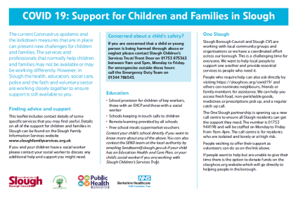

The current Coronavirus epidemic and the lockdown measures that are in place can present

Preparing for children to return continued…

• Settings should consider how to continue to support the learning of children who do not attend settings, including how these children can maintain contact with their key person and peers through the early years setting, and how parents and carers can be supported to provide a positive learning environment at home. The Department for Education’s Hungry Little Minds campaign features tips and practical activities that parents and carers can do at home with children to support their early learning. The campaign website has been updated to include a wealth of online educational resources available for parents and carers to support their child’s development at home. Settings can also direct parents and carers to the BBC’s Tiny Happy People campaign and the National Literacy Trust’s Family Zone for more ideas and content. The Department for Education has published further guidance on how to help children aged 2 to 4 to learn at home during the coronavirus outbreak.

Discuss concerns children might have with the child’s parents. Consider ways to support children’s transitions back into the setting.

Planning a personal, social and health education (PSHE) focused curriculum for the initial period back is advisable. This could focus on supporting with anxiety, loss of family, friends, fear of going out/being in large groups.

Support parents and plan for children (where appropriate) to have the opportunities to talk about fears and concerns – they may initially be excited about returning to the setting but there will be internal worries.

Education: Consider the transitional arrangements from home learning back into the setting. Enable opportunities for parents to feedback to the setting about achievements and concerns.

• Prior to settings opening there should be a mechanism for parents to express concerns about how their child is learning at home. Early intervention may head off an issue when setting re-opens.
• Consider how you can involve staff in developing policies for your setting and ensure that they are personalised where necessary, for example for staff who have responsibility for providing 1:1 support for children or for children with additional needs.
• Settings should consider how to continue to support the learning of children who do not attend settings, including how these children can maintain contact with their key person and peers through the early years setting, and how parents and carers can be supported to provide a positive learning environment at home. The Department for Education’s Hungry Little Minds campaign features tips and practical activities that parents and carers can do at home with children to support their early learning. The campaign website has been updated to include a wealth of online educational resources available for parents and carers to support their child’s development at home. Settings can also direct parents and carers to the BBC’s Tiny Happy People campaign and the National Literacy Trust’s Family Zone for more ideas and content. The Department for Education has published further guidance on how to help children aged 2 to 4 to learn at home during the coronavirus outbreak.

Learn at home
Help children aged 2 to 4 to learn at home during coronavirus (COVID-19)
https://www.gov.uk/guidance/help-children-aged-2-to-4-to-learn-at-home-during-coronavirus-covid-19

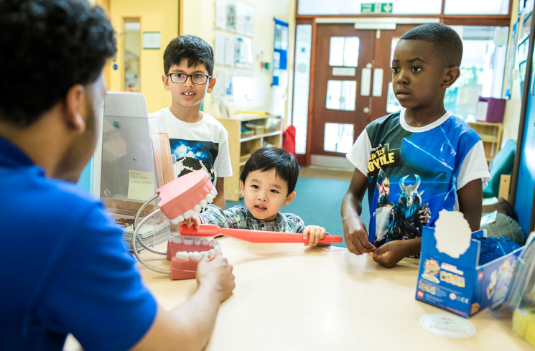
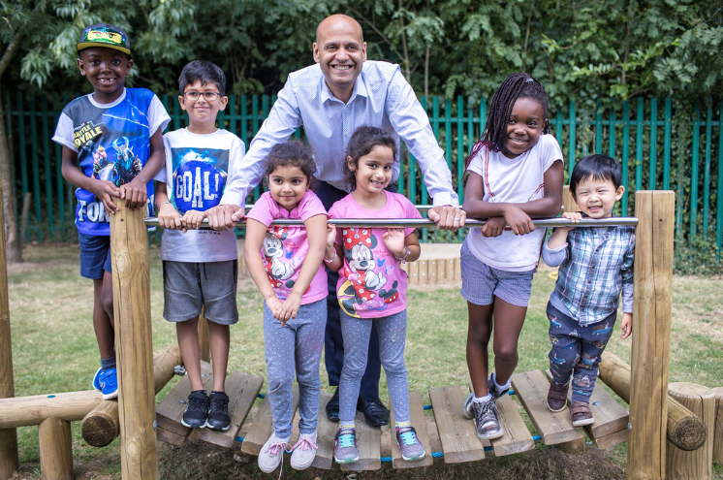
H

Answering your questions

Ask Michael
Service Lead Early Years and Prevention
I am concerned about settling SEND children back into my setting after lockdown, and transitioning some new ones. Where can I get advice and support with this?

We have a very experienced team supporting SEND at Slough Borough Council. Whilst we cannot visit your setting at the present time (because of Covid 19 guidance), we are very happy to take phone/video calls.

Cathie Woodbridge and Sarah Covell, the Area SENCo team, can offer advice, strategies, and ideas for helping children settle back after what has been a very unsettling time for them.

Sanji Bains and Debbie Segarra, our Specialist Support Teachers, may have worked individually with these children and may know them well – they, too, would be very happy to help.

Please do not hesitate to get in contact with a member of the team, we are here to help. Please contact earlyyears@slough.gov.uk
.

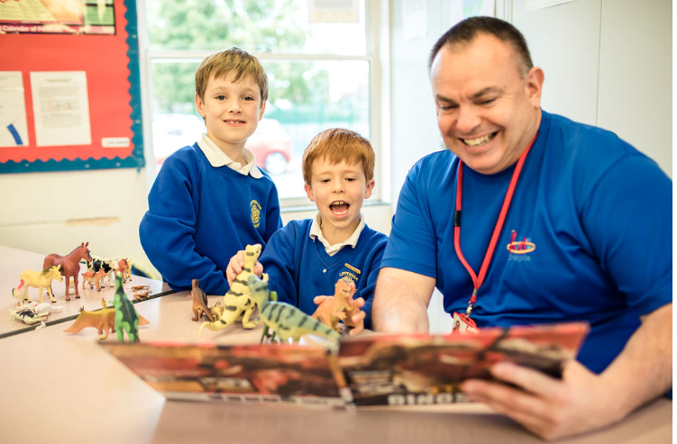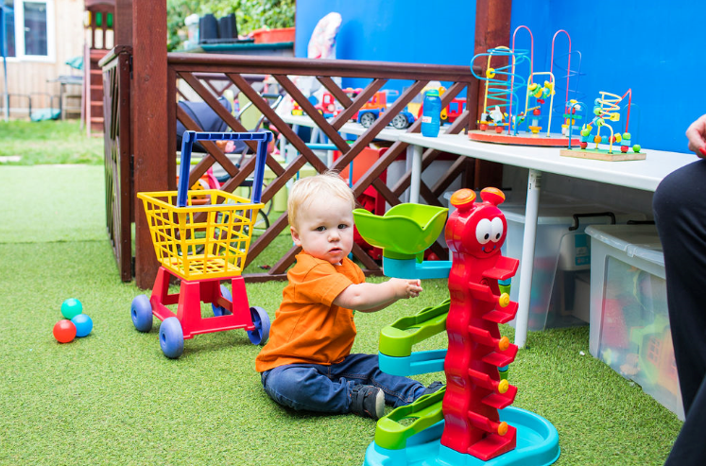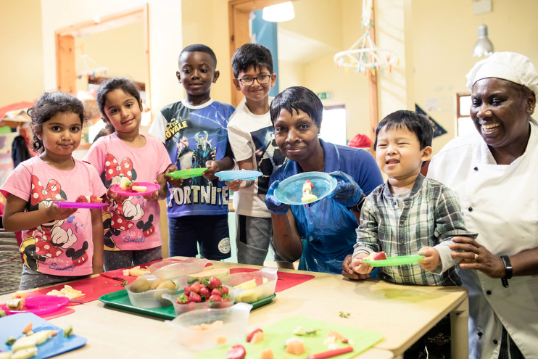

If you would like to submit a question to ask Michael or any of the Early Years and Prevention Service team please email earlyyears@slough.gov.uk

nsering your questions

COVID 19: Support for Children and Families in Slough

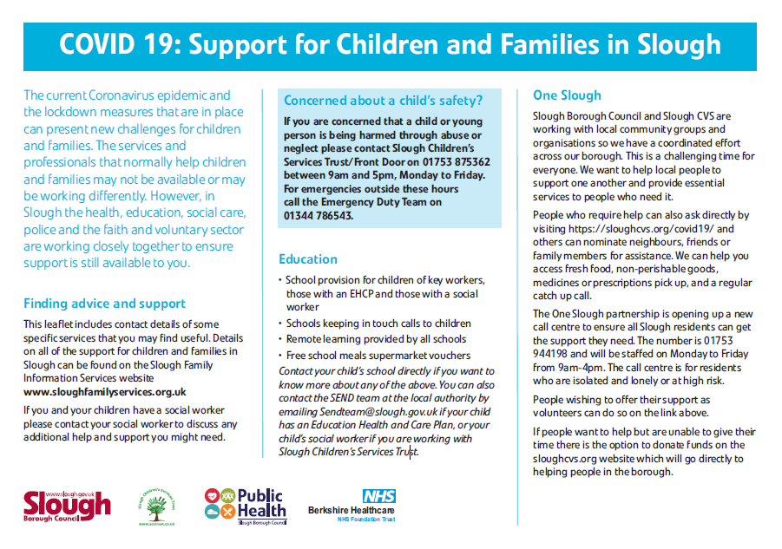
The current Coronavirus epidemic and the lockdown measures that are in place can present new challenges for children and families. The services and professionals that normally help children and families may not be available or may be working differently. However, in Slough the health, education, social care, police and the faith and voluntary sector are working closely together to ensure support is still available to you.

Finding advice and support.
This leaflet includes contact details of some specific services that you may find useful. Details on all of the support for children and families in
Slough can be found on the Slough Family Information Services website www.sloughfamilyservices.org.uk

If you and your children have a social worker please contact your social worker to discuss any additional help and support you might need.

Education
• School provision for children of key workers, those with an EHCP and those with a social worker
• Schools keeping in touch calls to children
• Remote learning provided by all schools
• Free school meals supermarket vouchers

Contact your child’s school directly if you want to know more about any of the above. You can also contact the SEND team at the local authority by
emailing Sendteam@slough.gov.uk if your child has an Education Health and Care Plan, or your child’s social worker if you are working with Slough Children’s Services Trust.

One Slough
Slough Borough Council and Slough CVS are working with local community groups and organisations so we have a coordinated effort across our borough. This is a challenging time for everyone. We want to help local people to support one another and provide essential services to people who need it.

People who require help can also ask directly by visiting https://sloughcvs.org/covid19/ and others can nominate neighbours, friends or family members for assistance. We can help you access fresh food, non-perishable goods, medicines or prescriptions pick up, and a regular catch up call.

The One Slough partnership is opening up a new call centre to ensure all Slough residents can get the support they need. The number is 01753 944198 and will be staffed on Monday to Friday from 9am-4pm. The call centre is for residents who are isolated and lonely or at high risk. People wishing to offer their support as volunteers can do so on the link above. If people want to help but are unable to give their time there is the option to donate funds on the sloughcvs.org website which will go directly to helping people in the borough.

Sector Updates
Nursery World - NSPCC launches nationwide programme of activities for babies
https://www.nurseryworld.co.uk/news/article/nspcc-launches-nationwide-programme-of-activities-for-babies

The NSPCC is calling on early years practitioners to help promote a campaign that encourages better childhood brain development.

The charity launched Look, Say, Sing, Play across the UK today (3 June) saying that the initiative has increased significance during the coronavirus pandemic lockdown.

The campaign asks parents of children under two years old to look at what their baby is focusing on and how they react, say what they are doing and copy the sounds their baby makes, sing along to their favourite tune or play simple games and see what their baby enjoys.

It does this though weekly emailed tips for parents that provide an activity idea designed to fit into daily routines, which do not require any equipment.

Each tip is accompanied with an explanation of the science behind why the activity is beneficial to their child's brain development.

More than 19,000 parents have signed up since the scheme was launched as a pilot in June 2019 in Yorkshire and Humber, Scotland, Walsall in the West Midlands and the South East.

In Grimsby, North East Lincolnshire Council-run family centres incorporated the approach in their rhyme-time sessions, and local private nurseries also delivered the activities.

NSPCC head of local campaigns Helen Westerman said early years practitioners could both signpost parents to the campaign, particularly during lockdown, and use the activities in their own practice.

'It's a departure from the things NSPCC would usually do, in that it's a universal offer, but people have really taken to it,' she said.

'With lockdown and parents struggling to do things with their children, actually having something they know improves their baby's brain and gives them a bit of confidence is really good.'

Ms Westerman said one nursery manager had reported that the activities helped her staff engage more with babies in the setting. 'We want practitioners to do it in all sorts of early years settings,' she added.

Examples of Look, Say, Sing, Play activities include singing laundry hokey cokey when sorting washing, window watching and discussing what you can see outside, or telling a child about what colours you like and why.

One mother involved in the trial said the campaign boosted her confidence as a parent to nine-month-old Jessica.

'The Look, Say, Sing, Play tips have been really helpful during lockdown, especially because I am a first-time mum and a lot of the time I question whether I’m doing the right thing,' said Kelly Evans of Sittingbourne in Kent.

'It’s been especially hard during the lockdown as there have been less things to do to entertain Jess.'

Another reported that her second child, Huxley, was reaching milestones earlier than his older sister, Lyra, had done (photo right).

'I have been using the tips with Huxley since he was born and I have noticed that he started clapping and crawling a lot earlier than Lyra did,' said Karis Welch from West Yorkshire.

'This may just be a coincidence, but I didn’t do these sorts of activities with Lyra until she was a bit older.'

Videos showing parents trying out the Look, Say, Sing, Play tips at home are available on YouTube, and practitioners can access resources such as play session plans and posters on the NSPCC website.

More information
•Campaign - https://www.nspcc.org.uk/keeping-children-safe/support-for-parents/look-say-sing-play/
•Resources - https://learning.nspcc.org.uk/news/2019/february/look-say-sing-play-launches
•Videos - https://www.youtube.com/watch?v=QwFnvBkzC1Y&feature=youtu.be

Actions for schools during the coronavirus outbreak
What schools need to do during the coronavirus (COVID-19) outbreak. Updated to reflect the announcement by the Prime Minister that the government’s 5 tests have been met and the decision, based on all the evidence, to move forward with the wider opening of education and childcare settings. https://www.gov.uk/government/publications/covid-19-school-closures?utm_source=3500ae75-d368-4870-98df-388d214a67ec&utm_medium=email&utm_campaign=govuk-notifications&utm_content=immediate#history

24.4 Will this apply to out of school settings?

While we have set out that schools should be preparing to welcome back some of their pupils on a phased basis from the week commencing 1 June, this is not the case for out of school settings.

Out of school settings covers ‘any institution that provides tuition, training, instruction or activities for children in England, without their parents’ or carers’ supervision, that is not a school, college, 16 to 19 academy or provider caring for children under 8 years old, which is registered with Ofsted or a childminder agency’, and would include for example settings such as supplementary schools, community activities, after school clubs and tuition, as well as holiday clubs.

It should also be noted that where providers, with the exception of childminders who may continue to look after children in their care, are caring for children over 5 and are registered with Ofsted (either on the compulsory or voluntary part of the General Childcare register), they should also not be preparing to welcome back pupils where they are either operating outside of school premises, or caring for children from more than one school.

24.5 What does this mean for school-based wraparound provision?

School-based wraparound providers, such as breakfast and after school clubs, can operate for children in eligible year groups (those in Reception, year 1 and year 6) or those within priority groups (such as children of critical workers and vulnerable children) if they are:
•operating on the same premises as the school those children are attending, and
•only caring for children of that school and no others

Those who do open should ensure they are following the same protective measures being taken by schools during the day and work with schools to follow their arrangements, such as keeping children in the same small consistent groups that they are in during the school day.

If wraparound providers are unable to implement the same protective measures as the school, they should remain closed for the time being.

Implementing protective measures in education and childcare settings.
Coronavirus Health and Safety Checklist
This checklist has been developed in conjunction with Implementing Protective Measures in Education and Childcare Settings.
https://www.gov.uk/government/publications/coronavirus-covid-19-implementing-protective-measures-in-education-and-childcare-settings/coronavirus-covid-19-implementing-protective-measures-in-education-and-childcare-settings

“Please see the Flowchart 038A PPE - Educational Setting to determine the PPE you will require;;
• Can use your local supply chain to obtain PPE
• Where this is not possible, Slough Borough Council are able to support our schools who need assistance in the provision of PPE in order to operate safely. You may approach the Council on PPE@slough.gov.uk for supplies (refer to Flowchart 038A PPE Educational Settings). PPE costs will be charged at cost.”

HMRC- COVID-19 – more webinar dates available
As part of the government’s commitment to support businesses and individuals, the Coronavirus Statutory Sick Pay Rebate Scheme is now live on GOV‌.UK

Find out if you can use the Statutory Sick Pay Rebate Scheme, or how to make a claim on the Coronavirus Job Retention Scheme, by joining one of the following updated webinars. Demand for these webinars has been exceptional, so we’ve added even more dates.

Coronavirus COVID-19 Statutory Sick Pay Rebate Scheme: Providing an overview of the scheme, this webinar looks at who can claim, when to start paying SSP, employees you can claim for, making a claim, keeping records, and more.
Choose a date and time
Coronavirus Job Retention Scheme – How to make a claim: This guides you through making a claim, including the essential information you need, what to do before you make your claim, calculating and processing your claim.
Choose a date and time
There are a limited number of spaces, so save your place now.

ding Confidence
SLOUGH EARLY YEARS AND PREVENTION SERVICE: TELEPHONE: 01753 476554 / EMAIL: earlyyears@slough.gov.uk

