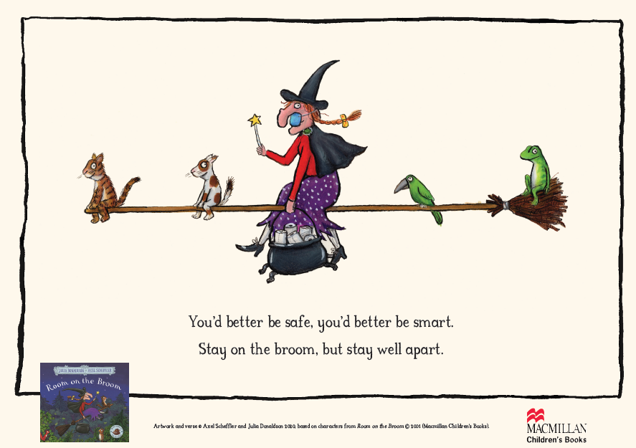 |  | Early Years and Prevention Service  - COVID-19
Recovery Planning for EArly Years and childcare providers |  | In This Issue: 8th June 2020

Slough Early Years and Prevention Service, has developed a recovery planning document for leaders and managers to use as a discussion tool to enable senior staff, including childminders, to plan for the recovery of early years provision. The use of the document is optional; it has been created to support thinking and planning. We intend that this document is helpful, whilst recognising that it is not complete nor a perfect fit to every settings situation. Please contact your Early Years Advisory Teacher or Development Worker if you wish to explore any of these questions in greater depth.

The following resources were referred to when compiling this document:
- Coronavirus (COVID-19): guidance for schools and other educational settings, Department for Education (DfE)
- Planning guide for early years and childcare settings
- Coronavirus (COVID-19): implementing protective measures in education and childcare settings
- Actions for early years and childcare providers during the coronavirus outbreak
- Actions for educational and childcare settings to prepare for wider opening from 1 June 2020 (DfE)
- Early years foundation stage: coronavirus disapplications
- Safe working in education, childcare and children’s social care
- Coronavirus (COVID-19): implementing protective measures in education and childcare settings (DfE)
- What parents and carers need to know about schools and other education settings during the coronavirus outbreak (DfE)
- COVID-19: cleaning in non-healthcare settings (Gov.uk)
- Opening schools and educational settings to more pupils from 1 June: guidance for parents and carers
- Supporting your children's education during coronavirus (COVID-19)
- Coronavirus (COVID 19): list of online education resources for home education
- Our plan to rebuild: The UK Government’s COVID-19 recovery strategy

Recovery Planning

Actions for early years education and childcare settings to prepare for wider opening
- Conducting a SEND risk assessment during the coronavirus outbreak
- Staying safe outside your home
- Staying alert and safe (social distancing)
- Legionella risks during the coronavirus outbreak

Posters of Julia Donaldson and Axel Scheffler Reimagined Images and Verses
From the Gruffalo Cave and to the Family Tree: Staying home with your favourite characters Julia Donaldson and Axel Scheffler have been inspired to create an extraordinary set of illustrations and verses to help share the important message about staying safe and to help lighten the spirits of families everywhere.

Amend your current policy on sickness management
Agree a protocol for responding to a suspected case of coronavirus and ensure your setting

Recovery planning continued…..

Guiding principles

•When settings re-open it will not be returning to normal.
•This will be no easy task and requires a great deal of careful thinking.
•The DfE has provided outline guidance and each setting will need to consider how this applies to their context/situation.
•Coronavirus will not have gone away; a core principle of the education system is the safety and wellbeing of children and staff.
•Strategies must dovetail with national strategy in fighting COVID-19 to reduce/minimise the rate of infection.
•It is possible that there will not be a vaccine for 18 months or more – that means settings will need to build a strategy to manage the risk over an extended period.
•Providers cannot stay closed interminably – a prolonged closure of settings will itself cause real harm to many children.
•Children’s experiences during lockdown will have varied massively.
•It is likely that any strategy would need to incorporate measures that limit the chances of close contact – such as adjusting class sizes, and staggering break times.
•It will be difficult for younger children to observe full social distancing and no one should pretend otherwise. It is unrealistic to believe that providers will always be able to keep children two metres apart from each other straightforward but an engagement process that considers all perspectives will lead to the strongest plan and the one most likely to be widely supported and appreciated. For example, how will you devise and then win understanding and support for a plan to accommodate children in a way that works for those children, parents and staff, within your physical environment?
•Changing scenarios will make any single plan unlikely to be the finished article. Settings along with the settings community need to be agile and flexible and adjust as they go through the period of recovery.
•Asking the what if?
•Recovery is an endurance event, not a sprint – the first steps are re-opening, but there are likely to be many other phases.

•There needs to be an opportunity to celebrate contributions during the childcare phase – and the opportunity for staff and children to share and reflect.
•For success, it will need wide consensus and deep reassurance among parents and staff. Any plan will need to accommodate a balance between meeting the needs of children, all parents (including those who may be trying to return to work) and all staff.

We know that many parents and carers will be apprehensive about their child/ren returning to early years provision but we know that attending early education lays the foundation for lifelong learning and supports children’s social and emotional development. These key messages need to be shared with parents sensitively along with the messages relating to scientific evidence regarding the spread of coronavirus in young children. Please see appendix A

There are a number of immediate issues which educational and childcare settings will need to consider. We recognise that each setting and community is different, and that leaders will need to make their own judgements on the most important issues for them.

Demand for childcare is likely to be lower than usual at first, and existing space requirements and staff to child ratios for these age groups should allow for small group working. Where the physical layout of a setting does not allow small groups of children to be kept at a safe distance apart, we expect practitioners to exercise judgement in ensuring the highest standards of safety are maintained. In some cases, it may be necessary for providers to introduce a temporary cap on numbers to ensure that safety is prioritised.

.

Recovery Planning
Slough Early Years and Prevention Service, has developed a recovery planning document for leaders and managers to use as a discussion tool to enable senior staff, including childminders, to plan for the recovery of early years provision.

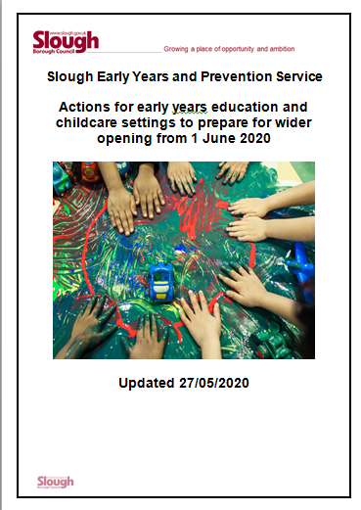
H
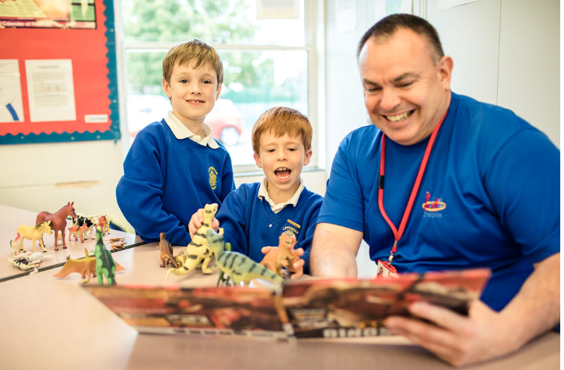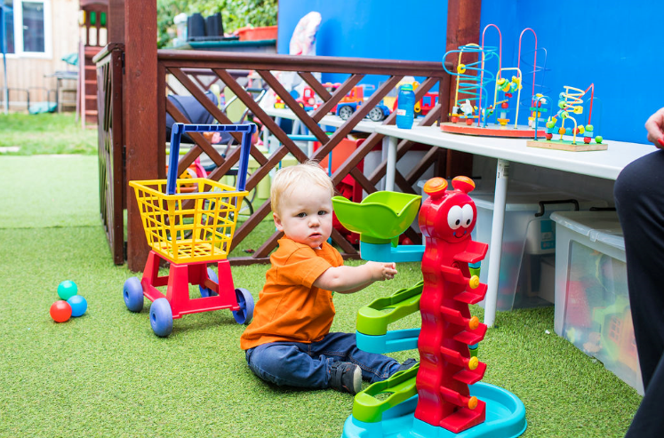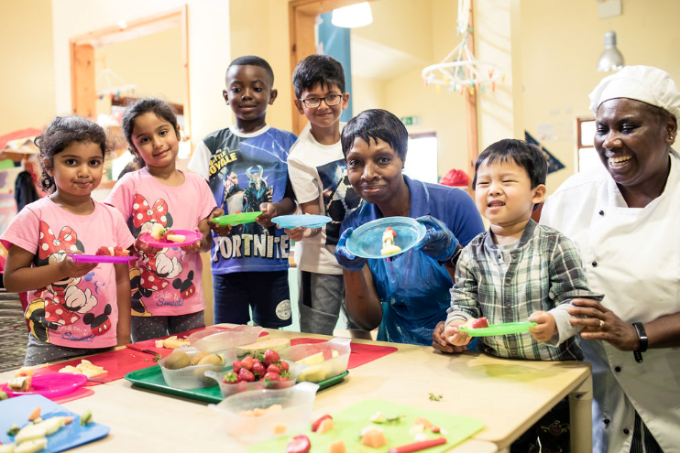

Ansering your questions

Agree a protocol for responding to a suspected case of coronavirus and ensure setting is prepared

Amend your current policy on sickness management to ensure your setting has a protocol in place for responding to a suspected case of coronavirus and that you are prepared with the resources and staffing levels to implement this if necessary. All protocols should include the following measures.
Anyone who begins to display coronavirus symptoms while in the setting should be sent home immediately and follow government guidelines on what to do if you or someone in your household develops symptoms. If a child is waiting to be collected, they should be separated from their group and isolated with one member of staff if this is possible.
A facemask should be worn if a distance of 2 metres cannot be maintained from a child who is symptomatic and awaiting collection and if contact is necessary, then gloves, an apron and a facemask should be worn. If a risk assessment determines there is a risk of splashing to the eyes, for example from coughing or spitting, then eye protection should also be worn. Settings should ensure they are prepared to respond in line with the guidance on protective measures in education and childcare settings and guidance on using PPE in education, childcare and children’s social care settings.
Once the child or member of staff has left the setting, settings should follow Cleaning of non-healthcare settings to ensure areas they have been in are disinfected and any PPE and other waste is disposed of safely.
Once early years and childcare providers open to more children, all staff and children who are attending a childcare setting will have access to a test if they display symptoms of coronavirus, and are encouraged to get tested in this scenario. Visit the guidance on coronavirus testing and how to arrange to have a test.
Where the child or staff member tests negative, they can return to their setting and the fellow household members can end their self-isolation. If the child or staff member tests positive, the rest of their immediate group within their setting should be sent home and advised to self-isolate for 14 days. For childminding settings, this applies to everyone attending your setting who came into contact with the child or staff member. The other household members of those advised to self-isolate do not need to self-isolate unless the child or staff member they live with subsequently develops symptoms. Take appropriate steps to deputise responsibilities or arrange cover if affected members of staff fulfil designated roles, for example paediatric first aid, SENCO or safeguarding lead.
As part of the national test and trace programme, if other cases are detected within the setting, Public Health England’s local health protection teams will conduct a rapid investigation and will advise settings on the most appropriate action to take. In some cases a larger group may be asked to self-isolate at home as a precautionary measure. Where settings are observing guidance on infection prevention and control, which will reduce risk of transmission, closure of the whole setting will not generally be necessary.
Ensure that emergency contacts are updated in advance of wider opening and consider where these may need to change, for example if previous emergency contacts are in a shielded group. Plan how you will communicate your protocol to parents and carers and ensure they understand their role and will be available to collect their child if necessary.

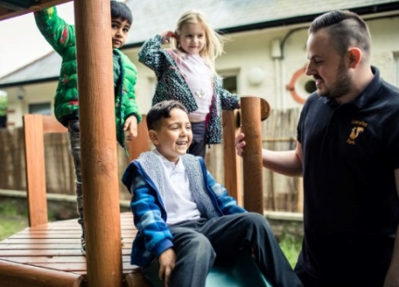

Sector Updates
Posters of Julia Donaldson and Axel Scheffler Reimagined Images and Verses
From the Gruffalo Cave to the Family Tree: Staying home with your favourite characters Julia Donaldson and Axel Scheffler have been inspired to create an extraordinary set of illustrations and verses to help share the important message about staying safe and to help lighten the spirits of families everywhere. https://www.gruffalo.com/activities/activities/posters-of-julia-donaldson-and-axel-scheffler-reim

Ofsted: coronavirus (COVID-19) rolling update
Ofsted guidance and information relating to coronavirus (COVID-19) for schools, early years, children's social care and further education and skills providers. Updated to add that from 8 June 2020, we will start to return to doing on-site registration visits for early years and childcare providers. Individuals who have an application that is at the ‘ready for a visit’ stage will soon receive a telephone call from us. https://www.gov.uk/guidance/ofsted-coronavirus-covid-19-rolling-update?utm_source=2ff8a558-30e9-4371-a928-8c6e815d9c04&utm_medium=email&utm_campaign=govuk-notifications&utm_content=immediate#history

HMRC: COVID-19
As part of changes to the Coronavirus Job Retention Scheme (CJRS), I’ve outlined below important dates that may impact you in the coming weeks.
Important dates – what you need to know now
•The scheme will close to anyone who hasn’t been furloughed for 3 weeks by 30 June, so you will only be able to claim for employees after that if they have been furloughed for a full three-week period at any time before the end of June.
•So, if you intend to furlough an employee who hasn’t been furloughed before, you will need to agree that with them and start their period of furlough on or before 10 June – this is the last day on which someone who has never been furloughed before can start a period of furlough and qualify for the scheme – this ensures the minimum three-week period is complete by 30 June.
•You will then have until 31 July to make a claim for any periods of furlough up until 30 June – this applies to both employees furloughed for the first time and those you have previously furloughed and claimed for.

The future of the scheme: The rules of the scheme are changing from 1 July.
•On 12 June, we’ll publish full guidance on all the scheme changes on GOV.UK – search for 'Coronavirus Job Retention Scheme' to find this – webinars offering more support on the changes will also be available to book online from 12 June – please do not call us for more information, as everything you need to know about the scheme changes will be published online on GOV.UK.
•From 1 July, you’ll have the flexibility to bring previously furloughed employees back to work part time, you can decide the hours and shift patterns they work to suit the needs of your business – you’ll pay their wages for the time they’re in work and can apply for a scheme grant to cover any of their normal hours they are still furloughed for.
•Also, for periods starting on or after the 1 July, the maximum number of employees you can claim for in any period cannot be higher than the maximum number you have claimed for in a previous period. For example, if your highest single claim for periods up to 30 June was for 100 people, you can’t claim for more than this number in later periods.
•From 1 August, you will need to contribute towards the wage costs of your furloughed employees until the scheme ends on 31 October.

Making changes to your claims if you have over-claimed
If you’ve made an error in a CJRS claim that means you received too much money, you must pay this back to HMRC.
We’ve updated the application system so you can tell us if you have over-claimed in a previous claim – when you apply you’ll be asked if you need to reduce the amount to take account of a previous error. Your new claim amount will be reduced to reflect this. You should then keep a record of this adjustment for six years.

If you have made an error in a CJRS claim and do not plan to submit further claims, we are working on a process that will allow you to let us know about your error and pay back any amounts that you have over-claimed. We will update guidance and keep you informed when this is available.
Protect yourself from scams

Actions for early years and childcare providers during the coronavirus outbreak
What childcare services early years settings, childminders and local authorities need to provide during the coronavirus (COVID-19) outbreak. We have added a clarification on the requirement for providers to carry the appropriate insurance (for example, public liability insurance) to cover all premises from which they provide childcare or childminding. https://www.gov.uk/government/publications/coronavirus-covid-19-early-years-and-childcare-closures?utm_source=0cbc5c5c-f45c-4dd4-bdbb-14e81aab0f8e&utm_medium=email&utm_campaign=govuk-notifications&utm_content=immediate#history

Carers Week
JOIN THE FUN AT THIS YEAR’S VIRTUAL CARERS WEEK IN SLOUGH

June 8th-14th is Carers Week - there are lots of exciting events and activities happening online by Slough Carers groups, from coffee mornings and art sessions, to cookery, quizzes and a virtual choir.

Carers Week is an annual campaign to raise awareness of caring, highlight the challenges unpaid carers face and recognise the contribution they make to families and communities throughout the UK. It also helps people who don't think of themselves as having caring responsibilities to identify as carers and access much-needed support. This year, people are continuing to face new challenges as a result of the coronavirus outbreak. Many more people have taken on caring responsibilities for loved ones at home…YOU may be one of them.

Slough Carers groups have put together some fun and engaging events during this week. Take some time out from your caring responsibilities and join in, it’s sure to put a smile on your face. We’re taking virtual events to another level to connect with carers this year. There’s something for everyone including a variety of quizzes and games, a cook-a-long, get-togethers, mindfulness sessions for your body and mind and opportunities to explore your creative side. Alongside this, there will be opportunities to ask questions to support you in your caring role and meet the Slough Carers Support team, who will be hosting some sessions. They have been busy over the last few months contacting carers as well as providing COVID-19 One Slough support.
Carers Week events have been organised and run by Slough Carers Support, Special Voices, Apna Virsa, Slough Young Carers, Aik Saath, Khatun’s Kitchen and Thrive365.

During the week, Slough's young carers will be taking to social media to show people living in our town and beyond, what it means to be a young carer to them. The young people attending Slough Young Carers reflect both the diversity of Slough and the diversity of carers, with regards to both the people they look after, the caring they do and its impact on their lives. Follow @SloughYC on Twitter or @sloughyoungcarers on Instagram to see what Slough's young carers want to share with you!

For the full programme and to book, visit: https://bit.ly/Slough-Carers-Support-Carers-Week

https://photos.google.com/share/AF1QipPbKvMdyG45PU_jVgF1OO84izPp1hwm4iMlTLgfiheK8PzpwxDyfWluthpKgKFJNQ?key=Q2YyUzdsZElpNE4wY2dHbll1Ykt1ZVNyOVdwc1VR

Integrated Health & Wellbeing Slough service

Please find below
•Leaflet for the Integrated Health & Wellbeing Slough service
To summarise IHWS, we work with a range of partner organisations to triage, assess and provide lifestyle interventions to those living in Slough. The interventions include both in-house (stop smoking, children & adult weight management, falls prevention, NHS health check) and external (Drug & Alcohol service, emotional wellbeing, etc.).

•COMPASS poster and a brief outline of the service

All of our services are currently being offered remotely. Partners will be notified when face to face service recommences.

Protocol for Assessment of Non-Independently Mobile
Children Residing in Berkshire who are presenting with Bruising: Updated June 2020

ding Confidence
SLOUGH EARLY YEARS AND PREVENTION SERVICE: TELEPHONE: 01753 476554 / EMAIL: earlyyears@slough.gov.uk

