Early Years and Prevention Service
  - COVID-19

Recovery Planning for EArly Years and childcare providers |  | In This Issue: 10th June 2020

It is important In these uncertain times to remind parents why early education is key to their child’s development. Many families are considering their options and thinking about their need to use early years and childcare provision. Some are now use to their children being at home and others are unsure about how safe their child will be at an early years setting.

We all need to share the key messages to remind parents why early education is so important, as well as letting them know what procedures the setting is putting in place to ensure the risks of COVID are minimalised.

There are many studies and research projects that have validated the significance and impact of a good early education, why not share some of the findings with your families and potential future families?

• A major study on the impact of effective preschool education, (Effective Provision of Pre-school Education) commissioned by the Department for Education and Skills, found that early education improves a child’s development and behaviour and children who start their early education under the age of three years have ’better intellectual attainment and peer relationships ’. https://discovery.ucl.ac.uk/id/eprint/10005309/

•The EPPE study also found that children who attend a good early education setting start school with a cognitive advantage and the longer children are in an early years setting, in months and years rather than the number of hours per day, the greater the advantage they have. https://discovery.ucl.ac.uk/id/eprint/10005309/

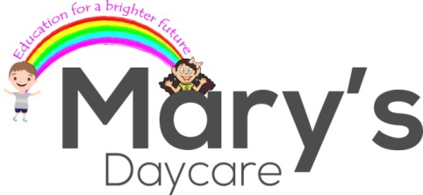
•A second major study also funded by the Department of Education – Effective Preschool, Primary and Secondary Education (EPPSE) found that early education experience continues to influence a child’s development throughout their learning journey until the age of 16 and children who attend effective, high-quality preschools for a longer duration show better intellectual and social profiles. https://www.ucl.ac.uk/ioe/research-projects/2019/mar/effective-pre-school-primary-and-secondary-education-project-eppse

•Early Education starts before a child is born “It is scientifically proven that, the period from pregnancy to age 3 is a very sensitive period for brain development” NURTURING CARE FOR EARLY CHILDHOOD DEVELOPMENT World Health Organisation

Recovery Planning

Why is Early Years Education important?

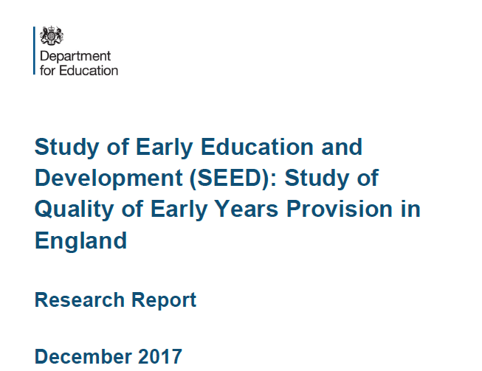
Why is Early Education important?
Study of Early Education and Development (SEED) highlights the value of early years education for all; pages 1 - 2

MARY’S DAYCARE REOPENING AFTER LOCKDOWN
Ofsted registered Outstanding Childminder shares her story about reopening after a period of lockdown; page 3

The benefits of good early education

•’’The first five years are critical to a child’s lifelong development and early education can play an important role in determining their success. A child’s early experiences influence their brain development, establishing the neural connections that provide the foundation for language, reasoning and problem-solving, social skills, behaviour and emotional health – characteristics that are significant factors in each child’s success at school and beyond. The early years are therefore the most important time when the foundations for learning are built through purposeful play in safe, stimulating, learning environments, with the support and guidance of Early Years educators who respect and value the importance of developmentally appropriate teaching and learning strategies’’. Bright Horizons

•Study of Early Education and Development (SEED) highlights the value of early years education for all. The findings published by the Department for Education July 2018 which tracked 6,000 children from the age of two concluded that childminder settings were found to improve children’s language development between the ages of two and three, while children who spent time in nurseries were found to have improved social and emotional development and get on better with their peers. The report found that a rich home learning environment had beneficial effects on cognitive and socio-emotional development, but these were largely independent of the effects of ECEC on outcomes. https://www.gov.uk/government/collections/study-of-early-education-and-development-seed

In 1997 Effective Pre-School, Primary and Secondary Education (EPPSE) was instigated as the UK’s first major study to focus on the effectiveness of early years education. More than 3,000 children were assessed at the start of pre-school (at approximately three years old) and their development monitored as they entered school until they made their post-16 education, training or employment choices. Children were assessed at the start of the study and on entering school at primary ages 6, 7, 10 and 11 and secondary ages 14 and 16. A sample of children with no pre-school experience was used as a comparison to the main study.
What were the key findings?
- Children who had early years education gained higher English and mathematics GCSE results and were more likely to achieved five or more GCSEs at grades A*C.
- Children who had experienced high-quality pre-school education were better at self-regulation, social behaviour and less inclined to hyperactivity.
- Children who had experienced high-quality pre-school settings were more likely to follow a post-16 academic path.

With less face to face contact with parents and prospective parents at the moment remember to use as many means as possible to reach out and remind parents of the services you offer. Send out messages to remind parents of the various funded early education offers such as 2 year old funding, 30 hours childcare, help with childcare costs including tax free childcare.

To ensure places can be taken up in the autumn term applications for 2 year old funding and 30 hours childcare need to be made or reconfirmed before 31st August. It’s best to prompt parents now so they don’t miss out.

.
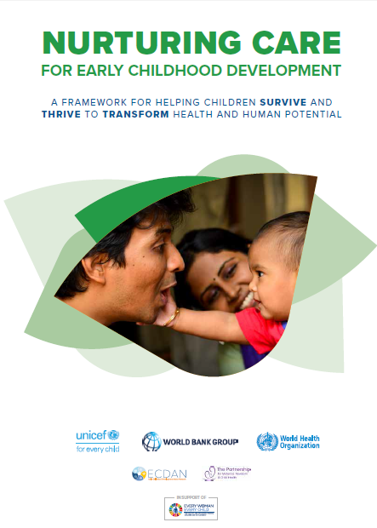
.

social media
The Early Years Service have already started to share some key messages on social media please check out the councils twitter page https://twitter.com/SloughCouncil and our own early years facebook page https://www.facebook.com/sloughearlyyears/

H
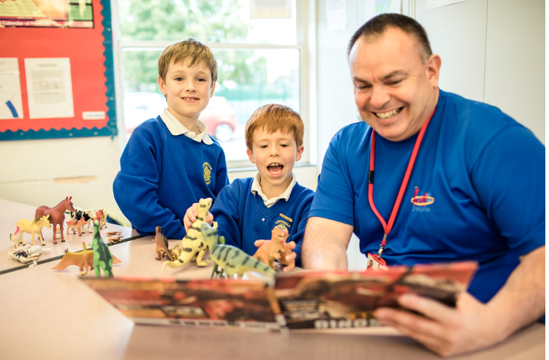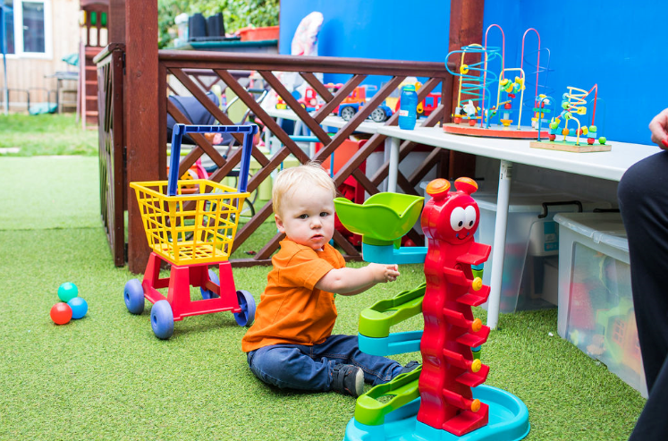

Anseri

ng your questions

Mary’s daycare: reopening after lockdown

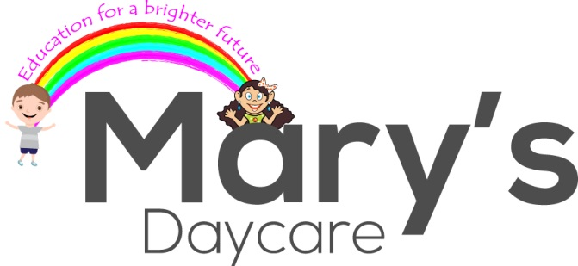

Ofsted registered Outstanding Childminder shares her story about reopening after a period of lockdown
Dear all
I hope you’re all well and keeping safe during these disconcerting times. No one could ever have prepared for the current situation.
My doors re-opened this week and with a staggered, carefully planned transition - I warmly welcomed the children to the ’new normal’ and they were delighted to be reunited with their peers. It was a great feeling to finally be back with the children. The children wasted no time in getting involved in their activities and enjoyed being outdoors.

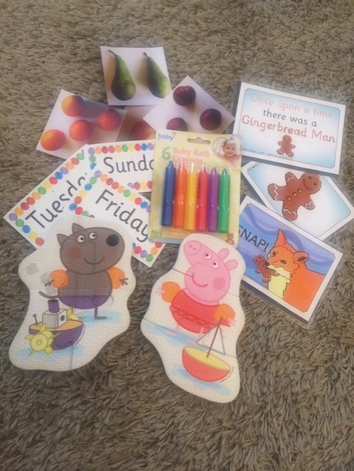
Considering mental health and well-being for many children, returning to a childcare setting after an extended break can feel a bit daunting. To support mental health I was able to answer questions they had. This was supported by Axel Scheffler’s new, free information book ‘Coronavirus – book for children’
Another fantastic resource I found was Dr Zand and Dr Chris on operation ouch (CBBC).
On reflection I was quite anxious about health and hygiene but I realised whilst putting in place my risk assessment that good hygiene is something that I always take pride in and has always been normal practice within my home setting.
The new trend! Wipe and clean resources! This week I made wipe and clean story cards, used bath crayons (so easy to wash) and foam bath puzzles to go in our water tray.

Sector Updates
The Oral Health Improvement Team
Following advice from our Infection Control Team at Oxford Health NHS Trust and Public Health England, it has been agreed that due to the Coronavirus Pandemic to suspend tooth brushing for the current time in Schools, Nurseries, Early Years Settings and Special Schools where children are in a contained area and would be tooth brushing together. This offers further protection to all those involved, both in the activity and supervision from a small risk of spray.

We have also been advised that current ‘used’ toothbrushes should be disposed of. It is advisable that all storage equipment, brush buses etc. to be thoroughly cleaned for storage and future use. New toothbrushes can be made ready (in wrapping) for use when things settle.

This is of course only a suspension for the Early Years/school settings. We would still like you to encourage your children to be brushing their teeth before they come to your settings and of course at night time before bed, and following a healthy lifestyle.

Regarding accreditation: this will not change the Accreditation Award you have at the present time. This will not affect you working towards the Silver Award or the preparation work for the Gold Award Accreditation.

When things settle and tooth brushing can be resumed in settings, we can then accredit your setting with a Gold award if your children are tooth brushing to the correct guidelines.

If you require any further training materials or would like any further information regarding our online training please contact us at Oral.Health@oxfordhealth.nhs.uk

PPE Purchasing

Further to our correspondence regarding PPE the council now has a web form for you to access rather than use the email address. You can find the web form here:
https://slough-self.achieveservice.com/service/PPE_stock_update

Thames Valley Guidance for Childcare and Educational Settings in the Management of COVID-19 - Flowchart - Version 04.06.2020
Please be aware of this new flow chart summary from PHE South East Health Protection Team:
Guidance for Childcare and Educational Settings in the Management of COVID-19. Version 1.1 Date 04/06/2020
Actions:
- Suspected Covid-19 case in child or staff member
- Confirmed Covid-19 case in child or staff member
- 2 or more confirmed cases in the same group/class

If you have any infection control concerns or questions call the Thames Valley Health Protection Team on 0344 225 3861.

Bowak Jangro disinfectant – Product alert
Please find below a letter for all schools on the use of Bowak Jangro disinfectant.
We have been informed that some schools across Berkshire have been using it on food contact surfaces. It is not designed for this purpose.

Government Updates

A letter addressed to the Head of Early Years from Jo Mackie, Deputy Director, Early Years Strategy and Entitlements - Department for Education
The Coronavirus Job Retention Scheme
On 29 May the Chancellor announced upcoming changes to the Coronavirus Job Retention Scheme (CJRS). These changes include new flexibility for employers to agree any working arrangements with previously furloughed employees from 1 July. HMRC will publish further detailed guidance on this, and the DfE guidance, available here, will be updated accordingly.
As previously, providers should now only access the CJRS if necessary, and only if the conditions set out in DfE’s guidance continue to be met, where there is a lack of demand for places that requires a continued full or partial closure.

The latest date that providers can furlough staff that have not been furloughed before is 10 June. All staff that have been furloughed at least once by this date – whether or not they are on furlough as of 10 June – will continue to be eligible for the scheme after 1 July. In the great majority of instances we expect that providers will be removing some or all of their staff from furlough, given the wider opening that is now possible. However, we recommend that providers consider their own circumstances and whether it is necessary to furlough additional staff by 10 June (while continuing to ensure the conditions set out in DfE’s guidance are met).
The Department for Education would expect providers to bring staff off furlough and back to work as demand increases. In practice this will mean that, for example, if a provider has furloughed six members of staff, and they need three back at work in order to meet demand for childcare, then they should bring three staff off furlough and back to work, and reduce their claim on the CJRS accordingly.
We encourage providers to keep in contact with their LA about their circumstances to ensure they have the information they need to help with local planning, and ensure that parents have access to the places they need.

30 hours code validity dates
The Department for Education has previously asked local authorities to use their discretion to relax the validity dates on 30 hours codes where parents were ordinarily eligible and expecting to take up a 30 hours childcare place between 1 April 2020 and 31 August 2020, but have missed the reconfirmation/application deadline of 31 March 2020. This will enable children to take up their places in the summer term.

Previously, only the children of critical workers, and children who are vulnerable, are able to access childcare. Now that early years settings are open to all children, we are asking local authorities to exercise their discretion in accepting the codes of all children who missed the 31st March deadline, provided they meet the eligibility criteria and where there is capacity for providers to take them on. Providers and local authorities will need to confirm that the child taking up the place did in fact attend before 1st April 2020 to ensure they are eligible for a 30 hours place in the summer term.

We are still encouraging parents to continue to apply for, and reconfirm, their 30 hours entitlement, even if they choose to keep their child away from their childcare setting, to help them prepare for their transition back into childcare attendance in September.

Funding
The DfE are planning to talk to LA heads of early years teams, sector providers and their representatives regarding the current and future funding arrangements. As soon as the LA has more information on this it will be shared with the sector.

LGA Early Years Reference Group

We would like to highlight yesterday’s announcement from the Chancellor that parents on statutory maternity and paternity leave who return to work in the coming months will be eligible for the furlough scheme even after the 10 June cut-off date. Claims from July onwards will be restricted to employers currently using the scheme and previously furloughed employees. However, this announcement confirms that parents on statutory maternity and paternity leave who return to work in the coming months after a long period of absence will be permitted to be furloughed. This also applies to staff on adoption leave, shared parental leave, and parental bereavement leave.

On holiday programmes, there is still no decision on whether these will be allowed to go ahead. There are a few parliamentary questions (here and here) awaiting an answer which may give some more insight and help move things along. I will let you know when answers are published.

SLOUGH EARLY YEARS AND PREVENTION SERVICE: TELEPHONE: 01753 476554 / EMAIL: earlyyears@slough.gov.uk

