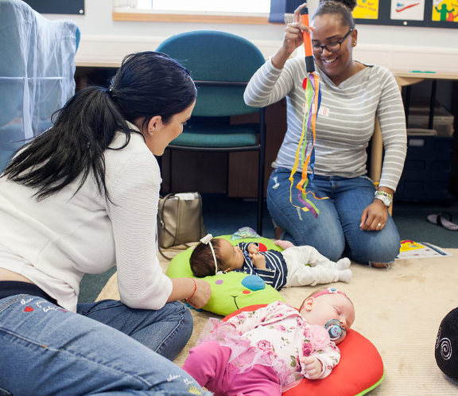 |  | Early Years and Prevention Service  - COVID-19
Recovery Planning for EArly Years and childcare providers |  | In This Issue: 11th June 2020

It is at times like this that many people will be feeling uncertain about different situations and using early years and childcare provision may be something that parents are unsure about. Parents may currently have a choice about accessing provision and some may not, either way we all have a role to play in promoting the positive outcomes that early education can have for children.

Consider what your setting could be doing to support the changes and support families who are unsure about using early years and childcare provision now and in the future. There are many things that each provider could do to engage families at this time, even when you might not be able to show prospective parents around.

Some suggestions to consider:
- Share the benefits of early education via your newsletters, websites or social media
- Share videos and photo’s of what the setting now looks like
- Share videos and written materials about the routines and structure of the day
- Share videos of the practitioners talking about the new procedures and processes that have been introduced, including health and hygiene, key worker groups, risk assessments, when should they not attend, what resources have been restricted and why etc.
- Take and share photo’s of the staff team
- Share home learning opportunities
- Share regular communications, including photo’s of children playing in the setting
- Talk about the extended support services that providers can offer children and families such as links with the health visiting team, speech and language support
- Make regular phone calls to families to find out how they are and what support they might need
- Talk to new parents about why your setting is the setting they should choose for their child
- Talk to families about transitions, this could be from home to the setting, from one area of the setting to another
- Promote outdoor learning and the benefits of it for young children
- A personal letter or postcard from the key person over the summer and/or a personal video message so they can replay it
- Parent testimonial / voice of the child – why they are happy to come back, what have they missed
- Invite them to visit the garden area when all of the other children have gone home
- Use zoom to connect with those children at home so they can see their friends in the setting and also have it as an opportunity to show them what the ‘new normal’ environment looks like

Recovery Planning

Building confidence

BUILDING CONFIDENCE
Consider what your setting could be doing to support the changes and support families who are unsure about using early years and childcare provision now and in the future. Page 1
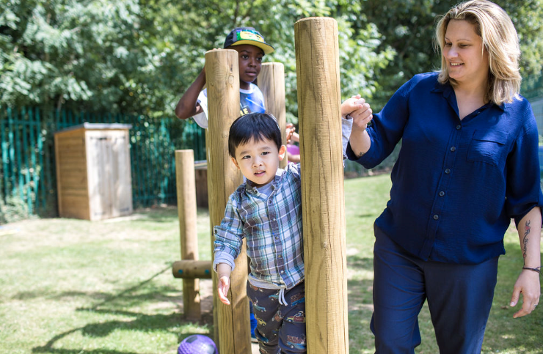

IS IT SAFE?
Penn Road Children’s Centre Manager shares her experiences of reopening for more children following the lockdown period. Page 2
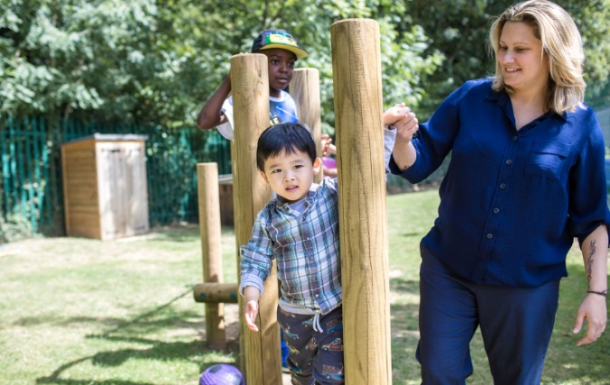
Is it Safe?

The news came on the 24th May 2020 that all early years settings could reopen and welcome children back into their settings. If you were anything like us that felt like a mountain to climb, even though we had continued to run one of our children’s centres for key workers and vulnerable children. Having only just got used to newly developed ways of working, ensuring our children and their families had regular contact and the opportunity to continue their learning at home with activities set by their key person, things were about to change again! So what did this new ‘new normal’ entail? Wading through numerous government guidance to understand the best and safest way to open for all children and staff, meant turning everything we know as early years professionals on its head and planning how we would do things differently.

The first mammoth task was to find out if families wanted their children to return on the 2nd June. The children’s centres made phone calls and sent emails to ask if children required a space, on top of our regular weekly contact with all families. This produced a range of questions from families; is it safe to return?; how are you going to keep my child two metres from everyone else?; why does it need to be different?; are you taking everyone’s temperature when they arrive? – just a few of the questions we have been asked.

So what was our response to the biggest question of all, ‘is it safe?’, we hear you ask….To be honest, all anyone can do is to make it as safe as possible and don’t we all wish it was a simple as saying that sentence. This has involved deciding different phases for children to return, creating ‘social bubbles’, staggered drop off and collection times, removal of all soft furnishings and toys including difficult to clean equipment, development of extensive cleaning schedules, two metre markings outside the entrance so that families can socially distance while they wait, the creation of sanitisation stations and isolation rooms, guidance for families about how we will be operating and a guide to be shared with the children before we welcomed them back to support their transition to ‘the new normal’. Using the Early Years Service guidance helped no end!
We are now on our second week and the children have been amazing, the resilience and sheer enjoyment they have shown in all opportunities presented to them has been wonderful to see. Their responses to new routines and the changes to the environment have shown that, done in the right way this can be positive for children. It is difficult to keep two metres apart, that goes with out saying, we are early years professionals, how do you not hug a child who is upset?;how do you stop a two or three year old from playing alongside another child as they slowly creep closer together, lost in their play? You don’t, you have to accept that some things are going to happen, but as long as you ensure you are following all safety guidance, stay within your bubble and reminding children to try and keep two metres apart, we can reduce the risk level significantly.

A week on, our children and families are now familiar with the routine and arrive promptly, at the allocated gate two metres apart from each other but still in full conversation. We have added in an ‘X’ marks the spot which indicates the point at which the child says goodbye to the person dropping them off and then joins the staff member meeting them at the gate. A simple but effective measure and this has been really positively received, with children and their families enjoying this moment to aide transition.

What happens if a bubble ‘pops’? Unfortunately, it is almost inevitable, and it already has happened to us in Slough Children’s Centres! The best advice we can offer is to talk to your families. Be open and honest from the start so they know what to expect if a child or staff member develops symptoms or tests positive (we have this covered in our guidance to parents and families). We have decided that if someone displays symptoms while in a Children’s Centre, that social bubble of both staff and children will be asked to self isolate until a test can be completed to confirm either way. Families have responded positively to this stance and appreciate that we are acting in the best interests of everyone and as quickly as possible.

Some times, regardless of how different things are there is always a silver lining, children in their early years have shown they can adapt at a flick of a switch but so can the early years professionals and providers, learning together, even if it is at the speed of lightning we welcome the ‘new normal’ until its time to change again.

.

H
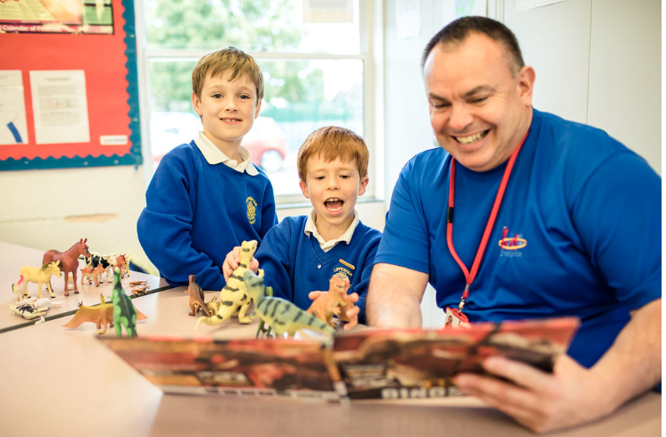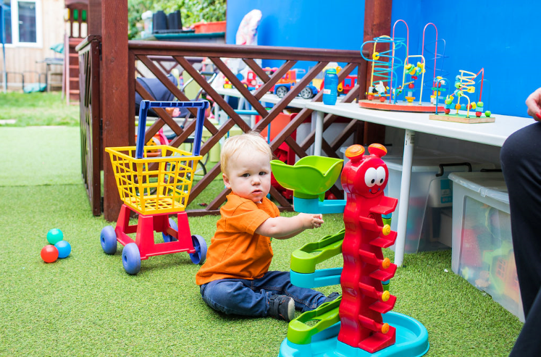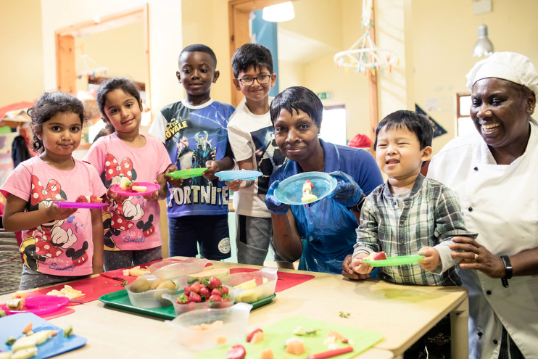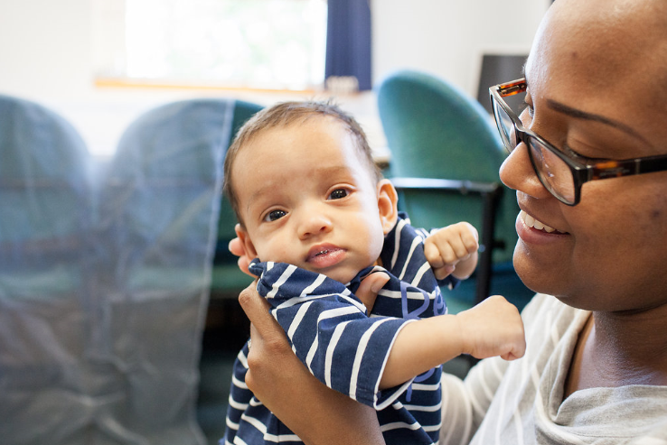

eri

Sector Updates
The Oral Health Improvement Team
Following advice from our Infection Control Team at Oxford Health NHS Trust and Public Health England, it has been agreed that due to the Coronavirus Pandemic to suspend tooth brushing for the current time in Schools, Nurseries, Early Years Settings and Special Schools where children are in a contained area and would be tooth brushing together. This offers further protection to all those involved, both in the activity and supervision from a small risk of spray.

We have also been advised that current ‘used’ toothbrushes should be disposed of. It is advisable that all storage equipment, brush buses etc. to be thoroughly cleaned for storage and future use. New toothbrushes can be made ready (in wrapping) for use when things settle.

This is of course only a suspension for the Early Years/school settings. We would still like you to encourage your children to be brushing their teeth before they come to your settings and of course at night time before bed, and following a healthy lifestyle.

Regarding accreditation: this will not change the Accreditation Award you have at the present time. This will not affect you working towards the Silver Award or the preparation work for the Gold Award Accreditation.

When things settle and tooth brushing can be resumed in settings, we can then accredit your setting with a Gold award if your children are tooth brushing to the correct guidelines.
If you require any further training materials or would like any further information regarding our online training please contact us at Oral.Health@oxfordhealth.nhs.uk

PPE Purchasing

Further to our correspondence regarding PPE the council now has a web form for you to access rather than use the email address. You can find the web form here:
https://slough-self.achieveservice.com/service/PPE_stock_update

Thames Valley Guidance for Childcare and Educational Settings in the Management of COVID-19 - Flowchart - Version 04.06.2020
Please be aware of this new flow chart summary from PHE South East Health Protection Team:
Guidance for Childcare and Educational Settings in the Management of COVID-19. Version 1.1 Date 04/06/2020
Actions:
- Suspected Covid-19 case in child or staff member
- Confirmed Covid-19 case in child or staff member
- 2 or more confirmed cases in the same group/class
If you have any infection control concerns or questions call the Thames Valley Health Protection Team on 0344 225 3861.

Bowak Jangro disinfectant – Product alert
Please find below a letter for all schools on the use of Bowak Jangro disinfectant.
We have been informed that some schools across Berkshire have been using it on food contact surfaces. It is not designed for this purpose.

Government Updates

Preparing for the wider opening of schools and early years settings
Guidance on the actions for education and childcare settings to prepare for wider opening from 1 June, at the earliest, can be found here:
https://www.gov.uk/government/publications/actions-for-educational-and-childcare-settings-to-prepare-for-wider-opening-from-1-june-2020

Guidance on implementing protective measures in education and childcare settings can be found here:
https://www.gov.uk/government/publications/coronavirus-covid-19-implementing-protective-measures-in-education-and-childcare-settings

Guidance for early years providers to help them prepare to open their settings for children of all ages from 1 June can be found here:
https://www.gov.uk/government/publications/preparing-for-the-wider-opening-of-early-years-and-childcare-settings-from-1-june

Guidance for parents and carers as schools and other education settings in England open to more children and young people can be found here:
https://www.gov.uk/government/publications/closure-of-educational-settings-information-for-parents-and-carers

Supporting early career teachers
Information for school leaders, early career teachers or newly qualified teachers on the Early Career Framework and the professional development package. Updated ‘Rollout of Early Career Framework professional development package’ with details about the PIN (prior information notice).

Latest shielding information for children

Health Policy team
This page provides advice to members on which paediatric patient groups should be advised to 'shield' during the COVID-19 outbreak, to protect those at very high risk of severe illness from coming into contact with the virus. It also provides frequently asked questions on how 'shielding' applies to children and families.

SLOUGH EARLY YEARS AND PREVENTION SERVICE: TELEPHONE: 01753 476554 / EMAIL: earlyyears@slough.gov.uk

