Early Years and Prevention Service
  - COVID-19

Recovery Planning for EArly Years and childcare providers |  | In This Issue: 12th June 2020

Many parents are still wondering if it really is safe to send their child to an early years and childcare provision. They are asking settings if they can guarantee it will be safe for children and staff. This is why all providers are taking precautious and a phased approach to the wider opening.

The government have worked closely with Public Health England (PHE) to develop guidance on implementing protective measures which settings should put in place. This guidance sets out a hierarchy of controls which providers should work through and which, when implemented, create an inherently safer system where the risk of transmission of infection is significantly reduced.

These controls are:
•avoiding contact with anyone with symptoms
•frequent hand cleaning and good hygiene practices
•regular cleaning of settings
•minimising contact and mixing

’Ensure that all parents and carers understand that if a child has coronavirus symptoms, or there is someone in their household who does, they should not attend the setting under any circumstances. Ensure parents and carers are aware that all children attending the setting, and members of their household, will have access to a test if they display symptoms of coronavirus and they are encouraged to get tested in this scenario’’. https://www.gov.uk/government/publications/preparing-for-the-wider-opening-of-early-years-and-childcare-settings-from-1-june/planning-guide-for-early-years-and-childcare-settings#communicate-with-parents-and-carers

‘’Agree a protocol for responding to a suspected case of coronavirus and ensure setting is prepared
Amend your current policy on sickness management to ensure your setting has a protocol in place for responding to a suspected case of coronavirus and that you are prepared with the resources and staffing levels to implement this if necessary. All protocols should include the following measures.

Recovery Planning

If the bubble pops!

IF THE BUBBLE POPS!
Many parents are still wondering if it really is safe to send their child to an early years and childcare provision.. Page 1 & 2

NEWSLETTERS & CONTENT
Over the last few weeks we have published many newsletters with an array of different articles. Check out what has been covered so far. Page 2 & 3
If the bubble pops?

Anyone who begins to display coronavirus symptoms while in the setting should be sent home immediately and follow government guidelines on what to do if you or someone in your household develops symptoms. If a child is waiting to be collected, they should be separated from their group and isolated with one member of staff if this is possible.
A facemask should be worn if a distance of 2 metres cannot be maintained from a child who is symptomatic and awaiting collection and if contact is necessary, then gloves, an apron and a facemask should be worn. If a risk assessment determines there is a risk of splashing to the eyes, for example from coughing or spitting, then eye protection should also be worn. Settings should ensure they are prepared to respond in line with the guidance on protective measures in education and childcare settings and guidance on using PPE in education, childcare and children’s social care settings.
Once the child or member of staff has left the setting, settings should follow Cleaning of non-healthcare settings to ensure areas they have been in are disinfected and any PPE and other waste is disposed of safely.
Once early years and childcare providers open to more children, all staff and children who are attending a childcare setting will have access to a test if they display symptoms of coronavirus, and are encouraged to get tested in this scenario. Visit the guidance on coronavirus testing and how to arrange to have a test.
Where the child or staff member tests negative, they can return to their setting and the fellow household members can end their self-isolation. If the child or staff member tests positive, the rest of their immediate group within their setting should be sent home and advised to self-isolate for 14 days. For childminding settings, this applies to everyone attending your setting who came into contact with the child or staff member. The other household members of those advised to self-isolate do not need to self-isolate unless the child or staff member they live with subsequently develops symptoms. Take appropriate steps to deputise responsibilities or arrange cover if affected members of staff fulfil designated roles, for example paediatric first aid, SENCO or safeguarding lead.

As part of the national test and trace programme, if other cases are detected within the setting, Public Health England’s local health protection teams will conduct a rapid investigation and will advise settings on the most appropriate action to take. In some cases a larger group may be asked to self-isolate at home as a precautionary measure. Where settings are observing guidance on infection prevention and control, which will reduce risk of transmission, closure of the whole setting will not generally be necessary.
Ensure that emergency contacts are updated in advance of wider opening and consider where these may need to change, for example if previous emergency contacts are in a shielded group. Plan how you will communicate your protocol to parents and carers and ensure they understand their role and will be available to collect their child if necessary’’. https://www.gov.uk/government/publications/preparing-for-the-wider-opening-of-early-years-and-childcare-settings-from-1-june/planning-guide-for-early-years-and-childcare-settings#Section4

.

Newsletters and content so far:

Article 1: 1st June 2020
- Risk assessments COVID – 19
- Supporting CPD
- SBC Business Support Fund
- Ask Michael: Many childminders and some providers will again start dropping off and collecting children from schools this week, nationally some schools have banned childminders from doing so. Do you know what the Slough’s schools position is on this?
- Sector updates (JRS, Self employed support scheme, critical workers, Coronavirus (COVID-19): implementing protective measures in education and childcare settings, Oftsed updates, Actions for educational and childcare settings to prepare for wider opening from 1 June 2020, Changes to the law on education, health and care needs assessments and plans due to coronavirus)

Article 2: 2nd June 2020
- Class sizes and staff availability
- Supporting Children: SEND
- Ask Michael: If a parent cannot get their full entitlement at Nursery/school can the funding be transferred to a childminder and what is the procedure to do this, i.e do the parents need to give the nursery an end date etc.,?
- Resources to help children to learn about coronavirus and how to keep themselves and others save
- Sector updates: Data collection, Early years foundation stage statutory framework (EYFS), Caring for your water dispenser upon schools re-opening, Handwashing and respiratory hygiene posters, What parents and carers need to know about schools and other education settings during the coronavirus outbreak

Article 3: 3rd June 2020
- Health and safety
- Actions for early years and childcare providers – update 2nd June
- Ask Michael: Slough Early Years and Prevention Service had a pot of money that was used to extend provision / childcare places? Is there now any flexibility with regards to using any ‘spare’ money to develop provision rather than extend it.
- Sector updates: Data collection, Actions for early years and childcare providers during the coronavirus outbreak, Ofsted: coronavirus (COVID-19) rolling update, What parents and carers need to know about schools and other education settings during the coronavirus outbreak, Updated guidance on the early years foundation stage (EYFS) statutory framework, Providing apprenticeships during the coronavirus (COVID-19) outbreak, Parenting Special Children Events during the Coronavirus lockdown, Local Government Association – Update regarding the new guidance for after-school clubs and wraparound care, Public Health: reducing your risk coronavirus

Article 4: 4th June 2020
- Preparing for children to return
- Ask Michael: I am concerned about settling SEND children back into my setting after lockdown, and transitioning some new ones. Where can I get advice and support with this?
- COVID 19: Support for children and families in Slough
- Sector updates: Nursery World - NSPCC launches nationwide programme of activities for babies, Actions for schools during the coronavirus outbreak, Implementing protective measures in education and childcare settings, HMRC- COVID-19 – more webinar dates available

Article 5: 5th June 2020
- Personal protective equipment (PPE)
- Ask Michael: Private, voluntary and independent early years providers including childminders are being asked to submit daily numbers of children on Monday’s and Thursday’s every week. Why is the local authority collecting this information and what are you doing with it?
- Numbers are increasing
- Sector Updates: Foundation Years – FAQs, The 2020 Early Years Summit, Family Resources to support parents and carers during lockdown, NHS East Berkshire CCG: Lift the Baby, Post Lockdown Pathway, Actions for early years and childcare providers during the coronavirus outbreak

Article 6: 8th June 2020
- Actions for early years education and childcare settings to prepare for wider opening
- Agree a protocol for responding to a suspected case of coronavirus and endure the setting is prepared
- Sector updates: Posters of Julia Donaldson and Axel Scheffler Reimagined Images and Verses, Ofsted: coronavirus (COVID-19) rolling update, HMRC: COVID-19, Actions for early years and childcare providers during the coronavirus outbreak, Carers Week, Integrated Health & Wellbeing Slough service, Protocol for Assessment of Non-Independently

Article 7: 9th June 2020
- Early Years Foundation Stage
- Bursts for Learning
- Mental Health support available for children and young people in England
- Thames Valley Guidance for Childcare and Educational Settings in the Management of COVID-19 - Flowchart - Version 04.06.2020
- Sector updates: The Oral Health Improvement Team, PPE Purchasing, Study launched to monitor prevalence of coronavirus (COVID-19), Funding available for set-up and training on digital education platforms, Government Updates, LGA Early Years Reference Group - wraparound care

Article 8: 10th June 2020
- Why is Early Years Education important?
- The benefits of good early education
- Mary’s Daycare: Reopening after lockdown
- Sector updates: The Oral Health Improvement Team, PPE Purchasing, Study launched to monitor prevalence of coronavirus (COVID-19), Thames Valley Guidance for Childcare and Educational Settings in the Management of COVID-19 - Flowchart - Version 04.06.2020, Bowak Jangro disinfectant – Product alert, Government Updates, LGA Early Years Reference Group

Article 9: 11th June 2020
- Building confidence
- Is it Safe?
- Sector Updates: The Oral Health Improvement Team, PPE Purchasing, Study launched to monitor prevalence of coronavirus (COVID-19), Thames Valley Guidance for Childcare and Educational Settings in the Management of COVID-19 - Flowchart - Version 04.06.2020, Bowak Jangro disinfectant – Product alert, Government Updates, Latest shielding information for children

Article 9: 12th June 2020
- If the bubble pops!
- Newsletters and content so far
- Sector Updates: Thames Valley Guidance for Childcare and Educational Settings in the Management of COVID-19 - Flowchart - Version 04.06.2020, Government Updates

H
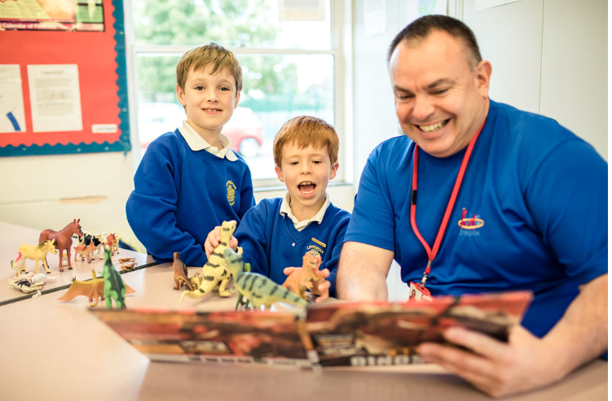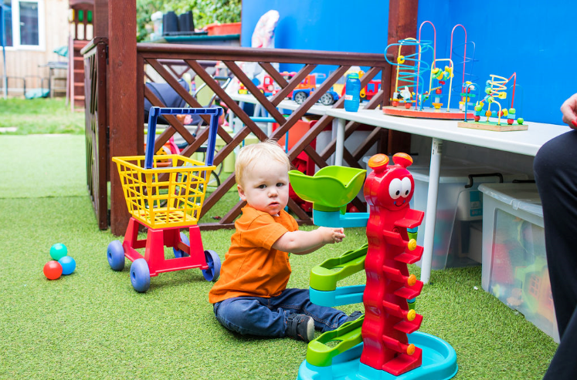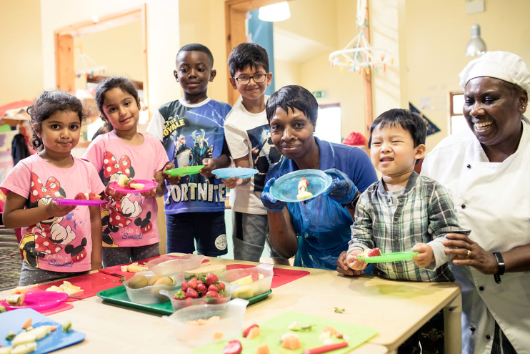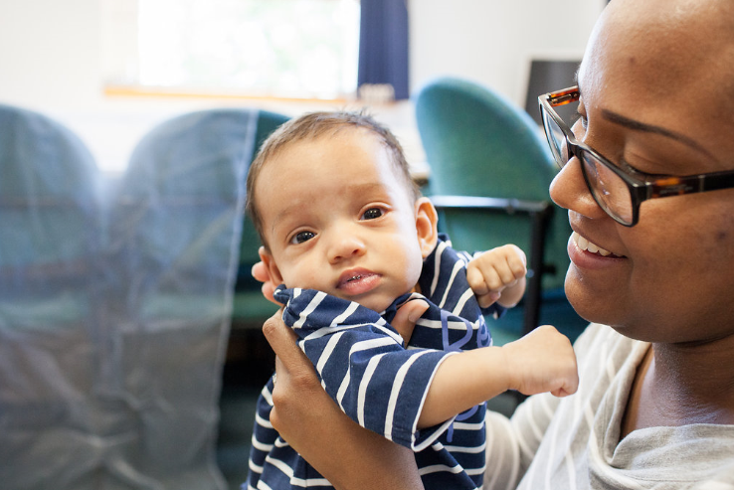

e

Sector Updates
Thames Valley Guidance for Childcare and Educational Settings in the Management of COVID-19 - Flowchart - Version 04.06.2020
Please be aware of this new flow chart summary from PHE South East Health Protection Team:
Guidance for Childcare and Educational Settings in the Management of COVID-19. Version 1.1 Date 04/06/2020
Actions:
- Suspected Covid-19 case in child or staff member
- Confirmed Covid-19 case in child or staff member
- 2 or more confirmed cases in the same group/class
If you have any infection control concerns or questions call the Thames Valley Health Protection Team on 0344 225 3861.

Government Updates

EASING THE LOCKDOWN – The Government has announced that from this weekend, the government is allowing single adult households to form a ‘support bubble’ with one other household. Adults living alone, or single parents with children under 18, can spend time with one other household inside each others’ homes, and without staying 2 metres apart. People cannot switch the household they are in a bubble with, or connect with multiple households. The government is not advising anyone who is currently shielding to form a support bubble.
From 15 June, places of worship across England will be permitted to reopen for individual prayer.
Also from 15 June, non-essential retail will be able to reopen, providing they comply with the COVID-secure guidelines published in May.
The Government has announced that outpatients and visitors to hospitals must wear a face covering, as must all people travelling on public transport.

HOUSING – The ban on evictions from social or private rented accommodation has been extended by 2 months. New evictions are now suspended until the 23rd August, in order to provide greater protection to renters.

EDUCATION – The Government has confirmed that plans to bring all primary school pupils in England back to school before the end of term have been scrapped.
The Department for Education has announced new online resources to help schools and colleges respond to the impact of COVID-19 on mental health and wellbeing. Practical materials for primary and secondary schools to use to train staff about teaching mental wellbeing have been published.
The Department of Health and Social Care has announced that it will be launching a study to monitor the prevalence of COVID-19 in schools. The study will be voluntary, with teachers and pupils who take part being swab-tested for the virus.

Preparing for the wider opening of schools and early years settings
Guidance on the actions for education and childcare settings to prepare for wider opening from 1 June, at the earliest, can be found here:
https://www.gov.uk/government/publications/actions-for-educational-and-childcare-settings-to-prepare-for-wider-opening-from-1-june-2020
Guidance on implementing protective measures in education and childcare settings can be found here:
https://www.gov.uk/government/publications/coronavirus-covid-19-implementing-protective-measures-in-education-and-childcare-settings
Guidance for early years providers to help them prepare to open their settings for children of all ages from 1 June can be found here:
https://www.gov.uk/government/publications/preparing-for-the-wider-opening-of-early-years-and-childcare-settings-from-1-june
Guidance for parents and carers as schools and other education settings in England open to more children and young people can be found here:
https://www.gov.uk/government/publications/closure-of-educational-settings-information-for-parents-and-carers

SLOUGH EARLY YEARS AND PREVENTION SERVICE: TELEPHONE: 01753 476554 / EMAIL: earlyyears@slough.gov.uk

