

Slough Early Years and Prevention Service

Transitions toolkit

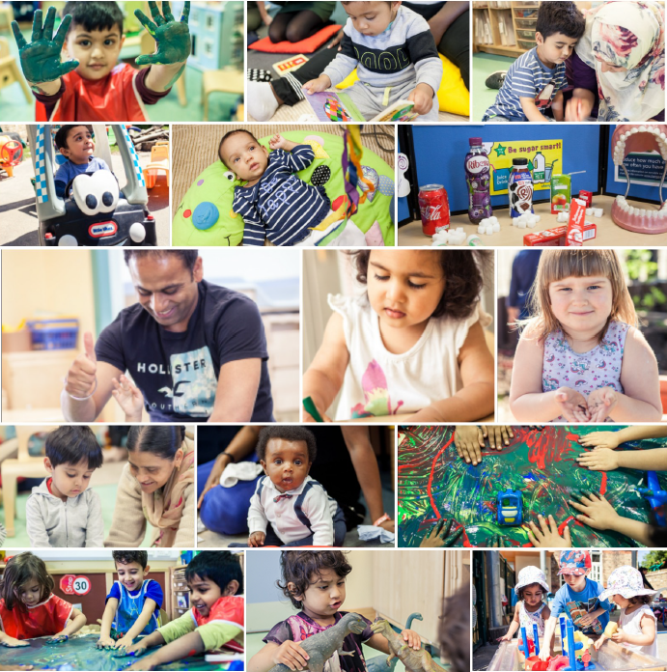



Contents

- Early Years Transition Book (after Coronavirus)
- How I found lockdown (child to answer)
- Lockdown Ladder: Steps to getting your child ready to come back to Nursery/School
- Health Protection Surveillance Centre Respiratory Hygiene Posters
- Top Transition Tips
- Things to remember: Covid-19
- Everyone gets sick sometimes: Social Story
- Handwashing: 20 second strategy
- Sneeze or cough into elbow
- Transitions back into school after COVID-19
- Hygiene: Makaton
- Parent feedback

Early Years
Transition Book
(after Coronavirus)

Please personalise and differentiate this book to meet the needs of the individual child before printing.

Nursery/School has been closed for a long time.
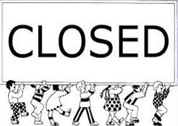

Insert School/nursery logo here

It has been closed because of Coronavirus.
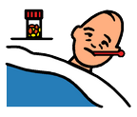

When Nursery/School was closed I stayed at home.
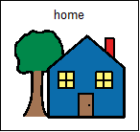

Nursery/School is ready to open again soon.


Insert School/nursery logo here

I will go back to nursery on:
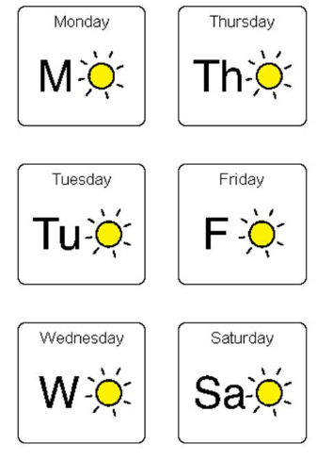

My classroom will be __________
Insert photo of classroom here

I will put my coat and bag here

Insert picture of cloakroom/pegs here

I will play outside here
Insert photo of play area here

I will eat my lunch/snack here

Insert photo of snack table/lunch hall here

I will go to the toilet/have my nappy changed here

Insert photo of toilet/changing place here

My teacher will be (insert name of teacher)
Insert photo of teacher here

Other adults to help me will be (insert names of support staff)

Insert photo of support staff here
Insert photo of support staff here

I will be able to play with:
Insert images of favourite activities here

Insert images of favourite activities here


Going back to nursery will be OK!

How I found lockdown
(child to answer)

How I found lockdown (child to answer)

This has been created to help provide your education setting with an insight into how your child has been feeling and getting on during lockdown. It will enable your setting to base their activities around your child’s needs. Please answer these questions with your child by filling in the blanks (if your child is not able to fill this in themselves please fill in on their behalf).
I have found lockdown….. |         Fun/Easy Boring Stressful Scared/Worried
Something I have enjoyed…..
Something I didn’t enjoy was….
Something that worried me was….
Something I learnt was….
I feel…..about returning to nursery/school | Excited/Happy Not bothered Not happy Upset
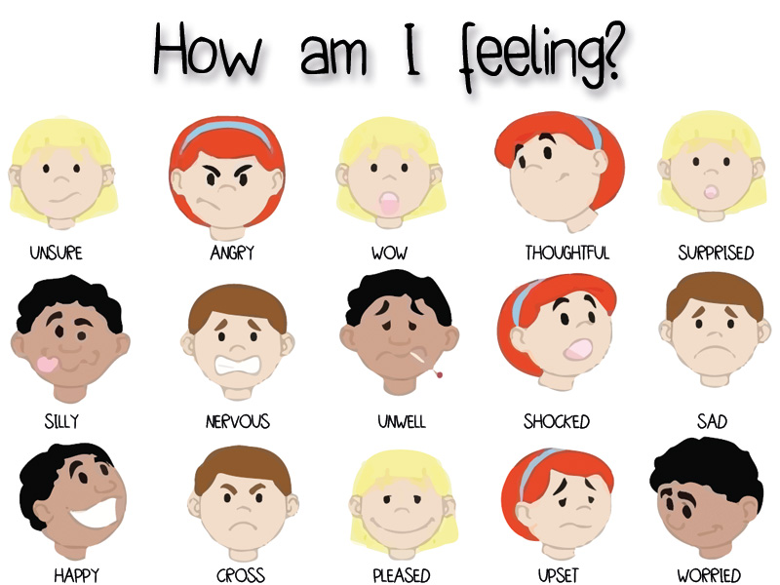

Draw a picture (or write any additional comments) about your experiences, during lockdown, at home (if your child is unable to complete this a carer could write some comments on their behalf)…

Lockdown Ladder

Steps to getting your child ready to come back to Nursery/School

Lockdown Ladder

Steps to getting your child ready to come back to Nursery/School.

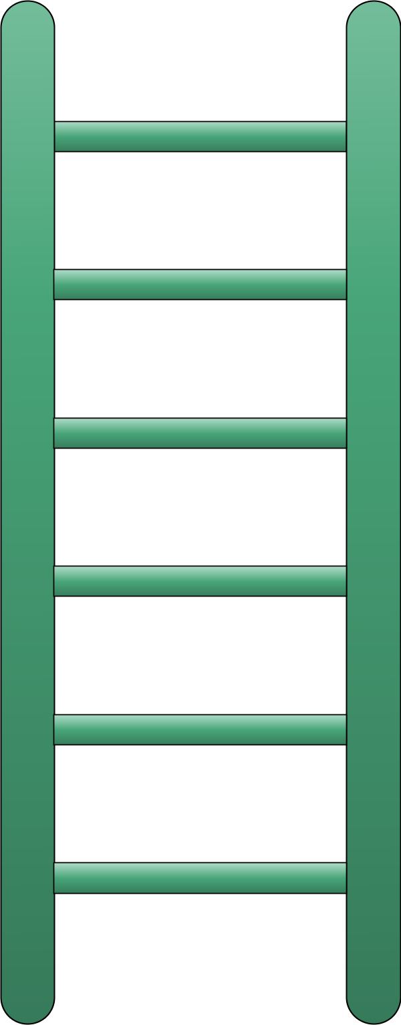
Top tip: A countdown calendar can help to show your child when/what day they will be going back to Nursery/School helping them to prepare for going back.
Ready for Nursery/School.

Top tip: Visual resources such as timetables and routine strips can assist with independent skills and can make transitions easier.

Practice your route to nursery/school with your child.

Top tip: Social stories are a good way of preparing your child for nursery/school and the changes ahead.

Create a morning routine e.g. washing, brushing teeth times, breakfast times.

Top tip: Rewards no matter how small are a good way of reinforcing positive behaviour.
Practice getting dressed into uniform or create a dressing routine.

Create a structured daily routine for your child e.g. play time, learning time, story time.
Try and get your child into a regular bedtime routine/sleeping pattern.
Try and get your child into a consistent eating pattern e.g. snack and meal times.

Health Protection Surveillance Centre Respiratory Hygiene Posters

Health Protection Surveillance Centre – Respiratory Hygiene Posters

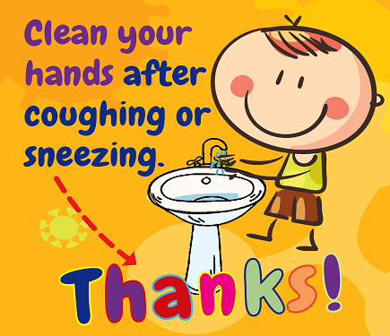
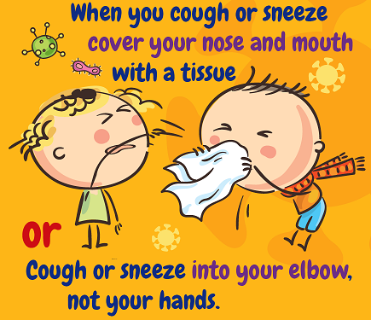
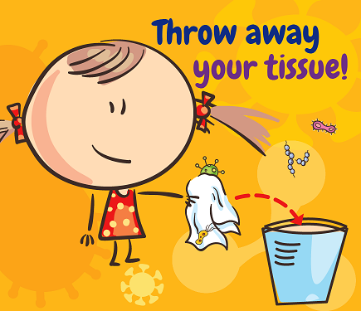
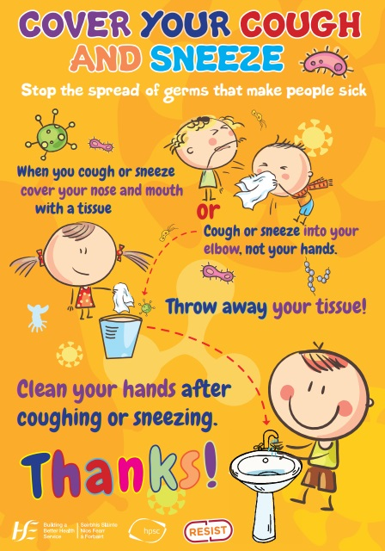

https://www.hpsc.ie/a-

Top Transition Tips

Top Transition Tips

All of these tips are advice to help you and your child’s transition back into how your lifestyle was pre lockdown. It aims to provide your child with the daily structure and routine that will be expected of them in the next few weeks and hopefully makes this transition easier for yourself as well as your child.

- Teach your child how to wash their hands correctly-
Tip: you could create a song that they have to sing before they are done washing.

- Teach your child about social distancing-
Tip: you could use a hoop and this is the child’s personal space to stay in, no one comes in or out while at your setting.

- Get your child into a similar routine as your nursery or school –
Tip: think about eating timings, play timings etc.

- Practice transitioning times (changing between different activities during the day)-
Tip: use sand timers for countdowns.

- Start to introduce a structured bedtime/sleep routine-
Tip: this will help with enabling your child to get up for school/nursery when the time comes more easily.

- Practice/create a morning routine that your child can continue when they go back to school/nursery-
Tip: washing, brushing teeth, getting dressed, breakfast.

- Once you know when your child is returning to nursery start a countdown calendar-
Tip: This will help your child to ‘see’ when they will be going back and prepare them for the transition.

Things to remember
Covid-19
Things to remember

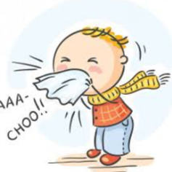
- Cover your mouth with a tissue or you arm when coughing and sneezing

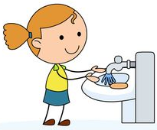
- Wash your hands before and after eating, when you cough, sneeze or go to the bathroom

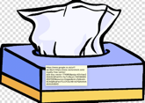
- Use a tissue when blowing your nose
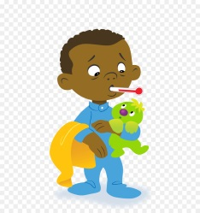
- Everyone gets sick sometimes

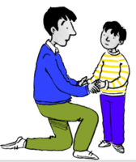
- If I feel scared I can tell my parents or someone I can trust



Everyone gets sick sometimes
Social Story

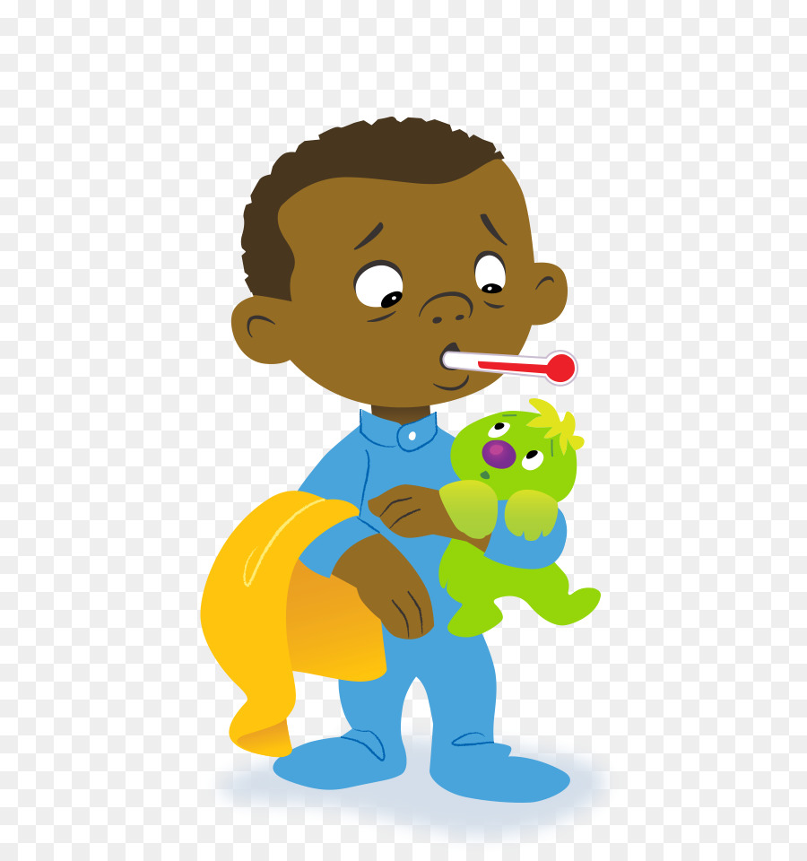
Everyone gets sick sometimes…

We get sick because of germs. Germs are tiny invisible things, that live on all things, including inside of me.
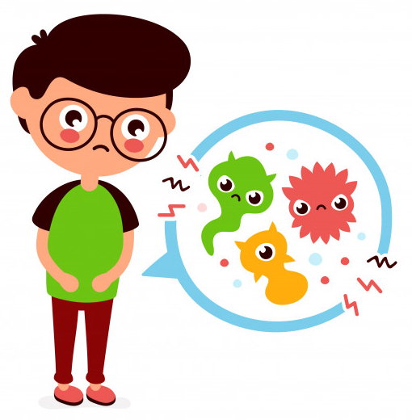
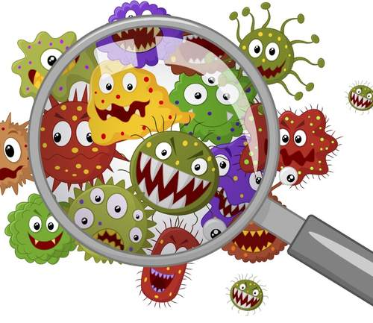

There are some germs that make us sick while some keep us healthy. If bad germs stick to me, they can cause me to get a cold, sore throat or a cough.
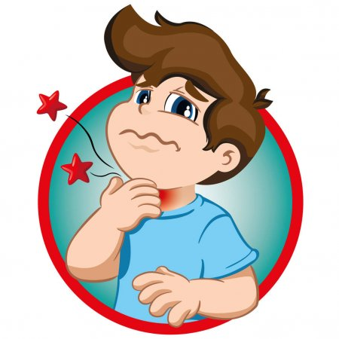

Sometimes, germs can make us really sick, like the germs that cause the flu. This might sound scary, but it’s ok! There are things I can do to help stop the germs from making me sick. These things are called hygiene.
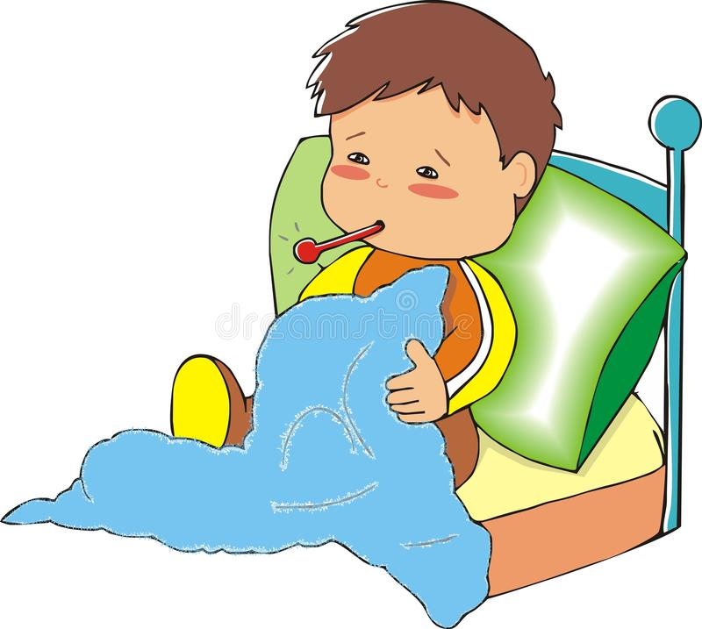

There are germs that doctors and scientists are still learning about. Sometimes this causes people to feel scared. It’s ok to feel this way. Scientists are working hard to make sure these germs don’t spread and help those that are sick.


Washing hands is the best way to stop the germs from making me sick
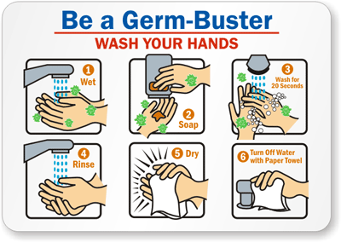

I can sing the ‘Happy Birthday’ song twice while washing my hands. This makes sure I wash my hand for a full 20 seconds.
First, I should always wash my hands before eating and after using the bathroom. If there isn’t a sink or place to wash my hands, I can use hand sanitiser gel or wipes. This gets the germs off my hands.
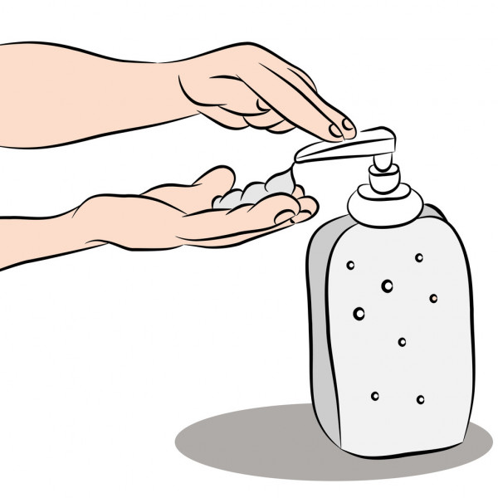

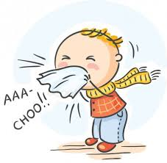
Germs live in sneezes and coughs too. If I have to sneeze or cough, I should cover my mouth with a tissue or arm. Once I am done sneezing or coughing, I should wash my hands.

If I have to blow my nose, using a tissue is a good idea. Once I am done, I should throw the tissue away and wash my hands.



Even though I use good hygiene, I still may get sick. It’s okay because everyone gets sick sometimes. My family may want me to stay home if I get sick. This is a good time for me to rest. Rest helps my body get better.
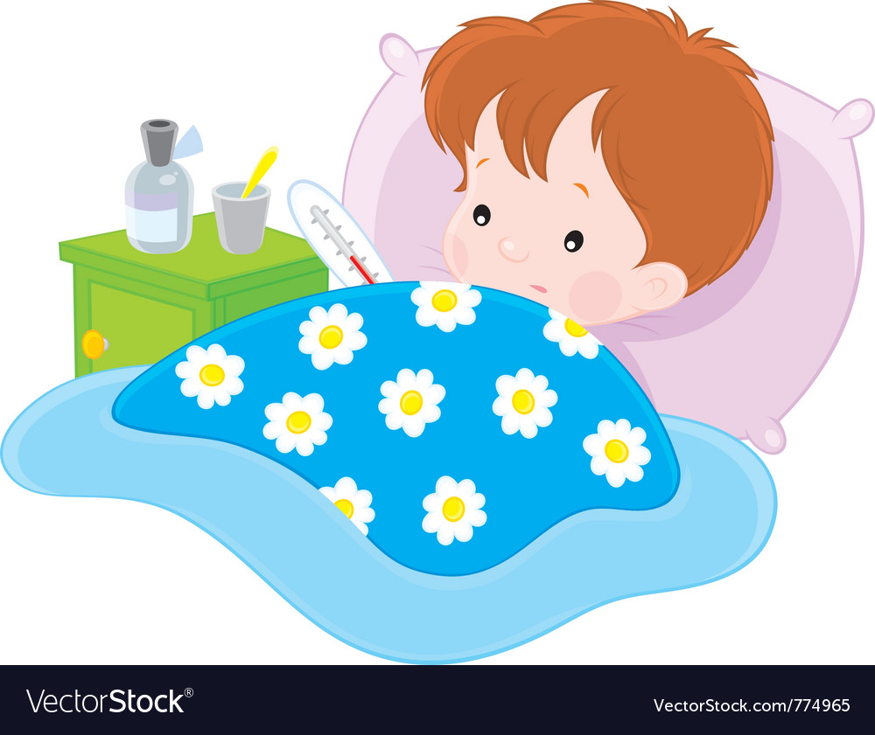

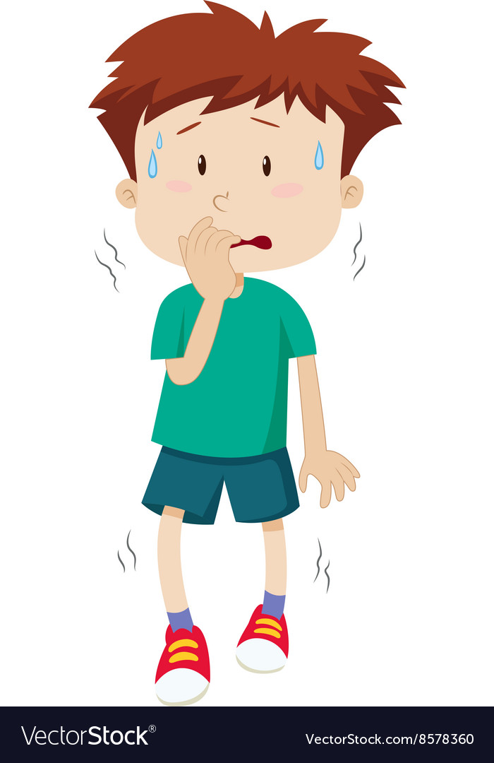
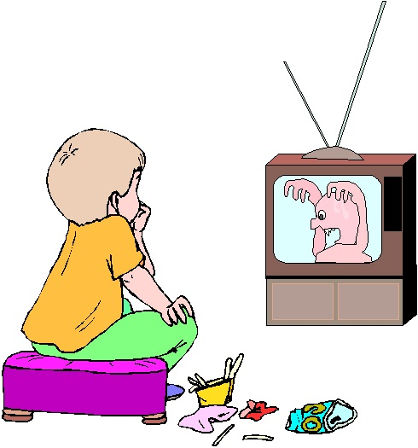
When lots of people start getting sick, people can become afraid. I may hear scary things at school or on TV. These things may make me feel scared, nervous or unsafe. It is ok to feel like this.

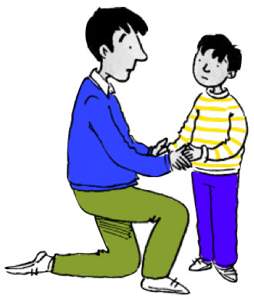
It’s okay to talk about my feelings. I can tell someone I trust how I am feeling. They can help me feel safe.

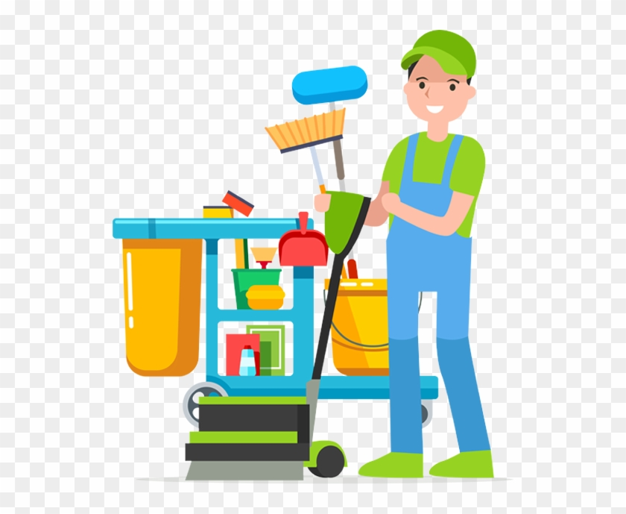
If a lot of people in my school or community get sick, I may have to stay off from school. This is so my school can get rid of all the bad germs that are making people sick.

Things to remember:
- Cover your mouth with a tissue or your arm when coughing or sneezing.
- Wash your hands before eating and after coughing, sneezing or using the bathroom.
- Use a tissue when blowing your nose.
- Everyone gets sick sometimes.
- If I feel scared I can tell parents or someone I trust.
My handwashing routine…

Handwashing
20 second strategy
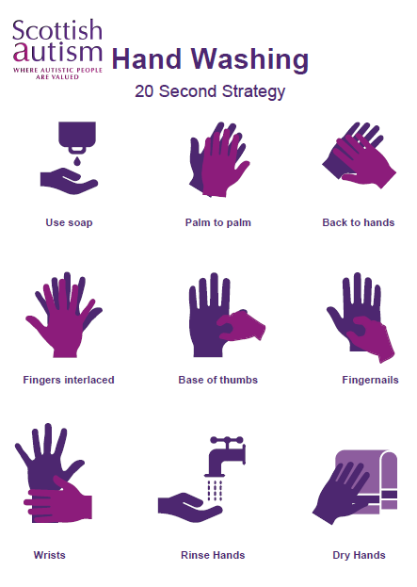

Sneeze or cough
into elbow
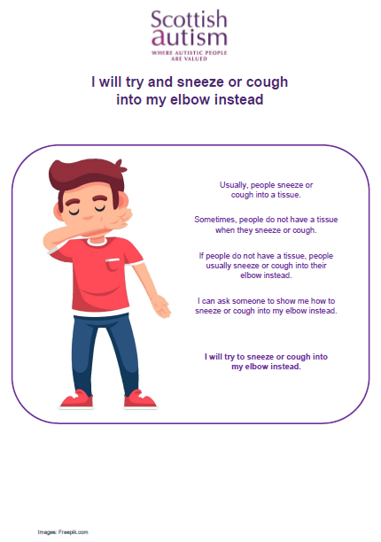

Transitions back into school after COVID-19
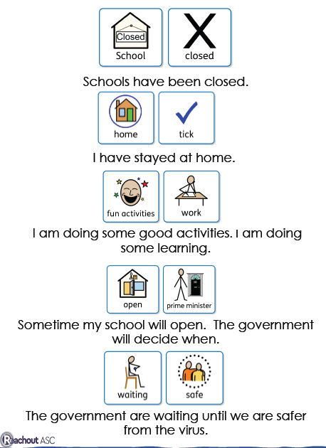

Hygiene
Makaton
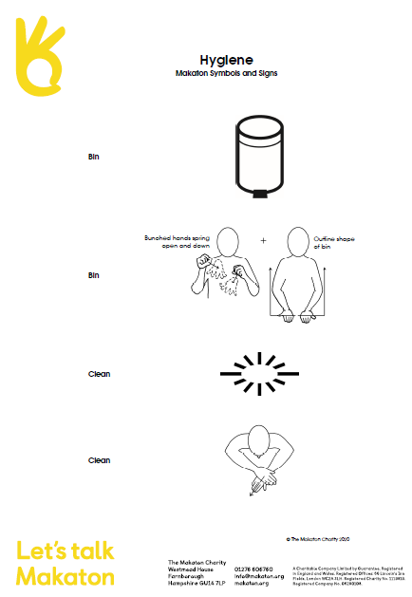

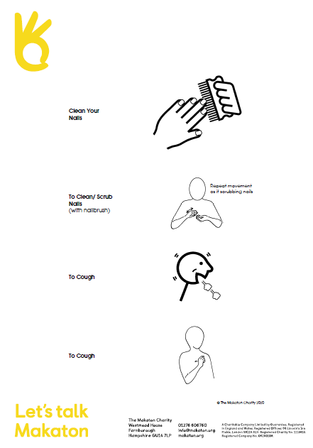

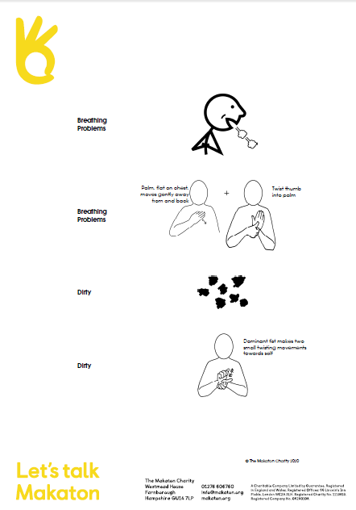

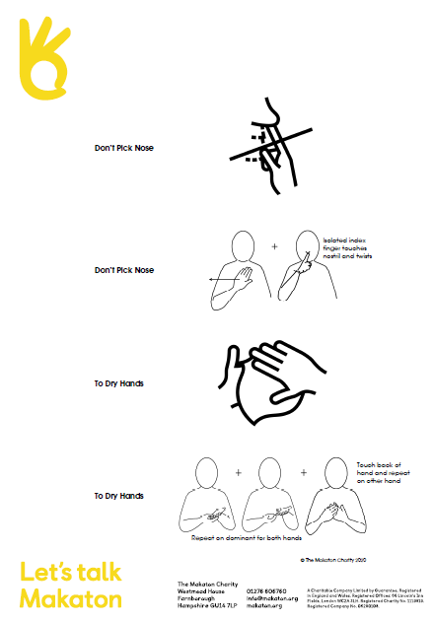

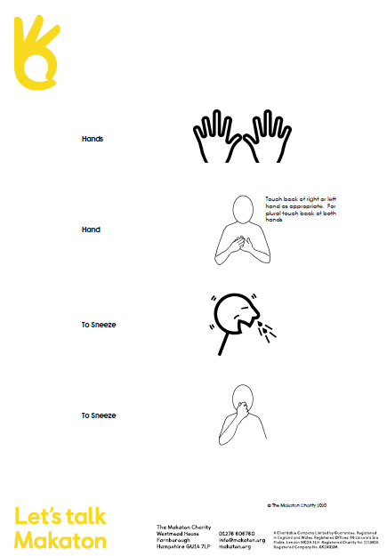

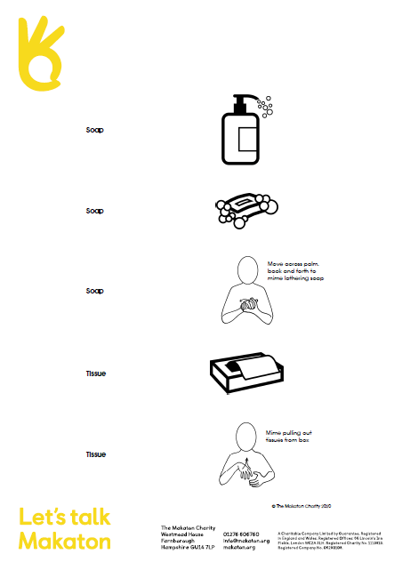

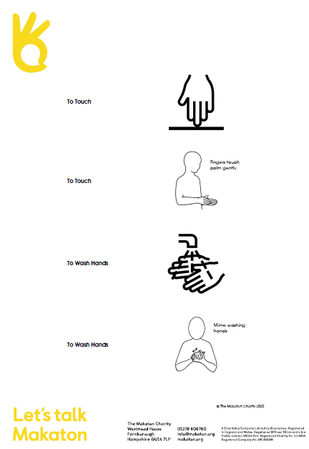

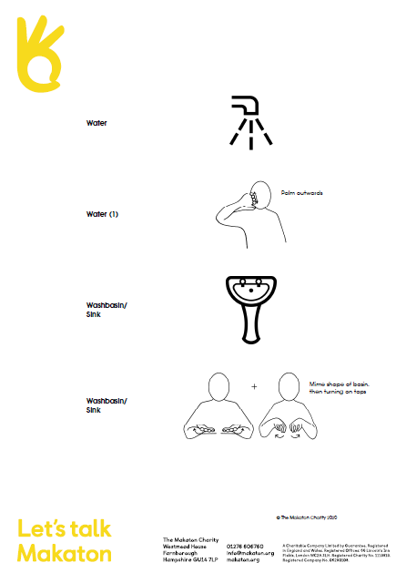

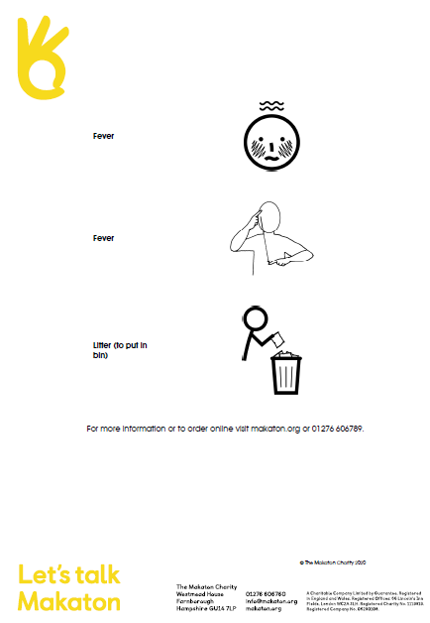

Parent feedback
Nursery/Setting:
Dear Parent/Carer,
In anticipation of child/ren returning to our setting/nursery we would like to invite you to feedback your experiences with your child throughout lockdown. We haven’t seen you or your child for some time now and we value your contribution to your child’s learning experiences. The information that you submit will also provide us with valuable information that could support your child’s transition back into nursery and perhaps thinking further ahead, into school.
What has your child enjoyed doing most during lockdown? (are there particular activities that your child has regularly accessed):

Has your child learnt anything new – this could be words, letters, numbers, IT skills, play skills, social skills, self-help skills?

Has your child found anything particularly challenging/stressful during lockdown?

If there is anything further you wish to add regarding you and your child’s lockdown experience please use the blank space overleaf:-
What have you, as a parent/carer; found most challenging with your child through your lockdown experience together?

