Early Years and Prevention Service
  - Good Practice

ready for the nex t stages of learning – covid 19 |  | June 2020
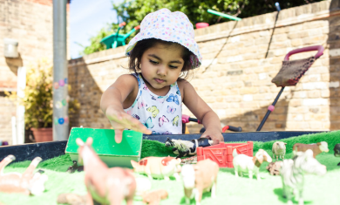

Action plan for Transition in Early Years

- What all organisations need to know
Actions | Timeline | Who for?
- Create and share the overall vision for reopening and children returning  - Create and share timeline and Transition framework  - Consider the need for Personalised transition action plan for various levels of support/document  - Recognise that all children can be vulnerable at this time of change, particularly those with additional needs.  - That organisations work together to meet the needs of the children  - Contacts for each area of concern and support required  - Child protection, domestic violence, food banks, Distancing for staff parents of agencies reminders and early years team and specialist support for vulnerable children  - Make sure people know the relaxed requirements of EYFS changes to ratios/staff etc and can support children going to their next stage of learning.  - A transition plan is in place in line with COVID DFE rules. – safety measures for all to abide by. (based on government guidelines)  - Make sure staff who work with children with additional needs have access to and have read reports from other professionals | End of June although timeline needs to change to ensure all children have some indication of what is to happen to them  Beginning of June | All
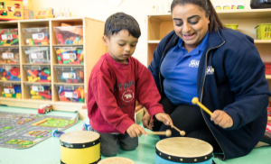
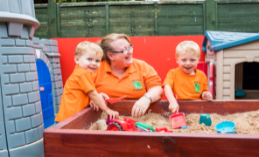
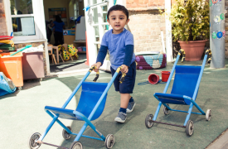

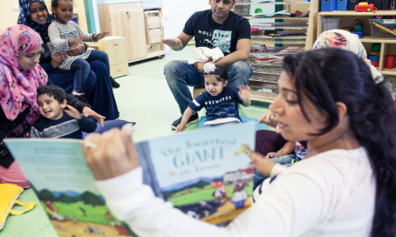
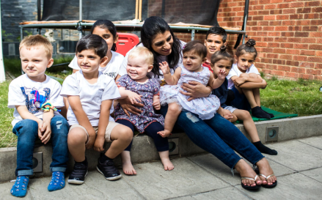
- How settings/schools can support early years parents
Actions | Timeline | Who for?
- Encourage schools to get email and phone numbers of parents so they can contact them and talk to the face to face safely – rather than home visits.  - Develop guidance for early education to parents with possible ‘Teams’/facetime with parents who have children who are vulnerable or SEND  - Video’s and tips on how they can support their child’s transition process - Encourage virtual visits for a child’s next school to the setting. Summer Term 2 to meet/talk with the child’s key person using IT technology such as what’s app video, zoom etc.  - Encourage families to walk the route to the new school as part of their daily exercise – talk about the things that they pass and positive conversations about the new school – friends, having lunch, new toys to play with etc  - Parents are reminded they need to keep their child’s immunisation schedule up to date prior to starting school. Not just COVID  - COVID reminders of social distancing measures that the setting will have on place for parents and children  - Work with parents to ensure staff know the languages spoken at home, and how families and people would like to be addressed. Develop awareness for the cultural rules regarding interaction and understanding of changes required due to COVID  - Develop Early Years guidance for parents – to focus on the importance of play and the 7 areas of learning/COEL and share with them the document What to expect, when?  - Develop two year old guidance. Share activities on encouraging healthy eating, sleeping routines and regular physical activity to keep well. Suggest examples of cooking at home, making smoothies and fruit kebabs.  - Read with children, talk with them and recognise and acknowledge their emotions.  - Encourage independent skills and hand washing and other hygiene routines during the day  - Enjoy playing games together. Encourage turn taking and sharing. Use games and home routines to count objects.  - See the Transition Toolkit which include Social stories | ASAP | Parents

H

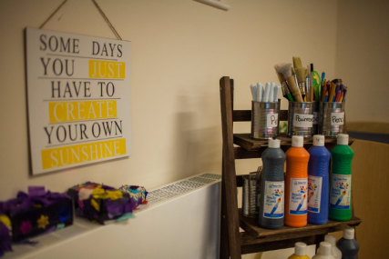
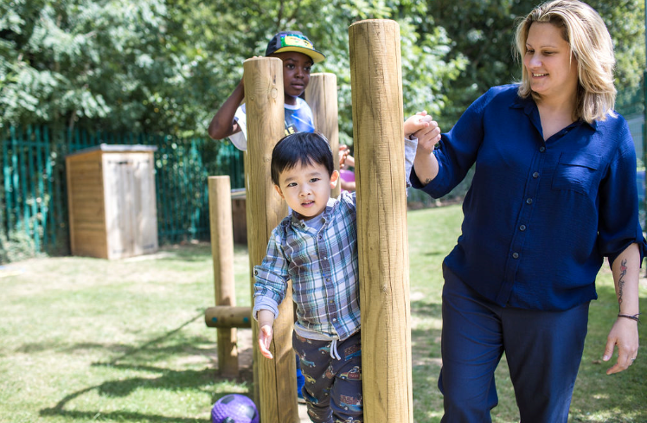

- How settings/schools can support children going to school

Actions | Timeline | Who for?
Listen to what parents can tell us about their children and accept that as parents and carers, they have a wealth of knowledge we would so well to listen.  Guidelines on how children should behave going to and from school.( Government guidance.  - Share with children the rules and expectations at a school/setting.- linked and not linked to COVID  Develop a parent friendly guidance on the focus in Reception.  Staff identify family’s who struggle or unable to provide the child with the equipment they need to start school such as school uniform and shoes and provide support.  Comment on good communication with parents and previous providers, staff identify and plan for individual needs of children prior to starting; such as support to toileting independently, to communicate, share resources and interact positively with other children and adults with distancing methods  Setting/school transition plan includes a section on transition for late and in-year arrivals. This may be due to self-isolation. Those children starting later should follow the same processes that would be part of the first cohort joining the school/setting  - Enabling environment and heuristic play and natural materials as resources, following government guidance and your own risk assessment. Resources could be split so this could happen as one off sessions with cleaning taking place after each session  - Intimate care policy and how that is affected by COVID – good practice would encourage key person where possible to undertake this for children’s emotional development as well as meeting the guidance about reducing the contact/mixing between children/adults  - Visual Resources can be shared with families before the children start with the setting. See the Transition Toolkit | ASAP | Schools/Settings (PVI’s)

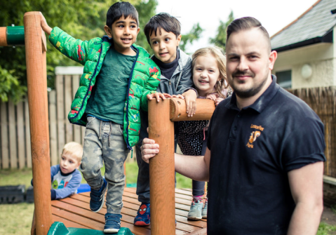
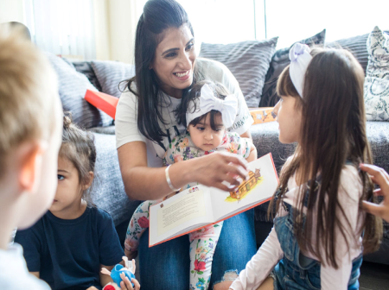
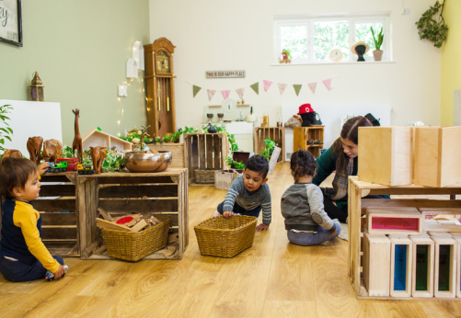

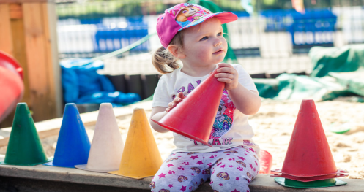
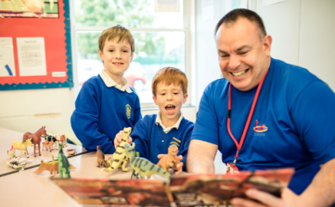
- The use of assessment

Actions | Timeline | Who for?
Define cohort – e.g. reception age/nursery age/2 year olds/ those that arrived late length of time in setting.  Inform what the assessment is linked to - Cornerstones/development matters/(non-statutory guidance) but must be linked to EYFS as its the statutory document we must abide by  Emerging developing secure/formative rather than summative – next steps and sharing individual children learning journals to show progress/COEL strengths.  Are they below their age/in line and in which areas?  Ensure toilet training is included & is inclusive  Ensure Characteristics of effective learning are enhanced and part of any assessment opportunities  Make sure that shared assessment is what they’ve learnt and not what they’ve covered.  The use of progress from their starting points particularly specific areas of learning (particularly, PSED with some all areas of learning) so they settle to learn.  Ensure staff know the strengths of a child’s COEL and which ones they have embedded well  Provide the next school/setting with a summary of attainment for each child, including the child’s two year check if it was carried out.  Staff provide additional information for the transition of children with SEND, medical needs and Looked-After Children  staff who work with children with additional needs have access to and have read reports from other professionals  Staff take into account the parents’ and child’s voice and record it to support the child to settle well and inform initial assessments. Information sent up by the feeder settings are read as part of this process  - Share strengths and area of development for individual children and any common strengths and areas to improve for a cohort. - | By July | Practitioners and teachers

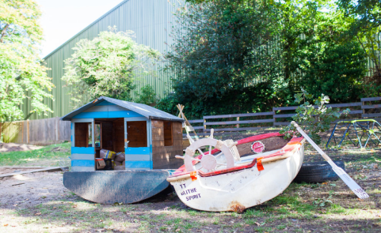
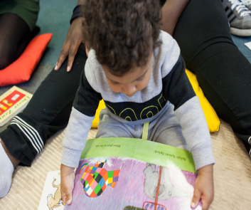

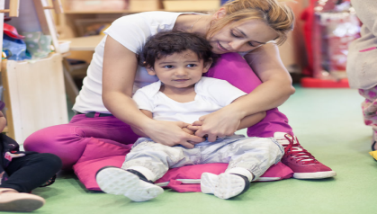
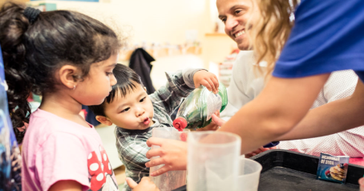
- What children may need to support transition

Actions | Timeline | Who for?
If possible, invite parents and children in for a visit – small numbers and distancing adhered to by the school staff and parents.  The new setting/school has a clear, welcoming procedure.  Establish routines and expectations so children feel more secure in new setting  Focus on purposeful play including activities that the children enjoy  Know the children and their interests and needs according to age so they can continues their learning from their last starting point.  The key person needs to play a pivotal role to play in supporting and preparing the child for transition even if by phone or facetime (if possible);(children who may experience feelings of sadness and resistance before leaving a setting, especially if he/she has been there for a very long time).  Opportunities for ‘purposeful play’ outside to support their development (for those children who have been in flats /indoors during lock down)  Creating a learning environment and Improving children’s opportunities to develop the characteristics of effective learning (Ofsted- these important as they take into their next stage of learning call these disciplines that children need)  COVID reminders of distancing  Ensure children have the opportunities to embed learning they may have forgotten (repetitive opportunities through the 7 areas of learning) and give examples  Remind and support children with how to wash their hands. Visual prompts are good to use.  Focus on children’s PSED and emotions – use practical resources and time for this  Help children to develop there dressing skills. Some children may need visual prompts.  Make use of the Bursts for Learning document for supporting home learning.  Use stories to explore the new situations that the child will experience when he/she moves. Stories, particularly open-ended ones, can empower a child to reason and problem solve independently.  Put up and talk about posters and social stories that address cover sneeze cough/catch it bin it kill it  Song and rhymes which reflect the needs of their learning about literacy and emotional literacy but linked to books which support them (books that reflect where they are emotionally but also phonically.( one size does not fit all!)  Children’s relationships with both adults and children. Having friends in the same key group may help children adjust to the demands of the new environment and stay away from other key groups  Some children will attend more than one setting during the course of the day e.g. a breakfast club, school, after school club and/or a childminder. practitioners work in partnership to exchange information Such as being settled, likes and dislikes home concerns and what their routines at the setting are compared to the main setting they attend  - Nursery / reception classes to take pictures of their environment to be able to send home to families so children are able to see their new environment. | As and when | Children

- Government Guidance doc. ‘Supporting children and young people with SEND as schools and colleges prepare for opening’

Actions | Timeline | Who for?
Paragraph 3: ‘Throughout the coronavirus (COVID-19) outbreak, educational settings have been asked to ensure that vulnerable children and young people can attend where appropriate, including those children and young people who have an EHC plan, and for whom it is determined, following a risk assessment, that their needs can be as safely or more safely met in the educational environment. As settings prepare for wider opening, they should continue to offer places to vulnerable children and young people and should look to bring back more children and young people with EHC plans in these target year groups. Their return should be informed by their risk assessments, to help educational settings and local authorities ensure that the right support is in place for them to come back.’  Link to full document: https://www.gov.uk/government/publications/coronavirus-covid-19-send-risk-assessment-guidance/coronavirus-covid-19-send-risk-assessment-guidance | ASAP/ongoing | Staff

Transition information, advice, strategies and resources ‘back to nursery post COVID19 Lockdown’ for settings, child-minders and parents.
INFORMATION | Timeline | Who for?
What learning opportunities did children have during lockdown and how do they feel about it?  Children, parents and families are likely to have had very different experiences with lockdown and home learning and opportunities for them to share these with others may be helpful. Use of materials from the ‘EY transition Toolkit Parents COVID19’(to be provided by Early Years and Prevent) such as;  ‘How I found Lockdown’ – child  ‘Parent feedback’  What do we know about the impact of coronavirus on daily life at the current time? How will information be shared with children about current advice on safety in relation to coronavirus?  Use of social stories;  - Read story pack to be provided by Early Years and Prevent:-  ‘Why haven’t I been going to nursery…’  ‘Sometimes I sneeze or cough…’  ‘When I have used a tissue…’  ‘Some people wear face masks…’  - Visual sequence strips for washing hands in the bathroom  - Incorporate Makaton signing ‘hygiene’ (document to be found in ‘EY Transition Toolkit Settings COVID19) to be provided by Early Years and Prevent. | ASAP/  ongoing | Staff & parents  Staff and parents – Staff can regularly read the social stories with children. Settings can share the social stories with parents either by printing off stories or sharing via email where possible.

INFORMATION | Timeline | Who for?
How are changes to nursery routines and rules being considered? What will be the same and what might need to change? How will clear structures and routines be communicated?  - Updated visual timetables  - Visual/verbal countdowns, rhythm or music  - Seating plans (use hoops, carpet squares etc.)  - Labelling of areas (photographs) for storing belongings  - Social stories  BELONGING:  How can we make sure children feel welcomed back to the nursery family?  - Warm and welcoming language which shows you have been thinking about them e.g. ‘I’ve missed seeing your smile’ or ‘I was thinking about you when…’  - Celebrating missed events together e.g. birthdays  RE-ENGAGING:  How can we prepare children for coming back to nursery?  - Is the lay-out of nursery going to be different? Could we share this through a virtual tour?  - Use materials from ‘EY Transition Toolkit for Parents COVID19’ to be provided by Early Years and Prevent e.g.  ‘Lockdown Ladder’’  ‘Early Years Transition Book’  ‘Top Transition Tips’  For further SEND support regarding advice/ resources for individual  children please contact:  Cathie Woodbridge - Senior Area Senco and SEN Advisor  Email: catherine.woodbridge@slough.gov.uk  Sarah Covell – SEND Support Officer  Email: sarah.covell@slough.gov.uk | ASAP/  ongoing | Staff & parents  Staff and parents – Staff can regularly read the social stories with children. Settings can share the social stories with parents either by printing off stories or sharing via email where possible.
