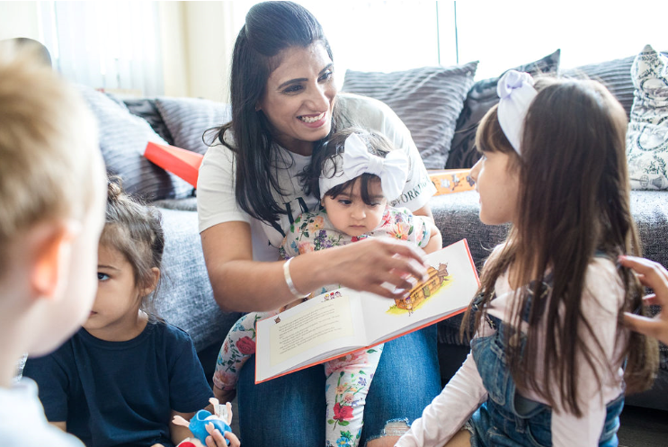
  Early Years and Prevention Service
    - COVID-19
Recovery Planning for EArly Years and childcare providers |  | In This Issue: 19th June 2020

Statutory guidance for schools and colleges on safeguarding children and safer recruitment.

'Keeping children safe in education (from 1 September 2020)'. This document is for information only and does not come into force until 1 September 2020 - continue to refer to KCSIE 2019 until then.
You should also read Coronavirus (COVID-19): safeguarding in schools, colleges and other providers alongside this guidance.
.
This is statutory guidance from the Department for Education (the department) issued under Section 175 of the Education Act 2002, the Education (Independent School Standards) Regulations 2014, and the Non-Maintained Special Schools (England) Regulations 2015. Schools and colleges in England must have regard to it when carrying out their duties to safeguard and promote the welfare of children. For the purposes of this guidance children includes everyone under the age of 18.

The guidance should be read alongside:
• statutory guidance Working Together to Safeguard Children;
• departmental advice What to do if you are Worried a Child is Being Abused - Advice for Practitioners; and
• departmental advice COVID-19: safeguarding in schools, colleges and other providers

COVID-19
Keeping Children Safe in Education (KCSIE) remains in force throughout the response to coronavirus (COVID-19).

The department has issued non-statutory interim guidance on safeguarding in schools, colleges and other providers during the coronavirus outbreak. This guidance supports governing bodies, proprietors, senior leadership teams and designated safeguarding leads to continue to have appropriate regard to KCSIE and keep their children safe.

The Early Years Foundation Stage Framework (EYFS) is mandatory for all early years’ providers. It applies to all schools, including maintained nursery schools that have early years provision.

Keeping Children Safe in Education (from 1 September 2020)


Transitions
Children who are supported through early transitions learn positive ways of coping with change. As they grow they are more likely to cope with change whenever it may occur and at any stage of their lives. Page 2

Ask Michael
What support is available to providers who are receiving monthly payments based on estimates given at the start of the financial year, when these estimates are much higher or lower than anticipated? Page 3
Transitions in Early Years

Children who are supported through early transitions learn positive ways of coping with change. As they grow they are more likely to cope with change whenever it may occur and at any stage of their lives. We want the transition to be an exciting, comfortable time for all the children, well supported by a thoughtful approach.
‘’When you think about transitions during the early years, you usually think of joining the setting, moving rooms for example from baby room to toddler room within the setting or starting school, these are usually defined as vertical transitions. Practitioners are very aware of these types of transitions and have activities and steps in place to make the transition as smooth and stress-free as possible for the child. However, it can be easy to forget that small changes throughout the day are also transitions such as moving from playing to have a nappy change, the room to the outdoors if its set periods or from story time to lunch time, these are often referred to as horizontal transitions. While most children will accept these changes and be happy to follow the routine and be un-phased by the transition some children will find these transitional parts of the day challenging and difficult to manage. This can lead to the children appearing to be in distress and episodes of unwanted behaviour. If the child is finding these transitional periods difficult you may find the child uncooperative, lashing out, having a tantrum, point blank refusing and in some cases aggressive as they try to avoid the change and disruption that is about to happen. There are some reasons that children may struggle with horizontal transition, and it may be useful to complete observations and refer to the child’s development tracking tools to discover in there are any areas of further concern’’. https://www.earlyyearscareers.com/eyc/learning-and-development/supporting-daily-transition/

‘The strong skills of all key persons ensure that all children are emotionally well prepared for the next stages in their learning. Practitioners skillfully support children’s transitions both within the setting and to other settings and prepare them for the move to school.’ Outstanding descriptors, Early Years Inspection Handbook, Ofsted (2018)
Key principles for good practice in supporting successful early years transitions
Unique Child
• Recognise that all children, can be vulnerable at times of change, particularly those with additional needs e.g. those with a Special Educational Need (SEN) or a child in care. Planning for these children will need additional, flexible support.
• Prepare the child for change. It is important that all children experience a positive transition. With appropriate preparation and understanding, children are more likely to feel secure and settle more easily into their new environment. It is here that the Early Years Summary/Transfer Form can act as a supportive tool within the transition process. Visual aids and social stories that can be shared with parents to also use at home will help prepare children for change.

Positive Relationships
• Transitions can be eased by careful proactive planning, sharing of information and mutual visiting between parents, carers and professionals.
• Listen to and acknowledge the important role of parents and carers throughout this process
• Work together; an essential element of an effective transition is for childminders, settings and schools to work together, to establish a clear understanding of one another’s aims, purpose and philosophy.
• Offer a range of opportunities for parents and carers to access information about the transition process, e.g. open days, information events, consultations, newsletters.

Enabling Environments
• Children cope better with transitions when conditions are similar, communication is encouraged, and the process of change takes place gradually over time
• The emotions that come with change can be successfully handled by children when their new setting/school has a clear, welcoming procedure.

Children learn and develop in different ways and at different rates
• Ensure that consideration is given to the child’s holistic needs. It is important to ensure that the continuity of children’s experiences involves all aspects of their care and learning

Starting in a childcare setting can be hard for parents as well as children. As a childcare professional, you're in a great place to support parents and children through this transition.

https://www.pacey.org.uk/working-in-childcare/spotlight-on/2-year-olds/separation-and-transitions/

Slough Early Years and Prevention Service has developed a Transition Guide and a Transition Tool Kit to help you with future planning arrangements



Ask Michael
Service Lead Early Years and Prevention

Answering your questions

What support is available to providers who are receiving monthly payments based on estimates given at the start of the financial year, when these estimates are much higher or lower than anticipated?

In these difficult times, we have to be as flexible as we can be to ensure that settings remain open and able to provide FEE, without causing overpayment and putting settings at risk if they have to pay funding back.
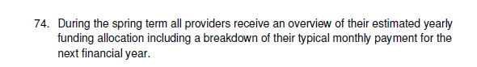
The DfE agreed to continue to fully fund all settings during lockdown. The payments made to settings in April, May and June were based on these estimates. Settings that took on vulnerable and key worker children over and above their funded numbers went to virtual panel for assessment and to agree payment by invoice. If you think you are in this position please contact us by email to EarlyYears@slough.gov.uk
All the current monthly payments have been calculated as shown in #75, although some childminders and settings are being paid a monthly figure based on the summer term only. If you feel that your setting would benefit from a termly calculation rather than an annual one, please send an email to EarlyYears@slough.gov.uk
We will not change any payments without a request to do so in writing.
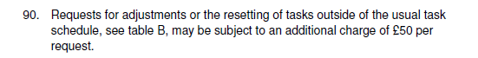
Multiple requests to change monthly payments or adjustment funding will attract additional charges
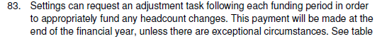

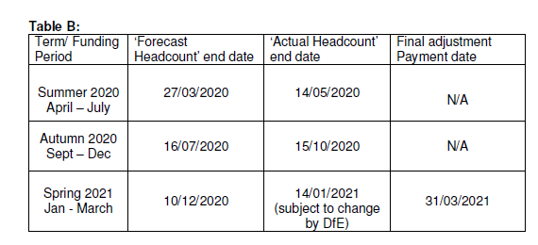
If your provision has exceptional circumstances such as financial hardship, we will consider making adjustment payments before the end of the financial year in March 2021. You will need to email EarlyYears@slough.gov.uk giving us your reasons for this. The Early Years and Prevention team made this change to adjustment funding because of the large proportion of settings who had to have funding clawed back at the end of the financial year.
Change to the Department for Education Early Years Data Return from 22nd June 2020
From 25th June the Department for Education are asking local authority early years teams to submit data from all providers once a week on a Thursday. They require information about children attending early years provision and information about the settings capacity.

This data will be used by the DfE and the local authority to monitor the supply of and demand for early years and childcare.

If your setting is not currently open you are not required to complete the submission, however if your setting is open other days of the week we ask you to complete the data sheet for your busiest day and submit this before 12pm on a Thursday.

Please submit your data sheet to earlyyears@slough.gov.uk before 12pm every Thursday.

Nursery schools and schools with nursery classes: All school with nursery provision are asked to submit their school registers to COVID-19.SchoolAttendance@slough.gov.uk. On Thursdays schools are required to include all nursery children on their submission, highlighting which children are in nursery.

Childminders: If your data does not change from week to week, you are not required to submit the same data every Thursday. However if the information you have previously submitted changes please complete a new data submission return and send to earlyyears@slough.gov.uk by 12pm on Thursday.

All childminders open on Thursday 25th June will be required to complete a submission.

PVI settings and children centres: Please complete the data task every Thursday before 12pm and email the data collection sheet to earlyyears@slough.gov.uk

The data collection sheet will be sent out to all providers (excluding nursery schools and schools with nursery classes) on Tuesday 23rd June.

Local Authority Discretionary Grants Fund (LADGF) Deadline extended to 21 June
Deadline to apply for Local Authority Discretionary Grants Fund (LADGF) to assist businesses facing financial hardship due to COVID-19 pandemic, has been extended to 21 June.

Until 21 June Slough businesses are set to benefit from an additional support fund set up by government to help small businesses who were not eligible for the Small Business Grant Fund or the Retail, Leisure and Hospitality Fund.

The Local Authority Discretionary Grants Fund (LADGF) will be distributed to businesses facing financial hardship due to the COVID-19 pandemic.
Slough Borough Council like other local authorities across the UK, will distribute grants to the value of £5,000. Local authorities are encouraged to make payments as swiftly as possible to support struggling businesses. It is anticipated that the first payments made under the scheme will be received by businesses early June.

Only businesses that were trading on 11 March 2020 are eligible for this scheme and businesses who have applied for the Coronavirus Job Retention Scheme are eligible to apply for this scheme as well.

The government has asked local authorities to prioritise the following types of businesses for grants:
- Small and micro businesses, as defined in Section 33 Part 2 of the Small Business, Enterprise and Employment Act 2015 and the Companies Act 2006.
- Businesses with relatively high ongoing fixed property-related costs.
- Businesses which can demonstrate that they have suffered a significant fall in income due to the COVID-19 crisis.
- Businesses which occupy property, or part of a property, with a rateable value or annual rent or annual mortgage payments below £51,000.
A document setting out the eligibility criteria and an online grant application form is now available on the council’s website so eligible businesses can submit their applications. Assessments and payments will be made throughout the month. More information and access to the form can be found here: https://www.slough.gov.uk/news/newsdetail.aspx?id=22321
Companies that are in administration, are insolvent or where a striking-off notice has been made are not eligible for funding under this scheme.
Only businesses which were trading on 11 March 2020 are eligible for this scheme.

This grant funding is for businesses that are not eligible for other support schemes. Businesses which have received cash grants from any central government COVID-19 related scheme are ineligible for funding from the Local Authority Discretionary Grants Fund.
Businesses who are eligible for the Self-Employed Income support scheme (SEISS) are eligible to apply for this scheme as well.
Businesses who have used the Job Retention Scheme are eligible.
Businesses who have received funding through Retail, Hospitality and Leisure grant, Small Business Grant or Self Employment Income Support Scheme are not eligible.

Grants are subject to tax.
COVID-19 and flexible working: the perspective from working parents and carers
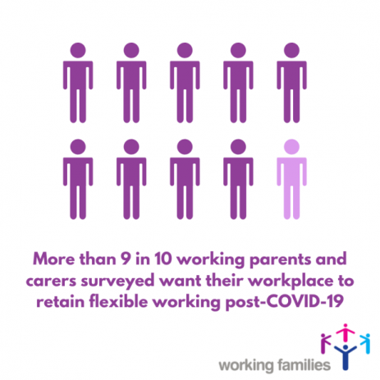
The COVID-19 lockdown has posed particularly intense challenges for the UK’s 13 million working parents. Since schools and childcare settings have closed, one in seven workers across the UK have had to make changes to their work pattern to balance work, childcare and very often home-schooling requirements.
For those who have been able to carry on working during the crisis, there has been a huge shift in the way we work, with an estimated half to two-thirds of workers working from home at some point during the lockdown. The COVID-19 pandemic has shown that flexibility can be unlocked in many, many more jobs than previously thought. In this report, based on Working Families’ survey of 1,063 working parents and carers, we explore these parents’ and carers’ experiences of flexible working during the lockdown, and their plans and aspirations for flexible working after the lockdown.
The overwhelming majority of working parents and carers we surveyed do not want their employer to return to revert to business as usual after lockdown is lifted. It is time for the UK government and employers to #flextheUK – extending the flexible working opportunities afforded some parents and carers during lockdown to all parents and carers.
https://workingfamilies.org.uk/publications/covid-19-and-flexible-working/?utm_source=Working+Families&utm_campaign=635611bdc3-EMAIL_CAMPAIGN_2019_09_06_08_51_COPY_01&utm_medium=email&utm_term=0_57b0d3009b-635611bdc3-124856953
Getting play right in early years post-Covid: a guide

In social distanced, infection-control orientated schools, how can we ensure children can still use play for learning? Like this, says Deirdre Grogan and Sue Ellis. Young children have been indoors and isolated for weeks. When they get back to school, they need a quality, play-based experience with opportunities to organise their own learning, choose their own resources and collaborate (in small numbers) with peers and adults.

Young children learn by being active and communicating, so how can we safely implement play in early years classrooms? Denmark met the challenge by creating small bubbles of children who work and play together, with each bubble having its own resource boxes for learning through play. Teacher feedback says it works and is easy to do.

So how should we tackle the challenge in the UK? Here is a guide we have put together.
https://www.tes.com/news/getting-play-right-early-years-post-covid-guide
Sue Ellis is professor of education at the University of Strathclyde and Deirdre Grogan is principal knowledge and exchange fellow at the University of Strathclyde

Victims First Specialist Service
Under Thames Valley Partnership, and working in partnership with Oxford Sexual Abuse and Rape Crisis Centre (OSARCC) and Trust House, the Victims First Specialist Service provides much needed specialist support for victims and witnesses of serious crime including Rape & Sexual Abuse and Exploitation & Modern Slavery. Commissioned by the Office of the Police and Crime Commissioner, the service is available to those living in the Thames Valley area of Berkshire, Buckinghamshire (inc Milton Keynes) and Oxfordshire.

Offering a holistic approach, this service helps those with longer term or more complex needs. The service provides crisis intervention and ongoing support to help those with multiple and/or historical experiences of crime, and those who have had a traumatic response to a single recent crime. When appropriate, our service will provide family-oriented support when several members of the same family (or a couple) have been directly or indirectly affected by crime.

HMRC: Important information for employers
The Employer Bulletin (June 2020, Issue 84) includes all of the latest Covid-19 updates to help you continue to meet your payroll obligations to HMRC and to claim any relevant grants and rebates during this challenging time. We’ve included the latest update on the Coronavirus Job Retention Scheme, along with updates on the Statutory Sick Pay Rebate Scheme and a reminder for reporting Expenses and Benefits for the tax year ending 5 April 2020.
To avoid delay, we recommend use of our online services should you need to contact or send us information.

Your next Employer Bulletin is scheduled for August 2020.
From 1‌‌ July 2020, the Coronavirus Job Retention Scheme is changing.
Employers will be able to bring previously furloughed employees back to work part time and decide the hours and shift patterns they work to suit the needs of their business. From 1‌‌ August, employers will be asked to contribute towards wages costs.

For the latest information, join the following live webinar:
Extension to the Coronavirus Job Retention Scheme and flexible furloughing – we’ll take you through the changes, flexible furloughing, claim periods and key dates.
Choose a date and time

If you haven’t managed to join, we've also added more dates for our popular live webinar:
Coronavirus COVID-19 Statutory Sick Pay Rebate Scheme – you can get the latest on who can claim, who you can claim for, how to make a claim, what you may be entitled to, and more.
Choose a date and time

You can ask questions using the on-screen text box.
We will endeavour to bring you the most up-to-date information to keep you fully informed of changes as they develop.

Newsletters and content so far:

Article 1: 1st June 2020
- Risk assessments COVID – 19
- Supporting CPD
- SBC Business Support Fund
- Ask Michael: Many childminders and some providers will again start dropping off and collecting children from schools this week, nationally some schools have banned childminders from doing so. Do you know what the Slough’s schools position is on this?
- Sector updates (JRS, Self employed support scheme, critical workers, Coronavirus (COVID-19): implementing protective measures in education and childcare settings, Oftsed updates, Actions for educational and childcare settings to prepare for wider opening from 1 June 2020, Changes to the law on education, health and care needs assessments and plans due to coronavirus)

Article 2: 2nd June 2020
- Class sizes and staff availability
- Supporting Children: SEND
- Ask Michael: If a parent cannot get their full entitlement at Nursery/school can the funding be transferred to a childminder and what is the procedure to do this, i.e do the parents need to give the nursery an end date etc.,?
- Resources to help children to learn about coronavirus and how to keep themselves and others save
- Sector updates: Data collection, Early years foundation stage statutory framework (EYFS), Caring for your water dispenser upon schools re-opening, Handwashing and respiratory hygiene posters, What parents and carers need to know about schools and other education settings during the coronavirus outbreak

Article 3: 3rd June 2020
- Health and safety
- Actions for early years and childcare providers – update 2nd June
- Ask Michael: Slough Early Years and Prevention Service had a pot of money that was used to extend provision / childcare places? Is there now any flexibility with regards to using any ‘spare’ money to develop provision rather than extend it.
- Sector updates: Data collection, Actions for early years and childcare providers during the coronavirus outbreak, Ofsted: coronavirus (COVID-19) rolling update, What parents and carers need to know about schools and other education settings during the coronavirus outbreak, Updated guidance on the early years foundation stage (EYFS) statutory framework, Providing apprenticeships during the coronavirus (COVID-19) outbreak, Parenting Special Children Events during the Coronavirus lockdown, Local Government Association – Update regarding the new guidance for after-school clubs and wraparound care, Public Health: reducing your risk coronavirus

Article 4: 4th June 2020
- Preparing for children to return
- Ask Michael: I am concerned about settling SEND children back into my setting after lockdown, and transitioning some new ones. Where can I get advice and support with this?
- COVID 19: Support for children and families in Slough
- Sector updates: Nursery World - NSPCC launches nationwide programme of activities for babies, Actions for schools during the coronavirus outbreak, Implementing protective measures in education and childcare settings, HMRC- COVID-19 – more webinar dates available

Article 5: 5th June 2020
- Personal protective equipment (PPE)
- Ask Michael: Private, voluntary and independent early years providers including childminders are being asked to submit daily numbers of children on Monday’s and Thursday’s every week. Why is the local authority collecting this information and what are you doing with it?
- Numbers are increasing
- Sector Updates: Foundation Years – FAQs, The 2020 Early Years Summit, Family Resources to support parents and carers during lockdown, NHS East Berkshire CCG: Lift the Baby, Post Lockdown Pathway, Actions for early years and childcare providers during the coronavirus outbreak

Article 6: 8th June 2020
- Actions for early years education and childcare settings to prepare for wider opening
- Agree a protocol for responding to a suspected case of coronavirus and endure the setting is prepared
- Sector updates: Posters of Julia Donaldson and Axel Scheffler Reimagined Images and Verses, Ofsted: coronavirus (COVID-19) rolling update, HMRC: COVID-19, Actions for early years and childcare providers during the coronavirus outbreak, Carers Week, Integrated Health & Wellbeing Slough service, Protocol for Assessment of Non-Independently

Article 7: 9th June 2020
- Early Years Foundation Stage
- Bursts for Learning
- Mental Health support available for children and young people in England
- Thames Valley Guidance for Childcare and Educational Settings in the Management of COVID-19 - Flowchart - Version 04.06.2020
- Sector updates: The Oral Health Improvement Team, PPE Purchasing, Government Updates, LGA Early Years Reference Group - wraparound care

Article 8: 10th June 2020
- Why is Early Years Education important?
- The benefits of good early education
- Mary’s Daycare: Reopening after lockdown

- Sector updates: The Oral Health Improvement Team, PPE Purchasing, Study launched to monitor prevalence of coronavirus (COVID-19), Thames Valley Guidance for Childcare and Educational Settings in the Management of COVID-19 - Flowchart - Version 04.06.2020, Bowak Jangro disinfectant – Product alert, Government Updates, LGA Early Years Reference Group

Article 9: 11th June 2020
- Building confidence
- Is it Safe?
- Sector Updates: The Oral Health Improvement Team, PPE Purchasing, Study launched to monitor prevalence of coronavirus (COVID-19), Thames Valley Guidance for Childcare and Educational Settings in the Management of COVID-19 - Flowchart - Version 04.06.2020, Bowak Jangro disinfectant – Product alert, Government Updates, Latest shielding information for children

Article 10: 12th June 2020
- If the bubble pops!
- Newsletter and content so far
- Sector updates: Thames Valley Guidance for Childcare and Educational settings in the Management of COVID-19 – Flowchart – Version 04.06.2020, Government updates

Article 11: 16th June 2020
- Public Health: Responding to Cases and Outbreaks of COVID-19 in Schools and Education Settings: Developing partnership working arrangements: V00.05
- KN 95 Face Masks – Product alert
- Anna Freud National Centre for Children and Families
- Newsletters and content so far
- Sector updates

Article 12: 19th June 2020
- Keeping Safe in Education Article 10: Week beginning 15th June 2020
- Transitions
- Ask Michael
- Change to the Department for Education Early Years Data Return from 22nd June 2020
- Local Authority Discretionary Grants Fund (LADGF) Deadline extended to 21 June
- COVID-19 and flexible working: the perspective from working parents and carers
- Getting play right in early years post-Covid: a guide
- Victims First Specialist Service
- HMRC: Important information for employers
- Newsletters and content so far
- Foundation Degrees and BA (Hons): Langley College
- Sector updates

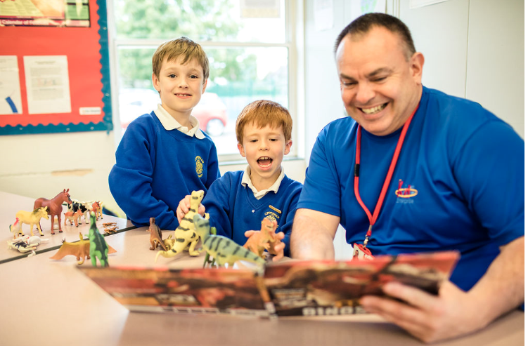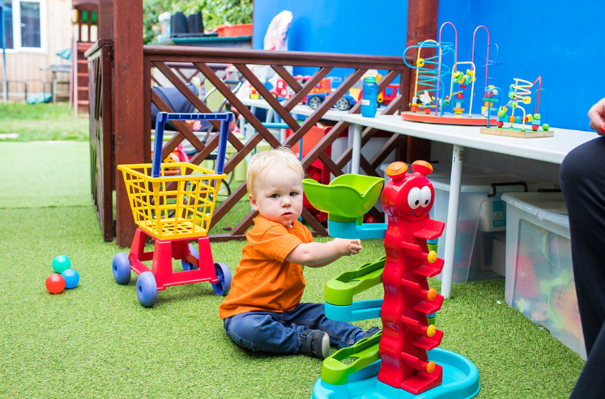



H
e
Foundation Degrees and BA (Hons): Langley College
We would like to introduce you to the Higher Education courses that we deliver for practitioners, teaching assistants, staff who are teaching or working with children and young people in the care and education sector.

The Foundation Degrees that we offer at our Langley campus are:
Foundation Degree in Children’s Development and Learning, through the University of Reading (suitable for anyone working with children aged between 0 –11years).

Foundation Degree in Working with Children and Young People, through the University of West London (suitable for anyone working with children and young people aged between 0 – 25years).

These are aimed at practitioners who hold a Level 3 qualification, and who are ready for the next stage of their professional development, and the completion of the Foundation Degree can then lead to a third year ‘top-up’ to a full BA Honours Degree, either here at The Windsor Forest Colleges Group (Langley Campus), or at a University of your choice.

This in turn can lead on to gaining Early Years Teacher Status or Qualified Teacher Status, or other wider career opportunities/progression. These are sector endorsed Foundation Degrees, designed to meet local childcare/educational providers’ needs for highly qualified and experienced practitioners/staff, whereby students study for one day a week whilst continuing to work in their childcare/school/other educational/behavioural settings. In this way students develop their ability to apply theory to their practice, which is a key learning outcome across all the modules, on all of these courses.

Please find below factsheets which provide information about these courses; entry requirements; module titles; and details of delivery.

-------------------------------------------------------------------------------
Sector Updates
Slough Schools Emotional Health and Wellbeing Virtual Support UPDATED
To: All early years providers, schools, FE, Virtual School and NEET team

Please see attached the MHST/Getting Help Newsletter (June edition). This newsletter outlines the exciting developments of the team, the service that will be offered to education settings and the progress with building partnerships so our services dovetail and do not duplicate.

We have used attachments as opposed to links as we have had feedback from some education settings regarding issues with links.

Kind regards

Ally

Allison Bradshaw
Project Manager– MHST/Getting Help Service
East Berkshire Child and Adolescent Mental Health Services (CAMHS)

Thames Valley Guidance for Childcare and Educational Settings in the Management of COVID-19
Please be aware of this new flow chart summary from PHE South East Health Protection Team:
Guidance for Childcare and Educational Settings in the Management of COVID-19. Version 1.1 Date 04/06/2020
Actions:
- Suspected Covid-19 case in child or staff member
- Confirmed Covid-19 case in child or staff member
- 2 or more confirmed cases in the same group/class
If you have any infection control concerns or questions call the Thames Valley Health Protection Team on 0344 225 3861.
Government Updates
NEW LINK: Early years and childcare: coronavirus (COVID-19)
What early years providers need to do during the coronavirus (COVID-19) outbreak.
https://www.gov.uk/government/collections/early-years-and-childcare-coronavirus-covid-19?utm_source=44298f1a-f792-4769-9834-b7c5ebf4b50a&utm_medium=email&utm_campaign=govuk-notifications&utm_content=immediate

NEW: What parents and carers need to know about early years providers, schools and colleges during the coronavirus (COVID-19) outbreak
Information for parents and carers about the opening of early years providers, schools and colleges, safety in schools, attendance, transport, school meals and exams. https://www.gov.uk/government/publications/what-parents-and-carers-need-to-know-about-early-years-providers-schools-and-colleges-during-the-coronavirus-covid-19-outbreak?utm_source=18fc8c53-fbc6-48b0-81b9-2ac32ee25aab&utm_medium=email&utm_campaign=govuk-notifications&utm_content=immediate

UPDATE: To safe working in education, childcare and children’s social care settings guidance
We have updated our guidance on safe working in education, childcare and children’s social care settings, including the use of personal protective equipment (PPE). The guidance has been updated to reflect recent changes on eligibility and access to testing, clarify PPE requirements for first aid and complex care, and confirm that guidance on cleaning non-healthcare settings applies following a suspected or confirmed case of coronavirus (COVID-19) and not in relation to regular, routine cleaning. The guidance can be found here: https://www.gov.uk/government/publications/safe-working-in-education-childcare-and-childrens-social-care

UPDATE: Keeping children safe in education during the coronavirus (COVID-19) outbreak
The keeping children safe in education (KCSIE) consultation, which was suspended on 31 March 2020, has now been withdrawn to allow schools and colleges to focus their efforts on responding to the coronavirus (COVID-19) outbreak. We have published revised KCSIE guidance for schools and colleges. This guidance is for information only and will come into force on 1 September 2020: https://www.gov.uk/government/publications/keeping-children-safe-in-education--2

UPDATE: Guidance for schools and colleges to support them keeping children safe, including online, during the coronavirus (COVID-19) outbreak can be found here: https://www.gov.uk/government/publications/covid-19-safeguarding-in-schools-colleges-and-other-providers

UPDATE: Supporting children and young people with SEND as schools and colleges prepare for wider opening
Guidance for settings managing children and young people with complex special educational needs and disability (SEND) during the coronavirus (COVID-19) outbreak. 18 June 2020 Updated - changes are listed within the document under 'Main changes to previous guidance'. https://www.gov.uk/government/publications/coronavirus-covid-19-send-risk-assessment-guidance?utm_source=e5558cd7-e624-40a5-be40-6520d3d95896&utm_medium=email&utm_campaign=govuk-notifications&utm_content=immediate#history

NEW: DfE Safeguarding
Right now, vulnerable children and adults may be particularly isolated, meaning that the family, community and professional networks they usually rely on may be unavailable or hard to access. At the same time, living under the current arrangements may increase the pressures that can contribute to abuse and neglect, or allow it to go unseen. Neighbours, volunteers and professionals can play a vital role in keeping adults and children safe.

The Home Office, in collaboration with a number of other government departments, has produced information and guidance for those who are operating in communities and may not be trained to recognise the signs of abuse or neglect. The guidance covers signs to spot and what to do if there is a concern. A full list of the assets available is in the following link (including web-friendly versions) for stakeholders to download artwork to print their own leaflets and posters, so please also share this too if it will help – https://homeoffice.brandworkz.com/BMS/albums/?album=2092&lightboxAccessID=9AD9C142-A301-458E-8BE489B20777137A
SLOUGH EARLY YEARS AND PREVENTION SERVICE: TELEPHONE: 01753 476554 / EMAIL: earlyyears@slough.gov.uk

