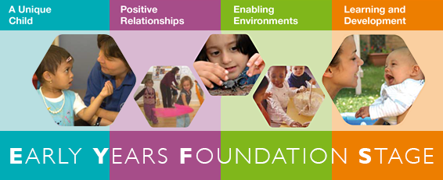 |  | Early Years and Prevention Service  - Good Practice
 |  | June 2020

The implementation of good practice in assessment supports a child’s continuing learning and development. Below provides points to consider and implement as part of your assessment processes, including a good understanding of the learning and development to support planning and provision for individual children.

Some of points you will find are particularly helpful at the time of transition.

Section 2 of the Statutory framework for the early years foundation stage provides settings with the statutory guidance they must have in place for assessment. Please refer to this alongside this aide memoire.

Additional supporting documents for learning and assessment include - Early Years Outcomes and Development Matters

There are many electronic systems that provide structure and support for recording assessments. These may include: Tapestry, Target Tracker, iconnect.

At transition please share with the new setting what system you use to record and track your assessments

EYFS assessments - good practice – aide memoire
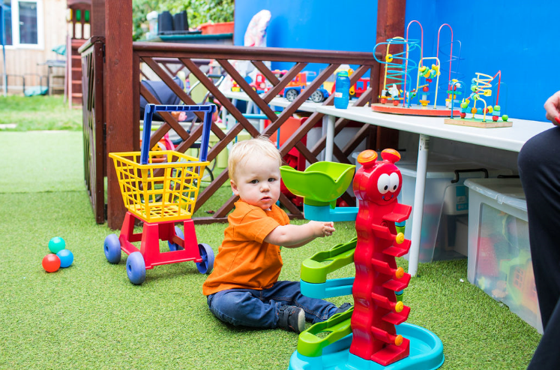

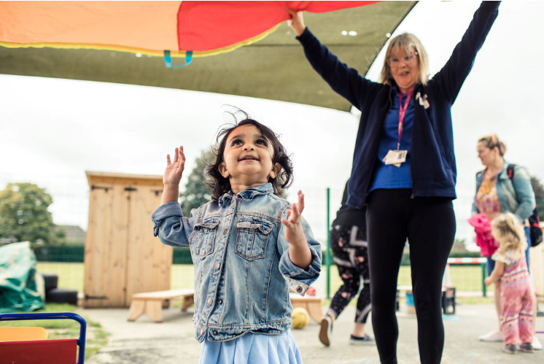

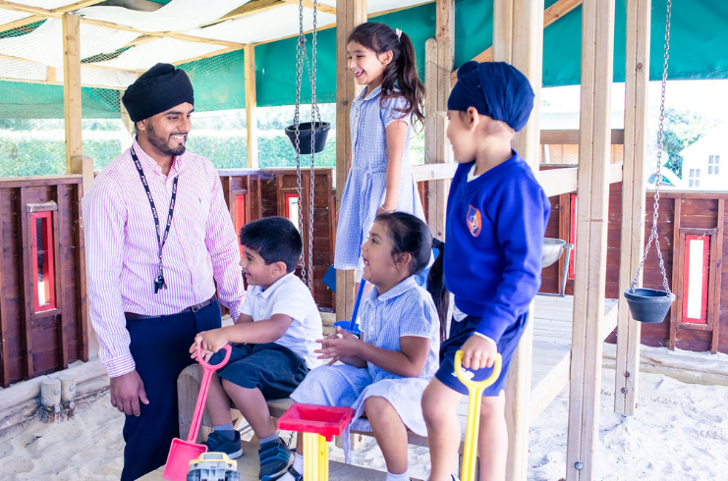

Before any child starts in a new setting or room you may want to consider:

Home visits which include interests of a child at current time but also home language spoken, ethnicity, religious celebrations/birthdays/dietary requirements/health and development needs i.e. toileting, allergies, medication,
Sharing and agreeing the settling in process with parents/carers to ensure the individual needs of the child are at the centre of decisions
The key person meeting with the family and child
Additional information is gathered from a previous practitioner/setting on anything important about the child, including progress
Information shared about a child’s interests and needs to support planning i.e. schema, preferred learning styles, need for visual cues etc
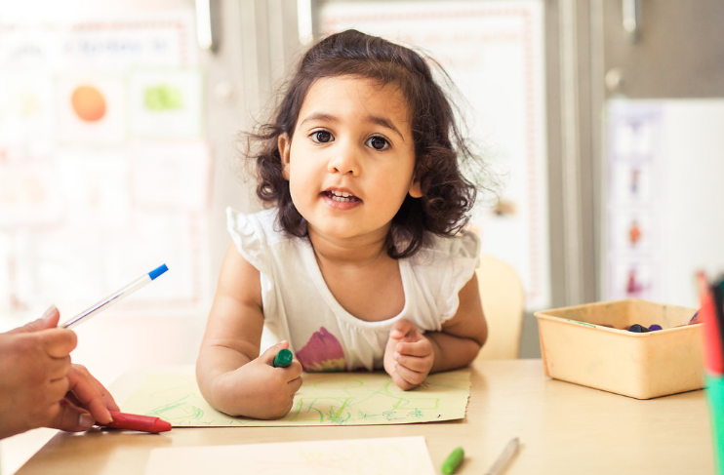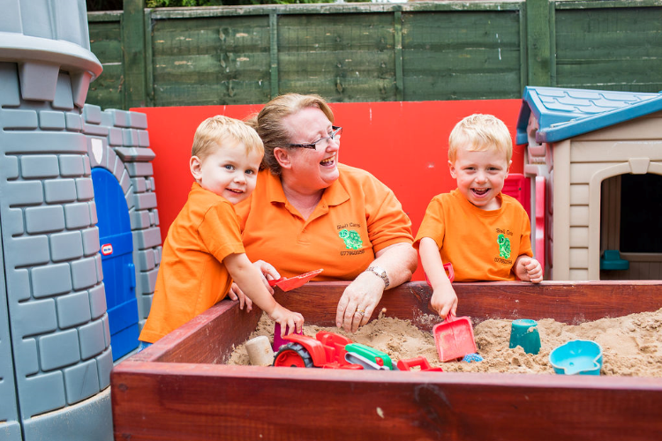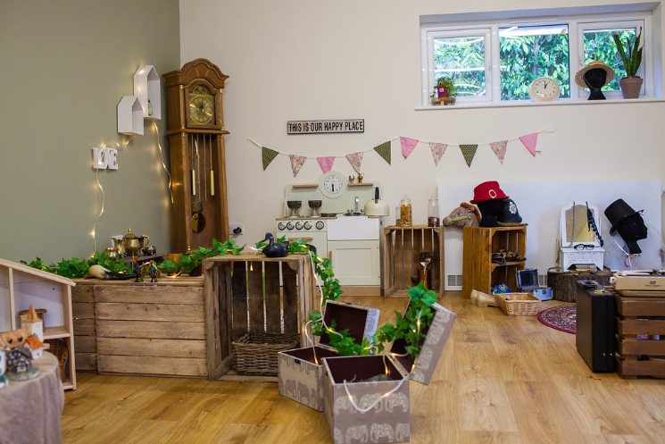
When a child starts at a new setting it is helpful to:
Make an initial summative assessment across the 7 areas of learning within the first weeks of starting. This will give you a starting for point for measuring progress in addition to knowing how best to support provision and planning for individual children.
Use observations from purposeful play to underpin your assessment.
For younger children focus on the prime areas of learning.
The following terminology is useful
- below typical development for their age
- in line typical development for their age
- above typical development for their age

H

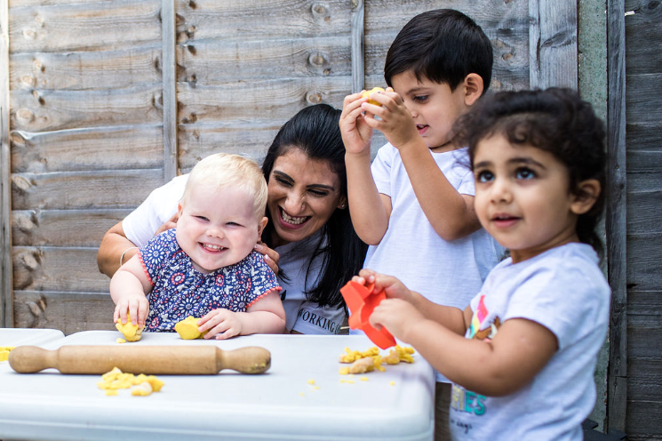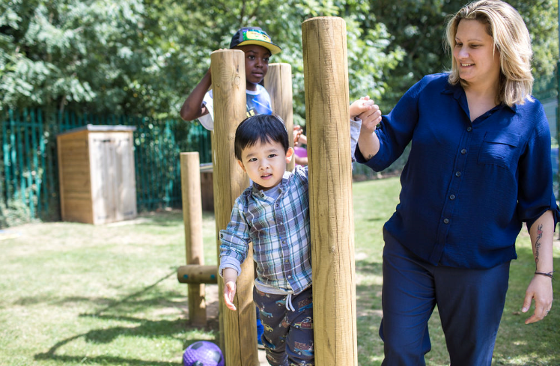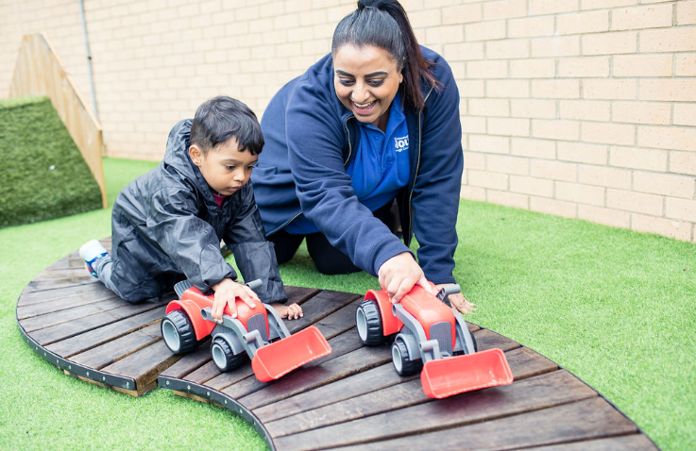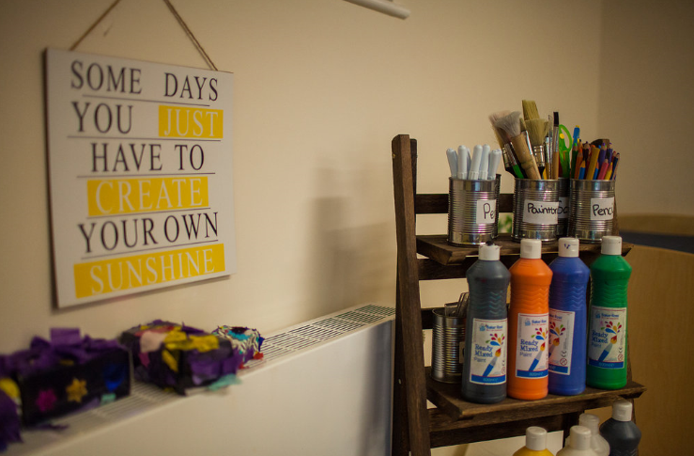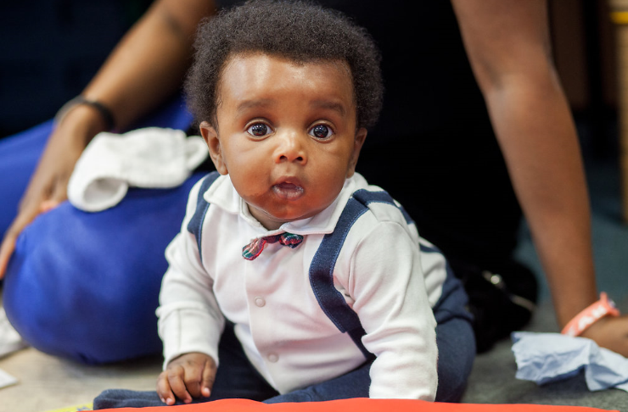

During the time at the setting the assessment process should include:

Observations are used primarily to inform planning and provision, as well as supporting children’s attainment and progress.

The majority of observation and evidence comes from child-initiated learning and interaction.
The adult led/supported observations are clearly noted as from this source.

Learning journals (electronic or hard copy) have been created for each child and include starting points and observations over time.
All areas of learning are evidenced
Prime areas may be a focus for younger children or those with developmental delay.

Good evidence should include photographs, video footage and photocopies of children’s ‘work’ (annotated on the rear). Most ‘work’ should go home to be celebrated and enjoyed

There are observations and evidence to support development in the Characteristics of Effective Learning (CoEL)
- Playing and exploring
- Active learning
- Creating and thinking critically
Reflect on the following points to include in provision and practice:
- being encouraged to take risks
- exploring and investigating
- being a more resilient and independent learner

The use of annotated photographs may be useful for evidence of a child’s engagement in play and learning.
A series of photographs or video footage can show the process of children developing these

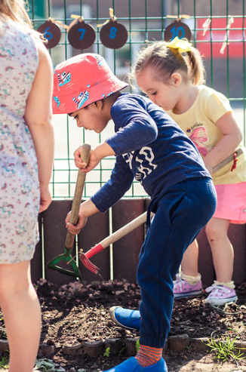

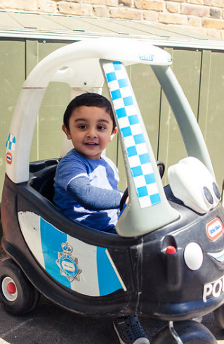

Clear targets with sufficient challenge are made from areas of learning and development and CoEL

Contributions from parent and learning from home is evidenced, valued and used to support planning and provision

Evidence includes child’s voice – opportunities for children to share and talk about their learning with each other

Dated observations including regular discussions between the family and key person to show progress in learning.

Cross referencing is clearly indicated between areas of learning and CoEL in observations when required

All statutory assessments are completed in line with EYFS guidance and expectation
- Progress Check at two (24-36months) A Know How Guide supports this process
- EYFS Profile (undertaken and completed in the summer term of the year a child reaches the age of 5)
- EYFS Reception Baseline Assessment(RBA) was due to start this September 2020, a recent update from the government states the start of this will be delayed for a year.
These process must involve key person and the parents/carers working collaboratively

The key person being aware of attendance patterns and discusses this with a senior staff member in supervision and with the family

Observations and assessments are internally moderated by management within the setting.
Records are maintained and reviewed to ensure actions are taken and any anomalies or emerging patterns addressed.

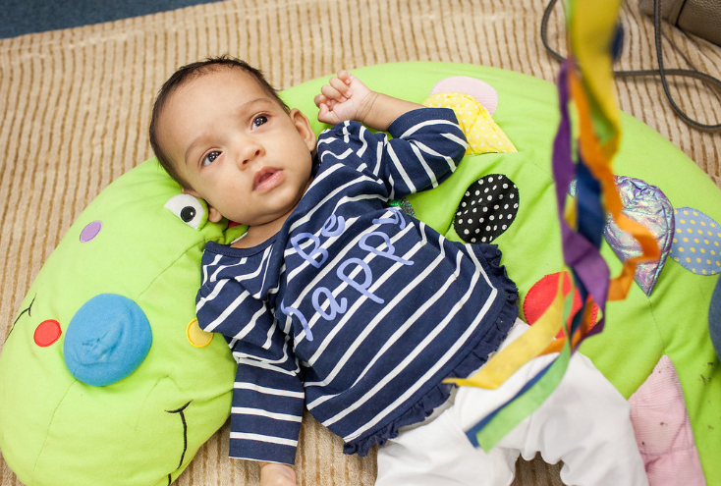

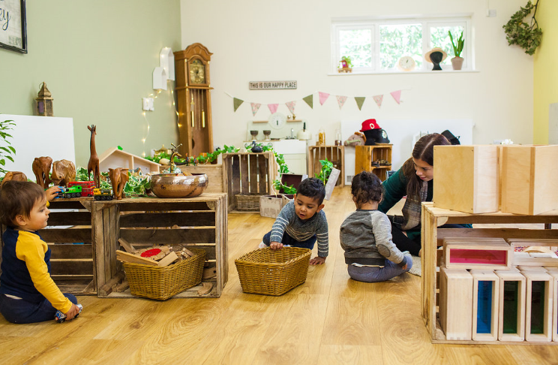
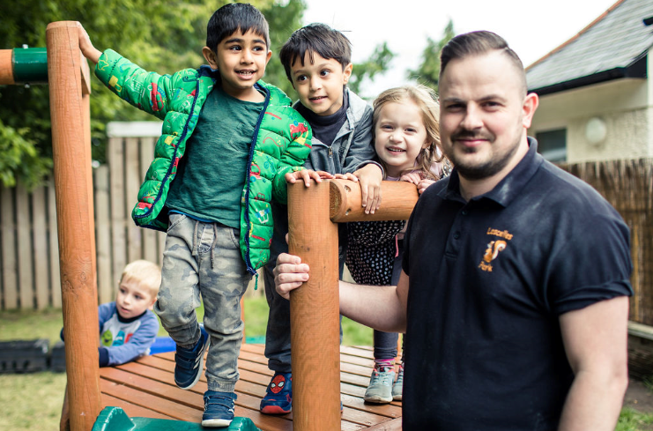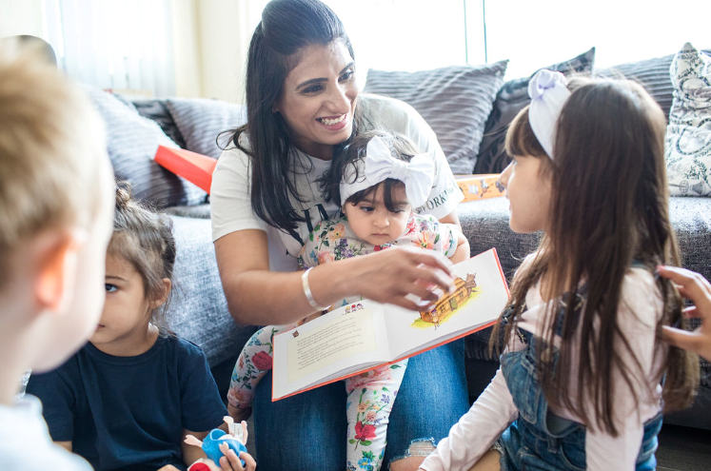

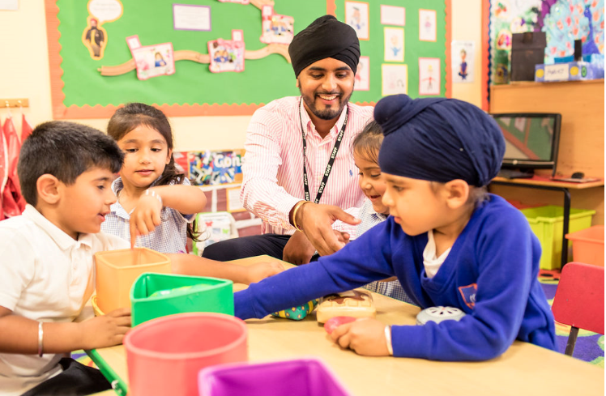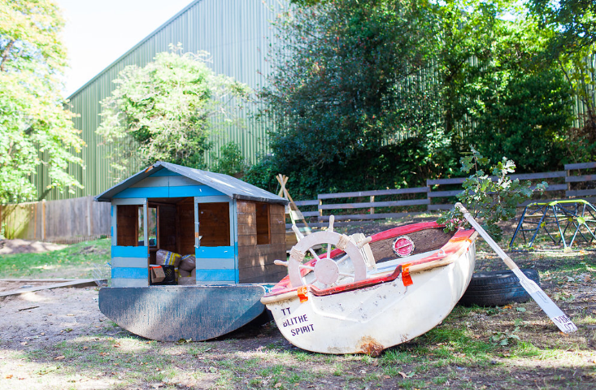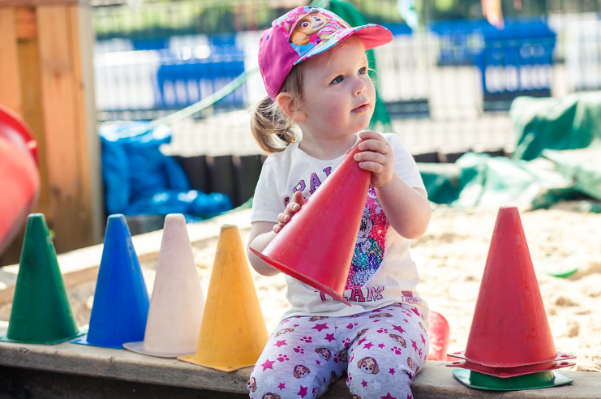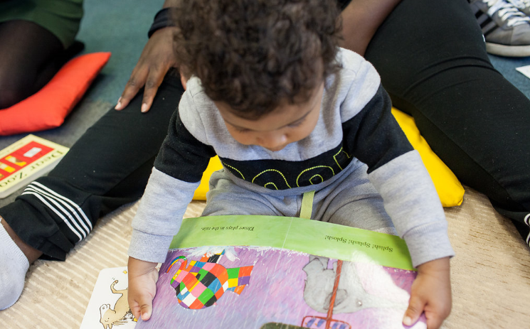

When a child moves to a new practitioner and/or setting the assessment processes should include:
Conversations between key person and next room/setting take place to support the evidence sharing

A summary/narrative of the child and their learning (conversation or written) to include:
What is meaningful and important to them
Information that will help with the settling process
Strengths and areas for development
Characteristics of effective learning
IEPs and I Talk monitoring information (where available)
Evidence/statement to show attainment level and progress level of the child.
Any next steps the child may be working on

Sharing of learning journals (electronic or hard copy) which show starting points and the progress for each child. (How much progress has a child made whilst at the setting over time? Are they at age related expectations?)

Parents being encouraged to share their child’s learning journal with the new setting once they have started

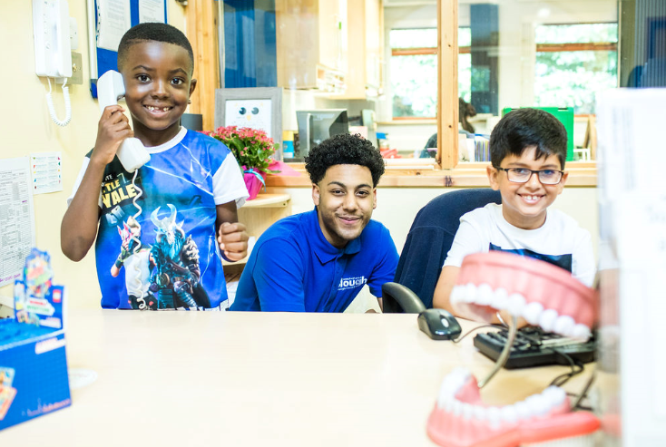
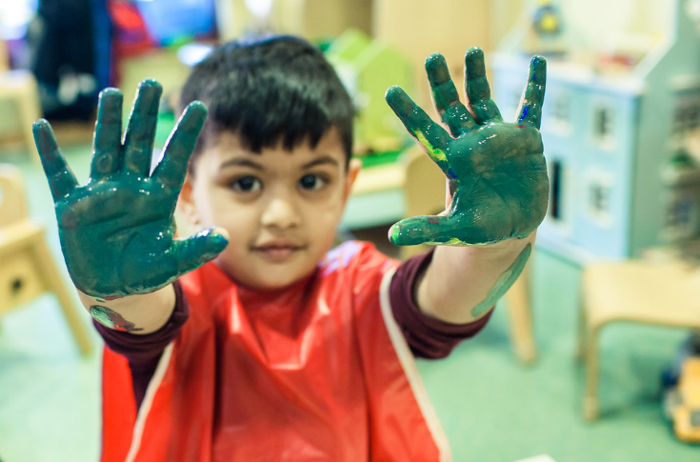
Additional Information and actions for when a child moves to a new setting will include:
Parent permission having been agreed to transfer internal records with new setting including contact details of any outside professionals and agencies involved the child.

