Slough Early Years and Prevention Service

Social Stories

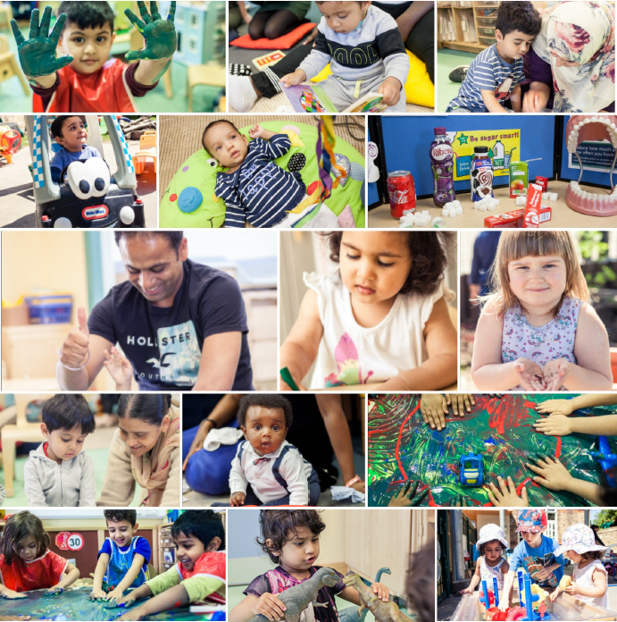

Why haven’t I been going to nursery?

Social Story 1

Why haven’t I been going to nursery?
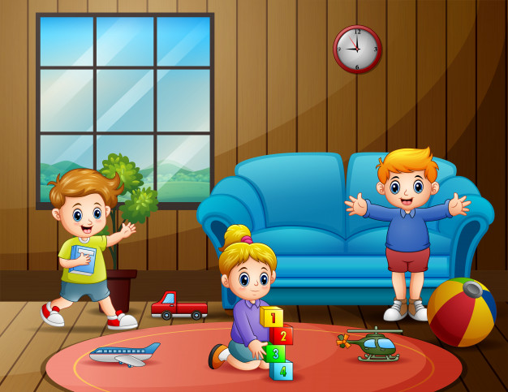
Most children have not been going to nursery, they have been staying at home…
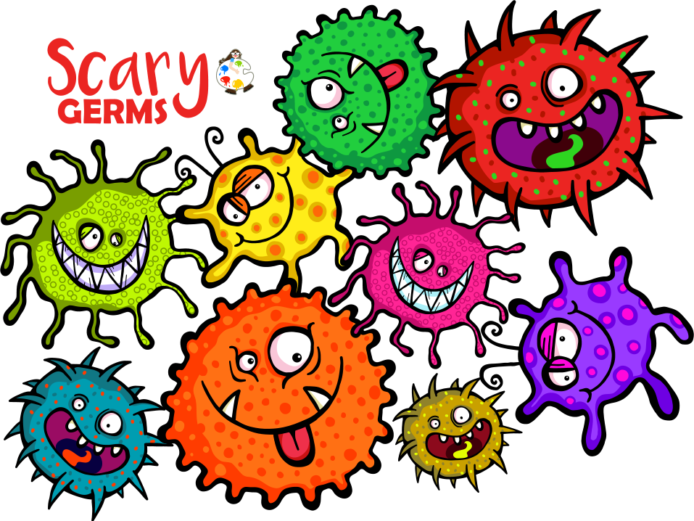
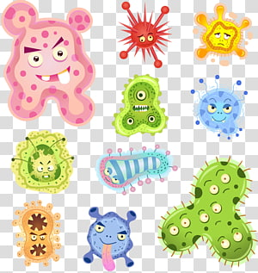
Children have been staying at home because there are some bad germs around at the moment…

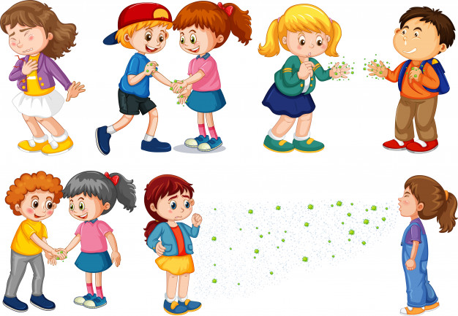
At the moment, if people get too close to each other they might get the bad germs on them…

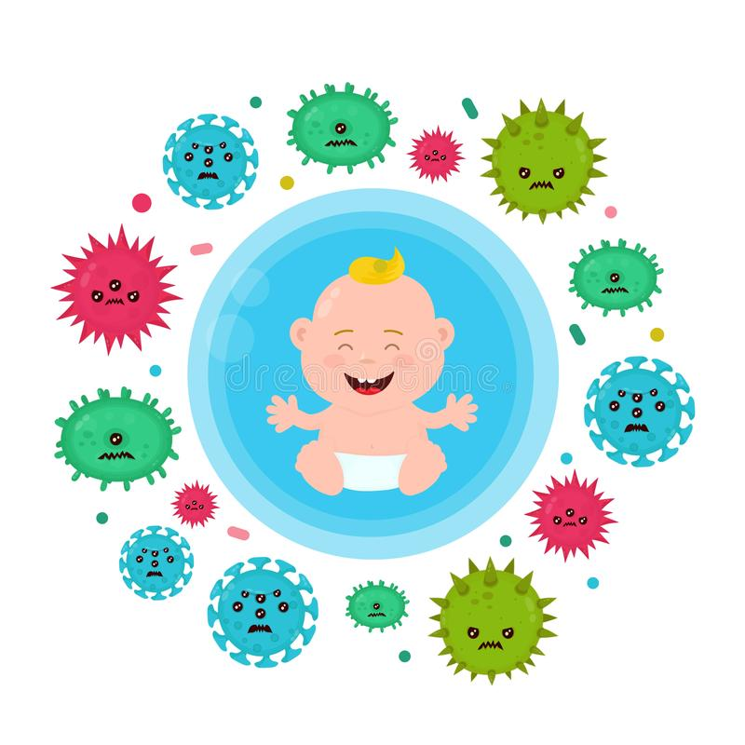
The bad germs can spread to people from coughs and sneezes…
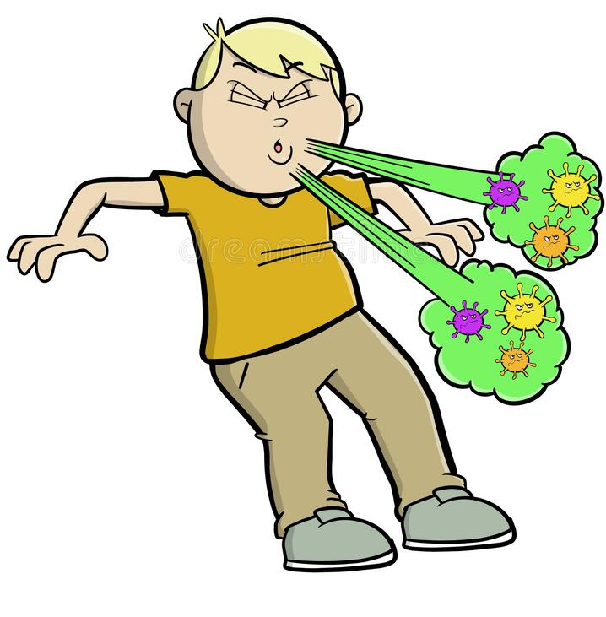
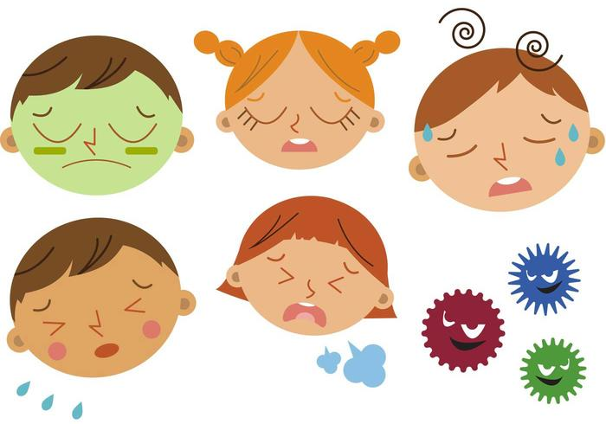
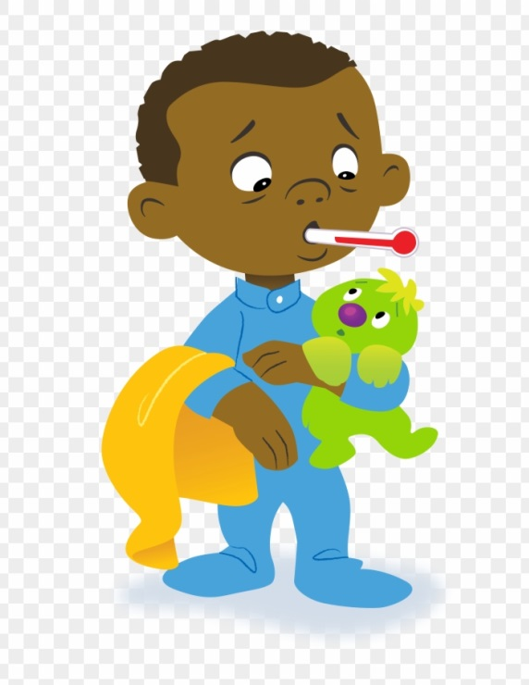
Some people might get sick from the bad germs…
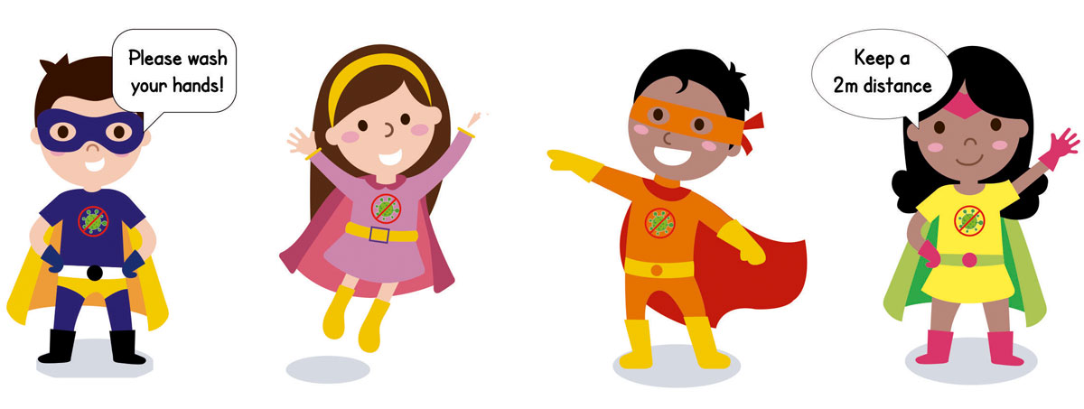
We need to try and stay apart from each other to stop the bad germs from spreading…
Keep your
Distance!

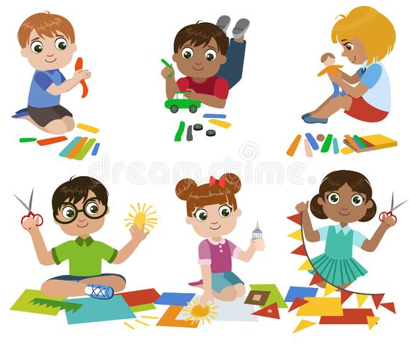
It is ok to go to nursery now but we still need to try and stop the bad germs from spreading…

Welcome
back!

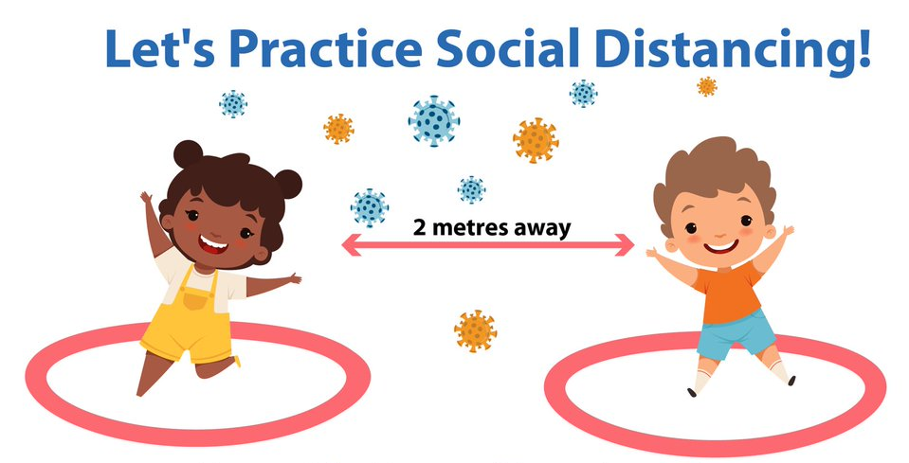

The adults will help me, if I am worried…
This will be ok… ok.ok.okok…
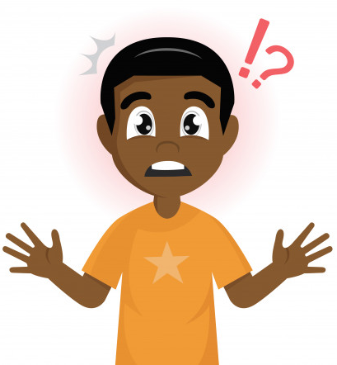
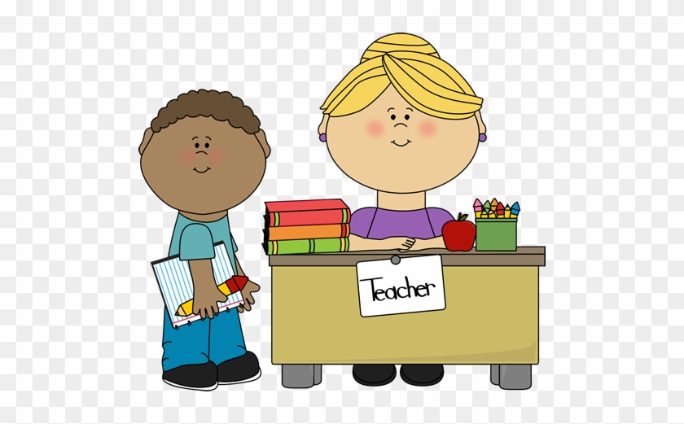

This social story type booklet can be read as a story on its own or it can be read before you read ‘Sometimes I sneeze or Cough’ and the subsequent stories;
‘When I have used a tissue…’ and
‘Some people wear face masks…’

As with the other stories; it is often useful, where possible, to use real objects alongside the story e.g. a tape measure, tissues, face mask etc.

As the story should initially be read on a regular daily basis you may wish to print off and laminate the pages for durability. If you are reading the stories to groups of children you may decide to enlarge the pages to A3.

Sometimes I sneeze or cough

Social Story 2

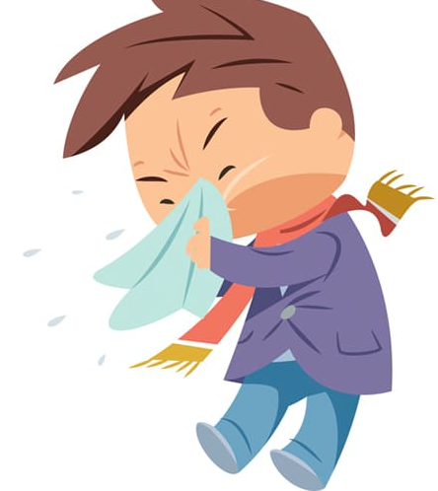
Sometimes I sneeze or cough…

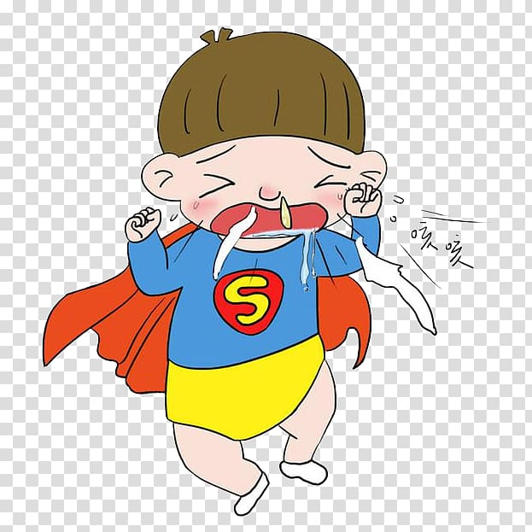
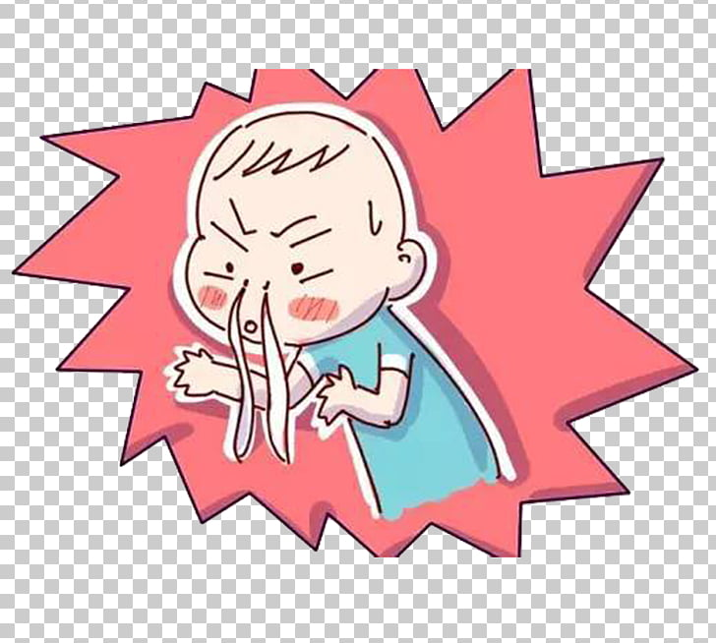
Sometimes when I sneeze or cough, water may come out of my nose or mouth…

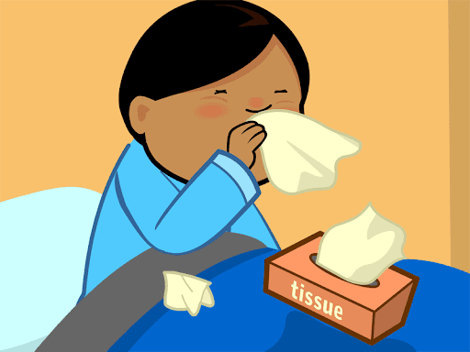
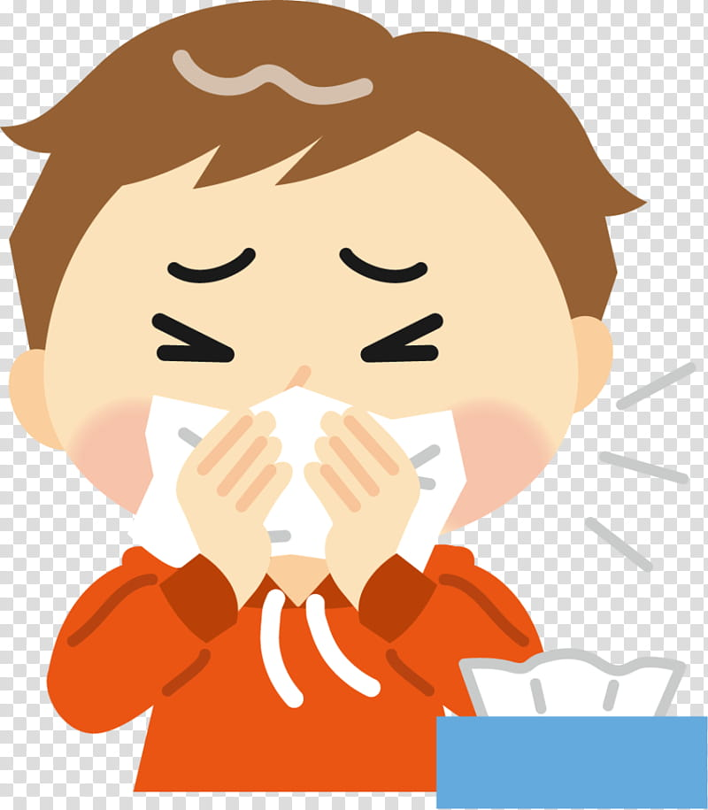
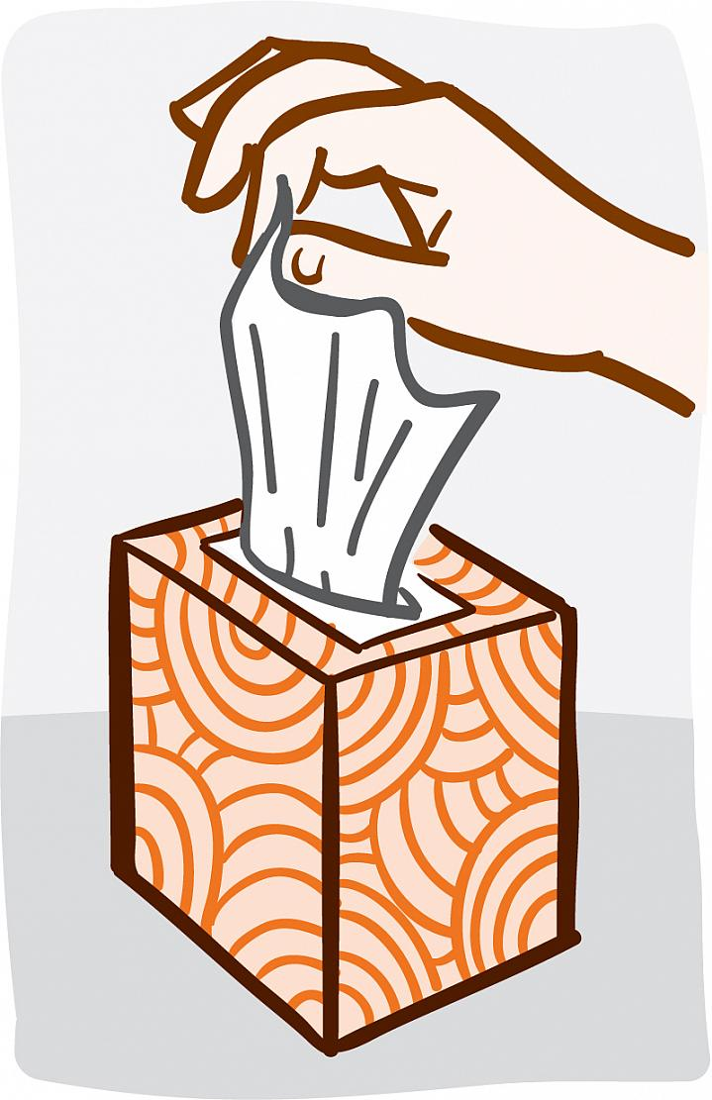
When I sneeze or cough I should try to cover my nose and mouth with a tissue…
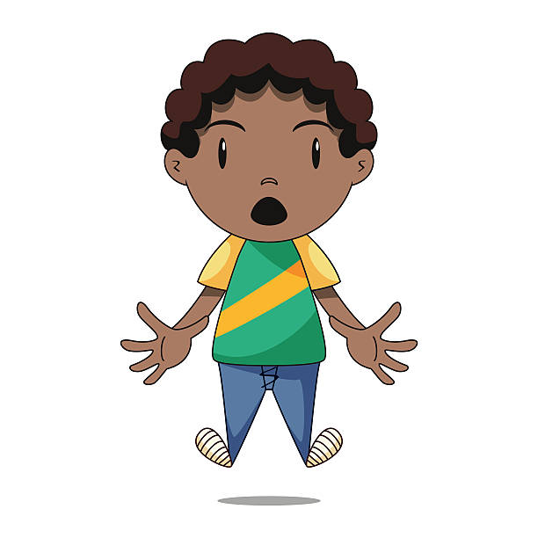
Sometimes I may not have a tissue when I sneeze or cough…
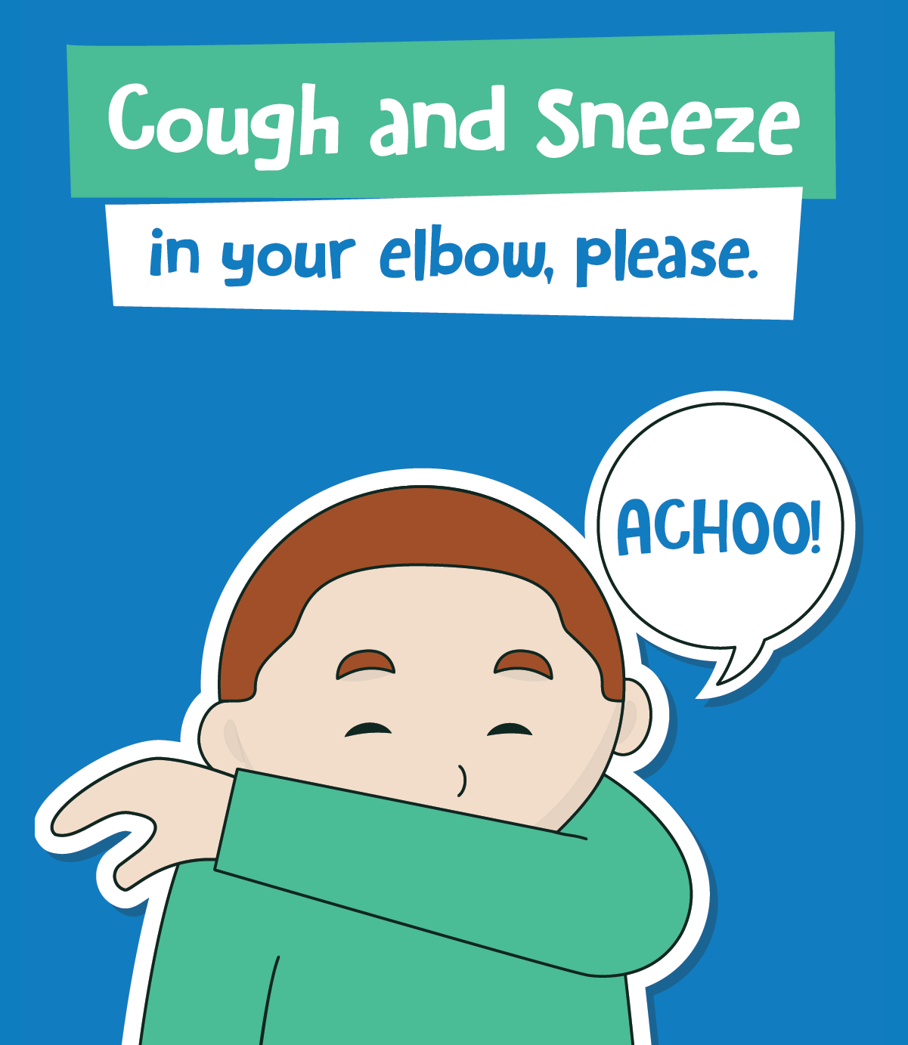
I can sneeze or cough into my elbow instead…
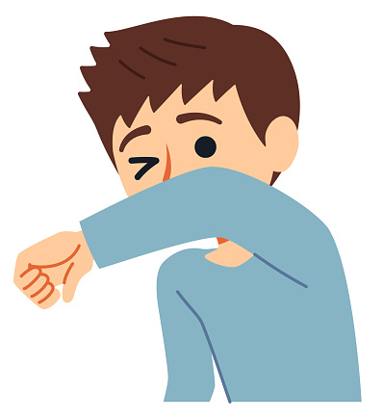

I will try and cover my nose and mouth when I sneeze or cough…

The main Booklet ‘Sometimes I sneeze or cough…’ is a social story type booklet that can be read to a child or a group of children to support their understanding on the topic discussed within the booklet. There are two add-ons (see below for details).
The booklet ‘When I have used a tissue…’ can be read as a stand alone booklet or it can be added into the main social story ‘Sometimes I sneeze or cough…’ It should be inserted after the page ‘When I sneeze or cough I should try to cover my nose and mouth with a tissue…’
The booklet ‘Some people wear face masks to protect themselves from germs …’ can be read as a stand alone social story type booklet or it can be added onto the end of the main social story ‘Sometimes I sneeze or cough…’
A social story is a short story used to explain a social situation to children. The objective is to share information; they should not to be used as ‘bossy’ rule books. It is often useful, where possible, to use real objects alongside the story e.g. a box of tissues, hand sanitiser, face mask etc.
As the story should initially be read on a regular daily basis you may wish to print off and laminate the pages for durability. If you are reading the stories to groups of children you may decide to enlarge the pages to A3.

When I have used a tissue

Social Story 3

When I have used a tissue I should put the tissue in a bin…

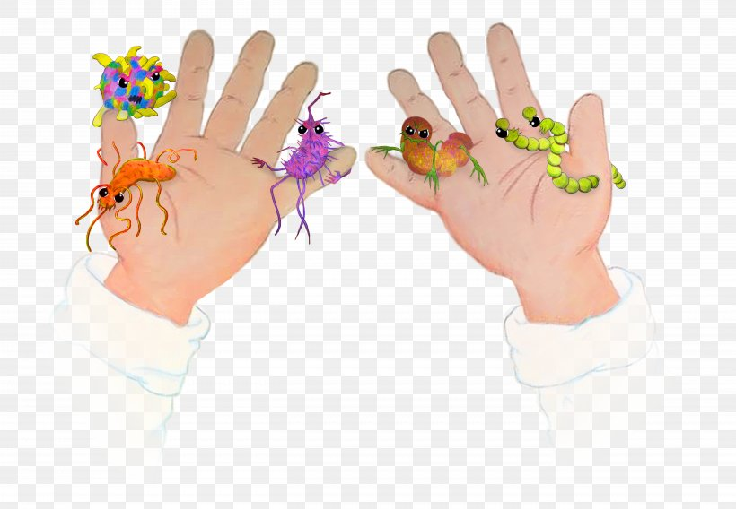
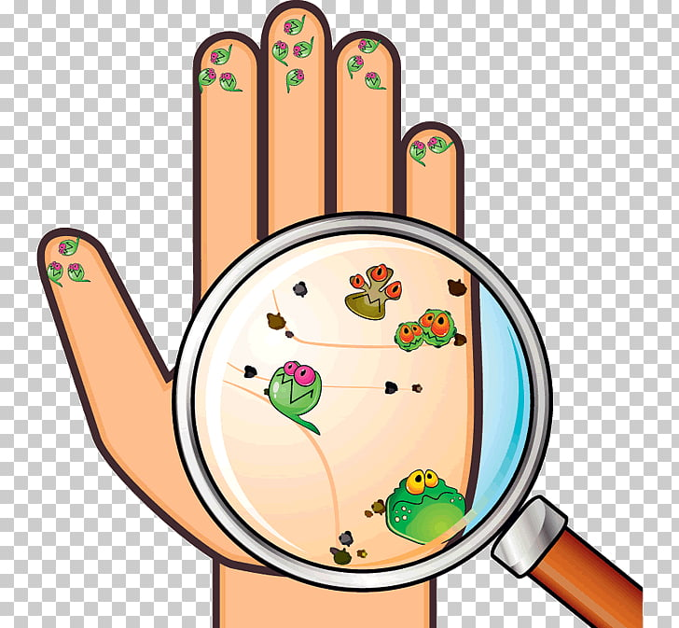
When I use a tissue to sneeze or cough I may have germs on my hands…
Germs are tiny and you cannot see them.
People can get sick from some germs…
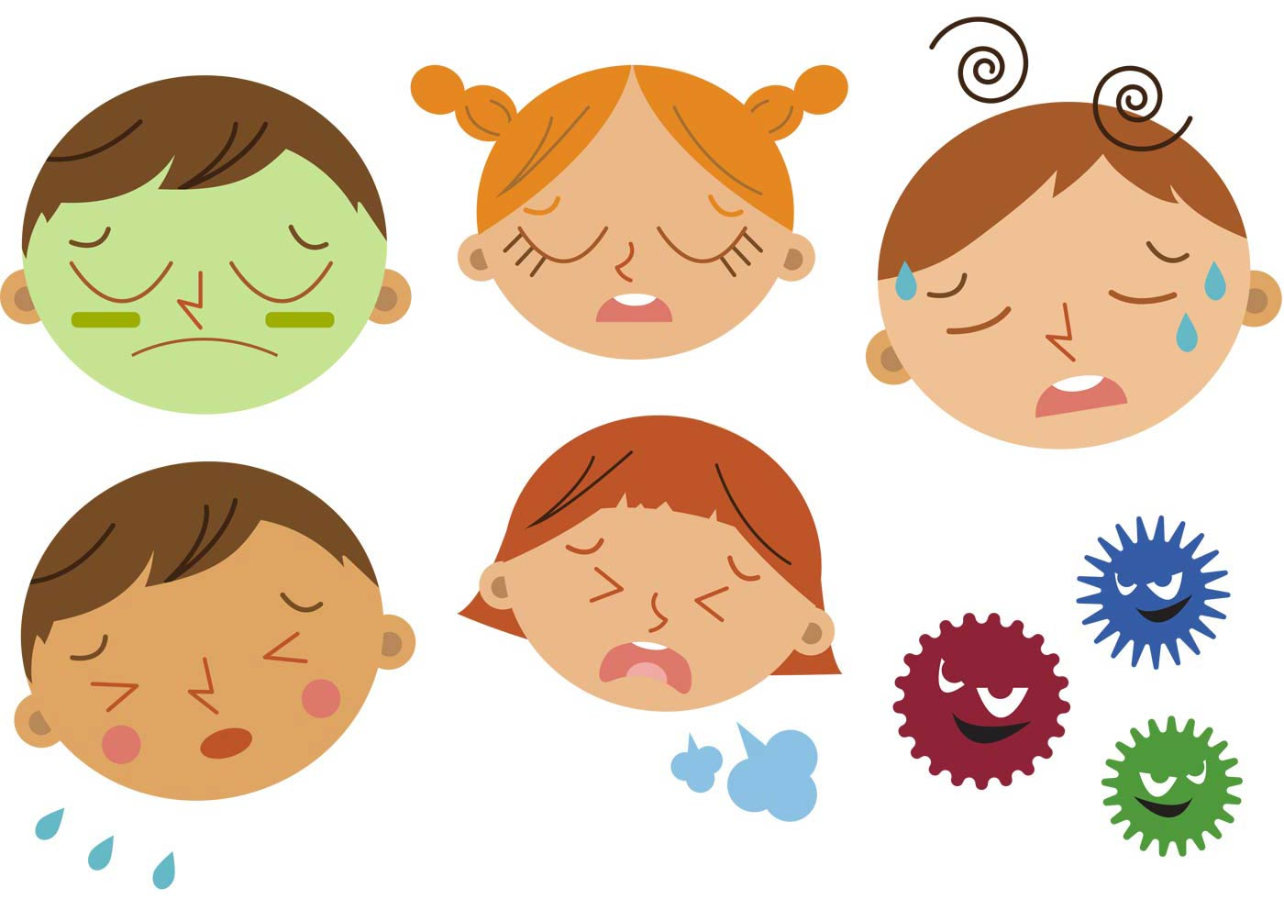

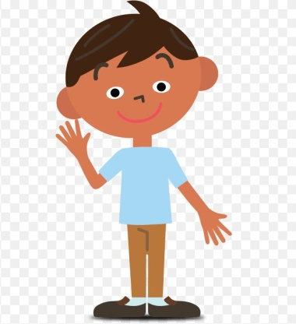
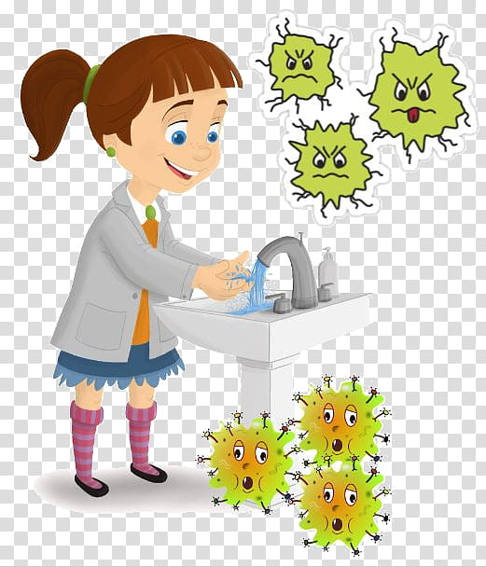
I will need to wash my hands when I have sneezed or coughed into them…

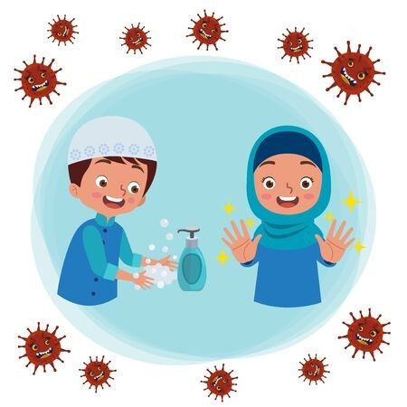
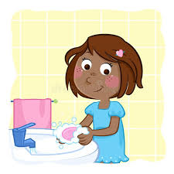
I can use soap and water to wash my hands or I can use hand sanitiser…

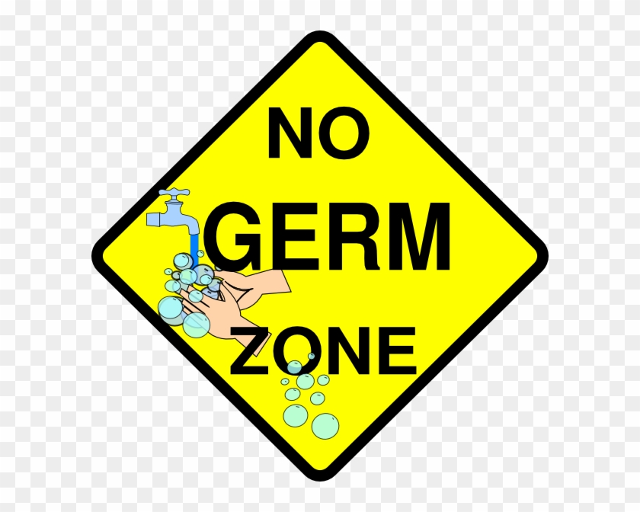
Washing my hands will get rid of the germs…
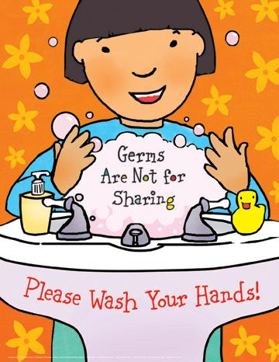

Some people wear face mask to protect themselves from germs

Social Story 4

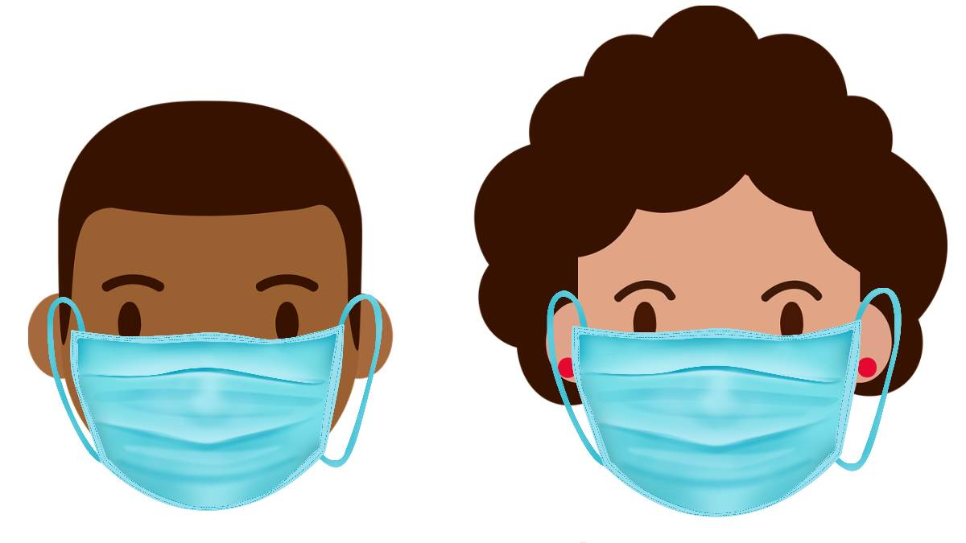
Some people wear face masks to protect themselves from germs…

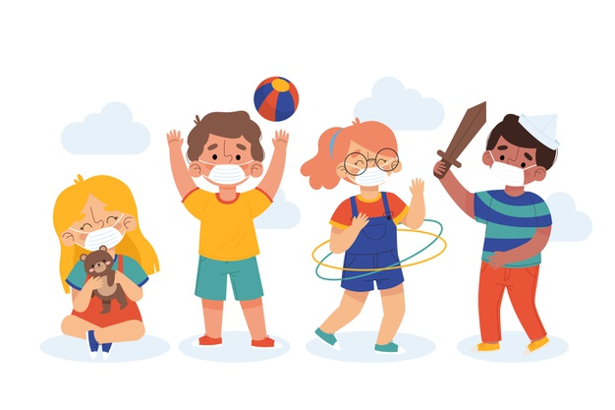
If I need to, I can wear a face mask…

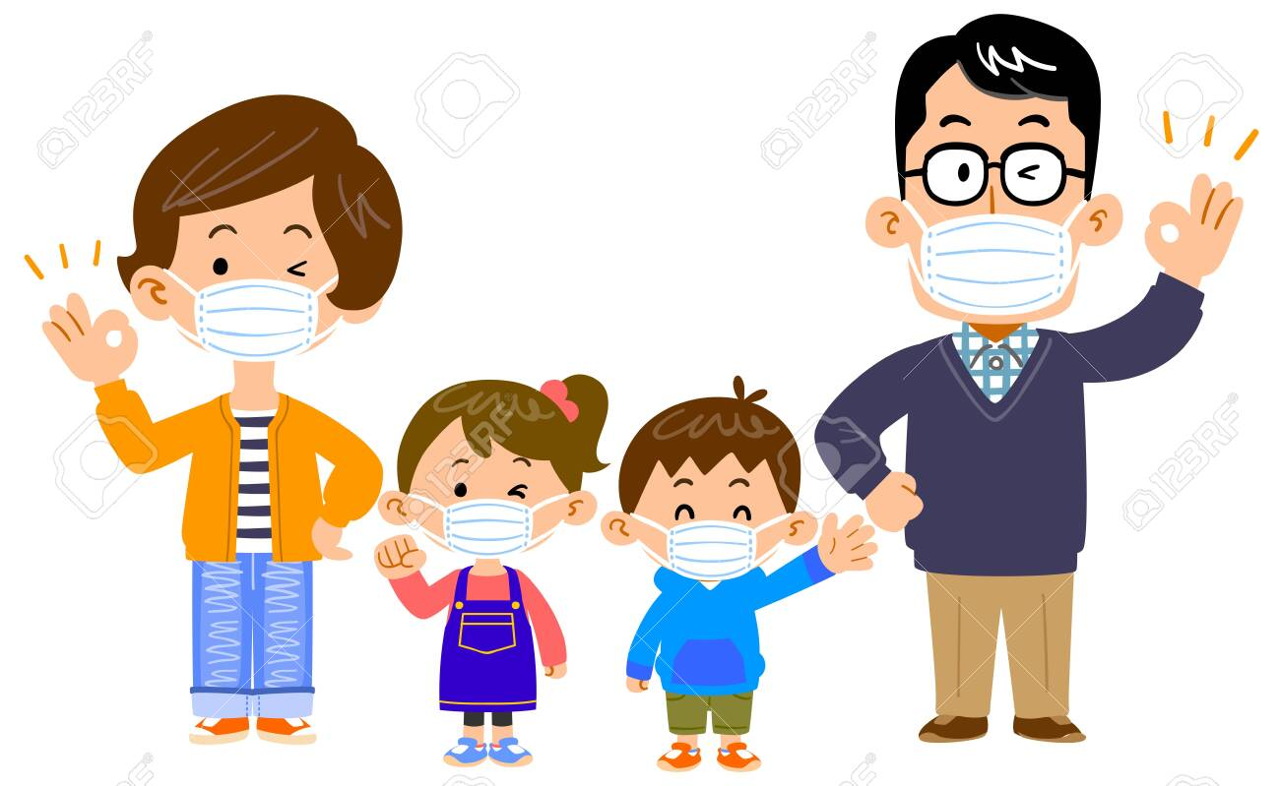
An adult will tell me if I need to wear a face mask…

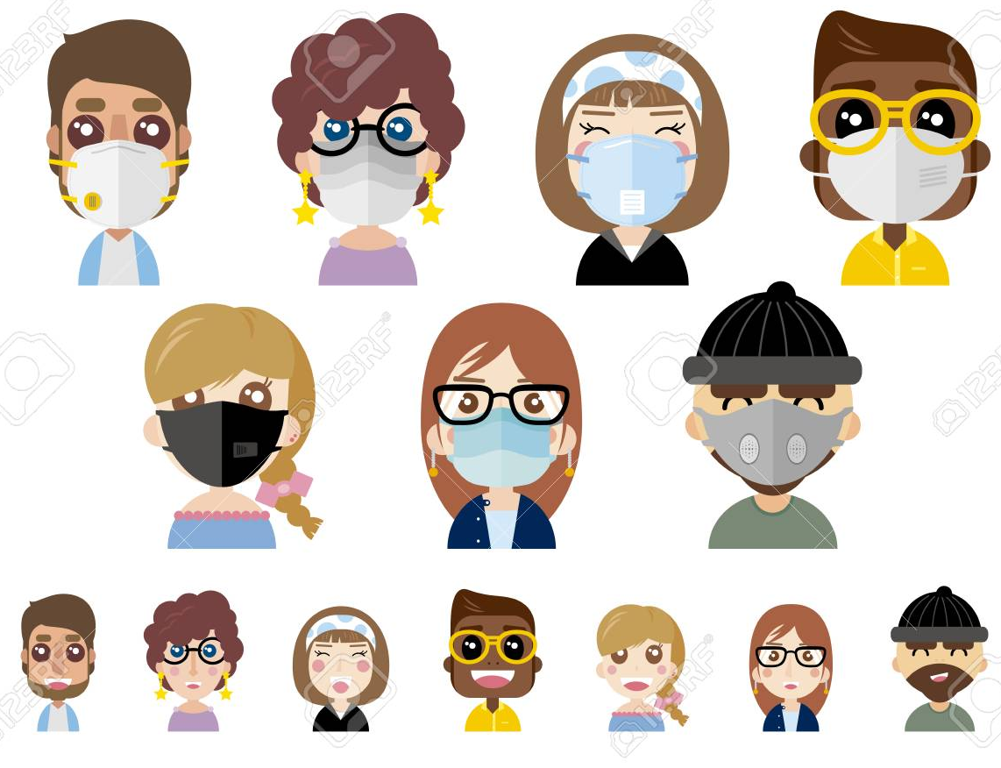
Some people might wear a mask; some people might not wear a mask…

This is ok…
The booklet ‘Some people wear face masks to protect themselves from germs …’ can be read as a stand alone social story type booklet or it can be added onto the end of the main social story ‘Sometimes I sneeze or cough…’
A social story is a short story used to explain a social situation to children. The objective is to share information; they should not to be used as ‘bossy’ rule books. It is often useful, where possible, to use real objects alongside the story e.g. a box of tissues, hand sanitiser, face mask etc.
As the story should initially be read on a regular daily basis you may wish to print off and laminate the pages for durability. If you are reading the stories to groups of children you may decide to enlarge the pages to A3.

