
  Early Years and Prevention Service
    - COVID-19
    - 3rd June 2020
Recovery Planning for EArly Years and childcare providers |  | In This Issue: 3rd July 2020

The DfE have updated this guidance as follows:
- set out a change to the protective measures in early years settings that will be effective from 20 July, removing the requirement to keep children in small consistent groups within settings but still minimising mixing where possible (sections 2.1 and 3.3)
- new content on risk assessment (3.1), supporting staff with increased risk factors (3.2) and system of controls (3.3)
- updated content on attendance at settings for those shielding, with changes to the advice effective from 1 August, and removal of content on vulnerable children since settings are open for all children (section 4)
- updated content on wraparound care (5.3)
- an update on Early Years Foundation Stage reforms (7.6) and Reception Baseline Assessment (7.7)

Since 1 June, early years settings, including childminders, have been able to welcome back children of all ages.
We are continuing to work with the early years sector to understand how they can best be supported to ensure that sufficient safe, appropriate and affordable childcare is available for those returning to work now, and for all families who need it in the longer term.
This guidance sets out what applies and what is set to change on 20 July, regarding the groups approach in early years settings, and regarding shielding from 1 August.

We will keep this guidance under review as we continue to monitor the situation over the summer. Please note: By the end of the summer term, Public Health England will publish revised guidance for cleaning non-healthcare settings to advise on general cleaning required in addition to the current advice on cleaning when there is a suspected or confirmed case of coronavirus (COVID-19).

Actions for early years and childcare providers during the coronavirus (COVID-19) outbreak Updated 2nd July
Please read the full guidance:
https://www.gov.uk/government/publications/coronavirus-covid-19-early-years-and-childcare-closures/coronavirus-covid-19-early-years-and-childcare-closures

Actions for early years and childcare providers during the coronavirus (COVID-19) outbreak Updated 2nd July


Actions for early years and childcare providers during the coronavirus (COVID-19) outbreak Updated 2nd July
Page 1
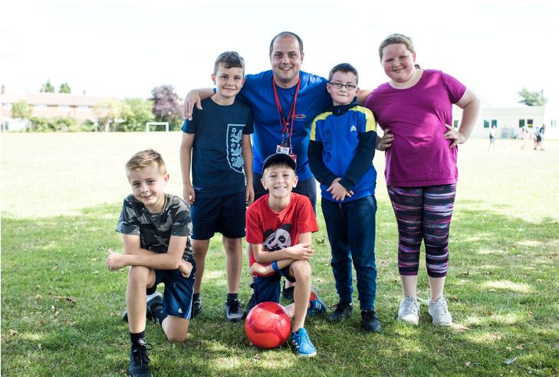
Protective measures for holiday or after-school clubs and other out-of-school settings for children during the coronavirus (COVID-19) outbreak
Page 3

Guidance for full opening - schools

Published 2 July 2020
https://www.gov.uk/government/publications/actions-for-schools-during-the-coronavirus-outbreak/guidance-for-full-opening-schools

It is our plan that all pupils, in all year groups, will return to school full-time from the beginning of the autumn term.

This guidance is intended to support schools, both mainstream and alternative provision, to prepare for this. It applies to primary, secondary (including sixth forms), infant, junior, middle, upper, school-based nurseries and boarding schools. We expect independent schools to follow the control measures set out in this document in the same way as state-funded schools. The guidance also covers expectations for children with special educational needs and disability (SEND), including those with education, health and care plans, in mainstream schools.

Separate guidance is available for early years, further education colleges and for special schools.

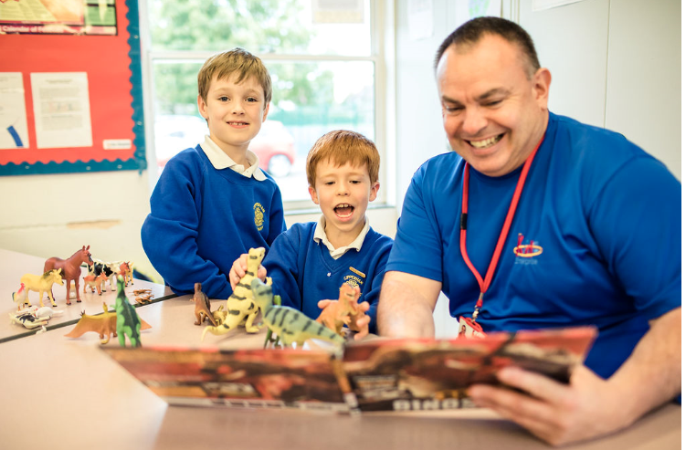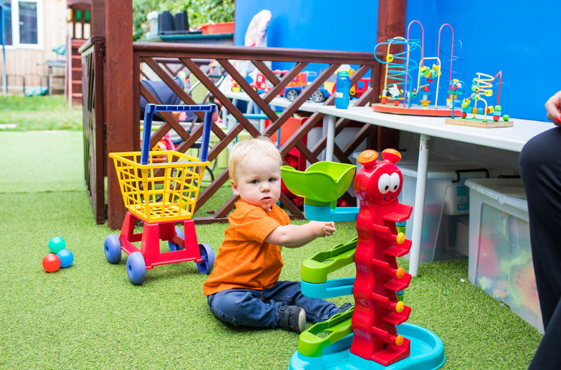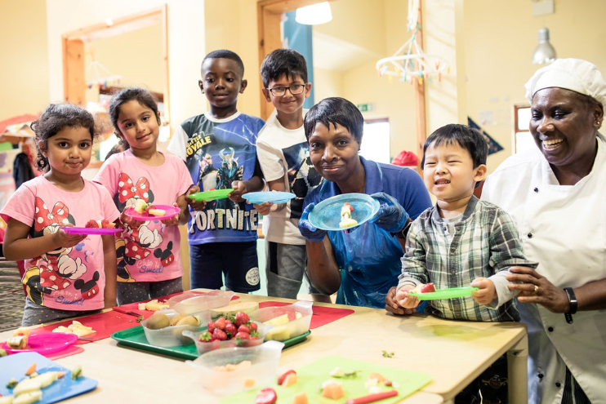

What parents and carers need to know about early years providers, schools and colleges during the coronavirus (COVID-19) outbreak

Information for parents and carers about the opening of early years providers, schools and colleges, safety in schools, attendance, transport, school meals and exams.

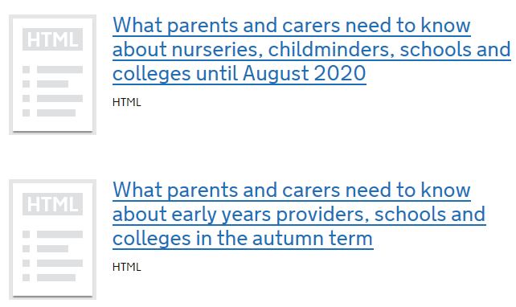

.

Information for parents and carers of children at:
•registered childcare providers (including nurseries and childminders)
•primary and secondary schools (including independent schools, maintained schools, academy trusts, free schools and special schools)
•colleges (for the purposes of this guidance ‘colleges’ means publicly funded sixth form and further education colleges, independent training providers and special post-16 institutions)

Published 18 June 2020
Last updated 2 July 2020

2 July 2020: Added guidance for parents and carers about early years providers, schools and colleges in the autumn term.

https://www.gov.uk/government/publications/what-parents-and-carers-need-to-know-about-early-years-providers-schools-and-colleges-during-the-coronavirus-covid-19-outbreak?utm_source=a4f2c389-4567-489e-bfe9-f60d374c0313&utm_medium=email&utm_campaign=govuk-notifications&utm_content=immediate#history

Protective measures for holiday or after-school clubs and other out-of-school settings for children during the coronavirus (COVID-19) outbreak
The DfE have published guidance for providers that run community activities, holiday clubs, after-school clubs, tuition and other out-of-school provision for children. We are aware many providers are already considering what protective measures to put in place to allow them to reopen more widely and as safely as possible during the coronavirus (COVID-19) outbreak.

This new guidance will support their planning and advises on practical steps they can take to minimise the risk to children, staff and parents who attend. Providers who open should implement this new guidance from the end of summer term, when state schools in their local area have closed. Until then, while schools are open in a provider’s local area, they should follow the same protective measures as schools to limit different groups of children mixing.

As the Prime Minister confirmed in his announcement on 23 June, providers who run community activities, holiday clubs, after-school clubs, tuition and other out-of-school provision for children can operate over the summer holiday, subject to the science and with safety measures in place. Adjustments to the current measures for these providers will be part of Step 3 of the recovery strategy (from 4 July).

We recognise the important role out-of-school settings (OOSS) play in providing enriching activities, giving children the opportunity to socialise with others outside their household and promoting their wellbeing. We also recognise the importance of these settings in providing additional childcare options to parents and carers, particularly those with younger children, who may need to return to or continue to work during the school holidays.

- The scientific evidence suggests that there is a moderate to high degree of confidence that the susceptibility to clinical disease of younger children (up to age 11 to 13) is lower than for adults. However, it remains important that protective measures as outlined in this guidance are put in place to help reduce the risk of transmission.
- For older children, there is not enough evidence yet to determine whether susceptibility to clinical disease is different to adults. Children and young people aged over 13 are still able to use out-of-school settings, but where older children are likely to attend, providers should still consider how to minimise any risk of infection and transmission of the virus.
- Providers should manage this risk by putting in place the protective measures as outlined in this guidance, for example, encouraging all children attending their setting to walk or cycle to the setting or get dropped off by a member of their household in a private vehicle rather than taking public transport.
- We are seeking to amend the current Health Protection (Coronavirus, Restrictions) (England) Regulations 2020, to enable providers to be able to open for both outside and indoor provision from 4 July, provided that they follow the protective measures set out by government, such as those outlined in this guidance.

Providers who open should implement this guidance from the end of summer term, when state schools in their local area have closed. Until then, while schools are open in a provider’s local area, they should follow the same protective measures as schools to limit different groups of children mixing. This means that if a setting opens before the end of the 2020 summer term, they should ensure they are:
•only caring for children from the eligible groups (children in early years, Reception, Year 1 and Year 6) and priority groups (children of critical workers and vulnerable children)
•only caring for children from one school or early years provider
•working closely with the school or early years providers that their children attend, to ensure that, as far as possible, children are kept in the same small consistent groups that they are in throughout the day, and otherwise maintain social distance

This guidance is for organisations or individuals who provide community activities, tuition, holiday clubs or after-school clubs for children, as well as their staff and volunteers. This guidance will be relevant for those providers which fall within the government’s definition of an out-of-school setting (OOSS), as well as those providers caring for children over the age of 5 and registered with Ofsted on either the compulsory or voluntary childcare register. Providers caring for children under the age of 5 should refer to the guidance for Early Years and Childcare providers during the coronavirus (COVID-19) outbreak.

Before restarting your provision, it is important that you carry out or refresh your existing risk assessment in line with the HSE guidance, identifying protective measures (such as those listed in the guidance on Working safely during coronavirus (COVID-19)).

Contents

About this guidance
How to use this guidance
Who is this guidance for?
Carrying out a risk assessment
Indoor provision
Considering group sizes
Effective infection protection and control
How should you manage toilet usage?
Reviewing staff availability
Who can attend your out-of-school setting?
Personal Protective Equipment (PPE)
Test and Trace
What happens if there is a confirmed case of coronavirus (COVID-19) in a setting?
Communicating Safe Working Measures with Staff
Communicating with Parents
Safeguarding and managing the wellbeing of children and young people in your setting
Equality
Annex A: Resources to help children learn about coronavirus and how to keep themselves and others safe.
The guidance for providers can be found here: https://www.gov.uk/government/publications/protective-measures-for-holiday-or-after-school-clubs-and-other-out-of-school-settings-for-children-during-the-coronavirus-covid-19-outbreak

Guidance for parents and carers of children attending out of school settings during the coronavirus (COVID-19) outbreak

We have also published guidance for parents and carers setting out what they need to know about changes to after-school clubs, holiday clubs, tuition, community activities and other out-of-school settings for children and young people during the coronavirus (COVID-19) outbreak. We have included information on what clubs and activities children and young people can attend, and what new safety measures parents and carers can expect them to have in place.
Communicating with parents

The guidance for parents and carers can be found here:
https://www.gov.uk/government/publications/guidance-for-parents-and-carers-of-children-attending-out-of-school-settings-during-the-coronavirus-covid-19-outbreak

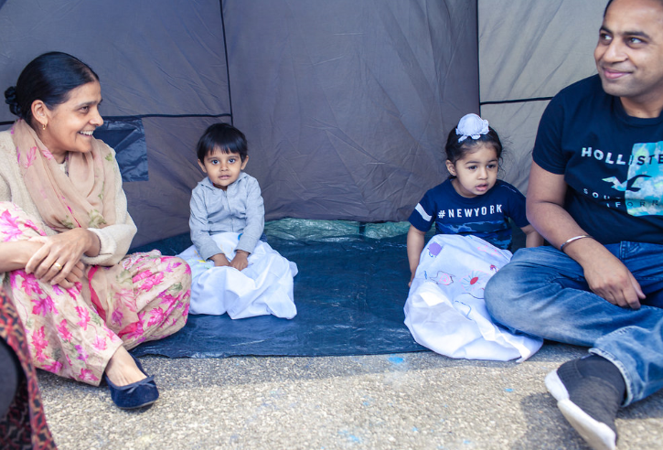
We know schools are doing all they can to reassure parents of the safety measures which are in place to welcome eligible children back to school and college this term.

To support schools with this, as part of the Government’s central “Stay Alert” campaign, you are likely to see information adverts on these measures on the radio and online to reassure parents that if their child is eligible to attend school, they should return before the summer break. These messages will sit alongside wider government messaging about public transport and returning to work, which aim to reassure the public as changes to lockdown measures are made.

The leaflets and films below are for parents of children in primary and secondary. You may want to share these with your parent network to support your engagement with children and families who have questions.

The leaflets can be found here:
https://coronavirusresources.phe.gov.uk/schools-/resources/leaflets/

The film for primary school pupils can be found here:
https://www.youtube.com/watch?v=BiefaCf2fvY

The film for secondary school pupils can be found here:
https://youtu.be/foQuuIWonl8

Hempsalls: Lockdown in Leicester and what it could mean for you
Here in Leicester we feel under the national and international spotlight as we enjoy the accolade of being the first lockdown city. The streets were teeming with press, cameras and reporters covering the news of non-essential shops closing again, schools preparing to close, bars and restaurants put on ice, and non-essential travel being prohibited. It really does feel like we were yesterday’s news and are today’s chip paper.

But there’s aspects to this story that has not received sufficient focus in our view. We have a warning to the school and early years community locally and across the country, for how long will this last, and who next and why?

Living and working in Leicester city centre we find ourselves in a new social experiment. It feels like we are under not house but city-arrest. We were all surprised to learn of an increased infection rate from Matt Hancock, the Health Secretary, in a daily briefing about two weeks ago. Since then we were the focus of public, political and press speculation, and now the subject of direct action.

Early years and childcare started to reopen again from 1 June, attendance was steadily growing. The Monday morning of 15 June saw the city hosting two-hour queues snaking around the city centre streets and corners as retail started to open up again. Roads around drive-thrus were gridlocked. People started to venture out after a three-month enforced hibernation. The community overall has patiently respected lockdown, and a gradual, sensible and cautious return of safe behaviours.

But there is a problem. And that is Leicester has huge poverty and inequalities. Living and working conditions are extremely challenging and unfair for many families even if they want to do their best and follow guidance. Factories, especially food factories, like in other parts of the country and the world, are proving to be hotspots for cross infections. Government financial support has not reached many as they fall within the gaps. I don’t think national health messages have reached or motivated many BAME communities. Indeed the emergency funding allocated to the city has already funded translated health messages.

But not just these communities, messages were seemingly incomprehensible to our leaders. Even our own elected mayor was caught, and apologised for breaking lockdown rules, and admitted he didn’t understand them, which only enhanced the Cummings effect. People started to ask for whom do these restrictions apply?

The second most important point is that Hancock has gone on record to say children are showing high levels of infection. This has been cited as a key problem. And whilst their symptoms are mostly mild, they are spreading the virus between each other and at home and in their communities. That is behind the decision to close the schools in Leicester this week. This has huge connotations for children and families returning to early years, childcare and schools.

The third concern for me was the initial announcement stated the extended lockdown was for two weeks before it was reviewed. Then we were told no decision will be made before 18 July 2020. That is three-weeks in old money. And when will sufficient data be identified and shared to relax our current conditions? Could it be four, six, or 12 weeks? Our whole sector and other communities should beware. Localities that share similar characteristics to Leicester, like Bradford, Rotherham, Bedford and Oldham (and others) need to prepare now for what could be an even more difficult time ahead.
James Hempsall OBE

Local lockdowns: guidance for education and childcare settings

What schools, colleges, nurseries, childminders, early years and other educational settings need to do if there's a local lockdown during the coronavirus (COVID-19) outbreak.
In light of the local outbreak of coronavirus (COVID-19) in Leicester, the government has taken action to control the spread of the virus in both Leicester and the affected surrounding areas. People in this area have been asked to stay at home as much as they can, and the government has recommended against all but essential travel.
From 2 July, we are therefore asking educational and early years settings1 to remain open only for priority groups- children and young people who are vulnerable, and the children of critical workers who absolutely need to attend- as they did at the beginning of this outbreak when national lockdown measures were in place.
Fewer children and young people making the journey to educational settings, and fewer children and young people in these settings, will help to control the virus in these circumstances.
The decision to ask educational settings to limit their operations has not been taken lightly. We appreciate the extraordinary work that all school and college2 leaders, their early years colleagues and educational staff have done throughout this outbreak, and are keenly aware that a return to more limited school, early years and college provision will be deeply frustrating as many children have returned since 1 June. We appreciate the impact these measures will have on parents and carers too, and the disruption they may face as a result of their child no longer being able to attend their school, college or nursery during the local lockdown. However, we consider these measures to be an important part of our overall response if we are to control the spread of the virus and protect lives in the current context.
This guidance sets out the key actions that schools, colleges and early years providers in Leicester and its surrounding areas should take to prepare for limiting attendance from 2 July 2020. We will work with the local authorities and individual nurseries, schools and colleges to support them follow the public health advice.
These local measures will be kept under review, and will be reviewed in 2 weeks. This means that the affected schools will not open more widely to more year groups before they close for the summer holidays.
https://www.gov.uk/government/publications/local-lockdowns-guidance-for-education-and-childcare-settings/guidance-for-educational-and-childcare-settings-in-leicester-and-the-affected-parts-of-leicestershire

nsering your questions

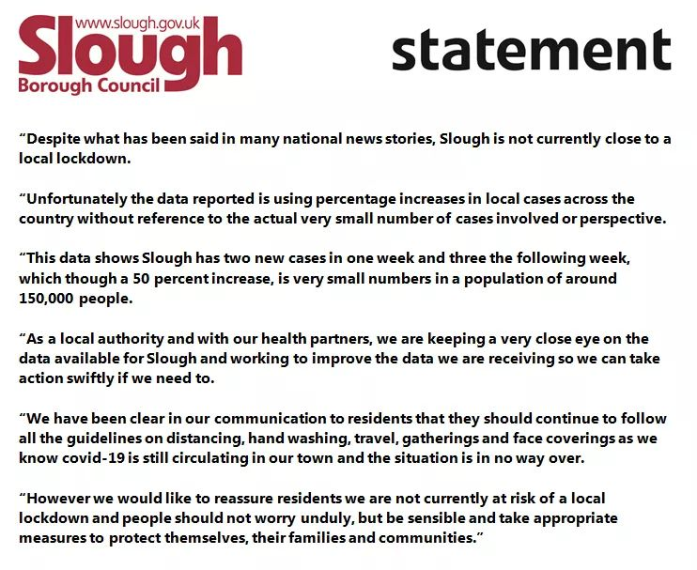
EYFS Reforms

In October 2019, DfE launched a public consultation seeking views on changes to the EYFS statutory framework. The consultation has concluded with the following changes made:
- Revisions to the educational programmes;
- Revisions to the early learning goals;
- Removal of the statutory duty for local authorities to externally moderate EYFS profile judgements;
- Removal of the 'exceeding' judgement criteria from the EYFS profile;
- Change to the safeguarding and welfare requirements to promote good oral health.

At the time of publication of the consultation response, the EYFS learning and development and the EYFS profile requirements have been disapplied for the duration of the COVID-19 outbreak.
DfE have also published the framework and EYFS profile handbook for schools participating in the EYFS reforms early adopter year from September 2020 to August 2021.

Next steps
The revised EYFS framework will be introduced on a statutory basis from September 2021. Some schools have volunteered to adopt the new framework from September 2020.

More detailed non-statutory curriculum guidance is being developed separately through an update of ‘Development Matters’. Foundation Years will be hosting a video podcast in due course.

The National Children’s Bureau and foundation Years have compiled
a short document which bullet points the key changes

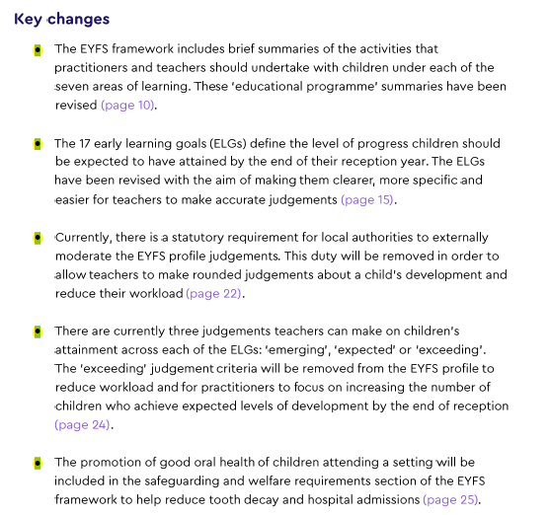

Government recognises the impact the Covid-19 outbreak has had on the early years sector and schools, particularly in terms of the impact on children’s learning and development as a result of closures. The EYFS reforms outlined in this response provide a strong basis to support children who may have missed critical months of early education. Therefore, government will proceed with offering schools the opportunity to adopt the final reforms from September 2020, followed by statutory national implementation as planned from September 2021.

EYFS Reform: The role of local authorities
Below is a letter to local authorities from Sarah Lewis Director, Early Years and Schools Strategy, Department for Education, on the government’s response to the consultation on reforms to the Early Years Foundation Stage.

Reforms set to boost early language outcomes and cut workload
Plans published to transform early years learning and development and reduce unnecessary teacher workload: Published 1 July 2020
Department for Education, Vicky Ford MP, and The Rt Hon Nick Gibb MP

Reception teachers will benefit from a cut in unnecessary paperwork giving them more time to support children’s early development, the Department for Education has confirmed in its response to a consultation proposing reforms to the Early Years Foundation Stage (EYFS).

More than 2,000 early years professionals responded to the consultation about revised early learning goals – key measures teachers use to check children’s development at the end of the Reception year – with a consistent view that they were clear and would contribute to a well-rounded assessment.

A focus on language and vocabulary development, as well as teaching numbers in maths, was welcomed – equipping children with important skills as they begin their school journey.

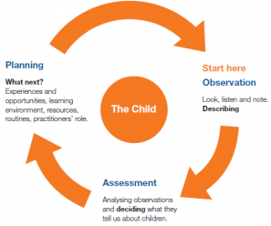
The Department for Education has also confirmed today, Wednesday 1 July, that disadvantaged and vulnerable pre-school aged children will receive additional support as they transition back into early education. Grants worth more than £1 million over six months will go to national early years voluntary and community sector (VCS) organisations including National Children’s Bureau, Early Years Alliance and Pacey.

Education Minister Nick Gibb said: It is encouraging to see that many Reception teachers and early years staff welcome our plans to reduce time spent on unnecessary paperwork and help them spend more time interacting with pupils in the classroom. These reforms will strengthen the teaching practice and improve pupils’ vocabulary and reading as they move into Year 1 and beyond. We will be rolling out these improvements to the whole early years sector from September 2021 and will continue working closely with nurseries and schools so that these positive changes keep driving up the standard of early education across the country.

The VCS grants will be targeted at improving outcomes for children most at risk of falling behind by the age of five, and will increase the support for young children with special education needs.

The Department for Education has also confirmed the Hungry Little Minds website – an online tool for parents and carers that includes tips to support children aged 0 to five with their learning at home – will be zero-rated by the major mobile providers, meaning that parents won’t use up their mobile data allowance if they browse the site from their smartphone.

Children and Families Minister Vicky Ford said: Nurseries, childminders and pre-schools have remained open to many children throughout the pandemic, providing reassurance and continuity to the youngest children during an uncertain time. The early years of a child’s education are crucial and it is vital now more than ever that we work with the sector and with parents to get children back on track.

That is why we are working with early years organisations as part of a wider effort to make sure no child falls behind, partnering with experts to help them catch up from any time missed in their formal education. We’re also making it easier for parents, no matter their background or income level, to access online resources that help them to support their children’s learning at home. The reforms to the Early Years Foundation Stage follow the Government’s commitment to improve the Early Years Foundation Stage Profile (EYFSP) in response to the Primary Assessment consultation in September 2017.

Today’s consultation response confirms that local authorities will no longer be required to externally moderate the EYFS Profile within schools when the measures become statutory from September 2021, reducing the burden on teachers to gather extensive evidence of a pupil’s development and allowing them to spend more time interacting with pupils. It builds on pilot findings published last year, where teachers found changes largely positive, with feedback that it helped focus on stories, group work and discussion, inspiring pupils to be more imaginative and improving their language skills. The improvements also resulted in a reduction in paperwork which lead to a better focus on supporting their pupils’ education.

Reception classes have been invited to bring in the EYFS reforms a year early if appropriate, marking a further step in cutting teacher workload and boosting early language development.

Professor Dame Alison Peacock, Chief Executive of the Chartered College of Teaching, said: The Chartered College of Teaching welcomes these reforms. It is vital that teachers and early years colleagues are free to spend the majority of their time focussing on leading learning rather than constantly tracking and monitoring progress for external moderation purposes.

Dr Julian Grenier, Head teacher at Sheringham Nursery School and Children’s Centre, said: I think it’s important for the sector to take hold of the opportunities these reforms offer us. Reducing the workload around the EYFS Profile will enable practitioners to focus their assessment work where it’s most needed. That’s for children in danger of falling behind the majority, and children who may have barriers to their learning.

This is an opportunity for schools to think about their early years curriculum, and what they want children to learn, experience and enjoy, rather than focusing on assessment data. The key to giving children better and more equal life-chances is to strengthen the profession in the early years. I hope that colleagues will seize this opportunity to put less emphasis on generating ‘data’ on more on developing a stronger and better-trained workforce.

Tiffnie Harris, primary specialist at the Association of School and College Leaders, said: We support this new approach to early learning because it will remove the administrative burden of external moderation and give our fantastic early years teachers more time to interact with children. Early years education is so important for future outcomes, and it is a key to narrowing the attainment gap between rich and poor. We very much welcome the focus on this vital phase.

Jan Dubiel, specialist in Early Childhood Education, said: Recent events have been a stark reminder of how unpredictable the world can be. As educators and policy makers concerned with early years care and education, we have a duty to ensure that we are preparing children to be knowledgeable, skilled, resilient and creative to manage and succeed in the future that they will face.

We are all committed to providing the most effective and up to date provision for children that will ensure this. The review of the Statutory Educational Programmes, Early Learning Goals and EYFS Profile provides us with a timely opportunity to reflect on, update and refine key aspects of the EYFS. https://www.gov.uk/government/news/reforms-set-to-boost-early-language-outcomes-and-cut-workload?utm_source=29c72e45-3800-4a05-afb1-e09d9d71e305&utm_medium=email&utm_campaign=govuk-notifications&utm_content=immediate

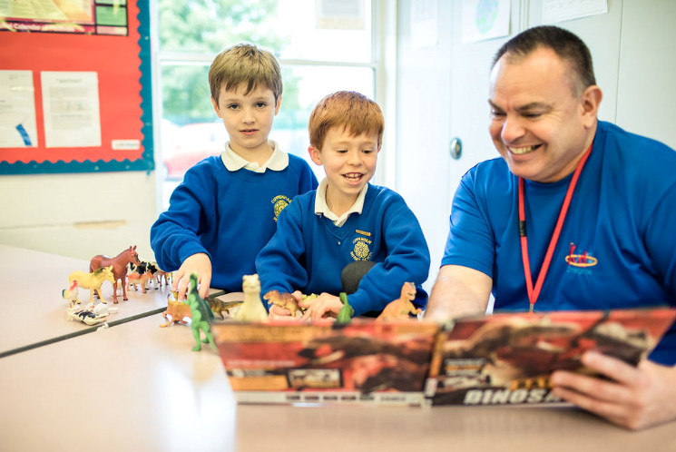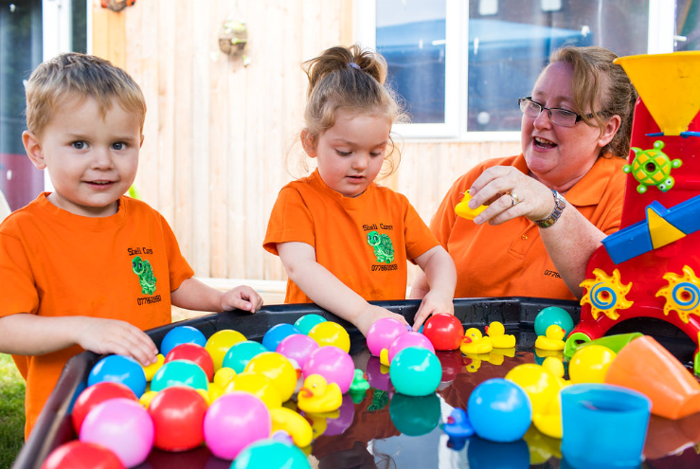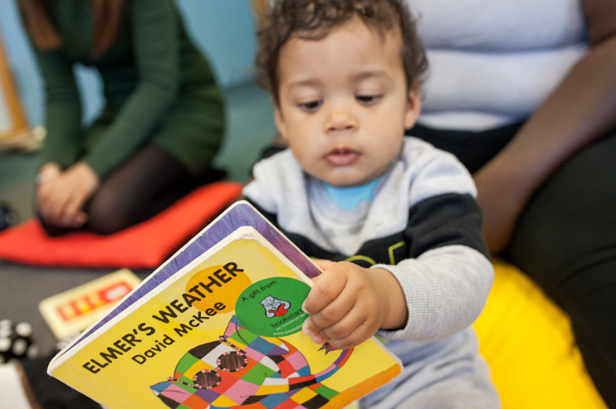
Sector Updates

Health visiting recovery plan
Update on Public Health Nursing 4 Slough’s continued effort to return to business as usual.
Public Health Nursing 4 Slough are now offering Face to Face visits for all 6 – 8 weeks checks in a community setting and offering face to face visits for the majority of all the New Birth visits. School Nurses are being accommodated within schools to carry out contacts with children who need support or an assessment. This is in addition to the visits being carried out with those identified as having a compelling need either in the home or in a community setting. Any family not wishing to leave their homes will continue to be offered video or telephone contacts.

Over the coming weeks, as we manage to secure more community settings, we will aim to increase the numbers offered appointments in the community in a more universal way. We have sourced a full range of PPE, portable protective screens and completed risk assessments for staff and clients to enable us to carry out Face to Face visits safely.
Debbie Rowe Head of Public Health Nursing Service

Special Voices : Please share with families
Please find below our latest newsletter, we are still here for you but due to Covid-19 we have adapted the way we do things for now and we will review all that we do depending on guidelines.
Our weekly coffee days are now virtual and do hope you will join us every Friday, anytime between 2 - 4pm, yes it is very different and not the same but we have to move forward in this way so we can stay in touch with you all, stay safe and hope you want to stay in touch with us. Each week you join us your name will be entered into a draw for a free small gift as a thank you for your continued support.
Friday 3rd July, topic – Have you been contacted about your child/young person's return to school in September? or, been contacted about a short break/holiday club during the school holidays? please let us know by text, telephone or email if you can't attend. We are using Zoom as we felt this was quite easy by going to google and downloading Zoom, once there you set up an account remembering to use a different password to what you use for all your other accounts. Please telephone us and we can help if you have not done this before prior to the meeting. Then if you are attending our Zoom meeting all you do is just text or email us prior to the meeting & we will send you the codes.
There are things that don't change, like your feedback and surveys, see we still need you all and have continued to feedback all your experiences to the relevant services that you have been giving us over these difficult times as they still want to know.
Government Updates

Iceland and the Company Group vouchers now available through the free school meal national voucher scheme
Through the free school meal (FSM) national voucher scheme, you can now select eGift cards for Iceland and the Company Group alongside:
- Aldi, Asda, M&S, McColl’s, Morrisons, Sainsbury’s, Tesco, Waitrose

Guidance on providing free school meals during the coronavirus (COVID-19) outbreak can be found here:
https://www.gov.uk/government/publications/covid-19-free-school-meals-guidance/covid-19-free-school-meals-guidance-for-schools
These eGift cards will also be available through the Covid Summer Food Fund, which will enable children who are eligible for benefits-related FSM to be supported over the summer holiday period. All vouchers for the summer holidays must be ordered at least one week before your school’s summer term ends.
Please read the short guidance document in full before ordering, to ensure your orders are processed correctly. The payments for the fund will be met centrally by the Department for Education.
The COVID Summer Food Fund guidance can be found here:
https://www.gov.uk/guidance/covid-summer-food-fund
We have also updated the application form and guidance on the temporary extension of free school meals to no recourse to public funds (NRPF) groups. This is to reflect the change in annual household income threshold to £16,190 after tax.
The sample application form and guidance can be found here:
https://www.gov.uk/government/publications/covid-19-free-school-meals-guidance/guidance-for-the-temporary-extension-of-free-school-meals-eligibility-to-nrpf-groups

SLOUGH EARLY YEARS AND PREVENTION SERVICE: TELEPHONE: 01753 476554 / EMAIL: earlyyears@slough.gov.uk

