|  |  |  |  |  |
| --- | --- | --- | --- | --- |
|  |  | |  | | --- | | Early Years and Prevention Service  COVID-19 | |  | |
|  |  |  |
| **Recovery Planning for EArly Years and childcare providers** |  | This Issue: 14th July 2020 |



# 

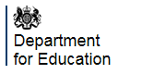

# **Plans for all children and young people to return to full-time education at the start of the autumn term. Page 1**

The guidance for the full opening of schools, early years and colleges at the start of the autumn

can be found here:

# **Guidance on the protective measures for holiday or after-school clubs and other out-of-school settings for children during the coronavirus (COVID-19) outbreak. Page 2**

|  |
| --- |
| * [Full opening of schools from the start of the autumn term](https://www.gov.uk/government/publications/actions-for-schools-during-the-coronavirus-outbreak?utm_source=14%20July%202020%20C19&utm_medium=Daily%20Email%20C19&utm_campaign=DfE%20C19) * [Actions for early years and childcare providers during the coronavirus (COVID-19) outbreak](https://www.gov.uk/government/publications/coronavirus-covid-19-early-years-and-childcare-closures?utm_source=14%20July%202020%20C19&utm_medium=Daily%20Email%20C19&utm_campaign=DfE%20C19)   This guidance should be read alongside the following guidance:  Guidance on infection prevention and control   * [Safe working in education, childcare and children’s social care settings](https://www.gov.uk/government/publications/safe-working-in-education-childcare-and-childrens-social-care/safe-working-in-education-childcare-and-childrens-social-care-settings-including-the-use-of-personal-protective-equipment-ppe) * [Planning guide for early years and childcare settings](https://www.gov.uk/government/publications/preparing-for-the-wider-opening-of-early-years-and-childcare-settings-from-1-june/planning-guide-for-early-years-and-childcare-settings)   Guidance on funding   * [Financial support for education, early years and children’s social care](https://www.gov.uk/government/publications/coronavirus-covid-19-financial-support-for-education-early-years-and-childrens-social-care) * [Coronavirus Job Retention Scheme](https://www.gov.uk/guidance/claim-for-wage-costs-through-the-coronavirus-job-retention-scheme) * [Use of free early education entitlements funding](https://www.gov.uk/government/publications/use-of-free-early-education-entitlements-funding-during-the-coronavirus-outbreak/use-of-free-early-education-entitlements-funding-during-coronavirus-covid-19)   Other relevant guidance   * Supporting [vulnerable children and young people](https://www.gov.uk/government/publications/coronavirus-covid-19-guidance-on-vulnerable-children-and-young-people) * Guidance on the temporary [early years foundation stage (EYFS) disapplications](https://www.gov.uk/government/publications/early-years-foundation-stage-framework--2/early-years-foundation-stage-coronavirus-disapplications) * [Ofsted’s response to coronavirus (COVID-19)](https://www.gov.uk/guidance/ofsted-coronavirus-covid-19-rolling-update) * [The government response to the consultation on EYFS reforms](https://www.gov.uk/government/consultations/early-years-foundation-stage-reforms) * [What parents and carers need to know about early years providers, schools and colleges in the autumn term](https://www.gov.uk/government/publications/what-parents-and-carers-need-to-know-about-early-years-providers-schools-and-colleges-during-the-coronavirus-covid-19-outbreak?utm_source=14%20July%202020%20C19&utm_medium=Daily%20Email%20C19&utm_campaign=DfE%20C19) |

The DfE have updated the [protective measures for holiday or after-school clubs and other out-of-school settings guidance](https://www.gov.uk/government/publications/protective-measures-for-holiday-or-after-school-clubs-and-other-out-of-school-settings-for-children-during-the-coronavirus-covid-19-outbreak?utm_source=13%20July%202020%20C19&utm_medium=Daily%20Email%20C19&utm_campaign=DfE%20C19) with more information on group sizes and the considerations that need to be made, and the opening of indoor sports facilities from 25 July, including indoor gyms, sports courts and fitness and dance studios.

# Guidance on the protective measures for holiday or after-school clubs and other out-of-school settings for children during the coronavirus (COVID-19) outbreak

If your school or college operates outdoors, you should also refer to the Department for Digital, Culture, Media and Sport’s [guidance for the public on the phased return of outdoor sport and recreation in England](https://www.gov.uk/government/publications/coronavirus-covid-19-guidance-on-phased-return-of-sport-and-recreation?utm_source=13%20July%202020%20C19&utm_medium=Daily%20Email%20C19&utm_campaign=DfE%20C19).

**Local Government Association update**

The Department for Education has published [further guidance for out-of-school settings](https://www.gov.uk/government/publications/protective-measures-for-holiday-or-after-school-clubs-and-other-out-of-school-settings-for-children-during-the-coronavirus-covid-19-outbreak/protective-measures-for-out-of-school-settings-during-the-coronavirus-covid-19-outbreak), including holiday clubs. This includes updated information on group sizes.

I’ve also received the following from DfE to clarify the position on group sizes (my highlight):

As the Prime Minister confirmed in his announcement on 23 June, providers who run community activities, holiday clubs, after-school clubs, tuition and other out-of-school provision for children can operate over the summer holiday, with safety measures in place.

We have amended the current Health Protection (Coronavirus, Restrictions) (England) Regulations 2020, to enable providers to be able to open for both outside and indoor provision from 4 July, provided that they follow the protective measures set out by government.

Until the end of term in a local area, settings should follow the same protective measures as schools to limit different groups of children mixing. This means that if a setting opens before the end of the 2020 summer term, they should ensure they are only caring for children from the eligible groups (children in early years, Reception, Year 1 and Year 6) and priority groups (children of critical workers and vulnerable children). These settings should only be caring for children from one school or early years provider and should be working closely with the school or early years providers that their children attend, to ensure that, as far as possible, children are kept in the same small consistent groups that they are in throughout the day, and otherwise maintain social distance.

From the end of term, the Department’s [protective measures guidance](https://www.gov.uk/government/publications/protective-measures-for-holiday-or-after-school-clubs-and-other-out-of-school-settings-for-children-during-the-coronavirus-covid-19-outbreak) outlines how these settings can minimise the risk to children, staff and parents who attend their settings by reducing the risk of infection and transmission of the virus. Providers should ensure, **as far as it is possible**, that they are keeping children and young people in small, consistent groups every time they attend. If possible, those attending these settings should practice social distancing in line with the [government’s current guidance](https://www.gov.uk/government/publications/staying-alert-and-safe-social-distancing/staying-alert-and-safe-social-distancing). To minimise the number of different children mixing, parents and carers are being encouraged to limit the number of settings their children attend as far as possible and attend local settings.

As the risk of transmission is considerably lower outdoors, providers who normally run sessions indoors should consider whether they are able to operate outside. If your setting usually operates outdoors, you should also refer to DCMS’s [Guidance on the Phased Return of Outdoor Sport and Recreation.](https://www.gov.uk/government/publications/coronavirus-covid-19-guidance-on-phased-return-of-sport-and-recreation/guidance-for-providers-of-outdoor-facilities-on-the-phased-return-of-sport-and-recreation)

# **Guidance for parents and carers of children attending out-of-school settings during the coronavirus (COVID-19) outbreak**

Guidance for parents and carers of children attending community activities, holiday or after-school clubs, tuition and other out-of-school settings. <https://www.gov.uk/government/publications/guidance-for-parents-and-carers-of-children-attending-out-of-school-settings-during-the-coronavirus-covid-19-outbreak?utm_source=bbe9b699-d375-41f2-ba77-609cc78e7026&utm_medium=email&utm_campaign=govuk-notifications&utm_content=immediate>



#### early years and childcare providers

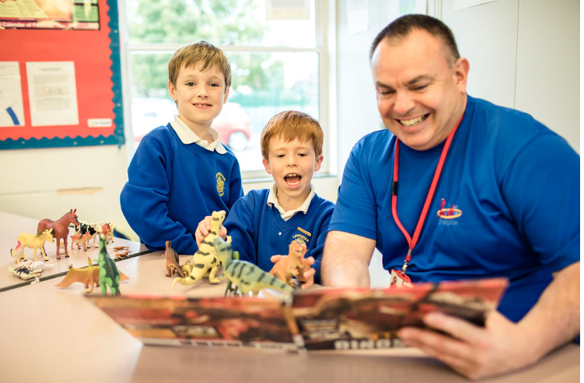  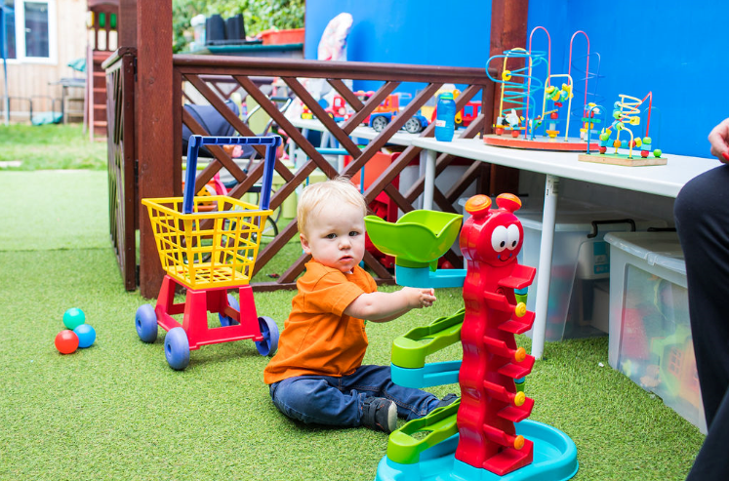  

**Leaders across the EY service attended a webinar with DfE and the below notes were taken:**

**DfE webinar for Local Authority Lead Officers 9th July 20**

Key points from the DfE webinar

* The temporary modifications to the EYFS will finish on 25th September and there are currently no plans to change this, however it is reviewed on a monthly basis (this could include extending the first aid cut off date)
* DfE are proceeding with securing early adopter schools for September and will share with LA’s if they have any schools in their area who have signed up
* DfE are planning to cross reference the main tow guidance documents for early years (Actions for EY & Planning guide) to produce one piece of guidance, being published soon
* From 20th July settings are not required to have ‘bubbles’ but should consider how they can minimise contact between groups of children where appropriate
* Parents and carers should be encouraged to limit the number of settings their child attends, where possible
* DfE Data collection task is likely to continue until the end of September but this will be reviewed in September
* Routine Ofsted inspections to start in Jan 2021 and regulatory work for settings with inadequate or RI with actions to commence in the autumn term
* Holiday clubs should be run with groups of 15 children and 1 staff and groups should not be mixed, they should be operating outdoors where possible and social distancing where possible
* From 20th July Holiday clubs can operate with children from different schools
* DfE are looking to procure a contract of support for the LA and hoping to have things in place in late autumn. This is likely to be focused on take up (2 year olds, SEND) and business support for providers. There will be a universal offer (guidance and best practice support) and a targeted offer.

Funding points (Emily Arch, DfE Head of EY funding)

* DfE are talking to ministers about their proposed arrangements for autumn term funding and will publish guidance before the end of term
* Funding updates for summer will be based on January census 2020 (as usual)
* Autumn term 2020 funding is usually based on January 2021 census and this is being discussed with minister and further guidance will be publish before the end of term
* There will be no exceptional costs/funding for the EY sector (like schools got)
* MNS should be accessing the job retention scheme, something which schools can not access
* With regards to sustainability the government has offered various schemes for the sector to access such as the job retention scheme, business loans, business grants, business rates relief. DfE plan to issue further guidance on the job retention scheme specific to the EY sector relating to the current offer and the continuation until October.
* There will be a government wide spending review during the late summer and early autumn and during this they will look at the overall funding levels for EY. We will find out in the autumn what our funding will be for 2021-22
* MNS funding discussions were put on hold due to COVID but this is still a high priority on the DfE’s agenda and they are now moving back to ‘their day jobs’. Ministers recognise the importance of MNS and are continuing to ask DfE to review the long term plans for this sector. More to follow

Lots of other questions in the chat box and the DfE will produce a Q&A sheet following the webinar

1. When will development matters be rewritten and published
2. Should out of school settings who are on the EY register follow the ‘actions for EY’ guidance or the holiday guidance?
3. Can holiday clubs offer off site activities and if so will there be a restriction on numbers in groups?
4. Will parents be able to join a new provision from 1st September if they are in their grace period for 30 hours?
5. Will schools be allowed to defer start dates for reception children and offer part time starts?
6. Staggered September starts are starting to cause issues and parents are going to struggle with additional childcare costs. Children attending school on a rota basis is also causing issues for working parents

**Ofsted adds early years regulation to role of national director for social care**

**Ofsted has expanded the role of its national director for social care, Yvette Stanley, by giving her responsibility for the regulation of childcare and childcare policy.**

<https://www.cypnow.co.uk/news/article/ofsted-adds-early-years-regulation-to-role-of-national-director-for-social-care#.Xw2i0lQPh1U.email>





The Reading Together Day (16 July) ambassadors and the [shared schedule of events](https://readingagency.org.uk/news/media/reading-together-day-schedule---highlights-announced.html), delivered by 18 organisations across the publishing, books and education sectors, has been announced. The day will deliver a programme of activity to highlight the importance of reading together and encourage the nation to keep reading. The campaign aims to reach as many families and young people as possible. <https://readingagency.org.uk/news/media/reading-together-day---ambassadors-announced.html>

 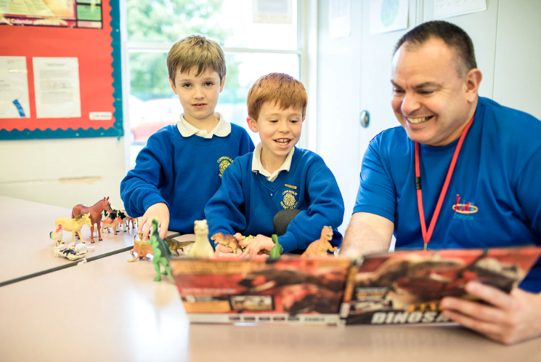 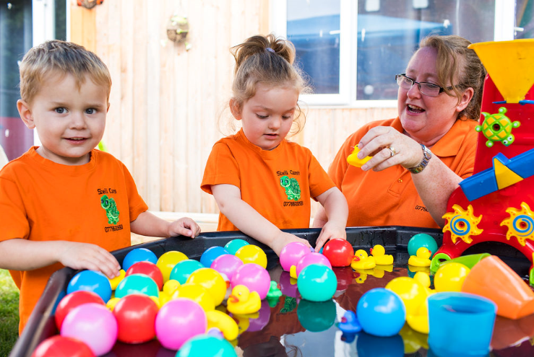 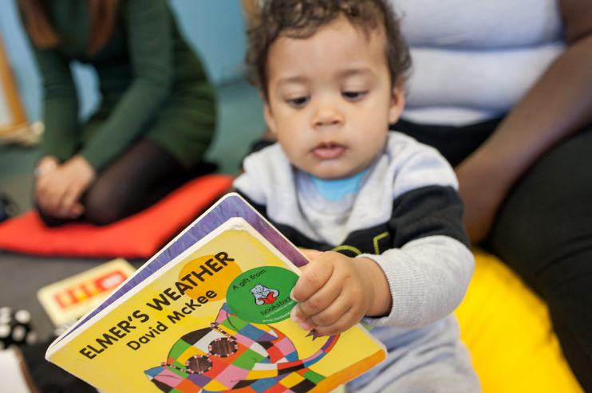

|  |
| --- |
| **SLOUGH EARLY YEARS AND PREVENTION SERVICE: TELEPHONE: 01753 476554 / EMAIL: earlyyears@slough.gov.uk** |