Early Years and Prevention Service
  - COVID-19

Recovery Planning for EArly Years and childcare providers |  | This Issue:17th July 2020

Shared care arrangements from autumn 2020

Wraparound provision, including 30 hours childcare and out of school care
Key points from DfE guidance documents
Guidance for full opening: schools
https://www.gov.uk/government/publications/actions-for-schools-during-the-coronavirus-outbreak/guidance-for-full-opening-schools
Shared care arrangements from autumn 2020
Key points from DfE guidance documents - Wraparound provision, including 30 hours childcare and out of school care
Page 1 - 2

The overarching principle to apply is reducing the number of contacts between children and staff. This can be achieved through keeping groups separate (in ‘bubbles’) and through maintaining distance between individuals.

It is likely that for younger children the emphasis will be on separating groups, and for older children it will be on distancing. For children old enough, they should also be supported to maintain distance and not touch staff where possible.

Schools with the capability to do it should take steps to limit interaction, sharing of rooms and social spaces between groups as much as possible.
Both the approaches of separating groups and maintaining distance are not ‘all-or-nothing’ options, and will still bring benefits even if implemented partially. Some schools may keep children in their class groups for the majority of the classroom time, but also allow mixing into wider groups for specialist teaching, wraparound care….
Test and Trace: Slough Please continue to share the essential health messages with our staff and families; Stay alert….Stay safe….Save lives by controlling the spread of the virus… and encourage them to use the testing site to get tested..
Page 2 - 3

Siblings may also be in different groups.

Extra-curricular provision
Schools should consider resuming any breakfast and after-school provision, where possible, from the start of the autumn term. We recognise that schools may need to respond flexibly and build this up over time.

We recognise that this will be logistically challenging for schools, particularly for clubs that would normally offer support across year groups, where parents are using multiple providers, or where childminders are picking up/dropping off pupils.

Schools should carefully consider how they can make such provision work alongside their wider protective measures, including keeping children within their year groups or bubbles where possible. If it is not possible to maintain bubbles being used during the school day then schools should use small, consistent groups.
Schools can consult the guidance produced for summer holiday childcare, available at Protective measures for out-of-school settings during the coronavirus (COVID-19) outbreak as much of this will be useful in planning extra-curricular provision. This includes schools advising parents to limit the number of different wraparound providers they access, as far as possible.

Actions for early years and childcare providers during the coronavirus (COVID-19) outbreak: https://www.gov.uk/government/publications/coronavirus-covid-19-early-years-and-childcare-closures/coronavirus-covid-19-early-years-and-childcare-closures

Settings should still consider how they can minimise mixing within settings, for example where they use different rooms for different age groups, keeping those groups apart as much as possible.

Settings should try to be as flexible as possible for parents and carers who work shifts or atypical hours and especially for parents who are critical workers.

Parents and carers should be encouraged to limit the number of settings their child attends, ideally ensuring their child only attends the same setting consistently. This should also be the same for staff.

Childminders and other settings should consider how they can work with parents to agree how best to manage any necessary journeys, for example pick-ups and drop-offs at schools, to reduce the need for a provider to travel with groups of children.

What parents and carers need to know about early years providers, schools and colleges in the autumn term: https://www.gov.uk/government/publications/what-parents-and-carers-need-to-know-about-early-years-providers-schools-and-colleges-during-the-coronavirus-covid-19-outbreak/what-parents-and-carers-need-to-know-about-early-years-providers-schools-and-colleges-in-the-autumn-term

Schools will be permitted to run breakfast and after-school activities. Schools will need to make sure these can be delivered in line with the wider guidance on protective measures, so they may need to run things differently and adapt over time.

Out-of-school settings - such as holiday or after-school clubs - can open to children and young people of all ages. It remains important that they put protective measures in place to help reduce the risk of transmission.

In order to minimise risks, you should consider sending your child to the same setting consistently and limit the number of different providers you access.

Protective measures for out-of-school settings during the coronavirus (COVID-19) outbreak:
https://www.gov.uk/government/publications/protective-measures-for-holiday-or-after-school-clubs-and-other-out-of-school-settings-for-children-during-the-coronavirus-covid-19-outbreak/protective-measures-for-out-of-school-settings-during-the-coronavirus-covid-19-outbreak

If you are caring for children both over the age of five and under the age of five, then you could apply the measures outlined in the early years guidance to the children under the age of five, and this guidance to the children over the age of five, if it is possible to do so. However, if you have mixed age groups together you will need to, as far as possible, keep all children irrespective of age in small consistent groups of no more than 15 with at least one staff member, or with more staff members to meet relevant ratio requirements.

Parents and carers are being encouraged to limit the number of settings their children attend as far as possible, and ideally to ensure their children attend the same setting consistently.

Providers are encouraged to consider measures they can put in place to reduce the extent to which children are mixing with others, by ensuring that children who attend your setting are assigned to a particular class or group when they return and stay in those consistent groups for future sessions, as far as it is possible. You should also discourage attendance from children who live outside the local area. Ideally, children who attend your setting should live within walking or cycling distance.

arly years and childcare providers

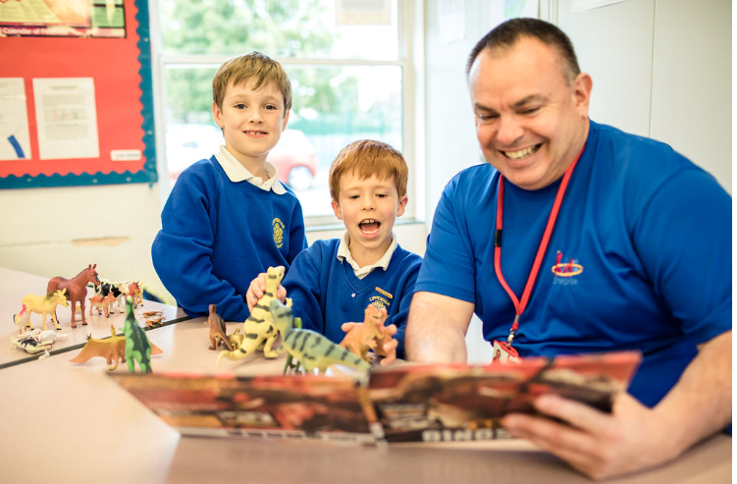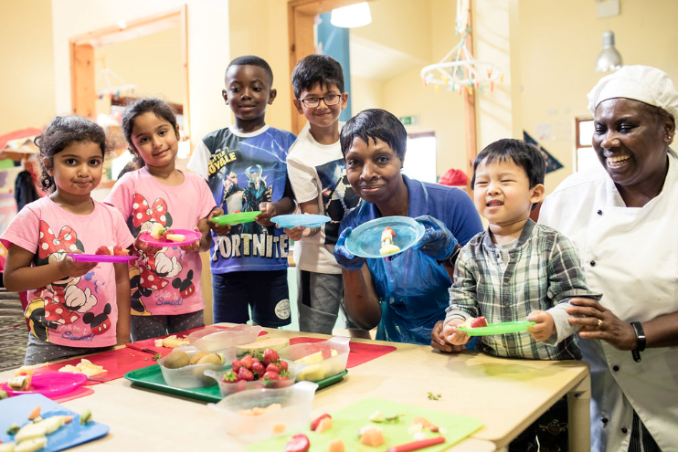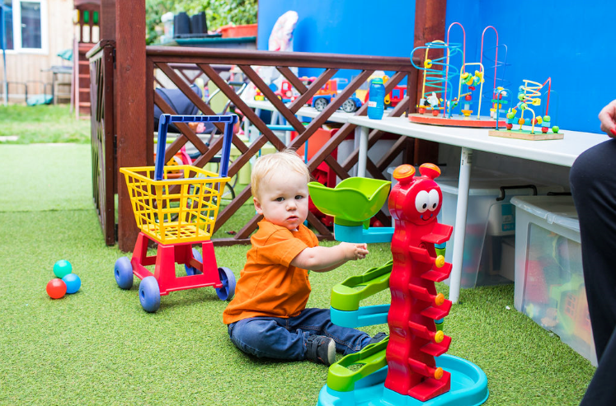

The Pan Berkshire Safeguarding Children Procedures Manual has been updated.
The manual is available to view at https://www.proceduresonline.com/berks/

Amendments: July 2020

Updated Chapters
Chapter Name | Details
Single Assessment | This chapter has been updated in line with the new digital referral system for reporting potential victims of Modern Slavery.
Bullying | This chapter has been updated to reflect Keeping Children Safe in Education statutory guidance (updated September 2019) and reference to Upskirting which is a specific example of abusive behaviour which has been linked to on-line bullying and grooming. Upskirting is a criminal offence and, as such, should be reported to the Police.
Children from Abroad, including Victims of Modern Slavery, Trafficking and Exploitation | This chapter has been updated to take account of the new NRM digital referral form and the change to a Single Competent Authority (SCA).
Children Missing from Care, Home and Education | This chapter has been updated in line with new NRM digital referral form to report Modern Slavery.

Next Update: January 2021

Slough schools and early years #ActiveParkWalk launch!
We are delighted to announce that working alongside Active Movement we have created four “#ActiveParkWalks complete with Active Walk, map, special markers and information QR codes.

They are Upton Court Park, Upton Lea Recreation Ground, Kennedy Park and Salt Hill Park – AND ARE NOW OPEN.

To celebrate, we have a special competition beginning August 4th 2020 as part of the Active Movement Summer activity for children, parents and any member of staff.

Simply encourage everyone to visit the park and take the walk. At each marker post along the walk, scan the QR code with your mobile phone and answer the question. There are 6 questions in total.

When you have them all, they should be submitted to the link available on the final QR code of the walk. Correct answers will then be put into a prize draw to win a special Active Movement standing desk for a randomly selected school and an extra set of Max Pack toys for a randomly selected early years setting.
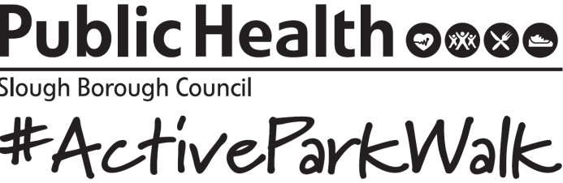
As a further incentive we will also be offering a pedometer to 100 residents that submit the 6 answers before the end of the school holidays..

For more information, go to https://www.publichealthslough.co.uk/campaigns/active-park-walks/

Test and Trace: Slough
Please continue to share the essential health messages with our staff and families; Stay alert….Stay safe….Save lives by controlling the spread of the virus… and encourage them to use the testing site to get tested.

Slough is currently struggling with contact tracing, and has some of the lowest tracing numbers in the South East. There needs to be an improvement in this to avoid a local lockdown, and prevent any further spread of the virus.

There may be various reasons why Slough has such poor results
• Some people don’t want to admit to having contracted the virus, and may not want to involve others by causing them to self-isolate.
• There are many small businesses in Slough and they want/need to keep operational
• Some do not trust the Government /call centre with their personal details

Here is a brief about contact tracing:
• Individuals are contacted by txt, e-mail or phone call
• Txt messages will come from NHStracing and calls from 0300 0135000
• Children under 18 will be contacted by phone wherever possible and asked for their parent or guardian's permission to continue the call.
• Individuals will be asked to sign in to the NHS Test and Trace contact tracing website at https://contact-tracing.phe.gov.uk
• Anyone who is unable to use the contact tracing website, will receive a call from a contact tracer who will ask for personal details (name, DOB, postcode) as well as the contact details of anyone the individual would have had close contact with over the past 2 weeks. They will also ask any other relevant questions.

It is vital that people aware of the importance of informing the call handler of ALL the contacts they have had with others over the past 2 weeks, not just some of the contacts. Compared to other areas, Slough is not showing many contacts with other. This may mean individuals are really not having contact with others, but given the cultural make-up of the population, it would seem unlikely.
Therefore, the message is clear….please highlight the importance of people being honest and providing ALL the relevant information when they are contacted.

The call handler WILL NOT:
o Ask for bank details or payments
o Ask for details of any other accounts (e.g. social media)
o Ask the individual to set up a password or PIN number over the phone
o Ask the person to call a premium rate number, such as those starting with 09 or 087

Please make your contacts/staff/ families aware of this!
Any further information can be found here - https://www.gov.uk/guidance/nhs-test-and-trace-how-it-works

Here's what you need to know about the EYFS reforms:
- A revised EYFS Framework will become statutory from September 2021. The Framework is likely to be virtually identical to the early adopters EYFS framework - see link below

- Infant and primary schools could choose to become Early Adopters from September 2020 using the Early Adopters EYFS Framework (https://www.gov.uk/…/p…/early-adopter-schools-eyfs-framework) and Early Adopters EYFS Profile Handbook (https://www.gov.uk/…/early-adopter-schools-eyfs-profile-han…) but read our advice on the option to be an "early adopter" in September 2020 (July 2020). https://www.early-education.org.uk/…/advice-early-adoption-…

There will not be an update of Development Matters for early adopters.
- Revised non-statutory guidance is expected in the autumn and exemplification materials will be available at some stage, but dates are not yet confirmed.

- Other early years providers cannot be early adopters.

- The current EYFS Statutory Framework remains in force until September 2021 for everyone other than early adopters.

- Choosing to be an early adopter of the new EYFS Framework and an early adopter of Reception Baseline Assessment in September 2020 are two separate decisions - you can do one, both or (we recommend) neither.

- You can read government's response to the consultation https://www.gov.uk/…/c…/early-years-foundation-stage-reforms
You might also want to:
- read our comments https://www.early-education.org.uk/…/government-eyfs-reform…
- and watch our EYFS reforms briefing video (see the videos tab on our page)

Sector Updates
Government Updates

Updated guidance on providing apprenticeships during the coronavirus (COVID-19) outbreak
We have updated our guidance on providing apprenticeships during the coronavirus (COVID-19) outbreak confirming that providers can now make arrangements for 19+ apprentices to return to on-site delivery, where this can be safely accommodated. We also confirm that the temporary flexibility suspending the funding rule requiring level 2 apprentices to study towards, and attempt, level 2 functional skills assessments has been extended until 31 December 2020. https://www.gov.uk/government/publications/coronavirus-covid-19-apprenticeship-programme-response?utm_source=15%20July%202020%20C19&utm_medium=Daily%20Email%20C19&utm_campaign=DfE%20C19

10 top tips to encourage children to read
Information to help parents think about ways to make reading enjoyable and engaging. These tips are for parents, carers and guardians of primary-aged children, to help them encourage and support their children to read. They contain ideas on how to plan reading opportunities at home, including during the coronavirus (COVID-19) outbreak. https://www.gov.uk/government/publications/10-top-tips-to-encourage-children-to-read?utm_source=2320ec48-9777-43be-8336-ca691bbb9cfe&utm_medium=email&utm_campaign=govuk-notifications&utm_content=immediate

Supporting your children's education during coronavirus (COVID-19)
Information, guidance and support for parents and carers of children who are learning at home. https://www.gov.uk/guidance/supporting-your-childrens-education-during-coronavirus-covid-19?utm_source=fb7c5ed3-c5fc-482c-86de-85027b30b828&utm_medium=email&utm_campaign=govuk-notifications&utm_content=immediate

Help children with SEND continue their education during coronavirus (COVID-19)
Advice for parents and carers looking after children with special educational needs and disabilities (SEND). Banner updated with information about pupils returning to school in the autumn term. https://www.gov.uk/guidance/help-children-with-send-continue-their-education-during-coronavirus-covid-19?utm_source=67154f47-8b28-4f1c-98a0-9649cd594005&utm_medium=email&utm_campaign=govuk-notifications&utm_content=immediate#history

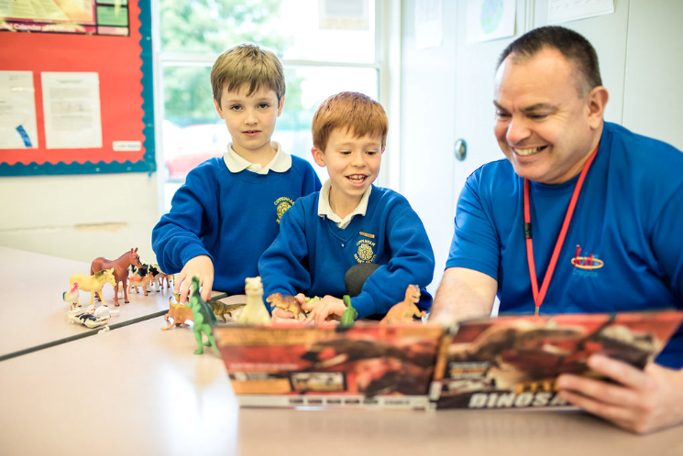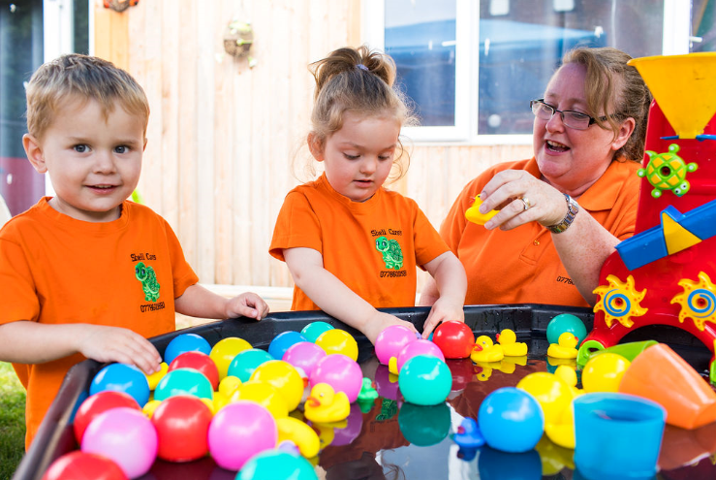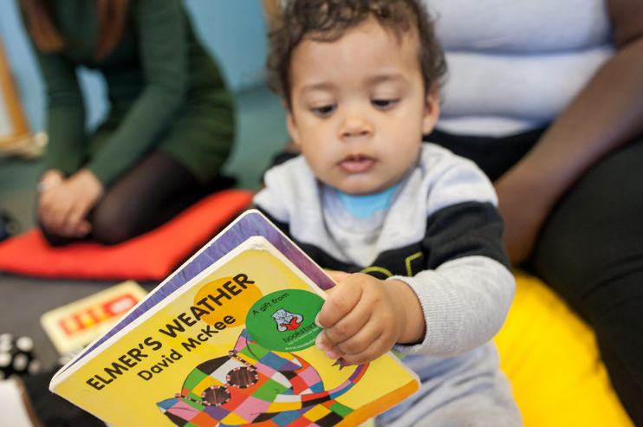
SLOUGH EARLY YEARS AND PREVENTION SERVICE: TELEPHONE: 01753 476554 / EMAIL: earlyyears@slough.gov.uk

