Early Years and Prevention Service
Weekly News Bulletin: 29th July 2020

Contents
- Actions for early years and childcare providers during the coronavirus (COVID-19) outbreak
- Actions for schools during the coronavirus outbreak
- Early years foundation stage statutory framework (EYFS): First Aid
- Face Coverings
- Guidance for schools on the winter flu programme
- Guidance on the coronavirus (COVID-19) catch-up premium
- Local lockdowns: guidance for education and childcare settings
- Prepare for the return to school with Mentally Healthy Schools
- DfE Early Years Qualifications
- Berkshire Opportunities
- Coronavirus: How will school be different in September?
- Tes: 3 things all EYFS teachers should remember in September
- Top tips for Autistic and ADHD children returning to school September 2020
- Steps to take following the death of a colleague in children’s services
- National impact of COVID: Early years and childcare

Actions for early years and childcare providers during the coronavirus (COVID-19) outbreak
Actions for early years and childcare providers during the coronavirus (COVID-19) outbreak
What childcare services early years settings, childminders and local authorities need to provide during the coronavirus (COVID-19) outbreak.
Updated to reflect changes in legislation to the 30 hours free entitlement and information on the validity of Paediatric First-Aid certificates.
27 July 2020

Actions for schools during the coronavirus outbreak
Actions for schools during the coronavirus outbreak
What all schools will need to do during the coronavirus (COVID-19) outbreak from the start of the autumn term.
Guidance updated to provide more advice and clarity on some aspects of the return to school in the autumn.
27 July 2020

Early years foundation stage statutory framework (EYFS)
The standards that school and childcare providers must meet for the learning, development and care of children from birth to 5.
Published 31 March 2014
Last updated 28 July 2020
Updated to reflect the extension of the validity of current PFA certificates.

6.2 Paediatric first aid
The changes

The requirement for at least one person who has a full PFA certificate to be on the premises at all times when children are present remains in place where there are children below the age of 24 months. Paragraph 3.25 and annex A of the EYFS set out more detail. However, if children are aged 2 to 5 within a setting, providers must use their ‘best endeavours’ to ensure one person with a full PFA certificate is on-site when children are present. If after using best endeavours they are still unable to secure a member of staff with full PFA to be on site then they must carry out a written risk assessment and ensure that someone with a current first aid at work or emergency PFA certification is on site at all times children are on premises.

‘Best endeavours’ means to identify and take all the steps possible within your power, which could, if successful, ensure there is a paediatric first aider on site when a setting is open, as per the usual EYFS requirement on PFA.

Please note this does not apply for childminders as they must already have a full PFA certificate.

New entrants (levels 2 and 3) will not need to hold a PFA certificate within their first 3 months in order to be counted in staff: child ratios, during the coronavirus (COVID-19) outbreak.

Additionally, if PFA certificate requalification training is prevented for reasons associated directly with the coronavirus (COVID-19) outbreak, or by complying with related government advice, the validity of current certificates can be extended to 25 November 2020 at the latest. This applies to certificates expiring on or after 16 March 2020.

If asked to do so providers should be able to explain why the first aider has not been able to requalify and demonstrate what steps have taken to access the training. Employers or certificate holders must do their best to arrange requalification training at the earliest opportunity. The practical elements of PFA courses should be delivered face to face, so that competency can be properly assessed.

Providers remain responsible for ensuring all children in their care are kept safe at all times.

https://www.gov.uk/government/publications/early-years-foundation-stage-framework--2/early-years-foundation-stage-coronavirus-disapplications

Face Coverings
- Full guidance on wearing face coverings has been published.
- From 24th July, face coverings become compulsory to wear in additional enclosed public spaces in England, including when buying food and drink to take away from cafes and shops, although not in hospitality settings, such as restaurants with table service.
- Face coverings will not be mandatory for children under the age of 11 or people with disabilities or certain health conditions, such as respiratory or cognitive impairments.
- The rules for shops will be enforced by the police, with anyone disregarding them at risk of a fine of up to £100. This will be reduced to £50 if the fine is paid within 14 days.

Please can you remind all staff and families of the importance of face coverings
A face covering does not have to be a mask, it can be a scarf or piece of fabric
The important thing is that it covers both nose and mouth
Please see the publicity material below which can use as appropriate.

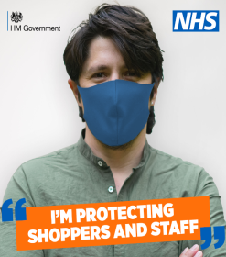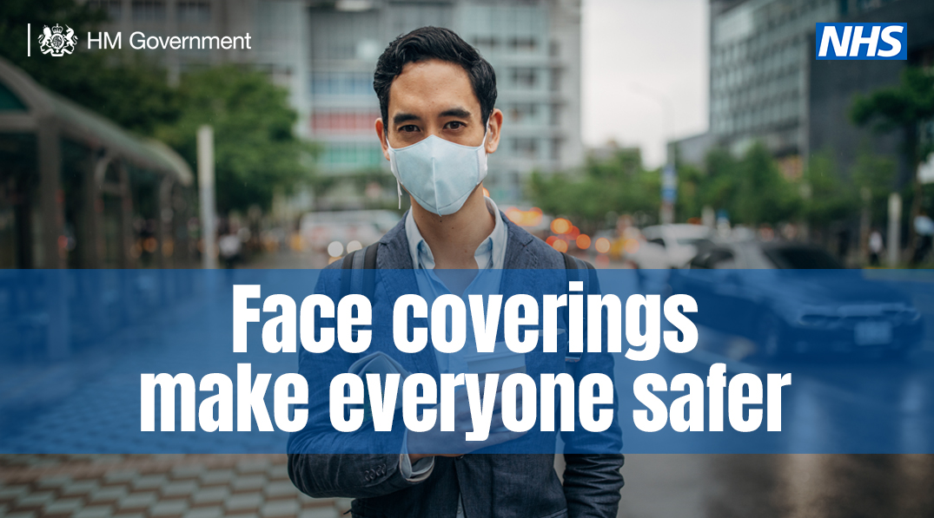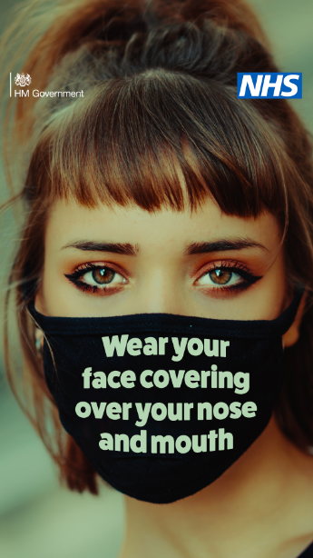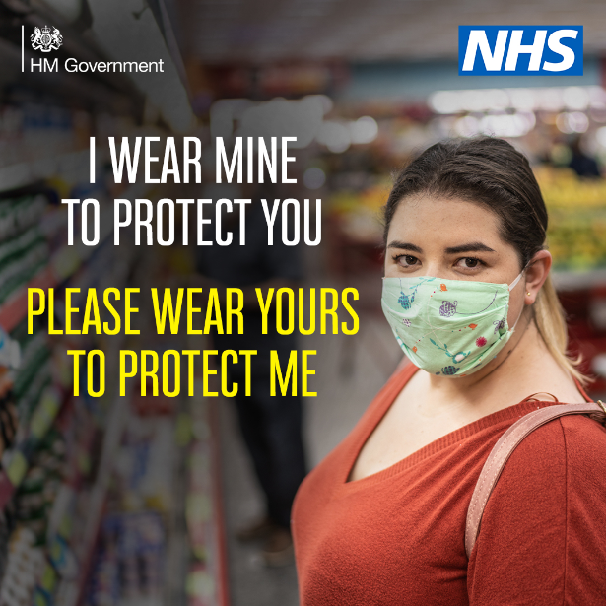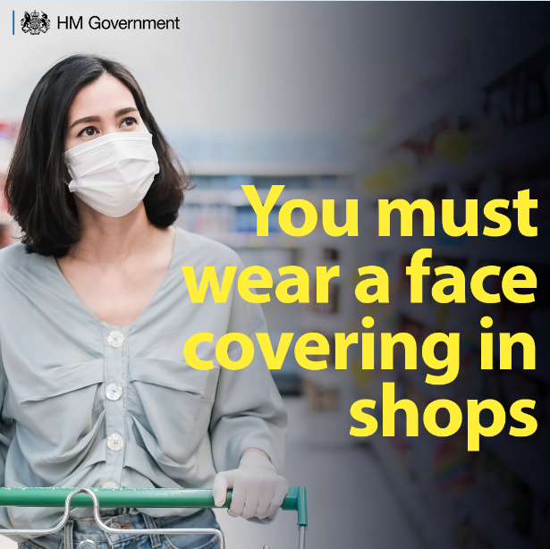

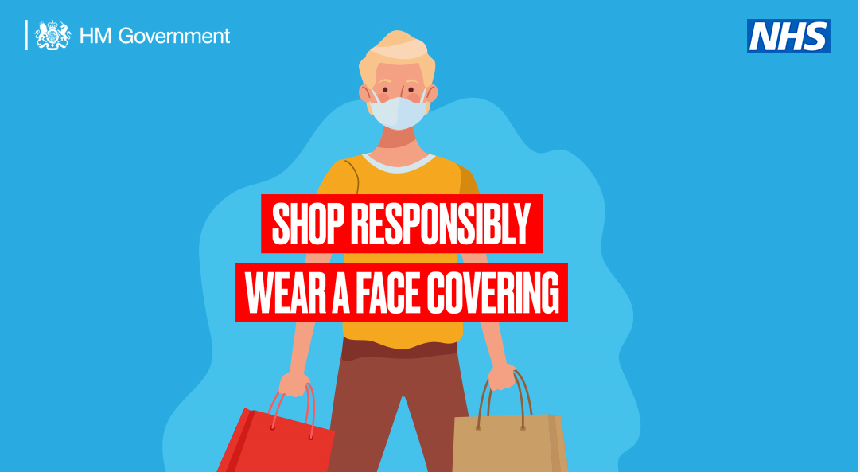

Guidance for schools on the winter flu programme
On Friday, the Department for Health and Social Care announced details of its expanded winter flu programme to protect vulnerable people and support the NHS, which includes:
- a free vaccine to be made available for people aged 50 – 64 later in the year
- households of those on the Shielded Patient List becoming eligible for free flu vaccinations
- the school programme expanded to the first year of secondary schools for the first time
Public Health England has published guidance on the expansion of the school programme and what this means in practice. This guidance has been produced to assist all school staff and headteachers with any questions about the nasal spray flu vaccination being offered to children during the autumn term 2020 and includes frequently asked questions. It is for school teaching and support staff and headteachers. It is not intended for children, parents or guardians, who will receive their own dedicated information at the appropriate time.

Guidance on the coronavirus (COVID-19) catch-up premium
In June, the DfE announced a £1 billion catch-up package to support pupils who may have fallen behind due to lost teaching time as a result of the coronavirus (COVID-19) outbreak. This package includes:
- a one-off universal £650 million catch-up premium for the 2020-21 academic year to ensure that schools have the support they need to help all pupils make up for lost teaching time. This funding will be available for all state-funded mainstream and special schools, and alternative provision.
- a £350 million National Tutoring Programme to provide additional, targeted support for those children and young people who need the most help.
Full details on eligibility, funding allocation, payments and use of the funds can be found in the guidance on the coronavirus (COVID-19) catch-up premium.

Local lockdowns: guidance for education and childcare settings
On 18 July, all additional lockdown restrictions were lifted in areas outside of Leicester City, Oadby and Wigston. This includes Charnwood and Blaby which are no longer in the local lockdown zone. Those areas outside of Leicester City, Oadby and Wigston will now return to national social distancing guidelines and educational and childcare settings in these areas that would normally be open over the summer period can continue to operate in line with national guidance.
From 24 July, some relaxation of restrictions will be allowed in Leicester City, Oadby and Wigston. We have updated our guidance for nurseries, childminders, schools and colleges in light of these continued restrictions.

Prepare for the return to school with Mentally Healthy Schools
Although some children have returned to school already, for many, the new autumn term will be their first time stepping into a classroom since lockdown began. Understandably, this may be a strange or worrying time for some children, parents and carers, and schools.

Mentally Healthy Schools is a primary school website that has produced a new toolkit of resources for schools and families, all focused on making sure the return to classrooms in the autumn is a mentally healthy one.
Early Years Qualifications
Check early years qualifications
Find out if a person’s qualifications allow them to work in an early years setting, and if you can include them in staff:child ratios.

Change made
Updates to level 3 qualifications early years educator criteria, level 2 early years practitioner apprenticeship standards and level 2 literacy and numeracy qualifications.

Berkshire Opportunities
THE GATEWAY TO EXPLORE JOBS, APPRENTICESHIPS AND COURSES IN BERKSHIRE
https://www.berkshireopportunities.co.uk/

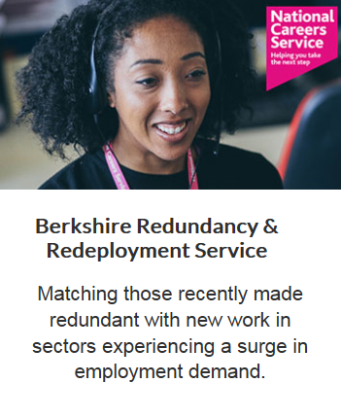

Coronavirus: How will school be different in September?
Plans for how schools in England should be run when students return have been announced by the government. https://www.bbc.co.uk/newsround/53256134

Tes: 3 things all EYFS teachers should remember in September
Teachers must not overlook the reality of how impactful lost social time will be on young learners - so recalibrating your thinking is vital.

No two days are ever the same in the EYFS.
Classrooms are constantly abuzz with laughter, chatter and discovery learning.

At the beginning of a child’s academic journey, play, social interaction and wellbeing are crucial.
And EYFS provides the foundations for children to prepare them for a lifetime of teamwork, self-development and conflict resolution that is necessary to succeed both in school and thereafter.

So, how then do we ensure that this is not lost after students have spent one-third of the most important years of school learning remotely?

Read more: https://www.tes.com/news/eyfs-international-teaching-social-development-vital

Top tips for Autistic and ADHD children returning to school September 2020

Steps to take following the death of a colleague in children’s services
Actions for employers and providers following a coronavirus (COVID-19) related death of a carer or colleague across children’s services. https://www.gov.uk/guidance/steps-to-take-following-the-death-of-a-colleague-in-childrens-services
National impact of COVID: Early years and childcare

EASING OF LOCKDOWN
- From Saturday 18th July, local authorities will have new powers to quickly respond to a serious and imminent threat of COVID-19 in their area.
- Local authorities can now close individual premises and public outdoor places, restrict events with immediate effect if they conclude it is necessary and proportionate to do so, make an application to a court to impose restrictions or requirements to close contaminated premises and public spaces, close a food business if there is an imminent risk of injury to health, or close a business by way of a Hygiene Emergency Prohibition Notice if the Regulations have not been followed and this in itself creates an imminent risk of injury to health.
- In addition, local authorities may also seek support from ministers to use powers under the Coronavirus Act 2020 to close schools or limit schools to set year groups attendance, to cancel or place restrictions on organised events or gatherings, or to close premises.
- Gyms will open in England from tomorrow with strict social distancing guidelines including capacity limits, reduced class sizes, equipment spaced out, improved ventilation, and customers will be encouraged to shower and change at home.
- Indoor performances to live audiences will also restart in August, subject to pilots. Larger gatherings in sports stadiums will also be piloted with a view to reopening in the autumn. Wedding receptions for up to 30 people will also be allowed.
- Most remaining leisure settings, including bowling, skating rinks, casinos and close-contact services such as beauticians will be allowed to reopen from 1st August, but nightclubs and soft play areas will stay closed.
- From 1st August, it will be up to employers to discuss with their workers whether it is safe to return to work. Workplaces are expected to carry out a risk assessment and should display the Government’s Staying COVID-19 Secure in 2020 notice, to show they have complied with the guidance on managing the risk of coronavirus.
- Anybody may use public transport now, although it is still advisable to consider alternative means of transport where they are available.

FLU VACCINE
- 30 million people will be offered the flu vaccine this year. This includes all over-50’s, those on the shielding list and the people they live with, those with medical conditions (diabetes, heart failure and asthma), all primary school children and Year 7 pupils, and pregnant women. This is intended to avoid the flu season combined with coronavirus overwhelming hospitals.

ESOL FUNDING – Slough is one of 30 local authorities that have been successful in securing a share of the £5.1 million Integration Fund for the English for Speakers of Other Languages (ESOL), which aims at helping residents with little or no English language skills to improve their language skills in order to better engage with their local communities.

