Early Years and Prevention Service
Weekly News Bulletin: 9th September 2020
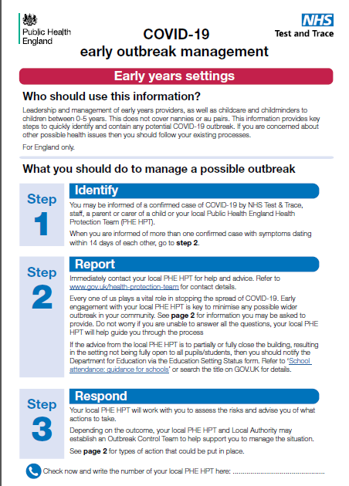
Contents
- Message from the Secretary of State
- Actions for early years and childcare providers during the coronavirus (COVID-19) outbreak
- One Slough: Covid-19 testing centre Montem update
- Infection control, immunisations and winter preparedness
- Parental survey: early years and childcare
- Schools with Nursery provision
- New Action Cards from the Joint Biosecurity Centre: How to respond to and report cases of coronavirus (COVID-19)
- Department of Health and Social Care webinars on coronavirus (COVID-19) testing
- Ofsted: coronavirus (COVID-19) rolling update
- Early years foundation stage statutory framework (EYFS)
- Schools begin teaching reformed Early Years Foundation Stage
- Early adopter schools: EYFS framework
- Keeping children safe in education (KCSIE)
- Introduction of T Levels
- Industry placements
- Early years ITT requirements and supporting advice
- Behaviour and discipline in schools
- Health and Safety Executive
- Public Health England report on the preliminary results of the coronavirus (COVID-19) testing and antibody prevalence surveillance in schools programme
- HMRC COVID-19 Employer support – live webinars
- Mentally Healthy Schools resources to help schools rebuild and recover

Message from the Secretary of State
Dear colleagues,

Now that the new academic year has begun I wanted to write and congratulate you and let you know how very grateful both I and the Prime Minister are for your efforts in getting us to this point.
I know that welcoming all our pupils back has meant significant adjustments for you and your teams and I am filled with admiration for the magnificent way you have responded.

Since I last wrote to you, most of our schools and colleges have now returned and I am sure pupils and all staff will have had a wonderful first few days catching up with each other, and I do hope that you enjoyed it too. I have been absolutely delighted to see on social media some of the reunions that have been taking place.

We know from reports we have had from our local teams that children are returning as planned, while the National Association of Headteachers released data from its members on Friday that showed nearly all schools had reopened.

As the Prime Minister has made clear, getting children back into school has been a national priority. I don’t need to spell out to you how important it is for a child’s educational development and long-term prospects. However, I realise that there is still some nervousness, both among parents and possibly some staff too, about the full reopening of our schools.

Welcoming back all children and young people full-time
The medical advice supporting this has been unanimous. The Chief Medical Officers of all the home nations recently set out the evidence of risks and benefits to health from schools opening, which led them to conclude that a pupil risked more by not being in school than they did by attending.

Public Health England (PHE) has also just published its own study on Covid-19 transmission in staff and students attending pre-schools and primary schools during a four-week period in the summer term. PHE found no evidence that pupils or staff in these schools were at greater risk of Covid-19 than the general population.

To reduce risk, we published guidance on 2 July which set out the PHE-endorsed ‘system of controls’ that schools should put in place. I have seen for myself some of the innovative ways you have been responding to this and am deeply grateful for all the work you have been doing to implement these protective measures.

The safety and wellbeing of you, your staff and your pupils has always been my priority. I want to reassure you again that all your staff and pupils have access to testing if one of them should develop Covid-19 symptoms. We have provided a small supply of home test kits if anyone develops symptoms while at school or college and who may otherwise be unable to access a test. Every school or college that has been attended by someone who tests positive will receive direct support and advice from their local PHE health protection team.

We all know that the disruption caused to schools and colleges by the pandemic has led to the loss of crucial classroom-based learning. For some pupils this will be more acute than others, which is why the £1 billion Covid Catch Up Fund will enable you to provide extra tuition and support for those who need it most in a way that will suit them best.

I will continue doing everything in my power to make sure that children can catch up on lost learning, continue their education and make the most of their potential as we strive to level up opportunity across the country.

And on behalf of the Prime Minister and all my colleagues across Government, I would like to say thank you again for all of your efforts, your resilience and your service to our country’s children and young people.

Actions for early years and childcare providers during the coronavirus (COVID-19) outbreak
What childcare services early years settings, childminders and local authorities need to provide during the coronavirus (COVID-19) outbreak.

7 September 2020
Added 'What to do if a child is displaying symptoms of coronavirus (COVID-19)'.
If anyone in your early years setting, school or college confirms to you a positive test for coronavirus (COVID-19), you should notify your local health protection team immediately. The health protection team will work with you to carry out a rapid risk assessment and identify the appropriate next steps.

https://www.gov.uk/government/publications/coronavirus-covid-19-early-years-and-childcare-closures?utm_source=388e75d6-38b6-4ef3-bf0f-f9728055dfb4&utm_medium=email&utm_campaign=govuk-notifications&utm_content=daily#history

One Slough
The covid-19 testing centre at Montem, Slough, is no longer accepting drop ins by car; only people with an appointment will be given a test.

People walking in will still be seen without an appointment if they have symptoms, but we are warning people that capacity is limited and not to park in the surrounding areas on or yellow lines.

This is due to an instruction from central government for the site to be appointment only; not an issue with the site operations locally.

Unfortunately this is not something we, as the council, have any control over, but we are very concerned about the effect this has on our residents and town and have expressed our views strongly to the government.

We would like to stress people should be respectful and polite to those on the Montem testing site; this was a national decision and not something they can go against.

We are also aware of an apparent shortage of appointments using the national system; the advice from government is to keep trying but to apply for a test if you have symptoms of covid-19.

To make an appointment we advise calling 119 or https://www.nhs.uk/conditions/coronavirus-covid-19/

Slough has decided to have covid champions, and have begun a recruitment drive for One Slough Community Health Champions. These champions will be volunteers who are willing to help communicate the essential health messages to the wider community. They will initially focus on covid, but will also be used to help communicate other health outcome.

Details can be found here https://oneslough.org.uk/champions/ and https://www.publichealthslough.co.uk/campaigns/one-slough/
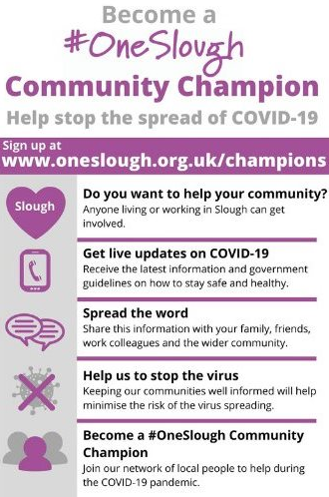

Infecttion control, immunisations and winter preparedness
We are fast approaching the ‘flu season’ and with coronavirus still at large, there is even more reason for staff and families to be armed with vital myth busting information about the flu vaccine.

We all need to know the facts and be reminded that flu still remains a health risk, especially for those who fall into the ‘vulnerable’ category. The vaccine still remains the single best form of protection against contraction.

There will be webinars available for parents/carers to access on 29/09. It is aimed at primary and secondary school age parents/carers, but absolutely suitable for ALL parents/carers.
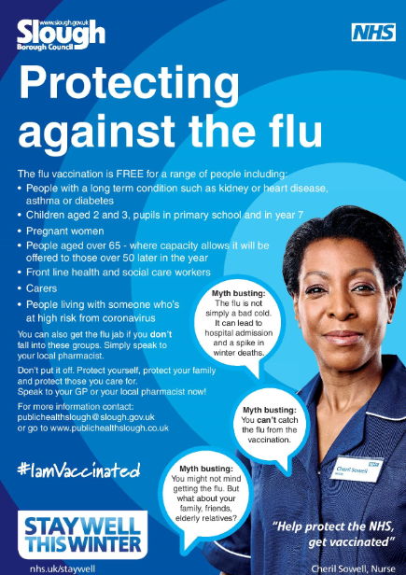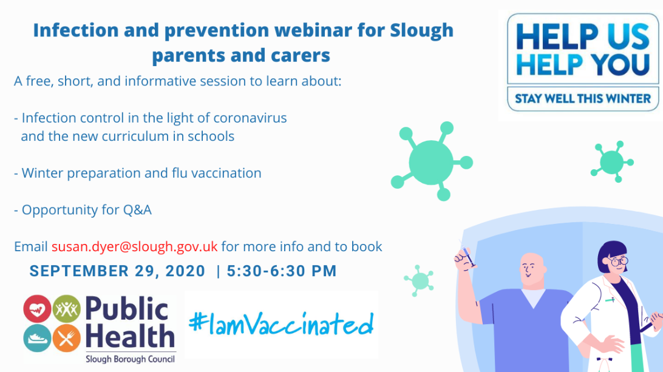

- https://www.youtube.com/watch?v=B1VDqqoGgW0

- https://twitter.com/NHSEnglandLDN/status/1295245290061074432

Parental survey: early years and childcare
Calling all parents!
Slough Borough Council is running a short survey about parents’ plans to use early years and childcare provision in September, following the effects of COVID-19. Please complete the survey if you have children who will be in childcare this September. Please also complete the survey if you have children but do not intend to access provision in September.

To access the survey visit https://www.surveymonkey.co.uk/r/KQTGGQ5. The survey closes on Friday 11th September 2020

For further information about early years and childcare please visit https://www.slough.gov.uk/schools-and-learning/early-years-and-childcare.aspx or call the Family Information Service on 01753 476589.

Schools with Nursery provision: DfE data collection
Local authority data collection on early years and childcare provision autumn term 2020
Since 6 April the DfE has asked local authorities to provide information on the status of the early years and childcare settings in their area by completing a short online data collection form. At the moment the DfE are continuing to ask early years and childcare settings to submit the data to the local authority on a weekly basis and the DfE will conduct a review of this request at the end of September. Previously we gathered this data from your daily registers which were sent to the schools team as this is no longer required as schools are submitting daily registers to the DfE via the Educational Settings Status Form, we therefore need to ask for the following submission.

Please complete the attached spreadsheet for your nursery provision (excluding reception aged children) every Thursday before 12pm and send to earlyyears@slough.gov.uk. Please submit the spreadsheet using the data from Wednesday’s registers. The first submission will be required on Thursday 10th September 2020.

If you have any questions regarding this request please contact earlyyears@slough.gov.uk or call Clare Thompson on 07796 313786
New Action Cards from the Joint Biosecurity Centre: How to respond to and report cases of coronavirus (COVID-19)
The Joint Biosecurity Centre has published Action Cards to provide the latest instructions to anyone responsible for businesses or organisations to identify, report and respond to coronavirus (COVID-19) cases. This includes action cards for education sectors.
The cards are designed to be printed or downloaded to keep on-hand. They provide the owners and managers of organisations a single point of access to the right information to ensure local Health Protection Teams can be notified quickly.
The cards complement and support existing local or sector specific guidance and are not intended to replace existing guidance or the expertise of local public health professionals.

Early Years action card from the Joint Biosecurity Centre (JBC) for education is available online here: https://coronavirusresources.phe.gov.uk/reporting-an-outbreak/resources/Education-Action-Cards/

Department of Health and Social Care webinars on coronavirus (COVID-19) testing
This week, the Department of Health and Social Care is hosting webinars that will focus on coronavirus (COVID-19) testing, specifically the testing routes available, when to allocate home testing kits and how these should be used. These sessions are available to all schools and further education colleges and can be booked through this online portal.

Schools and further education colleges have been receiving an initial supply of 10 home test kits in line with the commitment we made in July. Deliveries, which began on 26 August, have been made by Royal Mail. Email notifications were sent two days before delivery.

If schools or further education colleges have not received their test kits by the start of their term, they should contact the NHS Test and Trace helpdesk on 119.

You should only offer a home test kit to individuals who have developed symptoms while at school or college (or to their parent or carer if the child is under 18) in the exceptional circumstance that you believe they may have barriers to accessing a test elsewhere, and that giving them a home test kit directly will therefore significantly increase the likelihood of them getting tested. This will help you to take swift action to protect students and staff in the event of a positive test result

Further information on when to provide a test kit can be found in the guidance on home test kits for schools and further education providers.

Ofsted: coronavirus (COVID-19) rolling update
Ofsted guidance and information relating to coronavirus (COVID-19) for schools, early years, children's social care and further education and skills providers.
2 September 2020
Added links to guidance on what activity we will carry out for schools, further education and skills providers, and early years providers from September 2020.

https://www.gov.uk/guidance/ofsted-coronavirus-covid-19-rolling-update?utm_source=d289d822-8c83-494f-9f28-10f24981e2de&utm_medium=email&utm_campaign=govuk-notifications&utm_content=daily#history

Early years foundation stage statutory framework (EYFS)
Foundation Years: In April 2020, the government temporarily disapplied and modified certain elements of the early years foundation stage (EYFS) statutory framework to support early years providers during the coronavirus (COVID-19) outbreak.
The current disapplications will be lifted on 25 September 2020 and we will enter a 2 month transitional period for disapplications around staffing levels and Paediatric First Aid. This is in recognition that some providers may need time to get back to full staffing levels once the disapplications are lifted.
Further restrictions or requirements related to COVID-19 due to a local or national lockdown may affect a provider’s ability to comply with the EYFS. Therefore, government have laid new regulations which will come into force on 26 September 2020 and, with the exception of the EYFS Profile disapplication, will allow the disapplications to reapply where a provider is prevented from complying with the EYFS due to coronavirus related restrictions or requirements which have been imposed by govern

The standards that school and childcare providers must meet for the learning, development and care of children from birth to 5.
4 September 2020: Updated to reflect new regulations which allow temporary coronavirus (COVID-19) disapplications to re-apply if a provider is prevented from complying with the EYFS due to coronavirus (COVID-19) related restrictions or requirements. They also add disapplications around paediatric first aid to the transitional period, which originally only applied to disapplications around staffing levels.
https://www.gov.uk/government/publications/early-years-foundation-stage-framework--2?utm_source=eda5347f-8510-435b-a434-1ca50177f17c&utm_medium=email&utm_campaign=govuk-notifications&utm_content=daily#history

Schools begin teaching reformed Early Years Foundation Stage
Guidance published to support delivery of revised framework, focused on improving outcomes for every child

Reception teachers returning to the classroom at ‘early adopter’ schools this week will benefit from improved curriculum and assessment as part of the reforms to the Early Years Foundation Stage (EYFS) framework.
As pupils return to school full-time for the new term, some schools who have chosen to be among the first to adopt the revised EYFS reforms will begin delivering the new learning and development requirements to Reception classes, with a focus on improving outcomes in language, literacy and maths. Teachers will also see a cut to their paperwork meaning that they can spend more time focusing on teaching and interacting with pupils.

To read more visit https://www.gov.uk/government/news/schools-begin-teaching-reformed-early-years-foundation-stage?utm_source=7723b00d-8e70-4d60-8f49-cd6e7af05d60&utm_medium=email&utm_campaign=govuk-notifications&utm_content=daily

Early adopter schools: EYFS framework
The early years foundation stage (EYFS) framework sets the standards for learning, development and care for children from birth to 5.
3 September 2020
Added 'New Development Matters: non statutory curriculum guidance for the early years foundation stage'.

https://www.gov.uk/government/publications/early-adopter-schools-eyfs-framework?utm_source=21b85629-8858-447a-84f1-faabee9a69ec&utm_medium=email&utm_campaign=govuk-notifications&utm_content=daily#history

Keeping children safe in education (KCSIE)
On 1 September, keeping children safe in education (KCSIE) 2020 came into force. All school and college staff should read part 1 of this guidance. This version replaces both KCSIE 2019 and the ‘for information’ version published on 17 June 2020.

We have made changes in three circumstances:
- where legislation has required it, reflecting mandatory Relationship Education, Relationship and Sex Education and Health Education from September 2020.
- where additional information is available that will support schools and colleges protect their pupils, in areas such as mental health, domestic abuse, child criminal and sexual exploitation and county lines.
- important clarifications which will help schools and colleges better understand and/or follow our guidance.
A full breakdown of the changes made to the guidance are included in Annex H of the guidance.
It is important that all school and college staff are alert to the fact some children will have suffered harm during lockdown. As well as exposure to domestic abuse, online harms and radicalisation, children could have broader welfare and/or mental health concerns. Part 1 of KCSIE provides all staff with a basic understanding of what to look out for and what to do if they have a concern. If possible, schools and colleges should provide designated safeguarding leads, and any deputies, more time in the early weeks of the new term to support children and staff.

KCSIE part 1 is also available to view in 11 community languages.

Introduction of T Levels
Find out what T Levels courses include and how they work with other qualifications including grading and UCAS points.

4 September 2020
Minor updates to reflect that T Levels have started.
https://www.gov.uk/government/publications/introduction-of-t-levels?utm_source=ea9ee53c-46e3-49db-85c3-c1acf25ddde1&utm_medium=email&utm_campaign=govuk-notifications&utm_content=daily#history

Industry placements
Information about how industry placements for T Levels work and how employers can get involved.
- 4 September 2020
Minor updates to reflect that T Levels have started and to add a link to the video showing what employers say about industry placements.
https://www.gov.uk/guidance/industry-placements?utm_source=0514cef7-b5a5-4a2a-aba5-bfcc0a519408&utm_medium=email&utm_campaign=govuk-notifications&utm_content=daily#history

Early years ITT requirements and supporting advice
Advice for providers looking to offer early years initial teacher training (ITT).
4 September 2020
Updated temporary guidance changes due to coronavirus (COVID-19).
https://www.gov.uk/government/publications/early-years-itt-requirements-supporting-advice?utm_source=103e8ac3-9472-43f6-ad1a-9be0ae88bafc&utm_medium=email&utm_campaign=govuk-notifications&utm_content=daily#history

Behaviour and discipline in schools
How school staff can develop a behaviour policy. Includes checklists and resources to support full school opening during the coronavirus (COVID-19) outbreak.
2 September 2020
Added links to further guidance and resources.
https://www.gov.uk/government/publications/behaviour-and-discipline-in-schools?utm_source=a0d0fb22-d2a7-4f9a-9fc2-80bcf91a56bc&utm_medium=email&utm_campaign=govuk-notifications&utm_content=daily#history

Health and Safety Executive

Health and Safety Executive announcement on supporting schools to implement protective measures
The Health and Safety Executive (HSE) is continuing their work with schools to ensure all possible steps are taken to help keep pupils and staff safe and reduce the transmission of coronavirus.
Over the coming days and weeks, HSE will be phoning schools to check their risk assessments and the arrangements they have in place to reduce the risk of transmission of coronavirus.
To assist schools with any calls from HSE, we would suggest staff are made aware of the checks and designated individuals are familiar with the school’s risk assessment. In cases where the initial call raises concerns, HSE will work with schools to advise on next steps, which may include a visit if appropriate. This will be on a suitable date and time arranged in collaboration with the school.
We know that schools are working extremely hard to protect staff and pupils by putting protective measures in place. We hope this additional support from HSE will provide further reassurance to staff, pupils and parents.

Please ensure you’re following the latest government guidance and any subsequent updates issued by the relevant authority.

If you have any questions or concerns about coronavirus, the HSE has standard questions and answers available, if you still need assistance you can contact them by phone or email. All information is available on their website.

Public Health England report on the preliminary results of the coronavirus (COVID-19) testing and antibody prevalence surveillance in schools programme
Public Health England have published their report on the preliminary results of the COVID-19 testing and antibody prevalence surveillance in schools programme, also known as ‘sKIDs’.

The report concludes that there is no evidence that pupils and staff who were in schools were at increased risk of COVID-19, compared to the general population, and infection and transmission rates were low in preschool and primary schools under surveillance during the summer.

HMRC COVID-19 Employer support – live webinars
Changes to the Coronavirus Job Retention Scheme from 1‌‌ September mean that employers will need to fund 10% of furloughed employees’ usual wages for the hours they do not work and continue to pay their National Insurance and pension contributions.
Make sure you have the latest information by joining the live webinar:
Extension to the Coronavirus Job Retention Scheme and flexible furloughing
We’ll provide an overview of the scheme, including flexible furloughing, examples of how to work out the amount you can claim and the changes for September and October.
We’ll also share information on the Job Retention Bonus, including how to check if you’re eligible.
Choose a date and time

If you haven’t been able to join our popular webinar about the Coronavirus (COVID-19) Statutory Sick Pay Rebate Scheme, more dates have now been added. Get the latest information on:
- who can claim
- who you can claim for
- how to make a claim
- what you may be entitled to, and more.

Choose a date and time

You can ask questions during all our live webinars using the on-screen text box.
Our webinars are constantly updated to provide the latest government guidance on changes as they develop.

Mentally Healthy Schools resources to help schools rebuild and recover
Mentally Healthy Schools has created a set of practical resources to help make the transition back to school easier for everyone, and help the whole school community rebuild and recover.

The resources are designed to be social distancing-friendly and are suitable for all schools. They contain lesson plans for teachers, advice and guidance for parents, and simple activities for children to complete in class or at home.

