Halloween, Bonfire Night and Diwali
2020

Communications Pack

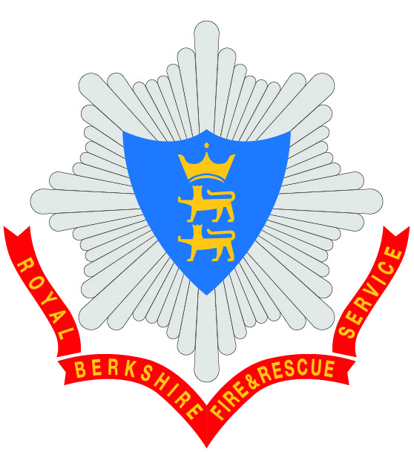

CONTENTS

Remember, remember to stay safe this November 3
Social Media Schedule 5
Halloween 5
Bonfire Night 6
Diwali 11

Remember, remember to stay safe this November
Royal Berkshire Fire and Rescue Service (RBFRS) is asking residents to remember remember to stay safe when planning their Bonfire Night and Diwali celebrations this year.

With many events cancelled this year due to the COVID-19 control measures in place, emergency services are preparing for a busier night than usual as celebrations are expected to take place in private gardens.

(insert name), said: “ Whilst most people enjoy fireworks responsibly, in the wrong hands they can cause real misery. Remember that fireworks are explosives, and as such should be treated with respect and only used in accordance with the manufacturer’s instructions and the Firework Code.

“We want everyone to enjoy their celebrations safely and while we are currently amidst a global pandemic, we are asking people not to take risks, putting additional pressures on our emergency services.”

Please stay safe and follow the Firework Code:
- Plan your firework display to make it safe and enjoyable, and ensure it finishes by 11pm, except for Bonfire Night, when the cut off is midnight and Diwali, when the cut off is 1am.
- Only buy fireworks which carry the CE mark, keep them in a closed box and use them one at a time.
- Read and follow the instructions on each firework using a torch if necessary.
- Light the firework at arm's length with a taper and stand well back.
- Keep naked flames, including cigarettes, away from fireworks.
- Never return to a firework once it has been lit.
- Don't put fireworks in pockets and never throw them.
- Direct any rocket fireworks well away from spectators.
- Make sure that the fire is out and surroundings are made safe before leaving.
If you buy fireworks for personal use, you are only allowed to use them on your private property or property where you have the consent of the landowner.
Royal Berkshire Fire and Rescue Service is asking residents to be considerate to their neighbours and avoid putting additional pressure on emergency services and the NHS by having a bonfire. However, if having a bonfire, please stay safe by following the advice:
- Build bonfires well away from buildings, fences, trees and garden structures.
- Never burn aerosols, tyres, canisters or anything containing foam or paint – many produce toxic fumes and some containers may explode causing injury.
- Don’t use petrol or paraffin to get the fire going as it could quickly get out of control.
- Keep a bucket of water or a garden hose nearby in case of emergencies.
- Never leave a bonfire unattended.
We hope that residents are able to plan a firework display that is both safe and enjoyable, but remember, fireworks can be frightening for people and animals. Tell your neighbours if you are planning to let off fireworks and ensure your display is over by the cut off time.
Additionally, people often can often let off sky lanterns to mark these occasions, but please reconsider this because of the fire hazard and risk they pose to property, crops, livestock and the environment.
For more information on celebrating safely this Bonfire Night and Diwali, visit rbfrs.co.uk/CelebrateSafely.

-ENDS-

Social Media Schedule

Halloween
Launch date: 19 October 2020
Social media run time: 19 October 2020 – 31 October
Hashtag: #Halloween2020

Platform, Date and Time | Copy | Asset
Twitter, Facebook and Instagram  19 October 2020 at 5pm | If you’re choosing a spooky Halloween costume to celebrate at home this year, make sure you check that it is labelled as flame-resistant. Find more advice about celebrating safely on our website: rbfrs.co.uk/celebratingsafely  #Halloween2020 | 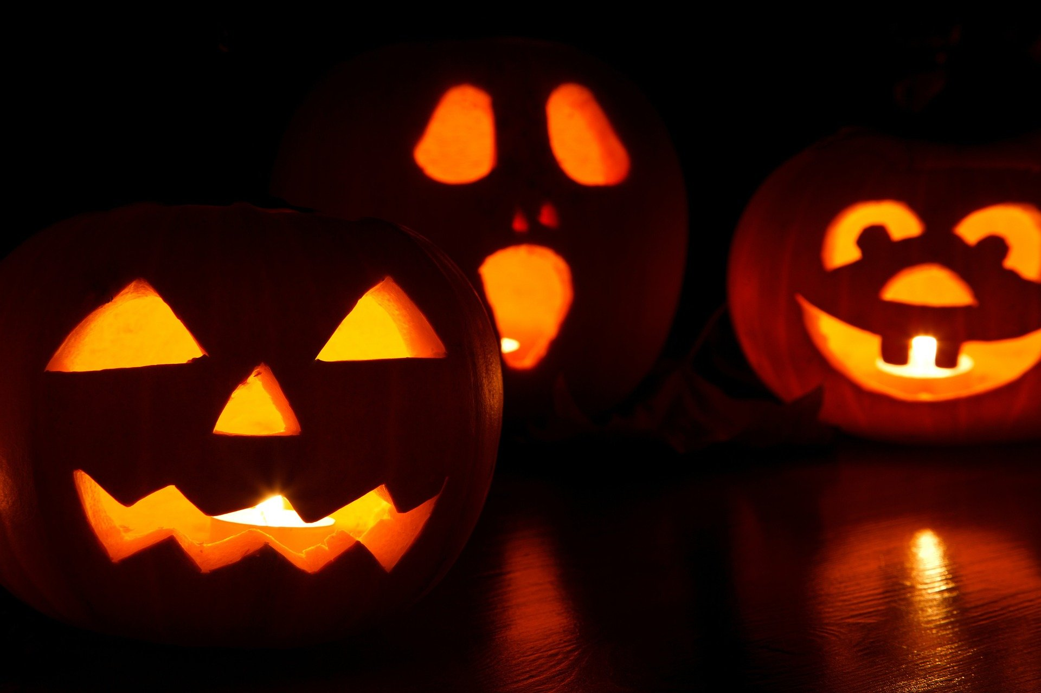
Twitter  22  October 2020 at 11am | This Halloween, scare your neighbours with your pumpkin, not your fire safety. Why not use an LED light instead? Find more advice on our website: rbfrs.co.uk/celebratingsafely  #Halloween2020 | 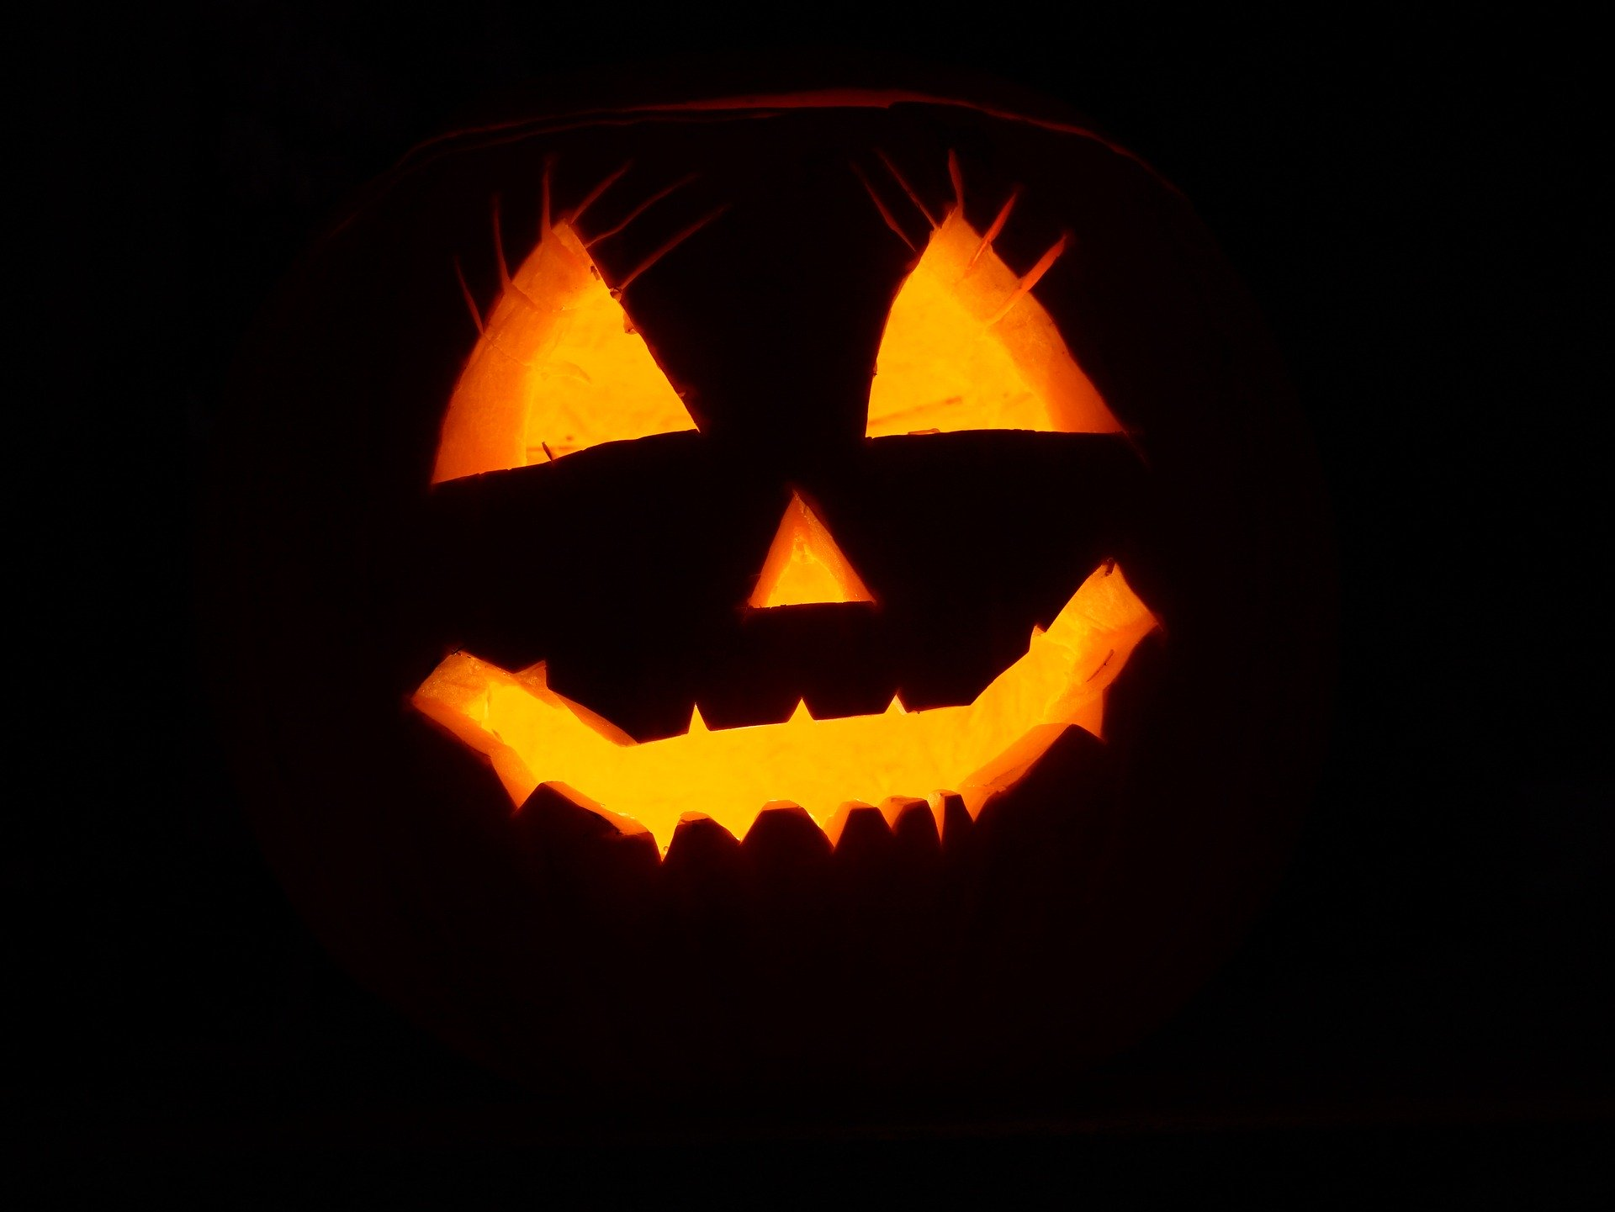
Twitter  25  October 2020 at 1pm | Nothing is more scary on Halloween than a lack of fire safety. If you’ve decked your house with decorations, make sure they’re away from open flames like candles. Find more advice on our website: rbfrs.co.uk/celebratingsafely  #Halloween2020 | 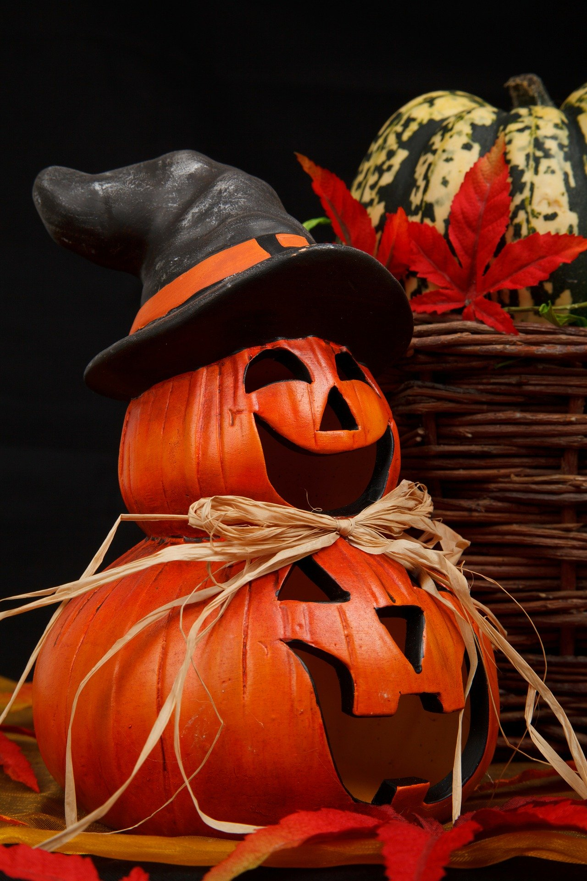
Twitter  29 October | Snuff out the risk of a fire this Halloween and make sure that you fully extinguish all candles before you go to bed. Find more advice on our website: rbfrs.co.uk/celebratingsafely  #Halloween2020 | 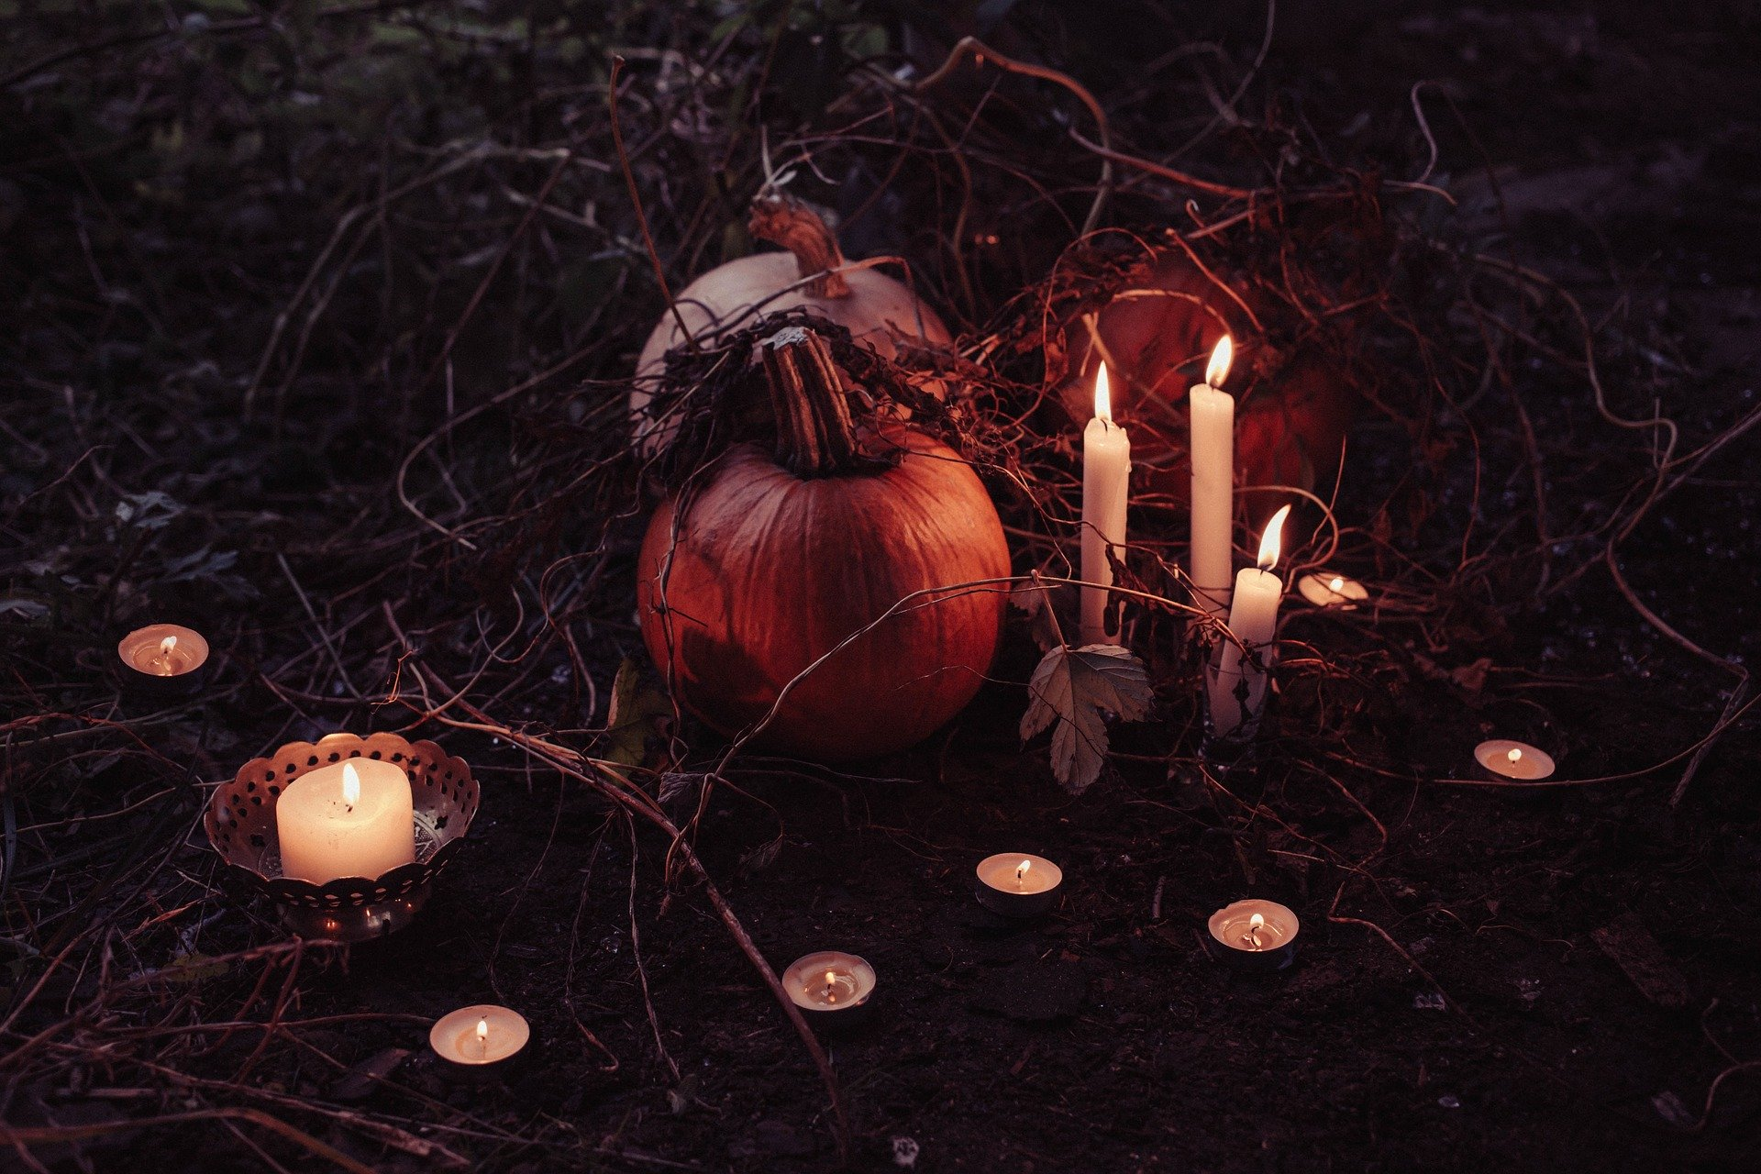
Twitter  31 October | Happy Halloween! If you’re celebrating this evening, make sure you take a look at our celebrating safely tips to make sure our firefighters don’t become your unwanted guests: rbfrs.co.uk/celebratingsafely  #Halloween2020 | 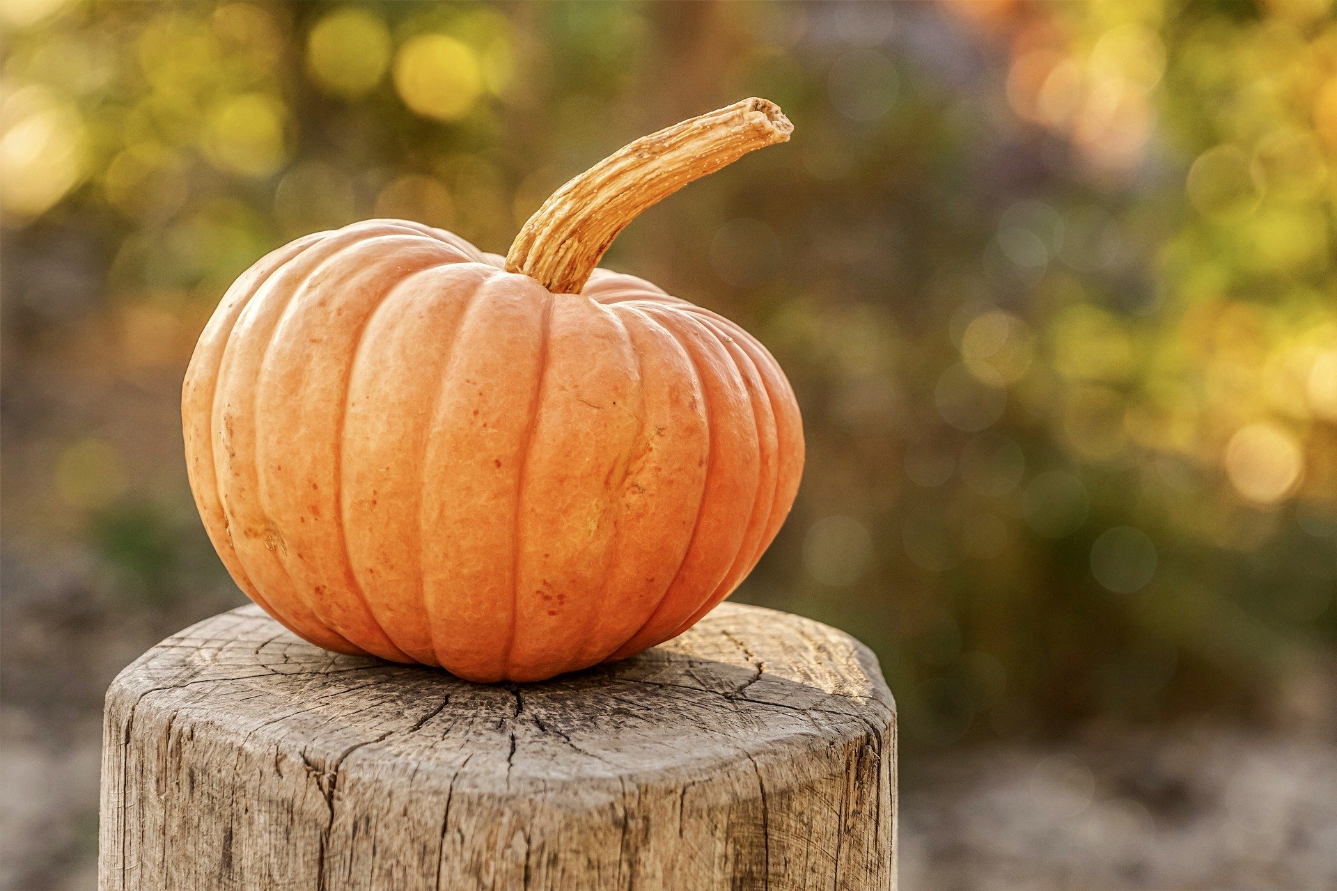

Bonfire Night
Launch date: 19 October 2020
Social media run time: 19 October 2020 – 8 November 2020
Campaign Hashtag: #FireworkSafety
Secondary Hashtag: #RememberRemember

Platform, Date and Time | Copy | Asset
Twitter, Facebook and Instagram  19 October 2020 at 1pm | This year due to #COVID19, public firework displays have been cancelled.  If you are thinking about organising a home display or having a bonfire, think carefully, plan carefully and follow the Firework Code and our bonfire safety advice:  rbfrs.co.uk/RememberRemember  #FireWorkSafety
Twitter  20  October 2020 at 11am | Remember, remember to buy fireworks right. Social media, markets or pubs, are not a safe place for your purchase, so make sure that you visit a shop and you only buy fireworks with a CE mark #FireworkSafety | 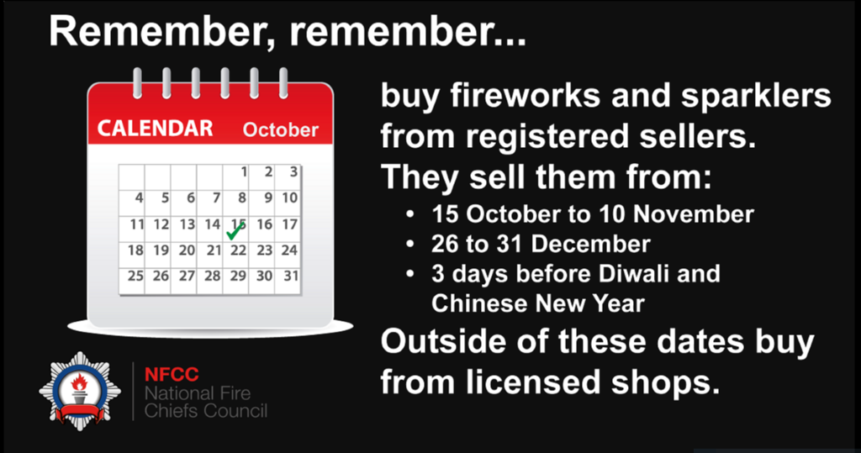
Twitter  21  October 2020 at 1pm | Remember, remember to stay safe this November. Check instructions are English before it gets dark and look out for a CE mark! #FireworkSafety | 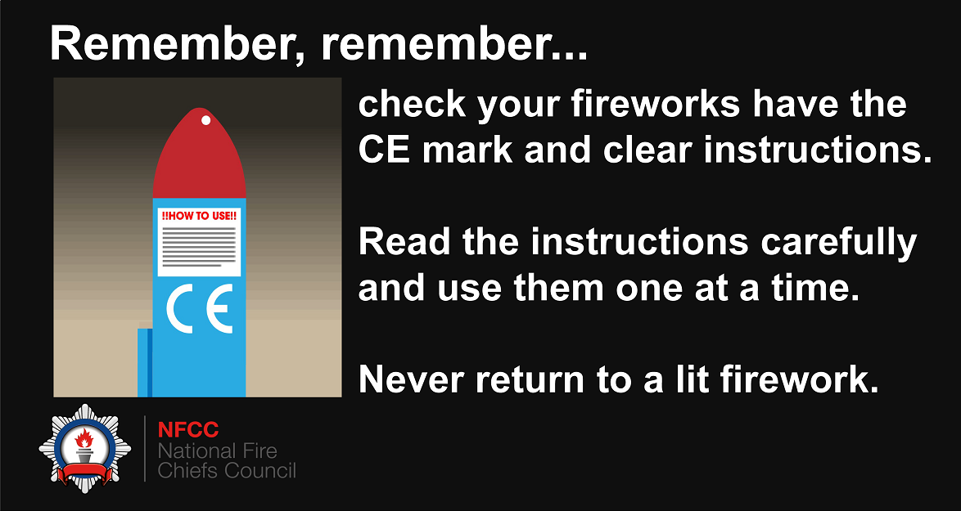
Twitter, Facebook and Instagram  22 October 2020 at 6pm | Remember, remember to stay safe this November. Between 2014 -2019, 38% of people with severe firework injuries in England and Wales were aged under 15 years old. A £2 firework at a small family display misfired and left Maisie Roe with burn injuries. Hear her story: https://youtu.be/iwczrDUNmqI  #FireworkSafety | Maisie Roe’s story
Twitter  23 October 2020 at 12pm | Remember, remember to stay safe this November. Firework packaging might be colourful, bold and bright. So, store fireworks safe, where kids won’t get hold and keep them well out of their sight #FireworkSafety | 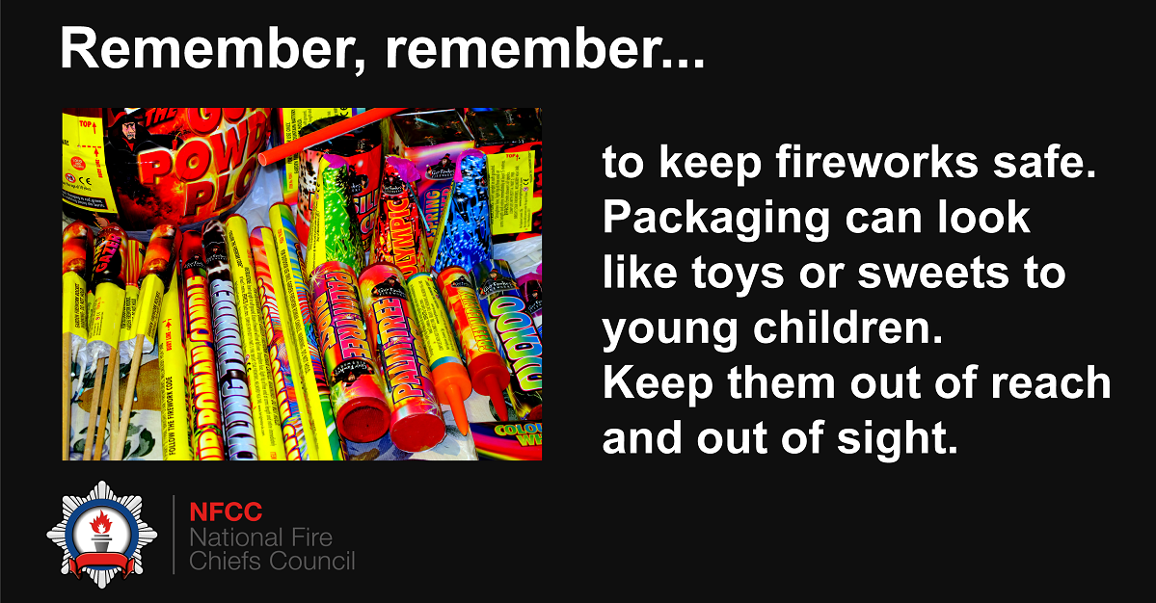
Twitter  24 October 2020 at 3pm | Remember, remember to stay safe this November. Are your fireworks right for the size of your garden? You need plenty of space to keep everyone safe, so ask for advice in the shop #FireworkSafety | 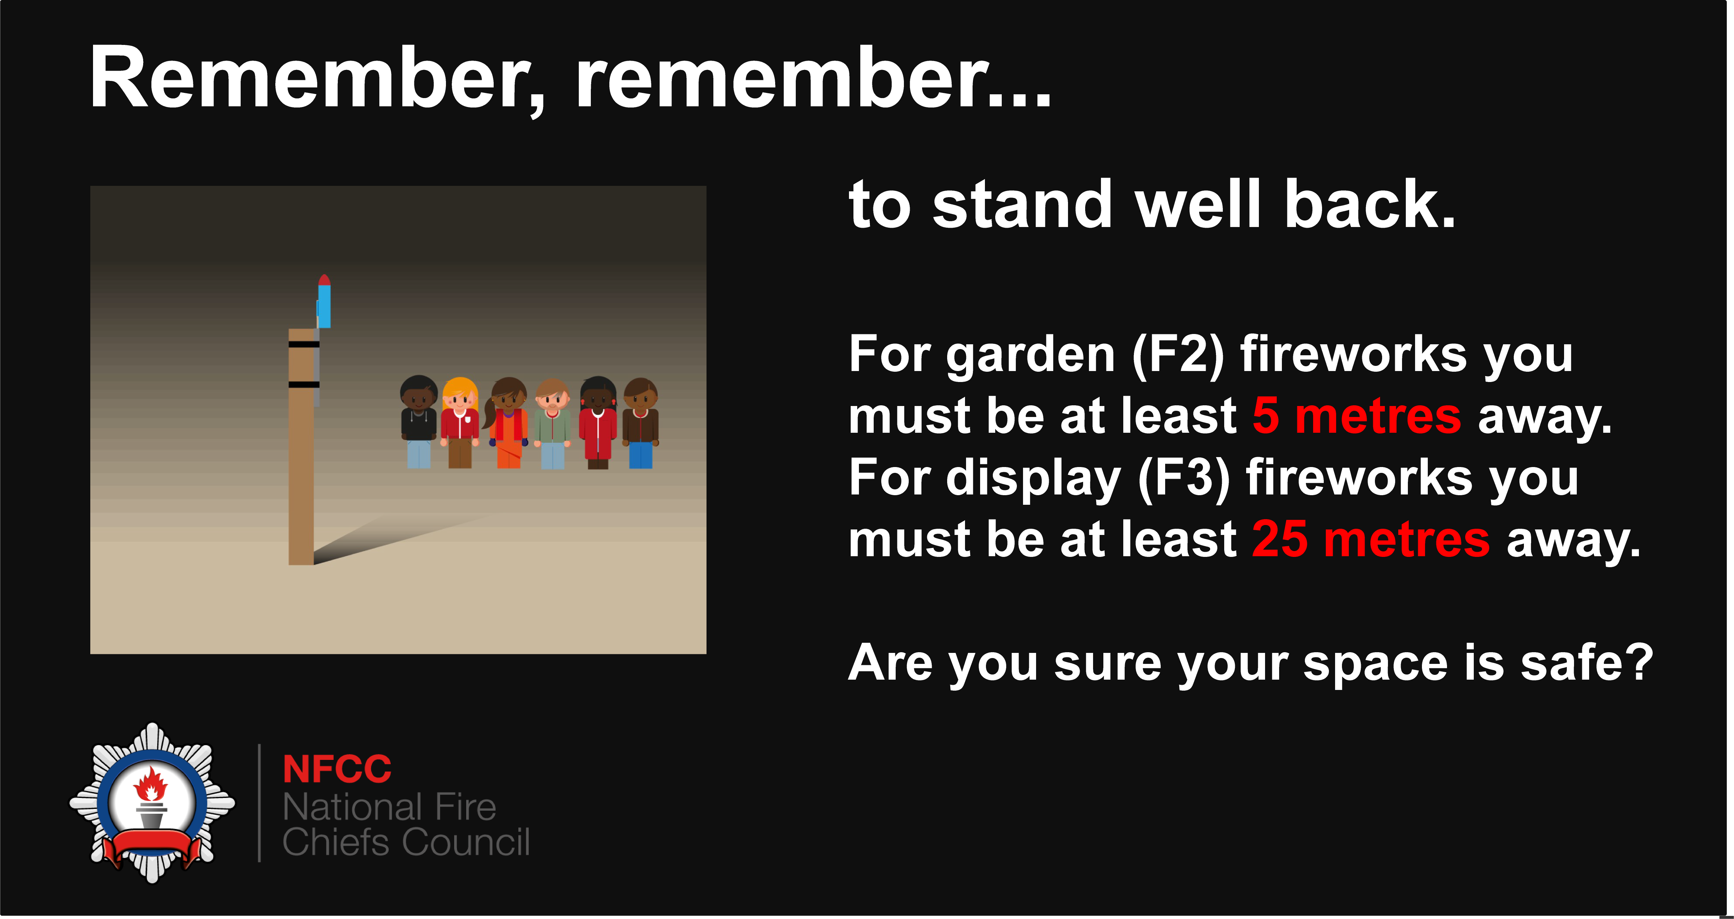
Twitter  25 October 2020 at 7pm | Remember, remember to stay safe in November. COVID-19 restrictions are in place to help you stay safe, so make sure you follow advice #FireworkSafety | 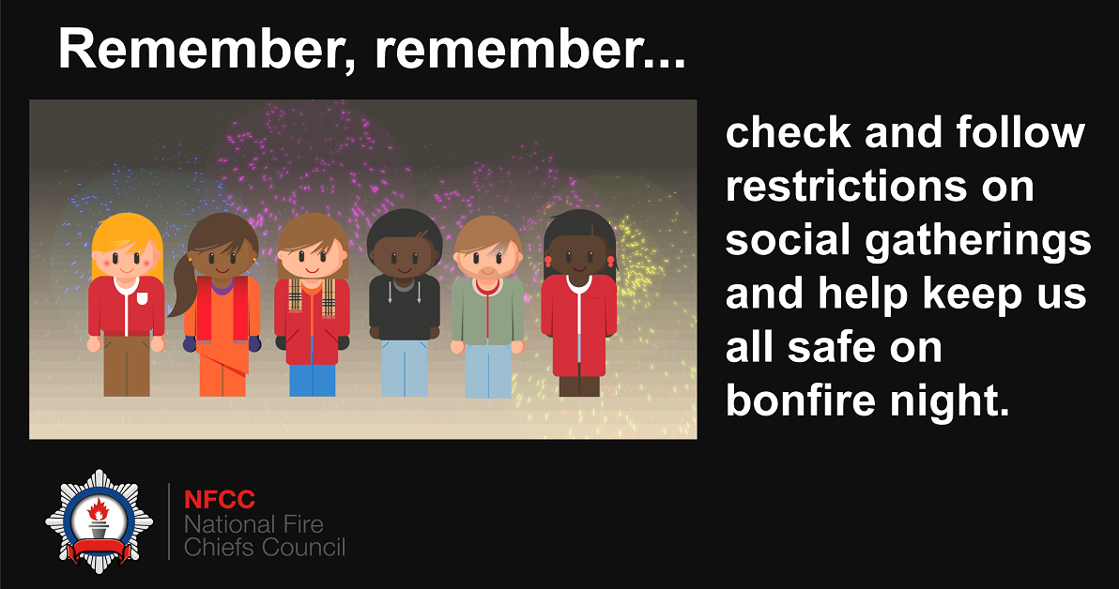
Twitter  26 October 2020 at 5pm | Remember, remember to stay safe in November. If you buy fireworks for personal use, you are only allowed to use them on your private property or property where you have the consent of the landowner #FireworkSafety | 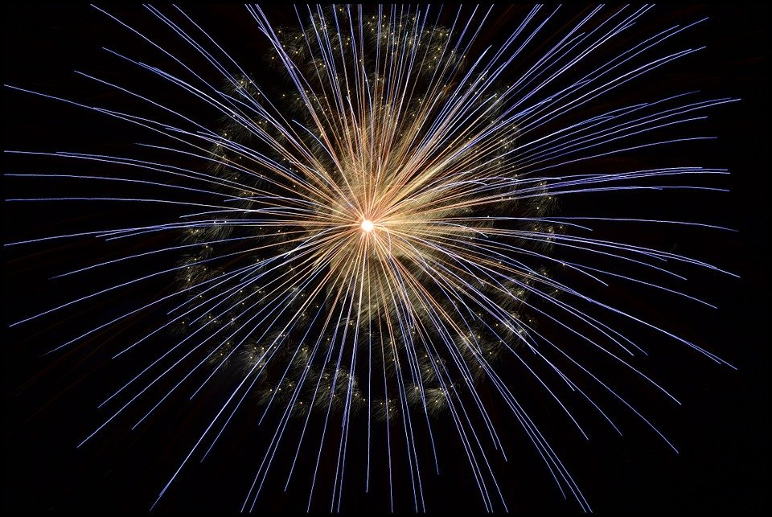
Twitter, Instagram and Facebook  27 October 2020 at 12pm | Remember, remember to stay safe this November. We urge you to think about your neighbours and emergency services when considering having a bonfire this year as they can easily become out of control. Find more advice on our website: rbfrs.co.uk/RememberRemember  #RememberRemember | 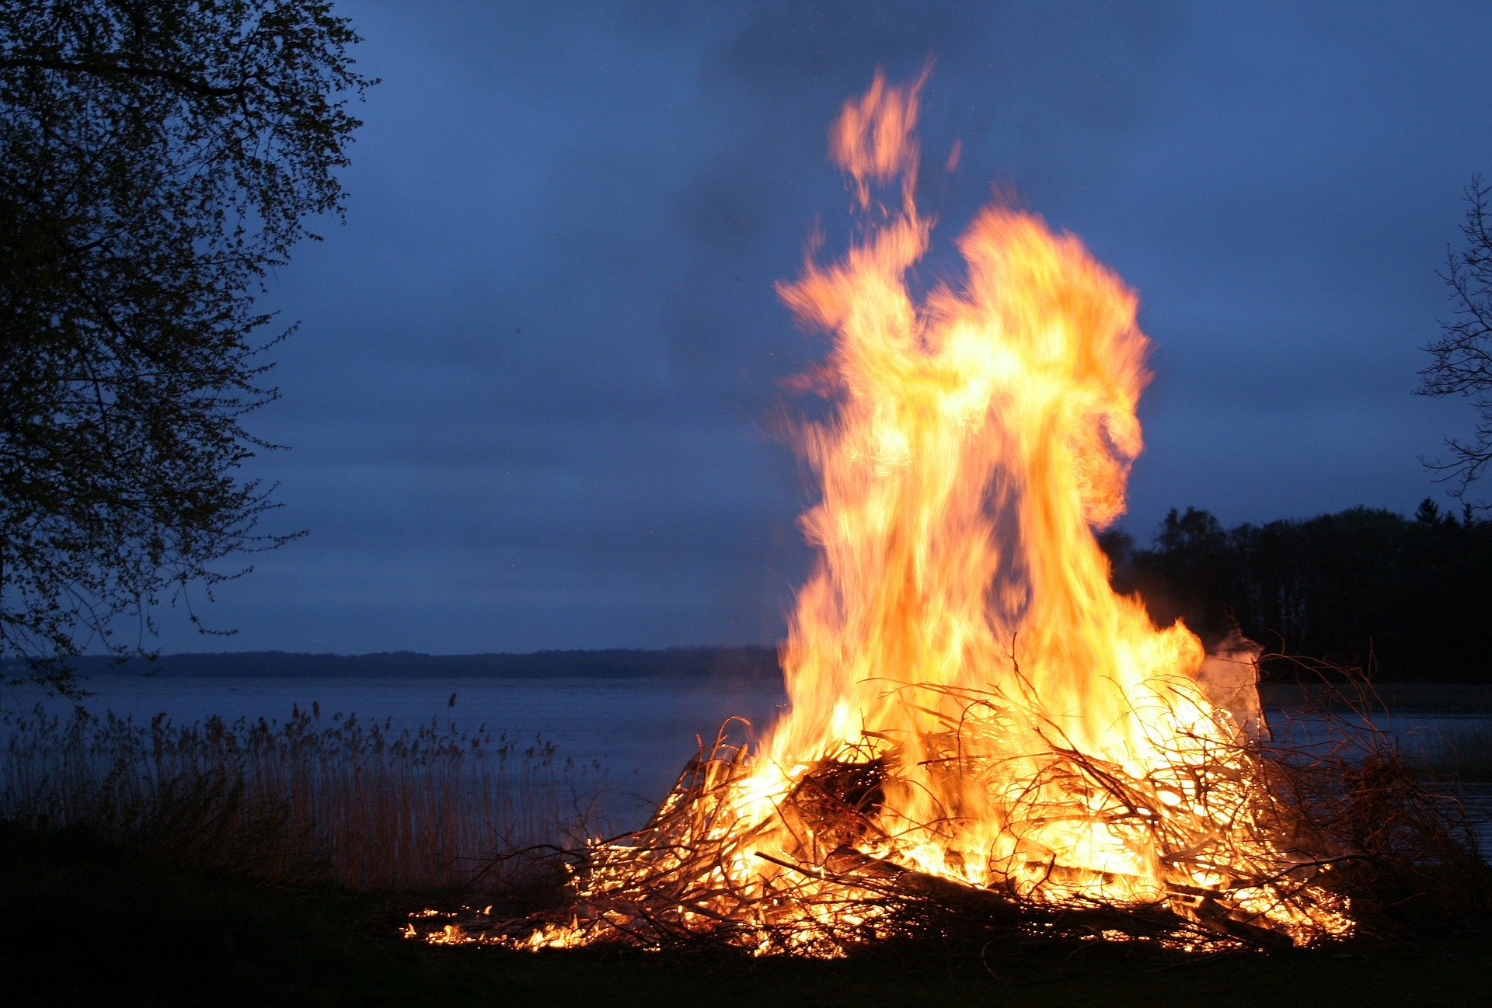
Twitter  27 October 2020 at 12pm | With public displays cancelled due to COVID-19 measures, we are asking you to avoid putting additional pressure on emergency services this year by having a bonfire to celebrate the 5th November.  Between 2014-19, there were 1,695 severe injuries nationally as a result of bonfires.  More info ➡️ rbfrs.co.uk/RememberRemember | 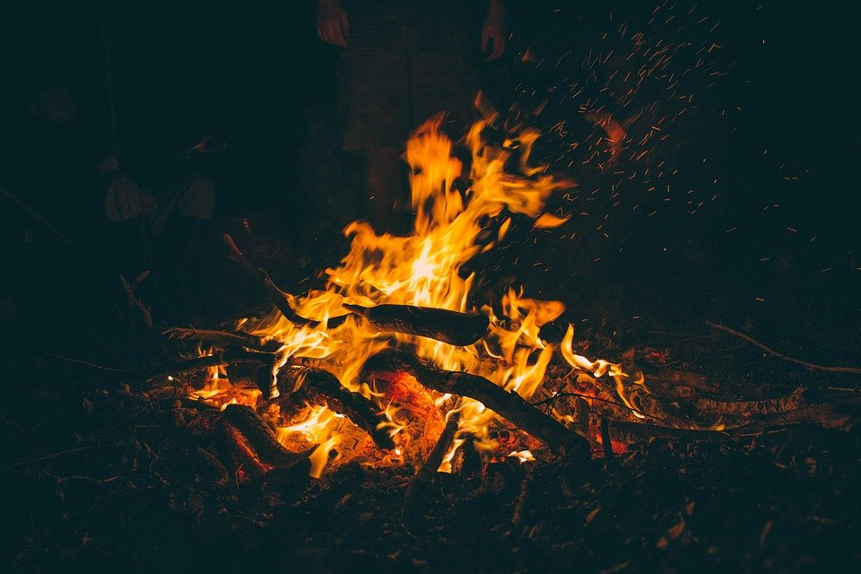
Twitter  28 October 2020 at 7pm | Remember, remember to stay safe this November.  Between 2014 -2019, 38% of people with severe firework injuries in England and Wales were aged under 15 years old.  A £2 firework at a small family display misfired and left Maisie Roe with burn injuries. Hear her story: https://youtu.be/iwczrDUNmqI  #FireworkSafety | 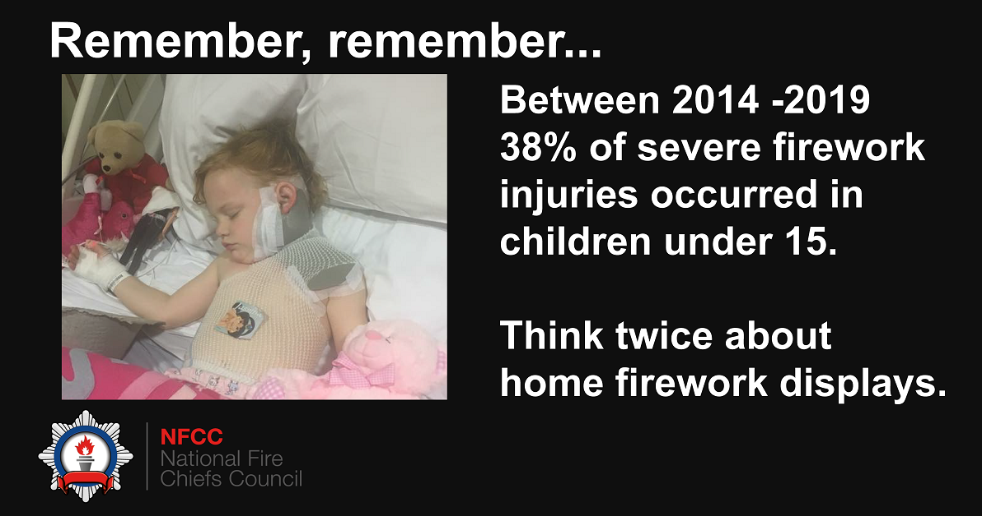
Twitter  29 October 2020 at 11am | Remember, remember to stay safe this November - don’t use petrol or paraffin to get the fire going as it could quickly get out of control. Find more advice on our website: rbfrs.co.uk/RememberRemember  #RememberRemember | 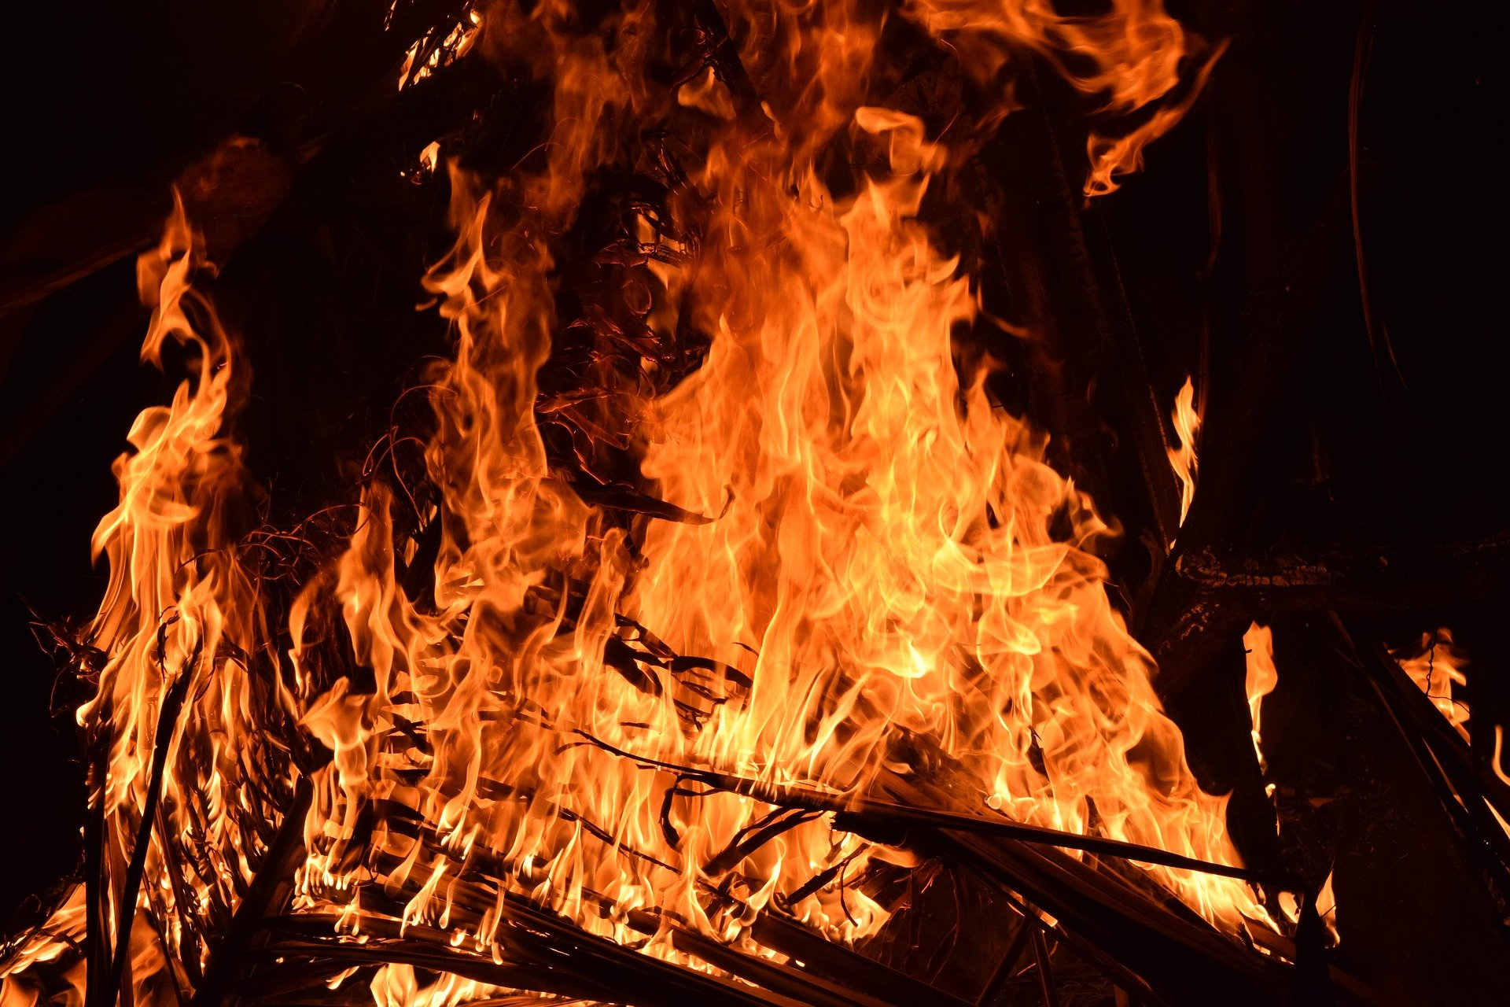
Twitter  30 October 2020 at 10am | Remember, remember to stay safe in November – don’t put fireworks in pockets or direct them towards other people – they could go off unexpectedly. Find more advice on our website: rbfrs.co.uk/RememberRemember  #FireworkSafety
Twitter  31 October 2020 at 9am | Remember, remember to stay safe this November – check your local COVID-19 restrictions before you celebrate Bonfire Night. Find out your local measures on the GOV website: https://bit.ly/314i16D  #RememberRemember
Twitter  1 November 2020 at 12pm | Remember, remember to put out the embers – make sure your bonfire is fully extinguished by using a bucket of water or sand. Find more advice on our website: rbfrs.co.uk/RememberRemember #RememberRemember
Twitter, Instagram and Facebook  2 November 2020 at 3pm | Bonfire Night will look a bit different this year, so it’s important you take the right safety precautions to make sure your evening goes off with the right sort of bang. Find advice on our website: rbfrs.co.uk/RememberRemember  #FireworkSafety  #RememberRemember
Twitter  3 November 2020 at 3pm | This year due to #COVID19, public firework displays have been cancelled.  If you having a home display or bonfire, think carefully, plan carefully and follow the Firework Code and our bonfire safety advice:  rbfrs.co.uk/RememberRemember  #FireWorkSafety
Twitter  4 November 2020 at 3pm | Please stay safe if you’re planning on celebrating Bonfire Night at home this year.  A £2 firework at a small family display misfired and left Maisie Roe with burn injuries. Hear her story: https://youtu.be/iwczrDUNmqI  Please be sure to follow our advice: rbfrs.co.uk/RememberRemember  #FireworkSafety
Twitter, Instagram and Facebook  5 November 2020 at 3pm | With public displays cancelled due to COVID-19 measures, we are asking you make sure you celebrate Bonfire Night safely.  A sparkler reaches a temperature of up to 2,000°C. That’s 20 times the boiling point of water, so please stay safe and keep children well away from fireworks.  rbfrs.co.uk/RememberRemember  #FireworkSafety | 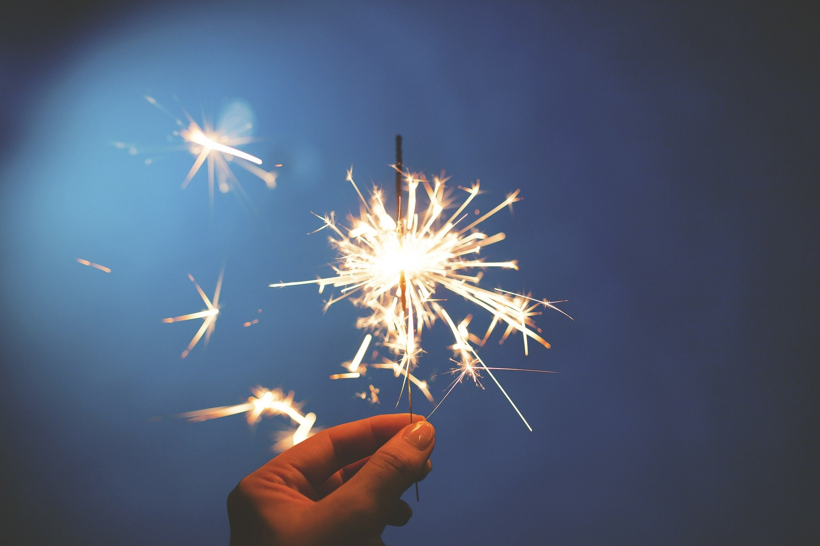
Twitter  6 November 2020 at 3pm | If you’re doing to be setting of fireworks to mark Bonfire Night, Plan your firework display to make it safe and enjoyable, and ensure it finishes by 11pm, except for Diwali, when the cut off is 1am.  For more information on firework curfews, please visit: https://bit.ly/311Y407  #FireworkSafety
Twitter  7 November 2020 at 3pm | Remember, remember to stay safe this November – check your local COVID-19 restrictions before you celebrate Bonfire Night. Find out your local measures on the GOV website: https://bit.ly/314i16D  #RememberRemember
Twitter  8 November 2020 at 3pm | Remember, remember to stay safe this November. We urge you to think about your neighbours and emergency services when considering having a bonfire this year as they can easily become out of control. Find more advice on our website: rbfrs.co.uk/RememberRemember  #RememberRemember

Social Media Assets
If you wish to use any of the above social media assets, please find them available for download here: https://we.tl/t-NSWTn6sk8U

Diwali
Launch date: 7 November 2020
Social media run time: 7 November – 14 November 2020
Hashtag: #Diwali2020

Platform, Date and Time | Copy | Asset
Twitter, Facebook and Instagram  7 November 2020 at 1pm | We know our residents might be celebrating Diwali differently this year, but make sure you keep yourself and your loved ones safe by following our candle safety advice: rbfrs.co.uk/celebratingsafely  #Diwali2020 | 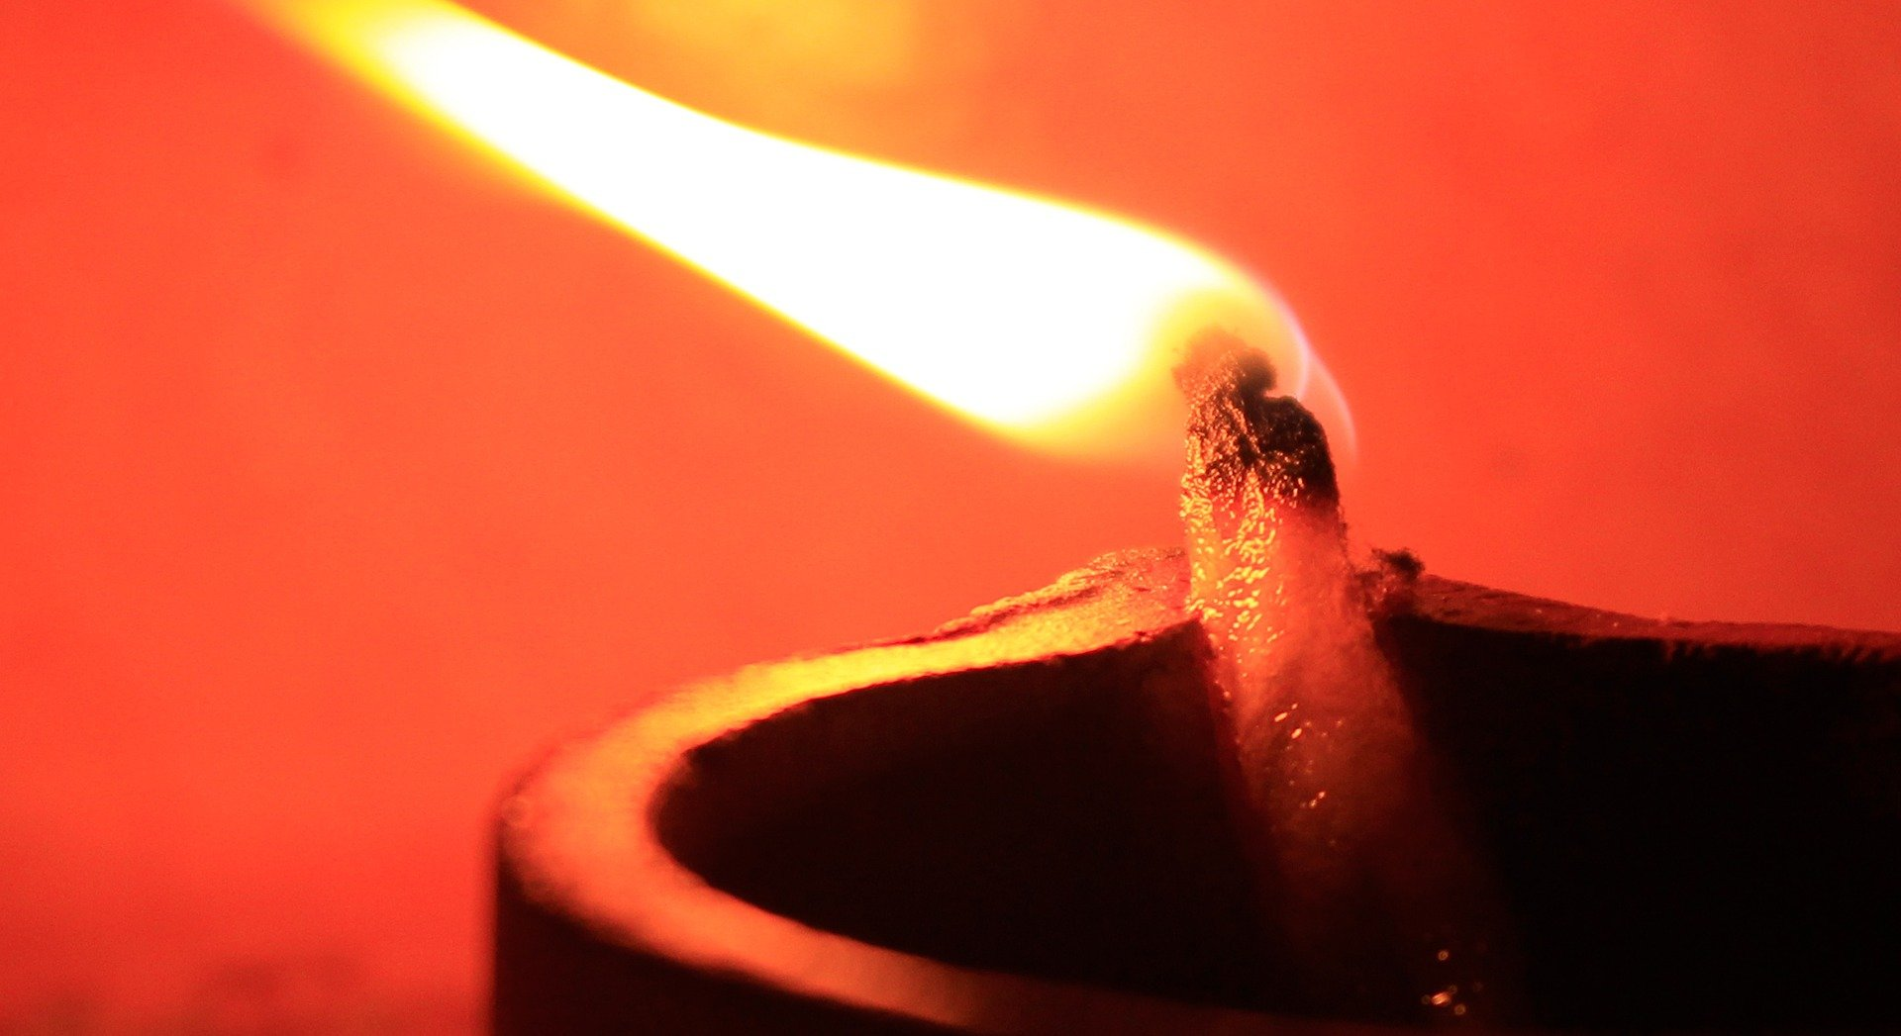
Twitter  10 November 2020 at 11am | We want our communities to be able to celebrate Diwali as safely as possible in these challenging times. Make sure candles are extinguished before you go to bed. Find more advice on our website: rbfrs.co.uk/celebratingsafely  #Diwali2020 | 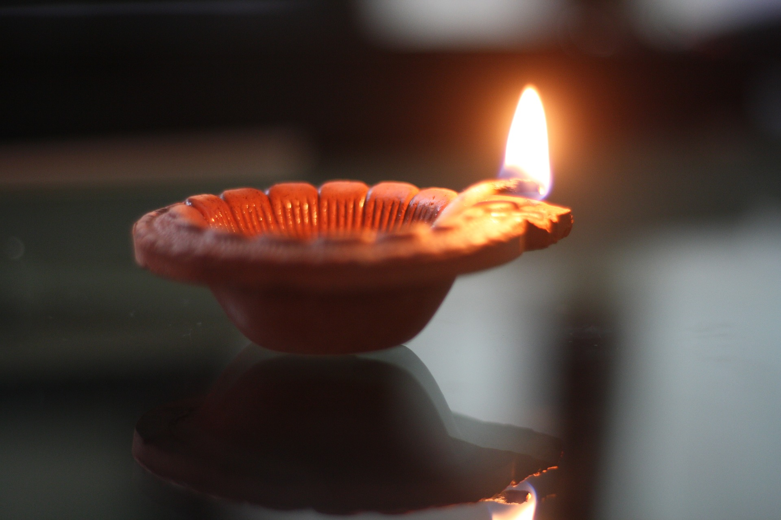
Twitter  12 November  2020 at 1pm | If you’re celebrating Diwali, help keep yourself and your loved ones safe by following our firework safety tips. Find out more on our website: rbfrs.co.uk/celebratingsafely  #Diwali2020
Twitter, Facebook, Instagram  14 November 2020 at 12pm | We hope our communities have a safe and happy Diwali. If you’re planning on celebrating tonight, find our celebrating safely advice on our website: rbfrs.co.uk/celebratingsafely  #Diwali2020 | 