Children and Families, Early Years Division

Weekly News Bulletin: 21st October 2020

## **New local COVID alert levels**

On 12 October the Prime Minister announced how the government will further simplify and standardise local rules by introducing a system of local COVID alert levels in England.

The previously published tiers of restriction for education and childcare, summarised in [annex 3 of the contain framework](https://www.gov.uk/government/publications/containing-and-managing-local-coronavirus-covid-19-outbreaks/covid-19-contain-framework-a-guide-for-local-decision-makers?utm_source=16%20October%202020%20C19&utm_medium=Daily%20Email%20C19&utm_campaign=DfE%20C19#annex-3-tiers-of-national-restriction), work alongside the new [local COVID alert level framework](https://www.gov.uk/guidance/local-covid-alert-levels-what-you-need-to-know?utm_source=16%20October%202020%20C19&utm_medium=Daily%20Email%20C19&utm_campaign=DfE%20C19).

At all local COVID alert levels, the expectation is that education and childcare provision should continue as normal. The government has been very clear that limiting attendance at schools and other education settings should only be done as a last resort, even in areas where a local alert level is ‘high’ or ‘very high’. Decisions on any restrictions necessary in education or childcare settings are taken separately on a case-by-case basis in the light of local circumstances, including information about the incidence and transmission of Coronavirus (COVID-19).

**Actions for early years and childcare providers during the coronavirus (COVID-19) outbreak**  
What childcare services early years settings, childminders and local authorities need to provide during the coronavirus (COVID-19) outbreak.

Amended information on local COVID alert levels and tiers of restriction (section 3), staff who are clinically extremely vulnerable (section 3), and children who are shielding (section 4).

4:31pm, 16 October 2020

<https://www.gov.uk/government/publications/coronavirus-covid-19-early-years-and-childcare-closures?utm_source=bd546068-dab4-4dca-ab6a-3d19142dfe5a&utm_medium=email&utm_campaign=govuk-notifications&utm_content=daily>

**Early Years Contacts**

The Slough Early Years Quality, Care and Learning team is available Monday – Friday 9am – 5pm. Please feel free to contact of us during this time. For any concern about a child, please contact The Slough Children’s Services Trust on 01753 875362.



QCL team contact numbers 1

**Face coverings in education**

Guidance on the use of face coverings for schools and other education institutions that teach people in years 7 and above in England.

<https://www.gov.uk/government/publications/face-coverings-in-education?utm_source=faf7ac3e-e02a-42df-a4c1-f0378ef12f61&utm_medium=email&utm_campaign=govuk-notifications&utm_content=daily>

## **Department for Education coronavirus (COVID-19) helpline opening hours**

The Department for Education coronavirus (COVID-19) helpline is available to answer questions about coronavirus (COVID-19) relating to education settings and children’s social care.

Please listen carefully to all of the available options before selecting the most appropriate option for your nursery, school, college or university.

Please select option 1 or 2 if you require specific advice on the action to take to respond to a positive case of coronavirus (COVID-19) in your setting. This option will take you through to a dedicated team of NHS Business Services Authority advisors who will work through a risk assessment with you to identify close contacts and will inform you what action is needed based on the latest public health advice.

Please select option 3 or 4 for any other questions about coronavirus (COVID-19) relating to education settings and children’s social care.

Phone: 0800 046 8687

Opening hours: Monday to Friday from 8am to 6pm  
Saturday and Sunday from 10am to 4pm

Please also email: [CV19notifications@slough.gov.uk](mailto:CV19notifications@slough.gov.uk) and report the positive case Slough

Please see the updated flow chart from PHE. The difference you will see is the first port of call is now calling the DFE number.



## **Public Health England’s (PHE) dedicated advice service opening hours**

Public Health England’s (PHE) dedicated advice service is available to early years providers, schools, colleges and out of school settings. The service provides support on the actions staff should take when they have been informed of a confirmed case of coronavirus (COVID-19) in their setting (i.e. a pupil or staff member testing positive).

Phone: 0800 046 8687 – option 1 to report a positive test within your setting

Opening hours: Monday to Friday from 8am to 6pm  
Saturday and Sunday from 10am to 4pm

**The COVID-19 pandemic and the early years workforce March - August 2020**: **Staffing decisions in an uncertain environment**

New research published by the Education Policy Institute (EPI) and National Day Nurseries Association (NDNA) shows that 71% of staff in early years settings were furloughed between March and August.  The pandemic and economic downturn have significantly affected early years education, causing disruption to providers since the lockdown began earlier in the year.

<https://epi.org.uk/publications-and-research/the-covid-19-pandemic-and-the-early-years-workforce/?mc_cid=ee731dccf4&mc_eid=6e26d5602e>

**Childminder agency (CMA) inspection requirements for Ofsted**

DfE requirements for Ofsted when organising and undertaking childminder agency (CMA) inspections.  
  
DfE requirements for Ofsted when organising and undertaking childminder agency (CMA) inspections.

Change made  
4:07pm, 15 October 2020

<https://www.gov.uk/government/publications/childminder-agency-cma-inspection-requirements-for-ofsted?utm_source=b5604b43-69b3-431e-84e2-038cce696c0e&utm_medium=email&utm_campaign=govuk-notifications&utm_content=daily>

**Virtual Baby Groups and Virtual Story and Rhyme Time**

Join the Virtual Baby Groups and Virtual Story and Rhyme Time delivered by the Early help Team

Starting Monday 19 October

Please contact [earlyhelp@slough.gov.uk](mailto:earlyhelp@slough.gov.uk) or call 01753 476589



Looking for something to do this half term? Join us for  virtual half term fun, please contact [earlyhelp@slough.gov.uk](mailto:earlyhelp@slough.gov.uk) or call 01753 476589 for more details, booking from 21st October



**Protective measures for holiday or after-school clubs and other out-of-school settings for children during the coronavirus (COVID-19) outbreak**

Protective measures for providers of community activities, holiday or after-school clubs, tuition and other out-of-school settings offering provision to children during the coronavirus (COVID-19) outbreak.

15 October 2020 - Updated with information about local COVID alert levels.

<https://www.gov.uk/government/publications/protective-measures-for-holiday-or-after-school-clubs-and-other-out-of-school-settings-for-children-during-the-coronavirus-covid-19-outbreak?utm_source=977ec831-3ad9-4ef8-bc0a-27485debf3de&utm_medium=email&utm_campaign=govuk-notifications&utm_content=daily>

**Guidance for parents and carers of children attending out-of-school settings during the coronavirus (COVID-19) outbreak**

Guidance for parents and carers of children attending community activities, holiday or after-school clubs, tuition and other out-of-school settings.

15 October 2020 - Updated with information about local COVID alert levels.

<https://www.gov.uk/government/publications/guidance-for-parents-and-carers-of-children-attending-out-of-school-settings-during-the-coronavirus-covid-19-outbreak?utm_source=32e9e5f3-25c9-4c94-b0fd-46e0ceae406e&utm_medium=email&utm_campaign=govuk-notifications&utm_content=daily>

## **New guidance for clinically extremely vulnerable people**

The Department of Health and Social Care has provided new [guidance on shielding and protecting people who are clinically extremely vulnerable (CEV) from coronavirus (COVID-19)](https://www.gov.uk/government/publications/guidance-on-shielding-and-protecting-extremely-vulnerable-persons-from-covid-19/guidance-on-shielding-and-protecting-extremely-vulnerable-persons-from-covid-19?utm_source=15%20October%202020%20C19&utm_medium=Daily%20Email%20C19&utm_campaign=DfE%20C19). The guidance is less restrictive than previous shielding guidance and includes advice at each Local COVID Alert Level.

What does this mean for clinically extremely vulnerable pupils?

|  |
| --- |
| * clinically extremely vulnerable pupils should continue to attend education settings at all Local COVID Alert Levels * a very small number of pupils or students under paediatric care (such as recent transplant or very immunosuppressed children) who have been advised by their GP or clinician not to attend school, should not attend. Absence for this reason can be recorded in the attendance register as: ‘not attending in circumstances related to coronavirus (COVID-19)’ – code X. Remote education should be provided immediately |

What does this mean for clinically extremely vulnerable staff?

|  |
| --- |
| * clinically extremely vulnerable staff can continue to attend school where the system of controls in the [department’s guidance](https://www.gov.uk/government/publications/actions-for-schools-during-the-coronavirus-outbreak/guidance-for-full-opening-schools?utm_source=15%20October%202020%20C19&utm_medium=Daily%20Email%20C19&utm_campaign=DfE%20C19) are in place in line with the school’s own workplace risk assessment |

In the future, formal shielding advice will only be reintroduced in some, but not all, very high alert level areas (level 3), based on advice from the Chief Medical Officer. In this event, the government will write to people separately to inform them if they are advised to shield.

<https://www.gov.uk/government/publications/guidance-on-shielding-and-protecting-extremely-vulnerable-persons-from-covid-19/guidance-on-shielding-and-protecting-extremely-vulnerable-persons-from-covid-19?utm_source=15%20October%202020%20C19&utm_medium=Daily%20Email%20C19&utm_campaign=DfE%20C19>

**The Early Childhood Unit at NCB**

## Policy News

[Foundation Years: Development Matters vodcast](https://ncb.us9.list-manage.com/track/click?u=93ca41ab24380caf57761bd37&id=6ead7d90a9&e=6e26d5602e)

Foundation Years hosted a [vodcast](https://ncb.us9.list-manage.com/track/click?u=93ca41ab24380caf57761bd37&id=176d34abe8&e=6e26d5602e) with Ada Simpson, Head of Early Years Quality at the Department for Education, and Dr Julian Grenier, Headteacher at Sheringham Nursery School and Children’s Centre, who answered the sector’s questions on the new Development Matters document.

## Research

[The COVID-19 pandemic and the early years workforce](https://ncb.us9.list-manage.com/track/click?u=93ca41ab24380caf57761bd37&id=e574569303&e=6e26d5602e)  
The Education Policy Institute (EPI) and National Day Nurseries Association (NDNA) have published a report summarising the findings of a quarterly survey, looking at the impact that the current COVID-19 pandemic is having on the staffing decisions of early years providers in the private, voluntary and independent sectors.

## SEND

[E-learning course: Holistic outcomes in EHC plans](https://ncb.us9.list-manage.com/track/click?u=93ca41ab24380caf57761bd37&id=85b3f32970&e=6e26d5602e) - CDC

### This new e-learning course from The Council for Disabled Children (CDC) is a free, self-guided course that takes all the key elements from CDC’s popular and well-received live training and repackages it into a series of online modules

## **Consultation**

[Early Years healthy development review: Call for evidence](https://ncb.us9.list-manage.com/track/click?u=93ca41ab24380caf57761bd37&id=7479e3ef19&e=6e26d5602e)   
(The Leadsom Review) 

**Bright Futures start in Early Years**

The Bright Futures campaign is making it’s way around Slough, promoting funded early education to families via this TUK TUK!

From the 19th October – 1st November 2020

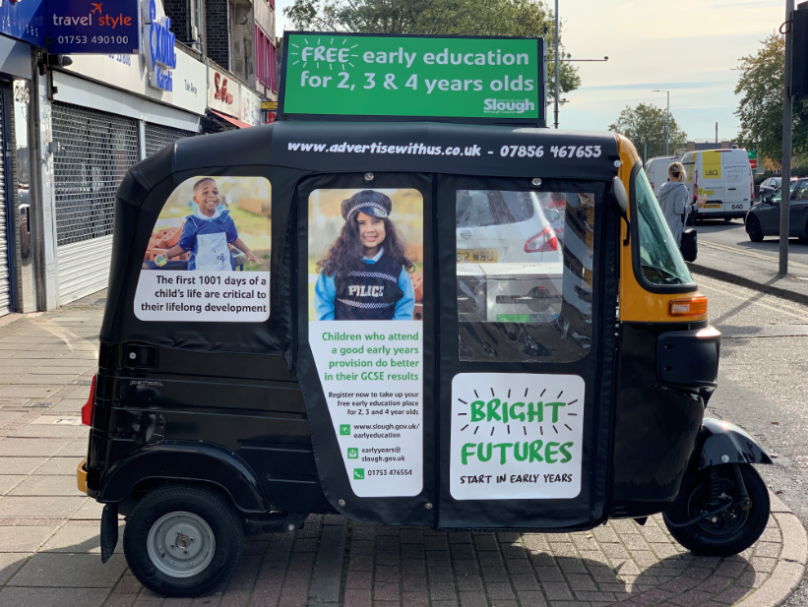

**Get ready for No Pens Day Wednesday**

Don't forget that this year's No Pens Day Wednesday is coming up on 25th November 2020. After missing out on valuable learning and interaction during lockdown, boosting children's language development is more important than ever.

Make the most of your day with the help of our resources for early years settings, including lesson plans, posters and more.  
  
Not sure where to start? Our [guide to the day](https://ican.us13.list-manage.com/track/click?u=7a8f7b55170feb79eed45ea7f&id=5dc79d1c5f&e=a97b27f104) will help you start planning your perfect pen-free day of learning.  
  
Don't forget to [share what you're up to with us](https://ican.us13.list-manage.com/track/click?u=7a8f7b55170feb79eed45ea7f&id=3788836277&e=a97b27f104)[on social media](https://ican.us13.list-manage.com/track/click?u=7a8f7b55170feb79eed45ea7f&id=6bcf038446&e=a97b27f104)using the #NoPensDay hashtag!

<https://ican.org.uk/no-pens-day-wednesday/resources/?utm_source=email%20campaign&utm_medium=email&utm_campaign=No%20Pens%20Day%20resources>

**Coronavirus mental health: how to avoid emotional exhaustion during the pandemic**  
Feeling overwhelmed by the rise in coronavirus cases? You’re not alone.  
  
Read in Stylist: <https://apple.news/Aw-VjubjsTMW3CX4t2btEnw>

Reopening education and childcare provision for all in England – IFS report and DfE guidance

The closure of early childhood education and childcare provision to all but key workers and vulnerable children during the height of the Covid-19 pandemic has had severe consequences for the finances of providers, many of whom were already facing challenges before the lockdown was imposed. Despite a range of government support programmes, many fee-earning providers lost significant income during the lockdown. While strict social distancing measures remained in place, the proportion of providers who survive in the medium term will depend on how quickly the demand for early childhood education and care returns. That is largely dependent on levels of employment and the economic recovery as well as the wider health concerns that parents hold being addressed.

Drawing mainly on the Nuffield Foundation funded Institute for Fiscal Studies (IFS) report [Challenges for the childcare market: the implications of COVID-19 for childcare providers in England](https://lgiu.us3.list-manage.com/track/click?u=00e86e4f795b3722410373cd1&id=861816d58f&e=69c8578f5e) (September 2020), this briefing summarises the financial consequences of the pandemic in relation to early childhood education and care providers. It details the support available to help providers and how these measures have interacted with the loss of income and the pre-pandemic finances of providers. It also explores the financial implications of the pandemic on the capacity of the sector, and comment looks at the local authority duty to ensure sufficient provision and what interventions might support providers.

<https://lgiu.org/briefing/reopening-education-and-childcare-provision-for-all-in-england-ifs-report-and-dfe-guidance/>

## **Mass coronavirus (COVID-19) testing pilots**

On 16 October, the [Prime Minister provided early details of small-scale pilots of new testing technologies](https://www.gov.uk/government/speeches/prime-ministers-statement-on-coronavirus-covid-19-16-october-2020?utm_source=19%20October%202020%20C19&utm_medium=Daily%20Email%20C19&utm_campaign=DfE%20C19) that will begin this week.

These include:

|  |
| --- |
| * repeat asymptomatic testing of certain groups to identify those most at risk of spreading the virus and break chains of transmission * lateral flow tests which are swab antigen tests that do not require a laboratory for processing. The results can be provided within an hour, and at the location where the test was taken * saliva test that detects the virus from saliva samples, which are easy to collect and simple for the person to provide |

The programme looks at technologies that will significantly increase the number of people who are able to be tested each day and reduce the time it takes to receive a test result.

The pilots will take place across the UK and in some of the worst affected regions, including the North West, North East and Yorkshire. They will include some students who are 16 and over (including Y12 and Y13 students in school) and staff at schools, colleges and universities, as well as some NHS hospitals and adult social care settings. The pilots will see individuals tested regularly, with confirmed results sent directly into the NHS Test and Trace system.

This is an early pilot, therefore if your school, college or university has not been contacted to take part in the pilot, no further action is required.

These pilots will not impact the work of NHS Test and Trace, which will continue as normal. If you have symptoms, you should continue to self-isolate and [book a test](https://www.gov.uk/get-coronavirus-test?utm_source=19%20October%202020%20C19&utm_medium=Daily%20Email%20C19&utm_campaign=DfE%20C19) via the usual routes. Anyone who tests positive, and their contacts, will still need to [self-isolate](https://www.gov.uk/government/publications/covid-19-stay-at-home-guidance/stay-at-home-guidance-for-households-with-possible-coronavirus-covid-19-infection?utm_source=19%20October%202020%20C19&utm_medium=Daily%20Email%20C19&utm_campaign=DfE%20C19) in accordance with current rules.

These tests are not a substitute for measures the government is already asking people to take, such as washing your hands, covering your face, and practising social distancing.

**Slough COVID update**

* Covid rate in Slough has increased and is now over 100/100,000
* Community champions have been recruited are now nearly 500 in total

#OneSlough Community Champions is a network of people made up of Slough's voluntary sector, residents and workers who sign up to receive regular trusted updates and advice. This can be passed on to family, friends and neighbours, in any way you want. You might be the person that everyone knows and trusts. You might be someone who wants to help in whatever way you can - even if this is your first time. Perhaps you are always on Facebook, post images on Instagram or look after a WhatsApp group, then you’re just who we’re looking for!  
Post trusted information to keep Slough safe. By having and sharing clear information, you, your friends, family and community can make informed choices.

**What's a #OneSlough Community Champion?**The idea is that all those who live or work in Slough sign up to receive regular trusted Covid-19 updates which they share with their family, friends and neighbours through social media, e-mail or over the phone.

**How to sign up?**  
People can sign up to be a #OneSlough Community Champion at**:** <https://oneslough.org.uk/champions/>

**General Comms update**

* One Slough are working closely with Hindu temples on support for Diwali
* Resources and promo material available for Halloween (see attached).Further information will be circulated about Trick or Treat
* Thames Fire and Rescue have also created the attached resource..

**Campaign update (#Fit2FightCOVID and Flu)**

* **#Fit2FightCOVID** campaign was launched 21st September on radio, Facebook, bus stops, billboards and the Tuk Tuk vehicle. Campaign will continue to run throughout the winter to support residents with moving more.
* Flu vaccination campaign ongoing. Please keep promoting to families. Some local issues in pharmacies with lack of vaccines due to increased demand. Presently, Boots and Tesco appear to have ample supplies. However, always phone ahead to check, and preferably book an appointment.

If some-one qualifies for the free vaccine they should have it through their GP as they have more availability. If some-one does not qualify for the free vaccine, they should shop around the various pharmacies. COVID vaccine preparations are continuing.

* See attached flyer on how to boost your immune system.

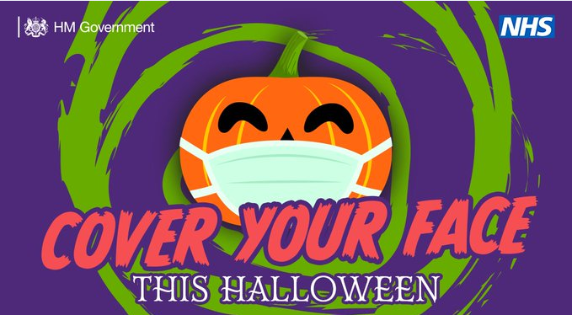 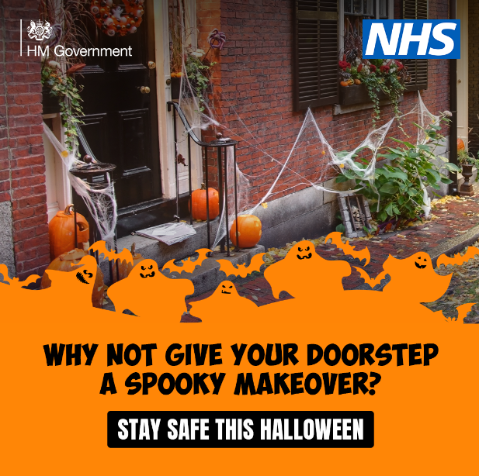 

**Training and Continuous Professional Development**

**MULTI-AGENCY TRAINING OFFER 2020-21 is under review (Level 2 Safeguarding)**

Covid 19 has presented many challenges for our workforce and has taught us a lot about Virtual working together!

We are currently revising all our training and developing virtual modules. We have committed to virtual training September through to March 2021 unless it is safe to have face to face training.

<https://www.sloughsafeguardingpartnership.org.uk/scsp/scsp/training/multi-agency-training-offer-2020-21-refreshed-in-light-of-covid-19>

**Safeguarding basics and COVID-19**

Below is a link to a video which has been developed to cover the basics of safeguarding during COVID-19.  It covers safeguarding for both children and adults at home and also includes domestic abuse and exploitation.

It takes less than 10 minutes to view and may be particularly useful as a resource for:-

* redeployed staff
* staff or volunteers  working in different ways within the safeguarding arena during this period
* volunteers who do not read English very well as there is no requirement to read the slides.

The messages are simple - “There is no excuse for abuse during Lockdown” and “Help is available -It is business as usual for safeguarding services”

Link to Slough Safeguarding basics <https://youtu.be/RDc4mBGbRmA>

**Safeguarding Level 3**

*It is always recommended that Designated Safeguarding Leads complete a localised Safeguarding course to ensure they have up to date information about local policy’s and procedures. Due to COVID 19 the Slough Safeguarding Partnership are currently unable to offer face to face training but will endeavour to review other options such as online training in the future. In the meantime there are a number of other organisations who offer Level 3 Safeguarding training online which you could access, however we strongly recommend that you ensure you are aware and up to date with Slough’s Safeguarding procedures* [*https://berks.proceduresonline.com/slough/index.html*](https://berks.proceduresonline.com/slough/index.html)

**Please note these courses are not recommendations and we are not endorsing the training. This list is not exhaustive**

**Level 3 Safeguarding Children: Paediatric First Aid Training Online**

This online safeguarding training level 3 course programme is aimed at all childminders, nursery staff, but also school teachers & support staff working with children & infants who could potentially assess and evaluating the needs of a child, infant or young person, who may be potentially at risk of harm.

<https://www.onlinepaediatricfirstaid.co.uk/product/level-3-online-safeguarding-children-course-childminders-nursery-staff/>

**Designated Safeguarding Lead (Level 3): The National Nursery Training**

As part of the National Nursery Training Designated Safeguarding Lead course you will learn:

* Understand the safeguarding structure and have an understanding of the law, policy and recommended guidance to uphold the highest safeguarding standards
* Understand the roles and responsibilities of the Designated Safeguarding Lead
* Be able to identify signs of possible abuse
* Understand the process to follow when a safeguarding issue is identified
* Understand the correct procedure for dealing with disclosures.
* Understand the varying levels of need of individuals and processes to follow.
* Understand the correct procedure for recording information and following due process beyond referral to external agencies.

<https://nationalnurserytraining.com/product/designated-safeguarding-lead-level-3/>

**Designated Safeguarding Lead online Course: EYFS Resources**

The Designated Safeguarding Lead course covers the following:

◦the definition of safeguarding and child protection,

◦recap on signs and symptoms of abuse

◦how to report concerns

◦how to respond to allegations of abuse

◦recording information correctly

◦roles and responsibilities of people and agencies

◦creating a child protection policy

◦the role of a Designated Safeguarding Lead (DSL)

<https://www.eyfsresources.co.uk/training/early-years-safeguarding-courses/designated-safeguarding-lead-online-course>

**NSPCC Safeguarding Training**

<https://learning.nspcc.org.uk/training>

**Prevent**

Prevent should be seen as part of the existing safeguarding framework;

While it remains rare for children and young people to become involved in terrorist activity, young people from an early age can be exposed to terrorist & extremist influences or prejudiced views. As with other forms of safeguarding strategies, early intervention is always preferable.

Slough Borough Council working with other local partners, families and communities, play a key role in ensuring young people and their communities are safe from the threat of terrorism.

Prevent training, aims of session.

• Understand Prevents aims

• Think about who may be vulnerable to Extremism and Radicalisation – all forms

• See why some people are able to influence and manipulate others to commit crimes

• Recognise when a vulnerable individual may be in need of help

• And be clear on what help and support looks like in this area, and who you should turn to if you have concerns

• Look at the threats, risks and vulnerabilities

6th October 2020 @ 10am – 12pm

10th November 2020 @ 10am – 12pm

9th December 2020 @ 10am – 12pm

12th January 2021 @ 10am – 12pm

9th February 2021 @ 10am – 12pm

9th March 2021 @ 10am – 12pm

To book a free space please email [Philip.Dobson@slough.gov.uk](mailto:Philip.Dobson@slough.gov.uk)

Alternative evening session will run on 23rd February 2021 @ 6.30pm – 8pm bookings via the Link <https://thelink.slough.gov.uk/events/early-years-prevent-training-1>

**Observation, Assessment & Planning (OAP)**

**Online Training**

We have spaces remaining on the below training course on Observation, Assessment and Planning Training at a reduced cost of **£19.60** per place. You do not need an invite to book, please see the link provided below.

The observation, assessment and planning cycle is crucial to children’s progress in the EYFS, and takes into account children’s current learning interests and styles, developmental stage and level of achievement, and individual needs, to inform how practitioners develop the environment, shape experiences and provide opportunities for play and learning.

**Monday 16th November 2020**

**1pm – 2.30pm (11 spaces remaining) or 6.30pm – 8pm (5 spaces remaining)**

Target audience: All practitioners responsible for and contributing to observation assessment and planning in the EYFS including childminders, practitioners, and EYFS school staff.

Cost: Full price for this training is **£24.50** however we are offering an AUTUMN SPECIAL of 20% off book your space now for only **£19.60**

To Book (1pm): <https://thelink.slough.gov.uk/events/early-years-observation-assessment-and-planning-training>

To Book (6.30pm): <https://thelink.slough.gov.uk/events/early-years-observation-assessment-and-planning-training-0>

**Strong Home Learning Experience to support children’s learning and development**

**National Literacy Trust – Words for life /New digital platforms for families and teachers**

The virtual school library will help primary schools give children who have been most adversely affected by COVID-19 access to books all year round. The words for life website supports with the home learning environment for children <https://wordsforlife.org.uk/?mc_cid=ea64f10f58&mc_eid=dfacb06fa7>

The websites are packed with free books, fun activities and exclusive author content.

For more information look [here](https://literacytrust.org.uk/news/to-celebrate-international-literacy-day-hrh-the-duchess-of-cornwall-opened-ivydales-new-school-library-and-launched-our-virtual-school-library-for-all-uk-schools/?mc_cid=ea64f10f58&mc_eid=dfacb06fa7)

**For Happy Healthy Early Years** - Support from trusted NHS professionals <https://healthforunder5s.co.uk/>

**Simple, fun activities for kids, from newborn to five** <https://hungrylittleminds.campaign.gov.uk/>

**Talk to your baby**

[www.talktoyourbaby.org](http://www.talktoyourbaby.org)

**Building a happy baby - a guide for parents**

[www.unicef.org.uk/babyfriendly](http://www.unicef.org.uk/babyfriendly)

**Education Endowment Foundation**

NEW: Supporting reading at home - we have made some of our resources available in Polish, Punjabi, Urdu, Bengali, and Lithuanian. <https://educationendowmentfoundation.org.uk/covid-19-resources/support-resources-to-share-with-parents/>

**Improving the Home Learning Environment** guide by the Department of Education and National Literacy Trust <https://assets.publishing.service.gov.uk/government/uploads/system/uploads/attachment_data/file/756020/Improving_the_home_learning_environment.pdf>

**The Toddler Meal Planner is a must have in every kitchen!**

Created in collaboration with parents to solve a real need, it makes it easy for parents to get the balance right, helping to take the guesswork out of toddler meals and set up healthy habits for life at a critical time in children’s development. You can find the meal planner [here](https://infantandtoddlerforum.org/blog/new-resource-inspired-by-parents-for-parents-the-toddler-meal-planner-is-a-must-have-in-every-kitchen/?utm_source=Email&utm_medium=Email&utm_campaign=August%20email)