Children and Families, Early Years Division
Weekly News Bulletin: 28th October 2020
Research and analysis
Survey of childcare and early years providers and COVID-19 (coronavirus)
Research with childcare providers in relation to the COVID-19 pandemic.
Published 26 October 2020
https://www.gov.uk/government/publications/survey-of-childcare-and-early-years-providers-and-covid-19-coronavirus?utm_source=d2a7b2ed-2fcd-4226-a50b-5872eb64d4f5&utm_medium=email&utm_campaign=govuk-notifications&utm_content=daily

Research and analysis
Providers’ finances: survey of childcare and EY providers 2019
Research into early years provider finances based on survey data from 2019.
Published 26 October 2020
https://www.gov.uk/government/publications/providers-finances-survey-of-childcare-and-ey-providers-2019?utm_source=75586f05-c3a1-4b92-bce5-2488bcdbefdc&utm_medium=email&utm_campaign=govuk-notifications&utm_content=daily

Research and analysis
Occupancy and staff ratios at early years providers
Research into occupancy, spare capacity and staff ratios for early years providers.
Published 26 October 2020
https://www.gov.uk/government/publications/occupancy-and-staff-ratios-at-early-years-providers?utm_source=205b2d14-b65a-4df0-a116-e926172be376&utm_medium=email&utm_campaign=govuk-notifications&utm_content=daily

Research and analysis
How early years providers support children
Research into how early years providers support disadvantaged children, children with SEND, the home learning environment and healthy eating.
Published 26 October 2020
https://www.gov.uk/government/publications/how-early-years-providers-support-children?utm_source=176ec720-4eee-4a22-a3b0-08f83bfa0624&utm_medium=email&utm_campaign=govuk-notifications&utm_content=daily

Guidance
Example lessons for remote teaching
Lesson plans shared by schools to help teachers adapt their practice for remote education following the outbreak of coronavirus (COVID-19).
Published 26 October 2020
https://www.gov.uk/government/publications/example-lessons-for-remote-teaching?utm_source=0d4184fb-9adb-42b3-be26-d5609a7ecc2e&utm_medium=email&utm_campaign=govuk-notifications&utm_content=daily

Press release
Protections for working parents eligible for childcare support
Eligibility extended for parents eligible for 30 hours and Tax-Free Childcare offers
Published 26 October 2020
Working parents who are on the Government’s coronavirus support schemes will still be eligible for childcare support even if their income falls below the minimum threshold requirement.
The Government has confirmed that from Sunday 1 November, eligible working parents who receive support through the Government’s new Job Support Scheme (JSS) and extended Self-Employed Income Support Scheme (SEISS) will continue to receive their childcare entitlements, including the 30 hours offer and Tax-Free Childcare, even if their income levels fall below the threshold temporarily whilst on these schemes.

Read more …. https://www.gov.uk/government/news/protections-for-working-parents-eligible-for-childcare-support?utm_source=f56d7e6a-83b3-4330-a0d2-fd37f91271b6&utm_medium=email&utm_campaign=govuk-notifications&utm_content=daily

HMRC: COVID-19: Employer support – live webinars
The Coronavirus Job Retention Scheme closes on 31‌‌‌ ‌October and you will need to make any final claims on or before 3‌0‌‌‌ ‌November.

The Job Support Scheme opens on 1‌‌‌ ‌November, with claims opening on 8‌‌‌ ‌December.
Make sure you have the latest information by joining the live COVID-19 support for employers webinar. We’ll provide an overview of:

- the Coronavirus Job Retention Scheme and how to claim
- the latest information on the Job Retention Bonus, including how to check if your employees are eligible, when you can claim and what you need to do now to prepare
- an introduction to the Job Support Scheme (JSS), which provides different types of support to businesses so that they can get the right assistance, at the right time, according to their situation.

We will continue to update our webinars to reflect the latest information as it becomes available.
Register here
We are also running monthly webinars on the Coronavirus (COVID-19) Statutory Sick Pay Rebate Scheme. Get the latest information on:
- who can claim
- who you can claim for
- how to make a claim
- what you may be entitled to, and more.
Register here
You can ask questions during all our live webinars using the on-screen text box.
Our webinars are constantly updated to provide the latest government guidance on changes as they develop.

Virtual Baby Groups and Virtual Story and Rhyme Time
Join the Virtual Baby Groups and Virtual Story and Rhyme Time delivered by the Early help Team

Starting Monday 19 October
Please contact earlyhelp@slough.gov.uk or call 01753 476589

Looking for something to do this half term? Join us for virtual half term fun, please contact earlyhelp@slough.gov.uk or call 01753 476589 for more details, booking from 21st October

What to do if a pupil is displaying symptoms of coronavirus (COVID-19)
We have published a list of actions that early years, schools and further education colleges must follow in the event that a child or young person displays symptoms or if they confirm they have tested positive for coronavirus (COVID-19). The action lists are sector specific and print friendly. They can be accessed using these links:
- action list for schools
- action list for early years and childcare providers
- action list for further education colleges
The Joint Biosecurity Centre has also published Action Cards to provide the latest instructions for anyone responsible for businesses or organisations on how to identify, report and respond to coronavirus (COVID-19) cases. This includes action cards for the education sector.

Guidance
Safe working in education, childcare and children’s social care
Preventing and controlling infection, including the use of PPE, in education, childcare and children’s social care settings during the coronavirus outbreak.
Published 14 May 2020
Last updated 22 October 2020

Updated information about how to report confirmed coronavirus (COVID-19) cases in the section on engaging with the NHS test and trace process.
https://www.gov.uk/government/publications/safe-working-in-education-childcare-and-childrens-social-care?utm_source=13e42a39-71b1-4efb-8f5c-1183c41597bd&utm_medium=email&utm_campaign=govuk-notifications&utm_content=daily#history

Guidance
Ofsted: coronavirus (COVID-19) rolling update
Ofsted guidance and information relating to coronavirus (COVID-19) for schools, early years, children's social care and further education and skills providers
Published 19 March 2020
Last updated 22 October 2020
Updated the information for early years and childcare.
https://www.gov.uk/guidance/ofsted-coronavirus-covid-19-rolling-update?utm_source=78eda994-9414-44cd-a2be-3992909a5229&utm_medium=email&utm_campaign=govuk-notifications&utm_content=daily#history

Specialist midwife urges mothers-to-be to have the flu jab to help protect themselves and their babies this winter

A specialist midwife is urging pregnant women to help protect themselves and their babies this winter by having the flu jab.

Whether you have recently conceived, are midway through your pregnancy or nearing your due date, Katharine Franks, specialist midwife, Antenatal and Newborn Screening cross-site lead for Frimley Health Foundation Trust, is encouraging mothers-to-be to have their flu vaccination.

Ms Franks said: “Pregnancy naturally weakens the body’s immune system and as a result, can increase the risk of a mother and unborn baby becoming seriously ill from flu.

“It is therefore recommended that all pregnant women have the flu vaccine not only to protect themselves but also their baby.

She added: “Studies have shown it is safe to have the vaccine at any stage of pregnancy and women who have the vaccine pass on some protection to their baby which will last for the first few months its of life.”

“We are pleased to be able to offer the vaccine to pregnant women attending the antenatal clinic or scan appointments at Wexham Park or Frimley Park Hospital sites and are working hard to expand this service to our Community Midwifery Hubs. Mothers-to-be can also contact their GP to arrange their flu vaccine or visit their nearby pharmacy.”

Strains of the flu virus change every year, and for that reason it is important to have the vaccine each year. Even if someone thinks they have had the flu already, they should still have the vaccine. There is more than one type of flu virus and it is important to reduce the risk as much as possible.

Flu can make otherwise healthy people feel very poorly for up to a fortnight. The symptoms, that come on very quickly, include fever, chills, headaches, aches and pains in the joints and muscles, and extreme tiredness.

Pregnant women benefit from the flu vaccine because it will: reduce their risk of serious complications such as pneumonia, particularly in the later stages of pregnancy; reduce the risk of miscarriage or having a baby born too soon or with a low birth weight; help protect their baby who will continue to have some immunity to flu during the first few months of its life; and reduce the chance of the mother passing infection to her new baby.

The vaccine is free for pregnant women and is available from their maternity service provider; their GP or local pharmacy.

For more, click here. 

COVID alert level 2: HIGH, effective 00:01 Saturday 24 October (i.e. midnight Friday).
This is due to the continuing and substantial rise of coronavirus cases and community transmission within the borough.
The main additional restriction is as follows:
- Residents must not meet socially with friends and family indoors in any setting unless you live with them or have formed a support bubble with them. This includes private homes, and any other indoor venues such as pubs and restaurants.
For the full and more detailed information on level 2 click here https://www.gov.uk/guidance/local-covid-alert-level-high

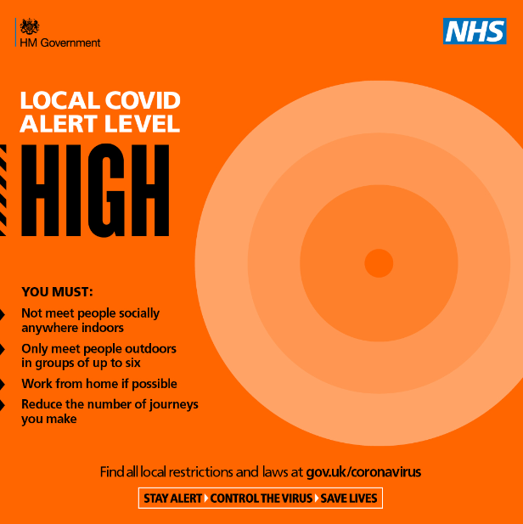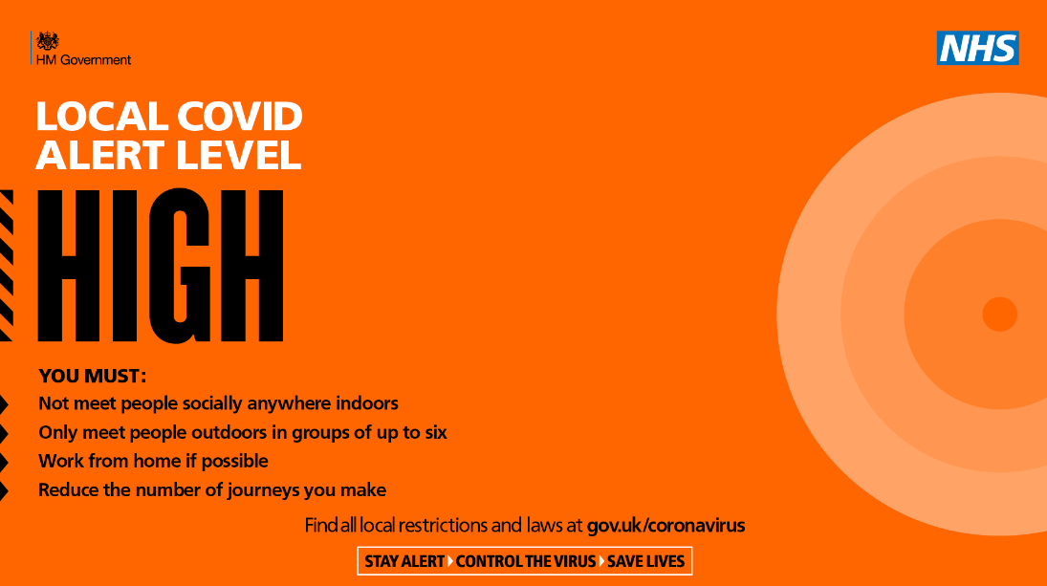

Updated guidance for schools
We have updated the guidance on actions for schools during the coronavirus (COVID-19) outbreak to include:
- additional information on the safe ventilation of schools
- a link to the Health and Safety Executive guidance on air conditioning and ventilation during the coronavirus outbreak
- a link to the Chartered Institution of Building Service Engineers coronavirus (COVID-19) advice
This guidance has also been updated to reflect the latest advice on shielding and local COVID alert levels.

Department for Education coronavirus (COVID-19) helpline
The Department for Education coronavirus (COVID-19) helpline is available to answer questions about coronavirus (COVID-19) relating to education settings and children’s social care.
Please listen carefully to all of the available options before selecting the most appropriate option for your nursery, school, college or university.
Please select option 1 or 2 if you require specific advice on the action to take to respond to a positive case of coronavirus (COVID-19) in your setting. This option will take you through to a dedicated team of NHS Business Services Authority advisors who will work through a risk assessment with you to identify close contacts and will inform you what action is needed based on the latest public health advice.
Please select option 3 or 4 for any other questions about coronavirus (COVID-19) relating to education settings and children’s social care.
Phone: 0800 046 8687
Opening hours: Monday to Friday from 8am to 6pm
Saturday and Sunday from 10am to 6pm

Safeguarding Rapid Review Learning
Schools have an unprecedented task providing support to families who had been isolated during lockdown and returning to school with highly complex problems.
Following a recent safeguarding review the SPR group undertook reflected similar key themes (neglect, being left home alone) as the Harry SPR case which was circulated last month.

The learning highlighted referrals made by all professionals, not just schools need to improve:
- The quality of referrals should include context and narrative about life for child.
- Staff need additional top up training in completing MARF referrals so that they provide the right information and appropriate threshold decisions are made swiftly.
- The MARF also needs improving to help practitioners articulate their concerns (which will be refreshed over the coming months).

In this uncertain environment it may very well be possible we may go into another lockdown, I wanted to share some of the learning which you may find helpful, focussing on the importance of seeing the child during welfare calls during lockdown. Phone calls can restrictive. Where possible making contact via a secure visual platform like Zoom so the child and their environment can be seen.
The SPR group were impressed by the school identifying the child as vulnerable (not known to social care) and noted the efforts made to contact him during lockdown as a good model. They felt that a virtual meeting might have helped. (but it may not have!)

A full briefing sheet will be produced over the coming weeks and shared with you all. In the interim I have outlined the main points for your reflection and practice development.

If you have any questions please feel free to contact me.

With thanks

Jatinder Matharu
Education Safeguarding Officer

Safeguarding lessons from local review
Approved case briefing note - Harry 1

Training and Continuous Professional Development

MULTI-AGENCY TRAINING OFFER 2020-21 is under review (Level 2 Safeguarding)
Covid 19 has presented many challenges for our workforce and has taught us a lot about Virtual working together!

We are currently revising all our training and developing virtual modules. We have committed to virtual training September through to March 2021 unless it is safe to have face to face training.

https://www.sloughsafeguardingpartnership.org.uk/scsp/scsp/training/multi-agency-training-offer-2020-21-refreshed-in-light-of-covid-19

Safeguarding basics and COVID-19
Below is a link to a video which has been developed to cover the basics of safeguarding during COVID-19. It covers safeguarding for both children and adults at home and also includes domestic abuse and exploitation.

It takes less than 10 minutes to view and may be particularly useful as a resource for:-
- redeployed staff
- staff or volunteers working in different ways within the safeguarding arena during this period
- volunteers who do not read English very well as there is no requirement to read the slides.

The messages are simple - “There is no excuse for abuse during Lockdown” and “Help is available -It is business as usual for safeguarding services”

Link to Slough Safeguarding basics https://youtu.be/RDc4mBGbRmA

Safeguarding Level 3
It is always recommended that Designated Safeguarding Leads complete a localised Safeguarding course to ensure they have up to date information about local policy’s and procedures. Due to COVID 19 the Slough Safeguarding Partnership are currently unable to offer face to face training but will endeavour to review other options such as online training in the future. In the meantime there are a number of other organisations who offer Level 3 Safeguarding training online which you could access, however we strongly recommend that you ensure you are aware and up to date with Slough’s Safeguarding procedures https://berks.proceduresonline.com/slough/index.html

Please note these courses are not recommendations and we are not endorsing the training. This list is not exhaustive

Level 3 Safeguarding Children: Paediatric First Aid Training Online
This online safeguarding training level 3 course programme is aimed at all childminders, nursery staff, but also school teachers & support staff working with children & infants who could potentially assess and evaluating the needs of a child, infant or young person, who may be potentially at risk of harm.
https://www.onlinepaediatricfirstaid.co.uk/product/level-3-online-safeguarding-children-course-childminders-nursery-staff/

Designated Safeguarding Lead (Level 3): The National Nursery Training
As part of the National Nursery Training Designated Safeguarding Lead course you will learn:
- Understand the safeguarding structure and have an understanding of the law, policy and recommended guidance to uphold the highest safeguarding standards
- Understand the roles and responsibilities of the Designated Safeguarding Lead
- Be able to identify signs of possible abuse
- Understand the process to follow when a safeguarding issue is identified
- Understand the correct procedure for dealing with disclosures.
- Understand the varying levels of need of individuals and processes to follow.
- Understand the correct procedure for recording information and following due process beyond referral to external agencies.
https://nationalnurserytraining.com/product/designated-safeguarding-lead-level-3/
Designated Safeguarding Lead online Course: EYFS Resources
The Designated Safeguarding Lead course covers the following:
◦the definition of safeguarding and child protection,
◦recap on signs and symptoms of abuse
◦how to report concerns
◦how to respond to allegations of abuse
◦recording information correctly
◦roles and responsibilities of people and agencies
◦creating a child protection policy
◦the role of a Designated Safeguarding Lead (DSL)
https://www.eyfsresources.co.uk/training/early-years-safeguarding-courses/designated-safeguarding-lead-online-course
NSPCC Safeguarding Training
https://learning.nspcc.org.uk/training

Prevent
Prevent should be seen as part of the existing safeguarding framework;
While it remains rare for children and young people to become involved in terrorist activity, young people from an early age can be exposed to terrorist & extremist influences or prejudiced views. As with other forms of safeguarding strategies, early intervention is always preferable.

Slough Borough Council working with other local partners, families and communities, play a key role in ensuring young people and their communities are safe from the threat of terrorism.
Prevent training, aims of session.
• Understand Prevents aims
• Think about who may be vulnerable to Extremism and Radicalisation – all forms
• See why some people are able to influence and manipulate others to commit crimes
• Recognise when a vulnerable individual may be in need of help
• And be clear on what help and support looks like in this area, and who you should turn to if you have concerns
• Look at the threats, risks and vulnerabilities

6th October 2020 @ 10am – 12pm
10th November 2020 @ 10am – 12pm
9th December 2020 @ 10am – 12pm
12th January 2021 @ 10am – 12pm
9th February 2021 @ 10am – 12pm
9th March 2021 @ 10am – 12pm

To book a free space please email Philip.Dobson@slough.gov.uk

Alternative evening session will run on 23rd February 2021 @ 6.30pm – 8pm bookings via the Link https://thelink.slough.gov.uk/events/early-years-prevent-training-1

Observation, Assessment & Planning (OAP)
Online Training
We have spaces remaining on the below training course on Observation, Assessment and Planning Training at a reduced cost of £19.60 per place. You do not need an invite to book, please see the link provided below.

The observation, assessment and planning cycle is crucial to children’s progress in the EYFS, and takes into account children’s current learning interests and styles, developmental stage and level of achievement, and individual needs, to inform how practitioners develop the environment, shape experiences and provide opportunities for play and learning.

Monday 16th November 2020
1pm – 2.30pm or 6.30pm – 8pm

Target audience: All practitioners responsible for and contributing to observation assessment and planning in the EYFS including childminders, practitioners, and EYFS school staff.
Cost: Full price for this training is £24.50 however we are offering an AUTUMN SPECIAL of 20% off book your space now for only £19.60

To Book (1pm): https://thelink.slough.gov.uk/events/early-years-observation-assessment-and-planning-training
To Book (6.30pm): https://thelink.slough.gov.uk/events/early-years-observation-assessment-and-planning-training-0

Strong Home Learning Experience to support children’s learning and development

National Literacy Trust – Words for life /New digital platforms for families and teachers
The virtual school library will help primary schools give children who have been most adversely affected by COVID-19 access to books all year round. The words for life website supports with the home learning environment for children https://wordsforlife.org.uk/?mc_cid=ea64f10f58&mc_eid=dfacb06fa7

The websites are packed with free books, fun activities and exclusive author content.
For more information look here

For Happy Healthy Early Years - Support from trusted NHS professionals https://healthforunder5s.co.uk/

Simple, fun activities for kids, from newborn to five https://hungrylittleminds.campaign.gov.uk/

Talk to your baby
www.talktoyourbaby.org

Building a happy baby - a guide for parents
www.unicef.org.uk/babyfriendly

Education Endowment Foundation
NEW: Supporting reading at home - we have made some of our resources available in Polish, Punjabi, Urdu, Bengali, and Lithuanian. https://educationendowmentfoundation.org.uk/covid-19-resources/support-resources-to-share-with-parents/

Improving the Home Learning Environment guide by the Department of Education and National Literacy Trust https://assets.publishing.service.gov.uk/government/uploads/system/uploads/attachment_data/file/756020/Improving_the_home_learning_environment.pdf

The Toddler Meal Planner is a must have in every kitchen!
Created in collaboration with parents to solve a real need, it makes it easy for parents to get the balance right, helping to take the guesswork out of toddler meals and set up healthy habits for life at a critical time in children’s development. You can find the meal planner here

