Children and Families, Early Years Division

Weekly News Bulletin: 11th November 2020

## **Education and childcare settings: New National Restrictions from 5 November 2020**

How New National Restrictions to control the spread of coronavirus (COVID-19) impact education, childcare and children’s social care settings.

The government continues to prioritise the wellbeing and long-term futures of our children and young people and will not be closing early years settings, schools, further education (FE) colleges or universities. It remains very important for children and young people to attend, to support their wellbeing and education and help working parents and guardians. Senior clinicians still advise that school is the best place for children to be, and so they should continue to go to school. Schools have implemented a range of protective measures to make them safe.

Childcare or education is one of the exceptions that children, young people and parents and carers can leave their home for.

<https://www.gov.uk/guidance/education-and-childcare-settings-new-national-restrictions-from-5-november-2020>

**Department for Education coronavirus (COVID-19) helpline – opening hours**

The Department for Education coronavirus (COVID-19) helpline is available to answer questions about coronavirus (COVID-19) relating to education settings and children’s social care.

Please listen carefully to all of the available options before selecting the most appropriate option for your nursery, school, college or university.

Please select option 1 or 2 if you require specific advice on the action to take to respond to a positive case of coronavirus (COVID-19) in your setting. This option will take you through to a dedicated team of NHS Business Services Authority advisors who will work through a risk assessment with you to identify close contacts and will inform you what action is needed based on the latest public health advice.

Please select option 3 or 4 for any other questions about coronavirus (COVID-19) relating to education settings and children’s social care.

Phone: 0800 046 8687  
Opening hours: Monday to Friday from 8am to 6pm  
Saturday and Sunday from 10am to 6pm

## **Department for Education guidance**

Our guidance to support education providers, local authorities and parents during the coronavirus (COVID-19) outbreak can be accessed using the links below:

|  |
| --- |
| * [Guidance for early years and childcare providers](https://www.gov.uk/government/collections/early-years-and-childcare-coronavirus-covid-19?utm_source=2%20November%202020%20C19&utm_medium=Daily%20Email%20C19&utm_campaign=DfE%20C19) * [Guidance for schools](https://www.gov.uk/government/collections/guidance-for-schools-coronavirus-covid-19?utm_source=2%20November%202020%20C19&utm_medium=Daily%20Email%20C19&utm_campaign=DfE%20C19) * [Guidance for further and higher education providers](https://www.gov.uk/government/collections/further-and-higher-education-coronavirus-covid-19?utm_source=2%20November%202020%20C19&utm_medium=Daily%20Email%20C19&utm_campaign=DfE%20C19) * [Guidance for local authority children’s services](https://www.gov.uk/government/collections/local-authority-childrens-services-coronavirus-covid-19?utm_source=2%20November%202020%20C19&utm_medium=Daily%20Email%20C19&utm_campaign=DfE%20C19) * [Guidance for holiday or after-school clubs and other out-of-school settings](https://www.gov.uk/government/publications/protective-measures-for-holiday-or-after-school-clubs-and-other-out-of-school-settings-for-children-during-the-coronavirus-covid-19-outbreak?utm_source=2%20November%202020%20C19&utm_medium=Daily%20Email%20C19&utm_campaign=DfE%20C19) |

**Advertising vacancies**

Does your setting currently have vacant places for early years children?

If you would like the Early Years Service to promote your vacancies on our [early years facebook page](https://www.facebook.com/sloughearlyyears/) or the Slough Borough Council [facebook](https://www.facebook.com/sloughcouncil/) and [twitter](https://twitter.com/SloughCouncil?ref_src=twsrc%5Egoogle%7Ctwcamp%5Eserp%7Ctwgr%5Eauthor) pages please email [earlyyears@slough.gov.uk](mailto:earlyyears@slough.gov.uk) and we will include your details in future posts about vacancies. Deadline this week Thursday 12th November by 11am

Alternatively please call Raj Braich on 07395 258 096

**Getting tested for coronavirus (COVID-19)**

Anyone who displays symptoms of coronavirus (COVID-19) can and should get a test. Tests can be booked online through the NHS [testing and tracing for coronavirus (COVID-19)](https://www.nhs.uk/conditions/coronavirus-covid-19/testing-for-coronavirus/?utm_source=10%20November%202020%20C19&utm_medium=Daily%20Email%20C19&utm_campaign=DfE%20C19) website, or ordered by telephone via NHS 119 for those without access to the internet.

Coronavirus (COVID-19) symptoms are:

|  |
| --- |
| * a high temperature * a new, continuous cough * a loss or change to your sense of smell or taste |

Staff and pupils must not come into their education setting if they have symptoms and must be sent home to self-isolate if they develop symptoms. All children can be tested if they have symptoms, including children under 5, but children aged 11 and under will need to be helped by their parents or carers if using a home testing kit.

We have published a list of actions that early years, schools and further education colleges must follow in the event that a child or young person displays symptoms or if they confirm they have tested positive for coronavirus (COVID-19). The action lists are sector specific and print friendly. They can be accessed using these links:

|  |
| --- |
| * [action list for schools](https://www.gov.uk/government/publications/actions-for-schools-during-the-coronavirus-outbreak?utm_source=10%20November%202020%20C19&utm_medium=Daily%20Email%20C19&utm_campaign=DfE%20C19) * [action list for early years and childcare providers](https://www.gov.uk/government/publications/coronavirus-covid-19-early-years-and-childcare-closures?utm_source=10%20November%202020%20C19&utm_medium=Daily%20Email%20C19&utm_campaign=DfE%20C19) * [action list for further education colleges](https://www.gov.uk/government/publications/coronavirus-covid-19-maintaining-further-education-provision?utm_source=10%20November%202020%20C19&utm_medium=Daily%20Email%20C19&utm_campaign=DfE%20C19) |

**COVID-19 series: briefing on early years, October 2020**

Research and analysis Evidence from research interviews with 208 registered early years providers and maintained nursery schools between 5 and 16 October. On 17 March 2020, all routine inspections were suspended due to the COVID-19 (coronavirus) pandemic.As part of our phased return to routine inspection, Ofsted is carrying out interim visits to early years providers.

<https://www.gov.uk/government/publications/covid-19-series-briefing-on-early-years-october-2020?utm_source=3219cf01-938a-414d-a735-8f821ca469a8&utm_medium=email&utm_campaign=govuk-notifications&utm_content=daily>

**Early years foundation stage statutory framework (EYFS)**

The standards that school and childcare providers must meet for the learning, development and care of children from birth to 5.

10 November 2020

Amended the content on early years foundation stage coronavirus disapplications to reflect the updated arrangements that were put in place from 26 September 2020, and national restrictions.

<https://www.gov.uk/government/publications/early-years-foundation-stage-framework--2?utm_source=cfc5b34a-cabf-4c0c-955b-e82c00acfb78&utm_medium=email&utm_campaign=govuk-notifications&utm_content=daily#history>

**New winter package to provide further support for children and families**

The Government announced a [new £170m Covid Winter Grant Scheme](https://www.gov.uk/government/news/new-winter-package-to-provide-further-support-for-children-and-families?utm_source=9%20November%202020%20C19&utm_medium=Daily%20Email%20C19&utm_campaign=DfE%20C19). This funding will be ring-fenced, with at least 80% earmarked to support with food and bills and will cover the period to the end of March 2021.

Local authorities will receive the funding at the beginning of December 2020.

This scheme will allow local authorities to support the hardest-hit families and individuals, as well as provide food for children who need it over the holidays. Local authorities understand which groups need support, and are best placed to ensure appropriate holiday support is provided, which is why they will distribute the funds, rather than schools, who will continue providing meals for disadvantaged children during term-time.

The Holiday Activities and Food Programme, which has provided healthy food and enriching activities to disadvantaged children since 2018, will also be expanded across England next year. This programme will cover Easter, Summer and Christmas in 2021, and will be available to children in every local authority in England.

<https://www.gov.uk/government/news/new-winter-package-to-provide-further-support-for-children-and-families?utm_source=9%20November%202020%20C19&utm_medium=Daily%20Email%20C19&utm_campaign=DfE%20C19>

**Ofsted interim visits to take place remotely during the period of national restrictions**

Ofsted has announced that during the period of national restrictions, they will carry out their work remotely where they can, only going on site where it is necessary to do so, or in response to urgent concerns.

Further information on their plans for remote inspections during the period of national restrictions can be found in the [Ofsted: coronavirus (COVID-19) rolling update](https://www.gov.uk/guidance/ofsted-coronavirus-covid-19-rolling-update?utm_source=9%20November%202020%20C19&utm_medium=Daily%20Email%20C19&utm_campaign=DfE%20C19).

## **Coronavirus Job Retention Scheme extended until the end of March 2021**

The [Coronavirus Job Retention Scheme (CJRS)](https://www.gov.uk/government/news/furlough-scheme-extended-and-further-economic-support-announced?utm_source=9%20November%202020%20C19&utm_medium=Daily%20Email%20C19&utm_campaign=DfE%20C19) will be extended until the end of March 2021. Workers in any part of the UK can retain their job, even if their employer cannot afford to pay them, and be paid at least 80% of their salary up to £2,500 a month. Early years providers’ access to the CJRS remains as published.

The Job Support Scheme, which was scheduled to come into force on Sunday 1 November, has been postponed as the Coronavirus Job Retention Scheme is being extended.

For organisations that are classified as public sector, and where there is continued public funding, for example local authority-maintained schools, staff that are supported by that public funding should not be furloughed.

Business premises forced to close in England are to receive grants worth up to £3,000 per month under the Local Restrictions Support Grant.

Further information on the financial support available can be found in the [guidance on the new period of national restrictions](https://www.gov.uk/guidance/new-national-restrictions-from-5-november?utm_source=9%20November%202020%20C19&utm_medium=Daily%20Email%20C19&utm_campaign=DfE%20C19).

.

**Guidance for clinically extremely vulnerable staff and children**

The Department of Health and Social Care has published [guidance on shielding and protecting people who are clinically extremely vulnerable from coronavirus (COVID-19)](https://www.gov.uk/government/publications/guidance-on-shielding-and-protecting-extremely-vulnerable-persons-from-covid-19/guidance-on-shielding-and-protecting-extremely-vulnerable-persons-from-covid-19?utm_source=5%20November%202020%20C19&utm_medium=Daily%20Email%20C19&utm_campaign=DfE%20C19).

This guidance advises individuals who are clinically extremely vulnerable to work from home and not to go into work. Individuals in this group will have been identified through a letter from the NHS or from their GP. Staff should talk to their employers about how they will be supported, including working from home where possible, during the period of national restrictions.

All other staff should continue to attend work, including those living in a household with someone who is clinically extremely vulnerable.

We now know more about the virus, and most children who were identified as clinically extremely vulnerable at the beginning of the coronavirus (COVID-19) outbreak are no longer identified as such. Schools should encourage parents to speak to their GP or specialist clinician, as soon as possible, if they have not already done so, to understand whether their child should still be classed as clinically extremely vulnerable.

Those children whose doctors have confirmed they are still clinically extremely vulnerable are advised not to attend school whilst this advice is in place. Where a conversation with a GP or specialist clinician has not taken place, the public health advice is that the child is still clinically extremely vulnerable and they are advised not to attend school. In these situations, we expect schools to be able to offer clinically extremely vulnerable children access to remote education, in line with previous guidance.

## Guidance for clinically vulnerable staff and children

Staff and children who are clinically vulnerable or have underlying health conditions but are not clinically extremely vulnerable, may continue to attend early years, childcare and school settings in line with current guidance.

**What parents and carers need to know about early years providers, schools and colleges during the coronavirus (COVID-19) outbreak** Information for parents and carers about going back to schools, nurseries and colleges in the autumn term.

6 November 2020

Added a link to the new national restrictions from 5 November guidance.

<https://www.gov.uk/government/publications/what-parents-and-carers-need-to-know-about-early-years-providers-schools-and-colleges-during-the-coronavirus-covid-19-outbreak?utm_source=ccba5ae8-49a8-4bf9-afa6-f9cca5a8ca74&utm_medium=email&utm_campaign=govuk-notifications&utm_content=daily#history>

**Providing apprenticeships during the coronavirus (COVID-19) outbreak** This document sets out guidance for apprentices, employers, training providers and assessment organisations in response to the impact of coronavirus (COVID-19).

6 November 2020

Added a link to the new national restrictions from 5 November guidance.

<https://www.gov.uk/government/publications/coronavirus-covid-19-apprenticeship-programme-response?utm_source=96cb0eb9-7ff1-4198-be18-dc313f443947&utm_medium=email&utm_campaign=govuk-notifications&utm_content=daily#history>

**Local Government Association updates**

Attached you will find a Q&A that the DfE pulled together and a summary below.

The Department for Education has published [the guidance for Early Years and Childcare](https://www.gov.uk/guidance/education-and-childcare-settings-new-national-restrictions-from-5-november-2020#early-years-and-childcare) settings following the announcement of the new national measures. When [reviewing the legislation](https://www.legislation.gov.uk/uksi/2020/1200/pdfs/uksi_20201200_en.pdf), it is important to note that the majority of services offered through early years will count underneath the education exemption, confirming that they are to continue operating as currently. In summary:

* Early years settings and childminders can remain open through the period of national lockdown, and parents can continue to use these settings as normal.
* Parents will be able to access other childcare activities (including wraparound care and some out of school settings) where reasonably necessary to enable parents to work, seek work, attend education or training, or for the purposes of respite care for carers.
* Parent and child groups (including baby and toddler groups) can continue where they provide support to parent and/or child, and children under 5 will not be counted within the 15 person limit - meaning parents and carers can attend such groups in larger numbers.
* There are some further restrictions, such as these need to operate out of an Ofsted or community setting (places of worship) and must be operated by a business, charitable organisation or public body.
* Childminders can meet under the national restrictions, therefore meeting with one other adult outside, regardless of the number of children under the age of five that are present.

In addition to a query that was raised – at a meeting with DfE they said on visits to settings:

The preference is to only do these where completely necessary and there is no alternative (like a virtual tour) but there is some discretion and appropriate covid-safety measures should be taken and a risk assessment.

Ofsted

[Ofsted have announced](https://www.gov.uk/guidance/interim-visits-registered-early-years-providers?utm_source=b3f82db4-29a1-45f9-a471-d129c6be7bd2&utm_medium=email&utm_campaign=govuk-notifications&utm_content=daily#history) that they will carry out a risk assessment for early years interim visits. Based on this. they will either deliver these remotely or make visits, if it is safe and necessary. They will be updating the sector on their long term plans in the next few weeks.

Outstanding queries

There are a couple of outstanding queries that I don’t believe to be covered in either the q&a or the guidance that you have raised with me that I will get back to you when I have received a response from the Department.

These include:

* Training programmes where students need to have a certain number of hours at a setting
* Clarification on CJRS where the previous had a qualification added that providers could only claim the non funded part of employees wages
* Clarification on PFA and extensions (note: q&a does say that training can take place during lockdown).

Flora Wilkie

Adviser – Children and Young People

Local Government Association



**Use of the NHS COVID-19 app in education and childcare settings**

Actions for leaders and staff when using the NHS COVID-19 app in education and childcare settings.

Change made  
The requirements on displaying QR codes have been updated alongside the information classified as necessary or required. Links to wraparound care and early years providers guidance have also been added.

6 November 2020

<https://www.gov.uk/government/publications/use-of-the-nhs-covid-19-app-in-schools-and-further-education-colleges?utm_source=a78cd9d2-11e0-4e84-805f-79f010d3adde&utm_medium=email&utm_campaign=govuk-notifications&utm_content=daily>

**Foundation Years COVID-19 update #21 - FAQs - 5 November**

From Thursday 5 November until Wednesday 2 December, national lockdown restrictions are in place in England. Early years settings and childminders can remain open and parents can continue to use these settings as normal.

Foundation Years will continue to provide updates via our [mailing list](https://ncb.us9.list-manage.com/subscribe/post?u=93ca41ab24380caf57761bd37&id=8f9a6de061), [Facebook](https://www.facebook.com/FamiliesinFoundationYears), [Twitter](https://www.twitter.com/foundationyears) and on the Foundation Years [website](http://www.foundationyears.org.uk/).

### [****Frequently Asked Questions (FAQs)****](https://foundationyears.org.uk/wp-content/uploads/2020/11/Early-Year-QA-5-Nov-2020.pdf)

This document answers the FAQs from the early years sector on the national lockdown. These answers have been checked with the Department for Education (DfE) and cover:

* Attending more than one setting
* Outdoor learning
* Visits to early years settings
* EYFS disapplications and Paediatric First Aid
* Safety measures in settings
* Funding and financial support
* + more

If you have any further questions, please submit these to [**foundationyears@ncb.org.uk**](mailto:foundationyears@ncb.org.uk).

**Carrying out Childcare Register inspections**

This guidance is for Ofsted inspectors carrying out inspections of providers that are only registered on either or both parts of the Childcare Register.

4 November 2020

Added a note on how we will carry out inspections during the national lockdown starting on 5 November.

<https://www.gov.uk/guidance/carrying-out-childcare-register-inspections?utm_source=55e1b9eb-9989-4fa4-8222-8a8ddf5e8f3c&utm_medium=email&utm_campaign=govuk-notifications&utm_content=daily#history>

**‘Health at Home’ campaign**

The ‘Health at Home’ campaign is an online resource with guidance and advice on how people can look after themselves whilst spending time in isolation due to the new coronavirus restrictions.

The following are examples of the range of free services available:

- Online, telephone and text “Stop Smoking” services #Quit4COVID

- Specific Coronavirus related Mental Health support and information

- Downloadable hints and tips of how to stay active at home, including bespoke advice for Early Years, Schools, Adults and those working from home #Fight2FitCOVID

- Nutritional advice, meal preparation guidance and a free virtual weight management service

- Access to online testing for Sexual Health services

For more information visit [www.publichealthslough.co.uk/campaigns/health-at-home](http://www.publichealthslough.co.uk/campaigns/health-at-home)

* Wellbeing workshops available:
  + Looking after your mental health and emotional wellbeing
  + Looking after your immune system this winter

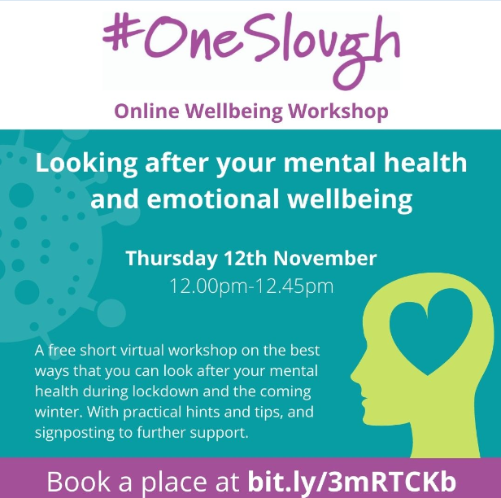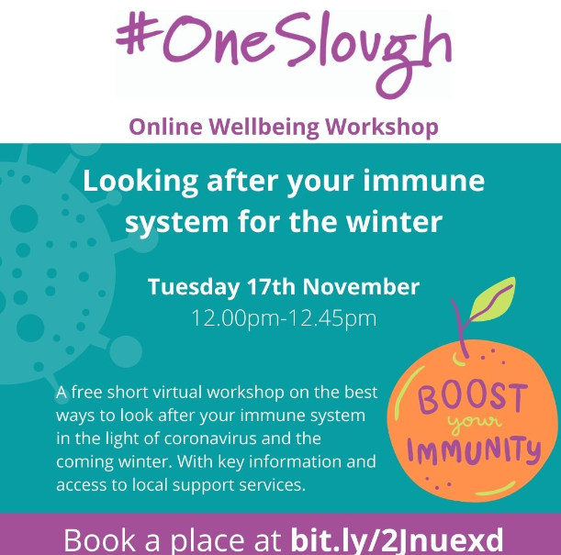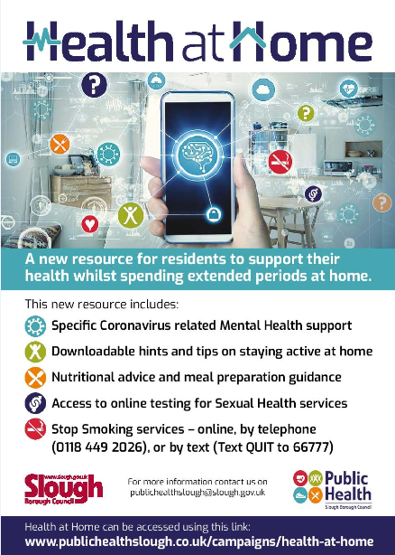

**Training and Continuous Professional Development**

**MULTI-AGENCY TRAINING OFFER 2020-21 is under review (Level 2 Safeguarding)**

Covid 19 has presented many challenges for our workforce and has taught us a lot about Virtual working together!

We are currently revising all our training and developing virtual modules. We have committed to virtual training September through to March 2021 unless it is safe to have face to face training.

<https://www.sloughsafeguardingpartnership.org.uk/scsp/scsp/training/multi-agency-training-offer-2020-21-refreshed-in-light-of-covid-19>

**Safeguarding basics and COVID-19**

Below is a link to a video which has been developed to cover the basics of safeguarding during COVID-19.  It covers safeguarding for both children and adults at home and also includes domestic abuse and exploitation.

It takes less than 10 minutes to view and may be particularly useful as a resource for:-

* redeployed staff
* staff or volunteers  working in different ways within the safeguarding arena during this period
* volunteers who do not read English very well as there is no requirement to read the slides.

The messages are simple - “There is no excuse for abuse during Lockdown” and “Help is available -It is business as usual for safeguarding services”

Link to Slough Safeguarding basics <https://youtu.be/RDc4mBGbRmA>

**Safeguarding Level 3**

*It is always recommended that Designated Safeguarding Leads complete a localised Safeguarding course to ensure they have up to date information about local policy’s and procedures. Due to COVID 19 the Slough Safeguarding Partnership are currently unable to offer face to face training but will endeavour to review other options such as online training in the future. In the meantime there are a number of other organisations who offer Level 3 Safeguarding training online which you could access, however we strongly recommend that you ensure you are aware and up to date with Slough’s Safeguarding procedures* [*https://berks.proceduresonline.com/slough/index.html*](https://berks.proceduresonline.com/slough/index.html)

**Please note these courses are not recommendations and we are not endorsing the training. This list is not exhaustive**

**Level 3 Safeguarding Children: Paediatric First Aid Training Online**

This online safeguarding training level 3 course programme is aimed at all childminders, nursery staff, but also school teachers & support staff working with children & infants who could potentially assess and evaluating the needs of a child, infant or young person, who may be potentially at risk of harm.

<https://www.onlinepaediatricfirstaid.co.uk/product/level-3-online-safeguarding-children-course-childminders-nursery-staff/>

**Designated Safeguarding Lead (Level 3): The National Nursery Training**

As part of the National Nursery Training Designated Safeguarding Lead course you will learn:

* Understand the safeguarding structure and have an understanding of the law, policy and recommended guidance to uphold the highest safeguarding standards
* Understand the roles and responsibilities of the Designated Safeguarding Lead
* Be able to identify signs of possible abuse
* Understand the process to follow when a safeguarding issue is identified
* Understand the correct procedure for dealing with disclosures.
* Understand the varying levels of need of individuals and processes to follow.
* Understand the correct procedure for recording information and following due process beyond referral to external agencies.

<https://nationalnurserytraining.com/product/designated-safeguarding-lead-level-3/>

**Designated Safeguarding Lead online Course: EYFS Resources**

The Designated Safeguarding Lead course covers the following:

◦the definition of safeguarding and child protection,

◦recap on signs and symptoms of abuse

◦how to report concerns

◦how to respond to allegations of abuse

◦recording information correctly

◦roles and responsibilities of people and agencies

◦creating a child protection policy

◦the role of a Designated Safeguarding Lead (DSL)

<https://www.eyfsresources.co.uk/training/early-years-safeguarding-courses/designated-safeguarding-lead-online-course>

**NSPCC Safeguarding Training**

<https://learning.nspcc.org.uk/training>

**Prevent**

Prevent should be seen as part of the existing safeguarding framework;

While it remains rare for children and young people to become involved in terrorist activity, young people from an early age can be exposed to terrorist & extremist influences or prejudiced views. As with other forms of safeguarding strategies, early intervention is always preferable.

Slough Borough Council working with other local partners, families and communities, play a key role in ensuring young people and their communities are safe from the threat of terrorism.

Prevent training, aims of session.

• Understand Prevents aims

• Think about who may be vulnerable to Extremism and Radicalisation – all forms

• See why some people are able to influence and manipulate others to commit crimes

• Recognise when a vulnerable individual may be in need of help

• And be clear on what help and support looks like in this area, and who you should turn to if you have concerns

• Look at the threats, risks and vulnerabilities

9th December 2020 @ 10am – 12pm

12th January 2021 @ 10am – 12pm

9th February 2021 @ 10am – 12pm

9th March 2021 @ 10am – 12pm

To book a free space please email [Philip.Dobson@slough.gov.uk](mailto:Philip.Dobson@slough.gov.uk)

Alternative evening session will run on 23rd February 2021 @ 6.30pm – 8pm bookings via the Link <https://thelink.slough.gov.uk/events/early-years-prevent-training-1>

**Strong Home Learning Experience to support children’s learning and development**

**National Literacy Trust – Words for life /New digital platforms for families and teachers**

The virtual school library will help primary schools give children who have been most adversely affected by COVID-19 access to books all year round. The words for life website supports with the home learning environment for children <https://wordsforlife.org.uk/?mc_cid=ea64f10f58&mc_eid=dfacb06fa7>

The websites are packed with free books, fun activities and exclusive author content.

For more information look [here](https://literacytrust.org.uk/news/to-celebrate-international-literacy-day-hrh-the-duchess-of-cornwall-opened-ivydales-new-school-library-and-launched-our-virtual-school-library-for-all-uk-schools/?mc_cid=ea64f10f58&mc_eid=dfacb06fa7)

**For Happy Healthy Early Years** - Support from trusted NHS professionals <https://healthforunder5s.co.uk/>

**Simple, fun activities for kids, from newborn to five** <https://hungrylittleminds.campaign.gov.uk/>

**Talk to your baby**

[www.talktoyourbaby.org](http://www.talktoyourbaby.org)

**Building a happy baby - a guide for parents**

[www.unicef.org.uk/babyfriendly](http://www.unicef.org.uk/babyfriendly)

**Education Endowment Foundation**

NEW: Supporting reading at home - we have made some of our resources available in Polish, Punjabi, Urdu, Bengali, and Lithuanian. <https://educationendowmentfoundation.org.uk/covid-19-resources/support-resources-to-share-with-parents/>

**Improving the Home Learning Environment** guide by the Department of Education and National Literacy Trust <https://assets.publishing.service.gov.uk/government/uploads/system/uploads/attachment_data/file/756020/Improving_the_home_learning_environment.pdf>

**The Toddler Meal Planner is a must have in every kitchen!**

Created in collaboration with parents to solve a real need, it makes it easy for parents to get the balance right, helping to take the guesswork out of toddler meals and set up healthy habits for life at a critical time in children’s development. You can find the meal planner [here](https://infantandtoddlerforum.org/blog/new-resource-inspired-by-parents-for-parents-the-toddler-meal-planner-is-a-must-have-in-every-kitchen/?utm_source=Email&utm_medium=Email&utm_campaign=August%20email)