Your child’s (or children’s) well being: A tool for parents and carers
DRAFT
Introduction
Parenting and caring for children is challenging. It can be really difficult to understand what needs to be done to ensure you do everything you possibly can to promote your child’s well being. Information on social and other media can be very misleading and can make parents feel they are at fault because they cannot provide the material things being pushed by various media. Messages about parenting are confusing and can sometimes be based on people’s personal views. This tool aims to help parents to work out the important basic needs of their child/ren. Parents can use the tool to assure themselves that they are doing everything they can to care for the child’s well being. It can also help them identify any gaps they may not have been aware of so that they can do something about it.
About the tool:
The tool is based on the United Nations Convention on the rights of the child. These are the basic rights of every child. These are used as the standard that parents/carers can use to work out how they are doing. You have been provided with this tool by a professional working with you because it might help you understand the basic needs of your child/ren and to work out any areas you might need help with.
Completing the tool is entirely voluntary. .All information provided will be kept strictly confidential. The professional who gave you the tool adheres to strict rules about confidentiality and will not share with anyone without your consent unless there are any child protection concerns.
How to use the tool:
The ideal way to use the tool is to familiarise yourself with all the questions first. If you are a two parent family, then do this together. The professional who gave you the tool can explain it to you and can help you complete it if you find that helpful. They may also provide their input to the tool providing their professional views which can help you. If, for any reason you feel unable to complete the tool, the professional can complete the tool with information they have and their professional views and will ask you to work with them to make sure the information is factual and as accurate as it can be..
You are encouraged to involve your child/ren in this as much as possible as they can really help you to understand their views and you can sometimes be surprised at what they tell you!
Take your time. This cannot be rushed. You may identify areas that require some discussion with the family or some clarification with the professional who provided you with the tool. We suggest that you do not take more than a week to complete it.
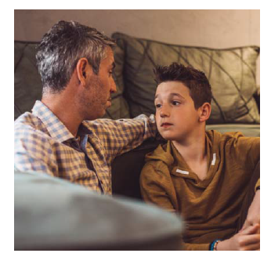
When the tool is complete
Share the tool with the practitioner who gave it to you. He/she will go through it with you to clarify the information provided and will work with you on whether you need any help and how to go about getting it for you.
If you do need some help, the professional will also discuss with you about whether you would like to complete the tool again at some point in the future as this can help you see any improvements following any help provided.

