Children and Families, Early Years Division
Weekly News Bulletin: 10th March 2021

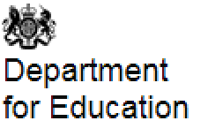

Message to education leaders from the Secretary of State for Education, Gavin Williamson
As schools and colleges welcome all children and young people back this week, I wanted to write to all of you to express my sincere thanks for all of your hard work.
During my visits to 3 schools in the last week, I have been extremely impressed by the continuing commitment, resolve and dedication of staff and pupils.
I have seen for myself the amazing job that schools and colleges are doing in the face of the unprecedented demands we are all dealing with as a result of the pandemic.
Leaders, teachers, support staff and all those who are essential to the running of schools and colleges have worked tirelessly to provide both face-to-face provision for vulnerable children and the children of critical workers, alongside remote education for those who have had to stay at home. Some, including early years, special schools and alternative provision settings, have remained open to all of their pupils throughout.
I know that, in addition, a huge amount of work has gone into preparations for the full return, with schools and colleges up and down the country getting ready to welcome pupils back to the classroom. This includes the incredibly impressive testing operations that have been set up across secondary schools and colleges.
From speaking with parents, pupils, teachers, leaders, unions and other sector representatives, I know the lengths you have gone, to implement and maintain vital measures to minimise risks and help to make sure that children and young people get the education they deserve.
I am extremely thankful to you and your staff. It is thanks to you that the country is able to begin step 1 of the government’s roadmap out of lockdown.
The children and young people at your schools and colleges are our shared future. I am very grateful for all you have done for them over these past long weeks and months.
My very best wishes for the weeks ahead.
The Rt Hon Gavin Williamson CBE MP
Secretary of State for Education

Pupils and students return to school and college from Monday 8 March
Pupils and students in all schools and further education settings return to face-to-face education
wraparound childcare can reopen and other children’s activities can restart only where it is needed to enable parents to work, attend education, seek medical care or attend a support group. Vulnerable children can attend childcare and other children’s activities in all circumstances

From today, as part of the educational setting status form, we have asked schools and colleges to provide information on settings offering onsite wraparound provision, the number of pupils including vulnerable children in wraparound provision, pupils with an education, health and care (EHC) plan or social worker and the number of those who could not be offered a place

Reporting missing test kit deliveries using the contact us form
Primary schools, attached nurseries, maintained nursery schools, secondary schools and colleges can use the contact us form to report any missing or damaged test kit deliveries. Before submitting a report for a missing delivery, please check that another member of staff has not accepted the delivery and allow 48 hours for re-delivery attempts.
The cut-off point for orders is every Wednesday at 5pm. Orders are usually delivered within 7 working days. If you place your order after the cut-off point, please allow 12 working days to receive your delivery.

Disposing of coronavirus (COVID-19) waste
The Department for Environment, Food and Rural Affairs has updated its guidance on how to dispose of waste during the coronavirus (COVID-19) pandemic including face coverings, personal protective equipment (PPE) and waste from lateral flow device (LFD) test kits.
For schools and colleges, LFD waste is not considered to be healthcare waste.
You should segregate LFD waste from any recyclable packaging or other material. Outer packaging provided with the LFD test kits can be recycled or disposed of through your existing waste streams.
Once a LFD test is complete all of the used LFD test kits (swabs, cartridges and devices) should be placed in the small waste bag provided with the kit, this should then be put in your black bag waste bins. Any disposable equipment such as face coverings, gloves, or aprons worn during the LFD testing process, either by those doing the test or those supervising others, should be put in your black bag waste bins
Under your waste management duty of care you must ensure that all waste produced onsite, including from the LFD test kits, is handled appropriately by a licenced waste management company.

Confirmatory PCR testing following a test at home
Around 1 in 3 people who have coronavirus (COVID-19) have no symptoms. By rolling out rapid testing to schools and universities at pace we are helping to uncover hidden cases of the virus, break the chains of transmission and stopping outbreaks before they get a chance to develop.
Students in secondary schools and colleges are currently testing on site – 3 tests, each 3 to 5 days apart – using Lateral Flow Devices (LFDs) as part of the rapid asymptomatic testing programme. Robust evaluations from PHE and the University of Oxford show that LFD tests are accurate, reliable and successfully identify those with coronavirus (COVID-19) who could pass on the virus without realising. The tests have extremely low rates of false positives. LFD tests taken on test sites, such as on school and college grounds, do not need a confirmatory PCR test. This is because these tests are done in a controlled environment and trained staff read the results.
If a pupil or student received a supervised school-based LFD test, as part of the rapid asymptomatic testing programme, and it was positive then they and other members of their household must self-isolate. PCR testing is not advised if you have received a positive result from an LFD test at a school or college test site. If a parent was to do this and it returned a negative result, the policy remains that the pupil or student, their close contacts, and other members of their household must still self-isolate.
All positive results from rapid tests undertaken at home do need to be confirmed with a standard PCR test. This is because these tests are not conducted in a controlled environment and will not have trained staff on hand. Following positive LFD test at home, a confirmatory PCR test should be booked online or by calling 119. Whilst awaiting the PCR result, the pupil or student and their close contacts should self-isolate. If the PCR test is negative, it overrides the self-test LFD test (at home only) and a child can return to school.
Home Testing Kits for nurseries in the private, voluntary and independent (PVI) sector

Following the announcement on 22 February, nurseries in the private, voluntary and independent (PVI) sector will soon have access to home testing kits through the COVID-19 education testing programme.

PVI nurseries can expect to start receiving initial deliveries of testing supplies and instructions for use for asymptomatic testing from this Thursday 11 March. You will not need to place an order or take any specific steps to receive an initial delivery of testing supplies. The initial delivery of supplies should last around 3 to 4 weeks.
Please make sure that someone is available who can accept the deliveries when they arrive. A delivery schedule will be circulated shortly which will provide details as to when your setting can expect its delivery. Please refer to this schedule in the first instance of any questions arising.
The lateral flow device (LFD) test kits should be stored securely at a temperature between 2˚C and 30˚C and so must not be stored outside.
You should not open the test kits or commence testing yet. We will circulate further guidance on asymptomatic home testing in the next couple of days. This will include in-depth guidance and webinars on how settings can manage the testing process.
To add you to the education testing programme, Ofsted has provided your contact details to the Department for Education and Department of Health and Social Care. We will only use your contact details to update you with the latest information on the COVID-19 education testing programme.
Kindest regards
Kate Cornish and May El Komy
Deputy Directors for Rapid Testing in Early Years
Published: 9 March 2021

Coronavirus (Covid-19) local restrictions in education and childcare settings

How settings can prepare for restrictions to help contain community transmission of coronavirus (COVID-19).
The contingency framework is a set of guiding principles designed to help decision makers when they are considering plans to apply, tighten or relax restrictions to education and childcare.
Nurseries, childminders, schools, 16 to 19 academies and further education (FE) providers should have a contingency plan for how they would operate if any of the approaches for easing and tightening of restrictions become necessary in their local area.

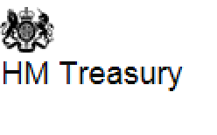

Key points from Chancellor Rishi Sunak second Budget
Recovery Loan Scheme
A new recovery loan scheme to support access to finance for UK business as they grow and recover from the disruption of the COVID-19 pandemic.
The Recovery Loan Scheme ensures businesses of any size can continue to access loans and other kinds of finance up to £10 million per business once the existing COVID-19 loan schemes close, providing support as businesses recover and grow following the disruption of the pandemic and the end of the transition period.
Once received, the finance can be used for any legitimate business purpose, including growth and investment.
The government guarantees 80% of the finance to the lender to ensure they continue to have the confidence to lend to businesses.
The scheme launches on 6 April and is open until 31 December, subject to review. Loans will be available through a network of accredited lenders, whose names will be made public in due course.
Published: 3 March 2021

Extension of the Self-Employment Income Support Scheme (SEISS)
A fourth and fifth phase of SEISS grant will be available
The fourth SEISS grant will run from February to April 2021. Businesses will get 80% of trading profits up to £7,500.
The fifth SEISS grant will be open for claims in late July, covering May 2021 onwards. Businesses reporting a fall in turnover of 30% and above will get an 80% of three months average trading profits. Those reporting a fall in turnover of less than 30% will get a reduced grant of 30%.
Find out if you are eligible here
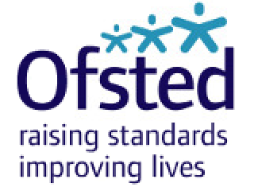

Actions for early years and childcare providers during the coronavirus (COVID-19) outbreak
Page summary:
What childcare services early years settings, childminders and local authorities need to provide during the coronavirus (COVID-19) outbreak.
Change made:
‘Actions for early years and childcare providers during the coronavirus (COVID-19) outbreak’ document updated to correct formatting and links.
Time updated:
1:55pm, 5 March 2021

Guidance for schools: coronavirus (COVID-19)
Page summary:
What school leaders, teachers and school staff need to do during the coronavirus (COVID-19) outbreak.
Change made:
Added ‘Awarding qualifications in summer 2021’ and ‘Quarantine arrangements for boarding school students from red list countries’ to the collection.
Time updated:
2:47pm, 5 March 2021

Ofsted Coronavirus (Covid-19) Rolling Update

Ofsted guidance and information relating to coronavirus (COVID-19) for schools, early years, children's social care and further education and skills providers.

Ofsted has updated the early years and childcare section of its coronavirus (COVID-19) rolling update to inform providers that notifications of confirmed cases of coronavirus (COVID-19) will not prompt a regulatory visit.
Updated: 5 March 2021

Reported Coronavirus (Covid-19) cases by registered early years and childcare settings

Updated: 8 March 2021

Protect yourself from scams
As part of the Budget, the Chancellor today announced a Taxpayer Protection Taskforce to tackle the minority who deliberately claim money they’re not entitled to. If you suspect fraud, please report it using our online form. Go to GOV‌‌.UK and search 'Report fraud to HMRC' for more information.
Stay vigilant about scams, which may mimic government messages as a way of appearing authentic. Search 'scams' on GOV‌.UK for information on how to recognise genuine HMRC contact. You can forward suspicious emails claiming to be from HMRC to phishing@hmrc.gov.uk and texts to 60599.
Access the National Cyber Security Centre’s guide on how to stay secure online and protect yourself and your business against cyber crime Cyber Aware
The Government has launched a consultation on a ‘Protect Duty’ which seeks to improve security and organisational preparedness at a wide range of publicly accessible locations, including education settings in the UK. The consultation will run until 2 July 2021.
The consultation will seek views on:
- who would a Duty apply to?
- what would a proposed Duty require stakeholders to do?
- how should compliance work?
- how would Government support those affected by a Duty?
Anyone in the UK who is linked to education or has an interest in education, such as parents or educators can take part in the consultation here

Funded Early Education
Summer term 2021

The (Headcount) Forecast for Summer 2021 (1/4/2021 to 31/8/2021) will be sent out on Friday 12th March 2021. You will have 2 weeks to complete this. If you have any problems logging in or completing the task, please call Sandra on 01753 875719 or Balli on 01753 476575

Slough Borough Council
Covid-19 Directory of Resources and Support

Slough Borough Council has put together a ‘Covid-19 Directory of Resources and Support for Education Providers in Slough’. This gives information about all the different resources/services across Slough Borough Council who are able to offer support to education providers during Covid-19.

We hope that you will find this a useful resource and please make contact with us via the Directory if we can support you and your school in any way.

Updates for Parents

What parents and carers need to know about early years providers, schools and colleges during COVID-19
Page summary:
Information for parents and carers about attending schools, nurseries and colleges in the spring term 2021.
Change made:
Added information on asymptomatic testing for parents and adults in households with children at school or college.
Time updated:
7:33pm, 5 March 2021
Rt Hon Vicky Ford MP
Parliamentary Under-Secretary of State for Children and Families

Open Letter to parents and carers of children and young people with SEND

Published: 5 March 2021

Slough Family Information Service
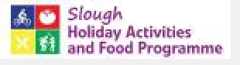
Information on the Slough Holiday and Activities Food Programme can be found here
Slough Special Voices: Newsletter No: 90

Autism and ADHD Support

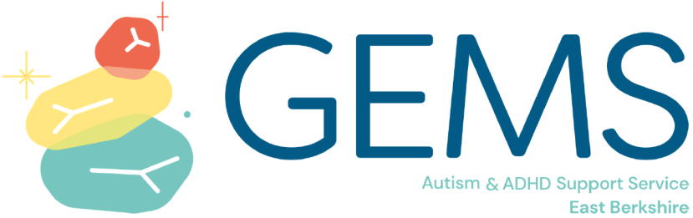

01753 373 244/0800 999 1342

www.gems4health.com

gems.4health@nhs.net
@Gems4Health

GEMS is for children, young people and adults who are diagnosed with, or who may have, autism and/or attention deficit hyperactivity disorder (ADHD). The service also supports parents and carers. Whatever stage of your autism/ADHD journey you are at – pre-assessment or post-diagnosis – GEMS offers a single point of contact where you can access information, advice and support.

