Children and Families, Early Years Division

Weekly News Bulletin: 12 May 2021

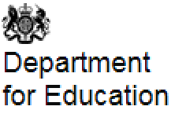

## **Coronavirus (COVID-19) Roadmap – guidance for education settings**

Yesterday, the [Prime Minister announced](https://www.gov.uk/government/speeches/pm-statement-at-coronavirus-press-conference-10-may-2021?utm_source=11%20May%202021%20C19&utm_medium=Daily%20Email%20C19&utm_campaign=DfE%20C19) that the country will move to Step 3 of the roadmap on **Monday 17 May**.

We have updated the following guidance to reflect these changes:

•       [early years and childcare providers](https://www.gov.uk/government/publications/coronavirus-covid-19-early-years-and-childcare-closures?utm_source=11%20May%202021%20C19&utm_medium=Daily%20Email%20C19&utm_campaign=DfE%20C19)

•       [schools guidance](https://www.gov.uk/government/publications/actions-for-schools-during-the-coronavirus-outbreak?utm_source=11%20May%202021%20C19&utm_medium=Daily%20Email%20C19&utm_campaign=DfE%20C19)

•       [special schools and other specialist settings](https://www.gov.uk/government/publications/guidance-for-full-opening-special-schools-and-other-specialist-settings?utm_source=11%20May%202021%20C19&utm_medium=Daily%20Email%20C19&utm_campaign=DfE%20C19)

•       [protective measures for holiday or after-school clubs and other out-of-school settings](https://www.gov.uk/government/publications/protective-measures-for-holiday-or-after-school-clubs-and-other-out-of-school-settings-for-children-during-the-coronavirus-covid-19-outbreak?utm_source=11%20May%202021%20C19&utm_medium=Daily%20Email%20C19&utm_campaign=DfE%20C19)

Please see the [guidance on the COVID-19 response – Spring 2021 (Roadmap)](https://www.gov.uk/government/publications/covid-19-response-spring-2021?utm_source=11%20May%202021%20C19&utm_medium=Daily%20Email%20C19&utm_campaign=DfE%20C19) for additional information.

## **Update to face coverings in education settings guidance**

As part of the government’s move to Step 3 of the roadmap, from **Monday 17 May**, new advice applies to the use of face coverings by staff, pupils and students in schools and further education in England. Our [guidance on face coverings](https://assets.publishing.service.gov.uk/government/uploads/system/uploads/attachment_data/file/984846/FINAL_Face_coverings_in_education_guidance.pdf) has been updated to reflect these changes.

**Reception Baseline Assessment (RBA)**

**For the attention of all headteachers, assessment leads and reception staff in maintained primary schools, free schools and academies.**

The [Reception Baseline Assessment (RBA)](https://www.us17.list-manage.com/track/click?u=8088a92c9c7454749d4a06114&id=08f8c1f384&e=5758bf6326) will be statutory in schools from **September 2021**. The RBA provides a snapshot of where pupils are when they arrive at school. It will provide a starting point to measure the progress schools make with their pupils between reception and the end of primary school. This will allow the department to take better account of the variations schools will experience in pupils’ starting points. This is especially important in 2021, when COVID-19 will have affected children’s lives in very different ways.  
   
Pupils will complete practical tasks using physical resources, and practitioners will log their responses using an online platform. Pilot analysis showed that pupils took an average of just over 14 minutes to complete the tasks. Schools will receive narrative statements describing what each pupil was able to do.  
   
We have published the [assessment and reporting arrangements](https://www.us17.list-manage.com/track/click?u=8088a92c9c7454749d4a06114&id=d1085ac79a&e=5758bf6326) to be used by headteachers and schools.  
   
On **Monday 17 May**, headteachers will receive a short online form to fill out. This form will capture key information about the school, and will allow headteachers to nominate an RBA lead to oversee the day-to-day running of the assessment.  
   
Assessment resources will be delivered to schools from **Tuesday 8 June.**   
For general enquiries about the administration of the RBA, please **phone 0330 088 4171 or email** [**receptionbaseline@nfer.ac.uk**](mailto:receptionbaseline@nfer.ac.uk)**.**

There also specific information in the new [Statutory framework for the early years foundation stage](https://assets.publishing.service.gov.uk/government/uploads/system/uploads/attachment_data/file/974907/EYFS_framework_-_March_2021.pdf)   p19 and Annex B p44 – 52 that schools, including headteachers and assessment leads must be aware of in preparation for this statutory assessment requirement.

***Further information about the RBA will be included in our EY Assessment and Moderation Meeting taking place on Thursday 20th May 4 – 5pm. Please see the link for further details for making a booking for this event.***

[**Youtube Video Reception Baseline Assessment (RBA)**](https://m.youtube.com/watch?fbclid=IwAR1ZO4rPeKrbpCDkUxqKHy4hP3ONNKnfL0rwgOGjWSjbD_RnXZ8S2HvZCQ0&v=qlJFl8NJwe8&feature=youtu.be)

[**Reception baseline assessment: equality impact assessment**](https://assets.publishing.service.gov.uk/government/uploads/system/uploads/attachment_data/file/983894/Reception_Baseline_Assessment_Equality_Impact_Assessment.pdf)

The Department for Education has conducted an equality impact assessment of the reception baseline assessment (RBA) which provides an assessment of the potential impact of the RBA on pupils with protected characteristics. It is published for the information of all interested parties.

**Published 6 May 2021**

**Ordering testing kits for private, voluntary and independent (PVI) nurseries**

The test kit supply process for PVI nurseries has now changed. We have introduced a new online system for ordering test kits for testing at home. You are now able to regularly re-order test kits and better manage stock levels and deliveries to your nursery.

Your Unique Organisation Number (UON) is needed to place orders for test kits, using the new online ordering system. You should have received a separate welcome email containing your UON. You can also find your UON using the [unique organisation number lookup form](https://organisation-number-lookup.test-for-coronavirus.service.gov.uk/). In order to use the UON lookup website, please enter your URN in the organisation ID field. If your URN is not prefixed with EY (for example EY123456), please add YE as a prefix to your URN (for example YE123456).

If you operate more than one nursery, you will receive a UON for each nursery. This will allow you to order test kits for each individual nursery.

Where an individual nursery is registered with Ofsted with more than one URN, you may also receive more than one UON. In this scenario, nurseries are advised to use the UON associated with their most recently registered URN.

In the unlikely event that you have a significant stock of self-test kits, you do have the option to reject your next delivery. After this you will need to use the new ordering system to place an order to receive further test kits.

You can order your test kit supplies using the [order coronavirus (COVID-19) tests for your organisation online form](https://request-testing.test-for-coronavirus.service.gov.uk/). For further information on how to place an order, please refer to the ordering guidance available on the [primary schools and nurseries document sharing platform](https://drive.google.com/drive/u/0/folders/1X4fLxy6_ppmpmKrv3hT2M6cduAN_GS54).

## **Summer Schools webinar and extended sign-up window**

The Summer Schools team is running an information session to tell you more about the 2021 summer schools programme and to answer any questions, **on Wednesday 12 May at 4pm** for one hour. Schools can [join the webinar here](https://teams.microsoft.com/l/meetup-join/19%3ameeting_YjVlYzIxZmUtN2I0ZC00OTI1LThkMDYtYTg0ZDVmOGRkZTMx%40thread.v2/0?context=%7b%22Tid%22%3a%22fad277c9-c60a-4da1-b5f3-b3b8b34a82f9%22%2c%22Oid%22%3a%22077ced02-08d4-4e99-be45-b6c9c10aac49%22%2c%22IsBroadcastMeeting%22%3atrue%7d&btype=a&role=a).

Some schools have asked if they can still sign up to the programme and we are therefore keeping sign-up open. The form will remain in place **until Friday 28 May**.

Schools can access their [funding allocation](https://www.gov.uk/government/publications/coronavirus-covid-19-summer-schools-programme-funding?utm_source=11%20May%202021%20C19&utm_medium=Daily%20Email%20C19&utm_campaign=DfE%20C19) before [signing up for the programme](https://form.education.gov.uk/service/summer-schools-programme) to indicate they intend to run a summer school. The process takes no more than a couple of minutes.

Further information is available in our [guidance on summer schools](https://www.gov.uk/government/publications/summer-schools-programme?utm_source=11%20May%202021%20C19&utm_medium=Daily%20Email%20C19&utm_campaign=DfE%20C19) – please contact the team at [Learning.RECOVERY@education.gov.uk](mailto:Learning.RECOVERY@education.gov.uk) if you have any questions.

## [**Attendance in education and early years settings during the coronavirus (COVID-19) outbreak: 23 March 2020 to 29 April 2021**](https://explore-education-statistics.service.gov.uk/find-statistics/attendance-in-education-and-early-years-settings-during-the-coronavirus-covid-19-outbreak/2021-week-18)

Between March 2020 and the end of the summer term, early years settings, schools and colleges were asked to limit attendance to reduce transmission of coronavirus (COVID-19). From the beginning of the autumn term schools were asked to welcome back all pupils to school full-time. From 5 January 2021, schools were asked to provide on-site education for vulnerable children and children of critical workers only.

The data on explore education statistics shows attendance in education settings since Monday 23 March 2020, and in early years settings since Thursday 16 April 2020. The summary explains the responses for a set time frame. [Explore Education Statistics](https://explore-education-statistics.service.gov.uk/find-statistics/attendance-in-education-and-early-years-settings-during-the-coronavirus-covid-19-outbreak/2021-week-18)

The data is collected from a daily education settings status form and a weekly local authority early years survey.

Previously published data and summaries are available at [attendance in education and early years settings during the coronavirus (COVID-19) outbreak](https://www.gov.uk/government/collections/attendance-in-education-and-early-years-settings-during-the-coronavirus-covid-19-outbreak).

**Published 5 May 2021**

[**Find a free level 3 qualification**](https://www.gov.uk/government/publications/find-a-free-level-3-qualification)

## Details of free level 3 qualifications available to eligible adults and the colleges and training providers who are currently able to offer free places.

**Updated**: 10 May 2021

[**Actions for early years and childcare providers during the coronavirus (Covid-19) outbreak**](https://www.gov.uk/government/publications/coronavirus-covid-19-early-years-and-childcare-closures)

**Page summary:**  
What childcare services early years settings, childminders and local authorities need to provide during the coronavirus (COVID-19) outbreak.

**Change made:**  
The guidance has been updated to reflect step 3 of the roadmap out of lockdown. Information has been included on staff wellbeing, clinically extremely vulnerable, safe removal of face coverings, attending more than one setting, visits to setting by external professionals, parent and child groups, organised performances, trips, childminders meeting other childminders.

**Time updated:**  
7:57pm, 10 May 2021

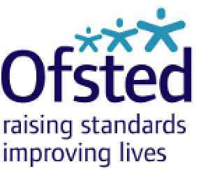

## [**Consented addresses for childminders and domestic childcare**](https://www.gov.uk/government/publications/consented-addresses-for-childminders-and-domestic-childcare?utm_medium=email&utm_campaign=govuk-notifications&utm_source=2fd97755-0e00-4228-9050-a3ca225223a0&utm_content=daily)

**Page summary**:  
This report details the names and addresses for childminders and childcare on domestic premises, where the provider has consented for their name and address to be published on the Ofsted inspection report website.

**Change made**:  
Updated consented addresses for childminders and domestic childcare as at 31 March 2021.

**Time updated**:  
9:30am, 7 May 2021

## [**Joiners and leavers in the childcare sector**](https://www.gov.uk/government/publications/joiners-and-leavers-in-the-childcare-sector?utm_medium=email&utm_campaign=govuk-notifications&utm_source=023e7a91-1f1b-4f59-9f83-21c7cd6ee40d&utm_content=daily)

**Page summary**:  
Management information aggregating monthly joiners and leavers on our registers. A time-series of joiners and leavers includes data since April 2020.

**Change made**:  
Published data on joiners and leavers in the childcare sector in March 2021

**Time updated**:  
9:30am, 7 May 2021

## [**Area SEND inspections and outcomes in England as at 31 March 2021**](https://www.gov.uk/government/statistics/area-send-inspections-and-outcomes-in-england-as-at-31-march-2021?utm_medium=email&utm_campaign=govuk-notifications&utm_source=756c70cb-db34-47c7-9796-b5853bc10372&utm_content=daily)

**Page summary**:  
Official statistics on inspections and outcomes of area SEND (special educational needs and disabilities) as at 31 March 2021.

**Change made**:  
First published.

**Time updated**:  
9:30am, 7 May 2021

[**Publication of statistics on childcare providers and inspections: report on the responses to the consultation**](https://www.gov.uk/government/consultations/publication-of-statistics-on-childcare-providers-and-inspections/outcome/publication-of-statistics-on-childcare-providers-and-inspections-report-on-the-responses-to-the-consultation)

This is a report on the outcomes of the consultation on the proposals for changes to our [statistical release on childcare providers and inspections](https://www.gov.uk/government/collections/early-years-and-childcare-statistics#official-statistics).

In summary we will:

* reduce the frequency of our official statistics from 3 times per year to twice per year.
* introduce new management information as outlined in the [proposal](https://www.gov.uk/government/consultations/publication-of-statistics-on-childcare-providers-and-inspections/publication-of-statistics-on-childcare-providers-and-inspections#proposal-2-providing-management-information). We will also look to adapt the data to include additional information where possible.
* apply the proposed changes to the data tables to provide a more detailed picture of the childcare sector. We will also incorporate additional fields into the tables where possible.

**Updated**: 11 May 2021

[**Ofsted: coronavirus (COVID-19) rolling update**](https://www.gov.uk/guidance/ofsted-coronavirus-covid-19-rolling-update)

Ofsted guidance and information relating to coronavirus (COVID-19) for schools, early years, children’s social care and further education and skills providers.

**Updated**: 7 May 2021

[**Guidance on writing complaint and compliance action outcome summaries**](https://www.gov.uk/guidance/guidance-on-writing-complaint-and-compliance-action-outcome-summaries#introduction)

Guidance for inspectors when writing outcome summaries. We publish these summaries when we or the setting need to take action.

**Updated**: 6 April 2021

**Updates for Parents**



## [**Local area SEND inspections: information for families**](https://www.gov.uk/government/publications/local-area-send-inspections-information-for-families?utm_medium=email&utm_campaign=govuk-notifications&utm_source=a559e0ed-b730-42dd-b954-f2d0133c1687&utm_content=daily)

**Page summary**:  
Information for families about inspections of local area services for children and young people with special educational needs and/or disabilities (SEND).

**Change made**:  
Added visit dates and webinar links for Northumberland County Council.

**Updated**:  
11 May 2021

**Disclosure and Barring Service**

The Disclosure and Barring Service (DBS) is running a campaign to raise awareness of job scams and employment fraud among job seekers. DBS is working alongside [JobsAware](https://www.jobsaware.co.uk/), a non-profit organisation, with cross-government support, that informs people of how to avoid job scams and unfair working practices, and supports job seekers with suspected fraud, malpractice and other poor experiences.

Job scams are extremely prevalent in the current job market. During the pandemic, almost three in four job seekers (74%) applied for jobs that were not genuine.

Lack of awareness and education surrounding employment fraud is one of the reasons that job seekers fall victim to these scams - it’s important that job seekers are equipped with the relevant knowledge, enabling them to identify potentially fraudulent job adverts.

Information provided through fraudulent job adverts can be used in a number of ways by criminals, including identity theft.

Chair of [JobsAware](https://www.jobsaware.co.uk/) - previously known as SAFERjobs - Keith Rosser, says:

*“With the way we work and look for work continuing to evolve, job scams are becoming increasingly common and sophisticated. We know how damaging it can be to fall victim to such scams now more than ever”.*

**Job scams: spotting the signs**

Common signs to look out for, when applying for a job.

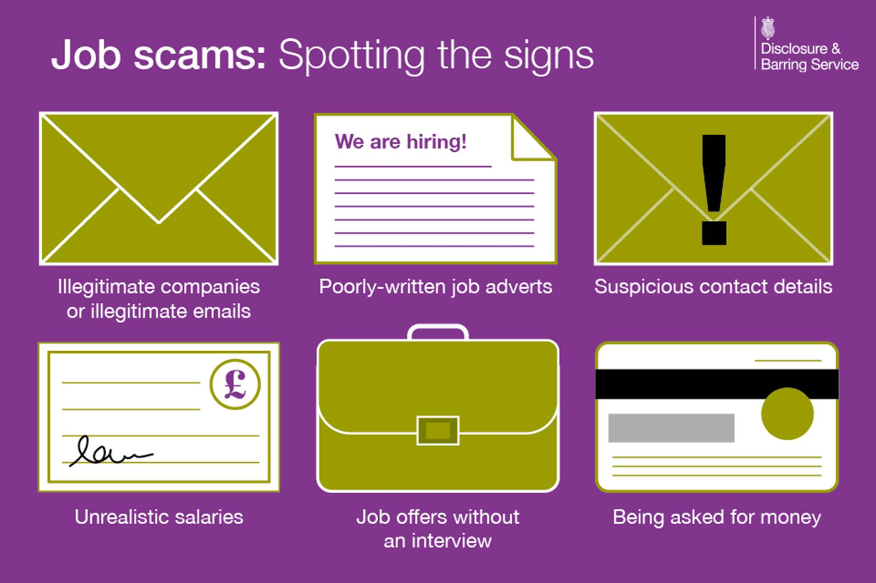

Executive Director of Barring and Safeguarding at DBS, Dr Suzanne Smith, says:

*“The exploitation of job seekers has risen during the pandemic and the methods being used are more and more sophisticated. We know that some companies have taken money for DBS checks from unsuspecting job seekers, relieved that they have been promised a job but the DBS check never arrives and the job was never real. The negative impact on the person on the other end of these scams is significant – we are working alongside JobsAware to help prevent this from happening by raising awareness and signposting those affected to where they can get help”.*

**Case study one:**

Amanda Paremain, 55, a job seeker from Birmingham, applied to a fake job advert on a popular jobs board website claiming to be from a holiday company. Despite not being asked to undertake an interview, she was offered the role, and then directed to a fake website to make a payment for a supposed DBS check. Before making the payment, Amanda made online checks, and found that others had been scammed by the same outfit.

**Case study two:**

Sami Ayubi, a 44-year old carer from Exeter, was offered a customer service role with a business that claimed to be a social network for footballers. After accepting the position, he was pressured to carry out an “expedited DBS check”. He was directed to a fake website for to make a “specially reduced” £15.99 payment and realised it was fraudulent. Sami has since discovered that many others have unfortunately fallen for the same scam.

Full versions of these case studies can be found here: [Case studies](https://assets.publishing.service.gov.uk/government/uploads/system/uploads/attachment_data/file/984423/Job_scams_-_case_studies.odt) (ODT, 9.56KB)

**What to do if you think you have fallen victim to a job scam**

If you suspect you have been targeted, been the victim of a job scam, or have been treated unfairly, please report the company and website to JobsAware [via their portal](https://www.jobsaware.co.uk/) and they will investigate and take further action if necessary.

If you have parted with money as part of a suspected job scam, please contact the police and they will take the matter further.

**Further information**

For more details on the campaign, or to speak to Dr Suzanne Smith of DBS, or Keith Rosser of JobsAware, please use the details below.

·       Dr Suzanne Smith: [DBSmedia@dbs.gov.uk](mailto:DBSmedia@dbs.gov.uk)

·       Keith Rosser: [Keith.Rosser@reed.com](mailto:Keith.Rosser@reed.com)

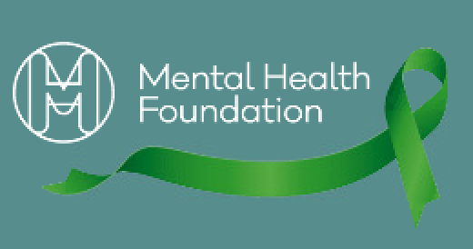

**Mental Health Awareness Week**

Mental Health Awareness Week takes place on **10-16 May 2021** and this year's theme is nature.

[Mental Health Awareness Week](https://www.mentalhealth.org.uk/campaigns/mental-health-awareness-week) is an annual event when there is an opportunity for the whole of the UK to focus on achieving good mental health. The Mental Health Foundation started the event 21 years ago. Each year the Foundation continues to set the theme, organise and host the Week. The event has grown to become one of the biggest awareness weeks across the UK and globally.

Mental Health Awareness Week is open to everyone. It is all about starting conversations about mental health and the things in our daily lives that can affect it. This year we want as many people as possible – individuals, communities and governments – to think about connecting with nature and how nature can improve our mental health.

However, the Week is also a chance to talk about any aspect of mental health that people want to – regardless of the theme