Children and Families, Early Years Division
Weekly News Bulletin: 26 May 2021

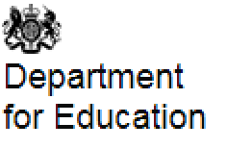

Test kit ordering weekly deadline change
The weekly deadline for placing orders for further lateral flow device (LFD) test kits is changing from 5pm on Wednesdays to 5pm on Tuesdays.
Orders placed before 5pm on Tuesdays will arrive the following week. Any orders placed after this time will be processed and delivered in the subsequent week. For guidance on how to place an order for further test kits, please refer to the document sharing platform for primary schools and nurseries . Please ensure that your stock covers a minimum of two weeks of testing at the time of placing an order.
Delivery schedules for the week commencing Monday 24 May are now available on the document sharing platforms. Please check the published delivery schedule prior to contacting the helpline in relation to expected timescales for receipt of deliveries. Please wait for 48 hours after a scheduled delivery date before contacting the helpline.

COVID-19 testing over May half-term
As lockdown eases, taking a rapid COVID-19 test twice a week, even if you do not have symptoms, will help us stay ahead of the spread of the virus, particularly as new strains appear. Around 1 in 3 people with COVID-19 have no symptoms and are spreading the virus without knowing. This includes those who have had their vaccine.
We want to thank you for your continued support in testing. Over 40 million tests with staff and students have now been conducted as part of the education testing programme.
Please continue to encourage your staff to test twice-weekly over half-term and test before returning to school after the holiday.
The result of a rapid test could be positive, negative or even void. But whatever it is, it should be reported straight away, every time. Recording all test results helps scientists stay ahead of the virus by spotting new outbreaks quickly and advising how to respond.
Reporting results is easy. Go to report a COVID-19 lateral flow test result or call 119 free from a mobile or landline. Lines are open every day, 7am to 11pm. Support is offered in 200 languages as well as British Sign Language and Live Video Assistance.

Covid Local Support Grant (previously Covid Winter Grant Scheme)

The DfE has once again topped up this grant to cover the May half term which is why we are approaching you now.

Every qualifying child will be eligible for a £15 payment, and we need your help to ensure that the children and their families in PVI and childminder settings are able to receive this.
Children qualifying for this grant in PVI and childminder settings are
- those in receipt of Early Years Pupil Premium
- those in receipt of 2 year old funding

If you need to check the qualifying children in your setting, please email Eyfunding@slough.gov.uk where our staff will be happy to help. Alternatively. Please contact Sandra Andrews on 07749 709909 or Balli Grewal on 07523 933028.

We would like you to provide vouchers (we suggest supermarket vouchers) in the sum of £15 to each of these children, and we propose to cover the costs of these in advance through a BACS transfer directly into your bank account

COVID-19 guidance now published in HTML
We have converted the following pieces of guidance from PDF to HTML format, making them more accessible and easier to navigate and read. We have not made any changes to the content of the guidance since they were last updated.
- Face coverings in education
- Contingency framework: education and childcare settings
- Actions for early years and childcare providers during the COVID-19 pandemic
- Schools COVID-19 operational guidance
- SEND and specialist settings – additional operational guidance
- Protective measures for holiday and after school clubs, and other out-of-school settings during the COVID-19 pandemic
- Guidance for parents and carers of children attending out-of-school settings during the COVID-19 pandemic

Attendance in education and early years settings during the coronavirus (COVID-19) outbreak: 23 March 2020 to 20 May 2021

A summary of attendance in education settings from Monday 23 March 2020 to Thursday 20 May 2021 and early years settings from Thursday 16 April 2020 to 13 May 2021, excluding out of term dates as data is not collected

Published: 25th May 2021

Department for Education COVID-19 helpline
The Department for Education COVID-19 helpline and the PHE Advice Service (option 1) is available to answer any questions you have about COVID-19 relating to education settings and children’s social care.
Phone: 0800 046 8687
Opening hours:
Monday to Friday from 8am to 6pm
Saturday and Sunday from 10am to 6pm
Bank holiday opening hours:
Monday 31 May from 10am to 4pm

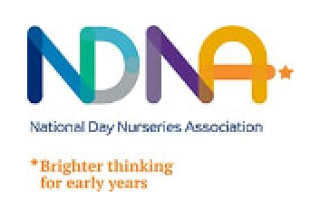
Maths Champions

The Maths Champions programme is part of an evaluation study funded by the EEF and DfE. The new and improved programme is currently under pilot testing and a full trial and evaluation of the programme will be starting in September 2021. We are recruiting 138 settings from PVI, maintained or school based early years provision who, if eligible, will take part in the study on a first come first served basis.

The link here will give providers an overview of the programme and what is involved as well as the eligibility criteria. Settings interested in taking part can complete the expression of interest form here.

We will also be running a drop in information session on June 17th at 4pm on Zoom for anyone who wishes to find out more and there will be a last opportunity to apply should any places remain.

For any further information, to ask questions, or to book onto the information session please email MCstudy@ndna.org.uk

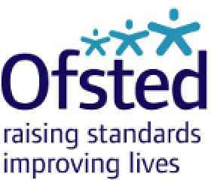

Nearly 9 out of 10 parents say their child’s school handled COVID-19 well
A large majority of parents (87%) think that their child’s school has handled the pandemic well, according to Ofsted’s annual Parents Survey for 2021, published today
This year’s survey asked a set of questions about the impact of COVID-19, and also found that 7 in 10 parents had received guidance or training from their child’s school to help support remote education at home.
However, around two thirds of parents reported that they were worried about their child’s learning loss and their mental health, while nearly half were concerned over their children’s physical health.
Over 1,000 parents with children at preschool, school and colleges in England participated in this year’s online survey. This is the sixth year the research has been conducted and it continues to provide important evidence to inform the development of Ofsted’s priorities.
Her Majesty’s Chief Inspector, Amanda Spielman said:
“This survey highlights just how much parents appreciate the huge effort and creativity schools have shown to help them educate their children at home.
Of course, there was only so much children were able to learn while schools were closed for lockdown, so it’s not surprising that so many parents are concerned about the impact of the pandemic on their child’s education, as well as their mental and physical wellbeing. Our visits and inspections have also reflected these concerns.
But now children are back in the classroom, I know teachers across the country will be doing all they can to bring them up to speed and help them to flourish”.
Among other findings, of those parents who had read an Ofsted inspection report, over 8 in 10 said they found the report useful, while the same number said they felt the report portrayed an accurate picture of the school or childcare provider.
The survey also reports that 7 out of 10 parents agree that Ofsted is a valuable source of information about education. Likewise, two thirds of parents agree that Ofsted’s work helps to improve standards of education. These results have remained relatively unchanged over the last 5 years.

Ofsted: coronavirus (COVID-19) rolling update
Ofsted guidance and information relating to coronavirus (COVID-19) for schools, early years, children’s social care and further education and skills providers
Updated : 7 May 2021

Slough Children First

There is a new LADO referral form to complete when making a referral to the LADO

Referral criteria
An allegation has been made that a person who works with children in a paid or voluntary capacity has:
- Behaved in a way that has harmed or may have harmed a child
- Possibly committed a criminal offence against children or related to a child
- Behaved towards a child or children in a way that indicates he or she would pose a risk of harm if they work regularly or closely with children

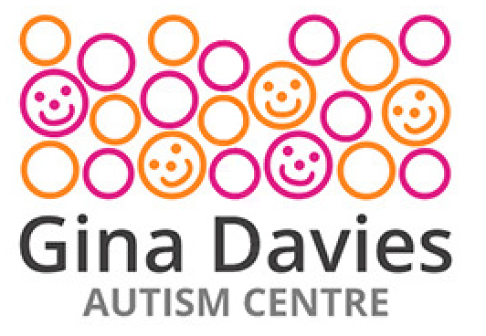

Attention Autism
Online Training
Gina Davies Autism Centre Training

This training is made up of 6 online sessions
This course equips attendees with the skills to set up and run the 6 Stage Attention Autism programme.

The training focuses on the practical aspects of intervention, working in a team and offering an irresistible invitation to learn. The Attention Autism programme targets the teaching of attention, communication and social interaction skills. Training is run applying the principles of the attention autism programme throughout each day. There are demonstrations of the techniques in action, films of the work with children, practical hands-on experience for participants and ideas for activities. The intention is to share the practical skills needed for participants to feel confident in setting up and running the intervention immediately.

Appropriate for Early Years Practitioners level 2 & 3, Early years assistants and practitioners supporting children on a 1:1 basis

Session 1 Monday 7th June, 6:30pm – 7:45pm Session 2 Monday 14th June, 6:30pm – 7:45pm
Session 3 Monday 21stJune, 6:30pm – 7:45pm Session 4 Monday 28th June, 6:30pm – 7:45pm
Session 5 Monday 5th July, 6:30pm – 7:45pm Session 6 Monday 12th July, 6:30pm – 7:45pm

Cost: £32.00 per place - This training is being highly subsidised by the inclusion grant

To book: https://thelink.slough.gov.uk/events/early-years-attention-autism-training-0

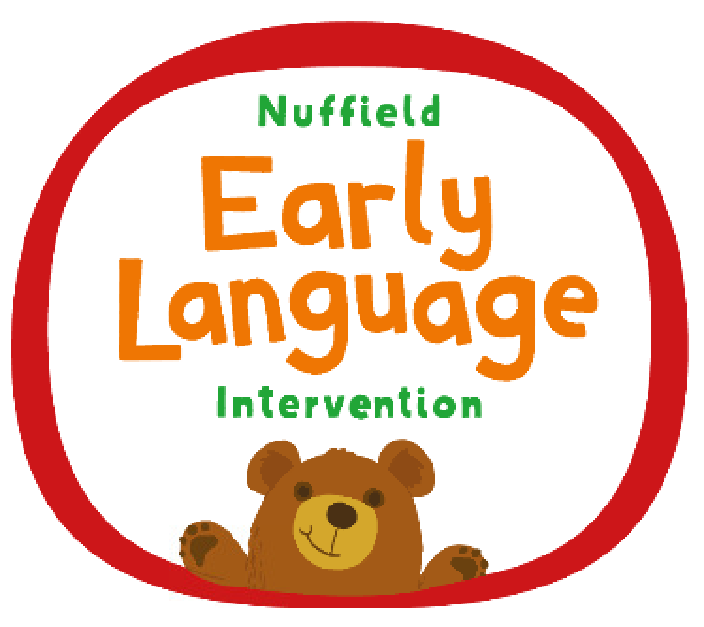

Nuffield Early Language Intervention - NELI

What is the Nuffield Early Language Intervention?
The Nuffield Early Language Intervention is a 20-week programme proven to help young children overcome language difficulties. It is designed for children aged 4-5 years and combines small group work with one-to-one sessions delivered by trained teaching assistants, targeting vocabulary, narrative skills, active listening and phonological awareness.

Schools can find out more information and complete their registration to receive NELI here. Places on the programme are limited and registration is offered on a first come first served basis

Training Offers from National Children’s Bureau

Listening to the Voices of Young Children Training
Pay per place, live, on line training, for all those working with young children who want to find out how to listen more effectively
- 2 half day sessions – Tuesday 15th June and Tuesday 22nd June from 9.30 – 12.15 , you need to attend both to complete the course
- This course explores why we listen to young children, how they communicate their views, wishes and feelings, and how to embed this essential skill in your everyday practice
- Introductory price of £99.00 for two half day sessions

Book via eventbrite
Tuesday 15th June to book and pay for your place at both sessions: https://www.eventbrite.co.uk/e/listening-to-the-voices-of-young-children-tickets-154575664975

Making it REAL Training
Pay per place, live, on line training that will equip practitioners to support parents so they can help their children’s early reading and writing and create a positive home learning environment.
- A one day training, Wednesday 23rd June from 10.00 – 4.00
- Includes practical ways you can support children and families across fours strands of literacy (environmental print, songs and rhymes, books and mark making) and the ORIM framework (Opportunities, recognition, interaction and model)
- The cost of this training is £149.00

Book via Eventbrite
Wednesday 23rd June 10.00 – 4.00 : https://www.eventbrite.co.uk/e/making-it-real-one-day-training-tickets-154550479645

Updates for Parents

Annual parents survey
Page summary:
Findings from online surveys on parents’ awareness and perceptions of Ofsted. Surveys conducted by YouGov on behalf of Ofsted.
Change made:
Published the Ofsted annual parents’ survey for 2021.
Time updated:
12:00pm, 20 May 2021

COVID-19 guidance now published in HTML
We have converted the following pieces of guidance from PDF to HTML format, making them more accessible and easier to navigate and read. We have not made any changes to the content of the guidance since they were last updated.
- Guidance for parents and carers of children attending out-of-school settings during the COVID-19 pandemic

Mental Health Awareness

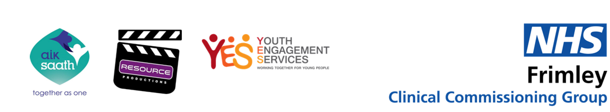

1 in 6 young people aged 5 to 16 will suffer from poor mental health – it can affect anyone, but many young people feel they need to pretend nothing is wrong. If you are a parent, normalise it and visit https://yesslough.org.uk/mental-health-and-wellbeing/ to find sources of support

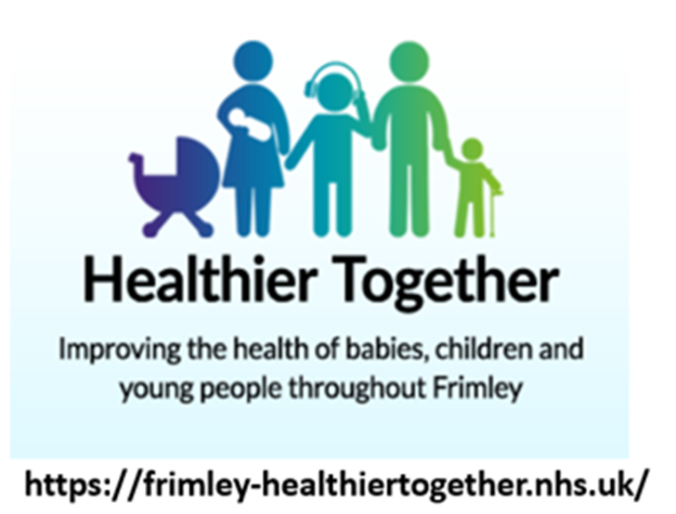

Healthier together

A new site has been launched by the Frimley health team. It is called Healthier Together and provides guidance for parents, carers and professionals….

It includes the following information:

- Clear traffic light system for illness advice – 0-18 years
- find help with day-to-day queries such as pregnancy, feeding, sleep and development
- topics from COVID to mental health and emotional well-being.
- Local services available in Berkshire, Bucks, Hampshire and Surrey.

