Autumn 2021 Assessment and moderation newsletter

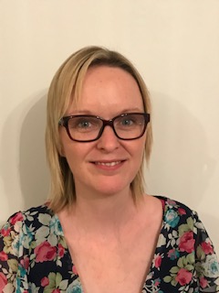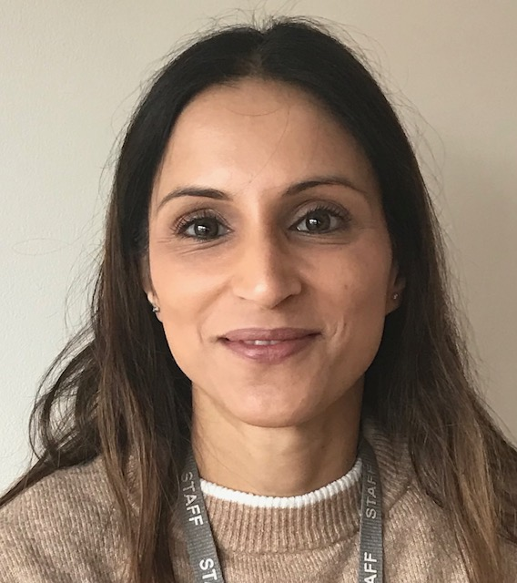
Jamie Debbie Ravinder

Welcome to this academic year. We are all hoping this year will bring some semblance of normality back to education, but who knows?

We would like to welcome someone else joining our team this year. Her name is Ravinder Sidhu. She will be shadowing Jamie this year so that if all goes well for her and SBC she may be able to take the mantle of Key stage 2 lead for assessment and moderation.

Recruitment of moderators for both Key stage 1 and 2

As several of our external moderators have moved on to pastures new we need more. We wish the previous moderators every success in their new roles and now need to recruit more.

We have had a lot of interest by teachers who wish to become moderators but still need more at KS1 and KS2. Thank you for your interest. There will be training for those who wish to become moderators in the spring term. As in previous years, potential moderators will need to successfully complete the standardisation exercise to become a moderator.

Below is the timetable of events. We will have dates locally for people to attend the training and complete the standardisation exercise. We will give exact dates and venues in due course.
There will also be training for teachers, new to Year 2 and Year 6. This training also serves as a refreshers for those who are more experienced with these year groups.

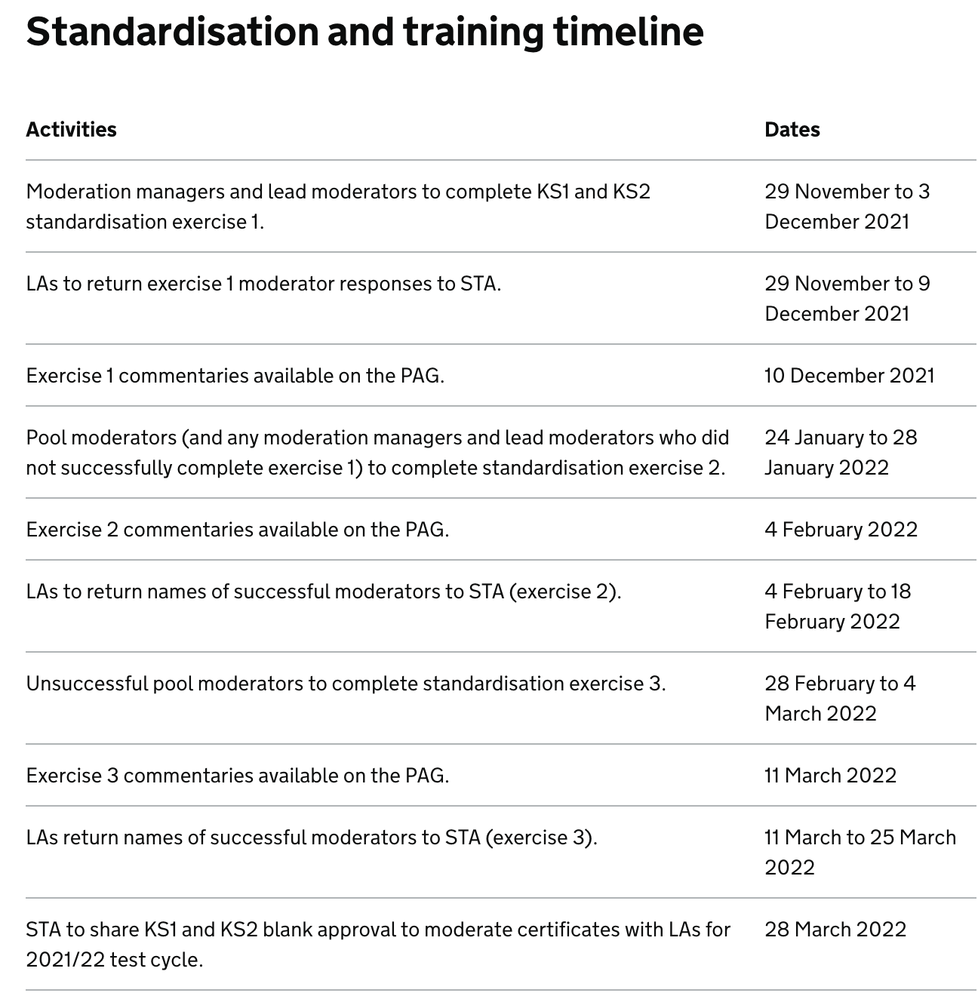

Academies, free schools and independent schools
Each key stage is moderated annually (excluding 2020 and 2021). We are required to moderate at least 25% of maintained schools and 25% of academies and participating independent schools, that have opted into the LA’s external moderation process.

With that in mind there are some dates to consider over the next half term.

December
Friday 10 December: Deadline for participating independent schools to:
Report to STA, on the Primary Assessment Gateway, that they have a written agreement in place with an LA to monitor their KS2 tests (and complete external moderation of KS1 and KS2 teacher assessment, if submitting)

Assessment and reporting arrangements

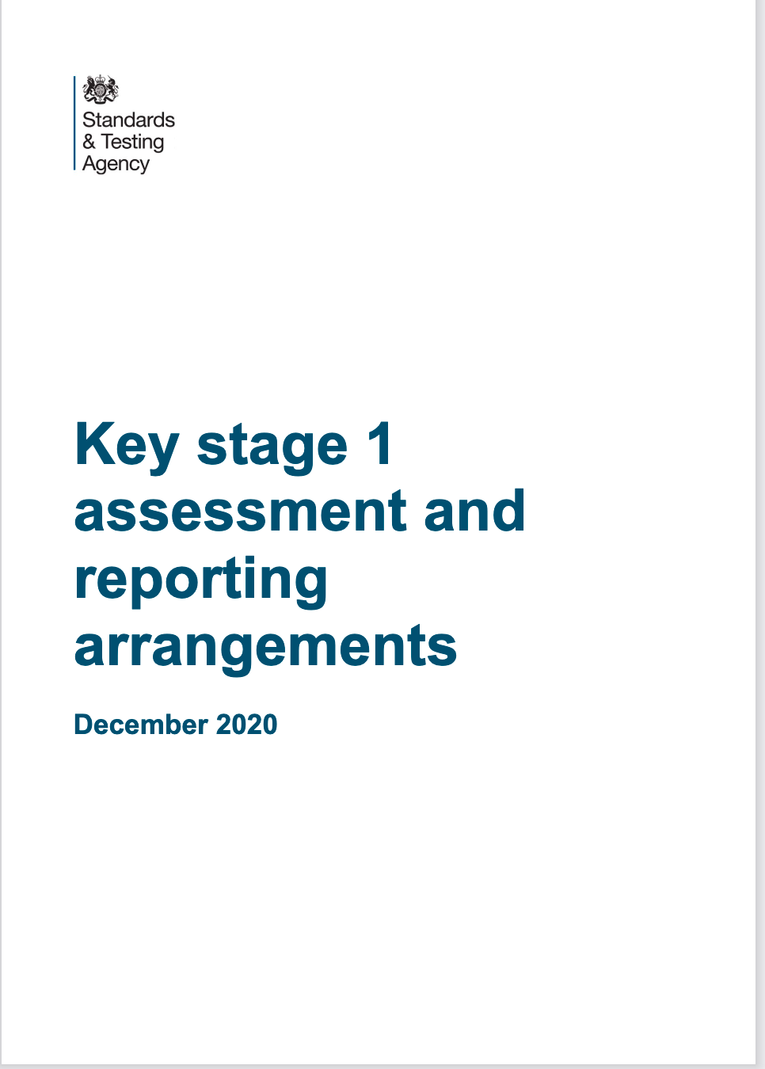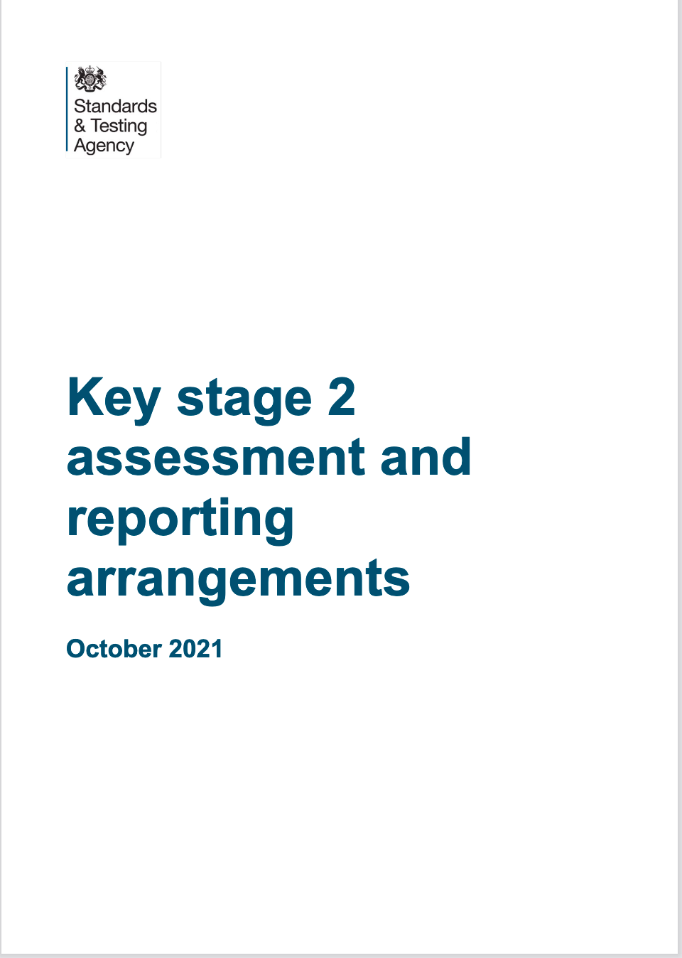
Assessment and reporting arrangements have been issued for both key stage 1 and 2.

They are available at:
https://www.gov.uk/government/publications/2022-key-stage-1-assessment-and-reporting-arrangements-ara

https://www.gov.uk/government/publications/2022-key-stage-2-assessment-and-reporting-arrangements-ara

Phonics Guidance

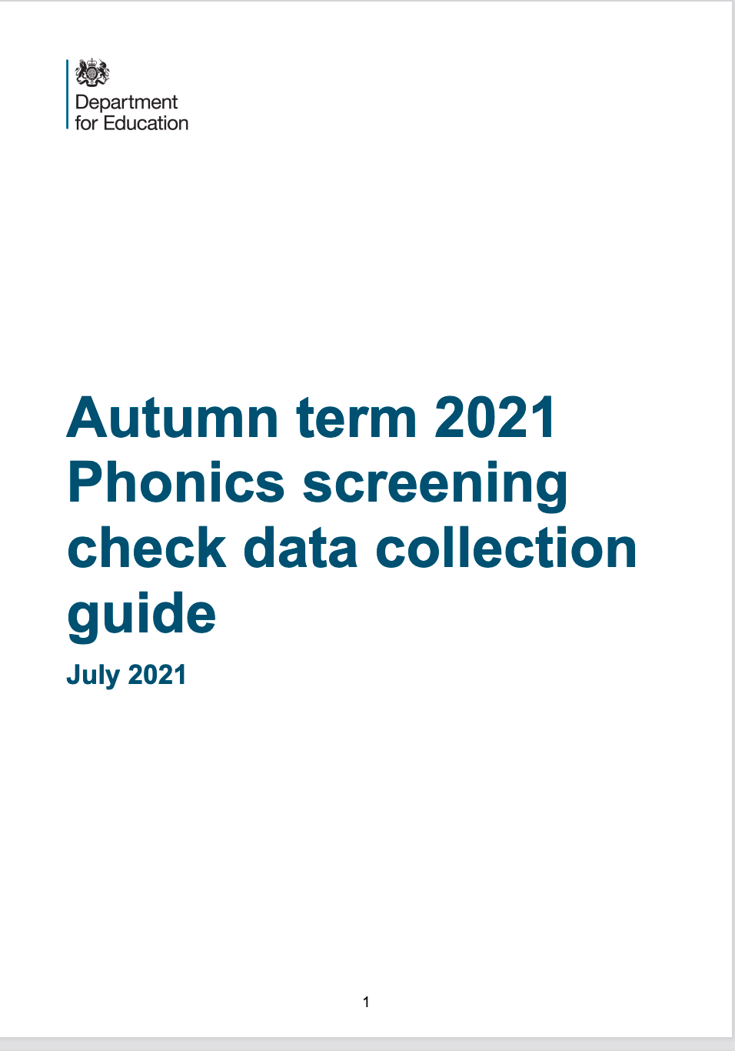

. Phonics screening check for year 2 pupils
Cancellation of the phonics screening check in June 2021 means that year 2 pupils did not take the check when they were in year 1. In the 2021/22 academic year, schools must administer a past version of the phonics screening check (from 2017, 2018 or 2019) to year 2 pupils during the second half of the 2021 autumn term and return results to their geographical LA by December 14th 2021.
Year 2 pupils who achieve the expected standard in the autumn 2021 check will not be required to complete any further statutory assessments in phonics. Year 2 pupils who do not meet the expected standard in the autumn 2021 check will be expected to take the statutory check in June 2022.
STA has published full guidance for schools on administering the check to year 2 pupils.
Administration period:
Schools have flexibility to decide when they administer the check within the second half of the 2021 autumn term. Where possible, schools are encouraged to administer the check at the beginning of the second half of the autumn term. This leaves the final weeks before Christmas to administer the check to any pupils who were absent.
If you would like more information about the Phonic Screening Check please read the information provided by the STA called, Administering the phonics screening check to year 2 pupils in the 2021 autumn term.

Training for moderators
There will be moderator training in the new calendar year in January.
There is separate training for Key stage 1 and Key stage 2 and they will be at different venues.
Debbie will lead Key stage 1 training
Jamie and Ravinder will lead Key stage 2 training.
The courses will be on Eventbrite in due course. So those who have informed use they would like to be a moderator this year and have had permission from their headteacher, please look out for them.
At the end of the training day, the standardisation exercise will need to be completed.

If you or someone in your team is interested in becoming a KS1 moderator there is still time to apply. To express interest candidates should;
- be qualified teachers with recent experience of teaching in Y2 (KS1) or Y6 (KS2)
- have recent experience of being a moderator or being moderated
- be available to attend moderation training and briefings - usually held as twilights
- be available to moderate in other schools on 3-4 dates in June 2022 - reasonable travel and supply costs can be claimed to cover this.
- have the support of their headteacher to take this role.
- pass the standardisation exercise

Date: 25th January 2022
Audience: For experienced Year 2 and Key stage 1 teachers.
An opportunity, for teachers to become moderators to support the LA with the verification of standards when schools are to be moderated this year
Lunch and refreshments available.
The training is face to face. The school has a mask wearing policy in place. There will be sufficient space in the room provided to socially distance.
Time: 9.30 – 4pm – to include standardisation test
Facilitator: Jamie Hassan + Rav Sidhu
Venue: Holy Family Catholic School
Cost: £110 per delegate

Date: 26th January 2022
Audience: For experienced Year 6 and Key Stage 2 teachers.
An opportunity, for teachers to become moderators to support the LA with the verification of standards when schools are to be moderated this year.
Please note there is no parking on site and you will need to bring lunch with you.
Lunch and refreshments available
The training is face to face. The school has a mask wearing policy in place. There will be sufficient space in the room provided to socially distance.
Time: 9.30 – 4pm – to include standardisation exercise.
Facilitator: Jamie Hassan + Rav Sidhu
Venue: Our Lady of Peace School
Cost: £110 per delegate
Date: 8th February 2022
Audience: For ECTs teaching year 2 and teachers new to year 2
Attendance is highly recommended for teachers in all schools to ensure that they are familiar with arrangements for end of Key Stage 1 assessment this year
Lunch and refreshments available
Time: 9.30 – 4.00pm
Facilitator: Debbie Powell
Venue: Holy Family Catholic School
Cost: £110 per delegate
Date: 9th February 2022
Audience: For ECTs teaching year 6 and teachers new to year 6
Attendance is highly recommended for teachers in all schools to ensure that they are familiar with arrangements for end of Key Stage 2 assessment this year.
Please note there is no parking on site.
Lunch and refreshments available.
The training is face to face. The school has a mask wearing policy in place. There will be sufficient space in the room provided to socially distance.
Time: 9.30 – 3.30pm
Facilitator(s): Jamie Hassan and Rav Sidhu
Venue: Our lady of Peace School
Cost: £110 per delegate

NB for both schools
Please note there is no parking on site
The training is face to face. The school has a mask wearing policy in place. There will be sufficient space in the room provided to socially distance.

Courses will be advertised on the Slough website called https; thelink.slough.gov.uk. There is a page called Statutory Moderation and Assessment. This is where training will be advertised and also on the same website LA Services/school effectiveness services

