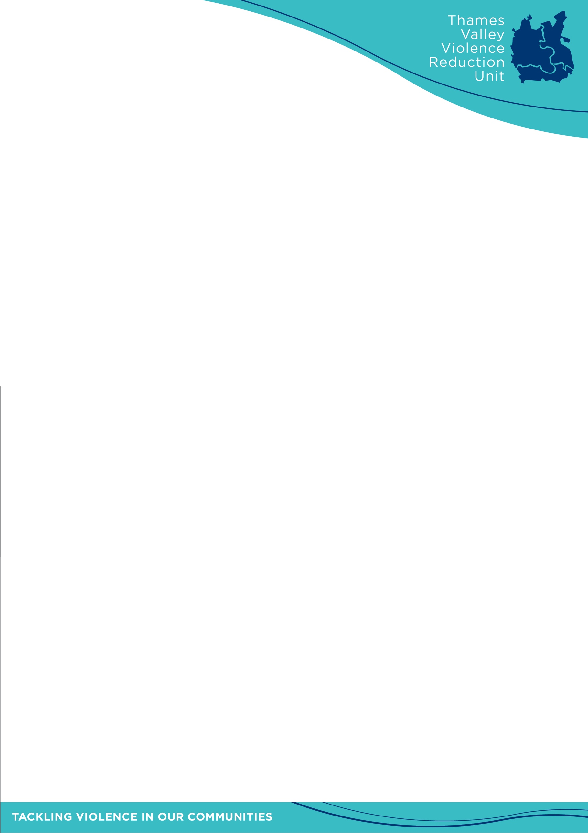

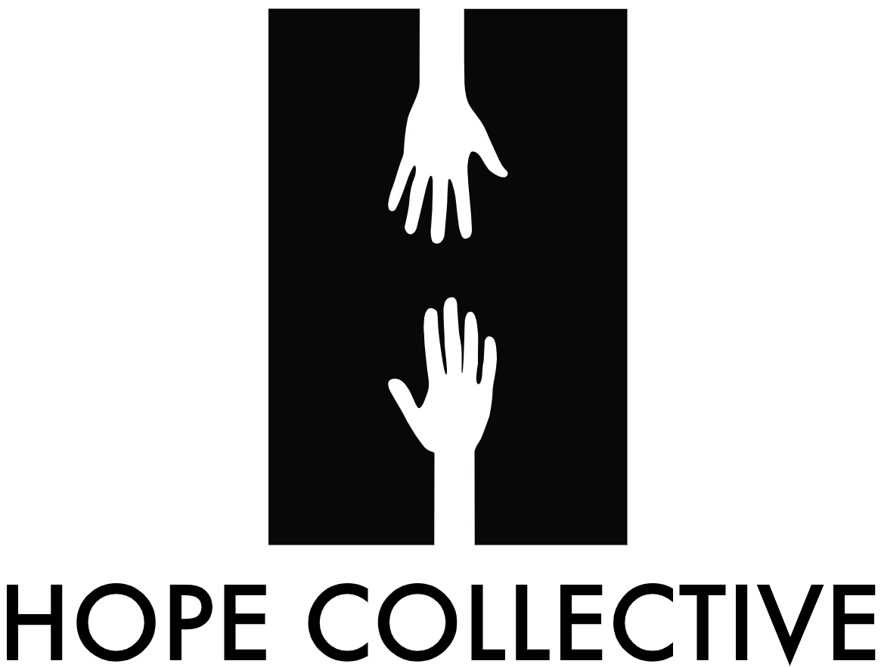

What would make for a fairer, safer society?
Invitation to young people to join the first Thames Valley “Hope Hack” youth voice event
Friday 4 March – 9.30am – 4pm, Madejski Stadium, Reading

The Thames Valley Violence Reduction Unit is inviting your organisation to participate in the first of a series of youth voice workshops taking place across the UK in 2022, sending a group of suitable young people aged 16 – 19 to the “Hope Hack” event on Friday 4 March at the Madejski Stadium, Reading.

The Hope Collective is a grass-roots organisation, set up in the wake of Damilola Taylor’s murder in 2006. It seeks to deliver upon his ambition that one day he would change the world, by giving young people a voice and inspiring them to be have a positive influence upon the world around them.

Last year, the Hope Collective worked with local partners to deliver a series of five “Hope Hack” workshops across the UK. Young people debated the issues associated with a fairer society and how to create solutions. They discussed issues such as opportunities in education, training and employment, challenges they faced such as discrimination and inequality, poverty and the risk of crime and violence.

In November, a delegation of those young people attended a Downing Street reception where they presented the summary findings to the Prime Minister, his policy team and officials from the Department for Levelling Up, Housing & Communities (DLUHC).

They were given a new mandate for 2022: To reach out to more young people and to involve them in identifying the problems, discuss how to solve them and to identify opportunities. They were invited to again compile their findings to present back late in the year to central government and to local partners.

The Hope Collective is now working with the national network of Violence Reduction Units (VRUs) to deliver a series of 22 events, and the Thames Valley will be hosting the first, launch event on 4 March.

We are inviting young people aged 16 – 19, ideally from a mix of backgrounds and perhaps those with greater experience of growing up facing adversity or who have strong views on how society could be improved. This is an opportunity for them to work with around 100 of their peers to directly identify the issues they face and find ways that we can work together to address them.

Would you have anyone who you feel would be suitable to participate? They would have the opportunity to be involved in the event, if they wish they could go further and become a “Young Ambassador” with the VRU and the Hope Collective. And they may even be chosen to join the national young persons panel presenting the findings to senior government politicians and officials later this year.

The overall series of events is to give young people an opportunity to have a say in creating a fairer and safer society. We will be focusing on the specific themes and issues of poverty and inequality.

Participants will hear from a key note speaker and challenged to play an active role in the day. They will be led by experienced facilitators from UK Youth, National Citizenship Service, the Hope Collective and our local partners Get Berkshire Active, Berkshire Youth and Reading FC Community Trust.

They will be provided information and research on the local context, facts, figures and definitions and encouraged to consider how poverty and inequality manifest locally. They will be led in discussions as to the sorts of inequalities some may face and the impact this has on individual life outcomes. They will work in groups to identify the issues and suggest potential solutions.

The event will be held at the Madejski Stadium in Reading. Registration will commence at 9.30am, prompt start at 10am and we aim to be finished by 4pm.

We aim to host around 80 young people together with accompanying adults (teachers/staff, visiting facilitators and observers).

You may have students who could attend without teacher/staff attendance. Or, you may wish to send a member of staff to accompany. We are happy to discuss this further.

If you have any transport provision (mini-bus, teacher’s vehicle) we can provide the cost of this. The stadium is also well served by buses and we can provide advice as required for those you feel comfortable could travel alone.

Refreshments and lunch are provided

We are working to finalise the agenda, but a draft agenda is below.

We are keen to finalise our attendee numbers and commence our registration process as soon as possible.

If you can assist with this important opportunity for young people to have their say and to influence national and local policy, please get in touch.

Key contacts:

- Sgt Russ Massie – VRU lead for Child Centred Policing (Early Intervention)
  - vru@thamesvalley.police.uk
  - 07843 377177

Stan Gilmour
Director
Thames Valley Police Thames Valley VRU

Draft agenda: Thames Valley Hope Hack
Youth voice workshop – Friday 4 March
Madejski Stadium, Reading

Time | Agenda item
9.30am – 10am | Arrival, registration and refreshments
10am | Event start
10am – 10.10am | Opening video and key note speaker
10.10 – 10.30am | Event housekeeping, ice-breakers and group setting
10:30 – 10:40am | Workshop overview
10:40 – 11.30am | Part 1: Research wall: What is poverty? What inequalities do we face? What does it mean to be poor and how can it effect our lives?  Working in facilitated groups, using the research wall, you will be presented information through videos, posters and displays.  Discuss your understanding of poverty and inequality and how it has an impact on future lives.
11.30 - 11.45am | Refreshments provided
11.45am – 1pm | Part 2: Rotating workshops:  Facilitators will lead the groups to analyse a number of key questions to identify issues
1pm – 1.45pm | Lunch provided
1:45pm – 2pm | Post-lunch energiser
2pm – 2.45pm | Part 3: Solutions:  Working within groups, discuss the issues identified in the workshops and identify ideas and solutions
2.45pm – 3pm | Part 4: Sunflower  Using colour Post-Its, the key issues, ideas and solutions are posted on the wall in a growing visual display
3pm – 3.20pm | Feedback presentation planning  Groups discuss the key issues they wish to feedback to the group upon
3.20 – 3.50 | Feedback
3:50pm – 4pm | Closing remarks

