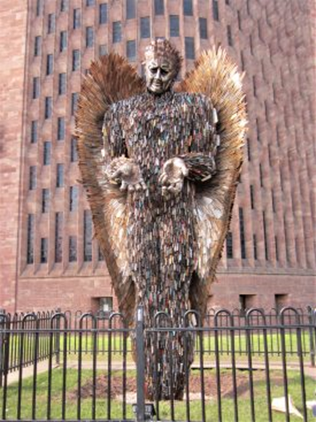
Stakeholder Briefing
Month of Action against Violence and Aggression
Slough
Dates Confirmed for Knife Angel Hosting
We now have confirmation that the Knife Angel, the National Monument against Violence and Aggression, will arrive in Slough on the 9th January 2023 following it’s hosting in Milton Keynes. The opening ceremony will follow on the 10th January 2023. This allows us time to unload and place the monument outside its location.
The location identified for the hosting of the Angel is outside Arbour Park, Slough.
New Announcements
We are pleased to announce the following partnerships and events that will take place across the period of the hosting of the Angel. This is just a snapshot of the work we are doing to raise awareness of violent acts and there are even more events taking place than those currently listed (we just can’t list them!)

If you think you as an individual, team or organisation can assist with putting on an event then please let us know.
Safety Centre Educational Programme
The Safety Centre will deliver 30 early knife crime intervention sessions for year 6 and 7 students talking about the choices and consequences of carrying a weapon. These sessions will provide valuable inputs to over 900 children on healthy decision-making.
We are pleased to announce that ALL 30 sessions were booked within 72 hours of the release of the sessions and we are now working with the Safer Slough Partnership and the Safety centre to expand the amount of sessions that can be delivered.

Watch this space!

Slough Youth Gospel Choir
The Slough Youth Gospel Choir will be completing a Performance “under the Angel” on Monday 16th January. In what is sure to be an emotional backdrop the Choir will perform a medley of songs. We thank Slough Music Service for completing this event
Slough Youth Parliament
The Slough Youth Parliament will be visiting the Monument on Tuesday 17th January between 6-8pm highlighting the Angels visit to Slough via Social Media channels and discussing important topics such as Knife Crime and Bullying.

Windsor Forest Group (Langley Campus)
We are pleased to announce that we will be working in partnership with Langley College to deliver the ‘Cut it Out’ Programme to students. The programme educates Beauty Therapists and hairdressers empowering them to have conversations to clients around domestic abuse.
Thames Valley police will also be holding an engagement event in the college talking about a range of topics from Bullying, Violence against Women and Knife Crime
What is the Month of Action?
The month of action against violence in January of this year, aims to bring together schools and parents, voluntary sector organisations, places of worship, community groups, local venues and businesses to work alongside statutory partners for Slough to take a stand together against violence in all forms.
This includes knife crime, which has resulted in a number of lives being tragically lost over the years, but also domestic abuse, hate crime, bullying and other forms of violence and aggression.
To mark the month of action, Slough will host the national monument against violence and aggression. Also known as the ‘Knife Angel’, the monument is a 27ft sculpture, made from approximately 100,000 bladed weapons collected in knife amnesty bins during police operations across the country. Created by the British Ironwork Centre, the monument travels to locations around the UK to educate children, young people and adults about the harmful effects that violent behaviour has on communities.

Why now?
Whilst serious violence in Slough has reduced over the last three years, we know that violence, particularly knife crime in recent months has become a particular concern for our community.
There is a clear desire in our town to work together to stamp out violence and a multi-agency and community response is required.
There is never a right or wrong time to talk about violence and aggression however, the New Year can act as a catalyst for encouraging conversation about violence and aggression and the monument and this month of activity will provide a good focal point and conversation starter for all.
Request for Volunteer Marshalls?
We are seeking the support of local businesses and organisations in volunteering their staff and time to stand with the Knife Angel during January to encourage conversation and discussion about violence and aggression. Previous hosts of the monument have commented on the benefit of engaging with the visitors to the sculpture though volunteers drawn from the local community.
Volunteers are being sought to give a few hours of their time between 9.30am and 2pm, to stand with the Angel and promote the anti-violence message. It could act as a team-building day for a workforce, or for a charity to share its own anti-violence message. A briefing about the Angel will be provided to volunteers prior to them manning the Angel
Volunteer Marshalls can volunteer either through the One Slough online portal or by e-mailing:
Karen.Bunce@thamesvalley.police.uk
Sergeant Ricci Dolan
Ricci.Dolan@thamesvalley.police.uk

Contact Leads
Thames Valley Police contact:
Chief Inspector Ashley Smith
Ashley.Smith@thamesvalley.police.uk
Inspector Karen Bunce
Karen.Bunce@thamesvalley.police.uk
Sergeant Ricci Dolan
Ricci.Dolan@thamesvalley.police.uk
Principal Risk and Exploitation Partnership Officer Helen Buckland helen.buckland@slough.gov.uk

