The Fill & Sign function in Adobe PDF can be used to sign the MOU.
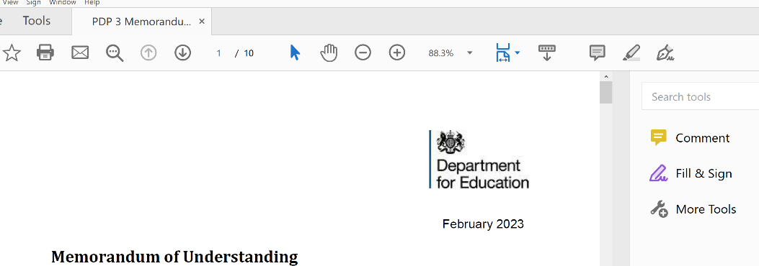

This can be found by clicking on the Fill & Sign icon which should appear down the right-hand side of the document once opened.

Once selected the following menu will appear across the top of the document
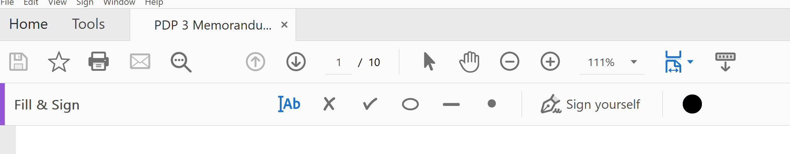
This icon can be used to insert text.
This icon can be used to add the signature.

The Text and signature boxes can be moved to be placed in the space for the signature block at the end of the document.

