|  |
| --- |
| Gastroenteritis outbreak pack for schools and other childcare settings |

The following guidance aims to help you manage an outbreak of gastroenteritis in a school or nursery environment. The principles are effective at limiting the spread of viral and bacterial infections, including norovirus. It has been produced with reference to national guidance, entitled ‘Health Protection in children and young people settings, including education’ and can be found here - <https://www.gov.uk/government/publications/health-protection-in-schools-and-other-childcare-facilities>

The guidance consists of the following sections:

1. Summary

General principles for effective control of gastroenteritis

1. Action Card 1

Key actions for the Head Teacher or Administrator to manage the outbreak.

1. Action Card 2

Key actions for caretakers and staff who will be undertaking cleaning, which is a vital step to reduce the spread of infection.

1. Action Card 3

Information to be provided to the Health Protection Team to help them give appropriate advice to manage the outbreak.

1. Action Card 4

Contact information for organisations that can provide help during an outbreak.

1. Links to the chapters of the national guidance - Health Protection in schools and other childcare facilities.

|  |  |  |
| --- | --- | --- |
| **Summary for Norovirus Outbreaks** | | |
| **Transmission Route:** | | Person to person by the faecal oral route, from aerosols of projectile vomit and from environmental contamination. |
| **Incubation Period:** | | 12 to 48 hours (length of time from acquiring the infection to developing symptoms) |
| **Exclusion:** | | 48 hours after their last episode of diarrhoea or vomiting |
| **Recommendations for action** | | |
| Hand Hygiene: | * Children should be supervised and encouraged to wash their hands before eating and drinking and after going to the toilet * Hand washing with liquid soap and warm water. * Paper towels should be used for drying hands and a wastepaper bin provided for disposal. * Alcohol gel is not effective against norovirus, but it can be used in addition to soap and water * Everyone should wash their hands-on arrival at school and before leaving * Sand, play dough and water play activities should be suspended for the duration of the outbreak. | |
| Cleaning and disinfection: | * Ensure the school surfaces are thoroughly cleaned daily using warm water and detergent. * All eating surfaces and toilet areas should be disinfected after cleaning twice daily using a hypochlorite solution 1,000 parts per million (such as Milton Solution) * It is recommended that toilets are cleaned at least twice a day and their condition monitored during the day, with a view to an extra clean if required. * Always wear disposable apron and gloves when cleaning. Dispose after use and wash hands as above. * The areas that should be cleaned and then disinfected should include:   + All areas of the toilet including rims, seats and handles   + Wash basins and taps   + Door handles and light switches   + All frequently touched equipment   + Frequently handled items such as telephones and computer keyboards   + Carpeted areas and soft furnishings should be cleaned as normal, preferably with a carpet shampoo rather than a vacuum cleaner (hypochlorite will bleach carpets and soft furnishings) | |
| Public spillage incident: | When spillages of vomit or diarrhoea occur:   * Cover the excreta/vomit spillages immediately with disposable paper towels. * Alwayswear a disposable apron and gloves when disposing of faeces/vomit. A face mask should be worn if there is a concern about splash contamination to the face. * After removing the spillage, clean the surrounding area with warm soapy water, followed by disinfection with a hypochlorite solution of 1000 parts per million. Always clean a wider area than is visibly contaminated. * Carpets contaminated with faeces or vomit should be cleaned with warm soapy water (or a carpet shampoo) after removal of the spillage with paper towels. This should be followed by steam cleaning if possible. * The area where the incident has occurred should be cleared and ventilated as soon as possible | |
| Food Safety: | * Everyone should eat and drink in designated areas (i.e. dining hall or staff room). * Open boxes of chocolates/biscuits and fruit bowls must be removed in an outbreak as they can easily become contaminated. * Food handlers should avoid contact with the school children during an outbreak, in order to avoid contamination of the kitchen or food. * Kitchens MUST have their own separate cleaning equipment. | |

**Further Information** can be found in the guidance: Health Protection in children and young people settings, including education <https://www.gov.uk/government/publications/health-protection-in-schools-and-other-childcare-facilities>

|  |  |
| --- | --- |
| **Action Card 1** | |
| **Title** | **Managing an outbreak of diarrhoea & vomiting in a childcare setting** |
| **Description** | **Overview of what to do in an outbreak situation** |
| **Who** | **Those members of staff that are responsible for overseeing/managing an outbreak i.e. Head Teacher, administrative staff, absence monitoring manager etc.** |
| **Definitions of an outbreak**   * an incident in which 2 or more people experiencing a similar illness are linked in time or place. *(This is important for infections where there could be serious outcomes such as meningitis or measles)* * a greater than expected rate of infection compared with the usual background rate for the place and time where the outbreak has occurred *(this is more applicable to gastro-intestinal or respiratory infections)*   **NOTE: You do not need to notify the Health Protection Team of all outbreaks of gastro-intestinal infections routinely. (see Action card 3)**  **What do you need to do?**   * Ensure good record keeping – names, dates of birth, symptoms, dates of onset of illness of cases, number and location of episodes of vomiting in communal areas etc. in the school. * Inform UK Health Security Agency (UKHSA) for advice & guidance (**see Action Card 3** for triggers of when to notify). * Prompt exclusion / isolation of affected children and staff, ensuring strict compliance with 48hour exclusion (i.e. fully recovered for 48 hours before returning to school) * Consideration should be given to advising parents and visitors about the outbreak. * Remind children about the importance of good hand hygiene. * Cookery activities for the children as well as sand, playdough and water play activities should be suspended for the duration of the outbreak. All potentially contaminated materials should be discarded and replaced in accordance with your local procedure. * Ensure robust infection control measures are in place: * Cleaning regime in place (see Action Card 2) * Guidance for the management of ‘Spillages of vomit or diarrhoea’ are followed (see Action Card 2) * Effective hand hygiene (see Summary Sheet) * Plentiful supply of personal protective equipment (PPE), liquid soap, paper towels, etc. * Individuals who have had diarrhoea should be excluded from swimming until at least 48 hours after symptoms have settled. * Non-essential visitors should be restricted and/or discouraged from visiting during the outbreak. * Dispose of all infection-exposed food items from communal areas i.e. boxes of chocolates, biscuits or bowls of fruit. * Declare the outbreak over when there has been 48 hours since the resolution of symptoms in the last known case. * Terminal clean (Action card 2) to be done as soon as possible after resolution of outbreak. | |

**Further Information** can be found in the guidance: Health Protection in children and young people settings, including education <https://www.gov.uk/government/publications/health-protection-in-schools-and-other-childcare-facilities>

|  |  |
| --- | --- |
| **Action Card 2** | |
| **Title** | Cleaning & disinfection of the school/nursery environment |
| **Description** | Germs that cause diarrhoea & vomiting will survive in the environment, so to stop the infection spreading it is important that the areas are maintained in a clean condition. Decontamination (cleaning and disinfecting) the areas thoroughly on a frequent basis is necessary. |
| **Who** | Caretakers, other staff with responsibility for cleaning |
| The following are terms that you may hear:   |  |  | | --- | --- | | **Detergent:** A cleaning agent that helps to remove dirt and grease from surfaces | **Disinfectant:** A chemical that destroys bacteria.  **Recommended Disinfectant:** Chlorine -releasing agent/hypochlorite solution (e.g. bleach or ‘Milton’ solution 0.1% at 1000ppm) | | **Routine cleaning:** A process that physically removes contamination which is done on a regular/daily basis. Warm water and detergent should be used to clean. | **Disinfection:** A process that reduces the number of germs to a level at which they are not harmful but is only effective if the surfaces and equipment are cleaned thoroughly with detergent and water beforehand. | | **Enhanced cleaning:** During an outbreak cleaning and disinfection should be done twice-daily as a minimum (plus as necessary). Particular attention should be given to frequently touched surfaces, e.g. door handles, flushes, taps, contact points, switches, mirrors, bins, furniture, stair rails, etc. | **Deep cleaning:** Intense and enhanced thorough cleaning process. Usually planned ahead e.g. during holiday periods. | | **Terminal cleaning:** Cleaning thattakes place at the end of an outbreak to ensure the area has been thoroughly cleaned and disinfected. This includes the steam cleaning of carpets and soft furnishings. | | | |
| To clean effectively you will need:  **Equipment**  Clean, disposable, single-use cloths, dedicated mop & mop bucket (different coloured equipment for different areas is a useful tool), dust pan and brush, clinical waste bags (yellow), spillage kit, paper towels, Personal Protective Equipment (PPE), steam cleaner.  Cleaning equipment used by the kitchen staff **must** be kept separate and used solely for kitchen.  **Chemicals**  Detergent (see above)  Disinfectant (see above)  Sanitiser – this is a commercial purchased combination of a detergent with disinfectant properties. | |

***You must always ensure that you follow your health and safety guidelines when handling chemicals*** ***including the use of appropriate PPE***

* During an outbreak cleaning and disinfection should be done twice daily.
* Warm water and detergent should be used to clean hard surfaces followed by disinfection with a 0.1% hypochlorite solution. Bleach or Milton are the recommended disinfectants (at 1000ppm), as they will kill both bacteria and viruses. If these are unsuitable, a disinfectant that has **both** antibacterial and antiviral properties **must** be used.
* Particular attention should be paid to cleaning and disinfecting toilet seats, toilet flush handles, door handles, washbasin taps, push-plates on doors, light switches, stair handrails and other frequently touched areas.
* Spillages of vomit or diarrhoea should be cordoned off and the area cleared immediately:
  + Wear disposable gloves and apron.
  + Use a spill kit or paper towels to soak up the spillage. Transfer these and any solid matter directly into a clinical waste bag.
  + Clean the soiled area with detergent and hot water, using a disposable cloth. A two metre area around the spillage should be cleaned.
  + The same area should then be disinfected with the freshly made hypochlorite solution.
  + Dispose of gloves, apron and cloths into the clinical waste bag.
* Wash hands thoroughly using soap and water and dry them with paper towels. Alcohol hand-rub is not a substitute for hand washing after cleaning up a spillage.
* Vacuum cleaning carpets and floor buffing are not recommended during an outbreak.
* Do-not use bleach on carpets or soft furnishings - a steam cleaner must be used to remove the bacterial or viral particles.
* Clothing contaminated with body fluids should be placed in a sealed plastic bag and taken home by the child/parent. Do not wash/sluice or soak the contaminated items on behalf of the child/parent.
* Carpets and soft furnishings should be steam-cleaned, or a carpet shampoo used.

**Further Information** can be found in the guidance: Health Protection in children and young people settings, including education <https://www.gov.uk/government/publications/health-protection-in-schools-and-other-childcare-facilities>

|  |  |
| --- | --- |
| **Action Card 3** | |
| **Title** | Reporting an outbreak of D&V to UK Health Security Agency South East (UKHSA SE) by telephone. |
| **Description** | This card gives you the contact number for UKHSA SE and details of the information that the UKHSA SE will require to help you manage your outbreak. |
| **Who** | Those members of staff that are responsible for informing UKHSA SE of an outbreak i.e. head teacher, administrative staff. |
| **When to report:**  Schools should notify the HPT in the following circumstances:   * Pupils and staff with vomiting and/or diarrhoea with onset of illness around the same time. * Cases of vomiting and diarrhoea associated with a school trip or event. * Any severe gastrointestinal illness that has resulted in hospitalisation etc. * Reports of severe or bloody diarrhoea. * Increased levels of concern in parents/public/media.   The general increase in GI cases which occur periodically (which are usually caused by norovirus) can be managed by the school using this guidance. | |
| **Phone: 0344 225 3861** | |
|  | |
| **What UKHSA SE will ask for:** | |
| * Name and address of the school, including the postcode * Contact person’s name and phone number * Total number of children at the school * Details of the year groups / classes * Number of staff at the school * Number of children affected, which year groups, details of siblings affected * Number of staff affected * Date of onset of first illness (onset date) * Details of any recent school trips, special events * Details of any episodes of public vomiting * Details of school caterers affected * School lunch / packed lunch ratio * School layout and facilities, particularly who shares toilets | |

**Further Information** can be found in the guidance: Health Protection in children and young people settings, including education <https://www.gov.uk/government/publications/health-protection-in-schools-and-other-childcare-facilities>

|  |  |
| --- | --- |
| **Action Card 4** | |
| **Title** | Contacts and further information |
| **Description** | This card provides details of the main contacts who can help you during an outbreak. |
| **Who** | Those members of staff who are responsible for informing UKHSA SE of an outbreak, i.e. administrative staff, head teacher |
| |  |  |  |  | | --- | --- | --- | --- | | **UKHSA** | | 0344 225 3861 | | |  | | | | | **School Nursing Teams** | | | | | Bracknell Forest Council | [0300 365 6000](tel:0300-365-6000) and select option 3  [Bracknellforest.SN@berkshire.nhs.uk](https://cypf.berkshirehealthcare.nhs.uk/Bracknellforest.SN@berkshire.nhs.uk) | Reading Borough Council | 01189 207514 [csnreading@berkshire.nhs.uk](mailto:csnreading@berkshire.nhs.uk) | | Slough Borough Council | 01753 373464 / 0800 7723578  [publichealthnursing.4slough@nhs.net](mailto:publichealthnursing.4slough@nhs.net) | West Berks Council | 01635 273384 [csnwestberks@berkshire.nhs.uk](mailto:csnwestberks@berkshire.nhs.uk) | | Royal Borough of Windsor & Maidenhead | 01628 682979 [school.nursing@achievingforchildren.org.uk](mailto:school.nursing@achievingforchildren.org.uk) | Wokingham DC | 0118 949 5055 [csnwokingham@berkshire.nhs.uk](mailto:csnwokingham@berkshire.nhs.uk) | | Buckinghamshire Overarching admin: 01296 838000, option 5 [bht.schoolhealth-enquiries@nhs.net](mailto:bht.schoolhealth-enquiries@nhs.net) | | | | | Aylesbury | 01296 566032 | Chalfonts & South Bucks | 01753 888835 | | Buckingham | 01280 826982 | Wycombe | 01494 426177 | | Chiltern | 01494 722988 |  |  | | Banbury  (North Oxford) | 01865 904234 | Oxford City and Central | 01865 904225 | | Abingdon (South Oxford) | 01865 904890 |  |  | | **Environmental Health Departments** | | | |  |  |  |  |  | | --- | --- | --- | --- | | Aylesbury Vale District Council | 01296 585 858 | Wokingham DC | 0118 974 6000 | |  |  |  |  | | Bracknell Forest Council | 01635 503 242 | Slough Borough Council | 01753 875270 | | Cherwell District Council | 01295 227990 | South Oxfordshire District Council | 01235 422403 | | Chiltern District & South Bucks District Council | 01494 732058 | Vale of White Horse District Council | 01235 422403 | | Milton Keynes District Council | 01908 252398 | West Berks Council | 01635 519192 | | Oxford City Council | 01865 249811 | Slough Borough Council | 01753 475111 | | Reading Borough Council | 0118 937 2465 | West Oxfordshire District Council | 01993 861000 | | Royal Borough of Windsor & Maidenhead | 01628 683820 | Wycombe District Council | 01494 421636 | | |

**UK Health Security Agency SE**

**Gastrointestinal Outbreak Pack for Schools and Nurseries**

National guidance is available on GOV UK website entitled ‘Health Protection in children and young people settings, including education’. The following are links to the individual chapters for ease of reading.

|  |  |  |
| --- | --- | --- |
|  | **What infections are, how they are transmitted and those at higher risk of infection** | [**https://www.gov.uk/government/publications/health-protection-in-schools-and-other-childcare-facilities/what-infections-are-how-they-are-transmitted-and-those-at-higher-risk-of-infection**](https://www.gov.uk/government/publications/health-protection-in-schools-and-other-childcare-facilities/what-infections-are-how-they-are-transmitted-and-those-at-higher-risk-of-infection) |
|  | **Prevention and Controlling infections** | [**https://www.gov.uk/government/publications/health-protection-in-schools-and-other-childcare-facilities/preventing-and-controlling-infections**](https://www.gov.uk/government/publications/health-protection-in-schools-and-other-childcare-facilities/preventing-and-controlling-infections) |
|  | **Supporting immunisation programmes** | [**https://www.gov.uk/government/publications/health-protection-in-schools-and-other-childcare-facilities/supporting-immunisation-programmes**](https://www.gov.uk/government/publications/health-protection-in-schools-and-other-childcare-facilities/supporting-immunisation-programmes) |
|  | **Managing outbreaks and incidents** | [**https://www.gov.uk/government/publications/health-protection-in-schools-and-other-childcare-facilities/managing-outbreaks-and-incidents**](https://www.gov.uk/government/publications/health-protection-in-schools-and-other-childcare-facilities/managing-outbreaks-and-incidents) |
|  | **Managing specific infectious diseases: A to Z** | [**https://www.gov.uk/government/publications/health-protection-in-schools-and-other-childcare-facilities/managing-specific-infectious-diseases-a-to-z**](https://www.gov.uk/government/publications/health-protection-in-schools-and-other-childcare-facilities/managing-specific-infectious-diseases-a-to-z) |
|  | **Specific settings and populations: additional health protection considerations** | [**https://www.gov.uk/government/publications/health-protection-in-schools-and-other-childcare-facilities/specific-educational-settings-and-populations-additional-health-protection-considerations**](https://www.gov.uk/government/publications/health-protection-in-schools-and-other-childcare-facilities/specific-educational-settings-and-populations-additional-health-protection-considerations) |
|  | **Children and young people settings: tools and resources (including exclusion table, posters, checklists)** | [**https://www.gov.uk/government/publications/health-protection-in-schools-and-other-childcare-facilities/children-and-young-people-settings-tools-and-resources**](https://www.gov.uk/government/publications/health-protection-in-schools-and-other-childcare-facilities/children-and-young-people-settings-tools-and-resources) |

**Hand-washing technique with soap and water**

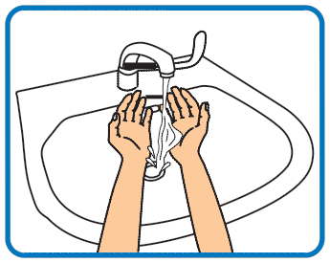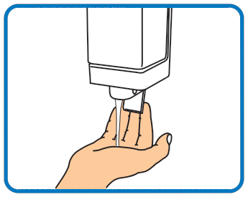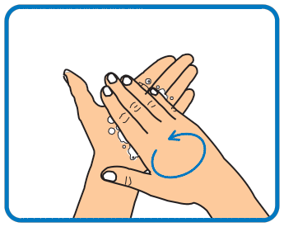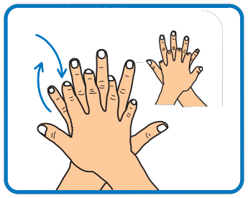**1 2 3 4**

Wet hands with water

Apply enough soap to cover all

hand surfaces

Rub hands palm to palm

Rub back of each hand with palm of other hand with fingers interlaced

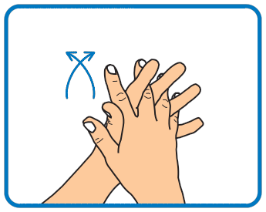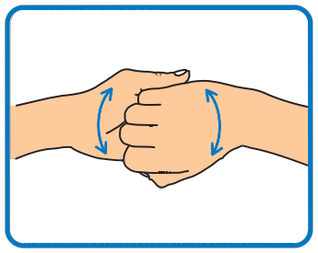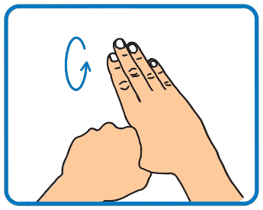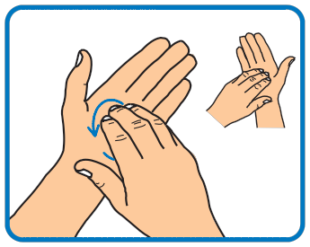**5 6 7 8**

Rub palm to palm with fingers interlaced

Rub with back of fingers to opposing palms with fingers interlocked

Rub each thumb clasped in opposite hand using a rotational movement

Rub tips of fingers in opposite palm in a circular motion

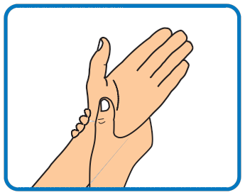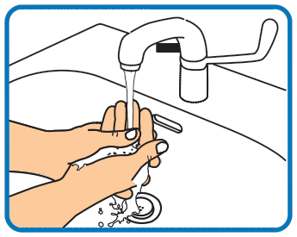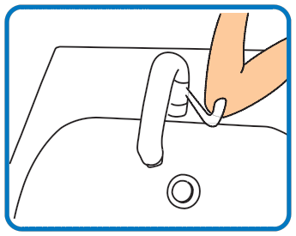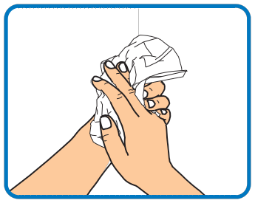**9 10 11 12**

Rub each wrist with opposite hand

Rinse hands with water

Use elbow to turn off tap

Dry thoroughly with a single-use towel

**13**

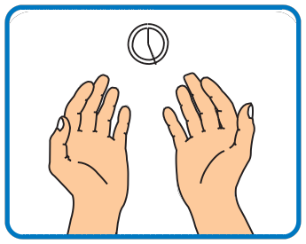Hand washing should take



15 –30 seconds

© Crown copyright 2007 283373 1p 1k Sep07

Adapted from World Health Organization *Guidelines on Hand Hygiene in Health Care*