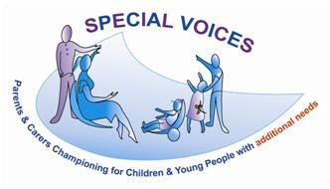

Special Voices Information/Local Offer Live Day
Friday 24th November 2023 - 9.30am - 1pm
Singh Sabha Sports Centre, Stoke Poges Lane, SL1 3LW

Special Voices are a voluntary group & the parent/carer forum for Slough, we look forward to welcoming you to another of our information days where you will receive a free gift bag on entry, refreshments, free parking on site and surrounding area. There will be an agenda of guest Speakers from 10am across Health, Education & Social Care to give an update on all that is happening for SEND (Special Educational Needs & Disability) children/young people/adults in Slough. Information stands with the providers available to speak with from services, groups and organisations. There will also be presentations on the new Local Offer website where you will be able to give feedback. Who is it for? Parents and carers of children, young people/adults with special educational needs or disabilities (SEND), professionals or service providers working with families of children/young people that have SEND. You can of course pop in anytime between 9.30am-1pm for coffee and meet the services that are available in Slough to support you and your family.

For further information/details/guest speaker list, or to book a stand at the event please contact: 07990693439 info@specialvoices.co.uk

