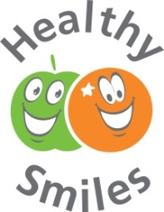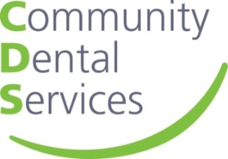

**Healthy Smiles Registration   
January 2025**

|  |
| --- |
| **Registration of Healthy Smiles**  We would like to register to take part in the Healthy Smiles programme. We understand that CDS will notify us when the programme is due to start and that we are agreeing to collect evidence in accordance with the standards.  Signature: _________________________ Print name: _____________________________  Role/Position: _____________________________Date____________________________  We have received or have not yet received oral health training (Please circle).  **Oral Health – Healthy Smiles Training**  We would like to book our FREE Oral Health – Healthy Smiles online training.  We understand that the training will cover all aspects of improving children’s oral health; brushing, diet and dental visits and how our setting can support better oral health in line with the EYFS Framework. The training will also offer important advice around; promoting oral health to children and families, activities the setting can take part in, how dental neglect should be addressed and possible changes to policies.  We understand that Healthy Smiles training will be offered virtually and will last approx. 90 mins. We confirm that we have the equipment needed to take part;  Laptop or smartboard/projector for group training, or separate devices – ie phone/tablet for separate team members, reliable internet connection, access to training platform ie Zoom or Microsoft Teams.  Once the training is completed, certificates of attendance will be issued with CPD minutes and will complete the training standard of the accreditation programme. The setting agrees to give consent to the emails we provide to CDS for the online training to be used to collect online evaluations post training.  We understand that once we have registered, Oxfordshire Community Dental Services OHIMP team will contact us to book our training at the start of the accreditation programme launch date above.  **Register setting:** Setting name: |
| Address: |
|  |
| Telephone: Mobile number (if applicable): |
| Email: |
| Website: |
| Manager or Healthy Smiles Champion name: |
| Number of staff who would like training? |
| How many children are currently on roll? |