Best Start Family Hubs

16th January 2026

Dear All,

Re: Parenting Programmes Staff Professional Development Opportunity

During the summer we launched a survey around the current offering for parenting programmes and support in Slough. Using the responses received and the impending Best Start in Life delivery expectations for local authorities, we have commissioned the Centre for Emotional Health to deliver training. The first round for professionals to be trained is proposed to be on the 3rd 4th 10th and 11th February. A further timeline of all training for professionals, community workers and the faith leaders will be shared shortly, with the aim to start the role out of parenting workshops for under 5s in April from Best Start Family Hubs, then progressing with a planned programme in each locality in Slough.

The Centre for Emotional Health training programme is based on the evidence-based Nurturing Programme, it equips professionals to deliver courses that promote emotional well-being and positive relationships in families, schools, and workplaces. The core philosophy is that feelings drive behaviour, and developing self-awareness, empathy, self-regulation, and positive relationship skills is crucial for leading an emotionally healthy life.

Key Aspects of the Training Programme
The training is designed for practitioners (such as family support workers, teachers, and health visitors, early years, community, voluntary and faith sector) to become accredited Parent Group Leaders or facilitators, enabling them to run programmes for parents and other adults in various settings.

Core Programmes for Practitioners to Deliver
The Centre offers a range of specific training courses to equip practitioners to deliver the following programmes to parents and carers:

The Nurturing Programme (10 weeks): The core, universal programme for parents of children of all ages (particularly effective for ages 3-12), which aims to improve emotional health for both adults and children and strengthen family relationships.

Welcome to the World (8 or 5 weeks): An antenatal programme focusing on the emotional health of expectant parents and their baby, as well as the relationships between them.
Talking Teens (4 weeks): Focuses on improving family relationships and communication for parents of teenagers (ages 11-19).

Keeping Your Child in Mind (4 weeks): A programme for parents focusing on the impact of adult relationships and conflict on children.

Parenting Puzzle Workshops (various durations): Shorter workshops for parents of children under 5, focusing on areas like the power of play and positive discipline.

The ultimate goal is to create emotionally healthy environments that lead to improved self-esteem, resilience, better relationships, and positive outcomes for individuals and communities.
The aim is to develop a sustainable delivery programme across Slough with partners committing to be part of a collective pool of trainers thus ensuring long term impact. If each organisation commits to training one member of staff over the next year, a planned and coordinated offer can be delivered through Family Hubs, schools and key community and faith venues.

I have attached some FAQ that I hope will answer any questions.
The only way to ensure a sustained long-term available programme for families is by joining together, delivering the help and support in the community, at the time of need. We look forward to working with you.

Please complete the expression of interest form using the QR code or clicking the link by Friday 23rd January. This will support us to plan the whole training calendar and offer places for the first training programme.
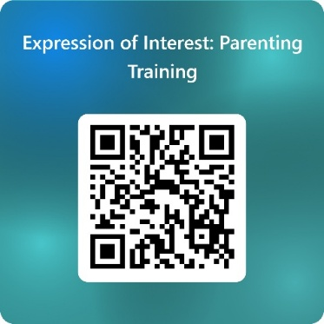

Expression of Interest: Parenting Training – Fill in form

Your sincerely,

MC Avis

Marie-Claire Avis
Head of Service Children’s Centres and Family Hubs
Education and Inclusion

