One-paragraph newsletter
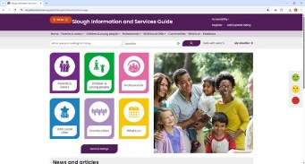
Help us improve Slough’s Information & Services Guide (FIS website).
We’re redesigning Slough’s Family Information Service website to make it clearer, easier to use and more responsive to the needs of families, carers, young people and professionals.
Please take a few minutes to scan the QR code and complete our short survey, and help us spread the word.
Your feedback will directly shape how people across Slough find childcare, SEND, Family Hubs and early help support in the future.

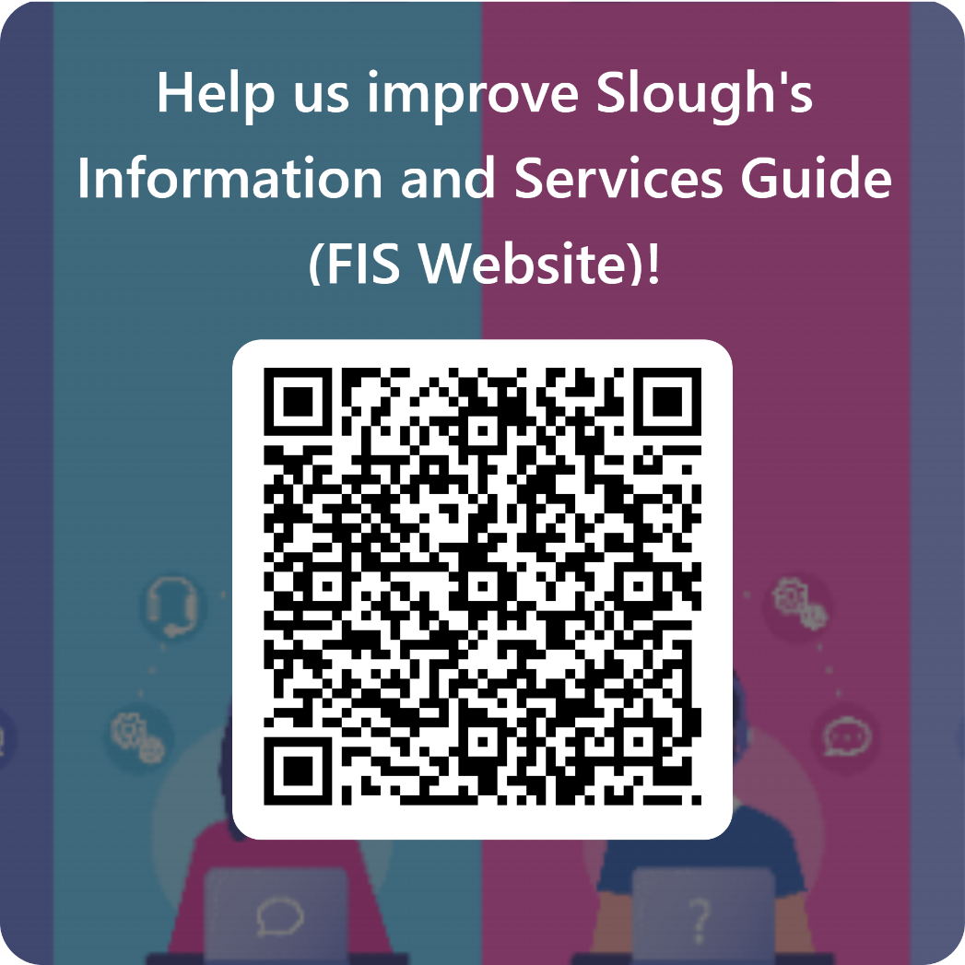
Help us improve Slough's Information and Services Guide (FIS Website)! – Fill out form
Slide or poster text to promote the QR code
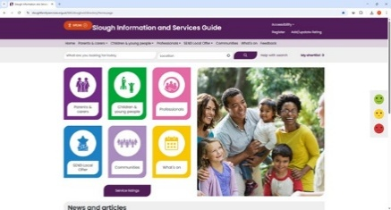
Help us improve Slough’s Information & Services Guide (FIS website).
Your feedback will help redesign Slough’s Family Information Service (FIS) website so people can find the right support, at the right time.
✅ For families, carers & young people
✅ For professionals who use or signpost to the site
✅ Takes just a few minutes
📱 Scan the QR code to share your views
Together, we can build a clearer, more helpful digital front door for Slough.

Help us improve Slough's Information and Services Guide (FIS Website)! – Fill out form

