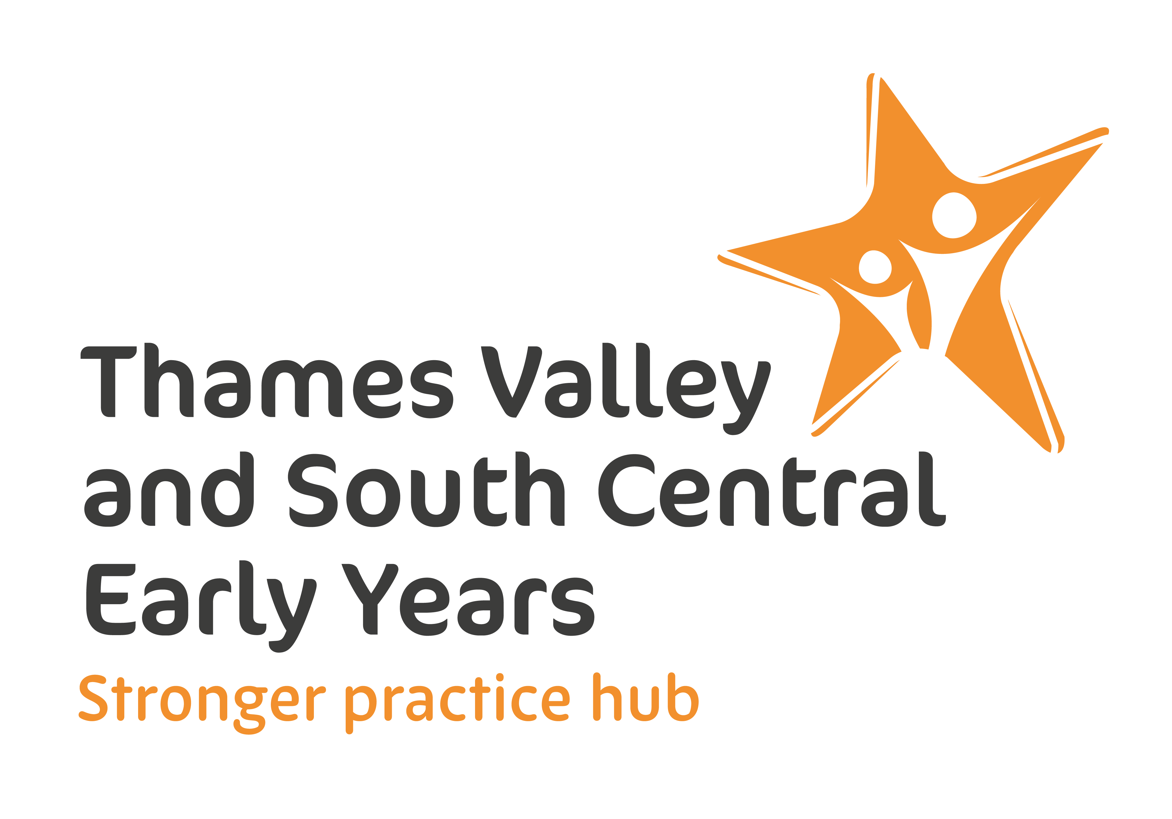


Expression of interest:
Early Maths Lead (EML)

Deadline for applications:
9am Friday 5th June 2026

Context
Every child deserves the best start in life. The earliest years shape future learning, wellbeing, and success. Through the Best Start in Life strategy, the Department for Education (DfE) is driving higher standards and strengthening the improvement system so that every child can thrive.
To support delivery of commitments made in the Best Start in Life strategy, DfE will be introducing Early Years Learning Leads (EYLL) for personal, social and emotional development (PSED), early language and early maths in each of the Early Years Stronger Practice Hubs (EYSPH) to provide support and training to early years educators.
EYLL will be based in EYSPH and will be responsible for:
- Improving outcomes for children by:
  - strengthening PSED, early maths and early language provision across early years settings by delivering high‑quality Stronger Practice continuous professional development (CPD).
  - providing targeted subject specific support to early years settings to strengthen practice in PSED, early maths and early language.
- Actively engaging with subject‑specific professional development and networks to deepen expertise, share good practice, and support high‑quality delivery across the EYSPH area.
This document relates to EYLLs for early maths ONLY.
EYSPH help early years settings to adopt evidence-informed practice and build trusted networks for sharing effective practice. There are 18 Stronger Practice Hubs in England - 2 per region. The Best Start in Life strategy committed to doubling the number of hubs to 36.
The hubs are strong providers of early years education with sound expertise and knowledge of the evidence base on what works to support child outcomes – trusted local experts that other early years providers can look to for advice and support.
For more information about EYSPH please visit Sharing evidence-informed best practice to support early years education and childcare | Stronger Practice Hubs

Opportunities now open
- Experienced early years professionals are invited to apply for the role of Early Maths Lead (EML). Applicants can apply as an individual or be released by their current employer.
- A comprehensive package of support including induction, training and follow up support will be provided to all EMLs.
- Induction and training for successful applicants will take place in September 2026, ahead of delivering support to educators and settings from October 2026.

Early Maths Lead (EML) – responsibilities
Overseen by the EYSPH lead and working closely with PSED and early language leads, EMLs will be responsible for:
- Attending training delivered by a DfE appointed subject matter expert and engaging with follow up support provided.
- Developing and delivering a locally specific early maths delivery plan outlining plans for sustained support to educators and settings, based on local needs analysis and mapping of existing provision.
- Delivering DfE owned early maths professional development
  - Stronger Practice CPD – maths for educators working with children aged 2-4 module (based on the EYPDP3 maths module)
  - Stronger Practice CPD – maths for educators working with children under 2 module (new module)
EMLs will deliver each module to a minimum of one cohort (between 12-18 educators) per term. Each module will be delivered over 6-12 weeks and will include a welcome webinar, facilitation of 3 webinars of 90 mins – 2hrs in length each and support to educators during the course.
- Providing bespoke support on early maths to a minimum of four settings per term underpinned by coaching approaches, modelling of practice and opportunities for reflection. This will include supporting settings to develop bespoke action plans to address identified needs and strengthen practice.
- Supporting early years settings/educators to select, adapt and embed evidence-informed approaches and interventions.
- Being an active member of a national and regional EML network, to share best practice and promote a joined-up approach across the 0–5 agenda, fostering greater coherence, consistency, and impact in service delivery involving Maths Hubs where appropriate.
- Working with local authorities (Bracknell Forest, Buckinghamshire, Hampshire, Milton Keynes, Oxfordshire, Portsmouth, Reading, Slough, Southampton, West Berkshire, Windsor and Maidenhead, Wokingham) and other relevant stakeholders e.g. Best Start Family Hubs, Maths Hubs etc to understand local needs, identify gaps, prevent duplication of services, and reduce the risk of fragmentation, thereby strengthening coherence across the local system.
- Working in partnership with Best Start Family Hubs, English Hubs, local speech and language therapists and health services (including the ELSEC programme where it runs locally).
- Encouraging settings to identify and use, in conjunction with high quality communication friendly practice, an effective screening tool annually with all children, to identify language delays and SEND.
- Maintaining accurate records of progress against Key Performance Indicators, impact and feedback from settings and other local stakeholders to inform practice and share with hubs and DfE.
- Working collaboratively as part of the Thames Valley and South Central EY SPH team, as required. For example (but not limited to): working closely with the Hub Lead, Hub Manager and other EYLLs; attending team meetings; contributing to the planning and strategic direction of the hub as required.

Early Maths Lead (EML) – person specification
Essential experience
- Has experience of working with children aged between 0 to 4 years old in an early childhood education context.
- Has experience working in, or with, a range of different childcare provider types (i.e. PVIs, childminders, school-based settings)
- Has experience of leading professional development in early maths.
- Has experience of mentoring others or using a coaching model of support, demonstrating the ability to build and nurture professional relationships.
- Has experience of developing and implementing a delivery plan which addresses the specific needs of early years settings and staff with input from key stakeholders including local authorities across multiple areas
- Has experience of working collaboratively with multi-agency teams and/or local authority services.
Essential early maths knowledge and attitudes
- Level 6 qualification.
- Level 3 qualification in speech, language and communication is desirable
- Understands the importance of evidence-informed practice and able to identify evidence-informed approaches, training and resources.
- Extensive knowledge of the key areas of early mathematics learning and able to communicate these clearly and confidently to educators and settings, while modelling a positive attitude to early maths.
- Enthusiastic to learn more about early maths practice and to engage in further reading and research.
- Demonstrates a commitment to inclusive practice and reducing inequalities in early outcomes.
- Understands the safeguarding requirements within the Early Years Foundation Stage (EYFS) statutory framework.
- Has completed some professional development in early childhood maths, such as:
- the Early Years Professional Development Programme (EYPDP) maths module.
- the Early Years Child Development Training (EYCDT) maths module.
- NDNA’s Maths Champions programme.
Essential leadership skills
- Excellent communication and interpersonal skills, with the ability to build trust and credibility beyond their setting.
- Able to deliver the key programme content with rigour whilst being responsive and sensitive to educators’ needs and prior experiences.
- Aspirational to support the improvement/facilitate the development of the quality of early maths practice.
- Open to reflecting on their practice as an Early Years Learning Lead.
- Ability to provide bespoke support to early years settings, tailoring approach to meet the unique needs of each context.
- A self-starter, able to work independently, make strategic decisions, proactively generate work, and collaborate effectively as part of a team.

Time required for the role
EMLs will be funded to work three days per week during term time. The SPH will expect the 3 days/week to be worked flexibly across the 38 weeks in order to meet the remit of the role. By negotiation, this may include working occasional evenings and/or weekends and not necessarily be working on the same set days every week. There may also be additional days in the holidays that we request the ELL to work based on the settings needs and will require some flexibility.
For The Thames Valley and South Central EY Stronger Practice hub, we may appoint more than one EML. In this scenario the distribution of responsibilities will be agreed as part of the recruitment process. Please indicate in your application if you would be applying to cover the role for the full three days, a lower number of days or whether your availability is flexible.
However, please note that DfE will only fund one of the appointed leads to attend each element of training, and only that individual may deliver the corresponding support. The same applies to attendance at national network meetings: funding is available for one lead only. Therefore, we ask for you to highlight in your application which role you would prefer to take on – training delivery or coaching and mentoring.
All EMLs will be required to complete relevant training for the role. Please see details below.

Training for the role
The DfE has appointed a Subject Matter Expert (SME) who will be responsible for providing training to all EMLs before they start delivering support from October 2026. Full details will be provided by the SME but is likely to include:
- September 2026:
  - Half day online induction session including evidence-informed approaches to practice.
  - Half day online session on coaching and mentoring approaches and effective improvement planning.
  - In person training on how to deliver the Stronger Practice CPD – maths for educators working with children aged 2-4 module (based on the EYPDP3 maths module).
- February 2027
  - In person training to deliver the new Stronger Practice CPD – maths for educators working with children under 2 module
Note: Three EYSPH will take part in the pilot of the Stronger Practice CPD – maths for educators working with children under 2 module. For EML based in the pilot hubs, training will take place in October 2026.
Dates and times of the training will be shared with successful applicants.
The Education Endowment Foundation (EEF) will provide input and support to the SME on evidence-informed practice, professional development and implementation.
The SME will also:
- provide follow-up support and quality assure training delivery through 1-2-1 supervision sessions, observation of workshops/webinars delivered by leads, group webinars/drop-in sessions and peer to peer reviews.
- facilitate networking and collaboration to share best practice including one face to face and two online events during the year.

Other details
These roles will be contracted by the SPH with an allocated day rate of £500/day to include travel and expenses. All roles are for 38 weeks of the year (term-time) can be undertaken in one of two ways:
- Being paid directly as a self-employed contractor / consultant
- By agreed release from your existing role, with payment be made to your setting for your release
Successful applicants will be reimbursed for travel costs to attend training and national and regional networking events.
ELLs will be expected to provide support to educators and settings across the whole of the geographic area covered by the EYPSH Bracknell Forest, Buckinghamshire, Hampshire, Milton Keynes, Oxfordshire, Portsmouth, Reading, Slough, Southampton, West Berkshire, Windsor and Maidenhead, Wokingham.
ELL will be expected to start by Monday 31st August and attend training in September 2026. Funding for ELL is available until the end of March 2028, with the possibility of extension to the end of March 2029.

How to submit your application
We invite you to submit an expression of interest, using the form below, outlining your relevant skills and experience for this role.
Please submit your expression of interest form to Thames Valley and South Central Early Years Stronger Practice Hub via manager@tveysph.org by 9am Friday 8th June 2026.
Your application will be assessed by a panel alongside other applications. Shortlisted applicants will be invited to a short in person interview at Blagdon Nursery School on Friday 12th June, Friday 19th June or Thursday 25th June.
If you have any further queries, please email the above mailbox.
We look forward to receiving your application.

Expression of interest (EOI) form

Applicant details
Name:
Email:
Phone number:
Current role:
Current employer name:
Current employer address:
- Please indicate the time you could commit to the EML role?
- 3 days
- Fewer days (please specify)
- Flexible
(delete as appropriate)
  - If you are applying for fewer days please do specify if you would prefer to be considered for the role of the trainer delivering the set DfE training or the coaching/mentoring role.
- Trainer
- Coaching/Mentor
(delete as appropriate)
Please skip this question if you are applying for the full 3 days.

- Please indicate if you are applying as an individual or if you will be released from your current employer to carry out the role of EML:
Applying as in individual/Released from employer (delete as appropriate)

- If you will be released from your current employer, please confirm you have your manager’s/setting owner’s/head teacher’s permission to take part in this programme:
Yes/No (delete as appropriate)
Please also attach a letter of support from a senior leader confirming your employer’s commitment to releasing you for the relevant number of days to take part in the programme.
I have attached a letter of support: Yes/No (delete as appropriate)
Note for employers: releasing a member of staff to participate in the programme as an EML will help support professional development at your setting or organisation, as well as grow connections with other early years settings and networks. Your setting will benefit from close involvement with evidence-informed practice within the sector. This will, in turn, influence educator practice along with the quality of early education and care in your setting. The EML will remain employed by your setting/school during their participation in the programme.

- Please confirm you are willing and able to travel within the EYSPH area to undertake the responsibilities required for the EML) role (e.g. deliver training, provide bespoke support to educators and settings, participate in networks etc)

Yes/No (delete as appropriate)
Questions
- Please describe your relevant experience of working in early years, including your current and past relevant roles.
You should look to include the following in your response:
- How many years you have worked in early years, the type of settings you have experience of and relevant roles e.g. room leader, nursery manager, EYFS lead
- Any relevant experience outside of working directly within settings.
- Include any experience of working with children with SEND, EAL, or from disadvantaged backgrounds.

(Please aim for 300 words)

- Please describe how you ensure your practice aligns with EYFS requirements
You should look to include the following in your response:
  - How you use child development milestones to inform planning or assessment in maths
  - How you have implemented strategies to address gaps in learning and development in early maths and how successful these were
- Your understanding of EYFS safeguarding and welfare requirements and other statutory requirements such as ‘Working Together to Safeguard Children’ and ‘Keeping Children Safe in Education’.

(Please aim for 300 words)

- Please describe your experience of supporting early years educators and settings to develop their understanding of children’s early mathematical development through leading professional development training, mentoring and/or coaching.
You should look to include the following in your response:
  - Experience of leading professional development training.
  - Experience of using a mentoring and/or coaching model of support.
  - Experience of providing both face-to-face and remote support, how you build trusting relationships and how you tailor your support for different settings or individuals.
  - The approaches you used and the impact of your support.
(Please aim for 300 words)

- Please describe how you ensure your early maths practice is evidence informed and how you have supported settings/educators to use an evidence informed approach.

You should look to include the following in your response:
  - Examples of resources or approaches you have used that are grounded in the latest research.
  - How you have signposted early years settings/educators to appropriate early maths professional development and age-appropriate, evidence-informed interventions.
(Please aim for 300 words)

- Each EML will be expected to develop and deliver a locally specific early maths delivery plan. Please describe your experience of working with stakeholders and how you would use this to develop and implement a delivery plan.
You should look to include the following in your response:
  - How you engage stakeholders including harder to reach stakeholders.
  - How you would ensure the delivery plan strengthened and complemented existing offers and avoided duplication/overlap.
  - Experience of engaging and motivating a diverse audience who may have less confidence in supporting children with maths or be reluctant to engage with support due to anxieties about maths.
- Your experience of working in partnership with a range of stakeholders including
e.g. settings, local authorities, Maths Hubs, Best Start Family Hubs, early years networks.

(Please aim for 300 words)

- Please list relevant qualifications and training for this role
E.g. Level 6 qualification in a relevant subject, additional relevant qualifications above Level 6, teaching qualifications, leadership/coaching qualifications, recent relevant CPD, safeguarding training, speech and language therapist.

This question is not scored. You must demonstrate that you meet the essential requirement of holding a Level 6 qualification. Other qualifications and training will only be considered if two candidates receive the same or very similar scores at both the EOI and interview stages.

