Early Education Service

Training and Continuous Professional Development Portfolio

Autumn Term 2026

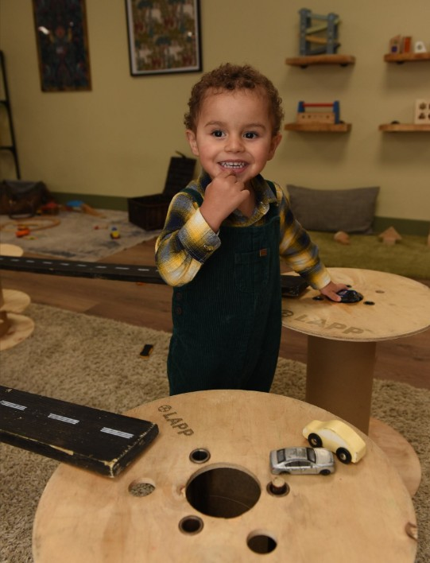




Section | Contents | Page
 | Introduction
 | Training monthly overview
 | Childminder Recruitment
 | Moving to Write Workshop
 | PVI Managers and Deputies Meeting
 | Introduction to ELLP Programme and ITalk
 | Baby Room Network – TVSPH
 | ITalk ELLP Network
 | Early Years PVI SEND Network
 | Designated Safeguarding Lead – Level 3
 | Early Years Cluster
 | Safeguarding
 | Safeguarding
 | Safeguarding Prevent & FGM
 | Prevent Duty training for Early Years Practitioners
 | FGM
 | Safeguarding
 | Safeguarding: LADO
 | Families First training offer
 | Families First - Inclusion
 | Families First – Recognition scheme
 | Families First – Business planning for success
 | First Aid
 | Maths Champion – Free Early Years Maths training
 | DFE EY child development training
 | Education Endowment foundation
 | Thames Valley EY stronger practise hub
 | Recommendations

Training & CPD

The Early Education Service in partnership with sector organisations have produced this training calendar to support you and your staff during the academic year 2026-27.

Slough Early Education Service is committed to supporting the sector with training and continuous professional development opportunities. We are constantly reviewing our offer and have created this portfolio based on feedback from the sector and national influences. We have planned a term’s worth of networks and training programmes, and we will continue to monitor the offer and explore options for the whole year.

All of the training that has been scheduled has been based on feedback from the sector but if you are looking for something specific that we haven’t organised please contact us and we will be happy to discuss your requirements, please email earlyyears@slough.gov.uk.

Slough Early Education Service is committed to supporting affordable professional development across the sector by keeping charges low.

Providers from other local authorities are welcome to access some of our training in Slough. If you would like to organise whole setting training, please contact us to discuss this. Please note: venue hire will add to the cost of the training course, but if you are considering using your own setting as the training venue, we ask that you consider carefully whether you can provide suitable adult facilities for all attendees (adult height chairs/tables, toilets etc). We can also provide online training where appropriate.

We need a minimum of eight practitioners to deliver a training session or workshop. If you are a sole provider or a group provider requesting fewer than eight training places, we will endeavour to find practitioners from other settings to join you in the training before confirming your booking.

All training courses scheduled throughout the year can be booked via ‘TheLink Website’: www.thelink.slough.gov.uk

Free networks and cluster meetings
Please book your space to attend the networks via TheLink website. We will send a reminder about the sessions and how to join the week before, so you don’t forget to attend, just because they are free there is still an expectation to attend!

These include: PVI SENDCO Network, ELLP I Talk, EY Cluster and PVI managers meetings.

Booking
Bookings will close two days prior to the training, please ensure you book your place(s) on time as once the bookings have closed you will not be able to book a place. Please note: if we do not have a minimum of eight bookings, seven days prior to the event, a decision will be made at this point to cancel or postpone the session, therefore it is advised to book as early as possible if you are planning to attend a session. It is important you identify the practitioners name and email address that will be attending, so they receive the joining information.

Waiting List
In the event a training course is oversubscribed, you will be contacted by a member of the Early Years team and asked if you would like to join a waiting list should a space become available.

Cancellations
- Any cancellations must be made seven days prior to the event, or you will be subject to a £15 cancellation fee.
- Non-attendance will also be subject to a £15 charge for free sessions and full charges for costed courses.
- If the Slough Early Education Service cancel a course all booked and paying participants will receive a full refund

Polite reminder and protocol for accessing online training and networks
- Join the meeting early to ensure everything is working OK, and so any technical issues can be resolved. The meeting will be open to you 10 minutes before the scheduled start time.
- Make sure your name is correct on the screen this helps us with the register and to be able to talk to you.
- Please ensure you arrive on time for training if you are more than 10 minutes late, unfortunately you will not be able to join the training.
- Turn your camera on and have it at eye level.
- If you have a poor internet connection, you can turn your camera off to improve the quality.
- Please ensure there is only one person per screen, this is to ensure that you can interact with the training as per the design of the course. Most of our training delivery will include the use of ‘break out’ rooms and this function does not work if a screen is shared with other delegates.
- If there is more than one person from the same setting attending the training, you will need to position yourself in a different room on a different screen.
- If you would like to run a whole group session where you project the training onto a big screen, please contact earlyyears@slough.gov.uk so we can organise and plan a session specifically for this purpose. In this situation we would design the course differently to meet the needs of your team.
- No unauthorised person should join the training and if the trainer suspects that this is the case, they have the right to end the online session for that individual. This is why we ask you to ensure you display your name and setting when you join the meeting and add this with your job role to the chat.
- Please maintain the level of respect that you typically would for a face-to-face environment and recognise confidentiality.
- If you do not comply with the above points the trainer has the right to remove you from the online session, and you will not be issued with a refund.

Ask questions
Please utilise the chat function when attending online training, to ask questions if you wish to do so. You can also raise your hand and select other visual responses. Most sessions will have time for questions built in and have the option to contact the trainer after the session.

Mute your microphone
When you are not talking or contributing to the session, it is useful to mute your microphone to ensure that any background noise does not disrupt the session. You can always unmute yourself when you want to ask a question.

Be respectful
This applies to your trainer and fellow delegates too. Remember, your trainers have put a lot of time and effort into delivering high-level course content, so maintain the level of respect that you typically would for a face-to-face environment. When it comes to your fellow delegates, remember that for some, this may be the first time that they will be undertaking an online course. Lastly, as with face-to-face sessions, please be on time and be respectful of other people’s time.

Be mindful of your language
As well as the obvious curse words or rude tone, this means avoiding using caps lock, sarcasm or humour that may be misconstrued. It is easy for written text to be misunderstood.

Try not to get distracted
Like a face-to-face classroom environment, distractions can hinder your learning experience, and this is something that you should look to avoid if you wish to fully take advantage of this time. 70% of workers state that they feel distracted within their working day, which is hugely problematic for motivation when you are trying to add development time into this schedule. So, switch off your phone, minimise your background noise and find an area where you will be able to set up and fully concentrate on the course at hand. Do not forget to switch off emails, messaging apps, and other pop-ups that can come up on your screen prior to the session.

Do not share inappropriate material
Sounds obvious we know but nothing that you share online is ever private, even in the breakout rooms with other delegates.

Maintain confidentiality
While you are learning, you may be encouraged to share workplace examples that relate to the topic of discussion. However, be mindful of client confidentiality, especially when sharing examples via the written chat box where information can be screen shot and shared outside of the training session. Remember that live online sessions could be recorded so can be accessed later.

Handouts
When attending training run by Slough Early Education Service it is encouraged that key messages and learning from the training is shared, however it is not expected that attendees would attempt to deliver or duplicate the training in anyway. If you do share any of the key messages, please acknowledge the original source of this intellectual property to be copyright compliant. Following the training session, you will be sent a copy of any handouts and a PDF version of the PowerPoint.

Feedback
Participants who attend training will be sent an email with a link to an evaluation survey. You will then have ten days to complete the feedback online. If you have not completed the survey within ten days your certificate will also no longer be available. Please make sure we have your correct email address.

Contacting the team about training
If you have any queries about training, including booking, cancellations, invites and joining information, please use the earlyyears@slough.gov.uk email address.

Please ensure you read the joining information that is sent to you prior to each course for the joining details. If you have not had confirmation of your booking with the joining link, please email the team at earlyyears@slough.gov.uk before the session is due to start/before the end of the working day so that someone can respond to you.

Check your junk/spam folder for emails they will have the training details in the message heading.

We ask you to log into the sessions 10 minutes prior to the session starting to enable our trainers to start promptly, if you have difficulty joining a session, please contact the team as soon as possible.

Please note that the Early Years team work with delivery partners to bring FREE and subsidised training to the EYFS sector so there is a charge for non-attendance.

Non-attendance will be charged at £15 per person, any cancellations must be made seven days prior to the event.

Training monthly overview

Will be added.

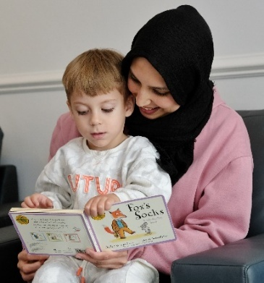
Childminder Recruitment
Introduction to Childminding and Home based care - Pre Registration Training

This training is open to any Slough resident who wants to become a Childminder and has attended an Information session.
** You will need to attend one of our Information Sessions before booking onto this training
This training is free and will take place over 7 sessions:
The time for each training session will be 09.30am – 12.00pm
Dates :
Session 1 – Thursday 8th October 2026
Session 2 – Thursday 15th October 2026
Session 3 – Thursday 22nd October 2026
Half term week break
Session 4 – Thursday 5th November 2026
Session 5 – Thursday 12th November 2026
Session 6 – Thursday 19th November 2026
Session 7 - Thursday 26th November 2026
Venue: Slough Library, Curve Venue @ The Curve, William Street, Slough, SL1 1XY
To Book: https://forms.gle/vsUe6jmZ5bZnnzbc8

You must attend all 7 sessions to complete this training course. Non-attendance will be charged at £50.00.
For any queries please e-mail: earlyyears@slough.gov.uk

PVI Managers & Deputies meeting
PVI Managers & Deputies Meeting
The PVI managers & deputies meeting is designed to support managers in the private, voluntary and independent sector and provide a networking opportunity. During the meeting the Early Years service will provide the sector with national and local update information.
Target audience: PVI managers & Deputy managers
Cost: FREE
Date: Monday 19th October 2026
Time: 6.30pm to 8.00pm
Venue: Chalvey Community Hub, Ladbrooke Road, Slough, SL1 2SR (limited parking available onsite)
To book: https://forms.gle/82oQP8dzZsHJ1yWQ9

Childminders Network: ELLP techniques of the week and speech, language and communication tips
Childminders Network: ELLP techniques of the week and speech language and communication top tips
This is a monthly bitesize session held online specifically for childminders who are ELLPs
We will look at one TOW each month to consider how this will look in your practice, the impact for children and how to share with parents
We will also use this to raise any questions and share good ideas and top tips for supporting speech language and communication
The session will be on every second Tuesday of the month, 7pm
If you have not attended an Introduction to ELLP session, please email karen.loft@slough.gov.uk before booking
Dates:
Tuesday 8th September 2026
Tuesday 13th October 2026
Tuesday 10th November 2026
Tuesday 8th December 2026

To book: https://forms.gle/gte7PZ9Vks4KUTyw7

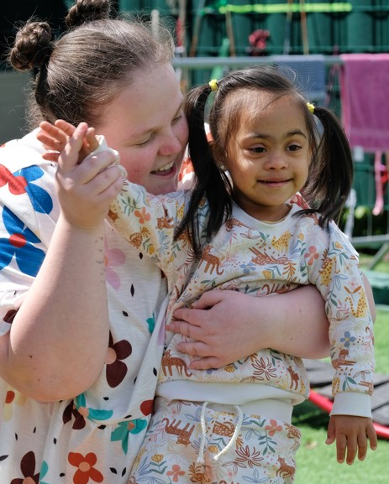
SEND and Inclusion
Early Years PVI SEND Network

The SEND PVI network meeting is designed for managers and SENDCOs from the private, voluntary, and independent sector. The network provider’s participants with the opportunity to network receive national and local update information and share good practice. This ssession is led by the Early Years Principle SENDCO Catherine Woodbridge

Target audience: Early years SENDCOs, Managers & inclusion leads
Date:
Time: 6:30pm - 8:30pm
Venue: Chalvey Community Hub, Ladbrooke Road, Slough, SL1 2SR (limited parking available onsite)
Cost: FREE
To Book:

Best Start in Life Strategy
Early years practitioners and Best Start Family Hub staff can discover more about the Best Start in Life strategy, and the role of Best Start Family Hubs and early years practitioners in supporting the home learning environment for families with children with SEND in a series of free webinars this autumn.

Follow the links below to book a place:

Date: 22nd September 2026
Time: 19:00-21:00
To book: https://www.eventbrite.co.uk/e/a-special-approach-to-making-it-real-to-support-families-and-practitioners-tickets-1991759455147

Date: 1st October 2026
Time: 12:30-14:30
To book: https://www.eventbrite.co.uk/e/a-special-approach-to-making-it-real-to-support-families-and-practitioners-tickets-1991760129163

Date: 13th November 2026
Time: 09:30-11:30
To book: https://www.eventbrite.co.uk/e/a-special-approach-to-making-it-real-to-support-families-and-practitioners-tickets-1991760293655

Introduction to ITalk and ELLP
Welcome to the ELLP programme and Italk
Do you have challenges meeting all the children’s speech language and communication needs in your setting?
Preverbal children, reluctant speakers, multilingual learners?
Based on the national Every Child a Talker ECAT programme devised by speech and language therapists and early years experts, in Slough we continue to support the EYFS sector through the Early Language Lead Practitioner ELLP programme.
Including a range of strategies and using Techniques of the Week TOW, this works with your embedded communication environment to support all children’s developing language and communication skills, with support from the Early Years advisory teachers, and termly networks to share good practice and input from CYPIT
Using ITalk monitoring to track your children and identify areas to support, the Slough Early Years team uses this data to work with the local speech therapy team to target support and training
This session is for all EYFS provision, private nurseries, schools and childminders
If you do not current have an ELLP, are not using TOW, come to this free introductory one hour session to find out more
Target Audience: EYFS provision, private nurseries, schools and childminders
Cost: FREE
Date: Tuesday 13th October
Time: 1pm - 2pm or 6:pm - 7pm
Venue: Online
To book: https://forms.gle/kWMyrw2XNE5VWyTG7
For any queries please e-mail: earlyyears@slough.gov.uk

Early Years Cluster
Early Years Cluster

William Overton, Director of Early Years, and his EYFS team are hosting the autumn term Early Years Cluster
William leads the team across the nursery class and 3 reception classes, and supports his own teams CPD as well as being an advocate for high quality early years practice across the Academy Trust

William and his team have a focus on supporting young children’s early communication development and oracy skills through high quality interactions, together with Hayley who is the EYFS ELLP
William will be sharing how they have used the EEF models of SHREC and STAIRS to develop the team’s expertise and the impact on children’s language and communication skills
Then there will be an opportunity to explore their learning environment and talk with their team

We are looking forward to you joining us visiting Western House Primary

Early Years Cluster; for early years practitioners in PVIs and EYFS teams in schools

For any queries please e-mail: earlyyears@slough.gov.uk
Target Audience: Early years practitioners working in PVIs and schools in Slough
Date: Wednesday 14th October 2026
Time: 4pm - 5:15pm
Venue: Western House Academy, Richards Way, Cippenham, SL1 5TJ
Cost: Free
To Book: https://forms.gle/gARnZ3FpQe2nDMTj8

Keeping children at the core, Ofsted and more
‘Keeping children at the core, Ofsted and more’

This will be an interactive discussion session to reflect on outstanding provision and practice every day, using the Early Years Ofsted Framework and tool kit, to improve outcomes for all children
We will share practical examples and challenge, helping managers, deputies and owners of PVI settings to see inspection as a reflection of quality rather than a standalone event
We invite you to join the termly sessions so that we can share key messages both locally and nationally from inspections and educational updates
We have made this an online to enable managers and deputies to join as well as encouraging PVI owners to join the sessions

Date: Thursday 19th November 2026
Time: 9:30 AM - 10:30 AM
Venue: Online
To book:

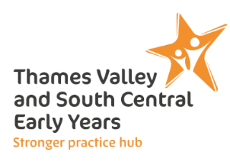
Thames Valley and South-Central Early Years Stronger Practise Hub

Childminder Network: Updates to Inspection Toolkit
Join this childminder network session, hosted by Paula-Jane Wylie which will discuss updates to the Inspection Toolkit.

Date: Thursday 10th September 2026
Time: 7:00 PM - 8:00 PM
Venue: Online
To book: Childminder Network: Updates to the Inspection Toolkit Tickets | TryBooking United Kingdom
Outdoor Learning with Pete Moorhouse
Outdoor Learning with Pete Moorhouse

In the webinar we will examine the value of learning outdoors highlighting key research. We will look at how we can create and make the most of outdoors environments, looking at a wide range of engaging opportunities we can offer children. We will examine leading educational pioneers thinking in promoting outdoor learning and reflect on our own pedagogical approach - particularly in relation to connecting to nature and embracing sustainability. We will also look the value of embracing risk and challenge in a positive sense. I will provide many examples of outstanding outdoor environments from many countries that will offer new ideas and inspiration.
Key aims:
* Understand the importance of learning outdoors
* Examine how the outdoors promotes health and well-being
* Explore how create a rich and varied outdoor environment and explore risky play
* Examine how we can nurture making strong lasting connections with nature
* Learn about key theorists approaches to learning outdoors
* See how learning outdoors encourage play and can embrace all areas of learning
* Examine many examples of stimulating environments and rich outdoor resources form a variety of countries
Date: Tuesday 15 September 2026
Time: 3:00 PM - 5:00 PM
To book: Outdoor Learning with Pete Moorhouse Tickets | TryBooking United Kingdom

Baby Room Network Session
Baby Room Network Session

👶 Baby Room Network: Creating a calm baby room
This network session we will discuss co-regulation, staggering settling in, coping with emotional distress.
Led by Dr Mona Sakr, Associate Professor of Early Childhood Education at Middlesex University, this network offers a unique opportunity to explore pedagogy, creativity, and leadership in the baby room. Mona’s passion for supporting practitioners in this vital area of early education shines through her work and her leadership of babyrooms-inspiringleaders.co.uk
Join us to:
✨ Network with other baby room practitioners
✨ Share experiences and best practice
✨ Gain valuable CPD to support your work with babies
Come and be part of a supportive and inspiring community dedicated to giving babies the very best start.

Date: Tuesday 29 September 2026
Time: 9:30 AM - 10:30 AM
To book: Baby Room Network Session Tickets | TryBooking United Kingdom

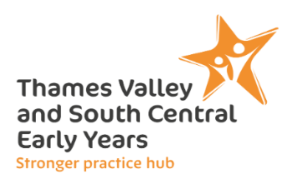
Moving to Write Workshops
Moving to Write Workshops

Before children can write, they need to move! The new DfE Writing Framework (July 2025) reminds us that handwriting starts with the body — from core strength and balance to fine motor control and precision.
Join our Moving to Write workshops to explore how movement, play and physical development lay the foundations for fluent writing.
We will aim to support Early Years Practitioners in:
• Understanding the physical development and skills that are needed for writing
• Knowing what type of environments and what activities will support development, skills and strength in bodies and fingers
• Planning for intervention - Knowing how to support children who are struggling with the tripod grip.
A lively, hands-on session packed with ideas to get children moving to write!

Date: Thursday 1 October 2026
Time: 9:00am – 12:00pm or 1:15pm – 4:15pm
Venue: Arbour Park, Stoke Road, Slough, SL2 5AY
Morning session: 9.00am - 12.00pm
Book here: https://www.trybooking.com/uk/GRMJ
Afternoon session: 1.15pm - 4.15pm
Book here: https://www.trybooking.com/uk/GRMM

Baby Music and Sensory Play
Baby Music and Sensory Play

* Originally booked for 25th June this training was postponed due to travel restrictions from the heatwave*
From the very earliest stages of life, movement shapes who we become. Even before birth, spontaneous movements begin to form the earliest connections between the body and the brain. Each movement strengthens neural pathways and supports the development of communication, emotional regulation, and learning.
In this inspiring and practical training session, we explore how music, movement, and sensory play can transform everyday interactions with babies and support healthy brain and body development.
Drawing on current research and practical experience, this session explores how simple musical interactions, gentle movement, and carefully considered sensory experiences can support babies’ neurological development and wellbeing.
What you will learn
Participants will explore:
• How early movement supports brain development and learning
• Why music is a powerful tool for connection, regulation and communication
• The importance of sensory play in the first year of life
• How rhythm, rocking and bouncing support vestibular and proprioceptive development
• Why babies’ feet play an important role in balance, coordination and body awareness
• How to create calm, responsive sensory environments rather than overstimulating ones
• Practical ways to integrate music and sensory play throughout daily routines in baby rooms
Practical ideas you can use immediately
You will leave with confidence, practical ideas, and a deeper understanding of why these small interactions matter so much for babies’ development.
Who is this training for?
- Anyone working with babies aged 0–2 years will benefit from this engaging and research-informed session.
Date: Thursday 1 October 2026
Time: 1:00 PM - 3:00 PM
Location: Ambleside Children's Centre, Ambleside Close, Woodley, Berkshire RG5 4JJ
To book: https://www.trybooking.com/uk/events/landing/117000

My Home as a Playground – Childminder Workshop
My Home as a Playground – Childminder Workshop

My Home as a Playground – Movement for Young Children in Home Settings
Young children thrive when their environment encourages exploration, curiosity, and movement – and the home can be the perfect playground. This on-demand course is designed specifically for childminders, offering practical strategies to turn everyday spaces into movement-rich environments that support physical, cognitive, and emotional development.
You’ll learn how to create safe, engaging opportunities for crawling, climbing, balancing, and imaginative play, all within the unique context of home-based care. With a focus on purposeful activity, physical literacy, and early motor skill development, this course equips childminders to make every day an active, joyful learning experience.

Date: Thursday 1 October 2026
Time: 7:00 PM - 8:15 PM
Location: New Bridge Nursery School, Montague Street, Reading, Berkshire RG4 5AU

Boosting Learning through Movement
Boosting Learning through Movement

This immersive training day explores the crucial role of movement in the cognitive, physical, and emotional development of young children. Grounded in the latest research, participants will examine how early movement experiences lay the foundations for brain development, communication skills, and emotional regulation.
Through interactive sessions, we will delve into:
The science behind sensory and motor development in the first few years of life -including the role of primitive reflexes
Practical strategies to create movement-rich environments that nurture curiosity and exploration.
The link between physical activity, neural pathways, and learning readiness.
Simple, inclusive activities that support vestibular, interoceptive and proprioceptive development.
Attendees will leave with a deeper understanding of why movement matters most in the earliest years of life and a toolkit of practical ideas to integrate into daily practice, empowering toddlers and pre-schoolers to thrive through active, playful learning.
Lunch and refreshments will be provided.
Date: Friday 2 October 2026
Time: 9:30 AM - 3:30 PM
Location: Shaw House, Church Road, Newbury, West Berkshire RG14 2DR
To book: https://www.trybooking.com/uk/events/landing/117141

Reception Years Maths Network: Mathematical Foundations
Book now to receive access to join our Reception Years Maths Network session.
Led by Nathan Crook, these network meetings will explore how children can be provided with learning experiences that enable firm mathematical foundations in number to be developed through the earlier part of the Reception year. Ideas shared will be presented in a form through which dissemination of thinking can be shared with wider staff teams. Throughout the network meeting, mastery approach pedagogies will be promoted, which align with provision through which playful maths experiences can be provided to children.
Date: Tuesday 6th October 2026
Time: 4:00 PM - 5:00 PM
To book: Reception Years Maths Network: Mathematical Foundations Tickets | TryBooking United Kingdom

SENCO Network
Join us for an inspiring online network session with SENCO from across the region.
Date: Tuesday 13th October 2026
Time: 6:30 PM - 7:15 PM
To book: SENCO Network Tickets | TryBooking United Kingdom

EYSPA Programme
https://www.strongerpracticehubs.org.uk/hubs/se/thvy-and-s-central-eysph/ebp/eyspa-ey-sp

The EYSPA programme begins in Autumn 2026 and will deliver targeted support to leaders in eligible settings to boost children’s development, improve outcomes and narrow the disadvantage gap.
Support will be open to group, school-based settings and childminder settings.
Selected settings will get support from an early years expert (EYSPA) to coach leaders and improve practice.
If the setting meets the eligibility criteria, they complete an application form and return it their local EYSPH, whilst also making the Local Authority aware. If selected, they will complete a diagnostic form which will support the hub in matching to the best possible EYSPA.

Who is the support for?
- Group-based settings: EYSPAs will offer in-person support at the setting for three to four full working days within a school term.
- Childminders: EYSPAs will offer four days of support, either in person or online, to a small cluster of four childminders over one term.

Eligibility criteria
- Ofsted Inspection Grading: A setting is eligible for support if it has received a:
  - ‘Needs Attention’ or ‘Urgent Improvement’ grading in any area of their most recent Ofsted inspection under the post November 2025 inspection framework.
  - An overall grading of ‘Inadequate’ or ‘Requires Improvement’ on the pre-November 2025 Ofsted inspection framework.
- The EYSPA will offer targeted support to improve concerns highlighted in the setting’s diagnostic from and their most recent Ofsted inspection report.

- Settings will also be eligible if they have high numbers of children on roll:
  - Eligible for Early Years Pupil Premium
  - Eligible for the Early Learning for 2 Year Olds Offer
  - With SEND needs and who qualify for support
- Settings may meet more than one of the above criteria; hubs will collaborate with Local Authorities to agree on which settings will receive EYSPA support

Childminder Support Programme

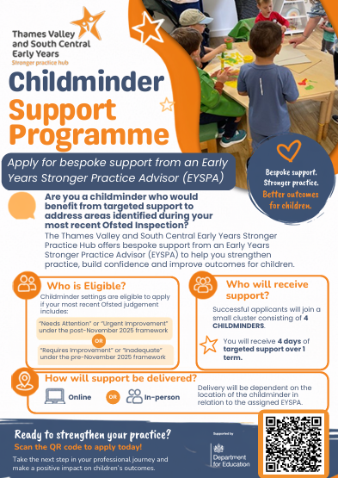

Early Years SEND partnership
The Early Years SEND Partnership is a national programme supporting professionals and parents with training, resources, and an approach to sharing learning, with the aim to increase access and inclusion in early years for children with SEN and Disabilities.

The Council for Disabled Children (CDC) leads the EYSEND Partnership and works alongside five partners: nasen, Speech and Language UK, Contact, Dingley's Promise, and the Early Childhood Unit (ECU) at the National Children’s Bureau.

Following an evaluation of the EYSEND partnership programme in 2024/25, a further evaluation was carried out for the year 2025/26 by Nottingham Trent University.

The aim of the evaluation was to provide a robust understanding of the impact of:
- The strategic work that has been undertaken with local areas.
- How system change at the local level has affected families of young children with SEND.

You can find out more about the programme and read the evaluation here: https://buff.ly/qWwyzvf

#

Assistive technology: introductory training materials
Assistive technology: introductory training materials
Assistive technology means tools, software and equipment that pupils with SEND can use to help them to learn.
This technology can be an important part of high-quality teaching if you use it effectively. It should support inclusive classroom practice as part of a wider set of strategies.
The National Institute of Teaching’s resources offer a short introduction to how you can use assistive technology in practice, covering early years, schools and colleges.

The resources will take around an hour to complete. They are:
- free to access
- aimed at teachers, but relevant to anyone working in education
- designed to be flexible – you can dip in and out as needed
- particularly focused on readily available tools and products

Trusted providers have developed them. They have used evidence-based content that meets the Education Endowment Foundation’s standards.
The content was originally created for the early career teaching entitlement.
DfE does not endorse or recommend any particular tool that the content mentions.
We plan to provide more comprehensive content on a wider range of assistive technology in 2027, as part of information on SEND CPD.

#

Safeguarding
Multi-agency safeguarding learning and development
September 2025-March 2026

https://www.sloughsafeguardingpartnership.org.uk/events

Introduction
Welcome to Slough Safeguarding Partnership training offer for 2026. This offer has been developed based on the Training Needs analysis that was conducted by the Safeguarding Partnership Learning & Development Forum.
We recognise the huge pressures on practitioners working to safeguard children and adults at risk,
as well as keeping our communities safe. This means every hour of training is precious and we
strive to make it the best that it can be.
We will continue to provide safeguarding training in a modular format so that practitioners can
access the courses that are most useful for them without the need for travel. All seminars are 2
hours long and take place via Microsoft Teams. Course sizes are restricted to ensure that we are
able to provide the best possible learning environment for all attendees and all attendees are
expected to have their camera on during the training. The seminars will concentrate on a specific
aspect of safeguarding practice in a multi-agency environment and are intended to support
practitioners who need to “refresh” or develop their safeguarding training.
What training do I need?
The training offer is entirely about multi-agency working and as such is all targeted at Level 3 of
the safeguarding competencies.
We do not provide in-house or single agency training, and we do not repeat the training you have
in-house. Whatever sector you work in, you should have attended your in-house safeguarding
introductory training before taking up any of the multi-agency training in this offer.
You need to have a good understanding of the role of your agency and your professional role in
safeguarding in order to acquire the partnership competencies you need. We believe in individuals
taking responsibility for their own learning, in discussion with their line management.
For colleagues looking to fulfil their responsibility for Level 3 children’s safeguarding,
simply choose the modules that are most appropriate for your learning needs to provide
you with your 8 hours CPD. https://www.sloughsafeguardingpartnership.org.uk

Safeguarding
Advanced Safeguarding - Live Virtual Classroom: NDNA
Gain the skills and ability to be a designated safeguarding lead and deliver safeguarding training to your team. This Live Virtual Classroom training consists of 4 x 90-minute modules that will be delivered 1 module at a time. The course will be completed over a period of 2 weeks with a gap task between each module. This course is designed for Nursery professionals acting as the DSLs. There are different start dates for this course so please check the link below for dates and availability.
NDNA Advanced Safeguarding
Level 3 Safeguarding Children: Paediatric First Aid Training Online
This online safeguarding training level 3 course programme is aimed at all childminders, nursery staff, but also school teachers & support staff working with children & infants who could potentially assess and evaluating the needs of a child, infant or young person, who may be potentially at risk of harm.
https://www.onlinepaediatricfirstaid.co.uk/product/level-3-online-safeguarding-children-course-childminders-nursery-staff/
Designated Safeguarding Lead (Level 3): The National Nursery Training
As part of the National Nursery Training Designated Safeguarding Lead course, you will learn:
- Understand the safeguarding structure and have an understanding of the law, policy and recommended guidance to uphold the highest safeguarding standards
- Understand the roles and responsibilities of the Designated Safeguarding Lead
- Be able to identify signs of possible abuse
- Understand the process to follow when a safeguarding issue is identified
- Understand the correct procedure for dealing with disclosures.
- Understand the varying levels of need of individuals and processes to follow.
- Understand the correct procedure for recording information and following due process beyond referral to external agencies.
https://nationalnurserytraining.com/product/designated-safeguarding-lead-level-3/

Safeguarding – Prevent & FGM
Prevent
Prevent should be seen as part of the existing safeguarding framework.
While it remains rare for children and young people to become involved in terrorist activity, young people from an early age can be exposed to terrorist & extremist influences or prejudiced views. As with other forms of safeguarding strategies, early intervention is always preferable.
Slough Borough Council working with other local partners, families and communities, play a key role in ensuring young people and their communities are safe from the threat of terrorism.
Prevent aims of session:

  - Understand Prevents aims
  - Think about who may be vulnerable to Extremism and Radicalisation – all forms
  - See why some people are able to influence and manipulate others to commit crimes
  - Recognise when a vulnerable individual may be in need of help
  - And be clear on what help, and support looks like in this area, and who you should turn to if you have concerns
  - Look at the threats, risks and vulnerabilities
https://www.elearning.prevent.homeoffice.gov.uk/edu/screen1.html


Prevent Duty training for Early Years Practitioners
I wanted to bring to your attention that the Department for Education is offering free virtual training sessions specifically tailored to support Early Years practitioners in understanding and fulfilling their responsibilities under the Prevent Duty.

The sessions are delivered by Regional Prevent Education Coordinators (RPECs) and are an excellent opportunity for staff to gain clarity and confidence in applying the duty appropriately within Early Years settings.

Further information, including upcoming session dates and how to register, is available via the official government website:
Regional Prevent Education Coordinators – Virtual Training Sessions



FGM
Female genital mutilation
FGM is illegal in the UK. Anyone who commits FGM faces up to 14 years in prison, a fine, or both. Anyone found guilty of failing to protect a girl from risk of FGM faces up to 7 years in prison, a fine, or both.
This resource pack includes:
- information on legislation and prevalence
- resources and good practice case studies for local authorities, the police, healthcare professionals and schools
- links to support organisations, clinics and helplines which can help people who think they might be at risk
- E-learning
- Free FGM Training Online | Recognising & Preventing FGM Free Course | Virtual College is available for professionals with safeguarding responsibilities.

It gives an introduction to FGM and the action you must take to protect girls who may be at risk.

Warning: Some of the content in the links included in this resource pack contain images or accounts that viewers may find distressing.
https://www.gov.uk/government/publications/female-genital-mutilation-resource-pack

Information for Professionals: Slough Safeguarding Partnership - Professionals
Information for Parents and Carers: Slough Safeguarding Partnership - Female Genital Mutilation (FGM)

Safeguarding

NSPCC Safeguarding Training
https://learning.nspcc.org.uk/training

Report into children’s use of the internet and online safety

Ofcom have released their annual report 'Children and Parents: Media Use and Attitudes', which introduces new insights into digital literacy, attitudes and understanding among children between the ages on 3-17. Their report includes information on how parents are monitoring and managing children’s digital usage, identifying important areas where parents and schools can improve children’s digital literacy.
With increasing levels of concern about the scale of Child Sexual Abuse Imagery involving children under the age of 10yrs (IWF, 2023), developing safe and positive behaviour and attitudes towards tech, needs to start from the moment children are accessing screens. Read the LGfL latest blog to find out more. The full report can be accessed here: Children's Media Literacy Report 2025
- Keeping children safe online | NSPCC
- Pre-school (0-5) online safety tips and advice | Internet Matters
- Teaching online safety in schools - GOV.UK
- Safeguarding children and protecting professionals in early years settings: online safety considerations - GOV.UK
- Online Safety Advice for Early Years Settings | Safeguarding Network

NSPCC Learning Newsletter
Stay informed about NSPCC Learning's professional training, events, services and resources.
Subscribe to NSPCC Learning Newsletter

New in the Library
Weekly list of the new child protection, safeguarding, child abuse and child neglect books, articles and resources added to our library collection.
Subscribe to New in the Library

Safeguarding in Education Update
Monthly bulletin for anyone working in education to keep up with the latest safeguarding and child protection developments as well as resources and training from NSPCC Learning.
Subscribe to Safeguarding in Education Update

CASPAR
A weekly email to keep you up-to-date with all the latest safeguarding and child protection news, policy, practice and research across the UK.
Subscribe to CASPAR

Safeguarding: LADO
Local Authority Designated Officer (LADO) Training

If you require this training, please email us at: earlyyears@slough.gov.uk. We don’t have a session scheduled this term however this can be arranged if required.

This session is delivered by our current LADO Dawn Isles.

The aim of this training is to increase knowledge and awareness of how to effectively respond when a child or young person makes an allegation of harm or abuse against a member of staff or volunteer.
By the end of this course participants will:
- Understand the procedures governing the managing of allegations against staff, carers and volunteers as outlined in the Berkshire Child Protection Procedures
- Understand the processes in responding to and investigating when allegations have been made against a member of staff or volunteer
- Know what to do and what happens, if you think a member of staff, carer or volunteer has harmed or may harm a child or is unsuitable to be working with children
- Understand the role of the Named Senior Officer and Local Authority Designated Officer (LADO) and when to involve them
- Be proficient in dealing with allegations and engaging with local statutory agencies during the allegation process

Target audience: Early Years Managers, Deputies, Childminders and Safeguarding leads, wraparound and HAF providers.

Cost: FREE

Families First Training offer

This project aims to deliver FREE training to support wraparound provision to be inclusive and
safe as well as supporting business skills to implement sustainable change. Three courses have been developed and are available to you for FREE.
Target Audience: HAF Providers, Wraparound Providers, Schools, Early Years settings with a Wraparound offer and anyone thinking about offering wraparound care.

Safeguarding
This course has been designed to specifically address the unique safeguarding issues which arise in out of school settings for school age children. It assumes a basic knowledge of safeguarding and will signpost for those who need to refresh this.

Contents - 6 Modules:
▪ A brief revision of some key facts about safeguarding
▪ Safeguarding in the wraparound sector
▪ Partnership working and information sharing
▪ Making safeguarding inclusive in the wraparound sector
▪ Creating a safe environment
▪ The voice of the child
Course length
2-3 hours in one sitting but to be completed at the learner’s own pace and we
actively encourage our busy workforce to try ten minutes a day. The course is online and enables trainees to dip in and out at their own pace. A series of films, questions and practical resources are included in the course.
To register: https://training.familiesfirst.org.uk/registration-slough-courses/


Families First Training offer - Inclusion

Inclusive Practice
This course aims to support a whole setting inclusive approach which welcomes all
children and celebrates difference. It supports understanding and practical ideas
to make changes which benefit all children through focusing on the inclusion of
children with SEND.

Contents
▪ What does it mean to feel included?
▪ Understanding the range of SEND and their impact on children and young people accessing wraparound care
▪ Practical strategies to develop a setting which is inclusive for everyone
▪ The voice of the child / young person
▪ Partnership working and information sharing
▪ Developing a whole setting approach to inclusion
Course length
2-3 hours in one sitting but to be completed at the learner’s own pace and we
actively encourage our busy workforce to try ten minutes a day. The course is online and enables trainees to dip in and out at their own pace. A series of films, questions and practical resources are included in the course.
To register: https://training.familiesfirst.org.uk/registration-slough-courses/


Families First – Recognition scheme
Rewarding your setting
Introducing the Families First Recognition Scheme
Your dedication to continuous improvement and providing the best possible care for children is what sets you apart. To honour this commitment, we are proud to introduce the Families First Recognition Scheme, designed to celebrate your investment in professional development.
Through this scheme, you’ll not only receive certificates that highlight your achievements — something you can proudly display to parents and carers — but also gain access to our exclusive Resource Pack, packed with practical tools and guidance to support your work.
For childminders and group settings, recognition goes even further: we’ll celebrate your success on social media, highlight it in Families First Peer Network Meetings, and share it directly with your local authority. This means your commitment is visible to families, peers, and local decision-makers — reinforcing the quality and professionalism of your provision.
We’ve created three distinct recognition routes depending on your role. Find the pathway that’s right for you below:
For Individuals (Working within a group setting)
Criteria: Complete any two of our three online courses (Business Planning, Inclusion, Safeguarding).
Your Recognition:
– A personalised Certificate of Achievement sent to you via email.
– Full access to our Resource Pack, filled with practical tools and guidance.

For Childminders
Criteria: Complete all three online courses (Business Planning, Inclusion, Safeguarding).
Your Recognition:
– A printed Certificate of Achievement delivered to you, to proudly display in your setting.
– Full access to our Resource Pack.
– Public recognition on our social media channels and at the next Families First Peer Network Meeting.
– Your Local Authority will be notified of your outstanding achievement.
– A powerful mark of quality you can share with parents, demonstrating your commitment to professional learning.

For Group Settings (Nurseries, Pre-schools, etc.)
Criteria: At least 50% of your staff complete any two of the three online courses, and at least one member of your team attends a Business Support Session.
Your Recognition:
– A printed Team Excellence in Training Certificate for your setting.
– Full access to the Resource Pack for your entire team.
– A celebratory feature on Families First social media channels.
– Formal recognition at the next Families First Peer Network Meeting.
– Your Local Authority will be notified of your setting’s commitment to excellence.

Families First Training offer – Business planning for success

Business Planning for Success
This course aims to support leaders, managers and owners through a ten step
business planning process which holds quality, sustainability and inclusion as
central throughout.

Contents
This course challenges a funding led approach to encourage settings to instead find the funding to fit their aims, and looks at potential income streams. This course also supports providers to comply with the equalities duties. A series of examples from our work with other providers nationally
will be shared throughout to keep the session ‘real’.
Course length
2 hours total. A day time and evening session is offered with each round to support
accessibility.
To register: https://training.familiesfirst.org.uk/registration-slough-courses/

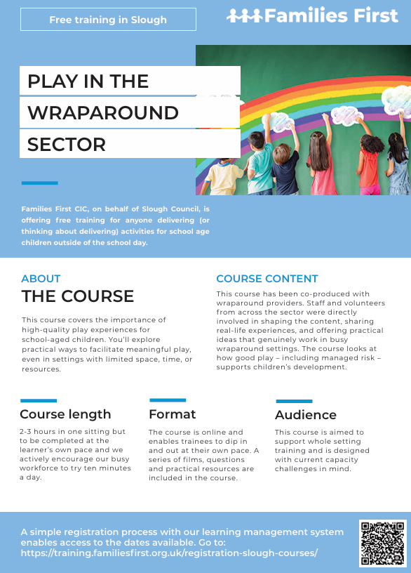
Families First Training offer -Play in the wraparound sector
First aid
MGM training
Paediatric First Aid Course – Classroom based
This Paediatric First Aid course was originally designed in conjunction with the National Childminders Association (now PACEY) and Preschool Learning Alliance specifically for those working with young children. It is the full Paediatric First Aid course as detailed in both the Childminder and Group Settings versions of Early Years Foundation Stage (EYFS) and is therefore the qualification accepted by OFSTED when inspecting registered childcare settings.
To find out date and book:
Paediatric First Aid EYFS Course – Classroom based – MGM Training

Tigerlily Training
Practical and online paediatric fist aid training for childcare and Early Years - OFSTED approved

Our blended paediatric first aid course is in 2 parts as follows:
eLearning to complete before the practical training day: Your eLearning code will be emailed to you with your course confirmation. We suggest you use a computer/laptop or tablet to complete this module. The eLearning takes approximately 6 hours to complete and can be completed over several days prior to your practical training
Practical Training Day: You will attend 6 hours of face-to-face training with our qualified First Aid Trainers. Please note all learners must complete an end of day practical assessment.
What to expect
- Comprehensive trainer-led practical training
- Professional, qualified, and dynamic trainers
- Suitable for new or experienced first-aiders
- Fully certified for 3 years

This course is EYFS compliant and meets Ofsted registration requirements. This paediatric course is suitable for EPA (End Point Assessment) for the Early Years Educator and EYFS requirements. EYFS 2025 Update - Blended First Aid meets full guidance.
At your place of work: For a group course at your place of work, please call 0300 3020 999 or email sales@tigerlilytraining.co.uk for a competitive quote.
At our training centres: £95 per person outside of M25 and £105 for London and inside M25.
6 hours of practical training excluding breaks and 6 hours of interactive eLearning. Your eLearning code will be emailed to you with your course confirmation.
Our open venue courses start promptly at 09.30 and finish at approx 16.30 - Please arrive at least 15 mins prior to the start time.
Courses at your place of work can be run at times to suit you.

Maths Champions- FREE Early Years Maths training
Improving outcomes for children by embedding maths into play and activities.
Maths Champions is an online professional development programme with 12 months access. The aim of this innovative programme is to improve children’s maths outcomes by providing access to a range of bespoke online training, evaluative tools and resources which can all be used to develop the knowledge, skills and confidence of practitioners working in your setting.
To view the available courses please visit the following link: Maths Champions - Bespoke Early Years Maths Training - NDNA

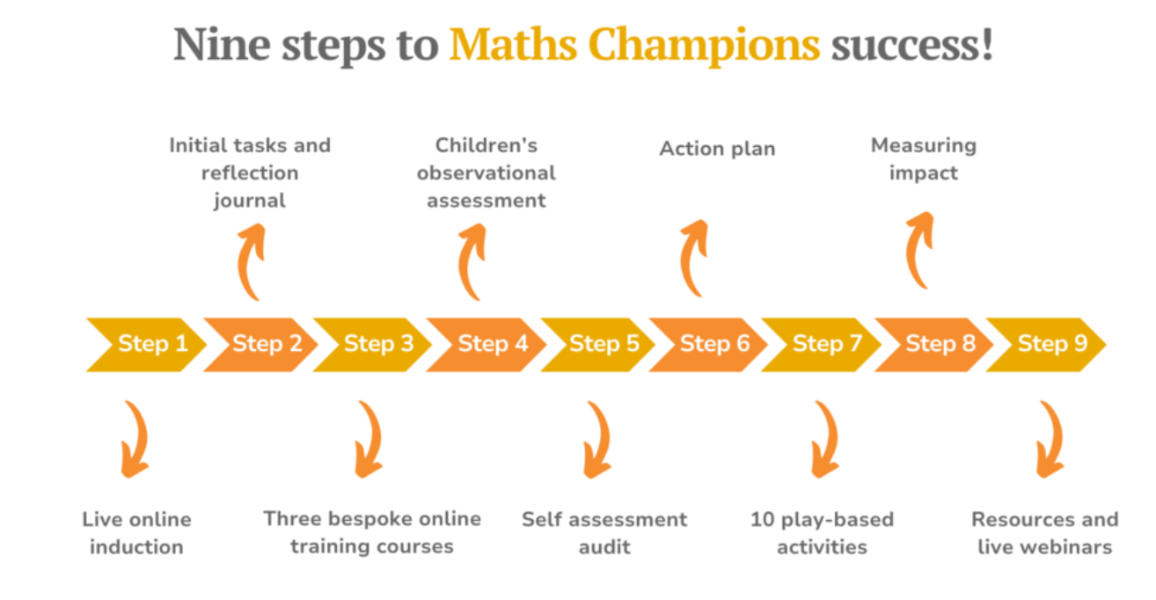

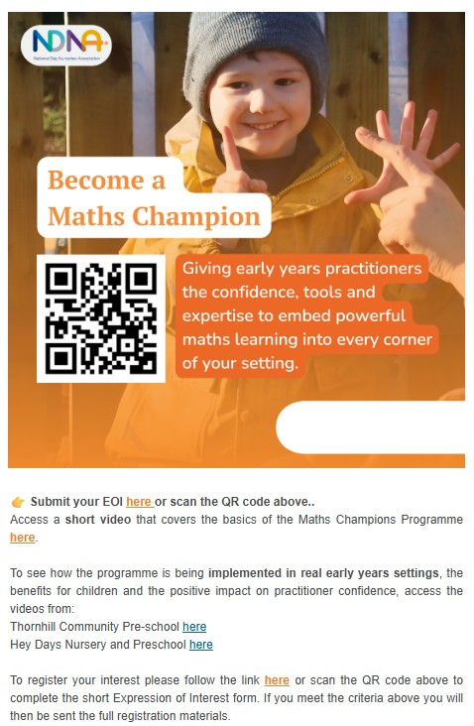

The Department for Education is offering free training opportunities for the early years workforce, including reception teachers.
Choose from:
Early years child development training: build your understanding of child development from birth through to reception.
Excellence in Reception teaching: a funded course designed to strengthen reception-specific teaching knowledge and practice.
National Professional Qualification in early years leadership: develop your leadership skills and confidence, with more funded places available in 2026.
Whether you're looking to deepen your expertise or take the next step in your career, these programmes are a fantastic opportunity to invest in your professional development.
Find out more and apply
Child development: Early years child development training: https://tinyurl.com/45c6hzwt
Reception teaching: Excellence in reception teaching course: https://tinyurl.com/bd8pz5zu
NPQ: Early years leadership national professional qualification: https://tinyurl.com/9defynhs

DfE Early Years child development training
Early years child development training

Overview
This training course will give you a thorough understanding of the most important aspects of child development in the early years, including reception years. Each training module on this site covers an important area of child development and has been written by early years experts, working with the Department for Education.

Why should I take this training
- is free
- is for childminders and nurseries
- combines theory with practical tips and ideas to use in your setting
- includes opportunities to reflect on your practice
- reinforces your understanding through learning check questions and tests
- links to additional resources
- offers the opportunity to download certificates of completion
- has been developed by expert practitioners

Programme content
The course has 8 modules. Each module should take between 1 and 2 hours to complete. You can pause and restart the training as much as you like.

Each module includes:
- opportunities to reflect on your learning and practice
- a learning log to make notes on your reflections
- practical tips and ideas to use in your setting
- learning check questions to test your understanding
- an end of module test
- the opportunity to download a personalised certificate of completion
Some modules also have short videos to enhance your understanding.

How to access the training
Create a log in here
Early years child development training : Home page (education.gov.uk)

Once you create your own log in you can work your way through the modules online at your own pace, there is even a learning journal you can complete to record your own notes.

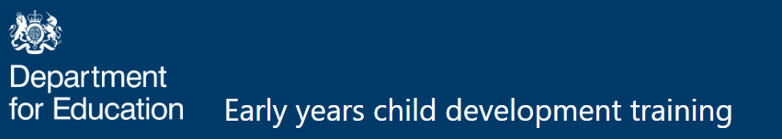

Safeguarding children and babies in Early Years settings
'Safeguarding children and babies in early years settings' - is the new FREE training that has been written by the NSPCC and in collaboration with the DfE. It was launched last week and we promised to post the details and the links for EY practitioners to access this authentic, research based safeguarding training.
Here's some details about the course.
The course comprises of 5 online modules.
💛What is safeguarding?
❤️Operating in line with legislation and guidance.
💙Recognising harm, abuse and neglect.
🧡Responding to and reporting harm.
💚Creating a culture of safeguarding.

The link to take you to the training is embedded into the new Early Years Foundation Stage statutory framework (Sept 2026) at the bottom of the Annex C: Criteria for effective safeguarding training. This takes you back to the main website page for the EYFS here:👇
https://www.gov.uk/government/publications/early-years-foundation-stage-framework--2
Scroll down the page on the website and you will come to the text below. 👇
DfE has developed online safeguarding training in collaboration with the NSPCC. The training is free for all early years educators. Log in to the early years safeguarding training. 👇
You may already have an account?
If you do not have an account, use the registration form to sign up. 👇
https://eysafeguardingtraining.vc-enable.co.uk/Register

Free online courses & e-learning training
Free online courses & e-learning training
Kickstart your learning with Virtual College's free online courses – from safeguarding to wellbeing. Gain expert knowledge and earn a downloadable certificate. Just pick a course, sign up, and start learning – no cost, no catch.
Free Online Courses | E-Learning Training | Virtual College

Education Endowment Foundation
EEF opportunities
For Reception:
Maths Through Picture Books: A 10-week intervention that aims to support reception aged pupils to develop their mathematical talk and confidence. Teaching assistants receive training, mentoring and resources to deliver a small-group intervention, using picture books to support conversations about number and operations.

Education Endowment Foundation
Education Endowment Foundation
We’re delighted to open recruitment for six new EEF-funded projects for primary and secondary schools.
These projects focus on key priorities including reading, mental health, science, maths, adventure learning, and teacher recruitment & retention.
Every year, thousands of schools across England take part in EEF projects — helping to build the evidence on what works.
Find out which projects your school could take part in:
https://tinyurl.com/7abr9ey2

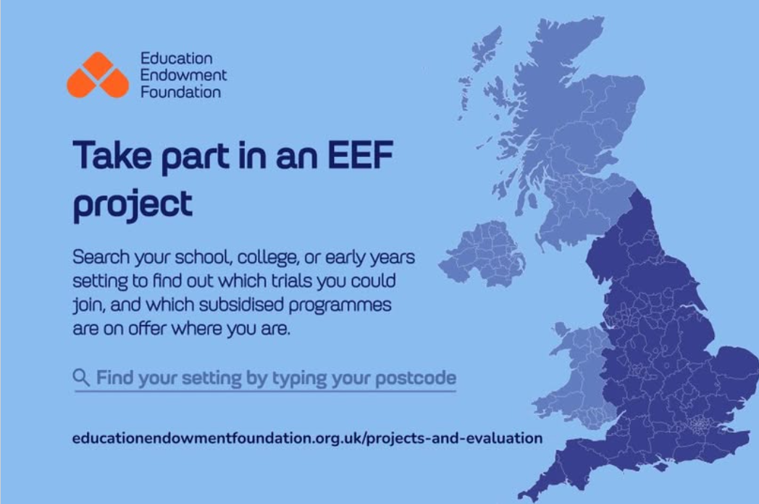

Thames Valley Early Years
Stronger practice hub

Welcome to the Thames Valley Early Years Stronger Practice Hub Newsletter, we have lots going on this term so please look below to see if you would be interested in joining one of our events or networks or sign up to one of the free programmes!
For more information about Stronger Practice Hubs, go to our website
If you have colleagues who are not already signed up to the hub, please ask them to join the hub.
JOIN THE HUB HERE

Childminders can access any of the courses and there is also a childminders network they can join. If childminders would like to join our ‘virtual network’ they just need to send an email to our admin Gen admin@tveysph.prg with their name, address and a mobile telephone number and Gen will organise the rest!

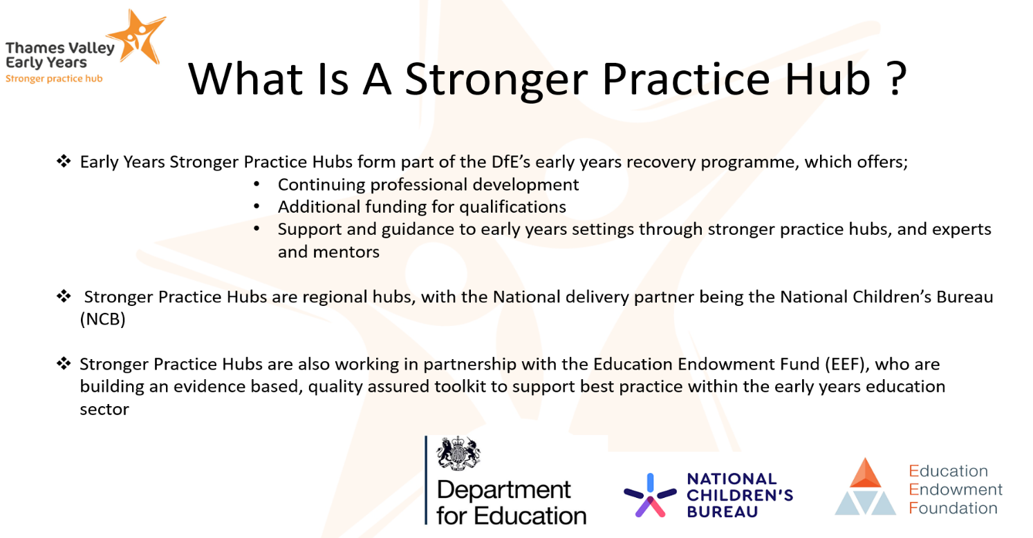

Recommended EY training partners
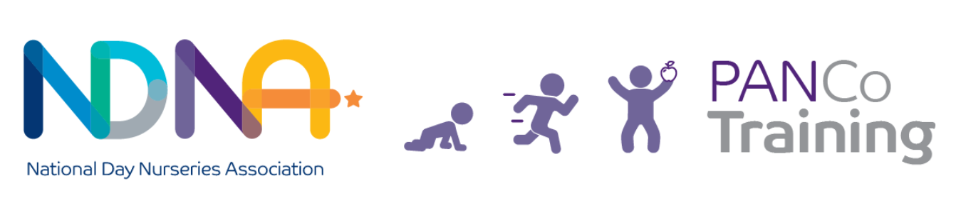
NDNA are now offering the PANCo training - NCFE CACHE Level 4 Award: PANCo (Physical Activity and Nutrition Coordinator)
The PANCo training programme is a well-being in action intervention that promotes positive nutrition and physical activity to support the prevention of obesity within early years settings. Our PANCo qualification gives early years educators a robust knowledge base and the skills to lead and support change within the setting.
Join the growing movement of PANCo Pioneers and Start Life Well Champions in our PANCo Network. Suitable for practitioners and leaders who want to foster health and well-being in their early years settings.
PANCo Training | Physical Activity & Nutrition in Early Years | NDNA

For a range of free and charged training courses we recommend you check out what is available through:

Training from PACEY | PACEY

Training | early years alliance (eyalliance.org.uk)
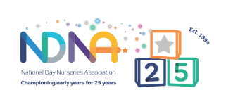
Early years and childcare training - NDNA


Early Years | Best Practice Network

Also check the Early Years weekly news bulletin for featured CPD and training opportunities

Recommended links and other training
Strengthening relationships and building happy homes by reducing parental conflict
Parental conflict is a pattern of destructive conflict behaviours which put children’s mental health and life chances at risk.
In Slough, we have four courses on offer to support parents in conflict. These courses are suitable for separated parents or parents still in a relationship. They can be offered online or face to face
.
To make a referral or to enquire further please contact Tracy Dickon – Reducing Parental Conflict
Co-ordinator Tracy.Dickson@sloughchildrenfirst.co.uk

Food hygiene training
Level 2 award - food safety in catering
Training is an essential part of good food hygiene practice and is a legal requirement for all food handlers. Please see below links to training providers which offer this online training.
Food Safety Level 2 | Highfield e-learning
All online courses (cieh.org)

There is also free online training available on allergies from the Food Standards Agency https://www.food.gov.uk/business-guidance/online-food-safety-training

Slough Museum
Slough Museum: https://sloughmuseum.co.uk/
Our current schedule is here (more stuff coming up soon): https://sloughmuseum.co.uk/whats-on/ ; for updates you can follow us on Facebook (Slough Memories profile and Slough Museum Page); Instagram and Twitter @sloughmuseum
Early years curriculum (0 to 5) - GOV.UK (www.gov.uk)
Early years and childcare: guidance for providers - GOV.UK (www.gov.uk)
Foundation Years - Latest news, policy and resources for early years professionals
Education Endowment Foundation | EEF
Professional Association for Childcare and Early Years | PACEY
National Day Nurseries Association - NDNA

