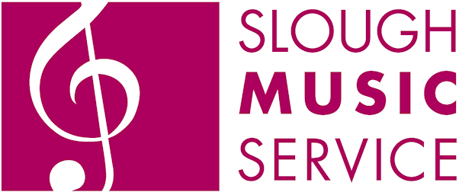
Slough Music Service
Application for Slough Youth Orchestra

Completed applications should be sent to:
Slough Music Service. Slough Borough Council, 15 Bath Road, Slough, SL1 3UF
Tel: 01753 875732 Email: music.service@slough.gov.uk

This form is for pupils attending the Slough Youth Orchestra rehearsals and performances unattended, ie: not with adult supervision from their school.
PLEASE COMPLETE IN BLACK INK AND USE CAPITAL LETTERS Our privacy policy can be viewed on our website

Pupil: First Name _____________________________ Second Name__________________________________

Date of Birth______________________ School Attended _____________________________________

Instrument ________________________ Name of instrumental teacher _________________________

Standard (Grade or equivalent): ______________________________________________________

Or length of time learning instrument: _________________________________________________

SPECIAL NEEDS Please give details of medical conditions, allergies or other special (medical or educational) needs _____________________________________________________________________________________________________

RECORDING / PHOTOGRAPHY Please delete the following paragraph if you do NOT GIVE PERMISSION:
Slough Music Service occasionally takes photos & audio/ video recordings of pupils for archive purposes, teacher training and use in promotional material (inc. internet). I give permission for material of my child to be used for these purposes.

SLOUGH MUSIC SERVICE CANNOT ACCEPT RESPONSIBILITY FOR THE CARE OF CHILDREN OUTSIDE OF REHEARSAL TIMES.
Declaration: I have read and accept the terms and conditions overleaf, and agree to abide by them. This is an ongoing agreement and will automatically be renewed each term. Please see terms and conditions for ending this agreement. Centre members are expected to attend rehearsals regularly and to be available for end of term concerts and other events. Signature: ___________________________________ Date: ______________

Slough Music Service would like to contact you by post informing you of the events and opportunities we offer young musicians in Slough. If you would like to receive these communications, please tick here:

