17th September 2018 – updated 12th October 2018

To: Head Teachers, Heads of Music and Instrumental Teachers in all Slough schools
Dear colleagues

Following last year’s very successful Slough Youth Orchestra projects, at which we had our young musicians playing together as a 50 strong symphony orchestra performing at The Curve and as guests of Buckinghamshire Music Service at the Royal Albert Hall, we are proud to offer 2 Slough Youth Orchestra projects next year. Most importantly the projects will remain free to all participants.

The invitation is open to all orchestral instrumentalists of grade 4+ and this year we hope to attract more musicians from schools across Slough.

Monday 19th November 9.30am – 2.30pm: rehearsal
Friday 23rd November 9.30am – 2.30pm: rehearsal
Wednesday 28th November 4pm: rehearsal
6pm: performance

Wednesday 20th March 9.30am – 2.30pm: rehearsal
Monday 25th March 9.30am – 2.30pm: rehearsal
Friday 29th March 4pm: rehearsal
6pm: performance

All rehearsals and concerts will be held at Langley Grammar School.

The conductor for this project is Tom Horn, who works extensively teaching for Buckinghamshire Music Service and has experience as musical director and conductor of many orchestras including, Pelly Concert Orchestra, The Marlow Orchestra, Aylesbury Youth Orchestra, High Wycombe Youth Orchestra, Buckinghamshire County Youth Orchestra, Haslemere Music Society and the Charity Symphony Orchestra, and has led the Slough Youth Orchestra at our debut performance and again last year.

We will fit the repertoire depending on the standard and numbers of musicians that apply to take part.

If we are overprescribed we may select musicians according to their standard, however this is most unlikely to happen, as we will try to accommodate everyone.

Last year’s performances were a great success and I very excited to be able to bring together musicians in Slough to form our borough youth orchestra again this year.

Please complete and return the reply slip below to myself, Laura Lancaster at Slough Music Service, Slough Music Service. Slough Borough Council, 15 Bath Road, Slough, SL1 3UF. Please also find attached a photograph consent form for parental approval.

I look forward to hearing from you
With best wishes
Yours sincerely
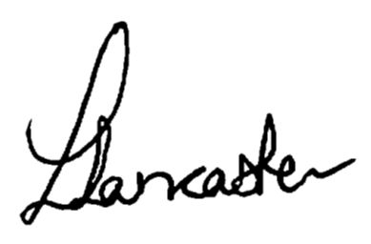
Laura Lancaster
Head of Slough Music Service


REPLY SLIP: Slough Youth Orchestra Autumn 2018 & Spring 2019

Please return this reply slip as soon as possible to Laura Lancaster, Slough Music Service, Slough Music Service. Slough Borough Council, 15 Bath Road, Slough, SL1 3UF. Tel: 01753 875732 Email: music.service@slough.gov.uk

Name of school …………………………………………………………………………………..............................................

Music department contact name …………………………………………………….……………………………………........

Telephone number ………………………………………… Email address …………………………………………...............

I would like to bring more than 5 musicians to join the Slough Youth Orchestra and a school staff member will supervise them November YES / NO
March YES / NO

Name of adult supervisor ……………………………………………………………………

I have up to 4 musicians who will join the Slough Youth Orchestra and they will attend unaccompanied November YES / NO
March YES / NO

Pupil name | Instrument | Standard (grade or equivalent)
Continue overleaf as necessary

Deadline for application is Thursday 18th October 2018

Signature ……………………………………………………………………………………. Date ………………………………..

