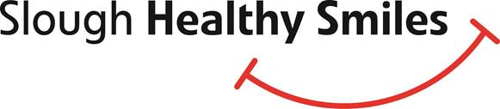

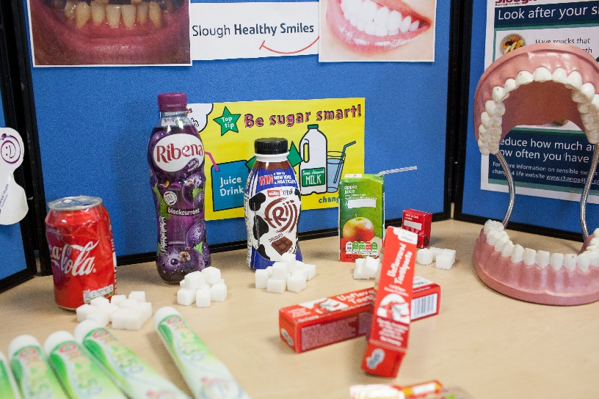

Slough Healthy Smiles has been working in partnership with Slough Borough Council across Slough and we would love to work with your settings to raise awareness of the importance of oral health for the families you work with both in terms of oral health but also in terms of the impact that the risk factors that can affect oral health can have on the general health of individuals including the risk of diabetes, cancer and obesity. Around 41 % of 5 year olds and 26 % of three year olds in Slough have decay and in England a child has an operation roughly every ten minutes to have teeth removed. Many of these 170 operations a day could be prevented and we would love to work with your teams to prevent children having to go through this.

Slough Healthy Smiles is able to offer

* **Information sessions** for the families you work with including sessions for parents with a colourful display board, leaflets and free samples and activities for children and a member of staff available to answer any questions on oral health. Alongside this we are also able to provide sessions for the children.

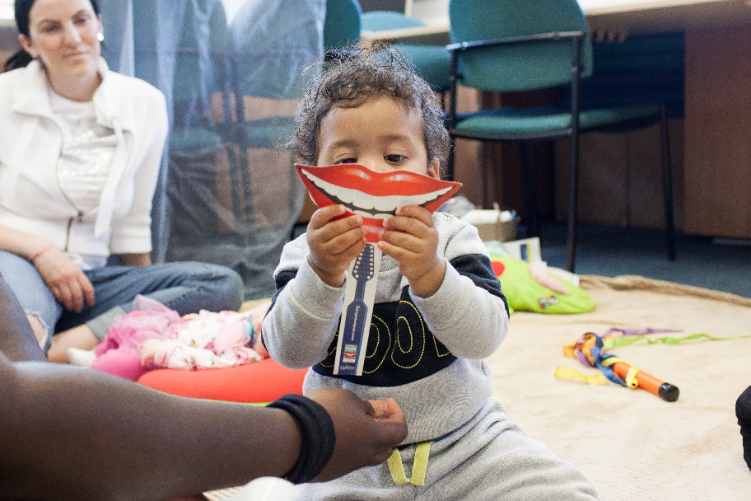

* **Training in oral health**, we are able to offer training sessions for early years staff. The training includes background on oral health specific to Slough, the key messages regarding oral health, helping families to access dental care and how to manage dental trauma. We are also able to offer training in introducing supervised tooth brushing in early years settings

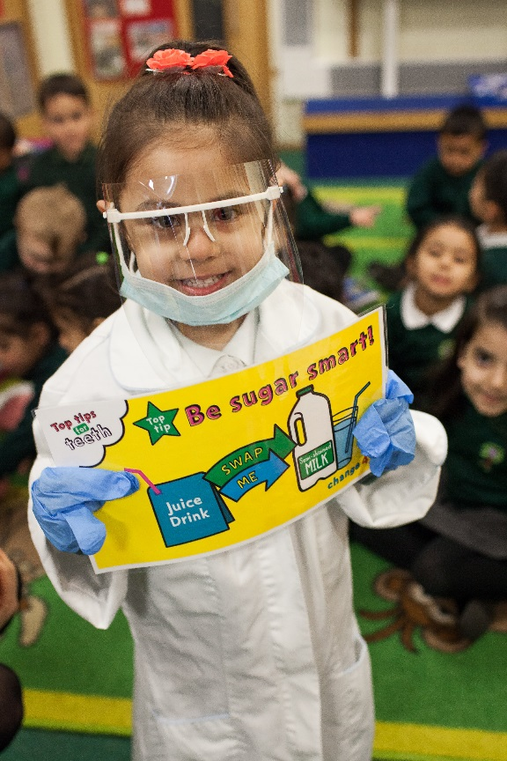

* **Accreditation of settings**. We would be delighted to provide you with more information regarding our Healthy Smiles Accreditation. The accreditation has three levels as detailed below

|  |  |
| --- | --- |
| Bronze | * An oral health promotion policy is promoted * There is a named Oral Health Champion at the setting * Nominated staff receive oral health promotion training * Tooth-friendly food, drinks and snacks are promoted * Positive oral health messages are shared to children and parents/caregivers |
| Silver | * As bronze above, plus: * An audit is conducted once per year to understand the oral health status of children attending the scheme * Actively deliver direct oral health education and outreach sessions linked to the curriculum * Incorporation of wider public health messages (hand washing, immunisation, pregnancy health, physical activity, healthy eating) by use of resources and displays |
| Gold | * As silver above, plus: * A supervised tooth brushing scheme is introduced at the setting |

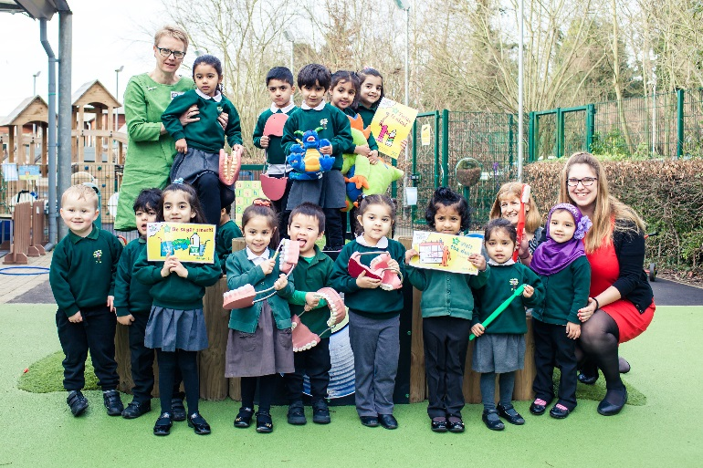

If your setting would like to take up any of the offers above, please contact the Slough Healthy Smiles Team on [oral.health@oxfordhealth.nhs.uk](mailto:oral.health@oxfordhealth.nhs.uk)