Autumn 2018 – Assessment and moderation newsletter

Welcome back to another year. The year has already started with a bang. Changes are afoot not just with assessment and moderation but other things as well. Would you believe Healthy Schools is back! I am not sure when it will happen locally but be aware its on the horizon again. It’s like déjà vu!

I would like to thank all the moderators who performed their duties admirably last year. The feedback from the schools was very positive. Also, a big thank you to all the schools who were very supportive of the whole process. In nearly all cases the evidence provided was extremely accurate and well organised.

I would like to also thank Hillingdon, and Rani Dadi ( my counterpart) who again has agreed to be our partner local authority for the appeals process for 2019.

Exemplification materials this year Key stage 1
There will be new exemplification materials coming out this term (Mid October) from the STA, to reinforce the revised standards in mathematics and reading for Key Stage 1 and 2.
14th December
This date is the deadline for academies to have a written agreement in place with their chosen LA for monitoring the tests and external moderation of their TA, and have reported this information to STA via NCA tools.
This is also the deadline for participating independent schools to have a written agreement in place with the LA that will complete monitoring of the tests and external moderation of their TA and have reported this information to STA. Independent schools that do not report which LA will be completing their monitoring and moderation will not be able to complete pupil registration and will not receive test materials.

Notice to academies
Unfortunately, the LA does not receive funding for moderation visits for academies. Like other local authorities, academies will be charged a nominal fee for an external moderation visit this year. A letter will be sent to all academies, free and independent schools for this service. This letter will be confirmation for which local authority they wish to be part of, for the external moderation visits. This letter will also be available of the Slough Links website. The cost has been decided and they are below:

The costs for a visit will be: - although these may have to be revised the following year.

1 and 2 form schools £400 – 2 moderators (locally agreed)
3 form schools £600 - 3 moderators
4 form schools £800 – 4 moderators

The letter will be available on the ‘Link’ website.

48 hours notice
As part of our local agreement we inform schools that they are to be externally moderated as soon as we possibly can. Unfortunately, some schools will not be allowed this courtesy. This will only happen to schools for which the STA has decided, for one reason or more, they wish to be moderated.
The STA has given guidelines that some schools will only be given 48 hours notice for a moderation visit. The visit will take place within the external moderation window – which is usually most of June.

2019 assessment and reporting arrangements (ARA) have been published in late October
You can find statutory guidance for the national curriculum assessments in the 2019 KS1, KS2 and EYFS

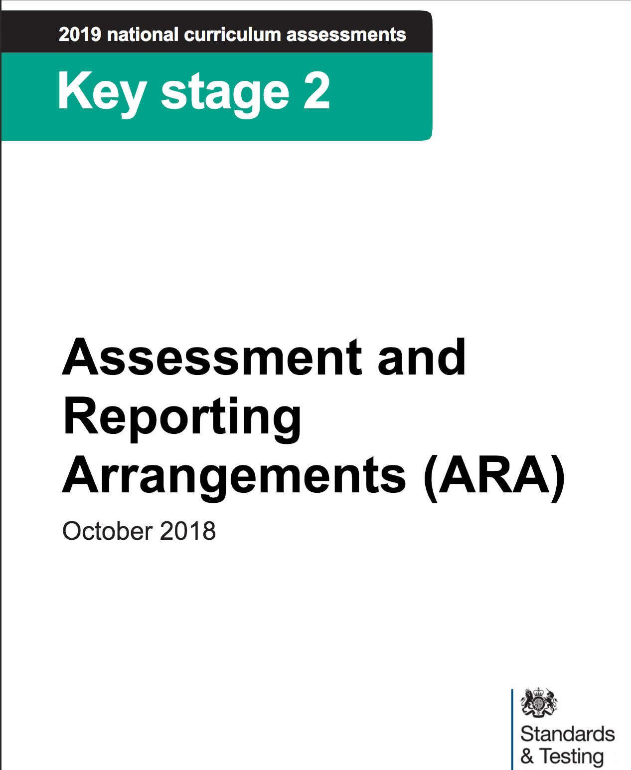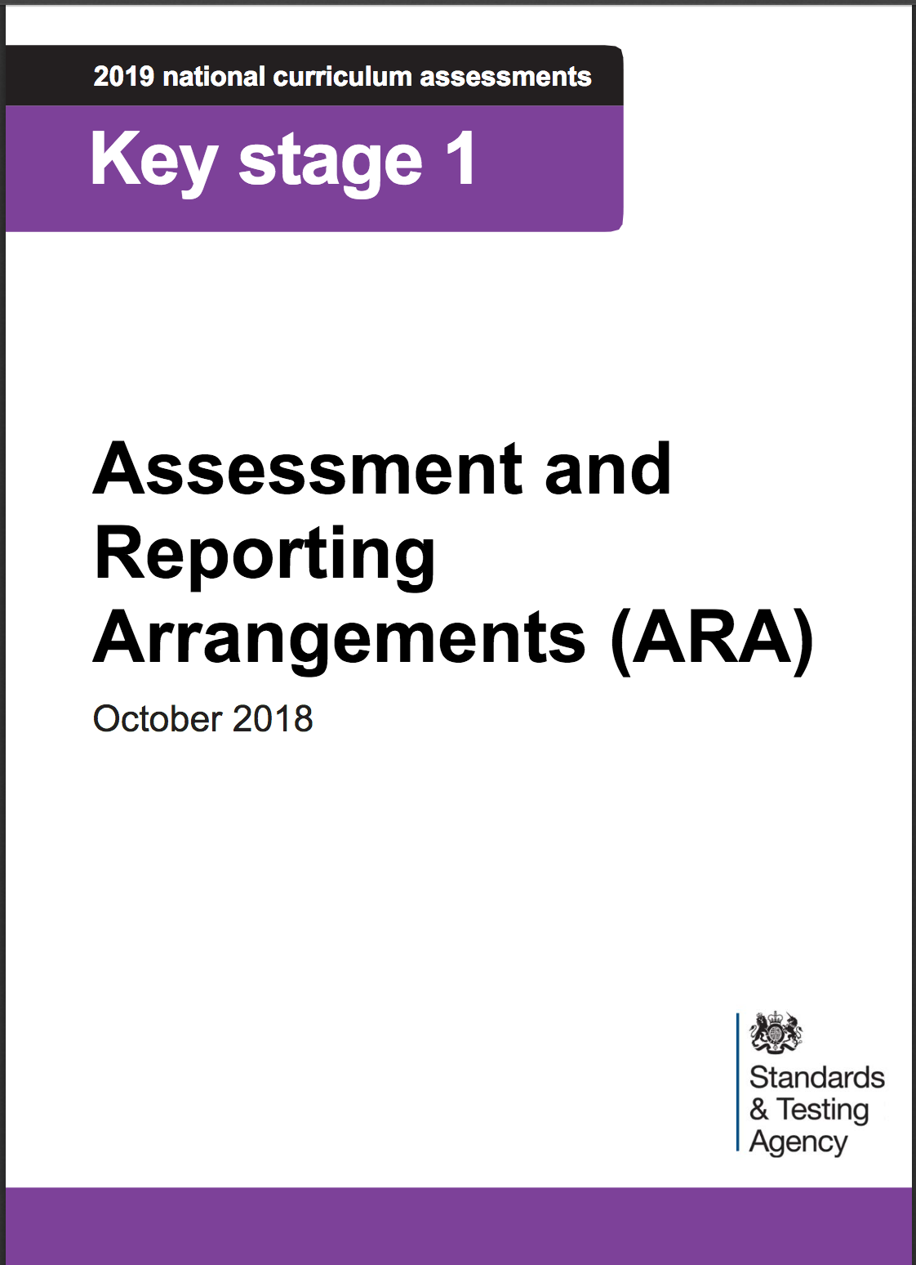

Teacher assessment Frameworks 2019

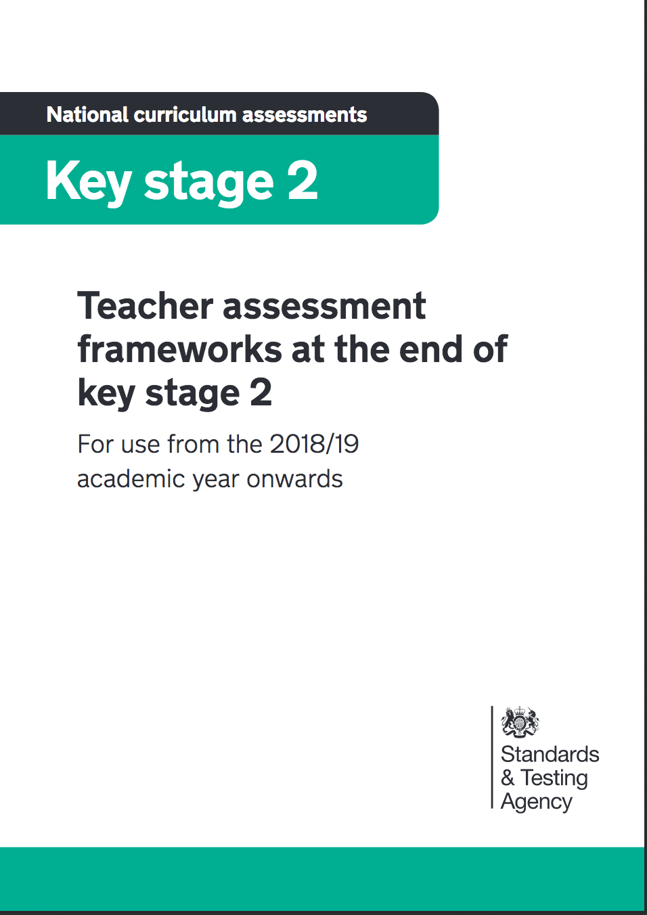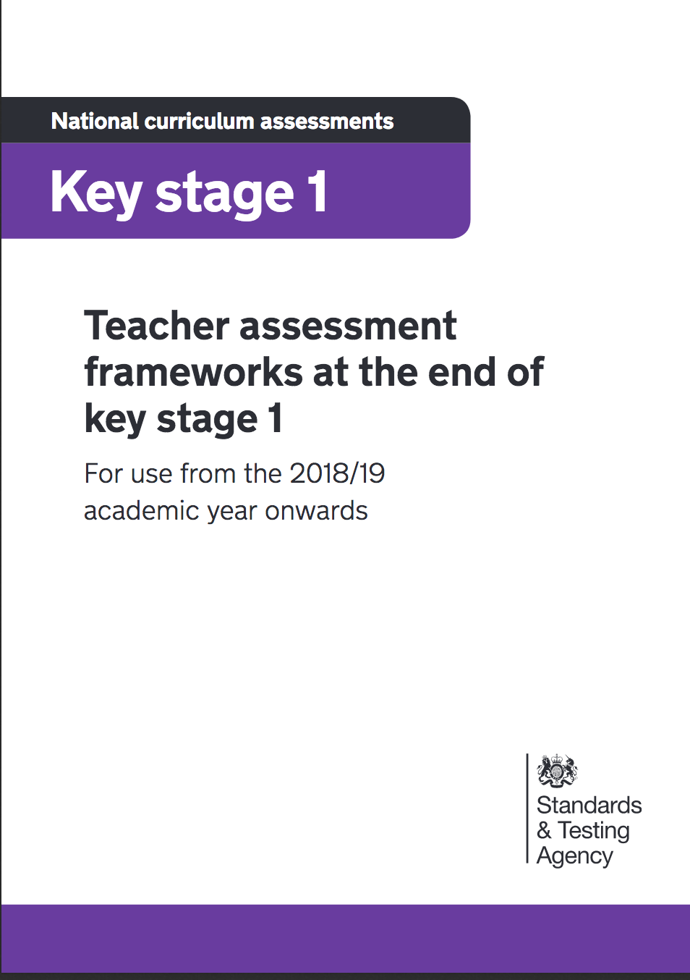
The revised teacher assessment frameworks are now available The Key Stage 1 framework includes the new frameworks for reading and mathematics. They are available via;

https://www.gov.uk/government/publications/teacher-assessment-frameworks-at-the-end-of-key-stage-1

https://www.gov.uk/government/publications/teacher-assessment-frameworks-at-the-end-of-key-stage-2

Potential Moderators –
It is a requirement that local authority (LA) moderators of key stage 1 (KS1) and / or key stage 2 (KS2) English writing must successfully complete a standardisation exercise to be approved to moderate in 2019.
In order for the STA to review the outcomes of the standardisation exercises, and to issue approval emails, they are asking that KS1 and KS2 English writing moderators provide their details via a short survey.
The following information is required from all potential moderators:
· full name
· email address
· LA name
· key stage(s) to be moderated
Please ensure that all of you who want to become moderators within their LA, or any external providers moderating for them in 2019, register your details individually by Friday 30 November 2018. The survey was part of the October 1st official communication to stakeholders from the DfE.
Please let me know if you want to be a moderator so you can complete the survey. I will send the survey link if you have not received it.

Courses will be advertised on the new slough website called https;thelink.slough.gov.uk. There is a page called Statutory Moderation and Assessment. This is where training will be advertised and also on the same website LA Services/school effectiveness services.

There will be a charge for the initial moderation training as some people may just want to do the training and not necessarily become a moderator. Also we are having to cover more of the costs incurred for moderation.

The standardization test will be on a separate day as the materials for the test will not be sent until later December.

Courses for Key stage 1 and Key stage 2

End of KS1 Assessment and Moderation
Audience: NQTs teaching year 2 , experienced teachers and new teachers to new to year 2
Attendance is highly recommended for teachers in all schools to ensure that they are familiar with the new arrangements for end of Key Stage 1 assessment this year.
Course Code: CPD?
Date: Thursday 22nd November 2018
Time: Prompt start at 9.30 am - 3.30 pm (Registration & refreshments from 9.00 am) – Lunch provided
Venue: Beechwood Conference and Research Centre
Cost: £130 per delegate
Trainer: Jamie Hassan – KS1 and 2 Assessment manager.
Key information for delegates: Delegates to bring early examples of work for 1 or 2 children in reading, writing and maths
KS2
Audience: NQTs teaching year 6 and experienced teachers new to year 6
Attendance is highly recommended for teachers in all schools to ensure that they are familiar with the new arrangements for end of Key Stage 2 assessment this year.
Course Code: CPD?
Date: Thursday 29th November 2018
Time: Prompt start at 9.30 am - 12.30 pm (Registration & refreshments from 9.00 am lunch provided)
Venue: Beechwood Conference and Research Centre
Cost: £95 per delegate
Trainer: Jamie Hassan KS1 and 2 Assessment Manager.
Key information for delegates:
Delegates to bring early examples of work for writing for 3 children at working towards/work at the expected level and working at great depth.
Potential moderator Courses exercise 2

KS1

Audience: For experienced moderators and or KS1 teachers

Course Code:

Date: Tuesday 4th December 2018

Time: Prompt start at 9.30 am - 3.30 pm (Refreshments and lunch provided)

Venue: Beechwood Conference Centre

Cost: £130 per delegate

Trainers: Jamie Hassan + 1 other

KS2 Audience: For experienced moderators and or KS2 teachers

Course Code:

Date: Thursday 6th December 2018

Time: 9.30 am – 3.30 pm (refreshments and lunch provided)

Venue: Beechwood Conference Centre

Cost: £130 per delegate

Trainers: Jamie Hassan.

Standardisaton exercise will be completed at a later date – the week beginning 10th December.

Key stage 1 standardisation excerise 2
Date: Wednesday 12th December
Venue: Cippenham Infant School
Start time: 4pm.

Key stage 2 standardisation exercise 2
Date: Thursday 13th December
Venue: Willow Primary School
Start time: 4pm

Standarisation Exercise 3 for moderators
There will be no training for this as we expect those who are interested to moderate attend the initial training in November. It will only be for the standardization exercise. It will be for those who could not attend the standardization exercises in December or for those who did not successfully complete exercise 2.
It will take place for both Key stage 1 and 2 moderators on the same day
Date: w/c Monday 14th January
Start time: 4pm
Venue: tbc

Moderators who do not successfully complete a standardisation exercise will not be emailed a letter of approval.

Finally, once again: Please make sure you register by completing the short survey via the DfE/STA updates. This must be done by 30th November 2018.

Cross school moderation opportunities

Once again, we have opportunities for staff to attend cross school moderation opportunities with other local schools. The following dates have been put in place. We have two places available on the to attend on the 7th November.

Wednesday 7th November 2018
Central Slough – Willow Primary
Key stage 1 and 2
Start time: 4pm
Finish time: 5/5.30

North Slough – Cippenham Infant(KS1) and Cippenham Primary(KS2)
Key stage 1 and 2
Start time: 4pm
Finish time: 5/5.30

14th November 2018
South/east Slough – Marish Primary
Key stage 1 and 2
Start time: 4pm
Finish time: 5/5.30

National Curriculum Assessments to be done this term

October 29th
NCA tools opens
Maintained schools and academies to order modified
versions of KS1 and KS2 tests

Special schools, PRUs, hospital schools and secure units to order standard and modified versions of the tests.
Independent schools participating in KS1 or KS2 assessments to place test orders and issue privacy notices to parents

November 23rd
Deadline for test orders close

28th January 2019
Access arrangements’ on NCA tools opens for applications for early opening, compensatory marks, additional time and timetable variations.

