

Slough Healthy Smiles would like to invite you to the next Early Years Oral Health Training day on Wednesday 7th November. The training day will include background information on oral health in Slough, key oral health messages regarding oral hygiene, diet and how to help the families you work with to access the right dental care along with information on setting up a supervised tooth brushing program and gaining a Slough Healthy Smiles Accreditation.

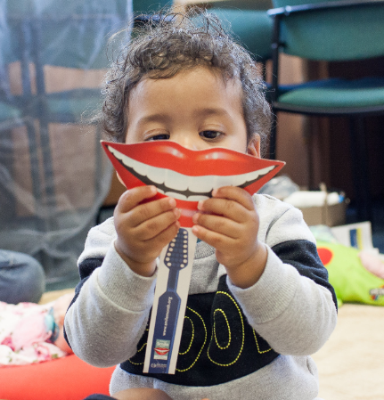

|  |  |  |  |
| --- | --- | --- | --- |
| **Oral Health Promotion**  **(Health and non-health professionals working with Children)** | | | |
| **Who should attend?** | | | |
| All health and non-health professionals working with children and involved in the delivery or promotion of oral care e.g. early years staff, children’s centre workers, school health nurses, health visitors, community nurses, allied health professionals, healthcare assistants, carers and dental practitioners.  No prior knowledge of oral health is required.  *N.B – Oral Health Promotion also provide the following sessions:*   * *Oral Health Promotion (Staff working with Adults)* * *Oral Health Promotion Refresher Course (for those with prior knowledge of oral health promotion who work with adults and/or children)* | | | |
| **How do I book?** | | **What type of training is it?** | |
| For further details or to book a place on the training please email jennifer.slatter@oxfordhealth.nhs.uk | | Face to face, 3 hour workshop session including oral health information in Slough, key oral health messages on diet, oral hygiene and accessing dental care, providing supervised tooth brushing and gaining the Slough Healthy Smiles Accreditation | |
| **AIMS**  To provide an evidence based workshop to equip staff (who work with children and their parents, carers and teachers) with the knowledge, skills and competencies needed to promote good oral health. | | | |
| **OBJECTIVES**   * To understand the implications of poor oral health * To recognise the factors which influence oral health (including healthy eating, weaning) * To understand key oral health promotion messages * To develop the skills needed to help support service users to improve their oral health * To understand the process of finding an NHS dentist and signposting into NHS Dental Services * To reflect on their own practice and identify ways of incorporating newly acquired knowledge into current practice | | | |
| **Date** | **Time** | | **Venue** |
| 7th November | 2-30-5:30pm | | Chalvey Grove Children’s Centre |