Slough Spring 2019 Moderation and assessment newsletter

Welcome to another term. By the time this newsletter is sent to schools, we should have the moderators who will perform the external moderation visits this year. All moderators will have successfully completed the standardisation moderation exercise to become moderators for both key stage one and two.

Cross school moderation opportunities linked to the interim standards.

I would like to thank senior leaders at Cippenham Infants, St Ethelberts and Marish who have allowed us to use their schools as a venue. As a result, we have some more opportunities for schools to share work for both key stage 1 and 2.

Please visit TheLink website for these opportunities.

Key stage 1 and 2
Venue: Cippenham Infant School
Date: Tuesday 26th February
Time: 4 – 5.30pm
KS1 Focus - Mathematics
KS2 Focus - Difference between Working towards and expected English writing.

Key stage 1 and 2
Venue: Marish Primary Academy
Date: Wednesday 13th March
Time: 4 – 5.30pm
KS1 Focus – Mathematics
KS2 Focus - Difference between Working towards and expected English writing.

Key stage 1 and 2
Venue: St Ethelberts RC Primary
Date: Wednesday 27th March
Time: 4 – 5.30pm
KS1 Focus - Mathematics
KS2 Focus - Difference between Working towards and expected English writing.

We use an online platform called Eventbrite where you can register for places and this can be accessed via the events and training page on TheLink website. Please register using this method so we some idea of numbers attending to help the school and for me to have the right number of resources available. If you have any enquiries on how to book your place please email thelink@slough.gov.uk or alternatively call 01753875504.

Many thanks to all those academies that have already confirmed their wish to be with Slough for the purposes of moderation.
As you know The Standards & Testing Agency (STA) requires all academies to have an agreement with a local authority for monitoring and moderation of statutory assessment in KS1 and KS2. The agreement needed to be in place by 14th December 2018. In the 2019 moderation cycle, STA have decided that academies will be automatically allocated to their geographical Local Authority, unless they notify STA (through NCA tools) by 14th December 2018. Just for our purposes academies are requested to please confirm by email to Jamie Hassan (Jameel.Hassan@slough.gov.uk) as soon as possible that they wish to be with Slough for the purposes of moderation and monitoring.

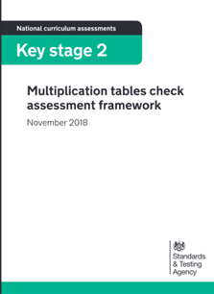

Year 4 multiplication check

Schools can voluntarily administer the check in June 2019.
In the assessment briefing it clarified that schools can choose to administer the check in June 2019. This voluntary check will take place between 10-28 June 2019.
If schools are wanting to take part in the check, they will need to check their pupil registration data is correct on NCA tools when the multiplication check area opens on 1st April 2019.
It might be worthwhile that schools do take part in the voluntary multiplication tables check in 2019. This will enable you to see the format of the check and assess any accessibility features pupil may need to shore up work.
This will help schools prepare for the statutory roll out in 2020.
Year 4 children will only face multiplication statements in the check. Related division facts, a key part of children’s mathematical learning, will not be tested as part of the check.
The test will be fully digital and take place on screen. It will be available to use on laptops, desktops and tablets.
The STA will publish full guidance for your IT administrators before April 2019, but it is expected that most equipment that has access to a web-browser should work with the check.
There will be 3-week window in June for the administration of the check. There is no set test day, nor an expectation that all children will take the check at the same time.

Prior the test window opens each year, there will be the opportunity for children to access a practice area to become familiar with the style of the KS2 times tables test.

Under standard administration (without any access arrangements) the check should take less than 5 minutes per pupil. There is no requirement for all children in a class to take the check all at once.
Children will get 6 seconds to input their answer. Children must be able to read, recall and enter their response within 6 seconds.
Children will enter their answer using a keyboard or by pressing digits using a mouse or touchscreen on an on-screen number pad.

New exemplification materials for KS1
New reading exemplification materials are available for teachers to use this year. These support the changes to mathematics and reading for 2019.

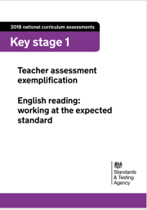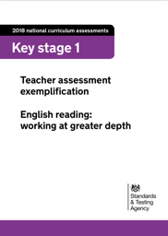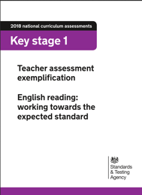

Although not statutory they are a useful tool to support decisions you make a child’s achievement at the end of the key stage.

For English reading, there are 3 separate documents for each of the interim standards.

https://www.gov.uk/guidance/teacher-assessment-exemplification-ks1-english-reading

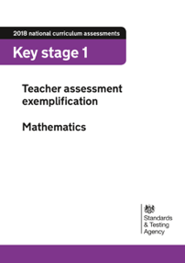

For mathematics, all standards are within one document.
https://www.gov.uk/government/publications/teacher-assessment-exemplification-ks1-mathematics
Exemplification materials for key stage 1 science and key stage 2 science are also available for the 2018/19 academic year.
The existing 2018 KS1 English writing and KS2 English writing exemplification materials should be used in the 2018/19 academic year.
These materials provide examples of pupils’ work to support teachers in making judgements against the statutory teacher assessment frameworks at the end of the key stage.
Hopefully the pre-key stage exemplification materials for English reading will be published this term.

Timetable for tests in 2019

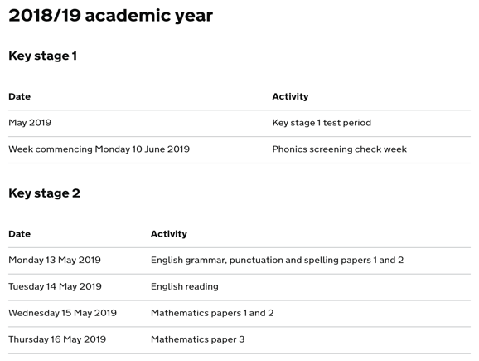

Test changes for the 2018/19 academic year
This year schools can choose what time they administer the tests to their pupils on the days specified in the statutory timetable. In the past schools were required to submit a notification of a start-time variation to STA if they intended to administer the tests to pupils in more than one sitting. From the 2018/19 academic year onwards, no notification is necessary.
Pupils must not take the tests before 7am or after 7pm (like you would do that!).
Schools may move the time of a test on the scheduled day if, for example:
- a pupil arrives late
- the school has a large cohort and there are not enough staff to administer the tests to all pupils at the same time
- there are pupils who need readers, translators or scribes and there are not enough staff to support them to take the test at the same time
- a pupil was unwell at the time the test was taken and is now in a fit state to take the test
- arrangements need to be made for a scribe because a pupil arrives in school with an injury
A school does not need to submit a notification to STA to change the start time of a test.
However, headteachers must authorise all start-time variations. They should be prepared to explain their arrangements if they receive a monitoring visit.
If a School varies the start time of a test the headteacher must confirm that:
- the content of the test(s) has remained confidential
- the pupil has not been in contact with any pupils who have already taken the test(s)
- the pupil has not had access to the test materials, for example, via the internet or social media
- the pupil is in a fit physical and mental state to take the test(s)
Headteachers may wish to contact the pupil’s parents to confirm that the confidentiality of the test(s) has been maintained.
If a pupil has had contact with pupils who have taken the test or had access to the test content, the pupil must not take the test. Instead, they should be marked as absent (A) on the test attendance register.
Failure to follow the guidance above could result in a maladministration investigation.
If a test has to be moved from the specific day then authorisation form the STA is required.
To move a test to a different day, a school must submit an ‘Application for a timetable variation’ in the ‘Access arrangements’ section of NCA tools.

A school can apply to move a test up to 5 school days after the date specified in the statutory timetable. The application form is available from Monday 28 January 2019 until Thursday 23 May 2019.

If you need to do this please check what you can do that for at:

https://www.gov.uk/guidance/key-stage-2-tests-how-to-apply-for-a-timetable-variation.

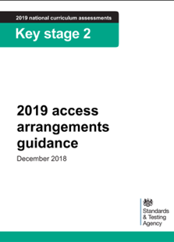

Some pupils may have specific needs. As a result, they may need additional arrangements so they can take part in key stage 2 tests.

This is guidance for schools about access arrangements available for pupils participating in 2019 key stage 2 SATs.
Types of support include:
- additional time to complete the tests
- early opening of test packs, to modify test papers
- compensatory marks for spelling
- the use of scribes, readers, word processors or other technical or electronic aids
- making transcripts
- written or oral translations and the use of accessibility objects in the mathematics test
- the use of prompts and rest breaks
- arrangements for pupils who are ill or are injured at the time of the tests
- administering the tests at an alternative location
This guidance is available from the following link:
https://assets.publishing.service.gov.uk/government/uploads/system/uploads/attachment_data/file/762829/KS2 access_arrangements_guidance_.pdf

Important dates this term
KS1
March 2019 - KS1 test administration guidance published.
Monday 25 March to Friday 29 March 2019
Schools receive KS1 test materials for English reading and mathematics, including any modified test orders.
April 2019 – Phonic Screening Check administration guidance published
KS2
Monday 28th January 2019
‘Access arrangements’ section of NCA tools opens for schools to make applications for early opening, compensatory marks, additional time and timetable variations.
Monday 18th February 2019
‘Pupil registration’ section of NCA tools opens.
Monday 25th February 2019
Deadline for schools to submit applications for early opening and compensatory marks.
March 2019
KS2 test administration guidance9 published.
Friday March 15th 2019
Deadline for schools to complete pupil registration.
Monday 8th April 2019
All schools that applied for early opening or compensatory marks notified of the outcome of their application on NCA tools.
Monday 29th April
Deadline for schools to submit applications for additional time.

