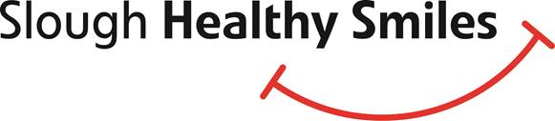

Oral Health in Slough

Accreditation for Early Years and Schools – press release

**Why is Oral Health important?**

Oral health and healthy teeth are important for eating, talking, and for having the confidence to smile and talk to other people at school, work or home. Tooth decay and gum disease can develop if we do not look after our teeth, oral and general health.

**Oral health and Slough**

Slough currently has one of the highest tooth decay rates in the South East with 41.5 % of five year olds having decay. Many of these children will experience pain, discomfort in eating, sleepless nights and need a general anaesthetic to have their decayed teeth removed, requiring time missed from school and work.

Slough Healthy Smiles has been working with Oxfordhealth NHS Foundation Trust, Slough Borough Council, Starting Well (a Smile4life initiative) and Active Movement in Slough to raise awareness of the importance of oral health and ways to improve oral health to reduce the impact of oral health conditions and decay on children and families. Supporting the children in our care establish good oral health habits at an early age means that they will have a better chance of keeping their teeth healthy all their lives.

Slough Healthy Smiles have provided training to staff working in the Early years’ sector, primary schools and to staff working with adults who are vulnerable. The Slough Healthy Smiles team offers an Accreditation System for the Early Years’ and primary school sector.

**What is Oral Health Accreditation for Early Years and Primary Schools?**

An acknowledgement and validation that your setting is promoting positive messages in how to improve oral health and healthy eating. Such as providing only water or milk to drink, providing a healthy snack, promoting reducing sugar intake, promoting active tooth brushing, encouraging children and their parents/carers to visit the dentist.

Slough Healthy Smiles will work with and support your setting to create and maintain positive messages of oral health improvement for the children and families in your care.

**What are the benefits of Oral Health Accreditation?**

* Acknowledges that you have made a commitment to improve the oral and general health of those in your care.
* Supports you to promote the health of those in your care and access resources to assist with this.
* Showcases that your champions of oral health and healthy eating have received evidence based training to promote these topics.
* Helps you to validate that you are working alongside the DOH 2016 white paper Childhood Obesity; a plan for action[[1]](#footnote-1), the DOH 2017 Statutory Framework for the early years foundation stage[[2]](#footnote-2): to promote healthy eating, and DOH 2016 [Improving oral health: a toolkit to support commissioning of supervised toothbrushing programmes in early years and school settings](https://www.gov.uk/government/uploads/system/uploads/attachment_data/file/574835/PHE_supervised_toothbrushing_toolkit.pdf)[[3]](#footnote-3)

**Early years settings and primary schools in Slough with Oral Health Accreditation**

Congratulations and well done to all 10 children’s centres, plus Homestart, Colnbrook nursery, Toad Hall nursery, Jack in Box nursery, Cippenham nursery, Cippenham Baptist Preschool, Little Diamonds preschool, Claycots Nursery, Britwell campus, Claycots primary school, Britwell campus.

Slough Healthy Smiles_logowould love to hear from you; if you would like further information regarding Oral Health Training and/or Oral Health Accreditation, please contact us on [Oral.Health@oxfordhealth.nhs.uk](mailto:Oral.Health@oxfordhealth.nhs.uk)

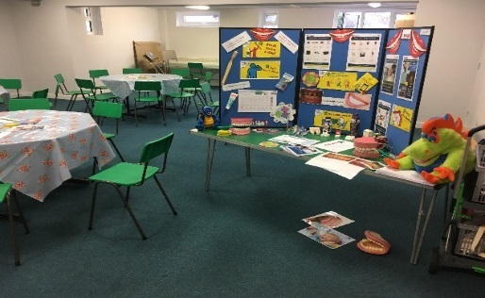 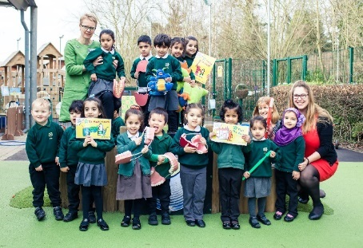

1. <https://www.gov.uk/government/publications/early-years-foundation-stage-framework--2> [↑](#footnote-ref-1)
2. <https://assets.publishing.service.gov.uk/government/uploads/system/uploads/attachment_data/file/546588/Childhood_obesity_2016__2__acc.pdf> [↑](#footnote-ref-2)
3. <https://www.gov.uk/government/publications/improving-oral-health-supervised-tooth-brushing-programme-toolkit> [↑](#footnote-ref-3)