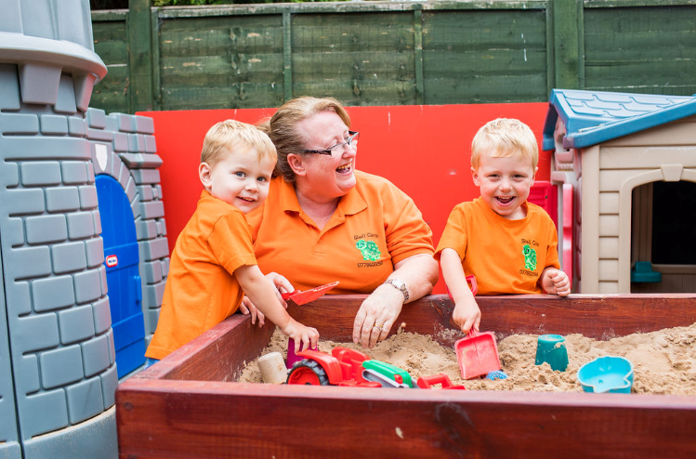 |  | Early Years and Prevention Service  - COVID-19  - ^{1st June 2020}
Recovery Planning for EArly Years and childcare providers |  | In This Issue: 1st June 2020

Every setting should carry out a risk assessment before opening. The assessment should directly address risks associated with coronavirus (COVID-19), so that sensible measures can be put in place to control those risks for children and staff. All employers have a duty to consult employees on health and safety, and they are best placed to understand the risks in individual settings.

Children will need to stay within their new class/group wherever possible and we will ask settings to implement a range of protective measures including increased cleaning, reducing ‘pinch points’ (such as parents dropping children off at the start and end of day), and utilising outdoor space.

If your site or buildings have been closed, or if parts of the building have been out of use for a long period, then you should consider undertaking a health and safety check of the buildings concerned including legionnaires checks if premises have been closed.

The DfE guidance on Implementing Protective Measures in Education and Childcare Settings contains detailed advice for settings on:
- Cleaning, including supplies of cleaning and handwashing products
- Testing and tracing
- PPE
- What settings should do in response to a case of COVID-19 being confirmed

What to include in your risk assessment:
• Some changes to emergency planning and the settings evacuation arrangements may be required.
• How to keep small groups of children together throughout the day and to avoid larger groups of children mixing
• How play equipment is used ensuring it is appropriately cleaned between groups of children using it, and that multiple groups do not use it simultaneously
• Remove unnecessary items from the learning environments where there is space to store it elsewhere
• Remove soft furnishings, soft toys and toys that are hard to clean (such as those with intricate parts)
• Consider how children and young people arrive at the education or childcare setting.
• Review arrangements for the supply of food to the setting and how snacks and meal times can be planned to ensure groups of children are kept together
• Limit external visitors to the setting
• Area dividers may help to keep children in different parts of the room, and floor markings could be helpful in assisting staff with keeping groups apart

Recovery Planning

Risk Assessments

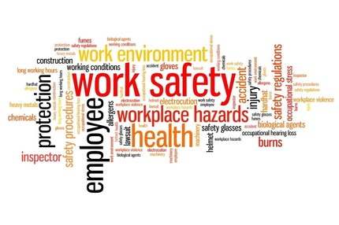

Risk Assessment
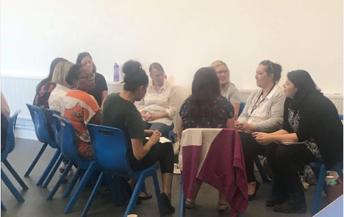
Every setting should carry out a risk assessment before opening. The assessment should directly address risks associated with coronavirus (COVID-19), so that sensible measures can be put in place to control those risks for children and staff.
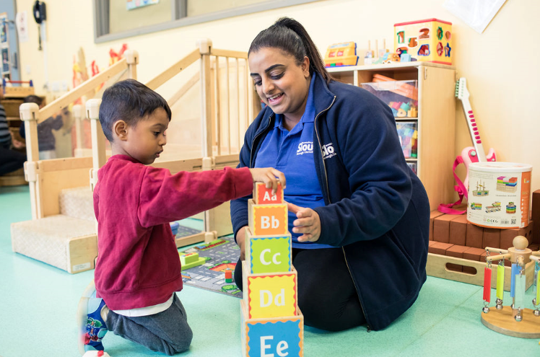

Continuous Professional Development
Communicate your plans for the wider opening of the setting from 1 June with staff, ensuring they are aware of and understand all new measures to reduce the transmission of coronavirus and their roles and responsibilities. Page #

Supporting CPD

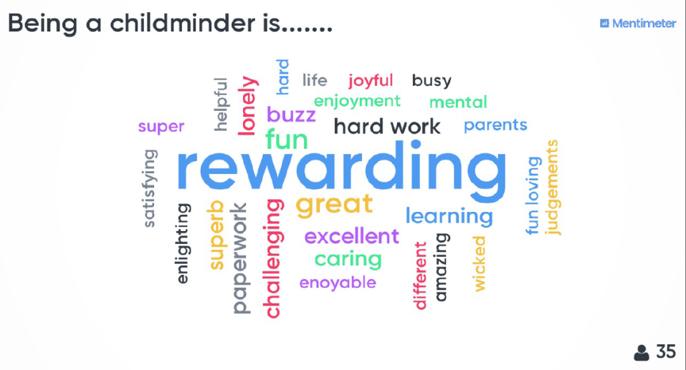
Communicate your plans for the wider opening of the setting from 1 June with staff, ensuring they are aware of and understand all new measures to reduce the transmission of coronavirus and their roles and responsibilities. Build in time for staff to review processes and procedures and to ask questions and raise any concerns in advance.

Ensure that all staff understand that those who have coronavirus symptoms, or who have someone in their household who does, should not attend the setting in any circumstances. Ensure staff understand that if they develop coronavirus symptoms, they are entitled to a test, and are encouraged to organise one in this scenario following government guidance on getting tested.

Consider the instruction and training that staff will need on infection control, for example putting on, taking off and disposing of PPE. Talk to staff about the plans (for example, safety measures, timetable changes and staggered arrival and departure times), including discussing whether training would be helpful

Where possible, staff meetings and training sessions should be conducted virtually and staff should remain at a safe distance from each other during breaks, including in staff rooms or other staff areas in the setting.

Consider:
• What staff development might be useful now? Not just focusing on skills and knowledge but about cultural/behavioural changes in ways of working and mindset.
• What additional capacity could be built through targeted continuing professional development (CPD) in the current period
• Decide what staff training (either delivered remotely or in setting) is needed to implement any changes the settings plans to make (for example, risk management, curriculum, behaviour, safeguarding).
• It is essential that staff are supported and feel valued.
• Are there any staff who are fit/well but highly anxious about returning? What can be done to support these individuals?

Safeguarding
Below is a link to a video which has been developed to cover the basics of safeguarding during COVID-19. It covers safeguarding for both children and adults at home and also includes domestic abuse and exploitation.

It takes less than 10 minutes to view and may be particularly useful as a resource for:-
• redeployed staff
• staff or volunteers working in different ways within the safeguarding arena during this period
• volunteers who do not read English very well as there is no requirement to read the slides.

The messages are simple - “There is no excuse for abuse during Lockdown” and “Help is available -It is business as usual for safeguarding services”
Link to Slough Safeguarding basics https://youtu.be/RDc4mBGbRmA

Nasen
1. An Introduction to Special Educational Needs and Disabilities (SEND)
WEBINAR - 10:30 3 JUN - 12:00 10 JUN 2020
2. How can SENCOs respond to the COVID lockdown and transition back to school?
WEBINAR - 10:30 - 12:00 16 JUN 2020
3. Early Years: working together with parents to identify SEND
ONLINE CPD - 13:30 - 15:00 23 JUN 2020
https://nasen.org.uk/event-listing.html

ACEs
Introduction to Adverse Childhood Experiences - Early Trauma. You will be able to identify adverse experiences that can impact on a child's development and their response to stress, understand the importance of healthy brain development in a child’s early years and the impacts of toxic stress, understand that experiencing adversity in childhood can have a significant impact over a person’s life. https://www.acesonlinelearning.com/

Health and Social Care Prevent COVID-19. This free online training course has been created by our partners at Learn Et Al. It aims to provide learners with information on COVID-19 and suggests best practice for businesses in the current climate. https://www.virtual-college.co.uk/courses/prevent-covid-19-free-training

Professional Development
Slough Early Years Service Professional Development Portfolio (PDP) contains suggestions for workshops and courses. https://thelink.slough.gov.uk/early-years/cpd

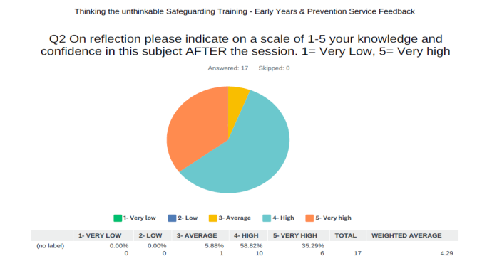
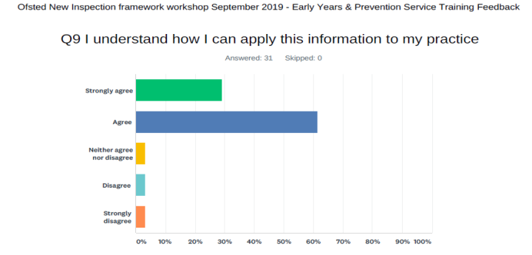
H

Answering your questions

Ask Michael
Service Lead Early Years and Prevention
Many childminders and some providers will again start dropping off and collecting children from schools this week, nationally some schools have banned childminders from doing so. Do you know what the Slough’s schools position is on this?

The planning guidance states ‘To minimise contact between groups of children and staff, children should attend just one setting wherever possible and parents and carers should be encouraged to minimise as far as possible the number of education and childcare settings their child attends. Childminding settings should consider how they can work with parents and carers to agree how best to manage any necessary journeys, for example pick-ups and drop-offs at schools, to reduce the need for a provider to travel with groups of children’.

Childminders and providers who need to attend schools should discuss these arrangements with parents. The parents should confirm with their child’s school what procedures the provider must follow when attending the school premises and the parents must confirm the arrangements as appropriate.

There is no borough wide position available.

If you would like to submit a question to ask Michael or any of the Early Years and Prevention Service team please email earlyyears@slough.gov.uk

Ansering your questions

Slough Borough Council Business Support Fund

From Monday (1 June) Slough businesses are set to benefit from an additional support fund set up by government to help small businesses who were not eligible for the Small Business Grant Fund or the Retail, Leisure and Hospitality Fund.

The Local Authority Discretionary Grants Fund (LADGF) will be distributed to businesses facing financial hardship due to the COVID-19 pandemic.

Slough Borough Council like other local authorities across the UK, will distribute grants to the value of £5,000. Local authorities are encouraged to make payments as swiftly as possible to support struggling businesses. It is anticipated that the first payments made under the scheme will be received by businesses early June.

Only businesses that were trading on 11 March 2020 are eligible for this scheme and businesses who have applied for the Coronavirus Job Retention Scheme are eligible to apply for this scheme as well.

Neil Wilcox, director of finance and resources, said: “The value of the payment to be made to a business is at the discretion of local authorities, which is why we are aiming to pay grants of £5,000 to ensure a greater number of businesses can receive much needed support from this new fund.

“Unfortunately the BEIS allocation to the council for this grant is only £870k which is a lot less than we were hoping for and less than what is really needed to support our local businesses. Therefore we are limited to paying only 174 businesses with a £5,000 grant.”

Councillor James Swindlehurst, leader of the council, said: “I am pleased our business community can access further funding through this new scheme.”

“Micro and small businesses play an important role in growing our local economy by creating jobs and sustaining growth so it is crucial we help them recover during these extraordinary circumstances.”

“I would encourage businesses who match the eligibility criteria to come forward and submit an application.”

The government has asked local authorities to prioritise the following types of businesses for grants:
• Small and micro businesses, as defined in Section 33 Part 2 of the Small Business, Enterprise and Employment Act 2015 and the Companies Act 2006.
• Businesses with relatively high ongoing fixed property-related costs.
• Businesses which can demonstrate that they have suffered a significant fall in income due to the COVID-19 crisis.
• Businesses which occupy property, or part of a property, with a rateable value or annual rent or annual mortgage payments below £51,000.

A document setting out the eligibility criteria and an online grant application form is now available on the council’s website so eligible businesses can submit their applications.
The application process timescale is limited and begins on the 1 June and closes on 12 June. Assessments and payments will be made throughout the month.

More information and access to the form can be found here: https://www.slough.gov.uk/health-and-social-care/covid-19-local-authority-discretionary-grants-fund-.aspx

• Companies that are in administration, are insolvent or where a striking-off notice has been made are not eligible for funding under this scheme.
• Only businesses which were trading on 11 March 2020 are eligible for this scheme.
• This grant funding is for businesses that are not eligible for other support schemes. Businesses which have received cash grants from any central
government COVID-19 related scheme are ineligible for funding from the Local Authority Discretionary Grants Fund.
• Businesses who are eligible for the Self-Employed Income support scheme (SEISS) are eligible to apply for this scheme as well.
• Businesses who have used the Job Retention Scheme are eligible.
• Businesses who have received funding through Retail, Hospitality and Leisure grant, Small Business Grant or Self Employment Income Support
Scheme are not eligible.
• Grants are subject to tax.

Sector Updates
Coronavirus Job Retention Scheme
On 29 May the Chancellor, Rishi Sunak, announced more details about the extension to the Coronavirus Job Retention Scheme (CJRS), with the key details outlined below for you.

Flexible furloughing
From 1 July 2020, you’ll have the flexibility to bring previously furloughed employees back to work part-time – with the government continuing to pay 80% of wages for any of their normal hours they do not work up until the end of August. This flexibility comes a month earlier than previously announced to help people get back to work.
You can decide the hours and shift patterns that your employees will work on their return and you will be responsible for paying their wages in full while working. This means that employees can work as much or as little as your business needs, with no minimum time that you can furlough staff for.
Any working hours arrangement that you agree with your employee must cover at least one week and be confirmed to the employee in writing. When claiming the CJRS grant for furloughed hours, you will need to report and claim for a minimum period of a week. You can choose to make claims for longer periods such as on monthly or two weekly cycles if you prefer. You will be required to submit data on the usual hours an employee would be expected to work in a claim period and actual hours worked.

If your employees are unable to return to work, or you do not have work for them to do, they can remain on furlough and you can continue to claim the grant for their full hours under the existing rules.

Employer contributions
From August, the government grant provided through the job retention scheme will be slowly tapered.
• In June and July, the government will pay 80% of wages up to a cap of £2,500 as well as employer National Insurance (ER NICs) and pension
contributions for the hours the employee doesn’t work – employers will have to pay employees for the hours they work
• In August, the government will continue to pay 80% of wages up to a cap of £2,500 but employers will pay ER NICs and pension contributions – for
the average claim, this represents 5% of the gross employment costs that they would have incurred if the employee had not been furloughed
• In September, the government will pay 70% of wages up to a cap of £2,187.50 for the hours the employee does not work – employers will pay ER
NICs, pension contributions and 10% of wages to make up 80% of the total up to a cap of £2,500
• In October, the government will pay 60% of wages up to a cap of £1,875 for the hours the employee does not work – employers will pay ER NICs,
pension contributions and 20% of wages to make up 80% of the total up to a cap of £2,500
• The cap on the furlough grant will be proportional to the hours not worked.

If you are a smaller employer, some or all of your employer NIC bills will be covered by the Employment Allowance, so you should not be significantly impacted by that part of the tapering of the government contribution.
Around a quarter of CJRS monthly claims relate to wages that are below the threshold where employer NICs and auto enrolment contributions are due, and so no employer contribution will be required for these furloughed employees in August.

Important dates
It’s important to note that the scheme will close to new entrants from 30 June. From this point onwards, you will only be able to furlough employees that you have furloughed for a full three-week period prior to 30 June.
This means that the final date that you can furlough an employee for the first time will be 10 June for the current three-week furlough period to be completed by 30 June. Employers will have until 31 July to make any claims in respect of the period to 30 June.

https://www.gov.uk/guidance/claim-for-wage-costs-through-the-coronavirus-job-retention-scheme

Guidance and support
Further support for employers and agents on how to calculate claims with this extra flexibility will be available by 12 June, including webinars and detailed online guidance. For information about how to claim, go to GOV.UK and search 'Coronavirus Job Retention Scheme'. Please do not call us for more information; everything you need to know about this scheme will be published online on GOV.UK.

Protect yourself from scams
Stay vigilant about scams, which may mimic government messages as a way of appearing authentic and unthreatening. Search 'scams' on GOV.UK for information on how to recognise genuine HMRC contact. You can also forward suspicious emails claiming to be from HMRC to phishing@hmrc.gov.uk and texts to 60599.
I hope this information helps and supports your business, and we’ll continue to keep you updated on scheme developments over the coming weeks.

Self-Employment Support Scheme
The government’s Self-Employment Income Support Scheme will be extended, giving more security to individuals whose livelihoods are adversely affected by coronavirus in the coming months, the Chancellor announced today (Friday 29 May 2020).

This scheme is being extended. You’ll be able to make a claim for a second and final grant in August 2020.
The online service for the second and final grant is not available yet. We will update this guidance to let you know when you can make your claim.

If you’re eligible the second and final grant will be a taxable grant worth 70% of your average monthly trading profits, paid out in a single instalment covering a further 3 months’ worth of profits, and capped at £6,570 in total.
https://www.gov.uk/guidance/claim-a-grant-through-the-coronavirus-covid-19-self-employment-income-support-scheme#extension

Critical Workers who can access schools or educational settings
List of critical workers (key workers) who can send their children to school or other educational settings during the coronavirus (COVID-19) outbreak.
Guidance updated to reflect the announcement by the Prime Minister that the government’s 5 tests have been met and the decision, based on all the evidence, to move forward with the wider opening of education and childcare settings. https://www.gov.uk/government/publications/coronavirus-covid-19-maintaining-educational-provision?utm_source=79e04c7f-cc9c-4b42-9706-d26f7d9b4f61&utm_medium=email&utm_campaign=govuk-notifications&utm_content=immediate#history

Coronavirus (COVID-19): implementing protective measures in education and childcare settings
Guidance for education and childcare settings on how to implement protective measures. Updated to reflect the announcement by the Prime Minister that the government’s 5 tests have been met and confirmation of wider opening of education and childcare settings from 1 June, and updated information on testing for coronavirus. https://www.gov.uk/government/publications/coronavirus-covid-19-implementing-protective-measures-in-education-and-childcare-settings?utm_source=f261be45-ab11-4961-bb70-5f8bfabcdd69&utm_medium=email&utm_campaign=govuk-notifications&utm_content=immediate#history

Actions for educational and childcare settings to prepare for wider opening from 1 June 2020
Next steps for the phased wider opening of educational and childcare settings. Updated to reflect the announcement by the Prime Minister that the government’s 5 tests have been met and the decision, based on all the evidence, to move forward with wider opening of education and childcare settings. https://www.gov.uk/government/publications/actions-for-educational-and-childcare-settings-to-prepare-for-wider-opening-from-1-june-2020?utm_source=eb04f15a-91b7-46f2-b711-7c192a40f1dc&utm_medium=email&utm_campaign=govuk-notifications&utm_content=immediate#history

Ofsted: coronavirus (COVID-19) rolling update Ofsted guidance and information relating to coronavirus (COVID-19) for schools, early years, children's social care and further education and skills providers
Updated with a new section on regulation and inspection of early years providers as they return to providing care for all children, including information for parents of children in early years provision during this time. https://www.gov.uk/guidance/ofsted-coronavirus-covid-19-rolling-update?utm_source=791ad138-baed-402e-8b8d-d0592ef18f8a&utm_medium=email&utm_campaign=govuk-notifications&utm_content=immediate#history

Changes to the law on education, health and care needs assessments and plans due to coronavirus
Guidance on temporary changes to special educational needs and disability legislation during the coronavirus (COVID-19) outbreak. Updated guidance with additional or amended material, including as to: cases in progress on 1 May 2020; annual reviews for those with EHC plans changing phase of education; actions following a tribunal ruling; and unchanged duties in relation to social care provision in plans. Also improvement to the format of the tables in Annex A and a minor change to footnote 1. https://www.gov.uk/government/publications/changes-to-the-law-on-education-health-and-care-needs-assessments-and-plans-due-to-coronavirus?utm_source=bda528ad-1686-42a5-bb5f-14842d8140f7&utm_medium=email&utm_campaign=govuk-notifications&utm_content=immediate#history

School behaviour and attendance: parental responsibility measures
Statutory guidance for schools, local authorities and the police on dealing with poor attendance and behaviour in schools. Updated guidance. https://www.gov.uk/government/publications/parental-responsibility-measures-for-behaviour-and-attendance?utm_source=57647e7e-11d8-41c0-8154-a18141e0c29f&utm_medium=email&utm_campaign=govuk-notifications&utm_content=immediate#history

Disapplication notice: school attendance legislation changes
Secretary of State for Education issues a second notice to disapply offences for non-attendance in schools during the coronavirus outbreak. Added a second notice covering June 2020. https://www.gov.uk/government/publications/disapplication-notice-school-attendance-legislation-changes?utm_source=c3a56e8c-6344-4b28-8dac-f40b879d05a1&utm_medium=email&utm_campaign=govuk-notifications&utm_content=immediate#history

ding Confidence
SLOUGH EARLY YEARS AND PREVENTION SERVICE: TELEPHONE: 01753 476554 / EMAIL: earlyyears@slough.gov.uk

