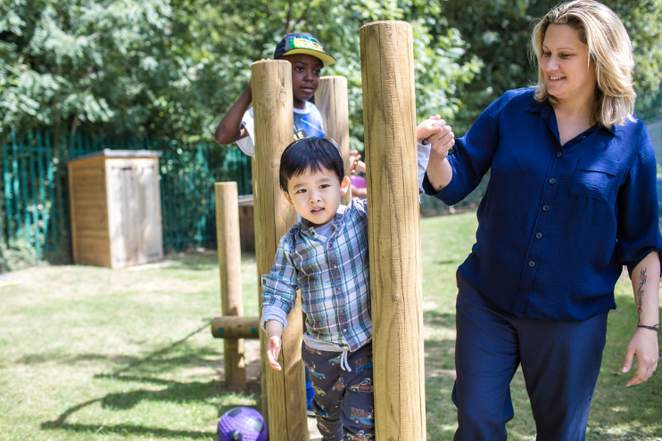 |  | Early Years and Prevention Service  - COVID-19  - 3rd June 2020
Recovery Planning for EArly Years and childcare providers |  | In This Issue: 3rd June 2020

There are many things to think about when reopening an early years or childcare setting and at the forefront of everyone’s minds will be what procedures need to be implemented in order to maintain everyone’s health and safety.

For cleaning and hygiene:
• Ensure sufficient handwashing facilities (running water and soap, alcohol hand rub, sanitiser, skin-friendly wipes) are available for staff and children, and that hands are washed upon entering the setting, regularly throughout the day, before and after eating and when they leave. Ensure children are supervised when doing this, especially if using hand rub or sanitiser, and learn how to do it effectively.
• Ensuring you have a good supply of disposable tissues throughout the setting to implement ‘catch it, bin it, kill it’. Ensure the availability of lidded bins, preferably operated by a foot pedal, and that tissues are immediately disposed into bins and that these are emptied throughout the day.
• Clean surfaces that children and young people are touching, such as toys, books, desks, chairs, doors, sinks, toilets, light switches, bannisters, more regularly than normal
• Ensure that all adults and children:
- frequently wash their hands with soap and water for 20 seconds and dry thoroughly. Review the guidance on hand cleaning
- clean their hands on arrival at the setting, before and after eating, and after sneezing or coughing
- are encouraged not to touch their mouth, eyes and nose
- use a tissue or elbow to cough or sneeze and use bins for tissue waste (‘catch it, bin it, kill it’)
• Ensure that help is available for children and young people who have trouble cleaning their hands independently
• Consider how to encourage young children to learn and practise these habits through games, songs and repetition
• Ensure that bins for tissues are emptied throughout the day
• Where possible, all spaces should be well ventilated using natural ventilation (opening windows) or ventilation units
• Prop doors open, where safe to do so (bearing in mind fire safety and safeguarding), to limit use of door handles and aid ventilation
• There is no need for anything other than normal personal hygiene and washing of clothes following a day in an educational or childcare setting

Recovery Planning

Health and Safety
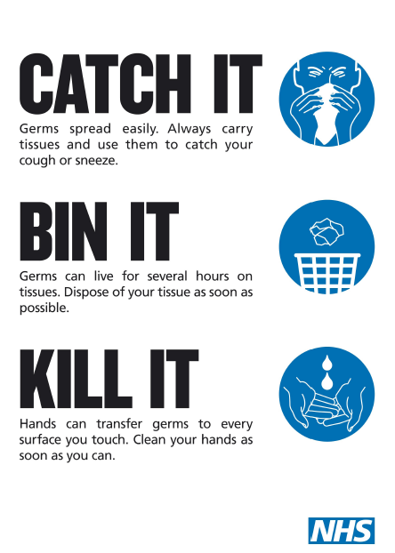
Health and Safety
Ensuring you have a good supply of disposable tissues throughout the setting to implement ‘catch it, bin it, kill it’. Ensure the availability of lidded bins, preferably operated by a foot pedal, and that tissues are immediately disposed into bins and that these are emptied throughout the day.

Ask Michael
ANSWERING YOUR QUESTIONS: please email your questions to earlyyears@slough.gov.uk

Actions for early years and childcare providers – update 2nd June

Actions for early years and childcare providers during the coronavirus outbreak

What childcare services early years settings, childminders and local authorities need to provide during the coronavirus (COVID-19) outbreak. This guidance is for providers registered with Ofsted and childminders registered with childminder agencies for children of all ages, including:
•nurseries and wraparound childcare
•before and after school clubs
•holiday clubs

This guidance does not cover nannies or au pairs.

The guidance has been updated to include a restructure of the document in line with wider opening, updated content on funding including in relation to:
- the Competition and Markets Authority and insurance
- updated content on infection prevention and control
- a new section on attendance
- new information on the use of community centres
- before and after school clubs
- a new section of safeguarding and welfare including provisions for children with SEND
- a clarification on paediatric first aid certificates

This guidance should be read alongside the following guidance:
Guidance on infection prevention and control
- Implementing protective measures in education and childcare settings
- Safe working in education, childcare and children’s social care settings
- Planning guide for early years and childcare settings

Guidance on funding
- Financial support for education, early years and children’s social care
- Coronavirus Job Retention Scheme
- Use of free early education entitlements funding

Other relevant guidance
- Actions for education and childcare settings to prepare for wider opening from 1 June 2020
- Supporting vulnerable children and young people
- guidance on the early years foundation stage (EYFS) disapplications
- Ofsted’s response to coronavirus (COVID-19)
.

Attendance
Attendance in education and early years settings during the coronavirus outbreak
A summary of attendance in education settings since Monday 23 March and early years settings since Thursday 16 April. https://www.gov.uk/government/publications/coronavirus-covid-19-attendance-in-education-and-early-years-settings?utm_source=27a445e7-2967-4dd7-bc1e-71ba528825e0&utm_medium=email&utm_campaign=govuk-notifications&utm_content=immediate

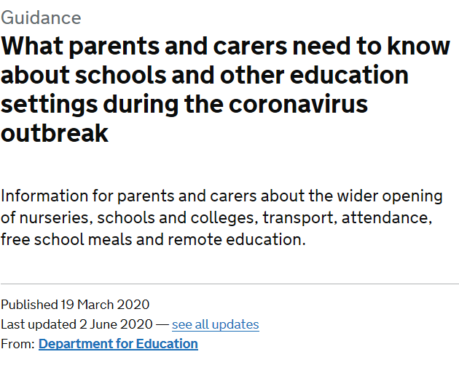
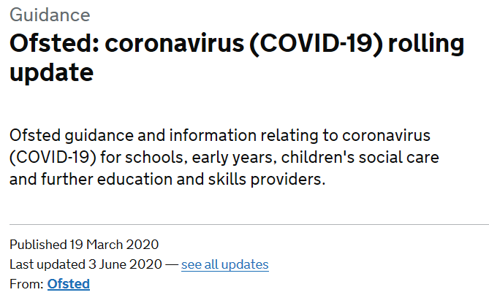
H

Answering your questions

Ask Michael
Service Lead Early Years and Prevention
Slough Early Years and Prevention Service had a pot of money that was used to extend provision / childcare places? Is there now any flexibility with regards to using any ‘spare’ money to develop provision rather than extend it.

The funding we have is for capital projects for the expansion or development of new places, in order to meet our Childcare Sufficiency duty. This still remains a statutory requirement of the local authority and we are continuing to look at our capital strategy planning and currently have an application round open at the moment. Even in the current climate we are still receiving enquiries for new development and have a number of providers who are aiming to submit their applications for Early Years Capital Development this year. The Early Years and Childcare Capital Development Grant has a set criteria and all applications are processed via the Capital Board, for more information please see https://thelink.slough.gov.uk/la-services/early-years-business-development

We are continuing to support providers with sustainability issues and ask any setting who believe that this is an issue, to discuss this with the Early Years and Prevention Service. We will work on a case by case basis to understand the need of that particular provider and we will continue to work with our DfE colleagues to ensure they are aware of the issues effecting the sector following COVID-19.

Slough Borough Council has a Local Authority Discretionary Grant Fund which may be applicable to you? Published on 29th May 2020 https://www.slough.gov.uk/news/newsdetail.aspx?id=22321 the council announced:

“From Monday (1 June) Slough businesses are set to benefit from an additional support fund set up by government to help small businesses who were not eligible for the Small Business Grant Fund or the Retail, Leisure and Hospitality Fund.

The Local Authority Discretionary Grants Fund (LADGF) will be distributed to businesses facing financial hardship due to the COVID-19 pandemic.

Slough Borough Council like other local authorities across the UK, will distribute grants to the value of £5,000. Local authorities are encouraged to make payments as swiftly as possible to support struggling businesses. It is anticipated that the first payments made under the scheme will be received by businesses early June.

Only businesses that were trading on 11 March 2020 are eligible for this scheme and businesses who have applied for the Coronavirus Job Retention Scheme are eligible to apply for this scheme as well.

Neil Wilcox, director of finance and resources, said: “The value of the payment to be made to a business is at the discretion of local authorities, which is why we are aiming to pay grants of £5,000 to ensure a greater number of businesses can receive much needed support from this new fund.

“Unfortunately the BEIS allocation to the council for this grant is only £870k which is a lot less than we were hoping for and less than what is really needed to support our local businesses. Therefore we are limited to paying only 174 businesses with a £5,000 grant.”

Councillor James Swindlehurst, leader of the council, said: “I am pleased our business community can access further funding through this new scheme.”

“Micro and small businesses play an important role in growing our local economy by creating jobs and sustaining growth so it is crucial we help them recover during these extraordinary circumstances.”

“I would encourage businesses who match the eligibility criteria to come forward and submit an application.”

The government has asked local authorities to prioritise the following types of businesses for grants:
• Small and micro businesses, as defined in Section 33 Part 2 of the Small Business, Enterprise and Employment Act 2015 and the Companies Act 2006.
• Businesses with relatively high ongoing fixed property-related costs.
• Businesses which can demonstrate that they have suffered a significant fall in income due to the COVID-19 crisis.
• Businesses which occupy property, or part of a property, with a rateable value or annual rent or annual mortgage payments below £51,000.

A document setting out the eligibility criteria and an online grant application form is now available on the council’s website http://www.slough.gov.uk/health-and-social-care/covid-19-local-authority-discretionary-grants-fund-.aspx so eligible businesses can submit their applications.

The application process timescale is limited and begins on the 1 June and closes on 12 June. Assessments and payments will be made throughout the month.”
.

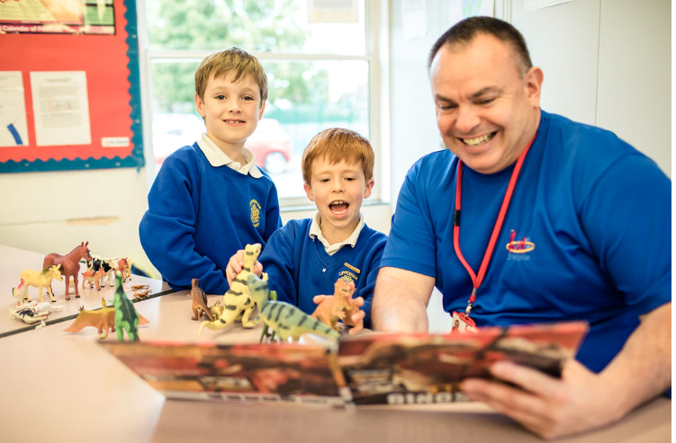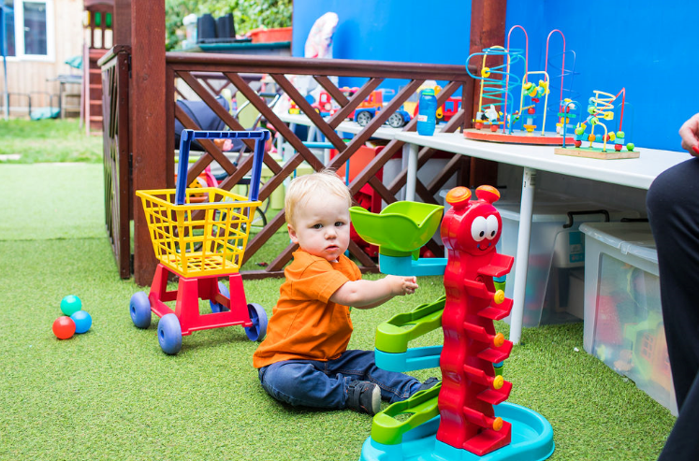

Ansering your questions

Sector Updates
Data collection
From Monday 1st June all providers that are open will be required to submit the following table with completed figures by 12pm on Monday’s and Thursday’s to earlyyears@slough.gov.uk. Please note we will NOT be requiring settings to submit Early Years registers every Friday from week beginning 1st June.

Attendance Totals – Children aged 0 – 4 years old only
1) Total number of children who are attending your educational setting today 0 -4 years old
2) Number of children with critical worker parents
3) Children in need (CIN)
4) Number of children with an Education , Health and Care Plan (EHC Plan)
5) Number of children who are both CIN and have an EHC Plan
6) Number of children assessed as vulnerable by providers or local authorities but not CIN and without an EHC Plan
7) How many 2 year old children attending your setting today are in receipt of their funding entitlement
8) How many 3 & 4 year old children attending your setting today are in receipt of their universal funding entitlement
9) How many 3 & 4 year old children attending your setting today are in receipt of their extended funding entitlement

Attendance Totals – Children aged 5 years and over only
1) Total number of children who are attending your educational setting today 5 years and over
2) Number of children with critical worker parents
3) Children in need (CIN)
4) Number of children with an Education , Health and Care Plan (EHC Plan)
5) Number of children who are both CIN and have an EHC Plan
6) Number of children assessed as vulnerable by providers or local authorities but not CIN and without an EHC Plan

Actions for early years and childcare providers during the coronavirus outbreak
What childcare services early years settings, childminders and local authorities need to provide during the coronavirus (COVID-19) outbreak. Guidance updated to include a restructure of the document in line with wider opening, updated content on funding including in relation to the Competition and Markets Authority and insurance, updated content on infection prevention and control, a new section on attendance, new information on the use of community centres and before and after school clubs, a new section of safeguarding and welfare including provisions for children with SEND and a clarification on paediatric first aid certificates.

https://www.gov.uk/government/publications/coronavirus-covid-19-early-years-and-childcare-closures?utm_source=be357592-21bf-44bb-a6e1-d0b39703de99&utm_medium=email&utm_campaign=govuk-notifications&utm_content=immediate

Ofsted: coronavirus (COVID-19) rolling update
Ofsted guidance and information relating to coronavirus (COVID-19) for schools, early years, children's social care and further education and skills providers. Updated to add information about Ofsted management information publications, and information for early years and childcare professionals on paediatric first aid certificates that are due to expire.

https://www.gov.uk/guidance/ofsted-coronavirus-covid-19-rolling-update?utm_source=761139b9-5b0a-4223-805a-a1ed15fce8e8&utm_medium=email&utm_campaign=govuk-notifications&utm_content=immediate#history

What parents and carers need to know about schools and other education settings during the coronavirus outbreak
Information for parents and carers about the wider opening of nurseries, schools and colleges, transport, attendance, free school meals and remote education. Updated information on what parents and carers need to know about schools, colleges and other education settings during the coronavirus outbreak. This includes information on the curriculum, afterschool activities, repeating a year for pupils, transport and keeping children safe online. We have also amended information on if its compulsory to send pupils to educational settings and education for children at home. It also includes updated information for parents of children with special education needs.

https://www.gov.uk/government/publications/closure-of-educational-settings-information-for-parents-and-carers?utm_source=d8846360-051b-48fa-bbff-e98202033108&utm_medium=email&utm_campaign=govuk-notifications&utm_content=immediate#history

Updated guidance on the early years foundation stage (EYFS) statutory framework
We have updated our statutory guidance for schools and childcare providers on the early years foundation stage (EYFS) to provide clarification on the progress checks for children aged 2. During the coronavirus (COVID-19) outbreak we do not expect providers to undertake this check, but providers should look out for any emerging concerns about any child in their care and endeavour to provide or seek additional support if needed.
The guidance can be found here:
https://www.gov.uk/government/publications/early-years-foundation-stage-framework--2

Providing apprenticeships during the coronavirus (COVID-19) outbreak
This document sets out guidance for apprentices, employers, training providers and assessment organisations in response to the impact of coronavirus (COVID-19). Updated with information on which apprentices should be prioritised in the offer of face-to-face training from 15 June, and details of the flexibility that enables apprentices to take end-point assessment ahead of receiving their calculated functional skills qualification results. https://www.gov.uk/government/publications/coronavirus-covid-19-apprenticeship-programme-response?utm_source=31aacbad-99f6-4229-9e04-fdaff8383d08&utm_medium=email&utm_campaign=govuk-notifications&utm_content=immediate#history

Parenting Special Children Events during the Coronavirus lockdown
We are running the following events, for Berkshire families, online via Zoom. They are free (£5 refundable booking deposit) or at a nominal cost. Please click on the highlighted event title for further information and to book. https://www.parentingspecialchildren.co.uk/news/coronavirus/

Local Government Association – Update regarding the new guidance for after-school clubs and wraparound care
The LGA have been in touch with DfE colleagues, who have confirmed that the information provided at the following website is correct:

http://outofschoolalliance.co.uk/restrictions-on-clubs-reopening

I understand that this is likely to cause problems in many areas and will keep raising, but hopefully this will at least provide clarification in the meantime.

DfE has also confirmed that childminders can continue to operate in line with existing guidance – this does not affect them.

Public Health: reducing your risk coronavirus
Public Health have been busy working on a new page of our website which gives residents some key ways that they can reduce their risk of Coronavirus. This page will help provide residents with some reassurances of how they can return to a new “healthy normal” whilst ensuring they are prepared for any future re-emergence of the virus.

www.publichealthslough.co.uk/campaigns/reducing-your-risk-coronavirus/

Within the page there is a new downloadable infographic called the “Post lockdown pathway”. This document gives residents some useful hints and tips of things they should consider throughout their day to ensure they are protecting themselves and returning to regular life.
Please consider promoting this new page and associated infographic to your contacts and on social media:

ding Confidence
SLOUGH EARLY YEARS AND PREVENTION SERVICE: TELEPHONE: 01753 476554 / EMAIL: earlyyears@slough.gov.uk

