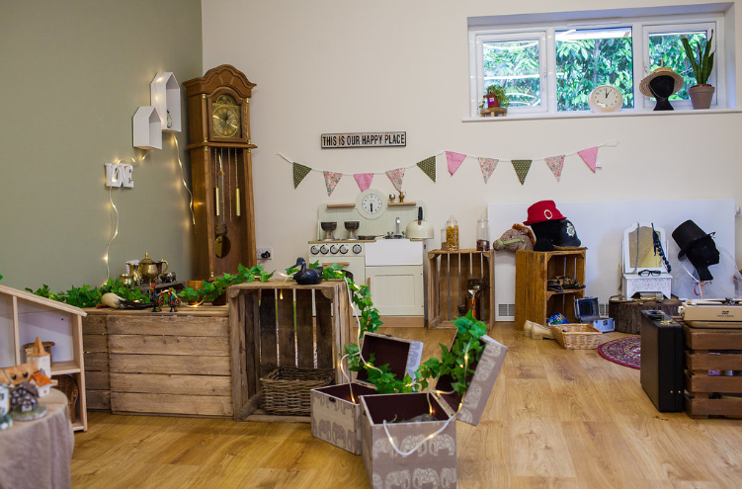 |  | Early Years and Prevention Service  - COVID-19
Recovery Planning for EArly Years and childcare providers |  | In This Issue: 5th June 2020

Transmission of coronavirus mainly occurs via respiratory droplets generated during breathing, talking, coughing and sneezing. These droplets can directly infect the respiratory tracts of other people if there is close contact. They also infect others indirectly. This happens when the droplets get onto and contaminate surfaces which are then touched and introduced into the mouth or eyes of an uninfected person. Another route of transmission is via aerosols (extremely small droplets), but this is only relevant to medical procedures for a very small number of children in education and social care settings.

The majority of staff in education, childcare and children’s social care settings will not require PPE beyond what they would normally need for their work, even if they are not always able to maintain distance of 2 metres from others.

PPE is only needed in a very small number of cases:
•children, young people and learners whose care routinely already involves the use of PPE due to their intimate care needs should continue to receive their care in the same way
• PPE should be worn if a distance of 2 metres cannot be maintained from any child, young person or other learner displaying coronavirus symptoms

Education, childcare and children’s social care settings and providers should use their local supply chains to obtain PPE.

• Where this is not possible, Slough Borough Council are able to support our settings who need assistance in the provision of PPE in order to operate safely. You may approach the Council on PPE@slough.gov.uk for supplies (refer to Flowchart 038A PPE Educational Settings). PPE costs will be charged at cost.

• When wearing PPE, ensure staff adhere to correct procedures on putting on and taking off PPE. Photo instructions found here:
https://www.gov.uk/government/publications/covid-19-personal-protective-equipment-use-for-non-aerosol-generating-procedures

•Used PPE and any other waste generated from the care of a possible or confirmed COVID-19 case should be disposed of in double sealed plastic waste bags, stored in a secure place for 72 hours, then put into normal waste collection service. PPE used when in contact with non-symptomatic pupils should be disposed of immediately in your clinical waste provisions.

Recovery Planning

Personal protective equipment (PPE)
Personal Protective Equipment
Education, childcare and children’s social care settings and providers should use their local supply chains to obtain PPE.
Numbers are increasing
More settings are opening their doors again and more children are starting back! See what the numbers look like in Slough.

PPE may be required……

How to work safely in specific situations, including where PPE may be required:

Reference to PPE in the following situations means:
•fluid-resistant surgical face masks
•disposable gloves
•disposable plastic aprons
•eye protection (for example a face visor or goggles)

Where PPE is recommended, this means that:
•a facemask should be worn if a distance of 2 metres cannot be maintained from someone with symptoms of coronavirus
•if contact is necessary, then gloves, an apron and a facemask should be worn
•if a risk assessment determines that there is a risk of fluids entering the eye from, for example, coughing, spitting or vomiting, then eye protection should also be worn

When PPE is used, it is essential that it is used properly. This includes scrupulous hand hygiene and following guidance on how to put PPE on and take it off safely in order to reduce self-contamination.

Face masks must:
•cover both nose and mouth
•not be allowed to dangle around the neck
•not be touched once put on, except when carefully removed before disposal
•be changed when they become moist or damaged
•be worn once and then discarded - hands must be cleaned after disposal
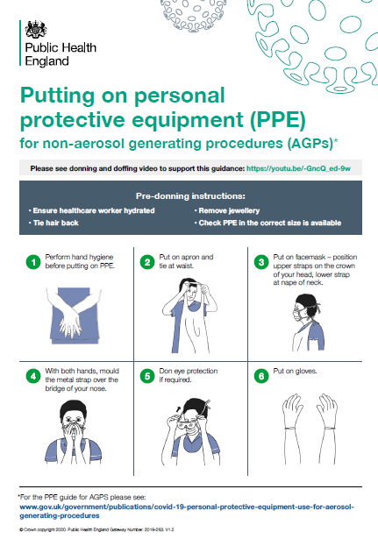
Is PPE required for tasks involving changing nappies or general care for babies?

Staff should follow their normal practice when changing nappies and caring for babies more generally, provided the child is not showing symptoms of coronavirus. This includes continuing to use the PPE that they would normally wear in these situations, for example aprons and gloves. If a child shows symptoms, they should not attend a childcare setting and should be at home.

How should PPE and face coverings be disposed of?

Used PPE and any disposable face coverings that staff, children, young people or other learners arrive wearing should be placed in a refuse bag and can be disposed of as normal domestic waste unless the wearer has symptoms of coronavirus, in line with the guidance on cleaning for non-healthcare settings.

Any homemade non-disposable face coverings that staff or children, young people or other learners are wearing when they arrive at their setting must be removed by the wearer and placed into a plastic bag that the wearer has brought with them in order to take it home. The wearer must then clean their hands.

To dispose of waste from people with symptoms of coronavirus, such as disposable cleaning cloths, tissues and PPE:
•put it in a plastic rubbish bag and tie it when full
•place the plastic bag in a second bin bag and tie it
•put it in a suitable and secure place marked for storage for 72 hours

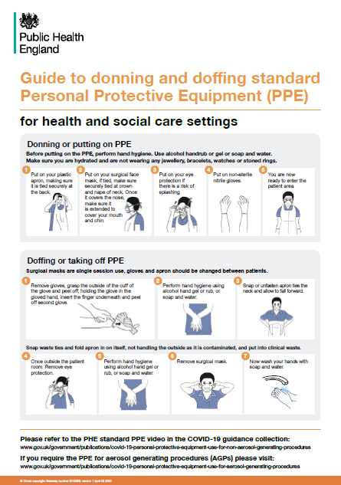
Waste should be stored safely and securely kept away from children. You should not put your waste in communal waste areas until the waste has been stored for at least 72 hours. Storing for 72 hours saves unnecessary waste movements and minimises the risk to waste operatives. This waste does not require a dedicated clinical waste collection in the above circumstances.

Further information is also available in the cleaning non-healthcare settings guidance

COVID-19: guidance for first responders
This guidance is for first responders as defined by the Civil Contingencies Act (2004), and others who may have close contact with individuals with potential coronavirus infection (COVID-19). This includes professionals and members of voluntary organisations who, as part of their normal roles, provide immediate assistance requiring close contact until further medical assistance arrives. https://www.gov.uk/government/publications/novel-coronavirus-2019-ncov-interim-guidance-for-first-responders/interim-guidance-for-first-responders-and-others-in-close-contact-with-symptomatic-people-with-potential-2019-ncov
.

COVID-19 PPE
COVID-19: personal protective equipment use for non-aerosol generating procedures Guidance on the use of personal protective equipment (PPE) for non-aerosol generating procedures (APGs). https://www.gov.uk/government/publications/covid-19-personal-protective-equipment-use-for-non-aerosol-generating-procedures
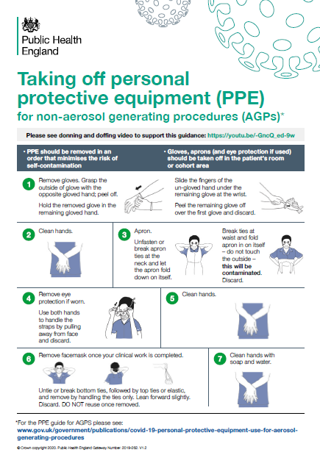
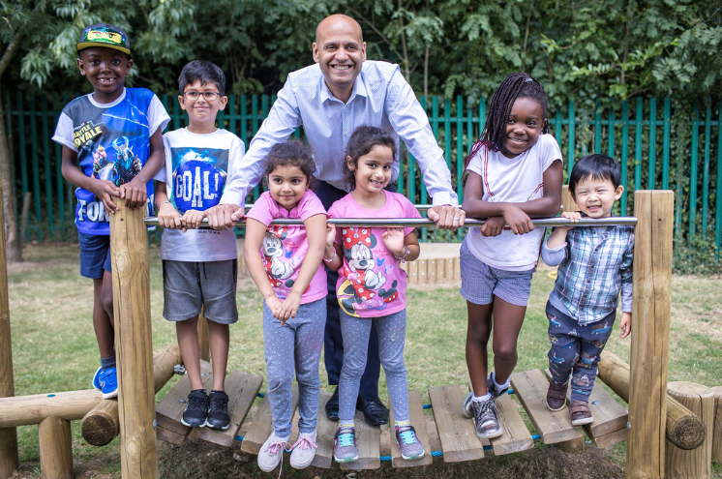
H

Answering your questions

Ask Michael
Service Lead Early Years and Prevention

Private, voluntary and independent early years providers including childminders are being asked to submit daily numbers of children on Monday’s and Thursday’s every week. Why is the local authority collecting this information and what are you doing with it?

The Department for Education have requested that local authority early years teams submit daily attendance figures to them om Monday’s and Thursday’s. This is a crucial data collection, and transparency around the availability of childcare settings is critical to helping decision making at this unprecedented time. Completing the data task is the best and most efficient way for us to let the DfE know about the early years and childcare provision in our area and any availability or other problems that may be arising. We recognise that you are very busy and under significant pressure at this time, however this information is also being used locally to inform our targeted work with providers, our contacts with families via the family information service and our duty to ensure we have enough early years and childcare provsion across Slough. The data is not currently linked to any funding allocation process.

Critical workers: The definition of critical workers remains unchanged.
Vulnerable children: Children who have a child in need plan, a child protection plan or who are a looked-after child
https://www.gov.uk/government/publications/coronavirus-covid-19-maintaining-educational-provision/guidance-for-schools-colleges-and-local-authorities-on-maintaining-educational-provision

Attendance Totals – Children aged 0 – 4 years old only
1) Total number of children who are attending your educational setting today 0 -4 years old
2) Number of children with critical worker parents
3) Children in need (CIN)
4) Number of children with an Education , Health and Care Plan (EHC Plan)
5) Number of children who are both CIN and have an EHC Plan
6) Number of children assessed as vulnerable by providers or local authorities but not CIN and without an EHC Plan
7) How many 2 year old children attending your setting today are in receipt of their funding entitlement
8) How many 3 & 4 year old children attending your setting today are in receipt of their universal funding entitlement
9) How many 3 & 4 year old children attending your setting today are in receipt of their extended funding entitlement

Attendance Totals – Children aged 5 years and over only
1) Total number of children who are attending your educational setting today 5 years and over
2) Number of children with critical worker parents
3) Children in need (CIN)
4) Number of children with an Education , Health and Care Plan (EHC Plan)
5) Number of children who are both CIN and have an EHC Plan
6) Number of children assessed as vulnerable by providers or local authorities but not CIN and without an EHC Plan

Schools with nursery classes / MNS please note: You are only required to submit register data to the schools team at the local authority via Paula Doneghan. You are not required to submit the same data to the Early Years and Prevention Service however we do ask that you highlight on your register returns which children are in your nursery classes. The early years team have to submit this data to the DfE twice weekly (Mondays and Thursdays) and we appreciate your assistance with this matter. Please include all nursery children on these days and not just critical worker or vulnerable children.
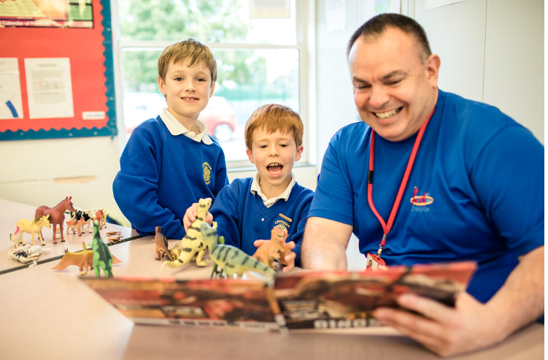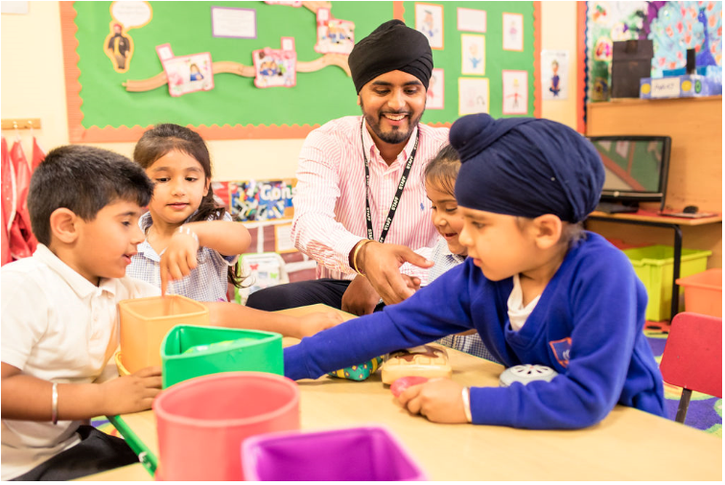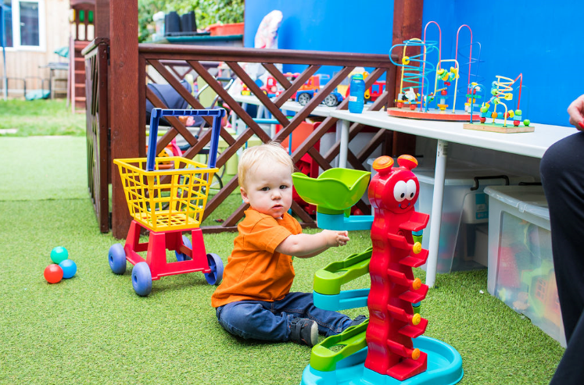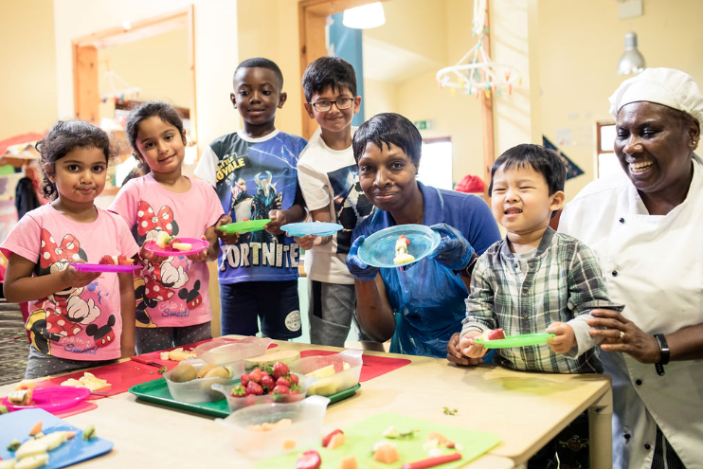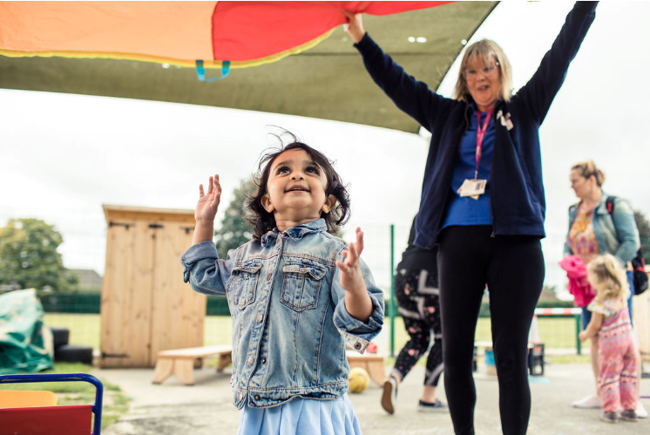

Ansering your questions

Numbers are increasing

So far this week a total of 81 providers are now open and accepting children into their setting, on Monday 148 children attending an early years and childcare provision and this increased to 228 children by Thursday.

Week beginning 1st June | Total Number of settings | Number planning to be open on 1st June | % opening on 1st June | Children attended Monday 1st June | Children attended Thursday 4th June | Increase
Childminders | 109 | 37 | 34% | 43 | 55 | 12
PVI | 29 | 9 | 31% | 96 | 157 | 61
CC | 10 | 8 | 80% | 0 | 52 | 52
Schools & MNS | 29 | 27 | 93% | 9 | 16 | 7
Total | 177 | 81 | 46% | 148 | 228 | 80

Another 22 settings are planning to open their doors during June and another 15 in July.
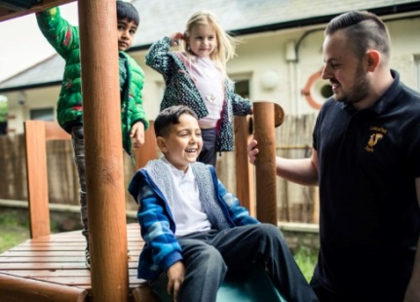
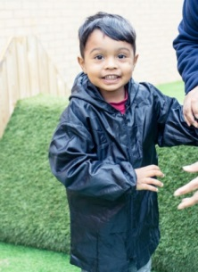
By the end of July it is anticipated that approximately 422 children will be back accessing their early years and childcare placement.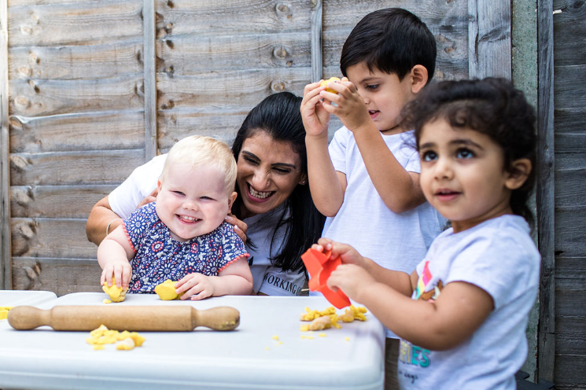

Sector Updates
Foundation Years - FAQs

Implementing protective measures in early years settings
Foundation Years have published answers to the sector's frequently asked questions (FAQs) on implementing protective measures in early years settings during the coronavirus outbreak. The answers cover:
- Using sandpits and water troughs
- Taking groups of children to outdoor public places
- Testing for under 5s
- The maximum number of children in a bubble in primary schools
Foundation Years also hosted a video podcast with the Department for Education (DfE) to answer your questions and share the latest information that providers can use when planning to reopen.

The 2020 Early Years Summit:
Speech, Language and Communication
FREE CPD · Watch online at your convenience from your own home
Monday 1st June - Sunday 7th June
https://www.earlyyearssummit.com/

Family Resources to support parents and carers during lockdown
Family Resources to support parents and carers during lockdown
Education Development Trust (EDT) and Elklan, have developed Family Resources, fun and friendly guides for parents to support their 2-4 year-old's communication skills.
Lyn Challender, Early Years Professional Development Advisor at EDT, has also published an article on how early years practitioners can support parents to navigate home learning.
NHS East Berkshire CCG: Lift the Baby
NHS EAST BERKSHIRE CCG are doing a facebook campaign for Lift the Baby during June. We are targeting all parents who have had a baby in the last 12 months. Please share the link as wide as you can and especially for those who are in contact with parents and parents to be:

You can view the ad for yourself by clicking on the following link: https://fb.me/1RLQfTTFCB3PWtS and then click ‘Show ad’ – it will then appear on your personal Facebook page for the next 24 hours, allowing you to like, share and comment on the ad, so that you can keep an eye on how it performs.

Post Lockdown Pathway
Post lockdown pathways gives residents some key ways that they can reduce their risk of Coronavirus. This page will help provide residents with some reassurances of how they can return to a new “healthy normal” whilst ensuring they are prepared for any future re-emergence of the virus.
www.publichealthslough.co.uk/campaigns/reducing-your-risk-coronavirus/
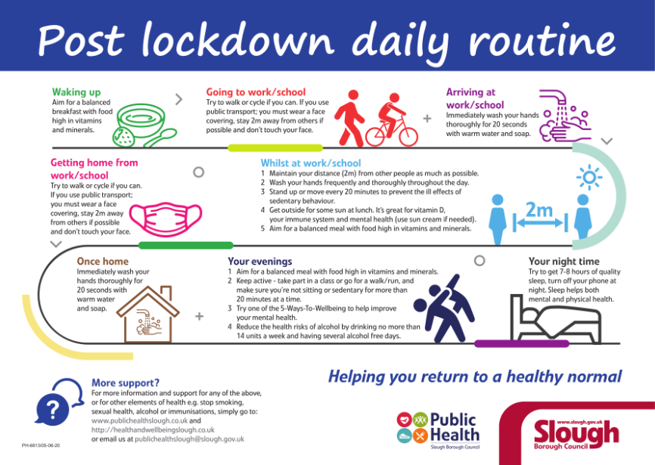
New version will go live on the 15th as the law changes.

Actions for early years and childcare providers during the coronavirus outbreak
What childcare services early years settings, childminders and local authorities need to provide during the coronavirus (COVID-19) outbreak. We have added a clarification on the requirement for providers to carry the appropriate insurance (for example, public liability insurance) to cover all premises from which they provide childcare or childminding. https://www.gov.uk/government/publications/coronavirus-covid-19-early-years-and-childcare-closures?utm_source=0cbc5c5c-f45c-4dd4-bdbb-14e81aab0f8e&utm_medium=email&utm_campaign=govuk-notifications&utm_content=immediate#history

ding Confidence
SLOUGH EARLY YEARS AND PREVENTION SERVICE: TELEPHONE: 01753 476554 / EMAIL: earlyyears@slough.gov.uk

